Cancel Columbus!

Patient Zero of the White Supremacist Plague

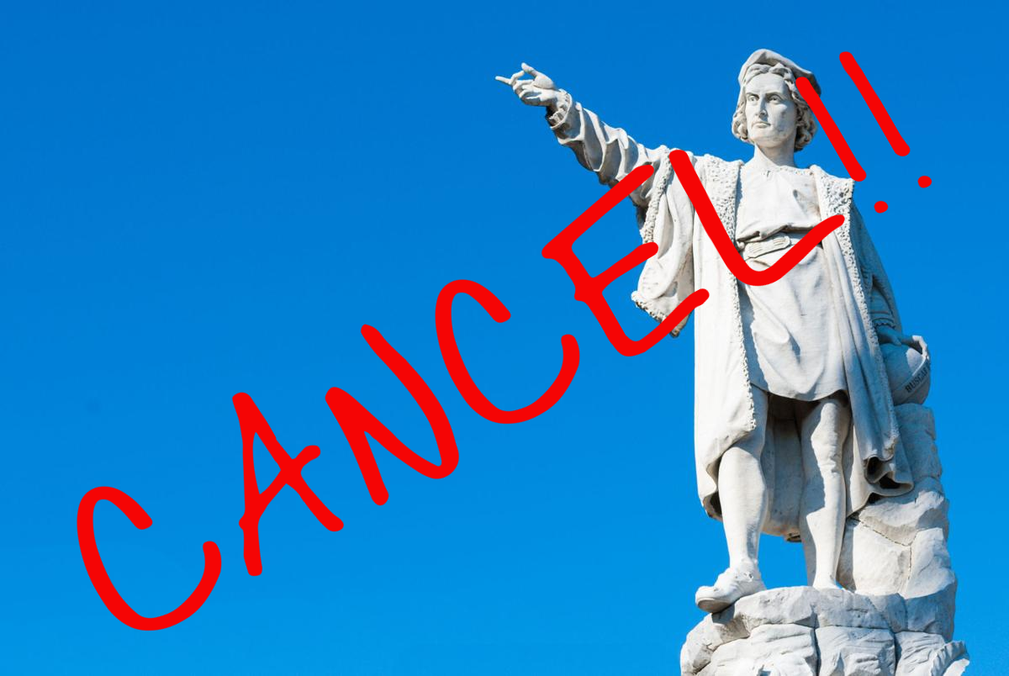

by

Timothy McGettigan, PhD
Professor of Sociology
Colorado State University-Pueblo

Abstract

White supremacy begins and ends with Columbus. Cancel Columbus. Cancel white supremacy.

Imagine a world  Where human beings  Treat human beings  Like human beings  Why is that so hard to imagine? | 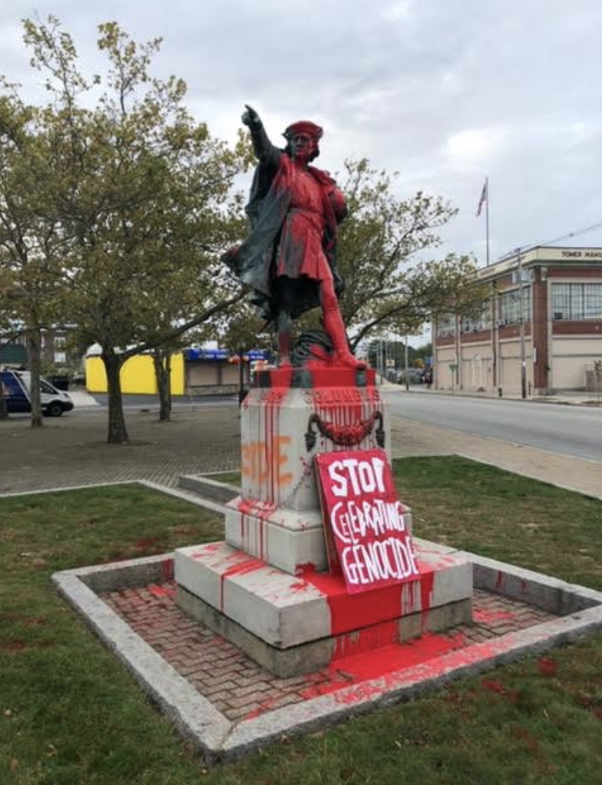

Introduction - The Worst Plague in History

The most devastating plague ever to strike humanity was not a virus. COVID 19 is awful, the Spanish Flu was horrific, the Bubonic Plague was hideous, but white supremacist racism has been the most devastating contagion ever to ravage humanity. What other affliction has maliciously invaded, terrorized, and annihilated the indigenous inhabitants of entire continents for the past 500+ years?

Many people believe that racism has always existed in its current form. But that's not true. Racism is a form of sadism (Meloy, 1997) that ebbs and flows in response to capricious social policy shifts. Quite simply, racist social policies create racist societies. By the same token, anti-racist policies create anti-racist societies (McGettigan and Smith, 2016). It's a two-way street, so never lose hope. But anti-racism is certainly an uphill trudge.

White supremacist racism emanated from a specific set of historical events. Before Christopher Columbus journeyed to the western hemisphere, there was no such thing as white supremacist racism (Mann 2005, 2011). To this day, white supremacists insist that they are innately superior to those they despise (Horne, 2018; Kusz, 2017; Wade, 2014). However, there is no scientific evidence to support those claims, and no one clung to such erroneous beliefs prior to 1492 (Malott, 2011). It was not until Columbus blundered into the New World (Bigelow, 1998) that greedy Europeans invented white supremacist racism as part of a diabolical scheme to secure uncontested ownership of the Western Hemisphere.

For the Love of God?!?

When Pope Alexander IV got wind of Columbus’ experiences in the New World, he sensed an opportunity. Though one might expect the leader of a benevolent religion to embrace the indigenous peoples of the Western Hemisphere as sisters and brothers, Pope Alexander IV had other ideas.

Instead of reaching out in fellowship, Pope Alexander IV decided to rob the Western Hemisphere’s inhabitants of their lives, their way of life, their dignity, and most importantly to the greedy Pope, their homeland.

Many people have wondered why Europeans were able to colonize so many new territories during Europe’s *glorious* Age of Discovery (Todorov, 1984). Because the winners typically write history (Zinn, 2010), apologists have often claimed that Europeans acquired colonies all over the world due to their innate superiority (Wade, 2014). But, far from an exhibition of intrinsic superiority, it was Europeans’ insatiable lust for booty and ultra-violence that fueled their campaigns of colonial domination. If you doubt my word, check out the marching orders that Pope Nicholas V issued to outbound European explorers/pirates in 1452:

...invade, search out, capture, vanquish, and subdue all Saracens and pagans whatsoever, and other enemies of Christ wheresoever placed, and the kingdoms, dukedoms, principalities, dominions, possessions, and all movable and immovable goods whatsoever held and possessed by them and to reduce their persons to perpetual slavery(!!!), and to apply and appropriate to himself and his successors the kingdoms, dukedoms, counties, principalities, dominions, possessions, and goods, and to convert them to his and their use and profit.

In sum, kill (or enslave) everyone you meet and steal all of their stuff. Apparently, human decency isn’t a job requirement for the papacy.

Like good little Christian soldiers, European explorers took their papal marching orders to heart and conducted the most gruesome genocide campaigns that the world has ever seen. If Europeans are superior at anything it is their unrivalled enthusiasm for perpetrating scorched-earth genocide on a hemispheric scale. But that's not a form of superiority to be proud of.

In spite of white supremacist claims to the contrary, biologically speaking all humans are equal (Sussman, 2014). Not identical, but equal (McGettigan and Smith, 2016). Racists attach enormous significance to minor cosmetic differences (e.g., skin tone, hair texture, ear, eye, and nose shape) not because of their biological significance, but because of their triviality (Spelsberg, 2011). Counterintuitively, racism tends to be vitriolic because of how difficult it is to maintain categorical distinctions in a species that exhibits so much uniformity (Montagu, 1964). The human penchant for ethno-blending--the technical term for which is “reticulation” (Sapp, 2012)--makes a mockery of racist struggles to fabricate ethnic purity (Hitler, 2000).

The biological facts are in: There is one human race and all humans are full-fledged members of it.

Severe social inequalities emerge as a consequence of unfair social policies rather than innate superiority or inferiority (McGettigan and Smith, 2016). When they learned of its existence, greedy Europeans decided to use any means necessary to acquire uncontested ownership of the New World (Jaimes, 1992). Columbus (1991) himself reported that, like all major landmasses as of 1492, the New World was densely-populated with indigenous inhabitants. So, in order for greedy Europeans to claim the New World for themselves, they had to concoct social policies which granted themselves permission to coldly, callously obliterate the Western Hemisphere’s countless inhabitants (Deloria, 1995).

What kind of sickos do stuff like that?

WTF!! No One Could Do Anything So Horrible…Could They?

Here we must pause to consider the staggering ruthlessness involved in meticulously extirpating the inhabitants of an entire hemisphere (Smith, 2015). Everyone knows that theft and murder are crimes. We all learned that in Kindergarten, right? We also know that people who commit crimes in the service of greed are bad eggs: they are criminals with a capital C. Furthermore, robbing and murdering a fellow human being is downright unconscionable. Now, try to imagine how much more awful is it to coldly, calculatingly rob, rape, and murder the inhabitants of an entire hemisphere into oblivion. Even worse, the perpetrators of New World genocide crafted a narrative that made them out to be heroes rather than villains for their monstrous misdeeds (Wolfe, 2006).

What kind of sickos do stuff like that?

There are no words to describe horrors of such magnitude. Nevertheless, that is precisely what Pope Alexander IV and his cronies set out to accomplish (i.e., unrestricted and unrepentant genocide) via the Doctrine of Discovery.

How did a stumblebum like Christopher Columbus come to be known as the discoverer of the New World (Zinn, 2010)? The Doctrine of Discovery stated that non-Christians were non-people. Bald-faced lie though it was, Pope Alexander IV insisted that--in spite of the fact that there were countless millions of indigenous inhabitants in plain view--Columbus was the first “Real Man” to set foot in the New World and, therefore, Columbus had a god-given right to claim discovery and ownership of that empty land (Terra Nullius) for his lords and masters in Europe. Proceeding from that self-serving lie, Pope Alexander IV created hell on earth (murder, mayhem, rape, robbery, deumanization, humiliation, etc. etc.) for the indigenous peoples of the Western Hemisphere.

PAUSE: Nah! That can't be right! Just because a greedy, cold-hearted Pope claimed that non-Christians should be raped, robbed and murdered out of existence doesn’t mean that his devoted Christian followers would ever carry out such depravity...would they?!?

As far as greedy Europeans were concerned, if Pope Alexander IV stated that the Western Hemisphere was Terra Nullius they needed no further convincing (Newcomb, 2008). The countless millions of poor, innocent souls who died in the meat-grinder of Manifest Destiny were, as far as Pope Alexander IV was concerned, naught but worthless heaps of collateral damage. What are human lives worth if they obstruct the path of a ruthless, power-mongering Pope?

While greedy Europeans raked in huge profits, the Doctrine of Discovery exacted a human toll that is almost too ghastly to countenance. Pope Alexander IV created a false, but highly-consequential dichotomy between Christians and non-Christians. Though that distinction involved naught but a simple cultural preference (NEWSFLASH: One can either choose to be Christian or not, right?), Pope Alexander IV treated Euro-Christianity as the sole criteria to determine an individual’s “worthiness” to exist: Euro-Christians were exalted as unimpeachable Real Men, while non-Christians were reviled as disposable sub-humans (Steuter and Wills, 2010). That false dichotomy also provided a rationale for the white supremacist racism that plagues humanity to this very day (Lehman, 2016): Greedy white men count. Others don’t.

Having been told that indigenous peoples were worthless subhumans, white supremacist racists (including luminaries such as George Washington, Thomas Jefferson, Abe Lincoln, Teddy Roosevelt, etc.) systematically carried out the hemispheric genocide that was required to bring Pope Alexander's fabled Manifest Destiny to fruition (Freehling, 1972; Guyatt, 2016).

As long as white supremacists cling to the transparent lie that indigenous peoples are worthless subhumans there need be no moral reckoning for the unspeakable horrors upon which The World’s Greatest Democracy has been built (Frederickson, 2015). That is why the Heirs of Columbus remain doggedly determined to preserve the pathetic lie that Columbus discovered America (Bigelow, 1998). The truth behind that lie is too horrible for the villains who cast themselves as heroes to admit (Foner, 2016). The Heirs of Columbus have managed to keep their dirty little secret under wraps for 500+ years, but, at long last the ugly truth is finally being revealed.

"But why?" The Sons of Italy bleat, "Why can't we perpetuate the insulting lie that Christopher Columbus was a great American hero?"’

Because you poor, deluded Columbophiles he was anything but that.

Revealing the Ugly Truth

As with COVID 19, we can’t remedy an illness by pretending it doesn’t exist. If a white supremacist contagion lurks among us, it will continue inflicting grievous harm until we confront and cure it (Alexander, 2012; McGettigan and Smith, 2016; Obama, 2008).

That’s why every last Christopher Columbus statue needs to kiss the sidewalk ASAP. Democracy won’t exist until we put an end to the lie that Columbus deserves credit for discovering the New World. So long as we continue blinding ourselves with preposterous Columbothology, we’ll continue pretending that Columbus and his heirs did not villainously murder the rightful inhabitants of an entire hemisphere; all told, Manifest Destiny qualifies as the most abominable crime in human history.

Columbus was not a hero. The sooner we embrace that all-important truth, the sooner we will be able to wipe out the enduring contagion of white supremacist murder and mayhem that Columbus-worship promotes and conceals (McGettigan and Smith, 2016).

We can't change what Columbus and Pope Alexander IV did 500+ years ago. But we can do everything in our power to prevent white supremacists from inflicting more injustice, violence and horror from now on.

The people who erected Columbus statues did so out of admiration for the man who brought white supremacy to the New World. It is unfortunate that they couldn’t have channeled their energy into more humanitarian projects.

Those who are determined to tear down Columbus statues do so in recognition of the genocidal atrocities that greedy white supremacists have inflicted throughout the Western Hemisphere--and far beyond!! Until every last Columbus statue has been laid low white supremacy will continue hiding in plain sight and rotting the heart and soul of The World's Greatest Democracy.

References

Alexander, Michelle, 2012. The New Jim Crow: Mass Incarceration in the Age of Colorblindness. New York: The New Press.

Bigelow, Bill, 1998. "Once upon a genocide: Columbus in children’s literature." Rethinking Columbus: The next 500 (1998): 47-55.

Columbus, Christopher, and Bartolomé de Las Casas, 1991. The Diario of Christopher Columbus's first voyage to America, 1492-1493. Vol. 70. University of Oklahoma Press.

Corcos, Alain F., 1997. The myth of human races. East Lansing, MI: Michigan State University Press.

Craven, Wesley Frank, 1942. "Columbus Discovered America." The Virginia Quarterly Review 18.3 (1942): 451.

Deloria, Vine, 1995. Red Earth, White Lies: Native Americans and the Myth of Scientific Fact. Fulcrum Publishing.

Foner, Nancy. "Black Immigrants and the Realities of Racism: Comments and Questions." Journal of American Ethnic History 36.1 (2016): 63-70.

Fredrickson, George M, 2015. Racism: A short history. Princeton University Press.

Freehling, W. W., 1972. “The Founding Fathers and Slavery.” The American Historical Review, 77(1), 81-93.

Graves, Joseph L. 2004. The Race Myth: Why We Pretend Race Exists in America. New York: Dutton.

Guyatt, Nicholas, 2016. Bind Us Apart: How Enlightened Americans Invented Racial Segregation. New York: Basic Books.

Hitler, Adolf, 2000. Mein kampf. Om Books International.

Horne, G., 2018. The apocalypse of settler colonialism: The roots of slavery, white supremacy, and capitalism in 17th century North America and the Caribbean. NYU Press.

Jaimes, M. Annette, 1992. The State of Native America: Genocide, Colonization, and Resistance. South End Press.

Kusz, K.W., 2017. Trumpism, Tom Brady, and the reassertion of white supremacy in militarized post-9/11 America. Sport and militarism: Contemporary and global perspectives, pp.238-254.

Lehman, Paul R, 2016. The System of European American (White) Supremacy and African American (Black) Inferiority. Xlibris Corporation.

Malott, C. S., 2011. “The Social Construction of the Dominant Psychological Paradigm: Columbus, Slavery, and the Discourses of Domination.” In Critical Pedagogy and Cognition (pp. 67-77). Springer Netherlands.

Mann, Charles C., 2005. 1491: New Revelations of the Americas before Columbus. New York: Knopf.

Mann, Charles C., 2011. 1493: Uncovering the New World Columbus Created. New York: Alfred A. Knopf.

McGettigan, Timothy and Earl Smith, 2016. A Formula for Eradicating Racism: Debunking White Supremacy. New York: Palgrave.

Meloy, J. Reid, 1997. "The psychology of wickedness: Psychopathy and sadism." Psychiatric Annals 27.9 (1997): 630-633.

Miller, Robert J., 2011. American Indians, the doctrine of discovery, and manifest destiny. Wyo. L. Rev., 11, 329.

Miller, Robert J., Jacinta Ruru, Larissa Behrendt, Tracey Lindberg, 2010. Discovering Indigenous Lands: The Doctrine of Discovery in the English Colonies. Oxford: Oxford University Press.

Montagu, Ashley. 1964. Man’s Most Dangerous Myth: The Fallacy of Race. Cleveland: World Pub.

Newcomb, Steven T., 2008. Pagans in the Promised Land: Decoding the Doctrine of Christian Discovery. Golden, CO.: Fulcrum Publishing.

Obama, Barack, 2008. "A More Perfect Union." The Black Scholar 38.1 (2008): 17-23.

Sapp, Jan, 2012. “Race Finished.” American Scientist 100 (2). p. 164

Smith, Andrea, 2015. Conquest: sexual violence and American Indian genocide. Duke University Press.

Spelsberg, Thomas. 2011. The Myth of Race: Our DNA Defines Who We Are. Rochester, NY: TCS Scientific Publishers.

Stephanson, Anders, 1996. Manifest Destiny: American Expansion and the Empire of Right. New York: Farrar, Straus and Giroux.

Steuter, Erin, and Deborah Wills, 2010. "‘The vermin have struck again’: dehumanizing the enemy in post 9/11 media representations." Media, War & Conflict 3.2 (2010): 152-167.

Sussman, Robert W., 2014. The Myth of Race: The Troubling Persistence of an Unscientific Idea. Cambridge: Harvard University Press.

Todorov, Tzvetan, 1984. The conquest of America: The question of the other. University of Oklahoma Press.

Wade, Nicholas, 2014. A Troublesome Inheritance: Genes, Race and Human History. New York: Penguin.

Wolfe, P., 2006. “Settler Colonialism and the Elimination of the Native.” Journal of Genocide Research, 8(4), 387-409.

Zinn, Howard, 2010. A People’s History of the United States. New York: Harper Perennial.

Direct all correspondence to Timothy McGettigan, PhD, Professor of Sociology, CSU-Pueblo, 2200 Bonforte Blvd., Pueblo CO 81001-4901, PH 719-549-2416, Email: proftim@fulbrightmail.org
Sadism is a form of malice that emanates from the misperception that politically-disadvantaged groups are qualitatively “inferior” beings. The horrors that white racists have inflicted on people of color throughout US history can be explained in part by the fact that the Founding Father’s were strongly influenced by The Doctrine of Discovery and the US Constitution characterizes people of color as subhumans: ⅗ (McGettigan and Smith, 2016).

