Type of the Paper: Peer-reviewed Conference Paper / Full Paper
Track title: Human-centred and nature-based approaches in cities

Global Approach - Local Solutions: Sectorial Planning Approaches for a Sustainable Urban Future in Piura, Peru.
Trinidad Fernandez ^{1,*}, Stella Schroeder ²
Names of the track editors:
Claudiu Forgaci
Rene van der Velde

Names of the reviewers:
Claudiu Forgaci
Thorsten Schuetze
Journal: The Evolving Scholar
DOI:10.24404/6151bea604e942000831d6f0

Submitted: 27 September 2021
Accepted: 1 June 2022
Published: 15 July 2022
Citation: Fernandez, T. & Schroeder, S. (2021). Global approach - local solutions: Sectorial planning approaches for a sustainable urban future in Piura, Peru. The Evolving Scholar | IFoU 14th Edition.

This work is licensed under a Creative Commons Attribution CC BY (CC BY) license.
©2021 [Fernandez, T. & Schroeder, S.] published by TU Delft OPEN on behalf of the authors.

¹ Fraunhofer Institute for Industrial Engineering IAO, Stuttgart, Germany; trinidad.fernandez@iao.fraunhofer.de; https://orcid.org/0000-0003-4766-6689
² University of Piura, Piura, Peru; stella.schroeder@udep.edu.pe; https://orcid.org/0000-0001-8591-2719
* Corresponding author

Abstract:
Smart and sustainable urban development is one of the leading solutions for local adaptation strategies and the efficient use of resources. The Morgenstadt Global Smart Cities Initiative (MGI) is a project funded by the International Climate Initiative (IKI) of the German Federal Ministry for the Environment, Nature Conservation, and Nuclear Safety (BMU), strengthening the development and implementation of sustainable transformation processes in cities. A sectoral approach based on empirical evidence analyses the resilience and climate risks from Piura (Peru), which is strongly affected by the consequences of climate change. The initiative uses the Morgenstadt City Lab methodology to develop integrated strategies and roadmaps for sustainable urban development. It contains a multidisciplinary survey and analysis technique. The data is leveraged by applying various methods, such as workshops, expert interviews, indicator surveys, clusters, and cross-impact analyses. Within the framework, a sustainable city profile is developed, identifying possible interventions, and co-creating project ideas with various stakeholders to improve resilience and climate change adaptation potential. The proposed solutions combine ecological and resilience objectives with opportunities for social and economic innovation that sustainably support urban development. They seek to become pilot projects and agents of sustainable integration and social inclusion that support different vulnerable communities and areas in the city.
Keywords: climate change adaptation; sustainability; smart cities; urban resilience

1. Introduction
The global trend of rapid urbanisation has forced cities to seek solutions that respond to different challenges in a fast problem-solving-oriented manner, emulating traditional unsustainable resource-intensive solutions and patterns (Simon, 2016). Cities contribute heavily to global climate change, responsible for roughly 70% of global greenhouse gas emissions, as well as being the hardest hit by the effects of climate change with rising temperatures worsened by air pollution and heat island effects, along dense populations facing high risks of infectious disease transmission, to name a few (OECD, 2008). Sustainable urbanisation has come to the forefront of debates, research, and policy agendas in recent years, where taking action will be especially important for developing countries, which will be most affected by the effects of climate change. A United Nations (Cousens & Szabó de Carvalho, 2020) survey revealed that climate change is one of the greatest national concerns, raising the importance of global cooperation to tackle it.

1.1 About the MGI
The MGI is a project funded by the Federal Ministry of Environment, Nature Conservation and Nuclear Safety (BMU) through the International Climate Initiative (IKI) aiming at helping cities increase their resilience to climate change impacts, as well as to support their GHG emission reduction efforts. The initiative builds on the implementation of City Labs to analyse, identify, and develop sustainable cross-sectoral solutions to optimize urban infrastructures, processes, or services in Kochi (India), Piura (Peru), and Saltillo (Mexico).
As part of the IKI network, the MGI’s primary objective is to mitigate the consequences of climate change in the pilot cities, to increase their resilience to climate risks, and to preserve their natural resources. The structure of the project fosters peer-to-peer learning, innovation, sustainable urban development practices, and collaboration between the local and global research communities, cities, citizens, as well as the private sector. The multi-stakeholder dialogue and the holistic urban system assessments in the participant cities are the vital elements to achieve the project’s objectives. Furthermore, the project methodology supports the cities in the development and implementation of analytical methods, strategic planning tools, and the increase of local expertise for a holistic, long-term, and sustainable urban development process.
The selection of the three participant cities were based on their vulnerability and the challenges they face in terms of climate change. All of them present a high degree of urbanisation or urban growth, and have identified urbanisation as a source as well as a solution to many sustainability challenges in regional development strategies. However, India, Mexico, and Peru don’t have a coherent approach that underpins urban climate change and sustainable urban development with innovative policies and efforts to develop carbon-neutral, interconnected, and sustainable technologies and infrastructures.
Altogether, the MGI initiative begins a long-term and sustainable transformation process, leading to replicable and financially viable solutions for a resource-efficient, resilient, and liveable city of tomorrow.

1.2 About Piura
The city of Piura is located in Northwestern Peru and is the capital of the region (Figure 1). The city is a service centre within a region characterised mainly by agriculture and fishing.

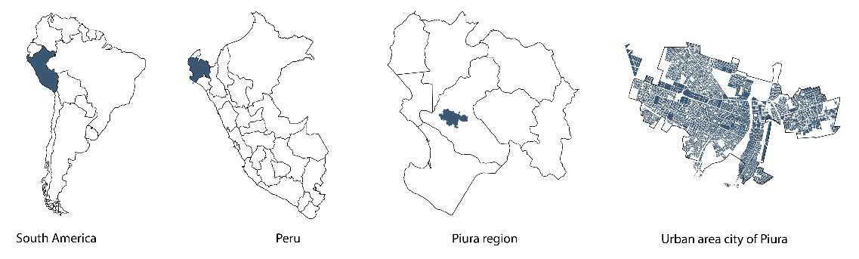
Figure 1: Location of Piura. Source: Own elaboration, 2021.
Due to its geographical location, the city and region are very vulnerable to climate change. The most important natural disaster is caused by the El Nino (FEN), a cycle of changes in water temperature and air pressure that affects regional rainfall (Broad, 2002) and which, in its last event in 2017, affected the areas surrounding the river that runs through the city, exposed to the effects of flooding (Figure 3).
Since the ‘70s, the city has experienced exponential urban growth and has its origin mainly in rural-urban migration, a trend that was noticed throughout the country. This has led to the informal occupation of land for residential use and has generated what is known as “land invasion” (Solá Morales i Rubió, 1997) of vulnerable land without basic water, electricity, and drainage services. The city of Piura shows sectors of urban segregation well defined by this informality.
Furthermore, the rapid growth challenges the ability of the city to respond to it led to a reduction of biodiversity, loss of agricultural land, heavy traffic producing air pollution, and increased energy consumption. In addition, the city centre of Piura is close to the riverbanks, and has become highly vulnerable to the effects of climate change, as it lacks a relationship between the city, the water, and green areas which could serve as protection against flooding. Moreover, blind water basins cause heavy flooding during the rainy season.
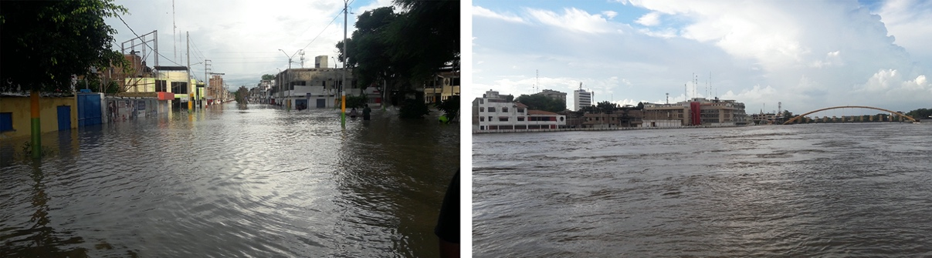Figure 2: City of Piura during FEN 2017. Source: Own photographs, 2017

1.3 Objective
Within the framework of the MGI project, City Labs are implemented to identify possible areas to intervene and co-create project ideas with various stakeholders to improve resilience and climate change adaptation potential.
As part of the wider project, the main objective of this article is to present an overview of the main findings of the sustainable city profile and the development of project ideas. The resulting roadmap aims to support the city’s efforts to mitigate GHG emissions, adapt to climate change, and conserve biological diversity. The proposed solutions are based on the concepts of smart cities, resilient cities, and nature-based solutions (NBS), combining ecological and resilience objectives with opportunities for social and economic innovation that sustainably support urban development. In this context, the City Lab seeks to support Piura to become a model of innovative, locally adapted, and climate-smart solutions aimed at increasing its resilience to the impacts of climate change, and preserving and efficiently using its resources at the same time. Additionally, these solutions are nature-based and stimulate the local economy.

2. Theories and Methods

2.1. City Lab Methodology
The Morgenstadt City Lab methodology consists of an in-depth analysis of a given city to create overarching systemic understanding of how it works (Fraunhofer-Gesellschaft, 2014). Multiple City Labs have already been implemented in several cities, mostly in Europe but with some already deployed in the global south. While most urban studies are based on macroeconomic data such as population growth, economic growth, and real estate prices, the City Lab approach is based on a city as an ecosystem approach. The City Lab framework is structured on three main levels of analysis: governance, technologies and infrastructure, and socio-economic strategy. Data gathering based on performance indicators for assessing the quantifiable sustainability performance; key action fields essential for sustainable development and a digital on-site assessment where the MGI team conducts interviews with key stakeholders to identify the main challenges, opportunities, and key impact factors that influence the development of initiatives, projects, and programmes deployed in each city. The results of each City Lab include an individual sustainability profile, a detailed analysis of specific urban sectors, an action-oriented roadmap, as well as the development of innovative measures and projects.

2.2. Selection process of project ideas
Following the analysis, 35 project ideas and interventions for the city of Piura were conceptualised and categorised using a ranking tool. This tool aimed to examine which project ideas have the greatest potential to meet the needs for the city of Piura, as well as the requirements of the MGI project and to prioritize and develop the most promising ones accordingly. Each of the proposed project ideas was evaluated using this tool. The criteria considered the alignment of the ideas with the city’s objectives, the engagement of local stakeholders identified during the City Lab activities, the potential for replicability within the region, as well as their potential regulatory constraints and risk of approval by different governmental levels. The tool also considered the potential for GHG mitigation and climate change adaptation, specifically considering resettlement and rehabilitation issues. Finally, the framework also ranked the projects according to their need for financial support from the public sector, the likelihood of obtaining public funding to support the project, and the interest that the measures could generate to secure the participation of the private sector for financial support in its implementation. Each of these criteria was assigned a specific score, based on the experience of previous City Labs (e.g., City Lab Coimbatore in India), as well as the KPIs of the MGI project.

3. Results
This section shows the main results of the City Lab and the relationship of the selected projects with each other and towards the sustainable development of Piura. After using the raking tool, these projects have been approved in a formal process, considering the information received during the stakeholder workshop, as well as internal workshops with local project partners.
A city vision for steering the long-term development was defined reflecting the most important challenges for the city’s future. The results of the City Lab shall contribute to transform Piura into a city with adequate management of water resources and with integration of the Piura River as a recreational area. A model city of ecological, economic, and social sustainability with accessible public spaces, native vegetation, and adequate urban infrastructure designed for its inhabitants. Also, the city should have a reliable, sustainable, and equitable energy supply.

3.1. City Lab results
Figure 3 illustrates the comprehensive framework applied in Piura and its performance in the different sectors of the city analysed. In a further step, the City Lab Piura is focused on the three sectors of urban planning, energy, and water. The sectors have been selected based on the critical sustainable urban development challenges as well as local stakeholder consultation.

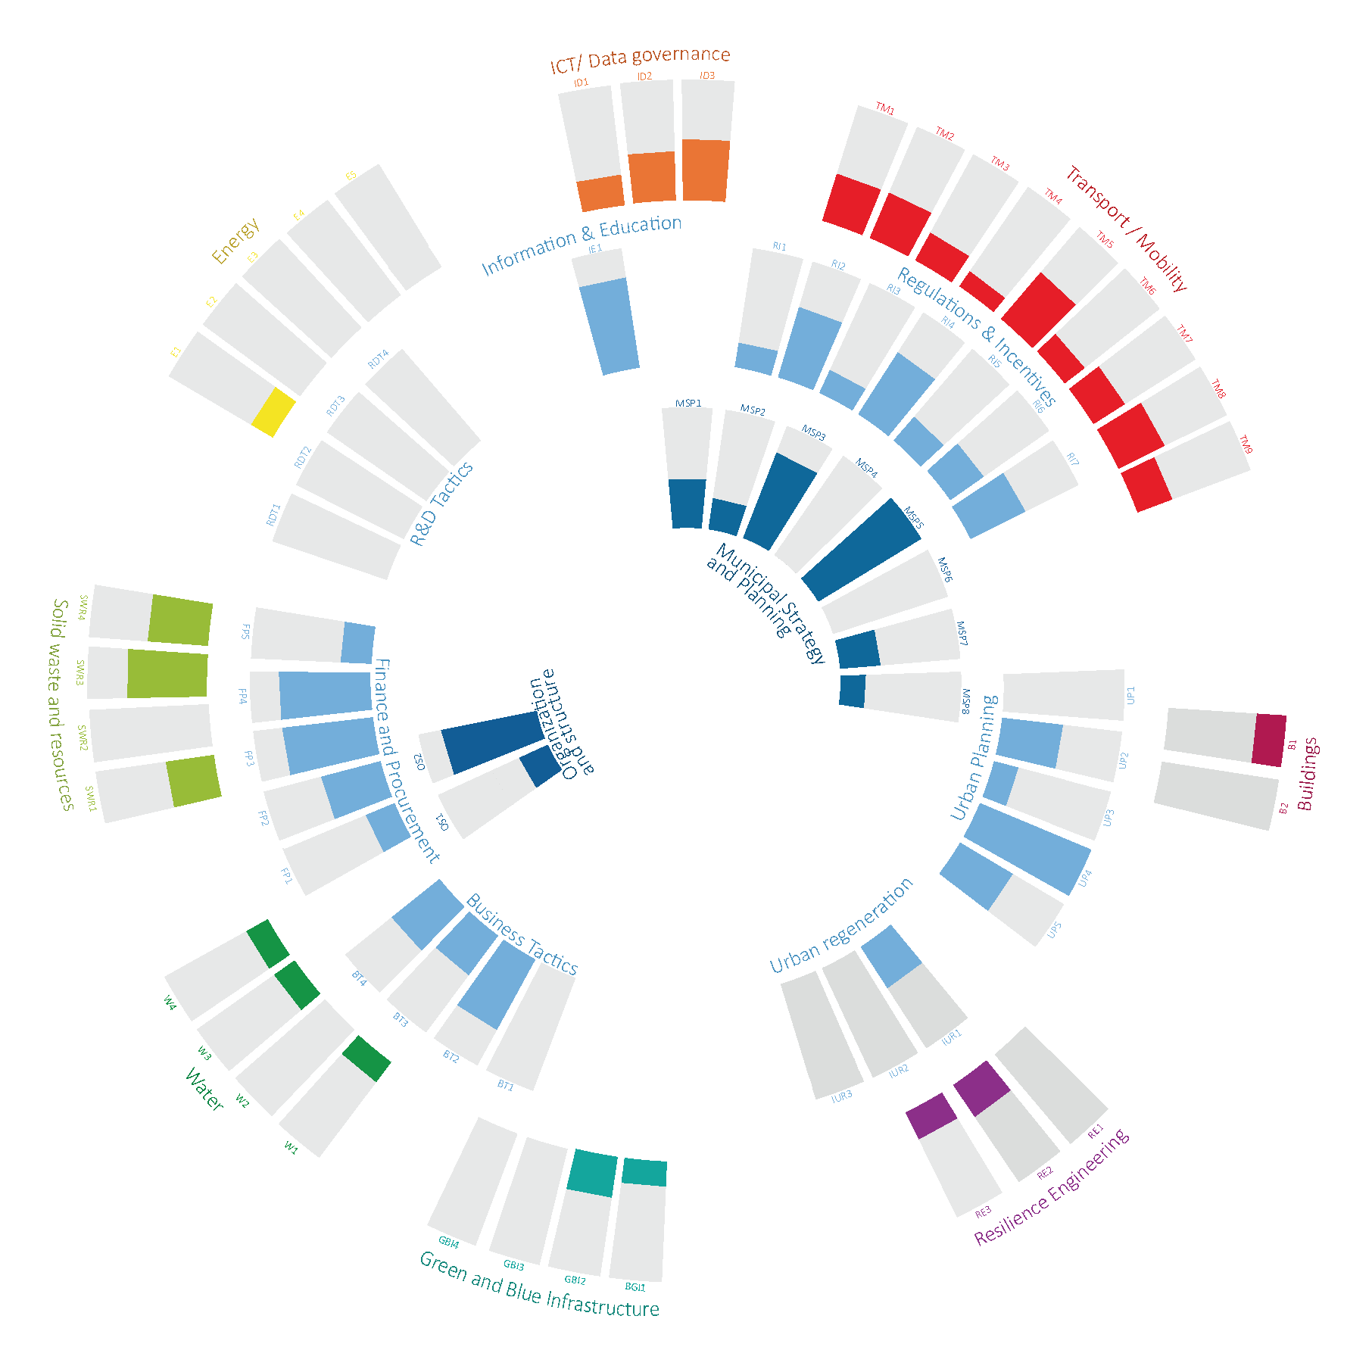
Figure 3: Sustainable Profile of Piura. Source: Fraunhofer IAO, 2021.
Piura is intrinsically vulnerable to climate change, largely due to its geolocation within a desert biome, making it prone to periods of drought which are becoming longer-lasting events. Experts predict that the FEN will not cause more intense rains that cause flows in the Piura River greater than those seen on previous occasions, but it will increase the frequency of such rains leading to high flows of water in the river and bringing more challenges to the increasing urbanisation. One of the most urgent challenges is an effective “territorial ordering” referring to areas at high risk of floods and extreme climatic effects, for which it is necessary to definitively determine habitable areas.
The analysis of the most critical action fields of Piura crystallized the city pathways towards sustainable development. They can be categorised into three clusters establishing digital connections and tools to improve resource efficiency; the utilisation of unique energy unexplored opportunities and favourable conditions; and the need to plan and implement sustainable development initiatives in Piura. These clusters involve major actions that are envisaged as key to the city’s sustainable urban development and climate resilience of the city.
Piura’s scenario is quite complex, but with great opportunities. The proposed interventions co-created in the City Lab contribute to sustainable development by considering the ecological, economic, and social pillars of sustainability necessary to prepare Piura to become a city prepared for the future challenges of climate change. Broadly speaking, the solutions aim to optimise the use of resources, seek opportunities for economic growth, and improve life quality for its citizens, emphasizing the protection of the population most vulnerable to climate change.

3.2. Sustainable urban measures
The main climate change mitigation measure would be to avoid deforestation and informal urban expansion, as well as the creation of new green areas within it, all of them closely linked to the control and ordering of the city’s population growth. Furthermore, new native vegetation that needs little water can be accommodated to improve soil quality, heat islands and promote shady public spaces for citizens. Therefore, Piura has great potential to benefit from nature-based solutions (NBS). These proposals seek to take advantage of green infrastructure as a sustainable urban drainage system (SUDS) that would also provide multiple environmental, social, and even economic benefits. Three of the prioritized projects are presented in this paper because of their high potential to create resilient cities with the use of NBS. Table 1 sums up the main aspects related to their contribution to the sustainable pillars. Projects are described highlighting the key components of the project ideas, including their objectives, building blocks, implementing partners, possible funding, as well as environmental impact considerations.

Table 1: Main aspects of prioritized projects related to their contribution to the sustainable pillars.
Projects/  Sustainability Pillar | Ecological | Social | Economical
Tactical urbanism | Increase of green areas. Depending on intervention, use of energy and water optimisation technologies | Social cohesion and citizen participation for neighbourhood interventions | New opportunities and attractiveness of the city
Decentralized system for sustainable water management | Better management of water resources | Promote the responsible use of water. Ensure access to water | Recovery of resources resulting from water losses, optimisation of the service allowing for service improvement and expansion possibilities
Arborisation of the city | CO₂ absorption by vegetation. Decreasing Urban Heat Islands (UHI) | Improve the thermal comfort of the city by improving the life quality of its citizens | Optimising water resources and maintenance of green areas

3.2.1 Tactical urbanism including urban gardens and pocket parks
Through Tactical Urbanism, the project seeks to transform the public spaces of Piura, making them more environmentally friendly and pleasant for its citizens. Thus, the intervention includes urban gardens and the provision of pocket parks, reinforcing the idea of ​​an inclusive and sustainable city over time. Part of the proposal is to offer job opportunities to the vulnerable, socially and labour-excluded population. Through education and training tools, a mutual learning system is forged that is replicable over time. Thus, contributing to local development and betting on the talent of the community. It is proposed to use viable, sustainable, low-cost, flexible construction systems; in addition to grey water reuse methods, since in the city the water resource represents another problem. The project intends to ensure that there are quality public spaces for everyone and that over time the radius of reach is greater, supplying the entire city.

3.2.2 Decentralised system for sustainable water management
Due to the location of Piura in a desert region, the natural sources of water are scarce. This factor leads to the need for proper resource management. However, the management of the water cycle in the city is deficient, caused by a lack of planning towards a sustainable development and by the irresponsible use of this resource (e.g., use of potable water for irrigation of green areas). In this way, the project seeks to implement decentralised wastewater treatment systems to contribute to the reduction of irresponsible drinking water consumption wherever it is not required. The decentralised system for sustainable water management proposes to motivate the private sector and society to implement this type of methodologies as a means of orientation towards a Circular Economy, increasing the interest of replication in other areas. Additionally, by implementing this type of system, the city seeks to promote the responsible use of water and will contribute to the awareness of citizens about these issues.

3.2.3 Arborisation of the city aligned with a reforestation programme of urban green corridors
The project focuses on increasing urban green coverage through an arborizing programme. Interventions focus on the development of urban green corridors that seek to link important natural areas of a city through a strip or corridor characterised by extensive vegetation. In this way, a kind of skeleton is created, capable of articulating greener and healthier cities. The project identifies the main streets where deforestation has occurred due to urban mobility projects or with potential for new vegetation and where linear spaces with green corridor potential can be linked. The cultivation of native plants in local/municipal/private nurseries is incorporated. This project contributes to decrease the temperature of the city and improve thermal comfort by mitigating heat islands and generating microclimates to reduce energy consumption. Moreover, it contributes to counteract CO₂ emissions, and represents an opportunity to promote the use of sustainable mobility. This not only improves the life quality of the citizens, but also contemplates recovering the regional native species characteristic and the city image.

4. More than finding a solution
By consolidating the City Lab methodology in Piura, the results outline the challenges around its performance and strategic implementation of sustainability, providing a profile that identifies areas for improvement, supporting the process of identifying solutions, as well as offering a vision that supports the elaboration of plans and strategies that prepare the city to adapt to climate change, and interventions (including NBS) supporting them.
However, it is necessary to address the gaps and offer suggestions, according to the different challenges in the implementation of the City Lab as well as in the formulation of project ideas.
These findings should be evaluated with caution due to three methodological limitations that could compromise their external validity: Firstly, the city does not have an accessible database, which made it difficult to collect data and indicators. Being that Piura is the capital of the province and the department, some data did not refer to which level was being referred to. Secondly, the MGI activities were carried out at the same time as the study of the new Metropolitan Development Plan was underway, which may have resulted in a delay of the proposed actions. Finally, the study envisaged a series of field activities, including visits, workshops, and interviews, which due to the Covid-19 pandemic had to be adapted to a digital format, limiting the active participation of some stakeholders.
The analysis showed that the city has focused on isolated solutions, which makes more concrete the need for integration of the various parallel and subordinate plans that do not integrate global and national strategies into their plans. As Albert (2019) states, resources are not always the problem, and much more can be done by aligning resources around a vision or master plan. The author argues that it takes more than just the implementation of clean technologies or optimisation using ICTs to prepare a city to face the challenges of climate change.
Furthermore, based on the assessment, a lack of interest, and investment of resources was observed, but also a lack of prioritisation not only from the city administration, but also from different actors involved in Piura’s urban development. Working in a co-creative process aims to foster acceptance and appropriation of the projects by the different local stakeholders. Clear commitment and human and financial resources allocated to sustainability at city level are needed to ensure the implementation of interventions at a comprehensive level, to avoid becoming fragmented initiatives (Krellenberg et al., 2019).
Finally, the research leads to some recommendations for further project development: Coordination with various similar initiatives in the city is essential, and if possible, it is worth waiting for the results to enrich the urban analysis. In the case of pilot projects, it is important considering an appropriate phase and efforts to deepen the pilot projects outlining so that they do not remain an idea but where interested stakeholders work together on their concretisation.

5. Conclusions
The project does succeed in establishing a strategy and project ideas that respond adequately to Piura’s needs, as well as prepare for the future.
However, it remains to establish a robust concept for measuring the impact of these measures, as well as to ensure local actors following up on the development and performance of them. Furthermore, the involvement of the local actors to develop and concretise the project ideas are not entirely clear, as the MGI envisages implementing only one pilot, leaving it outside the initiative and as a task of the city to pursue the remaining ones.
During the process, the importance of focusing the city’s efforts on establishing comprehensive plans that break down sector silos more than solutions and establish an opportunity to work together became clear. While some project ideas have a reference somewhere in the globe, work should focus on the opportunities that the city has. As such, the city should align implementations to consider the impact factors that can influence and support the development of these urban demonstrations.
According to the results, the interdisciplinary study, conceived in a first way with smart city concepts, has been adapted in a good way to address climate change adaptation and mitigation. It remains a task to develop the methodology further to respond to new lines of research in a more concrete way, incorporating the concepts of circular economy and citizen participation.
Finally, research underlines the importance of multi-sectoral studies, especially in the cities most vulnerable to climate change, considering how it will impact urban development, but also to keep their citizens safe from potential climate hazards.

Data Availability Statement
The City Lab is a framework developed by Fraunhofer. More information can be found here: https://www.morgenstadt.de/en/projekte/city_labs.html
Publications about the MGI project and the City Lab Piura can be found here: https://mgi-iki.com/. The City Lab Report is expected to be published in November 2021.
Contributor statement
Conceptualisation: Author 1, Author 2; Funding acquisition: Author 1; Investigation: Author 1, Author 2; Methodology: Author 1; Project administration and Supervision: Author 1; Visualisation: Author 1, Author 2; Writing-Original Draft: Author 1, Author 2; Supervision, Writing – Review & Editing: Author 1, Author 2
Acknowledgments
The project funded by the International Climate Initiative (IKI) of the German Federal Ministry for the Environment, Nature Conservation and Nuclear Safety (BMU).

References
Albert, S. (2019). Innovative Solutions for Creating Sustainable Cities. Cambridge Scholars Publishing. https://www.cambridgescholars.com/product/978-1-5275-3593-0
Broad, K. (2002). Stanley A. Changnon (ed.), El Niño 1997–98: The Climate Event of the Century. Climatic Change, 53(4), 523–527. https://doi.org/10.1023/A:1015246130461
Cousens, E., & Szabó de Carvalho, I. (2020, September 22). Why We Need International Cooperation Now More than Ever | World Economic Forum. https://www.weforum.org/agenda/2020/09/global-cooperation-international-united-nations-covid-19-climate-change/
Fraunhofer-Gesellschaft. (2014). Project Morgenstadt: City Insights Phase II (2014 – 2015) Development and Implementation of System Innovations for the City of Tomorrow. https://www.morgenstadt.de/content/dam/morgenstadt/en/documents/Project description_MCI2_July2014.pdf
Krellenberg, K., Bergsträßer, H., Bykova, D., Kress, N., & Tyndall, K. (2019). Urban Sustainability Strategies Guided by the SDGs-A Tale of Four Cities. https://doi.org/10.3390/su11041116
OECD. (2008). Governing Climate Change in Cities: Modes of Urban Climate Governance in Multi-level Systems. In OECD (Ed.), Competitive Cities and Climate Change.
Simon, D. (2016). Rethinking Sustainable Cities: Accessible, Green and Fair. In Rethinking sustainable cities: Accessible, green and fair. Policy Press. https://doi.org/10.26530/oapen_613676
Solá Morales i Rubió, M. de. (1997). Las formas de crecimiento urbano. Edicions UPC.

