Type of the Paper: Peer-reviewed Conference Paper/ Short Paper
Track title: The city is an object and a city is in transition.

Public Spatialisation in China: Rethinking the Interface in Industrial Building Renovations by Local and Transnational Design Firms
Jiawen Han ¹, and Wenya Xue ^{2,}*
Names of the track editors:
Birgit Hausleitner
Leo van den Burg
Akkelies van Nes
Names of the reviewers:
Birgit Hausleitner
Henco Bekkering
Journal: The Evolving Scholar

DOI:10.24404/6154007c8d831d0009180278

Submitted: 14 October 2021
Accepted: 01 June 2022
Published: 28 November 2022
Citation: Han, J. & Xue, W. (2021). Public Spatialisation in China: Rethinking the Interface in Industrial Building Renovations by Local and Transnational Design Firms. The Evolving Scholar | IFoU 14th Edition.

This work is licensed under a Creative Commons Attribution CC BY (CC BY) license.
©2021 [Han, J. & Xue, W.] published by TU Delft OPEN on behalf of the authors.

¹ Xi’an Jiaotong-Liverpool University; Jiawen Han@xjtlu.edu.cn; 0000-0002-6528-6404
² Xi’an Jiaotong-Liverpool University; wenyaxuexwy@gmail.com

Research highlights
1) This research critically analyses different firms’ design strategies regarding interface and the new social and spatial dynamics they have been bringing to the city.
2) This research investigates how the educational, social, and cultural differences embedded in Chinese and Western architects have created subtle differences in their understanding and interface strategies towards publicness of space.
3) This research highlights multiple approaches to interface intention in China’s urban regeneration and their various impacts on the adaptability of building for new social activities.
Keywords: Interface; Building Renovation; Public Space

1. Introduction
Many industrial buildings from the last century remaining in the city centres of post-industrial Chinese cities have been transformed to adopt new functions and new relationships with the urban area. The transition has impacted the shift toward Chinese cities as more public and dynamic places. However, the interface between industrial buildings and their surrounding streets/open space, which has played a key role in this transition, has been overlooked. This study attempts to rethink interfaces in renovation by mapping the three perspectives of permeability, transparency, and interstitiality.

2. Theories and Methods
Public space is inherently contradictory. Madanipour (2010) argues that the involvement of different powers are important for the making of public space. Public spaces are shaped both by “claims” and “the absence of claims”; by open to the public and by withdrawal from the public sphere (Madanipour, 2010). Due to the constraints of traditional Chinese Confucianism and the social hierarchy, many public spaces were in a subordinate position in the ancient Chinese cities. It was not until the entry of Western culture that the idea of urban public space began to be debated and changes were strategically implemented. In other words, public space as one of the most important social and spatial concepts in China since the early 1900s has arisen from the closer contact between the East and the West. From the 1910s, Chinese planners began to borrow Western urban planning concepts and applied them to urban parks, urban squares, and other spaces. From the mid-1950s, Chinese cities began to replicate the Soviet model in which industrial buildings dominated the location of the residential compounds. This gradual implementation from the West redefined the urban form for many Chinese cities within a century, so the theoretical framing of Western analysis of the urban form, especially for industrial areas, has a strong morphological significance for reference.
The industrial survivals in Chinese cities show a strong sense of boundaries and rarely have a positive relationship with the current city. Interfaces are vital in the transformation of the publicness of a space, since the access to the exterior influences the publicness of the space. Therefore, this article focuses on the interface of the industrial heritage and how it has enhanced the continuity of the industrial past and the present city. Interfaces have different evaluation criteria in mapping under different contexts. Typological research by Dovey and Wood (2015) distinguishes the interfaces in modern suburbs of three cities by accessibility, setback, transparency, and mode of access, in which permeability and transparency are crucial factors, and which are also included in the interface mapping in this research. However, the transformation of the industrial heritage in the West is freer in breaking their original spatial form and interface, while China’s industrial heritage projects normally choose a relatively implicit way to eliminate its sense of closure. Therefore, this paper also further selects interstitiality, namely the articulation of interfaces in transitional zones between public spaces as proposed by Mehta (2009) as an important aspect for reviewing industrial buildings’ publicization in the Chinese context. New spaces created during the renovation, often the interstitial spaces between new additions and the preserved old structures, to some extent articulate the publicness of the interface transitions. This article uses interface mapping, which visualises the documentation on building entrances, glazing, and interstitial spaces. Mapping in this paper is not simply a means of documenting the design of interfaces in the urban heritage, but also for interpreting notions of public spatialisation in renovations among architects by visualising the design of interfaces.

Therefore, this research analyses the interfaces in terms of permeability, transparency, and interstitiality. Permeability means the accessibility of the building interface. The autonomous access of pedestrians to a building requires a large and noticeable entrance. The larger the area of entrance, the higher the permeability, and the more contribution to improve the publicness of the building. For instance, industrial buildings for mass production had few entrances because interior space is for manufacturing instead of attracting people from surrounding communities.

Transparency in this research is not related to the scale of windows nor the transparency of light to interior space. It relates to the visibility of people both inside and outside the building. The more visual contact generated by the building interface between interior space and the exterior street, the higher the transparency of the interface. For example, the transparency is high when the building interface shows dynamic activities or distinctive spatial experiences of the interior space through openings such as glazing. When windows on building interface cannot bring visual contact between inside and outside people, such as when windows are higher than human eye-level or when glazing is intended to reduce the visibility of interior space, the transparency of the building is low. Interface with high transparency will contribute to the publicness of the space.

Interstitiality targeting on space between interior and exterior streets stimulates social activities. Framed by multiple layers of materials, interstitial space is the space between a building façade and its surrounding streets. The volume of space framed by old and new materials is an important factor in stimulating social activities on the building interface. Larger interstitial space between the building façade and the street provides more space for pedestrians and has more possibilities to generate autonomous social gathering.

The existing literature observes strategies to expand the publicness of interface and often interprets social factors instead of completing sufficient analysis on physical space. Social factors in this discourse are difficult to capture, such as space configuration, ownership (private or public), and management of public interest (collective memory and cultural character) (Varna and Tiesdell, 2010, Leclercq et al., 2020), which often leads to a lack of project-based details and evidence of how the publicness is transformed. Nevertheless, when interpreting this discourse using the interface as the perspective to observe physical spaces and then relates them to social impacts, seemingly parallel factors such as the revitalisation of culture, governmental management, and ownership become related. Hence, the role of the interface in the transformation of publicness in public space, though overlooked by existing literature, becomes the viewpoint of this research for targeting the discourse. This research investigates three cases including the revitalization of the entrance to the M Woods Museum by a Chinese firm, Vector Architects, the Garage by Neri&Hu, and the Kunming Rubber Factory by Kokaistudios. Kokaistudios and Neri&Hu are both international design firms based in China. The legend for permeability, transparency, and interstitially is analysed on how much they contribute to the publicness of a building interface. This study critically analyses each firm’s design strategies regarding interface and the new social and spatial dynamics they have been bringing to the city.

3. Results

3.1. Case studies of the permeability, transparency, and interstitiality of interfaces
In terms of permeability, the three cases have all been improved through various methods. The M Woods entrance revitalisation changed the position of entrances, both for guiding interior and exterior circulations and improving accessibility on another side of the building. The Kunming Rubber Factory Renovation did not change the number of entrances, but opened spaces between industrial buildings as public space and moved entrances from one side of the building to the other, which is close to external pedestrian pathways. The Garage by Neri&Hu reduced the number of entrances. However, their design strategies emphasised entrances through an extrusion of materials and signals illustrating the function of interior space. Comparing the three cases on their designs in relation to the improvement of permeability, it is evident that Kokaistudios consider the permeability important for generating public activities. Their approach, which removed the building entrances, is concise. Differing from Kokaistudios, Vector Architects removed entrances intentionally, not only to improve the permeability of the building interface, but also to design the circulation of the public from exterior streets to the interior gallery, and from interior space to exterior streets. Permeability for Vector Architects is related to a continual pathway linking interior and exterior spaces. The Garage by Neri&Hu focuses more on visual attraction instead of physical accessibility. Their approach to permeability is achieved by emphasising the existence of entrances through design instead of positioning entrances close to pedestrians.
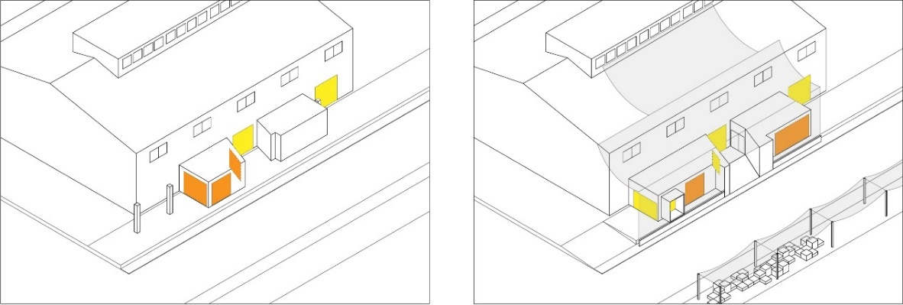
Figure 1. Revitalization of the entrance to the M Woods Museum by Vector Architects
The impacts of design strategies to transparency in these three case studies are different. However, the transparency of the building facades was improved by different extents. The M Woods entrance renovation changed the orientation of windows from parallel to the street to facing the street. The glazing before renovation allowed people in the interior space to see exterior activity. The renovation changed the visibility and allows visual contact between inside and outside people (Figure 1). Except for glazing, the architects applied semi-transparent materials for generating ambiguity. Although the interior space is not clearly shown, the semi-transparent layer improved transparency of the façade. Differing from Vector Architects, the approach by Kokaistudios has limited changes on the ground floor glazing, but improved visibility on the floors above (Figure 2). Although the orientation of the windows did not change during renovation, visual contact between the inside and outside is achieved on the industrial building. The mapping on the transparency of the Garage shows that visual contact from both sides is not as important to Neri&Hu as expressing the industrial memory of the building.
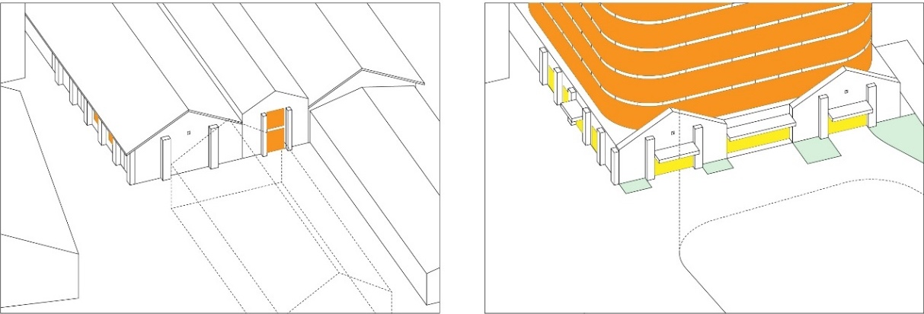
Figure 2. Renovation of Kunming Rubber Factory
The interstitiality of the M Woods Entrance Revitalization was improved on spaces in front of two building entrances and the space under a semi-transparent shelter opposite the main entrance. In this case, interstitial spaces built during renovation are intended to bring visual contact between people. In the revitalisation of the entrance to the M Woods Museum, changes to the permeability and transparency supplemented the creation of an interstitial space. The changes to the three aspects all aimed at stimulating visual contact of the people with the different spaces. The video on the official web page of Vector Architects (Vector architects) shows how the entrance is used by pedestrians. People sit under the semi-transparent shelter, observing others in the gallery, and on the exterior street. Although these autonomous activities are common in many other public spaces, the diversity demonstrates the success of the building interface and its catalytic effect on autonomous social activities.
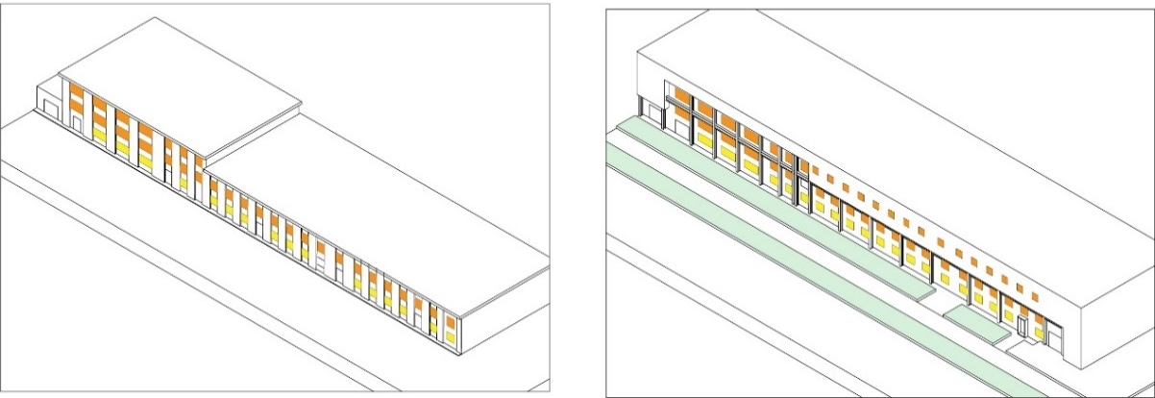
Figure 3. Windows emphasised in the building interface of the Garage
To see and to be seen is the dominant method for stimulating publicness of space in this case. The interstitial space in the Kunming Rubber Factory renovation refers to spaces in front of building entrances which are under cantilevers and framed by landscape. Interstitial spaces by Kokaistudios are not intended to stimulate public activities through public gaze, but to be open to all activities that may autonomously happen. Designs during renovation by Neri&Hu dramatically changed the building interface on its spatial experience (Figure 3). The interstitial space is framed by a brick building façade and steel support added during renovation. Interstitiality in this project is improved through the distinctiveness of the space instead of the temporary human activities that happen in the space.

3.2. Public spaces shaped in different projects by different architects
The design strategies in the three cases led to different results for the permeability, transparency, and interstitiality of the building interfaces, and consequently led to differences in the publicness of the spaces. The entrance of the M Woods Museum creates a public space that stimulates social activities. The renovation of the rubber factory created a public space that citizens can use in multiple ways. The Garage has a public space that evokes citizens’ shared memory of its industrial history, which generates an ideological publicness for citizens. The architects’ approaches to the building interfaces contributed to the subtle differences manifest in the projects. The three cases selected are in post-industrial Chinese cities. The projects were undertaken when renovating industrial buildings became an important part of the urban regeneration process. The architects’ differing education and practices shaped their understanding of industrial buildings and public spaces, resulting in their different approaches on how to integrate the industrial buildings into the post-industrial urban context.

This research is not intended to justify the connection between their diverse approaches and their cultural and educational backgrounds. Instead, it aims only to raise awareness of the possible differences in the publicness of the spaces due to various potential factors, so that the final spatial outcomes act as different forms of catalyst in the renovation projects and later, affected in different ways the transformation of the cities in China. Among these projects, Vector Architects as Chinese architects blurred the boundary between the old and new structures so that they serve the present usage of people and gave the building and space a new identity, rather than reiterating the building’s collective memory. Neri&Hu’s chief architects were educated in America, and they tended to emphasize the industrial characteristics. They transformed the building into a city landmark that attracted public attention. In contrast, the architects from Kokaistudios, who came from Italy, tended to minimise the integration of a new addition to an old structure, distinguishing the two clearly in physical space, whilst integrating them by function and using spatial integration for social activities. These strategies have inevitably been adapted to the different projects’ requirement and the local contexts. However, the hidden understanding of an industrial building, industrial heritage, public space, and publicness of the local Chinese architects and the transnational firms impacted their strategies and the final spatial configurations.

4. Discussion and conclusions:

Architects’ approaches to building interfaces generate different types of public space in Chinese cities. By analysing a building’s interface with regard to permeability, transparency, and interstitiality, the impact of design strategies on creating public space has been demonstrated. Although such architects did not explain their design strategies in relation to the public transformation of building interfaces in their design briefings, this research explicitly unfolded these underlying design strategies, which have cast subtle, different aspects of openness during and after renovations had taken place. This has shed light on the spatial design’s impact on how the public space can be received by the wider public. It also shows how the educational, social, and cultural differences embedded in Chinese and Western architects have created subtle differences in their understanding and interface strategies towards the publicness of space. It further highlights these approaches to interface intention in China’s urban regeneration and their various impacts on the adaptability of building for new social activities. This study enhances the understanding of strategies for interfaces and public spatialisation in the discourse of renovating industrial buildings in China.

Public spaces should be shared by all citizens, enabling public activities to take place and strengthening relationships between people. This type of public space with its openness was rare in traditional Chinese cities, which mainly consisted of enclosed and private family courtyards. However, as it is imperative in a rapidly globalising world to move toward a more-open society and more-inclusive cities, the adaptive reuse of these abandoned industrial buildings provides opportunities to generate usable public space that can be shared by all citizens, thereby revitalising their collective memory of the height of the industrialisation period.

Contributor statement
The authors confirm contribution to the paper as follows: research conception and design: Jiawen Han. Wenya Xue; data collection: Wenya Xue; analysis and interpretation of results: Wenya Xue, Jiawen Han; revision and paper preparation: Jiawen Han. All authors reviewed the results and approved the final version of the paper.

Acknowledgments
This work was supported by Humanities and Social Science Programme of the Ministry of Education of China, Young Scholar programme(19YJCZH045).

References

- Madanipour, A. (2010). Whose Public Space? International Case Studies in Urban Design and Development. New York: Routledge.
- Dovey, K., & Wood, S. (2015). Public/Private Urban Interfaces: Type, Adaptation, Assemblage. Journal of Urbanism, 8(1), 1–16.
- Mehta, V. (2009). Look Closely and You Will See, Listen Carefully and You Will Hear: Urban Design and Social Interaction on Streets. Journal of Urban Design, 14(1), 29–64.
- Hu, R. (2014). This is not a Building. Time + Architecture (1), 58–59.
- Kamalipour, H., & Peimani, N. (2019). Negotiating Space and Visibility: Forms of Informality in Public Space. Sustainability (Switzerland), 11(17).
- Kokaistudios. Former Kunming Rubber Factory Renovation. Retrieved from https://www.kokaistudios.com/en/portfolio/urbanrenewal/former-kunming-rubber-factory-renovation
- Leclercq, E., Pojani, D., & Van Bueren, E. (2020). Is Public Space Privatization Always Bad for the Public? Mixed Evidence from the United Kingdom. Cities, 100.
- Pafka, E., & Dovey, K. (2017). Permeability and Interface Catchment: Measuring and Mapping Walkable Access. Journal of Urbanism, 10(2), 150–162.
- Varna, G., & Tiesdell, S. (2010). Assessing the Publicness of Public Space: The Star Model of Publicness. Journal of Urban Design, 15(4), 575–598.
- Vectorarchitects. M Woods Entrance Revitalisation. Retrieved from http://www.vectorarchitects.com/projects/41

