Type of the Paper: Peer-reviewed Conference Paper / Full Paper
Track title: The city is an object and a city is in transition

Research on Urban Plot Openness Measurement and Influencing Factors: A Case Study of Downtown Nanjing
Linghao Wang ^{1,}*, Jie Liu ²
Names of the track editors:
Birgit Hausleitner
Leo van den Burg
Akkelies van Nes
Names of the reviewers:
Birgit Hausleitner
Maurice Harteveld
Journal: The Evolving Scholar

DOI:10.24404/6154998c1e981500089d383d

Submitted: 29 September 2021
Accepted: 01 June 2022
Published: 25 November 2022
Citation: Wang, L. & Liu, J. (2021). Research on Urban Plot Openness Measurement and Influencing Factors: A Case Study of Downtown Nanjing. The Evolving Scholar | IFoU 14th Edition.

This work is licensed under a Creative Commons Attribution CC BY (CC BY) license.
©2021 [Wang, L. & Liu, J.] published by TU Delft OPEN on behalf of the authors.

¹ Graduate student, School of architecture, Southeast University; Linghao.wang1016@gmail.com; 0000-0001-9349-2929
² Associate Professor, School of architecture, Southeast University; 101010513@seu.edu.cn
* Corresponding author

Abstract: The area inside the property boundary of a plot is often considered privately owned. However, resulting from the complexity of urban form transformation and urban planning regulations, the area within a plot boundary can also have public or semi-public attribution. The accessibility of the internal area of a plot is defined as the ‘plot openness’ in this paper. The openness of plots affects the spatial continuity in a city and reflects the mode of land development and urban planning. At present, the evaluation and analysis of urban public space have always been a hot research direction. But the openness of plots, the basic unit of urban forms, and its influencing factors have seldom been considered. This research aims at presenting a quantitative assessment framework to measure plot openness, and explore the potential factors including built density (FAR) and construction time that may affect the transformation of China’s urban plot openness. Taking Nanjing’s downtown as a case, this paper employs mapping to present the openness condition of the selected plots based on access and control type. Then, it proposes indicators including public space density (PSD), quasi-public space density (QSD), and depth of plot space (D) to quantitatively assess plot openness. At last, the regression analysis result reveals no strong linear relationship between plot openness and corresponding built density (FAR) in Nanjing’s downtown, whilst the descriptive statistic base on the development period shows that the transformation of plot openness is indirectly influenced by the land-use policy and urban planning regulations enacted in different periods.
Keywords: plot openness; urban form; public space; statistical analysis; Nanjing

1. Introduction
Accessible and shareable public spaces facilitate positive social interaction and diversity (Jacobs, 1961; Gehl, 1971), and bring a wide range of environmental and economic benefits (Sharifi, 2019). The description and analysis of urban public space is the most heavily researched topic. Researchers have explored various methods to delineate and evaluate public spaces. Focusing on linear public spaces in a city, the Space Syntax theory provides a configurational method to measure street spaces (Hillier and Hanson, 1984). In addition to the geometric attributes of public space itself, Urban Network Analysis (UNA) introduces the attributes of buildings into a weighted representation of spatial networks (Sevtsuk and Mekonnen, 2012). At present, researchers employ GIS, big data, and machine learning to analyse public space spatial distribution and accessibility (Biernacka and Kronenberg, 2018), public activities, and vitality (Zhang et al., 2018; Shen and Wu, 2021). So far, however, very few efforts have been devoted to quantifying and analysing the public space within plots, the basic unit of urban form.

The definition of public spaces can be classified in terms of ownership, access, control, and use (Lynch, 1981; Carmona, 2010; Németh and Schmidt, 2011). Following previous definitions, this research is mainly based on the access and control type of areas within plots. In general, the area inside the property boundaries of a plot belongs to the owner personally. Nevertheless, because of the transformation of land-use policy and the constraints of urban planning regulations, the area inside plots often presents diversified openness attributes. In this light, areas in privately owned plots that are accessible to the public will be defined as public spaces, whereas spaces in publicly owned plots that are not open to the public or controlled will not be defined as public spaces. Thus, this paper defines plot openness as the accessibility of the internal area of a plot.

The study of plot openness, especially to make it descriptive and figure out the factors that influence plot openness, is of great value. On the one hand, the public spaces inside the plot combine with streets, squares, and other urban public spaces constitute the urban open space system. On the other hand, in China, the public property land system and urban planning laws and regulations are closely linked. The evolution of plot openness is accompanied by the development and regeneration of urban space.

This research aims at presenting a quantitative assessment framework to measure plot openness based on evaluating the accessibility and configuration of areas within plot boundaries. And through statistical analysis, this research qualitatively interprets the mechanism that promotes the transformation of urban plot openness. In response to the aim of this research, the following questions will be answered: (1) How should plot openness in China’s cities be defined, and what indicators can be used to measure plot openness? (2) What factors can affect plot openness transformation in Nanjing downtown?

2. Theories and Methods

2.1. Literature review

2.1.1. Concept of plot and plot configuration
The plot is the tract of land with property boundaries on which buildings locate and present the land development pattern. It is identified as one of the plan element complexes (street system, plot pattern, and building pattern) by M.R.G. Conzen (1960). Kropf (2014) develops a generic multilevel diagram of urban form that systematically articulates and explains the hierarchical relations among buildings, plots, streets, and other form elements at different scales. Acting as the fundamental unit of urban forms, plots link micro-scale (buildings) and macro-scale (simple tissue and urban tissue) of urban forms. Song (2021) proposes the access structure which further develops Kropf’s theory to make it fit with China’s urban form. Song points out the complexity of plot configuration in China, and he introduces embedding to describe the morphological composition that a plot is not directly bound by any street spaces, and as a result, its area is enclosed by the area of a neighboring plot.

In the preliminary definition, a plot can be broken down into the buildings and attached areas (gardens or courtyards) (Kropf, 2014) which indicate the areas within the property boundary of a plot are privately owned (Figure 1 (a)). However, this definition is derived from traditional European cities, which is different from the urban form of China’s cities. The previous research findings of Song provide a typical case of the complexity of urban plot composition in China. Diagram (b) in Figure 1 illustrates the access order of embedded plots that one must cross the area of the neighboring plot before entering embedded plots. This plot configuration case implies the areas within the neighboring plot are public or semi-public rather than private. In current Chinese urban planning, the areas between plot boundaries and building redlines usually serve as pavement or street-front commercial spaces, which are accessible to the public. Areas within the building redline can also be public or semi-public corresponding to the plot function such as commercial (Figure 1 (c)).

According to previous research and the characteristics of plots in China, this paper tentatively proposes new layers of the hierarchical structure (Figure 2) by dividing the Areas in a plot into public space, semi-public space, and private space according to the management. Based on this definition, this paper will further introduce the plot openness concept.
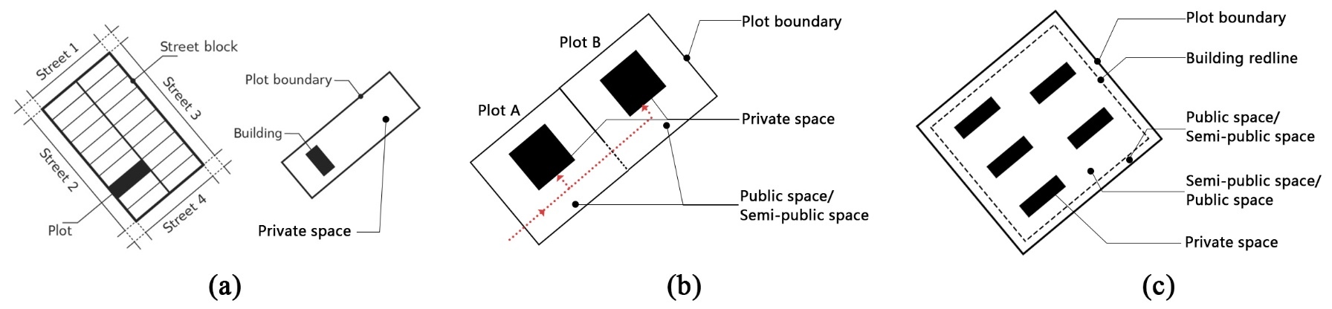
Figure 1 The characteristic of China’s plot configuration is different from traditional European plot configuration proposed by Conzen: (a) Areas in the traditional European plot are privately owned; (b) Areas in embedded plots are public or semi-public; and (c) Areas in contemporary Chinese urban plots are public or semi-public (Source: Author)
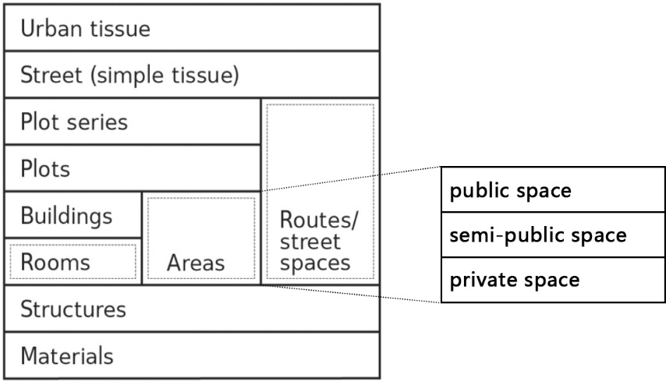
Figure 2 The subdivision of Areas within a plot based on the diagram proposed by Kropf.

2.1.2 Plot transformation and socio-economy factors
Plots provide a basic research scope to analyse urban physical form, and interpret the social and economic mechanism of the urban form transformation. Nanjing has experienced 70 years of urbanisation since 1949, it has undergone dramatic changes in physical form. Nanjing’s downtown embeds rich urban morphologies that exist as diversified urban blocks built in different periods including the Republic of China (1927–1937), the planned economy period of the People’s Republic of China (1949–1978), and the socialistic market-oriented economy period following the opening-up policy (1978-). This process of urban development has brought about great changes for the transformation of the openness of plots (Zhang and Ding, 2013). Land policies in different historical periods have influenced how developers use the land, including the management and control methods of areas inside plots. That is, the change of policies indirectly affects the transformation of plot openness. Moreover, the plot is both the unit of urban form structure and the control unit in urban planning regulations in China. The analysis of urban space openness based on the plot can connect with the control system of planning regulations, which facilitates the cognition of plot openness transformation (Zhang and Ding, 2018; Tang, 2017).

2.1.3. Openness measurement methods
Mapping is a fundamental and effective method to illustrate the openness of urban space. The method of mapping urban public space is not new. The Nolli map (1748) shows private spaces in black and public spaces in white (Verstegen and Ceen, 2013), and presents a graphic of urban public space form which reveals the ability of cities to act as a network of accessible public spaces. Based on field research, scholars further develop this mapping method to illustrate diversified public, semi-public, and private spaces in contemporary cities (Dovey, 2020; Ji & Ding, 2021). However, these mapping methods ignore proposing the basic research unit, making it difficult to present a systematic quantitative research method. Thus, this paper proposes to use plots as the basic mapping unit of openness research and introduces feasible quantitative analysis methods.

Current quantitative research methods on plot openness are inadequate, while the existing analysis methods for urban open space can provide some reference. Ji (2019) proposes methods of evaluating spatial openness, by using indicators of the number of openings and the sum of angles of the openings. Marchall (2017) demonstrates indexes of perimeter enclosure and surface enclosure to evaluate the enclosed form of open space. Yan (2017) employs indicators of public space density, public space ratio, and public space ratio of the interior and exterior to evaluate the coefficient and efficiency of open space in railway transit station blocks. Nevertheless, previous quantitative researches were mostly focused on describing physical form and geometry features of open space, rather than investigating the public attribute of areas in plot property boundaries. Since some open spaces, though physically open, are not open to the public because of management.

By summarising the existing literature, this paper introduces a new concept namely plot openness. It aims to describe the accessibility of areas within a plot property boundary. This case has not been widely discussed in existing studies of urban morphology. However, it can be frequently observed in many contemporary China’s cities, that have undergone rapid urbanisation and drastic transformation.

2.2. Research method
This study adopts both qualitative and quantitative methods. On one hand, quantitatively, this paper will establish an assessment framework for plot openness by proposing four morphological indicators. On the other hand, qualitatively, it will discuss the evolution of plot openness in Nanjing and interpret the factors that drive the transformation.

2.2.1. Case selection
This research studies two districts in downtown Nanjing, namely the old city and Hexi new district. These were selected to reflect varying plot openness during urbanisation in different historical contexts. The old city represents the urban development model of natural growth, its urban structure is mainly derived from the original urban fabric formed in the 1970s. Hexi new district is a completely new city area with orderly road grids constructed after 2000, which is the creation of a new city in non-urbanised areas. Fifteen sample blocks (Figure 3) are selected which contain 197 plots with residential, commercial, and office functions.
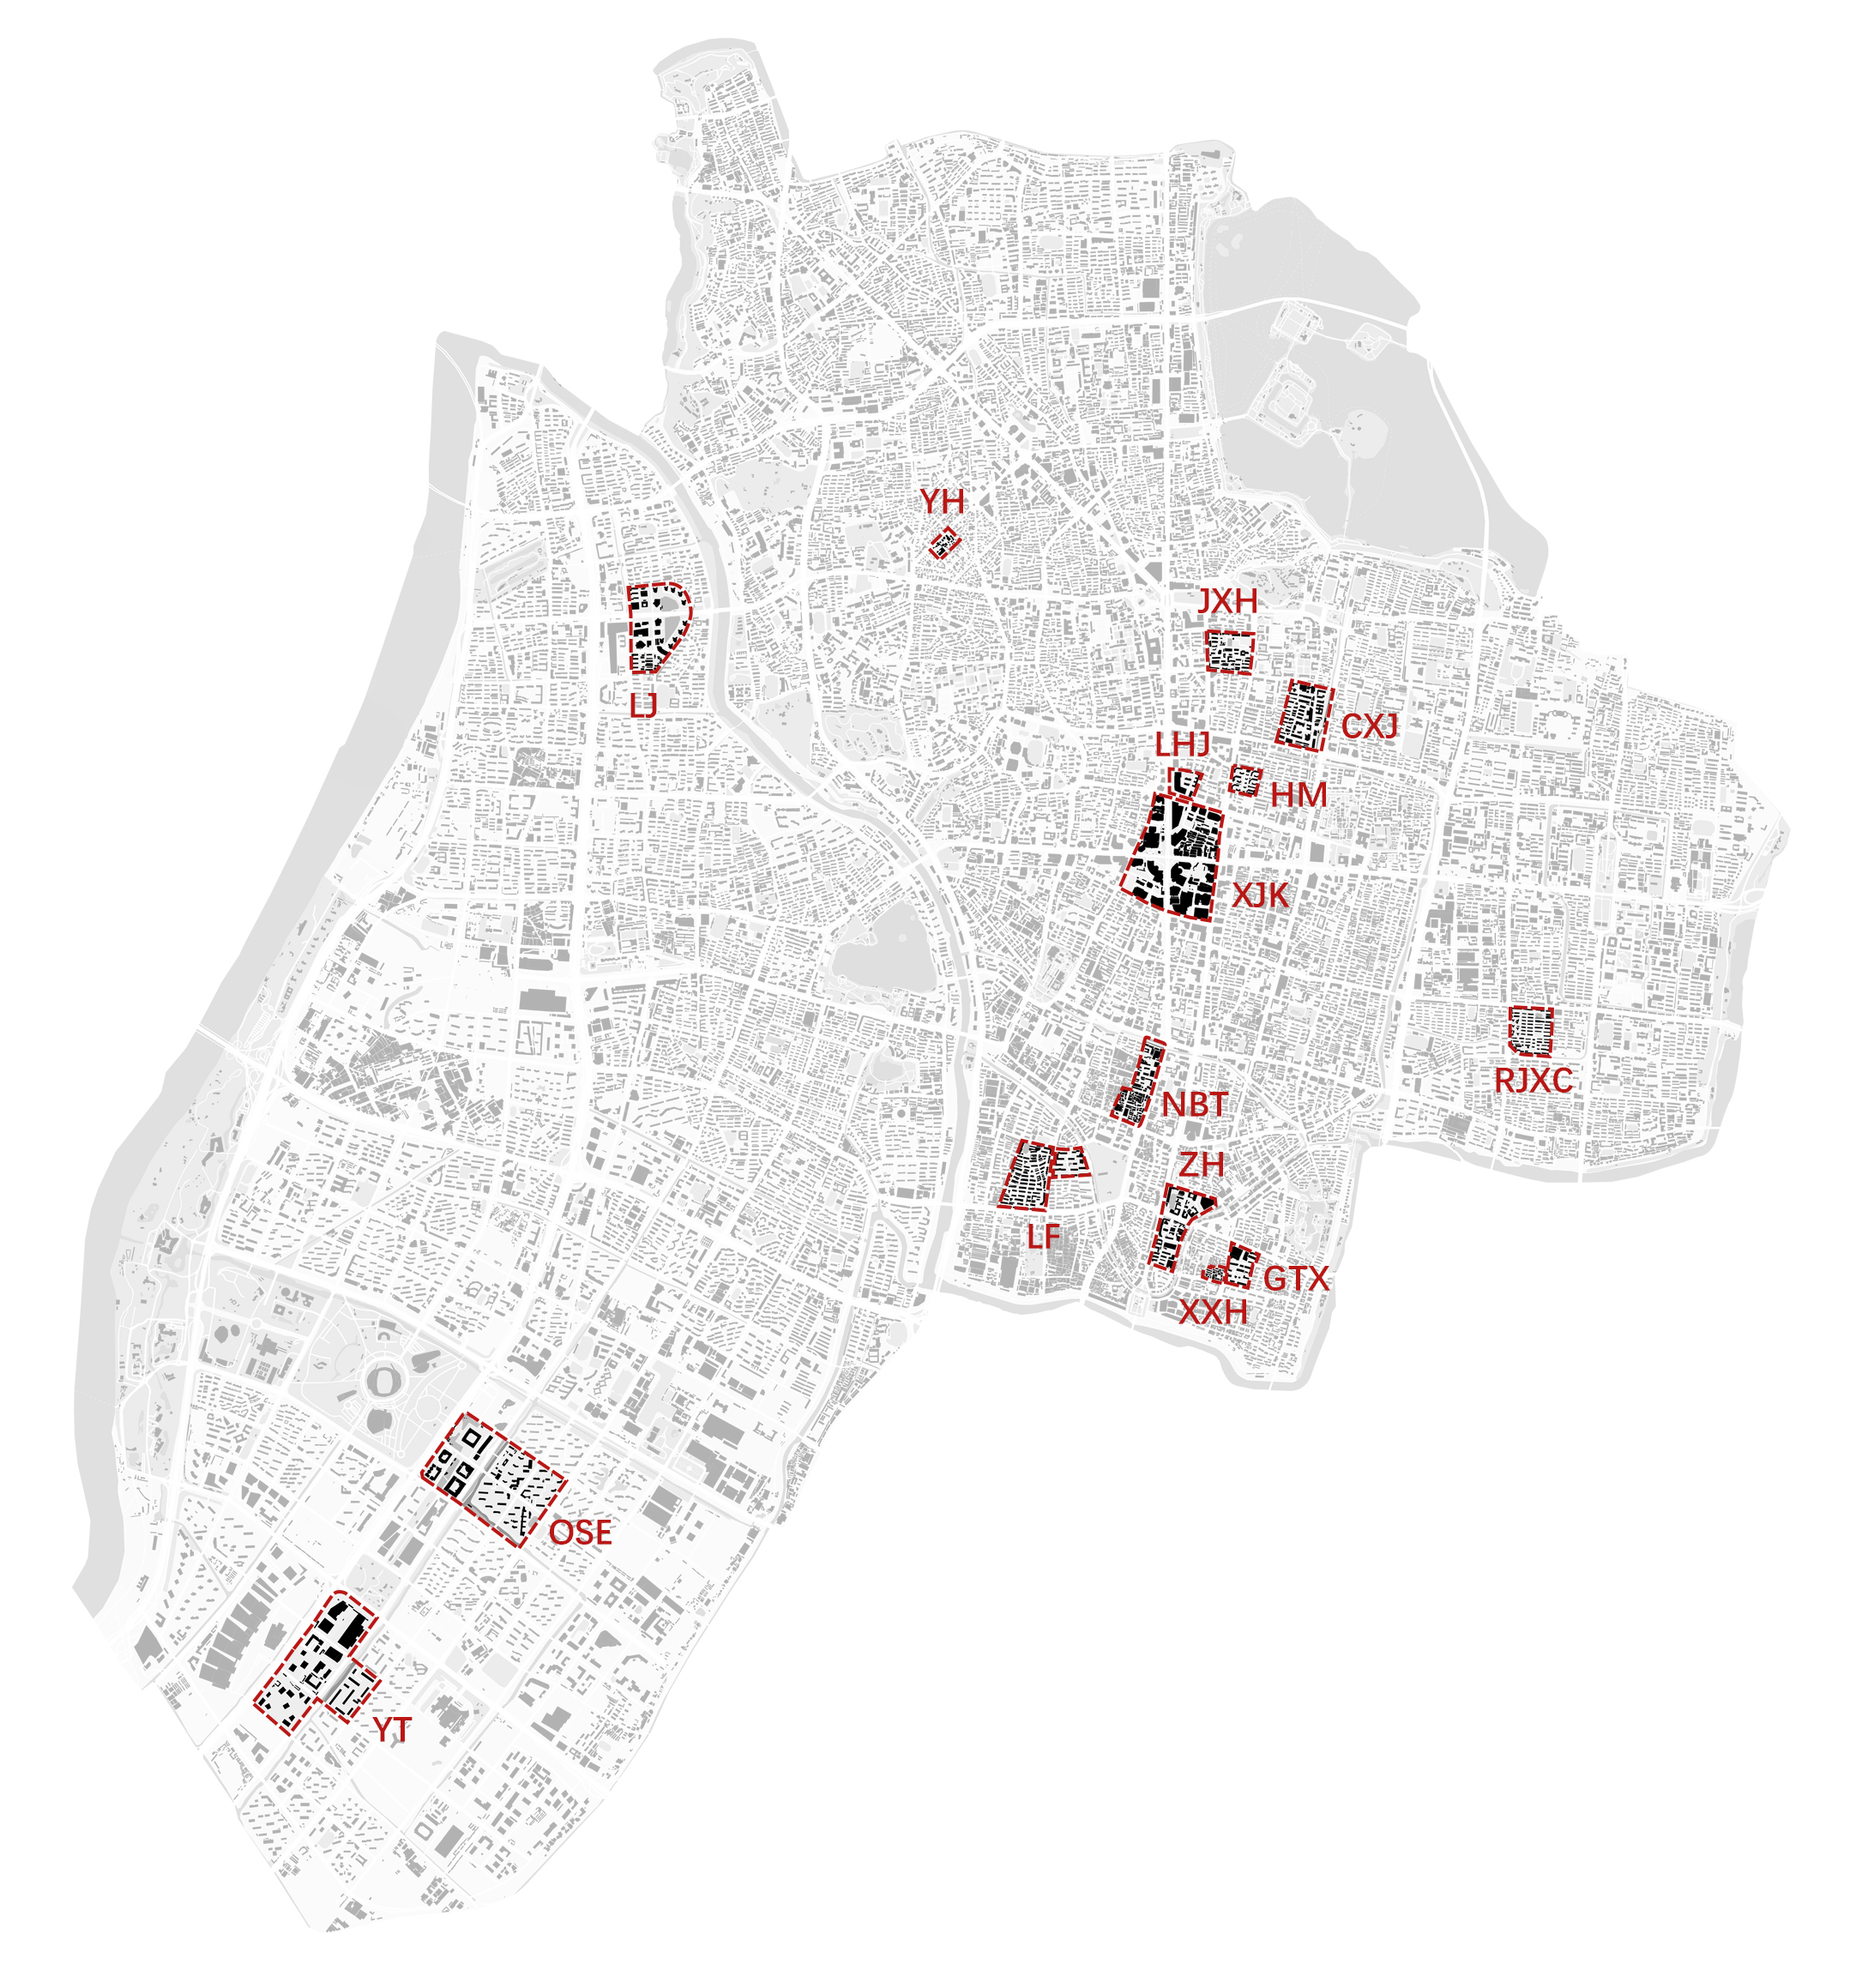
Figure 3. Research samples selected in Nanjing downtown (Source: Author)

2.2.2. Mapping and plot openness indicators
The measurement of plot openness is divided into multiple phases. Firstly, mapping and field investigation are employed to figure out the accessibility of area in plots, and classify spaces in plots into public space, quasi-public space, and private space. which respectively represent the area in a plot that is completely accessible, under management, and inaccessible. For instance, spaces in the plot HM-1-1 are mapped as Figure 4. The area along the boundary (the white area) is commercial space on the ground floor of residential buildings, which is public and served as pedestrian sidewalks. The area occupying most of the plot (the grey area) is living space which is controlled by an entrance guard and is open only to residents who live in the residential district. The grey area is a quasi-public space that is not completely accessible to the public. Residential buildings are in black color, which represents they are private territories.

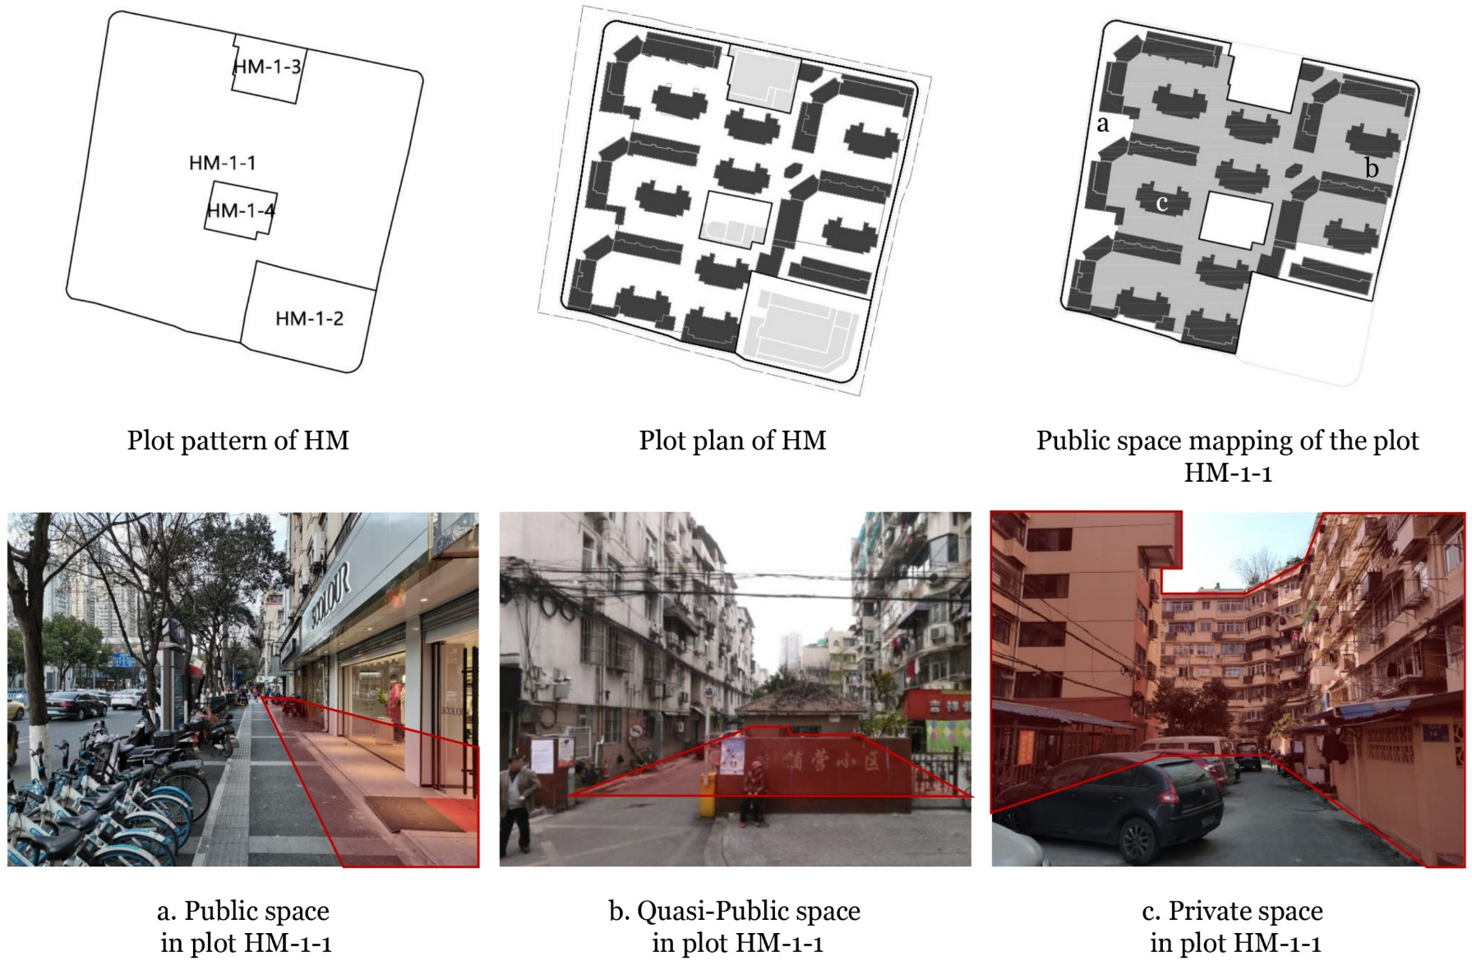
Plot boundy
Plot boundy
Figure 4. Classify and mapping areas in the plot HM-1-1 (Source: Author)

Secondly, plot openness indicators are proposed in this study (

Table 1 and Figure 5). Public space density (PSD) and quasi-public space density (QSD) are the ratios of public space area and quasi-public space area to plot gross area respectively, which represent the proportion of accessible area in plots. The plot depth expresses the complexity of space configuration in a plot, which refers to the access structure (Song, Zhang, and Han, 2021). This research transforms the access structure to represent the access order of areas in a plot defined in the mapping phase. For example, Figure 5 (d) illustrates the calculation of plot depth. Before entering the grey area (quasi-public space) from streets, one should cross the white area (public space). Thus, the depth level of the white area and the grey area in plot HM-1-1 is 1 and 2, respectively, and the depth of plot HM-1-1 is the average depth of these two areas, that is, 1.5. In a similar way, the depth of plot HM-1-4 is 3.

Table 1. Definition and calculation formula of plot openness indicators (Source: Author)
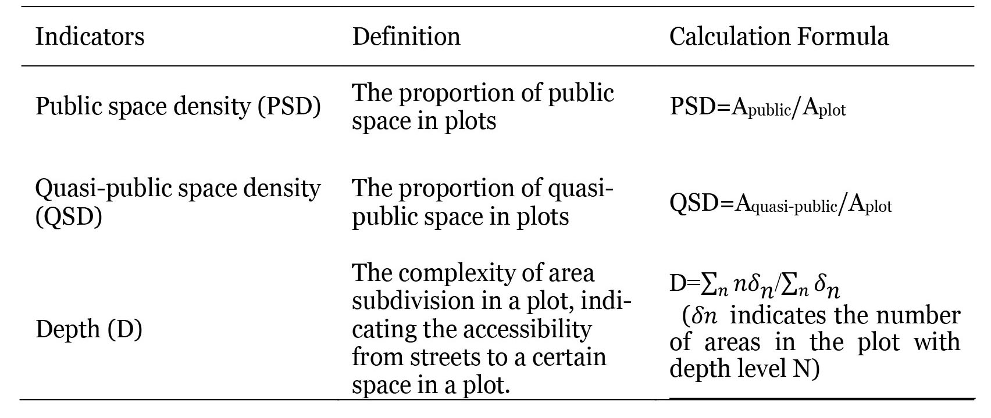

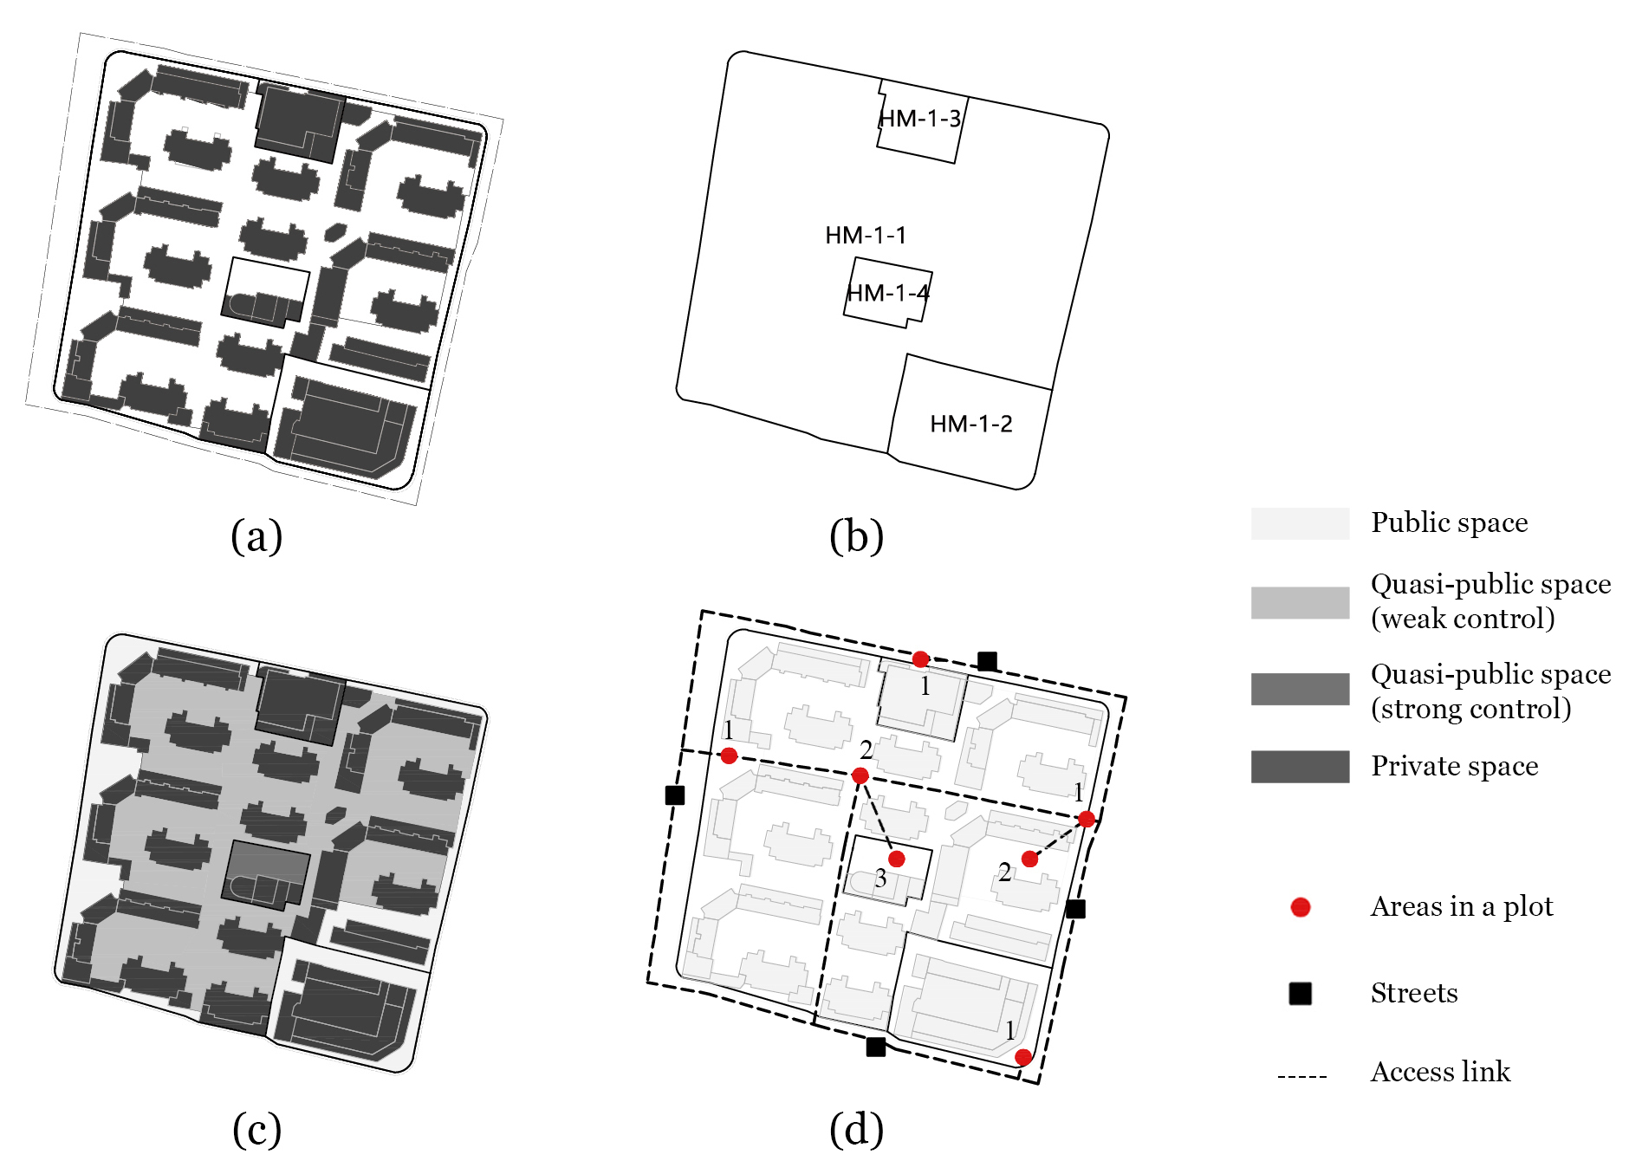
Figure 5. Plot openness indicators measurement illustration of Hongmiao: (a) plot plan; (b) plot pattern; (c) public space mapping; and (d) plot depth. (Source: Author)

2.2.3. Data collection and analysis
This study mainly obtains the plot data through planning administration in Nanjing and field investigation, which includes plot patterns and three-dimensional forms of buildings. Field investigation is an important process because the accessibility and access order of areas in a plot cannot be obtained directly, only field research can accurately recognize these characteristics. Then, online maps and Google Earth are used to revise the datum. In the data analysis phase, this study employs statistical analysis by using SPSS software. Regression analysis and box charts are used to demonstrate the drive factors of plot openness differentiation.

3. Results

3.1. The morphological features and plot openness of sample plots
Table 2. shows five samples development in the 1930s, 1980s, 1990s, 2000s, and 2010s, respectively, which are different in morphological features and plot openness.
Table 2. Morphological features and plot openness comparison of the selected samples: four diagrams in the table illustrate plot plan, plot pattern, public space mapping, and plot depth (Source: Author)
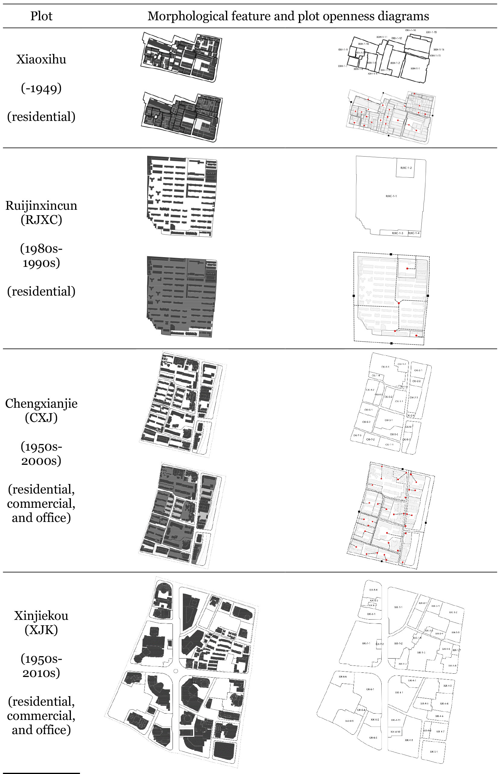
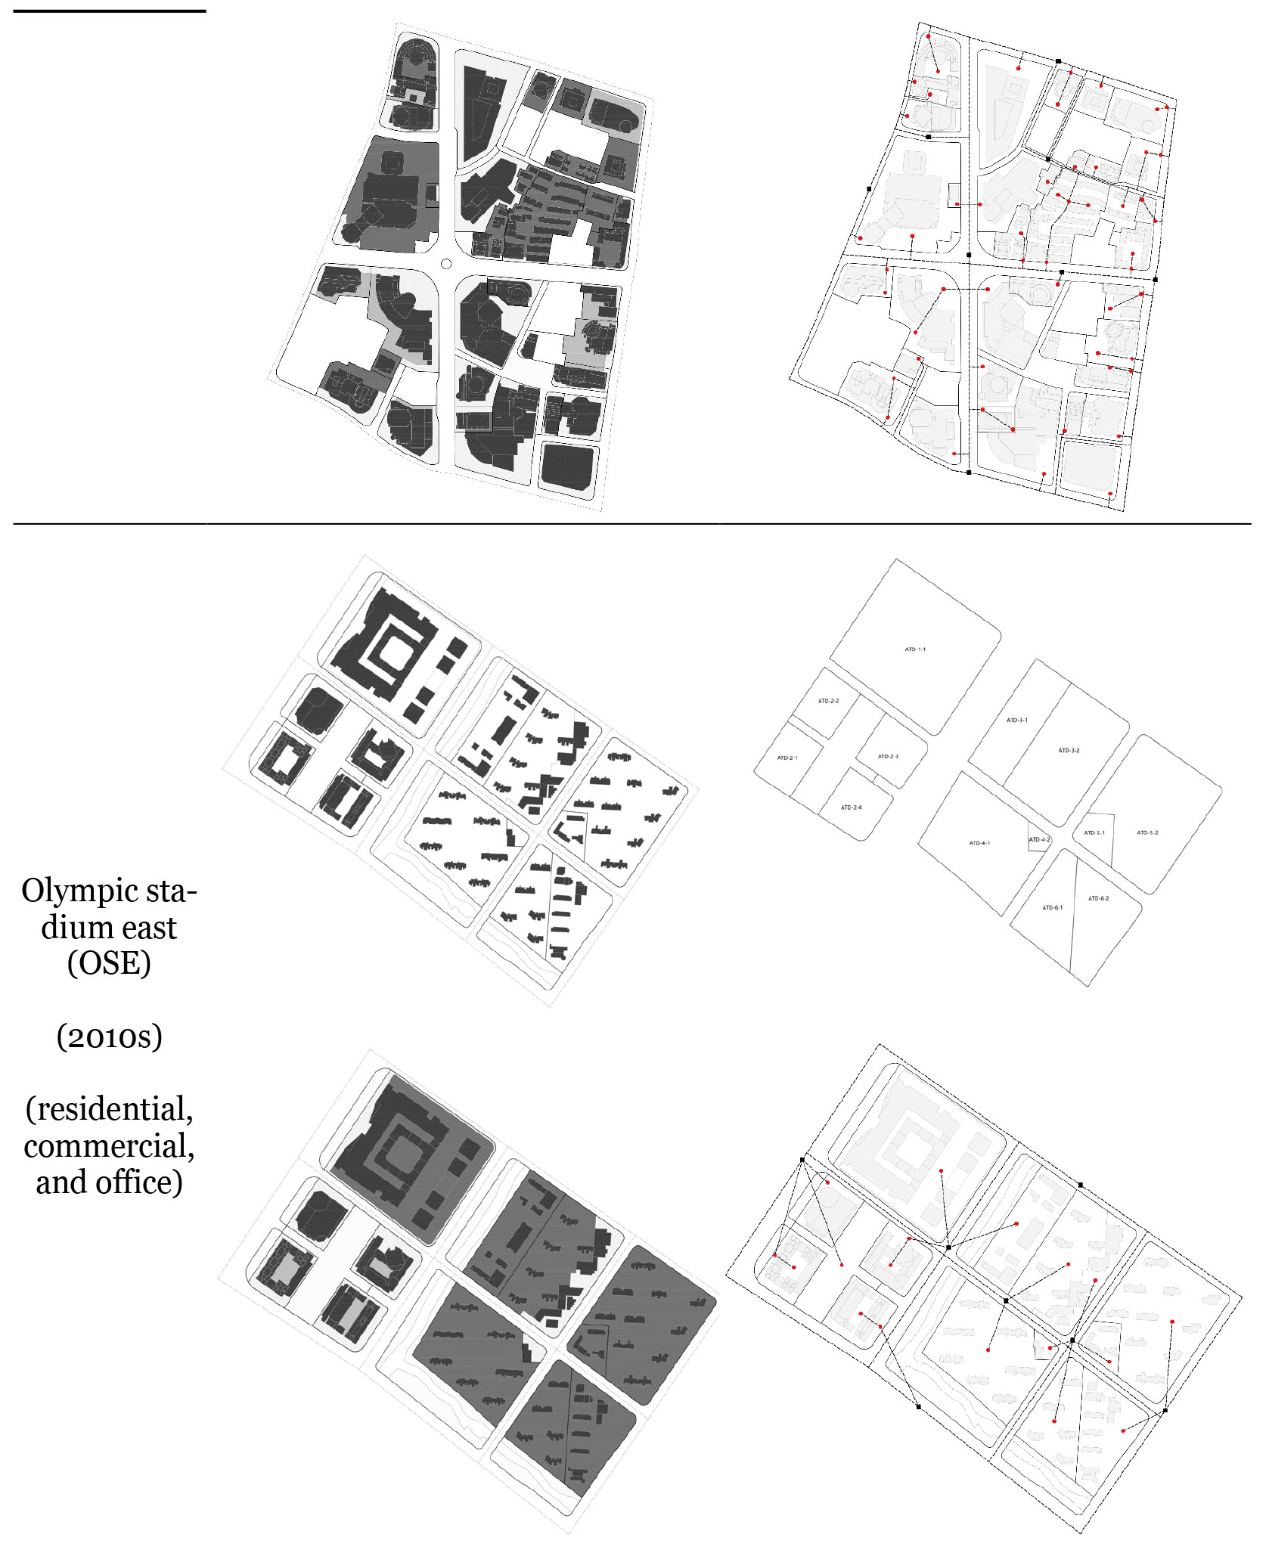

3.2. The effect of built density (FAR) on plot openness
Firstly, this paper will analyse whether built density is the potential factor that fosters the differentiation of plot openness. Since, it would be expected that the higher the built density of a plot, the higher openness of the plot. This paper mainly employs FAR (floor area ratio) to represent built density. The relation of built density and plot openness expresses the service capacity of public spaces in a plot, which reflects the quality of urban physical space. However, the regression analysis result shows that built density is not a strong factor that influences plot openness in downtown Nanjing (Figure 6). In residential plots, no strong linear relationship is shown between FAR and PSD (R²=0.0681) and QSD (R²=0.0202), indicating that the residential plot with higher density does not accommodate more public space or quasi-public space. The linear relationship between FAR and PSD (R²=0.0156) and QSD (R²=0.0017) of commercial plots is weaker. However, linear regression can explain the office plots better, the explanation coefficient for FAR and PSD, FAR and QSD explains roughly 30% and 45% of the variation, respectively (R²=0.2996, R²=0.4426). It indicates that built density affects the openness of office plots. The higher the built density of an office plot, the more the proportion of public space and less the proportion of quasi-public space in the plot area.
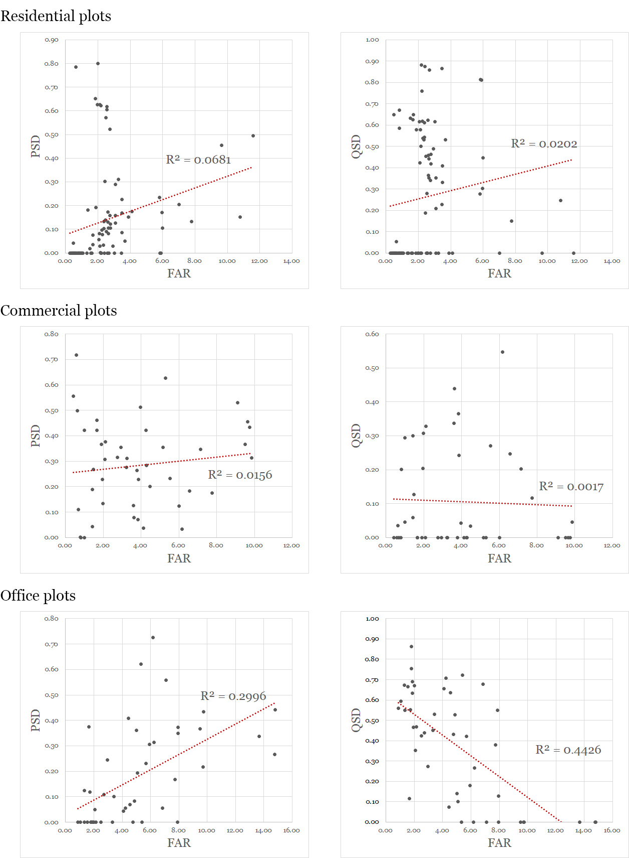
Figure 6. The regression analysis of plot density (FAR) and plot openness (PSD and QSD) in residential, commercial and office plots (Source: Author)

3.3. The effect of construction time on plot openness
Secondly, the factor of construction time of plots will be tested through statistical analysis. The construction time of the samples is divided into six phases: 1950s, 1980s, 1990s, 2000s, and 2010s. These periods are linked with the critical juncture of China’s land system reform. Figure 7 presents the transformation of plot openness in three functional plots. In residential plots, the proportion of public space of the plot is in an evolutionary trend of rising, falling, and rising with two turning points in 1980 and 2000. The proportion of quasi-public space has been on the rise, especially since 1990, indicating that residential plots tend to strengthen the control and management of areas in plots. In commercial plots, the proportion of public space has been increasing and is in a high proportion, while the proportion of quasi-public space is relatively low, indicating that the commercial plot has been inclined to open the space in plots to the public for commercial value. In office plots, the proportion of public space in the plots increased significantly after 2010. The plot depth of the three functions is roughly in the range of 1.0–2.0. Compared with residential plots, the plot depth of the commercial and office plots is lower, indicating that the space in commercial and office plots has a more direct connection with the surrounding streets with better accessibility. The plot depth of residential plots is relatively high from the 1980s to the 2000s, representing a complex plot space configuration. While in recent years, the space in newly built residential areas is usually directly connected with the surrounding streets.
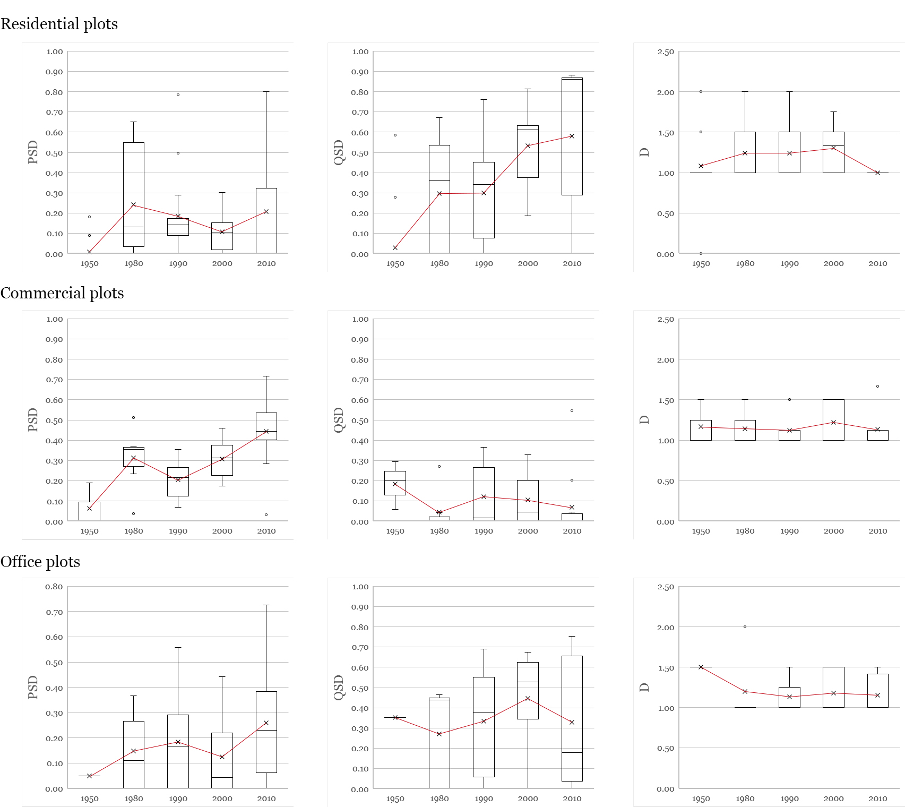
Figure 7. Boxplot diagram of plot openness transformation (Source: Author)

4. Discussion

4.1 Sociao-economy factors driven plot openness transformation
Previous statistical analyses show that the construction time is the main factor influencing the plot openness. The underlying reason lies in that plot openness is subject to the land development mode and the way of controlling public spaces in plots, which are affected by land-use policy and urban planning regulations enacted in different historical periods.

Before the founding of the People’s Republic of China (1949), lands were privately owned. Traditional courtyard dwellings often occupied a whole plot, leading to low plot openness, such as Xiaoxihu traditional block and Yi he road residence districts. Since the beginning of the 1950s, China has gone through a period of planned economy. The land ownership was fully transformed to state-owned, and the administrative allocation was mainly adopted in the land-use model. The work unit compounds (Danwei) system is an important national strategy and administrative tool for promoting urbanisation during this period (Zhang and Ding, 2018). All living needs of its members are supported by Danwei, such as working place, apartments, canteens, schools, hospitals, etc. The development of a Danwei occupies an independent large-scale plot bounded by walls, which is an introverted and self-sufficient urban unit. Thus, the plot openness is relatively low in China’s planned economy period.

In 1978, the urban economic structure began to adjust with the reform and opening-up, and the land market gradually formed. In the 1980s, the plot openness improved significantly, but there are differences among individual cases. During this period, the Danwei system led by a planned economy gradually came to an end, while the residential mode was still affected by the thought of a collective system. Most residential areas were welfare houses developed by the government. The phased development method often leads to complex plot morphological structures, and the boundary of some welfare housing plots has transformed complicated in nearly 40 years development. Nowadays, many residential plots developed in the 1980s have conducted self-organised renewal such as opening internal roads and opening storefronts in residences, which contributes to the improvement of plot openness in the 1980s.

After the reform of the housing system in 1992, commercial residences developed by real estate emerged. The property and construction boundary of plots has been clearly delineated in urban planning. In this case, developers usually choose to control the area inside the plot only for private use. Especially in the 2000s, the rapid urbanisation of Nanjing’s downtown facilitates the emergence of gated residential plots in the Hexi new district, which again led to the decline of the plot openness. Residential plots developed around 2010 still adopt a gated management mode, but community-supporting commercial spaces improve the plot openness to a certain extent. In terms of the plot depth, the newly built residence in this period often occupies a plot independently. Compared with the complex plot configuration in the old city generated by the incremental urban renewal process, the plot depth is relatively low with high accessibility in the new city. Moreover, the plot openness of commercial and office plots has been at a high level and gradually improved. Transforming from the introverted state-owned buildings to the modern commercial and office complexes, the areas in these plots are opened up and become part of the urban public space system.

Furthermore, Chinese urban planning regulations have been established and gradually completed since the 1980s. The open space along streets in a plot is mainly determined by the setback distance from plot boundaries required by urban planning regulations (Gao, 2017). Currently, detailed plot internal area design is regulated by urban design guidelines, such as regulating the major pedestrian access, public pedestrian corridor, public green space, sunken plaza, etc. inside plots. Therefore, mandatory planning regulations affect the openness of the areas within plot boundaries.
Table 3. Comparison of plot openness under the influence of land policies in different periods (Source: Author)
Periods | -1949 | 1949-1978 | 1978-1992 | 1992-2002 | 2002-
Land ownership | Privately- owned | State- owned | State-owned | Land Use Right system | Land Use Right system
Land development mode | Independent development | Administrative allocation and Project-based development | Administrative allocation and comprehensive development | Negotiation and project-based development | Government-led development plan
Critical juncture | — | Land nationalisation (1956) | Reform and opening-up policy (1978) Land Use Right system (1988) | Housing system reform (1992) | Land banking system (2002)
Urban planning regulation on plot openness | No requirement | No requirement | Requirement | Detailed requirement | Detailed requirement
Plot space accessibility | Low | Low | Low | High | High
Plot depth | Low | High | High | Low | Low
Plot openness | Low | Low | Low | High | High
Samples | Xiaoxihu; Yihe Road | Jinxinghe | Laifeng and Ruijinxincun residential district | Xinjiekou; Zhonghua road; Hongmiao | Xinjiekou; Longjiang; Olympic stadium east; Yuantong

5. Conclusions
This study is beneficial to prove the following contribution and conclusion.
First, it presents a quantitative assessment framework to measure plot openness based on evaluating the accessibility and configuration of spaces within plots. Combining field investigation and mapping methods, indicators of public space density (PSD) and quasi-public space density (QSD) reflect the proportion of accessible space area in a plot. Indicator of plot depth (D) expresses the complexity of plot configuration which explains the complexity of access links from streets to the subdivided areas within a plot.

Second, this study argues that the built density of plots has no strong linear relation with plot openness, which indicates built density is not the key factor that fosters the differentiation of plot openness. The regression analysis indicates that residential and commercial plots with high built density do not guarantee high plot openness, while the explanation coefficient for built density and plot openness could explain approximately 30% of the variation in office plots.

Third, the major difference in plot openness appears in the construction time of the plot. In the planned economy period (1949–1978), China’s urban plots are introverted and self-sufficient urban units. After the reform and opening-up policy (1978–), the structure of areas inside plots has become complicated which leads to diversified plot openness. China’s contemporary urban plots have relatively high plot openness, especially in terms of commercial and office plots. This transformation is mainly derived from the development of land-use policy and urban planning regulations.

As this research is still in its initial stage, some problems need to be solved and there is much work to be done. Due to the lack of sufficient historical data, this paper collects samples in different construction times for synchronic analysis instead of analysing the diachronic morphological evolution of the same plot. Besides, this paper adopts the analysis method of field investigation, it only chooses 197 plot samples in Nanjing’s downtown, more experiments are needed to verify this method. Future studies can improve the research method and accommodate more analysis samples.

Contributor statement
Linghao Wang: conceptualisation, methodology, writing-original draft; Jie Liu: conceptualisation, writing-review, and editing
Acknowledgments
Research for this paper was supported in part by the National Natural Science Foundation of China, for project “Research on the Integration and Optimization Control of Multi-Scale Urban Form’” (Program No. 51878138), January 2019–December 2022.

References
- Biernacka, M., & Kronenberg, J. (2018). Classification of Institutional Barriers Affecting the Availability, Accessibility and Attractiveness of Urban Green Spaces. Urban forestry & urban greening, 36, 22–33.
- Carmona, M. (2010) ‘Contemporary Public Space, Part Two: Classification,’ Journal of Urban Design, 15(2): 157–173.
- Dovey, K., & Pafka, E. (2020). Mapping the Publicness of Public Space: An Access/Control Typology. In Companion to Public Space (pp. 234–248). Routledge.
- Gao, C., & Ding, W. (2017). Correlation Analysis on Urban Morphology and Related Urban Laws and Regulations in China: A Case Study of Nanjing City. City Planning Review, 14(12), 45–57.
- Gehl, J. (1971). Life between Buildings: Using Public Space. New York: Van Nostrand Reinhold.
- Hillier, B., & Hanson, J. (1984). The Social Logic of Space. Cambridge University Press.
- Jacobs, J. (1961). The Death and Life of the Great American Cities. New York: Random House.
- Ji, H., & Ding, W. (2021). Mapping Urban Public Spaces based on the Nolli Map Method. Frontiers of Architectural Research.
- Ji, H., & Ding, W. (2019). AN APPROACH TO DESCRIBE BLOCK-BASED SPATIAL CONFIGURATION.
- Kropf, K. (2009). Aspects of Urban Form. Urban morphology, 13(2), 105.
- Kropf, K. (2014). Ambiguity in the Definition of Built Form. Urban morphology, 18(1), 41–57.
- Lynch, K. (1981) A Theory of Good City Form, Cambridge: MIT Press.
- Marshall, S., & Zhang, Y. Towards a Typomorphology of Public Spaces: Relating Place Type and Measures of Enclosure. In 24TH ISUF INTERNATIONAL CONFERENCE: CITY AND TERRITORY IN THE GLOBALIZATION AGE (pp. 1555–1565). Univ Politecnica Valencia.
- Németh, J. and Schmidt, S. (2011) ‘The Privatization of Public Space,’ Environment and Planning B, 38(1): 5–23.
- Sevtsuk, A., & Mekonnen, M. (2012). Urban Network Analysis. Revue internationale de géomatique–n, 287, 305.
- Sharifi, A. (2019). Urban Form Resilience: A Meso-Scale Analysis. Cities, 93, 238–252.
- Shen, Y., & Wu, Z. (2021). Functional Visibility Graph Analysis: Quantifying Visuofunctional Space with Social Media Check-In Data. Environment and Planning B: Urban Analytics and City Science, 23998083211001840.
- Song, Y., Zhang, Y., & Han, D. (2021). Access Structure. Environment and Planning B: Urban Analytics and City Science, 2399808320988560.
- Tang, L., Miao, J., & Ding, W. (2017). Building as Street Interface: Case Studies in Nanjing, China. UIA 2017 Seoul World Architects Congress.
- Verstegen, I., & Ceen, A. (Eds.). (2013). Giambattista Nolli and Rome: Mapping the City Before and After the Pianta Grande. Studium Urbis.
- Yan, Y., & Xu, L. (2017). Public Space Supply Coefficient and Efficiency Study: A Case Study of 14 Railway Transit Station Area Blocks. Time+ Architecture, 05.
- Zhang, L., & Ding, W. (2013). Urban Plot Characteristics Study: Casing Centre District in Nanjing, China. Urban form at the edge: proceedings from ISUF2013. Volume 2, 50.
- Zhang, L., & Ding, W. (2018). The Evolution of Chinese Danwei System and Its Influence on Plot Development: The Case of Nanjing. In Proceedings of the XXV ISUF International Conference. Siberian Federal University, Institute of Architecture and Design (pp. 319–331).
- Zhang, Y. Jin, Z., Kumari, R., Seah, C. M., & Chua, T. S. (2018). Measuring the Physical Profile and Use of Park Connector Network in Singapore Using Deep Learning and Big Data Analytics. In Proceedings of IFoU 2018: Reframing Urban Resilience Implementation: Aligning Sustainability and Resilience.

Samples includes Xinjiekou (XJK), Hongmiao (HM), Langhoujie (LHJ), Chengxianjie (CXJ), Jinxianghe (JXH), Nanbuting (NBT), Zhonghua road (ZHL), Gutongxiang (GTX), Xiaoxihu (XXH), Laifeng residential district (LF), Ruijinxincun residential district (RJXC), Yihe road (YHL), Longjiang (LJ), Olympic stadium east (OSE), and Yuantong (YT)
The “access structure” demonstrates the hierarchical spatial order of access from streets to plots and buildings in China’s cities.

