Type of the Paper: Peer-reviewed Conference Paper / Full Paper
Track title: Human-centred and nature-based approaches in cities

A Sense of Place: Site Specificity as a Way to Foster Resilient Urban Landscapes
Cristina Wong ¹
Names of the track editors:
Claudiu Forgaci
Rene van der Velde
Names of the reviewers:
René van der Velde
Ana Maria Fernandez-Maldonado
Journal: The Evolving Scholar

DOI:10.24404/61549b7f1e981500089d3ed7

Submitted: 15 October 2021
Accepted: 01 June 2022
Published: 24 August 2022
Citation: Wong, C. (2021). A Sense of Place: Site Specificity as a Way to Foster Resilient Urban Landscapes. The Evolving Scholar | IFoU 14th Edition.

This work is licensed under a Creative Commons Attribution CC BY (CC BY) license.
©2021 [Wong, C.] published by TU Delft OPEN on behalf of the authors.

¹ Universidad de Piura; cristina.wonglent@gmail.com; ORCID ID 0000-0003-2348-2842

Abstract: The current paper presents a tool able to achieve sustainable landscapes, meaning that the final product is the intertwining of design processes instead of arriving at a predetermined final form which is unfolded with the systems found in place. Spatial explorations are realised under the methodological umbrella of Research through Design, where the territory is analysed, synthetized, and evaluated through creative manners. This results in the exploration of geographical, cultural, and social dimensions in the form of mapping and designing transformative models. The aim of this research paper is to explore the idea of site specificity as a design tool to achieve sustainability in social-ecological systems, which claims the capacities of resilience and adaptation as its essential components. The emergence of proposing this project in Lambayeque, Peru arises from the need to mitigate the ravages caused by natural disasters, where flooding wreaks havoc resulting in the loss of productive land and critical infrastructure, as well as devastated towns, affecting mostly vulnerable population. The result is the capacity of natures – with a certain degree of manipulation – to become the stitching element throughout a dispersed territory in the form of green and blue networks running across the region, as part of sustainable urban water landscapes.
Keywords: site specificity; climate change adaptation; resilience; landscape urbanism

1. Introduction

Traditional urbanism discourse is usually stirred towards a connotation where natural and rural landscapes are relegated to secondary places. However, there is evidence of systems-based thinking, where ecology is taken as essential to address urban planning and design. One of the commonly borrowed terms from ecology is resilience, which deals with complexity and change, terms seen as the basis for innovation since change is deep-rooted in system dynamics (Erixon et al., 2013).

In order to achieve integral sustainable projects, the territory is viewed as a socio-ecological system where ecology is considered as a pivotal part of urban planning, thus giving the same level of importance to the built environment and to natural landscapes (ibid.) highlighting the relationships and processes among humans and nature. The socio-ecological system approach emphasizes the symbiotic relationship among the human dimension – people, communities, economies, societies, cultures – and the ecological dimension, and how these shape each other through time. By understanding the territory as a complex ecological model, uncertainties are considered fundamental since disturbances are embedded within socio-ecological systems, and which are subject to sudden and unpredictable change (Lister, 2007). The ubiquitous presence of abrupt uncertainties calls for an adaptive capacity in order to accommodate change, which are especially acute nowadays due to climate change-related events such as floods, droughts, heatwaves, and wildfires, among others.

A research-by-design case in the Lambayeque region, Peru is taken as a testing ground. The rapid urban growth of the last decades currently dominates the natural environment of Lambayeque, creating a false sense of self-sufficiency at the city level, comprising most functions and programmes on an urban scale. According to Tucci (2009), floods resulting from natural disasters are the main vulnerability suffered by developing countries. Moreover, natural disasters are intensified due to climate change, resulting in the loss of productive land and infrastructure, as well as devastated towns, affecting mostly vulnerable population. In the Peruvian case, the El Niño Phenomenon – FEN – affects the country resulting in heavy rains, floods caused by higher levels of river streams, landslides, extreme temperature, diseases such as cholera, and finally, large losses of endemic fauna and flora. Additionally, in 2017 a new climate pattern emerged called ‘El Niño Costero’ (Coastal El Niño), which caused even greater havoc: 14 of the 25 existing regions were declared in a state of emergency, disease outbreaks occurred, thousands of people died, and vast agricultural areas flooded. In the years when natural disasters affect the country, the national GDP is reduced by 5–7%, representing approximately 10 billion dollars.

In the current paper, site specificity is presented as a tool to design on multiple spatial and temporal scales, where both conceptual and tangible site exploration is possible, taking into account the perception and engagement of the human dimension to the site. Moreover, site specificity puts the idiosyncrasy of a community and physical features of landscapes on the same level of importance, creating an opportunity for the final design to be precisely curated for the place instead of coming up with a predetermined form. The aim of this research paper is to delve into site specificity as a design tool to achieve resilience within socio-ecological systems, and as a way to foster sustainable territories, acknowledging that the site results from an array of cultural, geographical, topographic, and social practices where the greater patterns such as geomorphology and hydrology are of the outmost importance (Berrizbeitia, 2007).

The working methodology is Research through Design ‘RTD,’ a “research method in which spatial design plays the main role” (Nijhuis & de Vries, 2020, p. 87), which allows for exploration by thinking and producing, where the agency of mapping plays a fundamental facet

An aspect of novelty to put forward with this paper is the notion of existing landscapes as the canvas where not just new landscapes are designed, but a new codependency of associations – relating this process to the milieu (Corner & Hirsch, 2014) – to the precise site where flooding takes place in order to create spatial interventions in the form of transformative models. This performance is a result of reading the territory under the umbrella of site specificity, understanding the geographical, cultural, and social formations of the region. It also takes into account the capacity of nature-based solutions – through mapping and transformative models – to illustrate the resilience and adaptive capacity as a way to overcome challenges faced by the Lambayeque region, in the form of green and blue networks running across the region that are part of sustainable urban water landscapes.

2. Theories and Methods
Landscape urbanism focuses mainly on structures or contexts that adapt to conditions, not to the mere shape of the place resulting in an aesthetic design (Berrizbeitia, 2007) that is capable of hosting innumerable forms of processes, relationships, and interactions. It is important to mention the omnipresent role of ecology in this approach, which in turn harbours processes of codependency.

Corner describes the specificity of site as an approach that takes into account its ‘environment, culture, politics, and economies, as a programme unto itself’ (Corner & Hirsch, 2014, p. 286). For the study, this position is merged with the one from Berrizbeitia, where the specificity of site places the experiences and physical attributes of a given landscape on the same level of importance (Berrizbeitia, 2007). By placing experiences, not just programmes or events, in such an assertive scene, the human agency is taken as a crucial piece of the ecosystem. The non-equilibrium paradigm in ecology considers humans as “learning and active agents of change” within ecosystems (Pickett et al., 2004, p. 376); it pays special attention to the dynamics and processes drawn within systems, while describing resilience as the “ability of a system to adapt and adjust to changing internal or external processes” (ibid., p. 373). This better aligns with the current project, as well as with urban planning and design disciplines since urban landscapes are considered systems of change where the built environment and its dynamics are in constant fluctuation.

Unlike the architectural object, a landscape urbanism project develops, adapts, evolves, and even improves over time. Moreover, it will possibly suffer change in its composition or structure over time (ibid.). For the Lambayeque case study, the course of time is comprised by two components: seasonal change and disruptive change – as uncertainties arising from extreme events such as the El Niño Phenomenon.

The RTD methodology is used as an umbrella for research and as a way to explore spatial possibilities to generate innovative results. In this context, the term ‘design’ is understood as a form of research in itself and as a “research method in which spatial design plays the main role” (Nijhuis & de Vries, 2020, p. 87). This methodology results in design explorations, in the making of several transformative models, aiming to expose challenges and opportunities of the site, and possible design solutions in order to face extreme weather conditions. The aforementioned methodology is used in order to put forward the idea of site specificity as a tool to achieve long-term sustainability.

In addition to the approach described above, this study takes the principles of spatio-temporal multi-scalarity in order to determine the degree of manipulation of the landscapes to achieve water security facing contingency and change. Thus, the spatial scales are the macro scale corresponding to the Lambayeque region, the meso scale corresponding to the Chancay-Lambayeque sub-basin, the micro scale corresponding to the rural town of Chongoyape, and finally, the streetscape scale corresponding to a closer look into the built tissue.

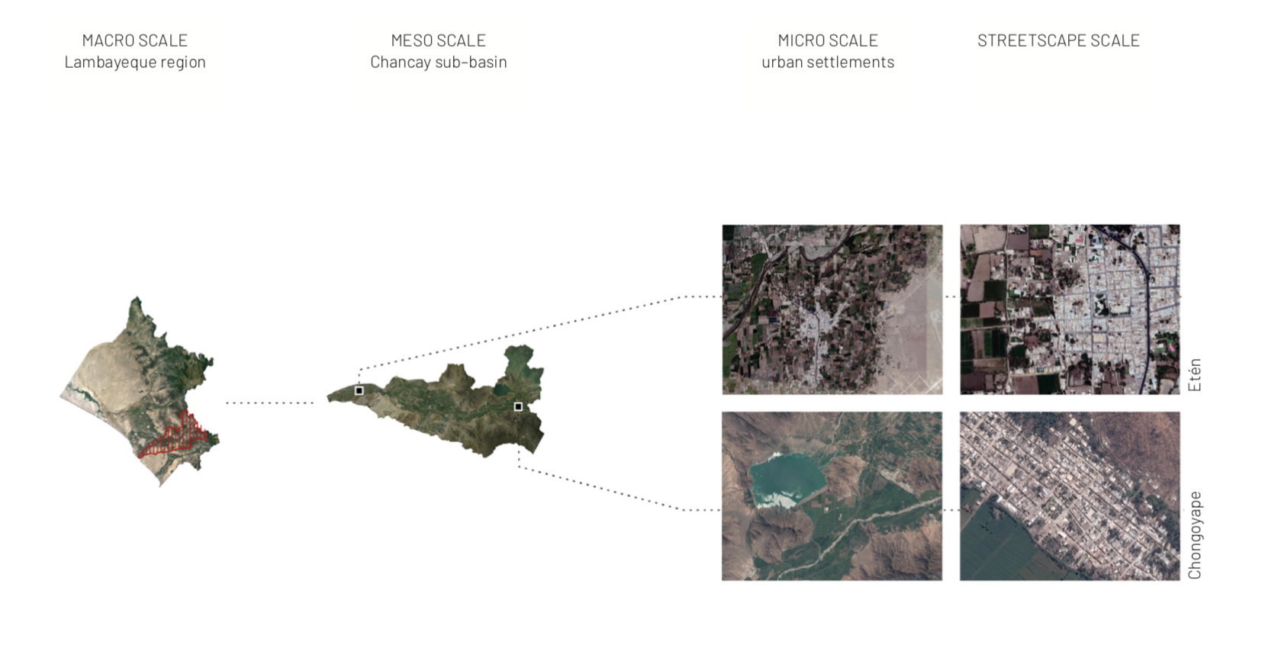
Figure 1. Spatial scales. Diagram of spatial scales: macro, meso, micro, and streetscape.

3. Results
3.1 Resilience and adaptive capacity thinking

Allowing a landscape to perform in multiple ways can fulfill the demand for public spaces while achieving sustainable development. Long-term sustainability requires the capacities of resilience and adaptation as its essential components.

The dynamic characteristic of ecosystems mentioned in the previous section is encouragement to design dynamic processes as resilient and adaptive systems that are able to steer paths in case of any known or unknown disturbances, in order for them to “adapt to changing conditions over time” (Berrizbeitia, 2007, p. 183). In this context, resilience is measured by how much uncertainty and change an ecosystem might absorb before changing paths or regimes (Czerniak, 2007; Erixon et al., 2013). In the Chancay-Lambayeque sub-basin, that would be translated into the amount of rainfall that the river can accommodate – after a natural disaster – before ‘flipping’ into a new behaviour of flooding. Additionally, “watersheds are integrators of diverse processes” given that subterranean water from aquifers, aquitards, aquiclude, and aquifugues accrue sediments and minerals that can be helpful or polluting agents downstream of the basin (Pickett et al., 2004, p. 376). Moreover, in the words of Folke (2016), “it is possible to convert different vulnerabilities and uncertainties into windows of opportunity, basing the transformation of landscapes on multi-scalarity, resilience, and flexibility, also adding the ability to adapt to design.” It is within this framework that the current case study takes place, designing green and blue infrastructures in an array of spatial and temporal scales in the Chancay-Lambayeque sub-basin.

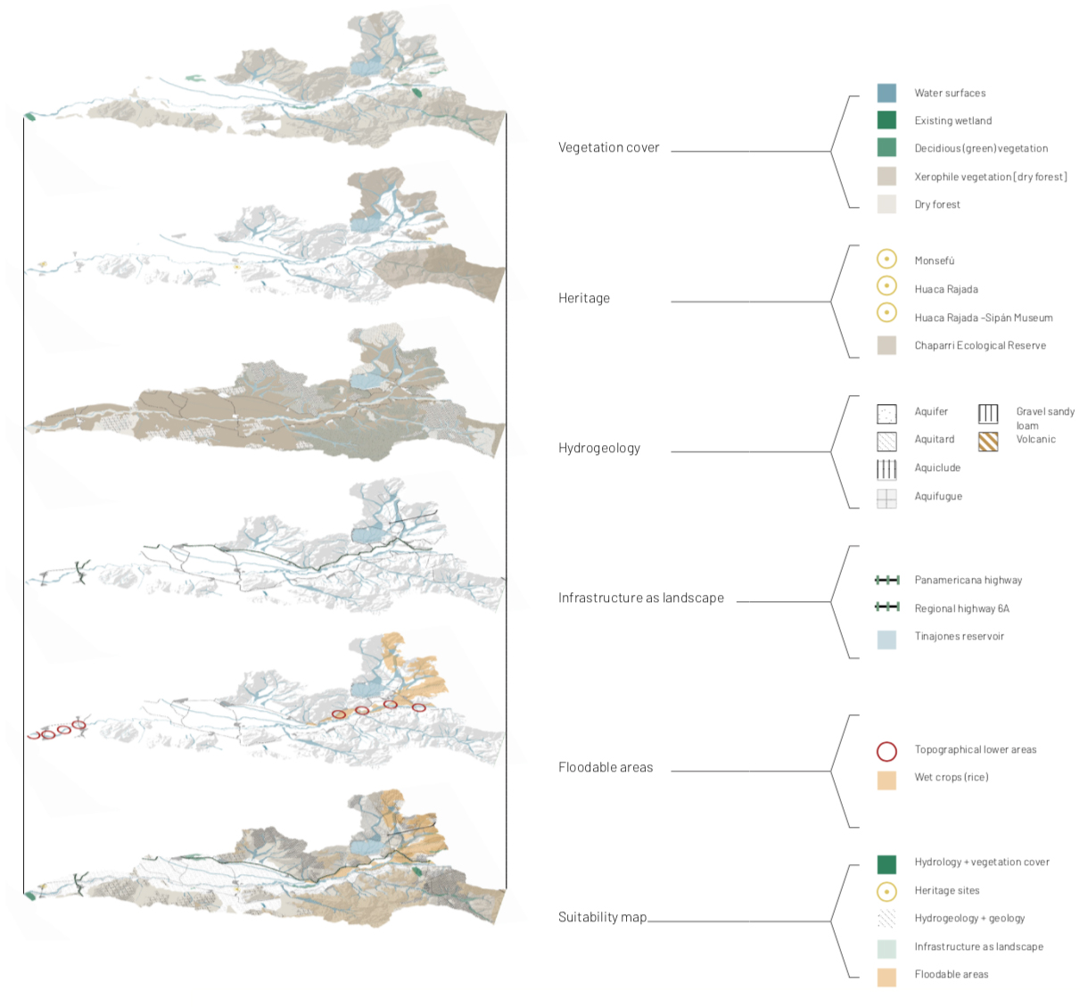

Figure 2. Analysis of the Chancay-Lambayeque sub-basin. The analysis of the territory using site specificity as the main exploration tool allows for the design to evolve taking into consideration physical qualities and idiosyncrasies of the sub-basin. Layers of the initial analysis and design include: vegetation cover, heritage sites, hydrogeology, infrastructure as landscape, and floodable areas resulting in a suitability map for the sub-basin.

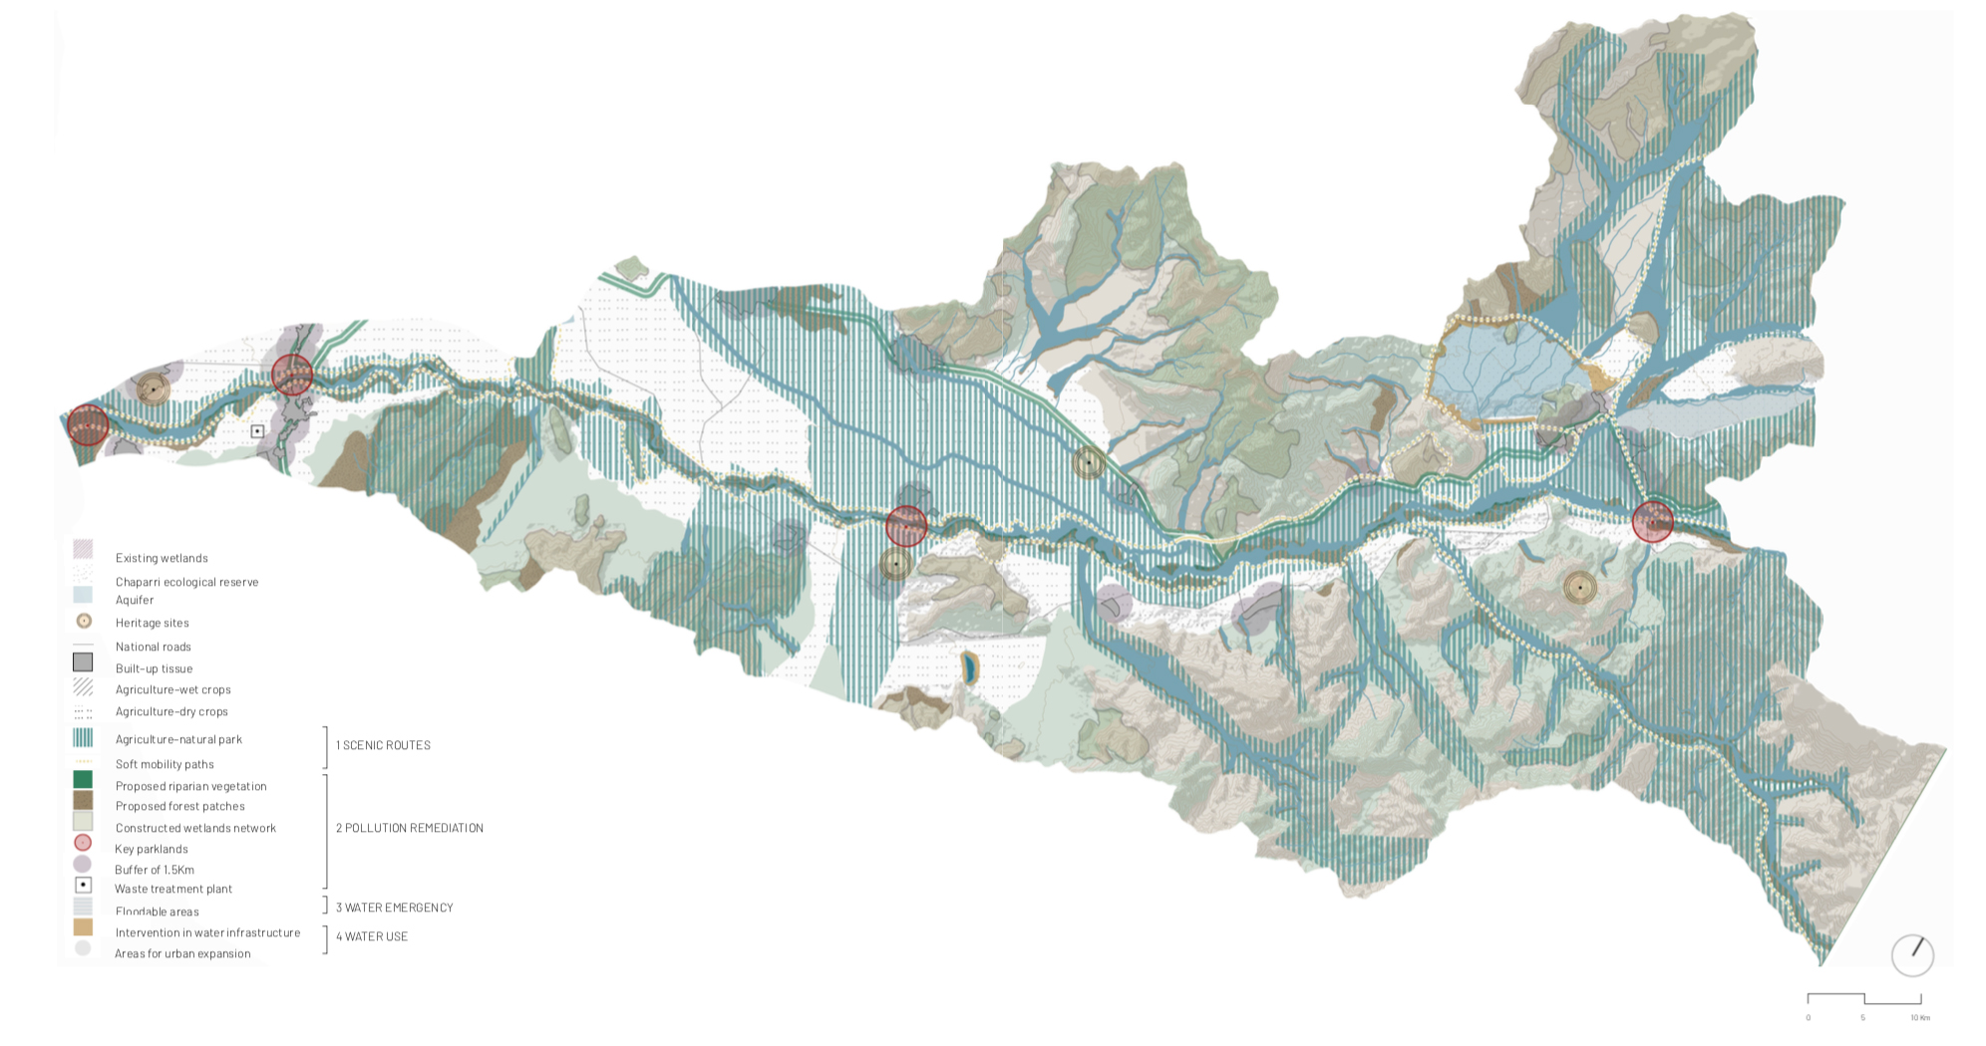

Figure 3. Agriculture-natural park as a result. The proposal at the sub-basin level results in an Agriculture-natural park along the Chancay-Lambayeque river corridor, which is comprised by four strategies: Scenic Routes, Pollution Remediation, Co-existence with water, and Use/Recreation water. These strategies, in turn, are composed by spatial interventions that are tested in smaller-scale sites that are transformative models along the river corridor, which function as the linking element at the meso and macro scale, initiating the proposal of the park green & blue networks, where an array of landscapes intertwine, profiting and retrofitting among each other achieving a new equilibrium of coexistence with flooding. (Wong, 2018)

Resilience and adaptive capacity thinking are closely related to sustainable development. For the current project, this is comprised of the design of green and blue networks which take the parcels close to the river axes, turning them into protected areas, creating an Agriculture-Natural Park. By giving this river corridor the status of a regional park, it will oblige farmers adjacent to the river to use natural pesticides and fertilizers, improving the soil next to the river, which in turn, improves the overall water condition. In return, the production is designated with an organic label which are valued much higher than that which results from ‘regular’ practices. Furthermore, rice producers next to the river will improve their crops by having regular water flow into their parcels. However, in the case of a natural disaster emergency, their crops can be used as part of the floodable emergency water system that incorporates the aforementioned space for river overflow. The overarching aim of the Park is to facilitate movement through the valley and to be the integrator among natural and man-made landscapes – while protecting biodiversity – into the expansion of existing growing cities. Moreover, it becomes the link that rural communities need in order to economically thrive (Wong, 2018). As part of the nature-based solutions, a network of constructed wetlands is designed, in addition to vegetation strips along water streams and terraced indigenous vegetation that is crucially important in the upper part of the sub–basin. Additionally, constructed wetlands are the main mechanism to remediate pollution in the sub-basin and water storage in case of drought. Forest patches are the main source of restoration of the water table, currently in danger for the construction of illegal wells. Finally, main crops of the region are rice and sugar cane, which need plenty of water. A strategy for self-organising, a fundamental requirement of long-term sustainability (Lister, 2007), in the upper part of the sub-basin is the diversification of crops to ones that do not need much water to sustain themselves, such as sweet potato, arracacha, strawberries – root crops – and, native fruit trees such as mango and passion fruit, to name a few.

By proposing these strategies, the sub-basin is able to adapt to unexpected changes without changing paths, which means that the recurring images from despair resulting from El Niño Phenomenon would belong to the past. Moreover, by generating a multi-scalar plan for the sub-basin, the perception and engagement at local and regional scales would be improved with either ecological performative agendas or architectural activities. These agendas and programmes are particular to the site, given that they correspond to the specific conditions of Lambayeque. So, the natural, rural, and urban landscapes ought to be adaptive to flooding from natural disasters and for the sporadic drought, given its geographic location within the ecosystem of a dry forest. Finally, by facing the adaption to future complexity, the performative ecology in the form of green and blue networks nourishes resilient and adaptive capacities within the Chancay-Lambayeque sub-basin.

3.2 The making of a transformative model

Site specificity is a way of understanding the landscape by engaging with it. Engagement modes include: observing, modeling, drawing mapping, among others. Moreover, the agency of mapping is used not just as a tracing method, but as a tool for discovering the landscape, resulting in a model that unfolds at the same time that constructs the project step by step, not being able to foresee its final form, drawing a line with planning, which leads to a fixed end (Corner & Hirsch, 2014, p. 212).

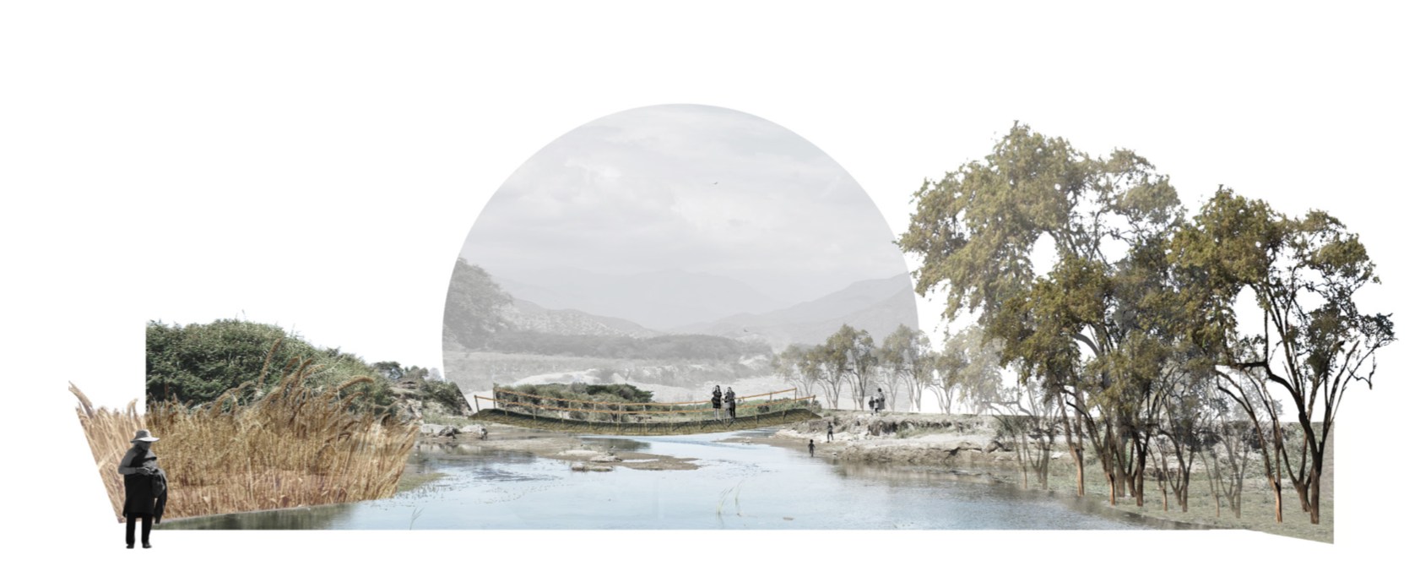

Figure 4. Transformative model. The figure shows the restoration of a section of the river and protection of endemic fauna and flora – such as the carob tree, palo santo – as part of the ecological performative agenda.

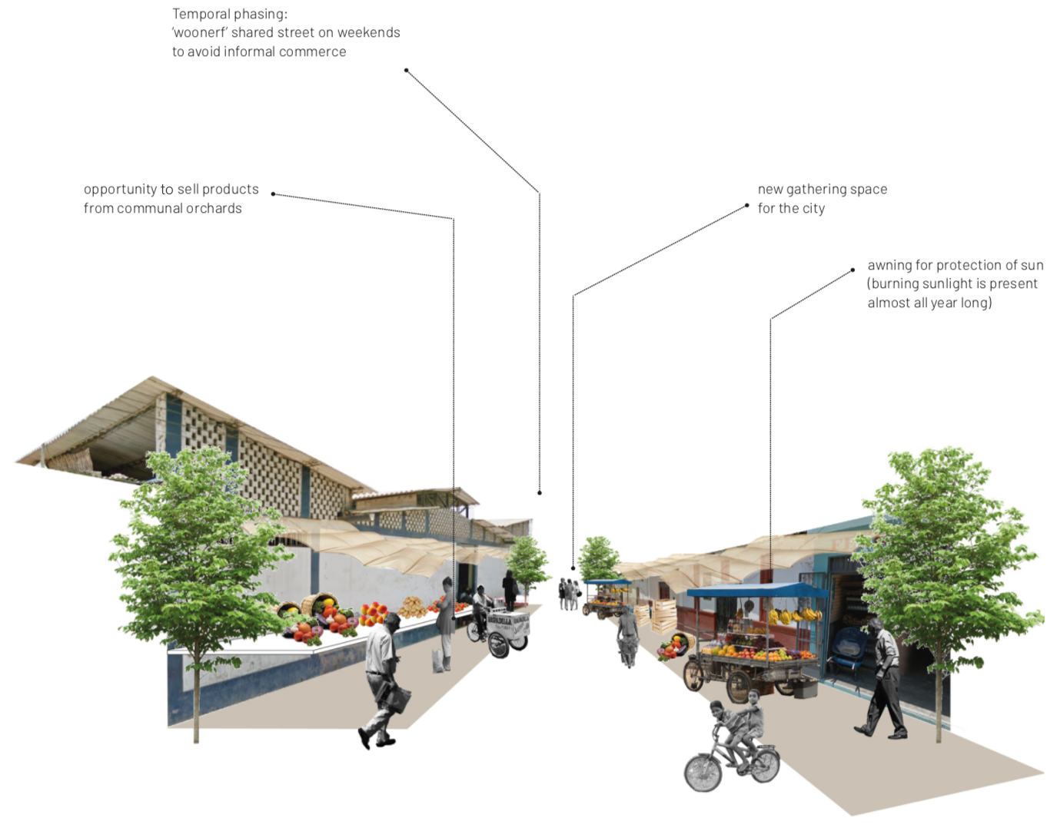

Figure 5. Transformative model. The figure shows the diversity, multifunctionality, and temporal phasing in architectural seed projects, as part of the programmatic performative agenda.

4. Discussion

The starting point of this paper raised the idea of ​​interpreting the Lambayeque region as a socio-ecological system, taking into consideration the range of tools, methods, and interventions that emerge from the coalition of urbanism, landscape architecture, and ecology to understand natural and man-made landscapes as living ecologies and agents of change. During the initial thesis the case study was introduced, where site specificity was used as a design tool to inform the final project with knowledge arising not only from the physical attributes of the site, but also from the intangible ones. Consequently, the project resulted in a series of transformative models as a way of exploration able to respond to future states of flooding. It should be considered that the essence of this tool is not to claim to be a specific configuration destined for success, since multiple variables come into play within each unique ecosystem, where the greater or lesser manipulation of the landscapes might result in an array of interventions. Furthermore, the final results are designed experiments that accommodate growth and change in the light of future adversities.

Adaptive projects have shown positive impacts in territories around the globe. Moreover, adaptive design and green and blue infrastructure calls for designing in a systemic way using multiple scales, and taking into consideration different contexts, perspectives, and voices (Bacchin et al., 2014; Lister, 2007). This study considers this requirement by using site specificity as a tool to understand a place from the ecological and societal dimensions, addressing unique issues in each spatial scale. By viewing the project under the tool of site specificity, designers can acquire knowledge from the site itself and, especially from the present and future users. Thus, leading to a sustainable proposal able to respond to the particular challenges of the site.

Ecosystems are comprised of physical and intangible attributes such as the idiosyncrasy of a community, cultural connotations of a place, and its historic events that evolved with time. Site specificity is also known as the initial step of taking into consideration local knowledge or bearing in mind the context where one is designing. By not having a coined term for this step, it diminishes its importance, disregarded to be barely used during the primary steps of the diagnosis. The second idea to put forward with this paper is to place site specificity as the coined term for describing this step, intertwining ecological and societal dimensions resulting in deeply-rooted design interventions. Finally, site specificity is not the definitive lens that results in a final design however, it is a design tool for exploration across multiple spatial and temporal scales (Berrizbeitia, 2007).

The use of the site specificity tool in the case study allowed to accomplish a thorough reading of the territory where new relationships of co-dependency were drawn within the region taking the Chancay-Lambayeque River as the carrying structure, proposing an agriculture-natural park, where both ecological – for protecting coastal dry forests and endemic fauna – and programmatic in the form of architectural seed projects whose dimensions are managed as performative agendas, along with functions, formal, and spatial attributes, and processes (Czerniak, 2006) in order to achieve a new sustainable equilibrium of coexistence with exceedance of water resulting from unexpected climate-related events. Furthermore, the design tool informed the aforementioned new equilibrium and afforded the project with the capacities of resilience and adaptation, which are at the core of sustainability. This way the project can withstand perturbations in the future, maintaining or adapting a stable state without changing courses.

5. Conclusions
Viewing the city through the lens of site specificity offers a way for exploration and discovery, and creating transformative models. This is a set of possibilities that allows, inter alia, for connections between the natural and man-made landscapes, thus generating correlations between different components of each system while engaging local communities in the decision-making and design processes, which is one of the principles to achieve adaptive design and planning, as argued by Kato & Ahern (2008). Moreover, the early involvement of the whole array of stakeholders gives them a sense of ownership, which allows for appropriation of spaces and for the community to be a strategic part of the monitoring and maintenance processes.

In the case of the Chancay-Lambayeque sub-basin, the Agriculture-natural park was designed to function as the main axis of the region, achieving climate adaptation for the transition to a new balance. It can be concluded that a network of green and blue infrastructure is necessary to improve – and even guide – access to natural areas that over time have been disappearing to accommodate highly urbanised environments (Bacchin, 2015; Wong, 2018). The use of the site specificity tool allowed for the recognition of ways of living which were not considered during the initial site visits, where only the physical attributes were recognised. As this study suggests, the site specificity tool improved the perception of the place, granting the appropriate knowledge to propose a design able to accommodate complexity.

The future direction¹ for this research project, Intertwined Natures, is currently under way in the rural town of Chongoyape, Lambayeque, where participatory design workshops are planned for the coming months. Community engagement and participatory design are taken as key tools in order to inform resilience in the bigger scale, since it is pointed out by Folke (2010) that “transformational change at smaller scales enables resilience at larger scales.” Moreover, the project aims for high levels of participation and collaboration among different stakeholders, community involvement in order to achieve a sense of appropriation of the proposed spatial interventions and a “sense of belonging.” Furthermore, the small-scale functions as a “driver for innovation, and thus for slow change and adaptation at larger scales” (Erixon et al., 2013, p. 278). Finally, the prospective idea of creating dialogues and cooperation bonds between academia and local communities is one of the objectives of the project in order to inform resilience.

1 Update: Given the upsurge of the Omicron variant during the COVID-19 pandemic, the aforementioned workshops had to be put on hold until further notice.

Acknowledgments
The author gratefully acknowledges the financial support provided by CDRI, Coalition for Disaster Resilient Infrastructure, as part of the Fellowship programme 2021–2022.

References

- Bacchin, T. (2015) Performative Nature, Urban Landscape Infrastructure Design in Water Sensitive Cities. Delft University of Technology, Unesco–IHE Institute for Water Education
- Bacchin, T., Ashley, R., Sijmons, D., Zevenbergen, C., van Timmeren, A. (2014). Green-Blue Multifunctional Infrastructure: An Urban Landscape System Design New Approach. 13th International Conference on Urban Drainage, Sarawak, Malaysia.
- Berrizbetia, A. (2007) Re-Placing Process. In J., Czerniak & G., Hargreaves (Eds.). Large Parks. New York: Princeton Architectural Press.
- Corner, J., & Hirsch, A. B. (Eds.). (2014). The Landscape Imagination: Collected Essays of James Corner, 1990–2010. New York: Princeton Architectural Press
- Czerniak, J. (2007) Legibility and Resilience. In J., Czerniak & G., Hargreaves (Eds.). Large Parks. New York: Princeton Architectural Press.
- Czerniak, J. (2006) Looking Back at Landscape Urbanism. Speculations On Site. In Waldheim, C. (2006). The Landscape Urbanism Reader. New York: Princeton Architectural Press.
- Erixon, H., S. Borgström, S. & Andersson, E. (2013). “Challenging Dichotomies - Exploring Resilience as an Integrative and Operative Conceptual Framework for Large-Scale Urban Green Structures,” Taylor & Francis Journals, vol. 14(3), 349–372.
- Folke, C., Carpenter, S., Walker, B., Scheffer, M., Chapin, T., Rockström, J. (2010). Resilience Thinking: Integrating Resilience, Adaptability and Transformability. Ecology and Society, 15(4), 20–20. doi:10.5751/es-03610-150420
- Folke, C. (2016). Resilience (Republished). Ecology and Society, 21(4). doi:10.5751/ES- 09088-210444
- Girot, C. (2006). Vision in Motion: Representing Landscape in Time. In Waldheim, C. (2006). The Landscape Urbanism Reader. New York: Princeton Architectural Press.
- Intergovernmental Science-Policy Platform on Biodiversity and Ecosystem Services (2020) Workshop on Biodiversity and Pandemics. Retrieved from: https://ipbes.net/pandemics
- Kato, S., Ahern, J. (2009). ‘Learning by Doing’: Adaptive Planning as a Strategy to Address Uncertainty in Planning, Journal of Environmental Planning and Management, 51:4, 543–559
- Lister, N. (2007) Sustainable Large Parks: Ecological Design or Designer Ecology? In J., Czerniak & G., Hargreaves (Eds.). Large Parks. New York: Princeton Architectural Press.
- Nijhuis, S., & de Vries, J. (2020). Design as Research in Landscape Architecture. Landscape Journal, 38(1-2), 87–103. https://doi.org/10.3368/lj.38.1-2.87
- Tucci, C. (2009) ’Mitigating of Water Related Natural Disasters in Developing Countries’ in Feyen, J., Shannon, K., Neville, M., & International Urban Water Conference International Urban Water Conference (2008: Heverlee, Belgium). Water and Urban Development Paradigms: Towards an Integration of Engineering, Design and Management Approaches: Proceedings of the International Urban Water Conference, Heverlee, Belgium, 2008. Boca Raton, Fla: CRC
- Waldheim, C. (2006). The Landscape Urbanism Reader. New York: Princeton Architectural Press.
- Wong, C. (2018). Intertwined Natures. Towards Territorial Cohesion & Flood Risk Adaptation in Lambayeque, Peru. Delft University of Technology.

