Type of the Paper: Peer-reviewed Conference Paper/ Short Paper

Track title: The city is an object and a city is in transition

Field-Urbanism: Reconstructing Agency of Architecture in Milan’s *Coree*

Elettra Carnelli 1

|  |
| --- |
| **Names of the track editors:**  Birgit Hausleitner  Leo van den Burg Akkelies van Nes  **Names of the reviewers:**  Birgit Hausleitner  Henco Bekkering  **Journal:** The Evolving Scholar  **DOI:**10.24404/6154a19eb673370008de0c55  **Submitted:** 29 September 2021  **Accepted:** 01 June 2022  **Published:** 22 September 2022  **Citation:** Carnelli, E. (2021). Field-Urbanism: Reconstructing Agency of Architecture in Milan’s *Coree*. The Evolving Scholar | IFoU 14th Edition.  This work is licensed under a Creative Commons Attribution BY (CC BY) license.  ©2021 [Carnelli, E.] published by TU Delft OPEN on behalf of the authors. |

1. Research and Teaching Associate, Technical University of Munich, Germany; elettra.carnelli@tum.de; https://orcid.org/0000-0002-0259-580

|  |
| --- |
| **Research highlights**   * The majority of buildings are not designed by architects, but are the result of processes and decisions that involve multiple actors (construction regulations, technical and industrial innovations, social norms, and practices). * Does that mean that building practices without architects are more successful in satisfying the needs of users? What are the reasons for their success? Could architects learn from these alternative approaches to building design? * This paper addresses these questions by examining the case study of *coree*, self-constructed settlements built on the outskirts of Milan between the 1950s and 1960s, focusing on the *corea* of Cerchiarello in Pero. * By analysing the formal and spatial features of Cerchiarello, contextualised in the historical, economic, and social frameworks that generated it, the qualities of *coree* building practices will be examined. Accordingly, the working methods and the protagonists behind the genesis, consolidation, and evolution of the *corea* of Cerchiarello will be reconstructed and examined. * The hypothesis of this study is that architectural research and practice should consider non-authorial and co-produced architecture as relevant as “high” architecture because it has its own methods and characteristics, whereby it can adapt to the changing needs of its inhabitants and thus reinvent itself. Therefore, the investigation of the methods and processes of *coree* should increase understanding of post-World War II Milanese architecture, and contribute to the development of practices aimed at making the urban fabric adaptable. |

**Keywords:** field-urbanism, everyday architecture, *coree*, post-World War II Italy, Milan

1. Introduction

Cities are complex structures undergoing constant change, where different actors and users engage in shaping the environment according to their needs and desires. In this process, architects are not always involved, especially in everyday architecture: “Most architecture . . . is by non-architects, or at least the result of larger processes that are, artistically speaking, unselfconscious: building regulations, governmental acts, the vernacular, planning laws, mass housing, the mallification of the suburbs, and inventions in the technical/industrial sphere” (Jencks, 2000, n.p.). In this respect, one might ask why the work of an architect represents a small portion of the building activity: are non-authorial and co-produced building practices more adept at satisfying the needs and desires of users? What are the reasons for their success? Can such practices contribute to the debate on the resilience and adaptivity of the urban fabric?

This paper addresses these questions by examining the case-study of *coree,[1]* self-constructed settlements that proliferated on the outskirts of Milan throughout the 1950s and early 1960s. Despite their bad reputation at the time, *coree* provided quality housing for migrants from different parts of Italy, and represented a family-based and collective response to the problems caused by immigration and rapid urbanisation in Milan during the post-War World II period, often helping integration. *Coree* self-constructors were often the elite within the immigrant world, and able to invest money and resources in construction, for whom *ad hoc* networks and processes formed. Indeed, realising *coree* involved many actors and much expertise, including surveyors, entrepreneurs, and technicians (Foot, 2004). *Coree* settlements consist mainly of single-family houses, whose design contains typical features of the dwellers’ region of origin, such as flat roofs (South of Italy) or pitched roofs (Veneto region), carefully differentiated to provide privacy and identity (Diena, 1963). Furthermore, the original buildings were continually modified and extended, to meet the needs of the occupants or to accommodate tenants. Additional stories and annexes were therefore part of the *coree* morphology, a permanent *non-finito* state resulting from an additive and contextual design method.

As a social and historical phenomenon, *coree* were investigated in two main moments in the 1970s and 1980s.[2] However, this unique and dynamic housing system has not yet been fully studied with regard to its crucial architectural and urban features: *coree* have been considered architectural by-products of post-World War II Milan, built and designed according to conceptions different from those valued and practiced in the “high” and authorial architecture of the time.

This paper examines the formal and spatial features of the *corea* of Cerchiarello[3] in the historical, economic, and social frameworks that generated it. This investigation focuses on Cerchiarello’s urban structure, its construction process, and those involved. Thus, the crucial features and qualities of non-authorial and co-produced building processesare examined as a basis for a broader discussion of contemporary design practices. I hypothesize that architectural research and practice should examine non-authorial and co-produced architecture, as in the example of *coree*,as “high” architecture: thanks to additive design methods, pragmatic approaches, stylistic syncretism, and shared authorship, *coree*’s architecture is able to adapt to the changing needs of users and thus to reinvent itself. In this sense, it can be considered as a modern form of vernacular, where traditional elements were adopted and re-interpreted by a network of professional builders, surveyors, technicians, and users. On an urban level, *coree* settlements can be seen from the perspective of the “field” as“coherent and enduring physical entities because they are inhabited, subject to, and continuously reshaped by the undending actions and interventions of the people who live within the material fabric” (Habraken, 2005, p. 31). So, examining the methods and processes of *coree* should help to understand post-World War II Milanese society better, and shed light on adaptive co-produced design approaches.

2. Theories and Methods

Examining the methods and processes of *coree* means focusing on how they were designed and constructed, i.e. on the mode underlying these architectural practices. The notion of mode, from modus operandi, is still marginal in architectural-historical approaches, even if it is crucial for a deeper understanding of the built environment (Boucsein, 2021). According to Yaneva, “if we consider architecture as a mode of activity, we cannot divide and subdivide its objects in styles, design principles, and architectural languages. We can only follow the differentiation of the activity into different modes as it impinges on different materials and employs different media.” (Yaneva, 2012, p. 108) From an analysis of *coree,* many external conditions that influenced their construction can be identified: economy (industrialisation, land ownership), society (networks, immigration), legislation (building regulations), and technology (infrastructure, building technology). These conditions show that, as Till argues, “architecture is … shaped more by external conditions than by the internal processes of the architect.” (Till, 2009, p. 1)

The architect’s reactions to these external conditions correspond to precise modes: the authors of “high” architecture often see external influences as obstacles to be overcome through the power of design; therefore, they strive to react to them with appropriate design methods (Banham, 1996). In contrast, those involved in non-authorial architecture, and in *coree* in particular, work with external conditions, translating them directly into architecture since they do not have the resources and the ambition to oppose these conditions. Through the perspective of mode, *coree* can be best understood and analysed as the product of specific post-war conditions reflected in built form, and as the result of the needs and desires of a precise group of users, for whom *ad hoc* networks and processes formed. In this sense, *coree* can be considered as a modern form of vernacular since migrants from all over Italy were constructing and employing their (building) traditions in a new context. When reading the characteristics of vernacular architecture according to A. Rapaport, similarities with the *coree*’s mode of designing and building can be recognized: “lack of theoretical or aesthetic pretensions; working with the site and micro-climate; respect for other people and their houses and hence for the total environment . . .; and working within an idiom with variations within a given order. . . Another characteristic of vernacular is its additive quality, its unspecialized, open-ended nature, so different from the closed, final form typical of most high-style design.” (Rapaport, 1969, pp. 5–6).

A combination of historical, architectural, and sociological approaches was chosen to identify the *coree*’s mode and to reconstruct their genesis. These approaches were implemented in two moments: firstly, the genesis of the *corea* of Cerchiarello was reconstructed through a formal-spatial analysis from archival files such as plans, official documents, and correspondence between surveyors, builders, authorities, and owners. The design processes and decisions were examined through the archival material and by comparing building files on selected houses in the same neighbourhood. Parallel to this formal-spatial analysis, qualitative research based on historical data (primary and secondary sources such as archive material, interviews, published work) was conducted, in order to identify the actors involved and the conditions incorporating the corresponding social and spatial changes. The methodological framework of Situational Analysis (Clarke, 2005) assisted in understanding the context and mapping the actors and conditions of the genesis of *coree*, together with the resulting networks (Zwangsleitner, 2017). In this way, situational maps supported the formal-spatial analysis, shedding light on the genesis, consolidation, and evolution of the *corea* of Cerchiarello(Fig.1).



Fig.1 Examples of the maps used for the analysis of Cerchiarello’s *corea*. Situational Analysis (Clarke, 2005) entails the creation of maps and analysis that, when applied to architectural research, can facilitate the identification of interdependencies or relations that might otherwise remain hidden or overshadowed by more obvious and representative argumentation strands (Zwangsleitner, 2017).

Left: Unordered Situational Map, depicting the elements and actors involved in a certain situation, in this case the formation of the *corea* of Cerchiarello.

Middle: Ordered Situational Map*.*

Right: Relational Analysis using Situational Maps. Focus on *coree*’s construction and single migrants.

For privacy reasons, the names of the involved actors have been removed.

3. Results

This section presents a first reconstruction of the design process and the networks involved in the building of Cerchiarello’s *corea* from 1951 to 1959. The analysis was developed by studying archival material in the municipal archive of Pero. The files consist mainly of planning applications, which include building permits, certificates of occupancy, drawings, and correspondence between owners, technicians, and the municipality. Situational maps were employed to identify the relations between the actors involved. Simultaneously, a formal-spatial analysis on the plans of selected houses was conducted to reconstruct the building and design processes.

The archival material reveals valuable information about the origin of the *corea* of Cerchiarello and its corresponding design and construction mode. Note that the existence of such material demonstrates that the *corea* of Cerchiarello was not illegal – even though Pero did not have a proper town plan until 1961 (Centro Studi PIM, 1963), planning applications were required to build. These applications were submitted by owners to the municipality, sometimes with the technical support of surveyors. However, even during construction, changes to the approved project were made. Evidence was found in the reports of municipal technicians, who often stepped in indicating necessary adjustments, such as the alignment with existing buildings or the position of the bathrooms, stairways, and windows. Building files reveal that owners, self-builders, surveyors, municipal technicians, and local authorities were key figures in the *corea* construction network. With regard to the surveyors, the same names recur in the building files: some of them appeared to have worked exclusively on *coree*, guiding owners, and self-builders through design and construction, as Foot also observed (2002, 2004).

Based on the municipal annual lists of new buildings, the first *corea*-houses in Cerchiarello date back to 1951. At the time, the process of allotting previous farmland had already started: the plots were sold to migrants, who sometimes further subdivided them. “Visually, we can imagine this early *corea* as a real village, isolated in the countryside . . .” (Foot, 2004, 56). Basic infrastructure and services, such as roads, electricity, and drains, were lacking (Foot, 2002) (see Fig.2). The 1:100 plans included in planning applications depict simple layouts of 2–3 room one-story houses, which provided space for one or two households (Fig.4). Two-story buildings were less frequent and were often the result of later extensions (Fig.3). Examples of this continuous construction can be found in the municipal archives: from 1954 on, many building permits were submitted for additional stories and extensions (Fig.4). The authors of these changes were surveyors or the users themselves, who modified the original design following a contextual approach, “most of the authors of this architecture … viewed their work as pragmatic and provisional responses to a state of emergency after the war, and … usually did not attach importance to notions of authorship.” (Boucsein 2021, p. 170)

Reading through building files, a pragmatic and additive approach to construction and design emerges. The morphology of Cerchiarello was influenced by this co-produced and non-authorial mode: the result is a variegated urban landscape, structured by small houses progressively extended with new and improved features (Fig.5). Therefore, the originality of Cerchiarello, and generally of *coree*, lies in their origins, as low-rise, urban village-shaped settlements, progressively evolving according to the needs of the inhabitants.

Fig. 2. Map of Cerchiarello, 1956. Now as then, Cerchiarello is clearly separated from the centre of Pero by natural and artificial barriers: the Olona River on the south-west side, the Sempione highway and the Condor refinery on the north-east side, and the Milan-Turin highway south. The map shows the urban structure of Cerchiarello’s *corea*, comprised of almost only single-family houses, with the exception of an older farmstead, arranged according to a compact and grid-like scheme. Cerchiarello was built on farmland that was subdivided and sold in the early 1950s. As in most other *coree*, the houses were built in open countryside, without proper roads or infrastructure.

Courtesy of GeoPortale – Comune di Milano

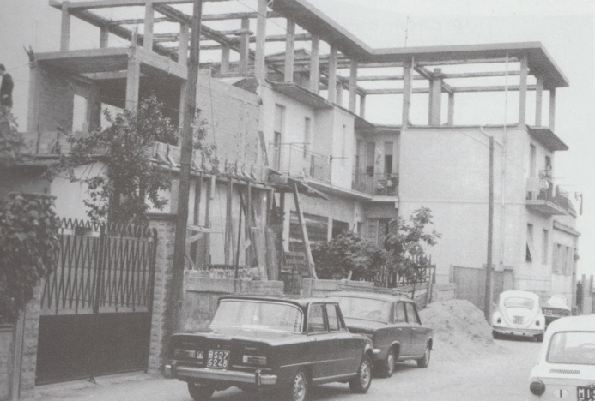

Fig. 3. The extension of a *corea*-house, a permanent non-finito state, 1973.

Courtesy of Piero Airaghi.

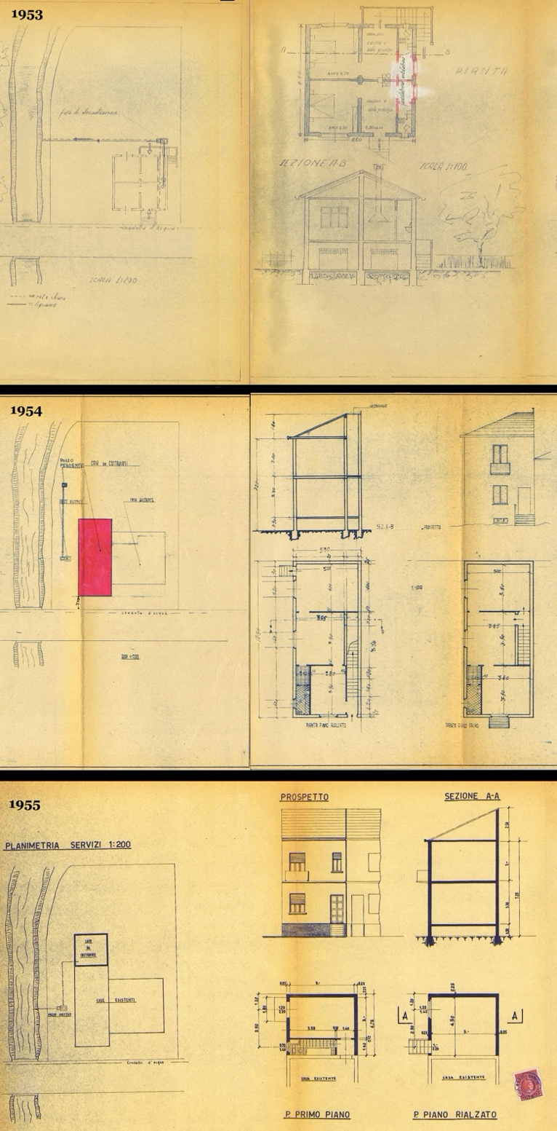

Fig. 4. The evolution of a house in Cerchiarello as an example of the design process in *corea*.

Top: The 1953 plans depict a simple layout of two apartments with two rooms each, providing space for two households. In the process of approval, municipal technicians often stepped in, indicating necessary adjustments. In this case, we can see that the configuration of the bathroom was changed at a later date (red marked walls).

Middle: In 1954, the building application for a first extension was submitted. The file is in the name of the same owner and his brother, who most likely moved to Cerchiarello looking for better opportunities, following a common pattern. This project has been signed by a surveyor, but often the changes were carried out by the users themselves.

Bottom: In 1955, the files for another extension were submitted. A new volume is designed on the back of the first extension, providing storage space on the ground floor and an additional room with a bathroom on the first floor, connected to the existing building.

Courtesy of Archivio Storico del Comune di Pero (archivio aggregato ex Comune di Cerchiate, files 8/1953, 39/1954, 2/1955)

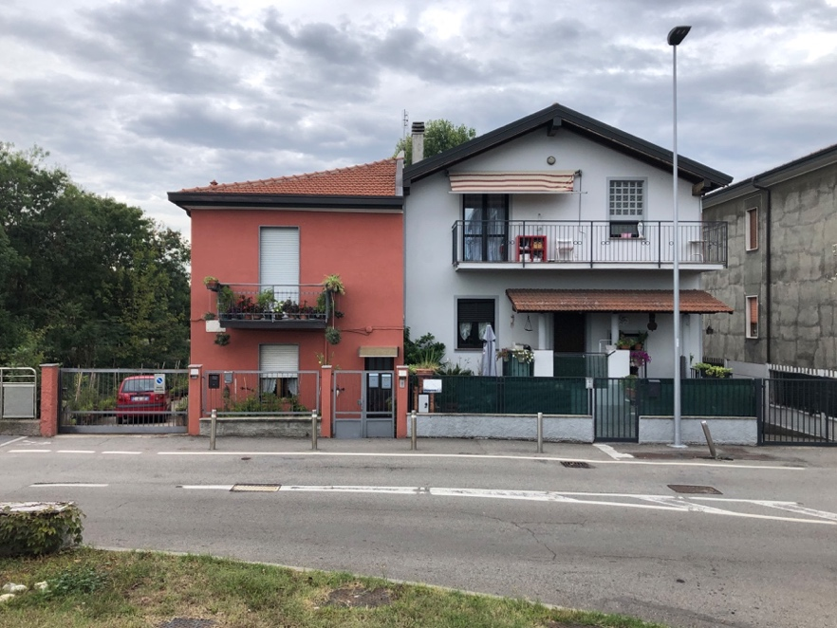

Fig. 5. The two houses from Fig. 3 today. Author photo.

4. Discussion and conclusions

After this initial analysis, *coree* emerge as complex and multifaceted urban structures, continually modified by different actors and processes. As argued by Latour and Yaneva, “architectural design embraces a complex conglomerate of many surprising agencies that are rarely taken into account by architectural theory” (Latour and Yaneva, 2008, p. 86) and practice. Indeed, *coree* were built under the extreme pressure of external circumstances (housing shortages, large scale immigration, loose construction regulations, among others), and their authors deliberately and consciously worked with the external conditions they encountered, translating them directly into architecture. In this light, *coree* can be understood as a modern form of vernacular through their mode, i.e. as the product of users’ expectations, of their expertise, and more generally of the unique conditions of post-World War II Milan, which were reflected in the built environment. The *coree*’s methods (additive, pragmatic, and non-authorial) were fundamentally different from those of “high” architecture: it was possible to continually modify these buildings even after “completion,” making the notion of authorship or originality secondary, as in vernacular architecture. Consequently, *coree* were adept in satisfying the evolving needs and desires of the users, creating unique “fields” of village-like neighbourhoods, homogenous yet differentiated (Foot, 2004).

This study identifies the qualities and highlights of non-authorial and co-produced architecture, using the example of *coree*. The investigation of their modes and characteristics can contribute to the development of practices aimed at making the urban fabric adaptable. Therefore, *coree* are worth further study, especially focusing on the influence of external factors, such traditions, building cultures, and the geographical origin of migrants, on design and construction, while extending the analysis temporally, from the 1960s to the present. In this way, the results of this research could provide a productive basis for discussions of contemporary architectural and urban practice and inspire greater appreciation of non-authorial architecture’s adaptive design methods.

**Contributor statement**

Supervision: Dr. Benedikt Boucsein

Resources: Patrizia Angelone, Piero Airaghi

Writing – Review & Editing: Stephen Starck

**Acknowledgments**

I heartily thank Elif Simge Fettahoğlu-Özgen and Daniel Zwangsleitner for their encouragement and support during the writing of this paper.

References

1. Alasia, F. (1975). *Milano, Corea. Inchiesta sugli immigrati*. Feltrinelli.
2. Banham, R. (1996). A Black Box. The Secret Profession of Architecture. In M. Banham (Ed.), *A Critic Writes: Essays*. University of California Press.
3. Boucsein, B. (2021). What the Files Reveal: Making Everyday Architecture Talk: *Dimensions*, 1(1), 163–172. <https://doi.org/10.14361/dak-2021-0121>
4. Centro Studi PIM. (1963). *Piano Intercomunale Milanese. Modello 25 luglio 1963. Relazione illustrativa allo schema proposto*. Centro Studi PIM.
5. Clarke, A. E. (2005). *Situational Analysis: Grounded Theory after the Postmodern Turn*. SAGE.
6. Diena, L. (1963). *Borgata Milanese*. Franco Angeli.
7. Foot, J. (2002). *Pero: Città d’immigrazione (1950–1970)*. Comune di Pero.
8. Foot, J. (2004). Revisiting the *Coree*. Self-construction, Memory and Immigration on the Milanese Periphery, 1950-2000. In R. Lumley & J. Foot (Eds.), *Italian Cityscapes. Culture and Urban Change in Contemporary Italy* (pp. 46–60). University of Exter Press.
9. Habraken, N. J. (2005). *Palladio’s Children* (J. Teicher, Ed.). Taylor & Francis.
10. Jencks, C. (2000, July 12). *Jencks’ Theory of Evolution: An Overview of 20th Century Architecture*. <https://www.architectural-review.com/archive/jencks-theory-of-evolution-an-overview-of-20th-century-architecture>
11. Latour, B., & Yaneva, A. (2008). “Give Me a Gun and I Will Make All Buildings Move”: An ANT’s View of Architecture. In R. Geiser & U. Staub (Eds.), *Explorations in architecture: Teaching, design, research* (pp. 80–89). Birkhäuser.
12. Lozanovska, M. (2019). *Migrant Housing: Architecture, Dwelling, Migration*. Routledge.
13. Meneghetti, L. (1986). Immigrazione e habitat nell’hinterland milanese: I casi di Bollate, Pero, Rho. In G. Petrillo & A. Scalpelli (Eds.), *Milano Anni Cinquanta* (pp. 251–359). Franco Angeli.
14. Rapoport, A. (1969). *House Form and Culture*. Prentice-Hall.
15. Rudofsky, B. (1995). *Architecture without architects. A short introduction to non-pedigreed architecture*. University of New Mexico Press.
16. Till, J. (2009). *Architecture Depends*. MIT Press.
17. Yaneva, A. (2012). *Mapping Controversies in Architecture*. Ashgate Pub. Co.
18. Zwangsleitner D. (2017, February 7-10*). Using Grounded Theory and Situational Analysis to Fathom the Field of Architecture. A Situational Analysis of the Modell Steiermark* [Paper presentation]. European Congress of Qualitative Inquiry ECQI, Leuven.

1. These settlements were known as *coree* because of their similarity to images appearing from the Korean War in the media in that period.
2. The first documents, including the works by of F. Alasia, D. Montaldi, L. Diena, and the research promoted by the Istituto Lombardo di Scienze Economiche e Sociali (ILSES), were produced during the 1970s and are distinguished by a clear political position, according to which the data and phenomena described are interpreted. During the 1980s, there was an attempt to draw up a historiography of the *coree*, which culminated in the work of John Foot, who described the phenomenon starting from the case study of the municipality of Pero.
3. Cerchiarello is a district of Pero, north-east of Milan, where the population grew dramatically, from 2,000 inhabitants in the 1950s to 10,000 by the early 1970s due to large scale industrialisation and the resulting migration (Foot, 2004).