Type of the Paper: Peer-reviewed Conference Paper / Full Paper
Track title: “Urban-rural Integration” and “Areas In-Between”

The Java Model: A Time-weighted Network Analysis of the Desakota
Neville Mars ¹, Fabien Pfaender ²
¹ Dynamic City Foundation / Mars Architects, Shanghai, China; nevillemars@me.com
² UTSEUS, Shanghai University / Costech EA2223 Université de Technologie de Compiègne; fabien.pfaender@utc.fr; 0000-0001-6338-9058

Names of the track editors:
Alexander Wandl
Rodrigo Cardoso
Names of the reviewers:
Alexander Wandl
Machiel van Dorst
Journal: The Evolving Scholar
DOI:10.24404/6155dbc224a29800097051ff

Submitted: 09 October 2021
Accepted: 01 June 2022
Published: 21 November 2022
Citation: Mars, N. & Pfaender, F. (2021). The Java Model: A Time-weighted Network Analysis of the Desakota. The Evolving Scholar | IFoU 14th Edition.

This work is licensed under a Creative Commons Attribution CC BY (CC BY) license.
©2021 [Mars, N. & Pfaender, F.] published by TU Delft OPEN on behalf of the authors.

Abstract: Peri-urban landscapes present a growing challenge for urban planners. Vast territories that comprise high population densities but few clear centralities erode the epistemological integrity of popular planning models. Meanwhile, as in situ urban-industrial development and top-down planned infrastructures transform these intricate landscapes, both the conceptual and practical challenges augment. Here, geospatial data can provide valuable insights. Network analyses can visualise the transformations within the peri-urban morphology. However, common ‘unweighted’ network graphs don’t reflect operational realities on the ground and thus fail to inform planning strategies. This paper explores combining distance and travel speeds to develop a ‘time-weighted' network model of the desakotas of Central Java. A one-hour travel boundary is introduced to demarcate the study area. Inadvertently, this reveals a regional loop that follows the expanding highway system, which suggests a limited efficacy of toll road developments. In response, this model lays the groundwork to evaluate a typical planning scenario: to build, or not to build a new toll road. The paper concludes that, the complexity of the impact on local communities, landscapes, and the regional ‘accessibility profile’ demands multi-scalar, multifaceted impact analyses to apprise strategic planning.
Keywords: Rural-urban integration, network analysis, Java, GIS, desakota, Indonesia

1. Introduction – data and the desakota
Gliding over the digital map, Java’s density spikes merge to form a thick cloud [Fig. 1]. This abstraction refutes any hard distinctions between city and countryside. Observing the desakota, which is Java’s version of a peri-urban landscape, contemporary urbanity reveals itself as simultaneously dispersed and increasingly tightly networked together. used into a paradoxical rural-urban continuum of global and local systems of urbanisation, Java’s data topography reaffirms the socioeconomic and ontological end of discrete urban nodes on a Cartesian plane, or what used to be simply known as ‘the city.’
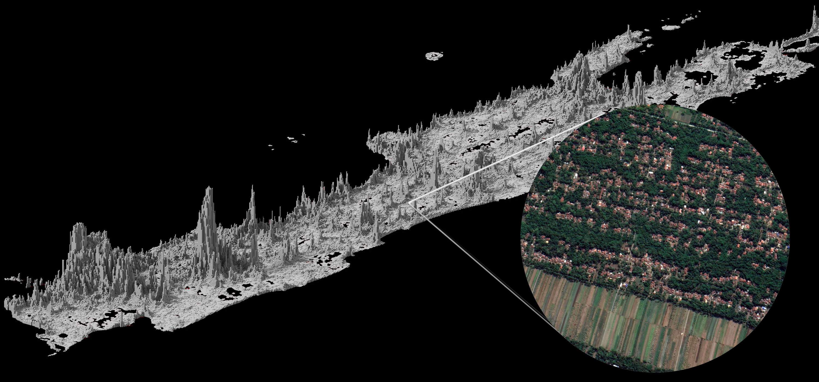
Figure 1.0 Population density map of Java Island. Census 2020. Circle insert: typical desakota striation, north of YIA airport, Central Java.

The concept of the city as a 'seamless whole,’ has expired (DeLanda 2006: 10). As unsurprising as the conceptual death of the city would be to urban theorists, going back to Deleuze, Alexander, and Bateson in the seventies, in recent decades this notion has become dramatically more relevant, notably across Asia’s peri-urban landscapes. This makes Deleuze’s reconceptualisation of the city as an ‘assemblage’ acutely pertinent in its urban fringes, notably of ‘Metro Java,’ i.e. the city cores and ‘extended metro regions.’ Where metropolitan intensities merge with the rhizomatous settlements of the hinterland, the last vestiges of a binary ideology – of urban versus non-urban – are under attack. Rather than urban densities seeping into the spatial void of the city’s imagined counterpart, the countryside, in populated agrarian societies, built-up and densely populated areas invariably merge with the spatial multiplicities of productive landscapes.

Java’s hinterland was never an urban void, not even a casual assemblage. The configurations of the desakota landscape have formed over centuries to systematically follow the variations within the natural geography. A lattice of rural communities continuously interweaves with the topographies of fertile land, fresh water, and forest. Resultant settlement patterns occurred in direct correlation to resource availability. The smallest unit of resource independence can be defined as a landscape ‘module.’ Occurring in a range of different forms, they are the building blocks of Java’s rural habitation. Innumerable modules link together to generate the desakota. In Deleuzian terms, this is a prime example of a “smooth space,” i.e. flexible, generative, and decentralised. Yet, ironically, the resulting morphology that the desakota land use module delivers, visually resembles its counterpart: the “striated space,” characterised by central control, intent, and hierarchy. (Deleuze & Guattari, 1980). The strands of land use types within each module link up to form a striated system of extended functional bands, which, we will argue, are critical to the success of the desakota. Today, however, actual Deleuzian striation is looming large, as nationwide public works are rapidly (and at times crudely) projected across the landscape to reveal a modern, globalised Indonesia by 2045.

These systems of urbanisation, their scales, ideologies, and socio-spatial realities, are polar opposites and their assimilation is often irreconcilable. In light of Indonesia’s rapid transformations, preserving and restoring its rural fabric is a core objective of the “Metro Java 2045” planning project of which this study is a part. The underlying premise is that the desakota’s uninterrupted land use striation can be equated with land use efficiency, sustainability, and even resilience, as defined in Indonesia’s Climate Roadmap (ICCSR).

2. Time-based network analysis

2.1. minute cities
Without significant hierarchies or centralities within its spatial networks, the desakota defies conventional planning logic built around the centre/periphery dichotomy. Yet the planning disciplines still hinge on this withering spatial construct, which in turn underpins other fundamental, yet increasingly contrived, planning polarities: urban/rural, planned/generated, top-down/bottom-up, formal/informal, productive/stagnant, accessible/isolated, development/preservation, and notably, global/local.

As the desakota absorbs all the generic components of a global, neoliberal urbanism, its ‘smooth spaces’ give way to disruptions and emergent hierarchies. Yet, while planning conventions collapse within the sphere of the desakota’s spatial transformations, maturing data technology brings its geospatial analysis within reach.

Spatial datasets allow us to map and analyse Java’s topological landscape within a rural-urban continuum. As the desakota’s spatial structure shifts from a predominantly horizontal ‘field condition’ to incorporate growing spatial hierarchies, its performance remains tied to the topology of mobility corridors and their ensuing land use patterns. Geospatial data allows its network structures to be modelled across scales (i.e., foot and bike paths (1.5m), single lane, and ‘one and a half lane’ roads (3m to 4.5m), trunk roads, and (planned) tollways.

According to Waldo Tobler’s First Law of Geography “everything is related to everything else, but near things are more related than distant things.” Within the socio-spatial and technological context of an urban assemblage, proximity is as much defined by time as it is by distance. ‘Spacetime’ is as much a reality for urbanists, as it is for theoretical physicists. To this end, the network analysis presented in this paper moves beyond common ‘unweighted' graphs to include parameters of distance and travel speed, from which, in turn, a system of travel times can be deduced.

While in recent years time-based planning strategies have become commonplace, in daily practice few models seem to be backed by empirical evidence. Concepts such as the 5/15/30/60-minute city models hold promise to bring critical amenities within (walkable) reach of residential communities. The objective to concentrate urban functions, people and mobility echoes other sustainable planning tropes, such as Transit Oriented Development (TOD), and the ‘compact city' writ large. As an umbrella model, the compact city is one of the theoretical cornerstones of sustainable planning. Its premise is that more condensed populations provide support for high-end public transit, services, and amenities, which in turn shorten commute times, frequency, and trip length, and thus lower energy demand. However, a discipline-wide accepted definition is still lacking (Neuman 2005), while its agenda of ‘ecological development’ perpetuates ‘inherent contradictions’ (Redclift 1987) at the heart of the planning discipline.

Hong Kong is the prototype compact city. It has expanded through hyper compact transit hubs that have kept commuting times reasonable. The desakota’s density (close to 1000 p/km2) is sufficiently high, but Java’s population of around 147.8 million (2020) is too finely dispersed to make the comparison meaningful. Despite this and the persistent epistemological contradictions, the compact city model has, arguably, performed as an ecological imaginary, streamlining efforts across the spectrum of planning specialisms and regions. This imaginary has given rise to a plethora of time-based planning concepts that aim for shared goals of mixed and intensified land use. But for the moment, these concepts, too, lack conceptual coherence and empirical foundation – specifically when applied outside of the West, and within the dispersed conditions of a rural-urban field.

The 15-minute city applies compact city logic to urban renewal. As such, it is reminiscent of 90s “village-in-city” schemes that aimed to disperse the programme throughout the city in order to limit suburb-to-centre mobility needs. As renowned urban planner Alain Bertaud has abundantly argued, this would subvert the very “reason d’être” of the city as a place for a large mobile labor force to congregate, thus improving its citizens’ ability to seek employment and housing opportunities. Edward Glaeser, shares a similar sentiment for the contemporary 15-minute city, calling it “an enclave – a ghetto – a subdivision,” which, he argues, undercuts the city as an archipelago of neighbourhoods, which should foster links between different social territories, as much as within them. But within the context of Java’s desakota, such criticism isn’t quite so obvious. Planned centralities could offer vital amenities and economic opportunity, whilst preventing ribbon developments and pressure on ecologies and intricate road systems.

Accessibility and transit solutions are site-specific. They have to be observed over the long-term and within the local context, through a lens of culture, scale, form, morphology, density, climate, etc. Yet, surprisingly, many global institutions and thought leaders (ADB, WB, Brookings Institution, Joan Close, Parag Khanna) still tend to uncritically equate economic development with road construction. This foregoes the precarious progress/preservation balance that emerging, tropical economies face. The traditional desakota communities were highly autonomous and localised. Their growing dependence on urban economies, tourism, and adoption of urban lifestyles, draws in components of a supra-regional reach. Expansion of infrastructural networks both supports and fuels this trend. In turn, this augments in situ urbanisation and socio-ecological fragmentation. Without significant rural industrialisation or population growth, the force driving land use changes and mobility needs isn’t urbanization, but globalisation.

Roads intersect as much as they connect. Crudely planned infra-corridors vitiate the desakota’s unique landscape striation. The desakota’s relative isolation is both its weakness and its strength. Yet, current development models reveal a bias for highway expansion. Densely populated productive landscapes, typically in monsoon regions, are the world’s dominant form of habitation. Intersecting these rice baskets with highways often presents an obvious choice for policymakers and market actors alike. The boost it gives local economies can be quick and construction easy and profitable. But at a time when grassroots activism has forced inner-city highways to be repurposed, demolished, and their construction blocked, in France, Korea, and India, respectively, investigating viable alternatives for the desakota and other peri-urban landscapes, reflects a global urgency.

2.2. Arborescence
Java’s island-wide tollway construction is part of a national planning project. Their accelerated emergence, driven by an unofficial objective to match Western level road densities by 2045, could be interpreted as Indonesia merely ‘catching up with the world’ – infrastructurally and, consequently, economically. For the study area, this presents a total road surface of 873 km² and a relatively high land coverage of 5%. Distribution by road level is, however, unequal, with residential and tertiary roads accounting for 806 km², while secondary and primary roads account for only 35 km², and 13 km² for trunk and highways. The bulk are municipal level roads (11% national, 11% provincial, 78% municipal, as of 2001) and of relatively poor condition. However, we aim to illustrate that in order to make such comparisons, the morphology of the network is a paramount consideration. Java’s developmental pathway is unlike western European countries, and certainly unlike today’s juggernaut of highway construction, China. In general terms, the former gradually strengthened their historical trade routes to connect Europe’s compact urban cores with bundled transit corridors, while the latter is well underway to project a universal road grid onto its landscape. They represent two extremes of highway development: the arborescent structure of a gradually maturing transit plexus, versus the uniform lattice of a built-from-scratch grid system.

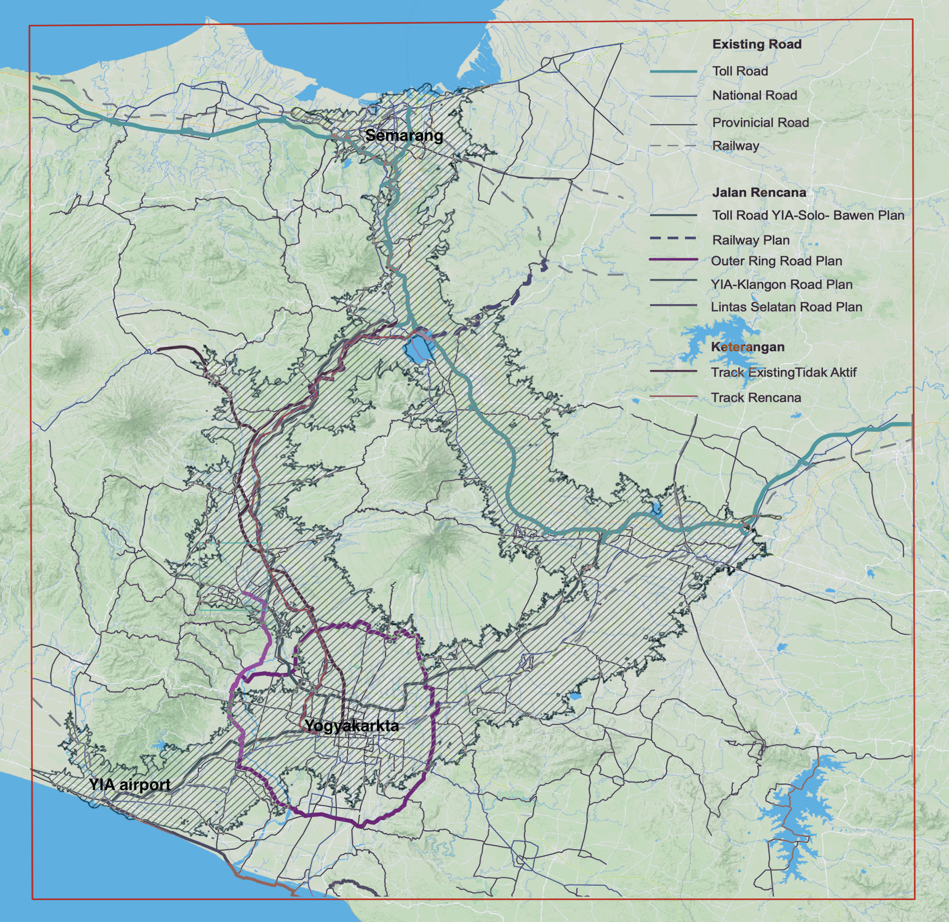
It seems unreasonable, however, to categorise Java’s road-network-in-transition as either one. The filigrain system of foot- and motorbike paths have served the desakota for decennia. Despite its high population densities, the homogeneous dispersion and localisation of activities allowed the network to function without forging much hierarchy. The desakota’s landscape modules tessellate across the plane in an organic tiling, incorporating connections where needed. In this system, a tollroad is neither an upgrade nor an emergent system, but a wholly novel entity, comprised of its own scale, speed, and space, which will induce its own socioeconomic, ecological, and network dynamics.

Figure 2.0 Study area of 130 x 130 km (red), and the one-hour travel envelope (black).

3. The one-hour city: framing a network analysis of Central Java

3.1. Green edge
Data-driven analyses have begun to unveil the innate complexities of peri-urban landscapes. However, operating within the vast expanse of Central Java’s hinterland presents a technical challenge: how can the boundaries of its geospatial analysis be demarcated? This question echoes the predicaments planners face when setting urban growth boundaries within the context of scattered and evolving cityscapes. From a performance and user perspective, Bertaud argues, one hour is a cut-off point for a “reasonable” commute. However, applied to large urban regions, with many inaccessible pockets, this presents a muddled accessibility profile. Conversely, we have contended that precisely within vast, decentralised urban networks, a ‘one-hour city’ concept can offer clarity as to where – and where not – to develop (Mars, Hornsby 2008), delineating a mobility based ‘green edge,’ instead of an arbitrary urban growth boundary. We’ve applied a similar time-based constraint to delineate our analysis of Central Java’s rural road system.

3.2. Polar opposite
Within the 130 x 130 km Central Java study area [Figure 2.0] two main urban centres cast their influence over the hinterland. A green edge can be simulated that encapsulates the polar structure of the regional corridors. Steadily, the national roads are upgraded to form a loop of tollways, with the volcano of Merapi Mountain at their centre. This simple structure offers an ideal framework to observe the transitions of the region’s accessibility profile, i.e. the impact of new toll roads on travel times, which can inform planning decisions. However, the model’s simplicity proved misleading, as it obscures the study area’s complex internal organisation, while proving technically challenging, as it seems this approaches the largest area current data analysis can adequately sustain before upsetting viability thresholds.

3.4. Describing the one-hour corridor
The one-hour city model simulates a space of 30-minute access on either side of the national highway and tollway loop. The resultant envelope is a single, undifferentiated entity of a one-hour commute from edge to nearest edge, perpendicular to the highways at its centre [figure 2.0]. This envelope can be defined using a precise geospatial methodology. The raw data is derived from OpenStreetMap (OSM). Cropped to our 130 x 130 km frame, this dataset of 2gb, provides the basis of a 4-steps adjustment process that ultimately yields the one-hour envelope.

Value of the highway tag | level
services, bus, busway, bus_guideway, access, bus_stop, via_ferrata, access_ramp, emergency_access_point, emergency_bay, service, footway, traffic_island, virtual, cyleway, cycleway, byway, path, track, pedestrian, steps, platform, bridleway, rest_area, escape, footway | 2
residential, yes, unclassified, crossing, unknown, bridge, lane, ford, psv, living_street, alley | 3
tertiary, tertiary_link, turning_circle, road, roundabout, ice_road | 4
secondary, secondary_link | 5
primary, primary_link | 6
trunk, trunk_link | 7
motorway, motorway_link, ramp | 8

Table 1.0 Overview of road levels 2 to 8 and the descriptions of the types they contain.

The first transformation distills the roads from the OSM map dataset, which include a variety of other geographic qualifiers not applicable to this analysis. However, currently only a few distillation tools can handle the large size of this dataset. We’ve applied the parser library policosm in Python language, developed specifically for such an operation. It does so by scanning the map and selecting connections with the tag ‘highway.’ This tag can be associated with a multitude of values, so we have introduced a system to reduce this variety to seven grades, as defined in Reference Table 1.

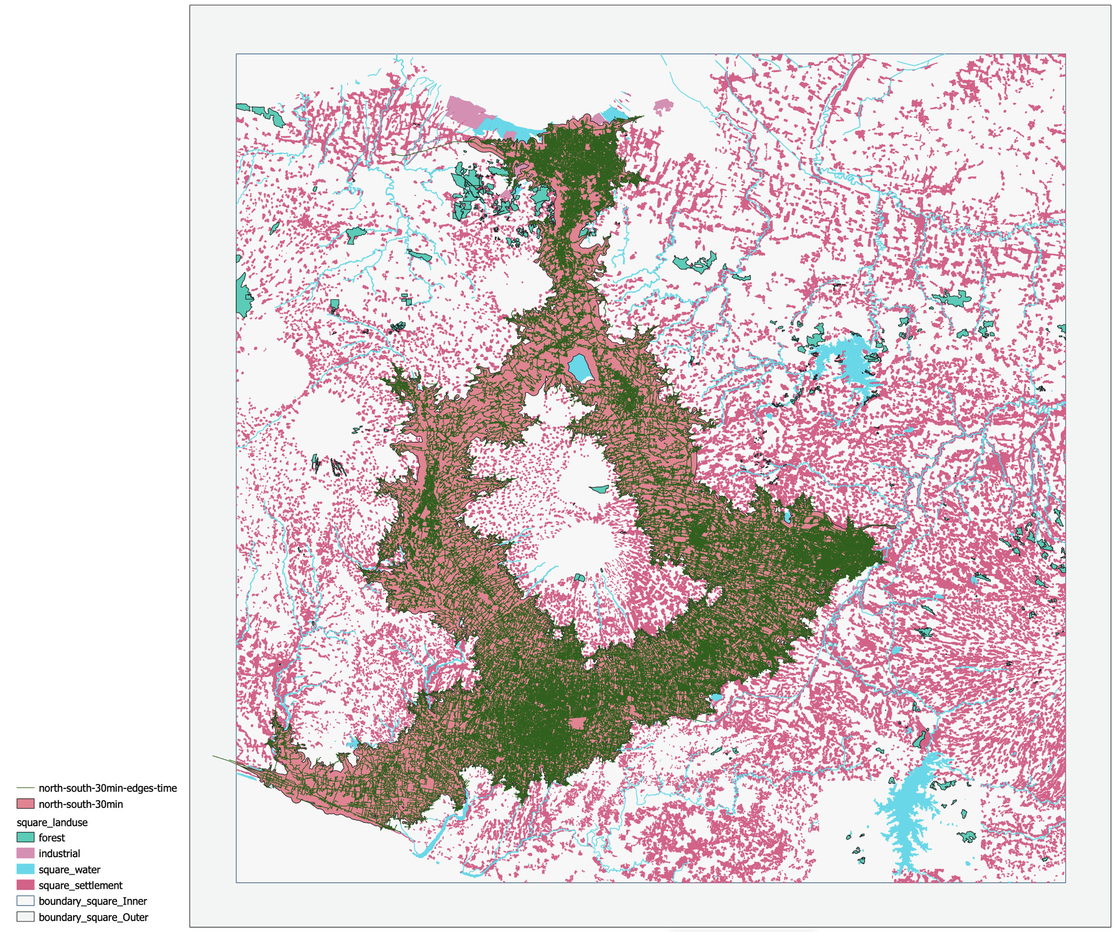
From here, the algorithm builds the network out, translating each point along the way as two vertices joined by an edge. At this stage, the roads are represented in a uniform graph. The second transformation is to refine the road network. However, the network contains too many vertices and edges for standard network algorithms to perform operations, such as a routing or centralities assessment, in a finite time. Therefore, simplifying the network while retaining its spatial information is critical in this process.

Figure 3.0 One-hour envelope projected onto settlement patterns of Central Java

The third transformation is to crop the 130 x 130 km area to create the corridor, or spatial envelope. This operation starts with establishing a series of anchor points throughout the area running from Semarang to Yogyakarta airport, in a loop encircling the volcano. [Figure 3.0] The anchor points are geographic tethers; once attached, the set of 17 anchors points are joined using a routing shortest path search weighed in time.

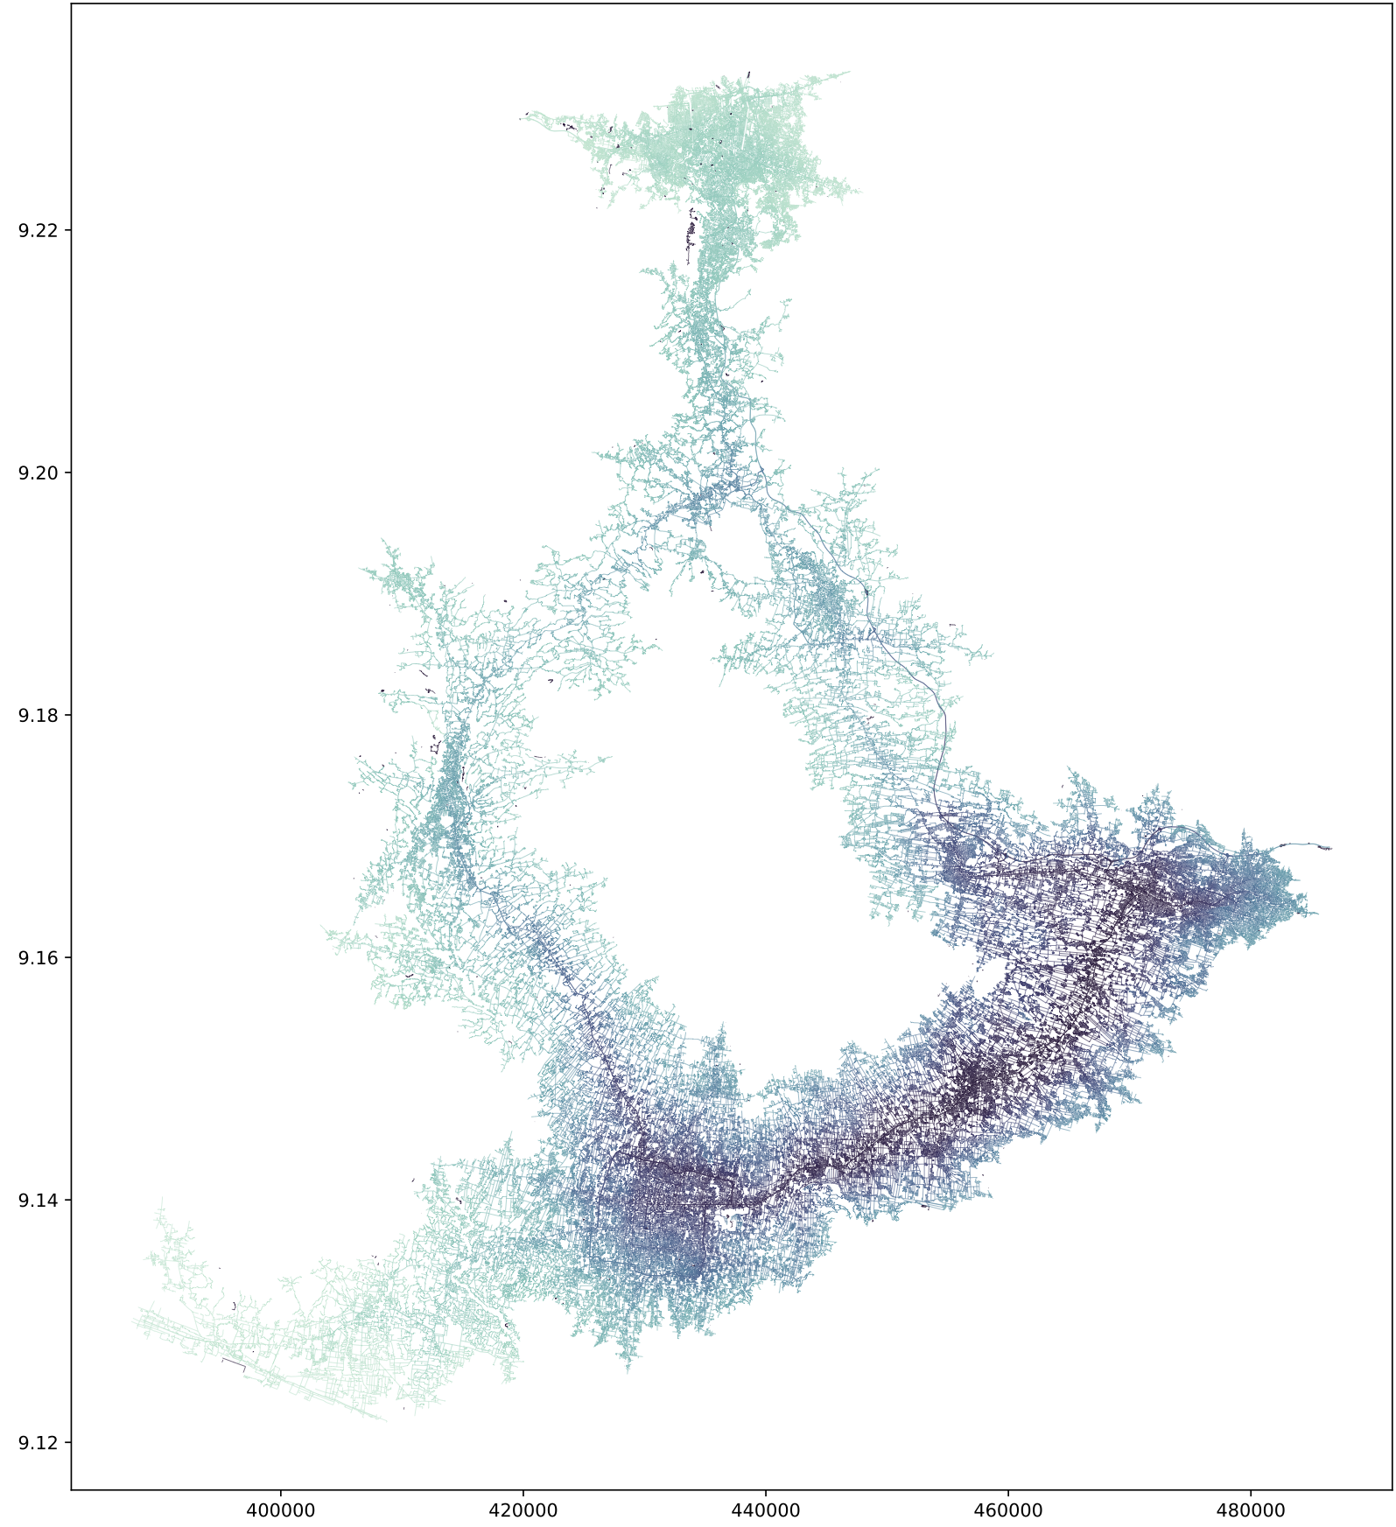
The time factor itself is a specific feature added to every edge corresponding to its geographical length (in metres, projection UTM zone 49S), multiplied by the speed observed on such edges, effectively ranging from 10KPH to 38KPH (Munawar 2011). The routing algorithm then generates a path that minimises the commute between each pair of successive anchor points. This delivers the basic network skeleton. From this skeleton, the one-hour corridor is simulated. The routing algorithm is employed once again, now weighted for time. For the corridor, the idea is to create a sub-network, or 'isochrone tree,’ from each of the 812 vertices of the backbone expending a maximal 30 min. travel time. These 812 branches create the time threshold, which are merged within a global network. This produces the final network dataset. The fourth transformation attributes an envelope to this one-hour corridor. It does so by creating a concave hull around each of the 812 tree-shaped networks and performing a 'unary union’ at each of them.

Figure 4.0 Closeness centrality ranging from 0 light blue to 1 dark purple.

4. Exploratory interpretation of the network data

This arduous process allows us to observe a more complete picture of the dense, singular network serving the desakota. Comparisons between travel time and travel distance, either using or avoiding the highway corridor, can now be made for the commute between any two points within the one-hour city loop.

The particularities embedded within the desakota, as described in the introduction, begin to reveal themselves – specifically its decentralised and dispersed structure. The visualisation itself validates our initial assumption that data analysis can offer a means to collaborate on conceptual problems, such as time-based planning models, and assess concrete spatial strategies.

As an initial stress-test of the intended cross-disciplinary dialogue, we have performed two simple experiments using two centrality measures commonly used in graph theory (Porta 2010). Both centralities are based on ‘shortest path’ computation on the 367,000 edges within this network, which in this model is computationally intensive for the graph-tool library (Peixoto 2014). The shortest path minimises the sum of the weight (in our case, time-distance) between two vertices, calculated for the centrality measure for every pair on the graph.

4.1. Closeness centrality

Closeness centrality reflects how close a vertex is to all the other vertices on the graph, i.e. the sum of the distance weight of all the shortest paths between one vertex and all the other vertices on the graph. The rendered outcome is presented in Figure 4.0

The higher (darker) values of the closeness centralities appear on the south east side of the network, with the exception of the backbone, i.e. the highways and tollways. This centrality is sensitive to how many vertices are in close vicinity with one another; in our one-hour model, this is highlighted in the south-east region. All vertices in this area are close to each other, forming an almost ‘optimal’ lattice. In norther part of Semarang, the network is also dense, so closeness centrality is expected to be higher. However, this is not the case as transit systems within the city are more hierarchical, thus, closeness reveals that only a few corridors connect many destinations. Conversely, a lattice-like network with few hierarchies brings all vertices close to each other in a non-hierarchical manner. This reveals that multiple destinations can be reached via multiple connectors without a significant drop in travel time. This rendering suggests that the villages can exchange across this vast area time efficiently, without relying on one specific set of connections where traffic would subsequently concentrate.

4.2. Betweenness centrality
To build on this idea, we have chosen to implement a ‘betweenness centrality’ algorithm, weighted again with distance as a factor of travel time between vertices A and B. This centrality is different from proximity, as instead of measuring how close each vertex is to all the others, it measures how many of the shortest paths from all vertices to all other vertices pass through each edge. The edges with a high betweenness score are more likely to get traffic. In a hierarchical city, the betweenness is usually found at cities’ main arteries, such as trunk or primary roads, or bridges. The outcome of betweenness centrality is visualised in Figure 5.0.

The betweenness in the figure has been filtered from the highest values. The reason for this is that the edges from the backbone have been obtained using the shortest path method, so their betweenness score eclipses the complexity of the underlying lower betweenness values. To remove the higher values, we simply remove one per thousand of the highest values. The betweenness values in the network highlight a distinct difference between the urban city situation, where the edges are very dense, and the desakota, where edges are less dense.

In cities, this centrality is not very helpful as they are more hierarchical structures. Removing the main travel routes result in tiny sparks of high betweenness on secondary and tertiary roads that hold no real value. The desakota structure, on the other hand, shows longer paths of high betweenness, spread among its vicinity, indicating a village-to-village favoured path with fewer low values (in yellow and green in Figure 5.0).

The combination of fewer low values and a high closeness indicates an optimisation of the land, where each connection is valuable, serving as a support for traffic with fewer additional options. The optimal network centralities observed here are a good indication of the practical benefits of the desakota in this specific rural-urban structure that may hold the key to sustainable densification.
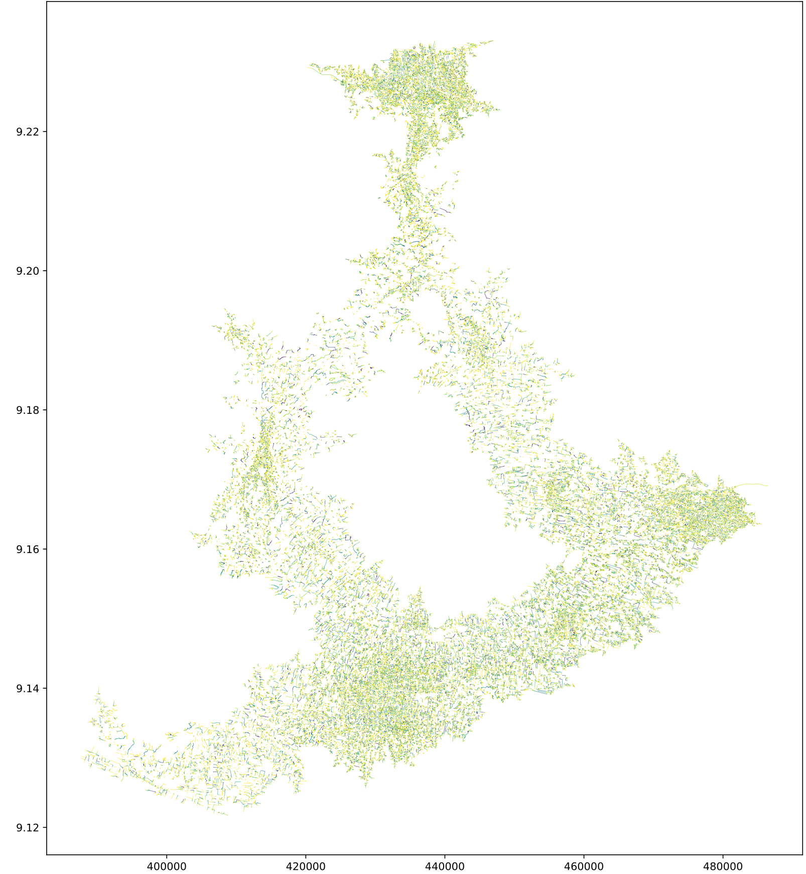

Figure 5.0 Betweenness centrality of the network edges are thresholded for the highest values as to let the lower structure appear. (Yellow is low, Blue is high).

5. Planning scenario and dialogue

5.1. Fait accompli
A reflexive process is elementary to urban planning. Feedback should be garnered at all stages of a project, and from all stakeholders. Though this principle isn’t really disputed, it is not often implemented. Precisely in regions where planning conditions are most challenging, and development projects would benefit most from critical evaluation, time and resources tend to fall short. In large countries with complex power structures such as Indonesia, implementing a long-term supra-regional planning vision is a particularly painstaking and largely opaque process. Decisions that have been made will, therefore, not soon be overturned, or indeed critically discussed in the public domain. Tollway expansions in Central Java that have received a green light, are in effect a fait accompli.

Nevertheless, with thousands of kilometres of new infrastructure on the agenda nationwide for 2045, the transformations of Central Java should serve as a valuable case study. As its highways are rolled out to create better access for tourism in culturally significant locations, such as to the Borobudur, there seems to be a broad consensus among local experts that this must be done sensibly. What this means, however, or how to achieve this – i.e. building elevated highways, fewer on and off ramps, tunnelling – remains to be seen. What is clear, as many have argued before us, is that the desakota is foremost a fragile heritage landscape. The success of the region will be rooted in the success of its rural communities, which in turn remains reliant on the integrity of the village-landscape modules linking up to form the desakota. This underscores that spatial visions for the region cannot be orchestrated through central planning alone. Decisions on highway development should be based on an holistic assessment, informed by a combination of observation, local input, and objective data points. Herein lies a challenge.

Operating with the luxury of a long-term perspective – anticipating the advent of new technologies and other societal shifts – allows us to believe alternative development models are feasible. Such models localise resource flows (i.e., smart grids), and will allow remote communities to virtually tap into global information flows (i.e., e-learning, e-healthcare, e-commerce), but also new agro-logistic hubs and other design initiatives, to be developed in the next phase of the Metro Java 2045 project. These are regional planning projects which do not put further strain on existing road networks.

6. Conclusions

In contrast to the radial accessibility profiles that form around public transit nodes, the one-hour envelope we have modelled, portrays the desakotas of Central Java as a single ~250km long linear city. The operational direction of this loop, however, functions as much along the highways, as it does perpendicular to them. The tollways within the envelope represent progress and, as the simulations indicate, a new centrality. Yet, this is a centrality that is paradoxically void of urban programme. This contrast suggests that the emergent hybrid landscape of this region is a product of the collisions between two urban configurations: tree and tessellation – the respective products of two disparates forms of urbanism, local and global. The models suggest there is no significant difference in accessibility between sections with national roads or tollways. It can be deduced, however, that cross-regional movement is more efficient along newer highways, at least where there is quick access to on and off ramps. Conversely, the models suggest that if new tollways dissect local networks, this can greatly impede local movements, or village-to-village connectivity. Where this may happen precisely requires more research. Ultimately, however, the long-term mobility needs (of people and goods) must be better understood in order to optimise the efficacy of Central Java’s emergent hybrid network. This requires a deeper understanding of the conflict between ideologies representing progress and preservation, of global and local systems of urbanisation and how these dichotomies are exacerbated by a gap between urban theory and planning practice.

Data Availability Statement
Global Land Analysis & Discovery (https://glad.umd.edu/dataset/global-2010-tree-cover-30-m) (Hansen et al., 2013)
OCHA Services (https://data.humdata.org/dataset/worldpop-population-counts-for-indonesia)
EEA (https://www.eea.europa.eu/data-and-maps/data/world-digital-elevation-model-etopo5)

Contributor statement
Initiator: Neville Mars
Data Curation: Fabien Pfaender
Formal Analysis: Fabien Pfaender
Investigation: Fabien Pfaender, Yeeun Boo, Harshitha Mruthyunjaya, Neville Mars
Methodology: Fabien Pfaender, Neville Mars
Visualization: Fabien Pfaender
Writing: Neville Mars, Fabien Pfaender
Editing: Eva-Mae Brazil

Acknowledgments
This study is part of a 3 year planning project by: MARS Architects/Dynamic City Foundation + Krill o.r.c.a., with UNDIP, Gajah Mada University, with support from Yogyakarta Heritage Society and the Ministry of Transportation of Indonesia. With generous support by the EFL Stichting and the Dutch Creative Industries Fund. For periodical updates: www.MetroJava2045.org.

References

Deleuze, G., & Guattari, F. (1980). A Thousand Plateaus: Capitalism and Schizophrenia. Paris: Les Éditions de Minuit.
Munawar, (2011) A. Speed and Capacity for Urban Roads, Indonesian Experience. Procedia - Soc Behav Sci 16, 382–387.
Porta, S., Latora, (2010) V. & Strano, E. Network Science, Complexity in Nature and Technology. 107–129 doi:10.1007/978-1-84996-396-1_6.
Wood, J. W. (2020) The Biodemography of Subsistence Farming, Population, Food and Family. Part of Cambridge Studies in Biological and Evolutionary Anthropology., Pennsylvania State University, June
Cairns, S. (2002). Troubling Real Estate: Reflecting on Urban Form in Southeast Asia. In 910888161 716897344 T. Bunnell, 910888162 716897344 L. B. Drummond, &amp; 910888163 716897344 K. Ho (Authors), Critical Reflections on Cities in Southeast Asia (p. 118). Singapore: Times Academic in association with Brill Academic.
Ahmadzai, F., Rao, K.M.L., Ulfat, S. (2019) Assessment and Modelling of Urban Road Networks Using Integrated Graph of Natural Road Network (a GIS-based approach), Journal of Urban Management, Volume 8, Issue 1, Pages 109–125, https://doi.org/10.1016/j.jum.2018.11.001.
Rui, Y., & Ban, Y. (2011). Urban Growth Modeling with Road Network Expansion and Land Use Development. In Advances in Cartography and GIScience. Volume 2 (pp. 399–412). Springer, Berlin, Heidelberg.
Tunas, D., (2019). Flows are Defined by an Interdependence of Between Economic Principles of Exchange and Their Enabling Infrastructures in Archipelago Cities: Planning Beyond Urban Boundaries, Social Urban Spatial Correlation (Harvey 1989; Lefebvre 1991)
Peixoto, T. P., (2014) “The Graph-Tool Python Library,” figshare. DOI: 10.6084/m9.figshare.1164194 [sci-hub, @tor]

Desakota is a peri-urban landscape typology of Java Island. The term, coined by Terrence McGee, is an agglutination of the words ‘desa’ (village) and ‘kota’ (city) used to describe the growth and features of areas of mixed urban and agricultural activities that characterise the previously rural hinterlands of many of the rapidly expanding urban centers of the developing world in a new era of ‘planetary urbanization.’ ” McGee T.G. (2017) The Sustainability of Extended Urban Spaces in Asia in the Twenty-First Century: Policy and Research Challenges. [In: Yokohari M., Murakami A., Hara Y., Tsuchiya K. (eds) Sustainable Landscape Planning in Selected Urban Regions. Science for Sustainable Societies. Springer, Tokyo.]
Vast territories notably in India, China, and Indonesia that constitute a hybrid landscape typology characterised by (fragments of) urbanisation dominating vast rural settings. Here it spawns urban functions and micro centralities, without clear dependencies to nearby urban cores. Lacking contiguity, urban density, and centrality, yet integrated with the urban economies that surround it, the rural//urban field defies common notions of city. The Chinese Dream – a society under construction. Lexicon. N. Mars, A. Hornsby. 010 Publishers, Rotterdam 2008.
EMRs, or mega urban regions, such as JABOTABEK are driving much of Java’s urban development (T. Firman et al., 2008).
A second paper of Metro Java 2045 charts these land use modules. “A Cluster-based Land Use Taxonomy for Central Java.” Boo Y., Mars, N.
A Thousand Plateaus: Capitalism and Schizophrenia, p. 474, Gilles Deleuze, Félix Guattari, “Mille Plateaux,” Les Éditions de Minuit, 1980.
www.MetroJava2045.org
How Markets Shape Cities. Bertaud, A. 2018 MIT Press.
The 15-minute city is a dead end — cities must be places of opportunity for everyone. LSE conference: The 15-Minute City. May 28th, 2021. https://blogs.lse.ac.uk/covid19/2021/05/28/the-15-minute-city-is-a-dead-end-cities-must-be-places-of-opportunity-for-everyone/
As Former Executive Director of the United Nations Human Settlements Programme Dr. Joan Clos argues at UNH III, Quito, 2016.
Connectography – Mapping the Future of Global Civilisation. Khanna, P. 2016 Penguin Random House.
Meijer JR, Huijbregts MAJ, Schotten KCGJ, and Schipper AM. 2018. Global Patterns of Current and Future Road Infrastructure. Environmental Research Letters 13: 064006. http://www.globio.info/download-grip-dataset
BPS Kabupaten Magelang. 2020. Kabupaten Magelang Dalam Angka 2020. Magelang
For reference, France and the USA have built 0.017 ha/capita road surface (1.9% of its land surface) and 0.057 ha/capita road surface (1.7% of its land surface), respectively.
Indonesia Road Sector Development. Junoasmono T. Deputy Director of Planning Integration and Network System Directorate General of Highways, 2015
In the north, Semarang, tethered to the east-west trans-Java expressway (AH2), and in the south, Yogyakarta, with the new airport (YIA) and ancient Borobudur as major anchor points. On the east side the National toll road 14 (Jalan Tol Ciledug — Pejagan), and on west side the National Road 15 (Jalan Jogja - Solo).
https://zenodo.org/record/1478235
http://metrojava2045.org/roadmap-borobudur/
http://jogjaheritagesociety.org

