Type of the Paper: Peer-reviewed Conference Paper/ Short Paper
Track title: the city is an object and a city is in transition

From Border to Interface: Evaluating the Design Strategies in the Regeneration of Industrial Heritage Projects in Shanghai from the Perspective of Public Space - Public Life
Yifan Dong ¹, Jingwen Gan ² and Huaqing Huang ^{3,}*
Names of the track editors:
Birgit Hausleitner
Leo van den Burg
Akkelies van Nes
Names of the reviewers:
Leo van den Burg
Maurice Harteveld
Journal: The Evolving Scholar

DOI:10.24404/615f349248285c0008e6a270

Submitted: 07 October 2021
Accepted: 01 June 2022
Published: 24 August 2022
Citation: Dong, Y., Gan, J. & Huang, H. (2021). From Border to Interface: Evaluating the Design Strategies in the Regeneration of Industrial Heritage Projects in Shanghai from the Perspective of Public Space - Public Life. The Evolving Scholar | IFoU 14th Edition.

This work is licensed under a Creative Commons Attribution CC BY-ND (CC BY-ND) license.
©2021 [Dong, Y., Gan, J. & Huang, H.] published by TU Delft OPEN on behalf of the authors.

¹ Nanjing University; yetfundong@gmail.com
² Nanjing University; hriegan@gmail.com
³ Shanghai Jiao Tong University; huanghq@sjtu.edu.cn

Research highlights
1) Diagrammatic analysis is used to reveal certain invisible pattern between pedestrian’s behaviors and architectural interfaces.
2) Tracking study based on Public Space – Public Life theory is adopted as the main research method.
3) Effective design guidelines of architectural interface are concluded as reference for future projects of industrial heritage regeneration.
Keywords: urban renewal; regeneration of industrial heritage; architectural interface; public space – public life

1. Introduction
Since the 1990s, Chinese cities have entered a phase dominated by regeneration and redevelopment (Wang, & Jiang, 2006). With the gradual decline of traditional industries and the ongoing socio-economic transformation, the regeneration of industrial heritages has been increasingly recognised as a significant and urgent topic in the agenda of urban renewal, especially in a modernist functional mega-city with a strong industrial background like Shanghai. Since 2002, Shanghai has started the regeneration of historical industrial areas alongside the Huangpu River with the goal of transforming the closed river banks into open public space by 2035 (Zhang, & Zhang, & Zhang, Qin, 2019). The industrial buildings in these areas, on the one hand, recall the old industrial memory of the city, while on the other hand, act as heterogeneous and isolative patches in the waterfront urban fabric due to their oversized volumes and rigidly closed borders. As Christopher Alexander believes – “The machine-like building is cut off from its surroundings, isolated, an island. The building with a lively building edge is connected, part of the social fabric, part of the town, part of the lives of all the people who live and move around it . . .” (Alexander, 1979, p.754). In the case of the regeneration of industrial heritages, in order to turn the enclosed objects into open space without altering their distinctive monolithic volumes, the design strategy of border space is especially worth concerning.

By the end of 2017, 45km of waterfront public space on both sides of the Huangpu River had been connected, and a significant portion of the waterfront industrial heritages have been renovated at both architectural and functional levels. They provide numerous cases for evaluating the effectiveness of interface design strategies. Based on Jan Gehl’s Public Space – Public Life (PSPL) research method, this paper uses the classic tracking study in the PSPL tools to survey the selected cases. Furthermore, new analysis and representation methods are proposed to reveal the patterns between the interface of the renovated building and the pedestrians’ behavior. In conclusion, effective design guidelines of transforming “border to interface” on an urban scale are summarised as reference for future projects of industrial heritage regeneration.

2. Theories and Methods

2.1. Research method: Public Space – Public Life (PSPL)
Classic PSPL tools focus on direct observation, and the survey data are suggested to be presented and interpreted as simple charts & graphs (Gehl Institute, 2020). For example, in the study of public life along different ground floor facades in Copenhagen, a bar chart was presented to compare the frequency of spontaneous behaviors of pedestrians through different types of facades, which leads to research conclusions (Gehl, & Kaefer, & Reigstad, 2006). Without a systematic approach to analysis, such a PSPL survey does not allow for a more comprehensive analysis of a larger sample size.

In the evaluation of the prototype toolkit of observation, the Gehl Institute looks to the next step of “correlating public life data with other qualitative place-data such as public space quality criteria” (Gehl Institute, 2016), bringing inspiration for the methodological improvements in this paper: a new analytical method, the point-line-plane framework, systematically expands the scope of the subject in the PSPL from a planar mapping to a three-dimensional space, and is directly related to the evaluation criteria for the architectural interfaces; a new representation method, the behavioral heat map, improves the presentation of public life data by processing the data in a computerised way. Complemented by these two, the PSPL method can facilitate researchers to visually establish the interrelations between the physical environment and behavioral data.

PSPL includes “contemporary tools that can be applied analytically to once again forge an alliance between life and space in cities” (Gehl, & Svarre, 2013). There are tools such as counting, mapping, tracking, etc. In this research, in view of the rambling nature of the Three Belt (Zhang, & Zhang, & Zhang, Qin, 2019) in which selected cases located, a tracking study in the PSPL toolbox is used.

According to Jan Gehl, in low-quality outdoor space, only necessary activities take place, but in high-quality outdoor space, despite the probability of necessary activity is unchanged in general, the duration of them has a tendency to extend and spontaneous behaviors ensue (Gehl, 1987). Thus, the walking speed is taken as the indicator of the overall effectiveness of the interface and spontaneous behaviors including turning head to look at the building, heading up to look at the building, staying somewhere near the architectural interface, and taking photos are recorded to reflect the quality of the interface more subtly.

2.2. Analytical method: point-line-plane framework
In order to analyse the relationship between the interface and the behavioral data, the interface need to be extracted into architectural components. Referring to the idea of imageability proposed by Kevin Lynch – the “quality in a physical object which gives it a high probability of evoking a strong image in any given observer” (Lynch, 1964), we extracted five components from the perspective of ordinary pedestrians’ observation. Furthermore, these components are classified into three geometric categories – point, line, and plane (Table 1).
Table 1. Components of architectural interface
Category | Components | Description
Point | Landmark | Extremely prominent object, especially the exposed old industrial mechanical construction
 | Entrance | Entrance for the public
Line | Transparent enclosure | -
 | Opaque enclosure | -
Plane | Semi-outdoor space | -
 | Slope | Ramps and grand stairs that open to the public

2.3. Representation method: behavioral heat map
After the tracking study, the spots where different spontaneous behaviors take place are overlaid on the masterplan of selected cases, and according to the density of the spots, heat maps of pedestrian behaviors are obtained.

With the abstract model of interface based on the point-line-plane framework, the heat maps can thus reveal certain invisible patterns between pedestrian behaviors and the architectural interface. As a result, effective strategies of interface design are concluded at the morphological level.

3. Results

3.1. Case study
This paper conducts detailed field research on three projects, namely Yicang Modern Art Museum (MAM), 1862 Old Shipyard (Mifa), and Green Hill (GH), which all share the problems of oversized volumes and closed borders commonly found in industrial buildings (Figure 1).

The tracking studies were carried out between 4pm and 6pm on fine autumn days. For each building interface in the selected cases, 200 pedestrians were randomly followed, whose behaviors were recorded on their path and walking speed was measured (Table 2). In addition, a section of the waterfront walkway connecting the building interface was selected to measure the pedestrian’s walking speed as a comparison.
Table 2. Pedestrians’ average walking speed of passing through different interfaces
 | MAM |  | Mifa |  | GH
 | Length/m | Average Speed/m*s⁻¹ | Length/m | Average Speed/m*s⁻¹ | Length/m | Average Speed/m*s⁻¹
Interface connected to the waterfront walkway | 93.0 | 0.978 | 200.0 | 0.913 | 46.8 | 0.919
Interface perpendicular to the waterfront walkway | 38.4 | 0.959 | 44.5 | 0.915 | 36.6 | 1.027
Interface facing the city | 112.3 | 1.039 | 200.0 | 1.172 | 36.6 | 1.148
Comparison section | 54.4 | 1.114 | 45.5 | 1.088 | 27.8 | 0.996

3.2. Result analysis
Based on the point-line-plane framework, abstract composition models of the three cases are extracted (Figure 2). Meanwhile, behavioral heat maps were made based on four types of pedestrian behaviors on passing through the building interfaces (Figure 3). Combining the heat maps, the walking speed data and the interface composition, some patterns between the interface components and the impact of the interface were summarised.

- The influence of point-like elements is closely linked to a comfortable field of vision.
“Our sense of sight is well developed straight ahead and to the sides . . . But of the world above us, we see very little.” (Gehl, 2006, p.32). The heat map of Mifa confirms this. Comparing Figure 3. b-2 with Figure 3. c-2, when walking on the waterfront walkway adjacent to the building interface, people are more interested in the first level of the interface, especially the entrances, than the industrial-looking landmark high above them. For GH, comparing Figure 3. b-3 with Figure 3. c-3, the landmark on the higher level is also attractive as the ground floor interface due to the receding building form (Figure 2. c) which makes it visible to pedestrians when approaching the interface by raising their eyes slightly along the building setback.

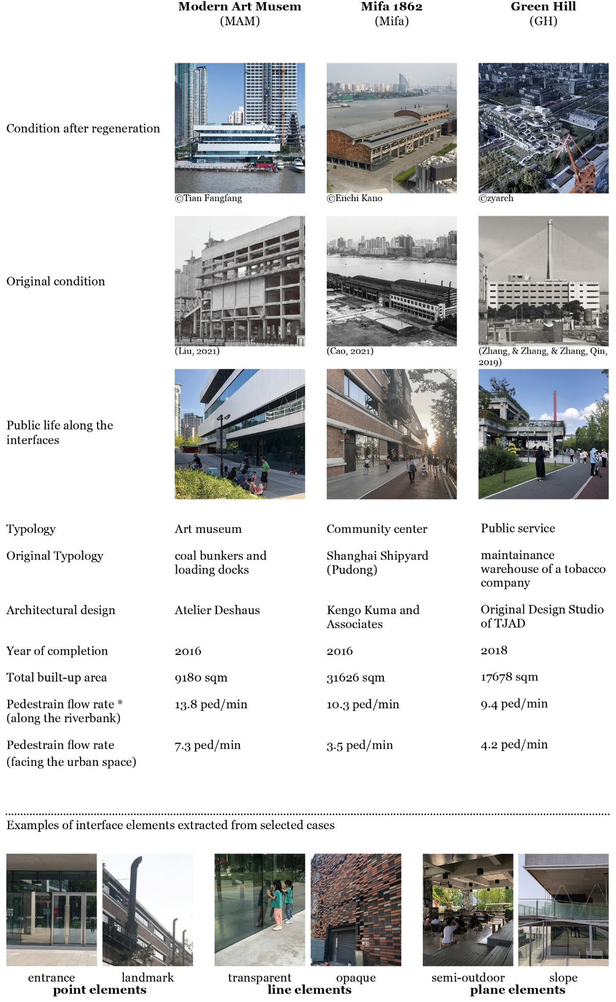
Figure 1. Basic information of selected cases
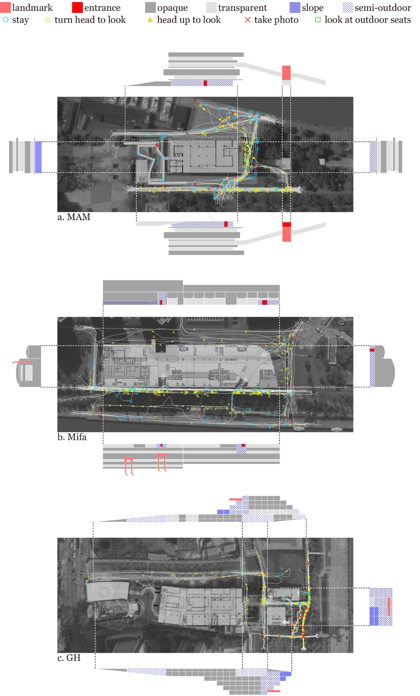
Figure 2. Composition of interface based on the point-line-plane framework and the path of pedestrians
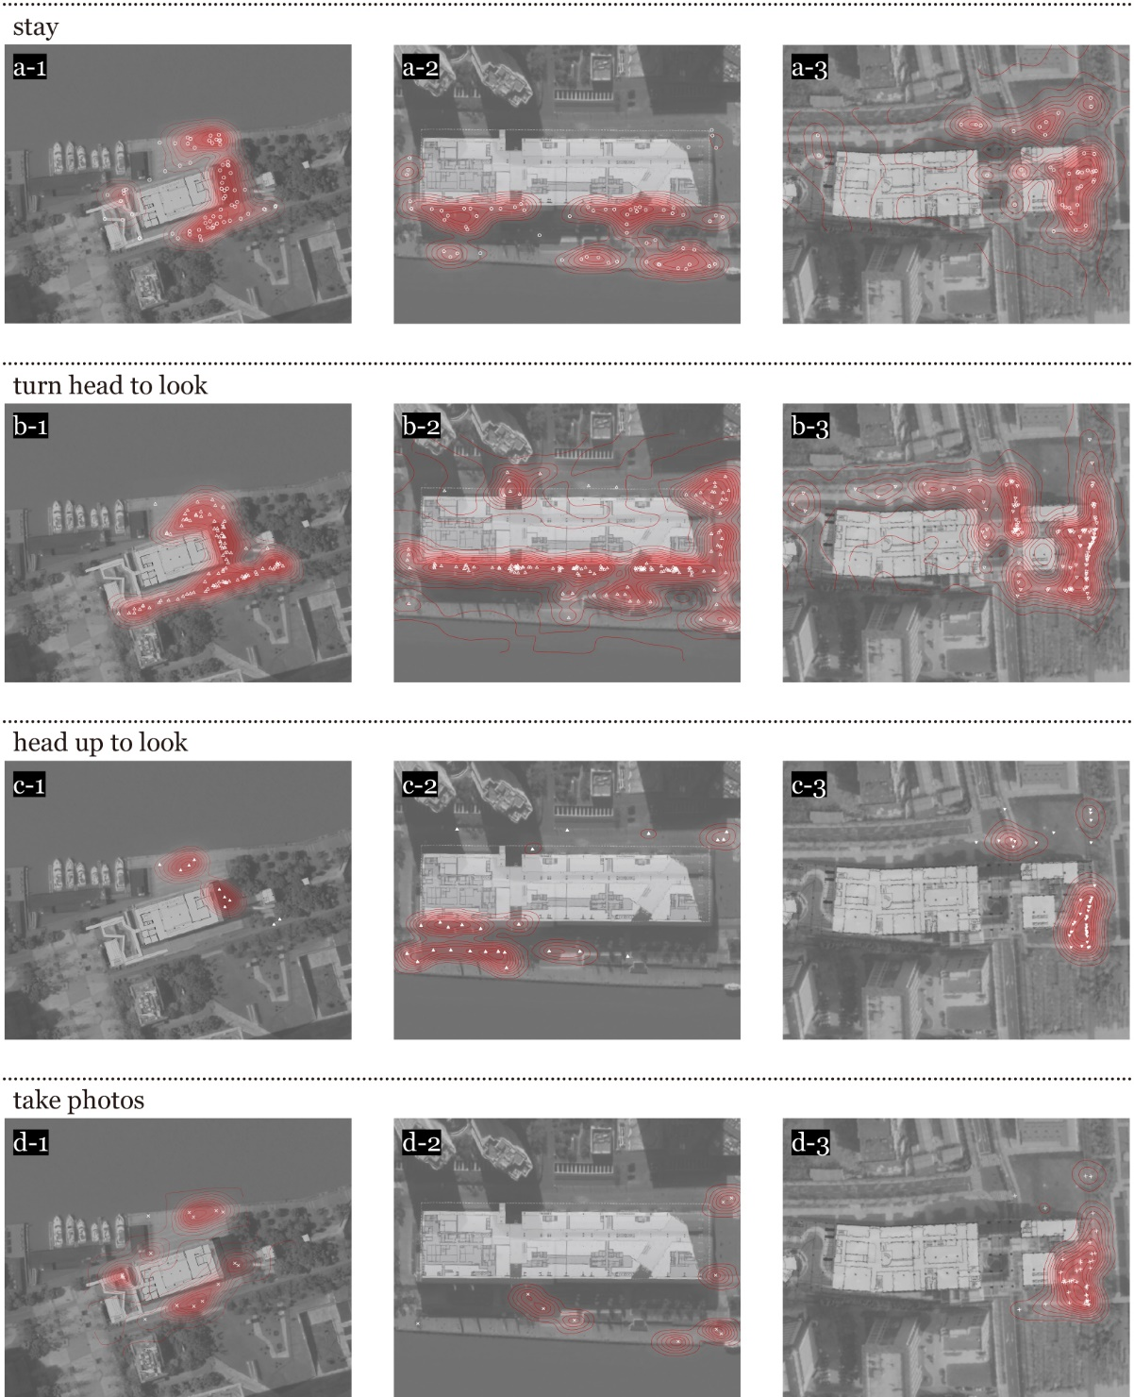
Figure 3. Behavioral heat map of selected cases

- The properties of the linear elements are most relevant to the linear roaming path of pedestrians. Therefore, the quality of the linear elements determines the pedestrians’ interaction with the interfaces and also influences their walking speed.

In general, open and transparent linear interfaces are more vibrant. All the three buildings have a commercial program of restaurants or cafes on the ground floor, creating rich interactions with pedestrians. For example, most of the restaurants in Mifa beside the waterfront have permeable curtain walls with outdoor cafes, effectively attracting views and stays (Figure 3. a-2, Figure 3. b-2). On the contrary, the side closer to the city retains more of the factory’s original trusses and displays a non-transparent façade with some mostly specialised retails, so the interaction with pedestrians is less frequent and the average speed of pedestrians is much higher (Table 2). It is worth noting that the ground floor interface of MAM is mostly glazed with highly reflective glass, which reduces internal and external permeability, but increases its attractiveness to interactions due to its mirrored effect, especially on the short side of the building (Figure 3. a-1, Figure 3. b-1). It also slows down the pedestrians’ walking speed (Table 2).

- Plane-like elements are important in stimulating activities, but only their combination with linear or point-like elements is a guarantee of their attractiveness.

The combination of a flat linear interface and recessed semi-outdoor space creates a sense of rhythm that is highly attractive to the pedestrians, such as the two recessed entrances with semi-outdoor space on the waterfront interface of Mifa (Figure 3. b-2) and the passage through the street in GH (Figure 3. b-3); whereas the relatively homogeneous and continuous under-corridor space lacks objects to make people stop and gaze, as in the case of the MAM. Whether or not the architects intended it to be, this interface, with its sculptural form, discreetly gives way to the riverfront plaza, which is a lively sightseeing space rich in activities and high pedestrian flow in the evening.

The combination of the slope and the landmark brings a strong dynamic to the riverside frontage of GH. The slope and the stairs provide a clear path to the landmark, and the attractiveness of the landmark creates an incentive for pedestrians to climb the slope. Therefore, lots of pedestrians tend to gather here, stop, and take photographs (Figure 3. a-3, Figure 3. d-3). However, the grass slope facing the city is significantly less vibrant because it is blocked by the fence. The architect’s intention to extend the public life of the city to the riverfront is not fully realized. Interestingly, at its interface facing the urban streets, the number of people coming specifically by taxi is literally higher than those directly attracted from streets, reflecting that the status of GH is considered more a landmark than a public space of neighborhood to some extent. There is also a similar pity for MAM. Although many visitors were attracted to the waterfront ramp to roam and take photographs (Figure 3. d-1), the connection between the ramp and the upper corridor was locked for management reasons, so the intention to connect the upper levels to the waterfront was not realised.

4. Discussion and conclusions:
The walking speed of people rambling along the riverside slows down to varying degrees as they pass through the architectural interface of regenerated industrial heritage (Table 2). Although walking speeds show a numerically insignificant difference, this data does contain a degree of value given the sufficient sample size. From a general perspective, slower walking speed proves that all the three cases have positive influences on the spatial quality of the riverside. From a closer perspective, some of the patterns summarised above may provide effective design strategies for other regeneration projects of industrial heritage in the future. Admittedly, some of these design strategies overlap with well-established European design experience, but in other words, they are justified by the data- and graph-based analysis presented in this study.

- The retention of industrial elements in some industrial heritage requires consideration as to whether there are suitable viewing points and whether they are in a comfortable visual range of pedestrians due to the relation with visual attractiveness.
- A transparent interface on the ground floor, like the glass curtain wall, is an effective strategy of slowing pedestrian walking speed and promoting public activity around it.
- Compared to setting the entrance on a flat interface, the rhythmic variation of the interface created by placing the entrance in a concave semi-outdoor space on a flat interface generates more attractions.
- People are likely to have an inclination to view the river from a higher place. The slope is therefore a natural attraction for people strolling along the river.
- Combining landmark and slope is a strong and valid gesture to attract people to explore the building.
- The gap between architectural design and operational management should not be neglected, which may prevent the design intention from being fully realised.

From the dichotomy between the industrial heritage and the waterfront space, to the lively social activities taking place around the regenerated heritage on the riverside, the importance and potential of the regeneration of industrial heritages is self-evident. From the perspective of PSPL, this study analyses the regenerated industrial projects that have already been put into use, and draws out certain patterns between the architectural interface and pedestrian behavior, providing a micro-scale perspective for the design and evaluation of buildings and their public realms.

Undoubtedly, the PSPL research method can reflect the public life of urban spaces truly and vividly, and it is also a compensate for the distortion of big data urban analytical method at the microscopic scale. However, as the study is mainly based on the direct observation of the researcher, it is difficult to eradicate the researcher’s subjective judgement. Therefore, to obtain valid analysis data, the researcher needs to have as much experience as possible in public life observation. As for the analysis of data collected by PSPL survey, other than the behavioral heat map proposed here by using the density of behaviors to simulate a heat map through geometrical fitting, future research may also be based on computational analytical methods such as numerical fitting and machine learning.

Contributor statement
Yifan Dong: Conceptualization, Methodology, Investigation, Visualization, Writing – Original Draft
Jingwen Gan: Conceptualization, Formal analysis, Investigation, Visualization, Writing – Original Draft
Huaqing Huang: Conceptualization, Supervision, Writing – Review & Editing

References
- Alexander, C. (1979). The Timeless Way of Building. Oxford University Press.
- Cao, B..(2021).“新陈代谢”下的重生——以上海船厂（浦东）2E1-1地块项目老船厂改造为例. Real Estate World (16),45–50.
- Liu, Y.. (2019). Rethinking Four Key Terms in Chinese Garden History on Several Adaptive Re-Use Projects along the Huangpu River. Architectural Journal.
- Liu, Y.. (2021). Shanghai Modern Art Museum and Its Riverside Walkway: Rebirth of the Ruins. Architecture Technique(07), 36–45+113.
- Lynch, K.. (1964). The Image of the City. MIT Press.
- Gehl Institute. (2016). The Public Life Diversity Toolkit. New York: Gehl Institute. Available at: https://gehlinstitute.org/work/the-public-life-diversity-toolkit/. Accessed Nov 2018.
- Gehl Institute. (2020). How to Use the Public Life Tools. New York: Gehl Institute. Available at: https://gehlpeople.com/tools/how-to-use-the-public-life-tools/. Accessed Apr 2022.
- Gehl, J.. (1987). Life Between Buildings: Using Public Space. Island Press.
- Gehl, J., Kaefer, L. J., & Reigstad, S. . (2006). Close Encounters with Buildings. URBAN DESIGN International, 11(1), 29–47.
- Gehl, J., & Svarre, B.. (2013). How to Study Public Life. Island Press/Center for Resource Economics.
- Wang, J., Jiang N.. (2006). 后工业时代中国产业类历史建筑遗产保护性再利用. Architectural Journal.
- Zhang, M., Zhang, Z., Zhang, J., Qin, S.. (2020). Hilly City and Its Responsive System - Green Hill on the Waterfront of Yangpu, Shanghai. Architectural Journal.
- Zhang, M., Zhang, Z., Zhang, J., Qin, S., & Wang, X.. (2019). Baptized Revitalization Regenerating the Public Space of Southern Yangpu Waterfront, Shanghai. Architectural Journal.

