Type of the Paper: Peer-reviewed Conference Paper / Full Paper
Track title: the city is an object and a city is in transition

Integrated Coastal Flood Design: Changing the Paradigm in Flood Risk Management
Luca Iuorio ¹, Andrea Bortolotti ²
Names of the track editors:
Birgit Hausleitner
Leo van den Burg
Akkelies van Nes
Names of the reviewers:
Leo van den Burg
Karin Hofert
Journal: The Evolving Scholar
DOI:10.24404/616051311d74bb0008d549ca

Submitted: 8 October 2021
Accepted: 01 June 2022
Published: 28 November 2022
Citation: Iuorio, L. & Bortolotti, A. (2021). Integrated Coastal Flood Design: Changing the Paradigm in Flood Risk Management. The Evolving Scholar | IFoU 14th Edition.

This work is licensed under a Creative Commons Attribution CC BY (CC BY) license.
©2021 [Iuorio, L. & Bortolotti, A.] published by TU Delft OPEN on behalf of the authors.

¹ TU Delft, Department of Urbanism; l.iuorio@tudelft.nl
² TU Delft, Department of Urbanism; a.bortolotti@tudelft.nl

Abstract: The relationship between the design of the flood protection infrastructure and the design of the urbanscape is the focus of this paper, and asks the question how these two types of design can consciously affect each other? The text presents the preliminary result of an interdisciplinary research conducted by a team of urban designers and hydraulic engineers on two pilot projects of coastal adaptation to extreme sea level rise on the North Sea: Vlissingen (NL) and Southend-on-Sea (UK). Spatial measures to accept the flood, land use change, water-proof housing developments, and the use of nature-based solutions are described in relation to the urban fabric. The aim is to discuss models of flood risk reduction which are alternatives to the more conventional coastal flood protection strategies. A different “designer” way of thinking and great effort to describe and analyse the two cases have been utilised to enlighten the spatial qualities of the urban form and its long-term adaptability.
Keywords: coastal flood; water infrastructure; integrated design; risk management; living with water

1. Introduction
In recent decades, global warming has increasingly challenged hydraulic engineers and urban designers to reshape and adapt coastal cities to sea level rise and intensifying storm events. (Davoudi, Crawford & Mehmood, 2009). The current flood risk-related challenges induced by climate change place pressure on designing urban areas in which both natural and man-made conditions can be out of balance. Flood risk is mostly oriented towards reducing the probability of flood events. Also, due to the changing hydrological cycle, exceptional river discharge, heavy rainfall, erosion, sedimentation, and subsidence, grey infrastructures (dykes, seawalls, dams, etc.) are constantly being built. But, the hard-engineered approach to flood risk management does not always work: especially in floodplain and coastal areas, these infrastructures have a significant growing impact on the (urban) landscape (Van Loon-Steensma & Kok, 2016).

Knowledge about the design of the urban fabric of the protected areas in relation to the overall risk reduction by the flood defense system is still limited (Nillesen & Kok, 2015), but growing. A separation between flood management and urban planning has been perpetuated over time by the idea that flood defence offers the primary condition for urban development. In the Netherlands, for example, technical interventions have made the territory livable, and the government has a strong and coordinated responsibility for both safety and spatial planning (Hooimeijer, 2014). Flood risk management, indeed, is considered the “conditio sine qua non” (Van der Woud, 1987) for urban development in the sense that without dykes there is no possible spatial order.

However, a new awareness – also in the field of engineering – is growing, especially in the Dutch context. In recent decades, this has triggered several experimental programmes in which the flood infrastructures have been approaching the water-space involved in the large span design of urban, rural, or natural lands. Examples such as the “Room for River” programme in the Netherlands, new dyke concepts (e.g., double dyke, wide green dyke), the use of nature-based solutions (e.g., marshlands, the Sand Engine, reconstruction of dunes, etc.) demonstrate that water protection infrastructure may have larger spatial footprint than the one that traditional dykes used to have in the past (Van Loon-Steensma & Vellinga, 2019). Nevertheless, accepting water, implementing nature-based solutions, improving emergency and evacuation plans, etc., all those measures demand overcoming the division and practical silos between urban planning and flood management.

Making space for water has become the hallmark of a new generation of flood management plans and strategies (Foster, Hudson, Bray & Nicholls, 2013; Thomas, 2014) that address a renovated attitude in living closer with it. Living with water includes the discipline of spatial design more than the current dominant engineering-based flood risk management paradigm. It overturns the hydraulic design approach – according to which there is no spatial order without flood defence (Van der Woud, 1987) – reclaiming the need to think of water protection systems any more as a line, but as a space. Spatial design is part of flood risk management and hydraulic engineering is part of spatial design. In this perspective, urbanised areas are intended as a historized, dynamic, and transitional objects that can adapt to climate change and environmental hazards through the means of integrated spatial and infrastructural design.

This paper discusses the preliminary result of an interdisciplinary research conducted on two middle-sized cities on the North Sea: Vlissingen, in the Netherlands; and Southend-on-Sea, in England. The case studies are part of the Interreg - Sustainable and Resilient Coastal Cities (SARCC) project, which gathers a number of municipalities across four European countries (France, United Kingdom, Belgium, Netherlands) willing to implement the transition of historical grey water defense infrastructure towards the development of more sustainable seafronts projects through the implementation of pilot projects (coordinated by the municipality of Southend-On-Sea in partnership with other public agencies and institutes among which TU Delft Department of Urbanism and of Hydraulic Engineering). The Vlissingen and Southend-on-sea pilot projects, discussed in this paper, were developed in collaboration by a team of urban designers, hydraulic engineers, and marine archaeologists.

Both projects reflect the broader scope of SARCC: the aim is to explore alternative models of coastal management and planning. Accepting water overtopping, using temporary dykes, and implementing changes in land use and building regulation are taken as main principles and translated into spatial actions to reduce overall flood risk in these cities. The intent is to expand the scope of the pilot design to include whole urban areas and establish more complex and resilient flood management in which several urban/spatial adaptation strategies are taken into account. The proposed spatial adaptation strategies are based on original hydrodynamic models which account for extreme storm surge and sea-level rise projections for the year 2100.

2. Vlissingen
Vlissingen is a medium-sized city (44,370 inhabitants) situated in the outlet of the Western Scheldt River on the North Sea coast. Thanks to this strategic geographical position, it has represented a crucial harbour since the XIV century. Its internal areas, as most of its province, are below annual flood events. Nevertheless, the area is protected both by a reinforced dyke, on top of which are built row buildings and towers (south) and sandy dunes (west) integrated to the regional blue and green network. Internal polders are drained by the Walcheren channel communicating with the sea through locks.

At present, Vlissingen’s primary flood defense structure is composed by the following elements: (i) a reinforced concrete slope along the sandy coastline; (ii) storm walls with a bullnose,above which lays the waterfront boulevard; (iii) the first row of buildings made by a mix of traditional 3-storey row houses and towers of different heights with commercial activities on the ground floors (some of which are accessible from a raised plaza with underneath parking); and (iv) a raised dyke on the back of the buildings, in the western part of the main boulevard.

In the past, due to the projection of future sea level rise (IPCC, 2019), the Municipality of Vlissingen has promoted a strategy of urban development which integrates adaptation to forthcoming flood risk. The so-called ‘Vlissings Model’ (Vlissingen & Ma.an, 2010) aims to create a sea-barrier with buildings themselves: foundations and first floors of new developments must be designed to anticipate the future rising of the coastal dyke. Recently, several buildings on top of the primary defence line have already been built according to these principles: they have higher ceilings at the ground level in order to further incorporate the eventual raising of the dyke.

Today, the Municipality is also promoting an urban renewal plan (including commercial and residential functions) that aims to recover a former artificial basin located in a central area of the city, behind the main dyke, to serve as water reservoir in case of flooding. The project will impact an empty, but spontaneously vegetated area called “Spuikom,” once connected with the nearby harbour that has been partially filled after the 1970s to allow the construction of new buildings and parking lots.

These two strategies have offered the opportunity to further investigate the spatial effects on the urban context. On the one hand, the Vlissings Model may require, in the long term, the entire demolition and reconstruction of the historical buildings along the seaside. On the other hand, the reactivation of the Spuikom requires the basin and its surrounding area (streets and buildings) to be redesigned to function as a buffer zone in order to give adequate space to excess water.

The TU Delft departments of Urbanism and Hydraulic Engineering have expanded the analysis for this second option. Building on original hydrodynamic models for storm events in the year 2100, it was possible to figure out most needed spatial adaptation measures in the historical urbanscape. In the suggested spatial vision, the Spuikom again becomes a basin to store water in the case of flood; the streetscape is designed with the scope of redirecting water into the reservoir; streets are equipped with movable barriers to divert the flood. In this “re-making space for water” approach the developments planned by the Municipality are taken into account and also create economic catalysts to feasibly transform the area.
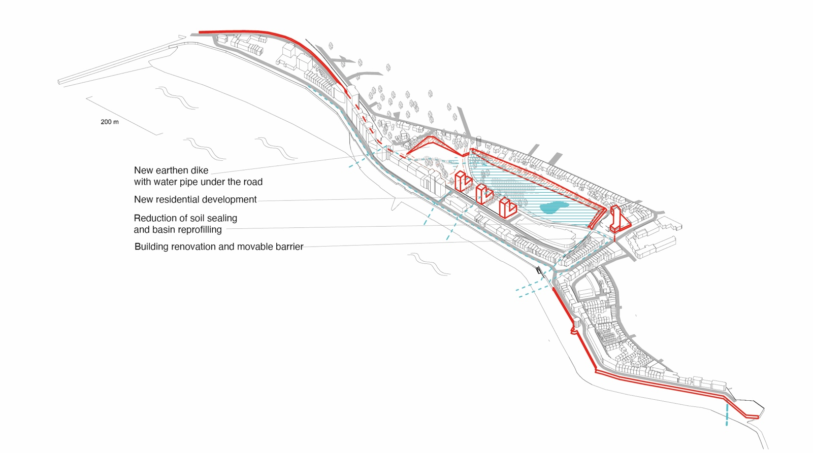
Figure 1. Making space for water. Spatial vision for Vlissingen. Drawn by A. Bortolotti. The strategy has been developed within the Sarcc project, TU Delft team: F. Hooimeijer, J. Bricker, A. Diaz, Q. Ke, A. Bortolotti.

3. Southend-on-sea
Southend is one of the most densely populated areas (181,800 inhabitants) outside London. It is located on the mouth of the Thames River and served by a capillary transport network which includes multiple train stations. Its waterfront has been, historically, an important leisure and recreational area. The urban structure is of sprawl-type dominated by single-family houses with gardens, whereas public and commercial services are concentrated along several high streets and recreational grounds (e.g., sports fields). Property development pressure is strong (Southend-on-sea, 2021), particularly along the seafront due to its high economic value.

From a geomorphological perspective, the municipality is divided into two parts: the town centre and western part are on high ground and not at risk from tidal flooding, while much of the sea front and the eastern part is on lowland and at risk of flooding.

The whole sea front is protected by hard defence structures including revetments, sea walls, and groynes to mitigate wave impact. Today, in coherence with the Thames Estuary action plan for 2100, the Southend-on-Sea Borough Council is promoting rebuilding and refurbishment works of the defences as they come to the end of their lifespan. Reinforcing the defence line may affect the link with the sea, whereas the aim is to minimise the visual impact on the historical area as much as possible. On this point, main policy lines have been established (i) “to integrate flood defence into developments – and ensure that the developments are designed with a proper understanding of the flood risk they face” (Thames Estuary 2100, 2012: 72) in the aim that (ii) “improvements to the flood risk management system should provide amenity, recreational, and environmental enhancement, and be designed to minimise any adverse impacts on the frontage” (Thames Estuary 2100, 2012: 214). Yet, responses for local flood risk management are still required to be designed or assessed in detail at the local scale.

In 2020, the Southend-on-Sea Borough Council appointed an engineering local firm for developing a set of nature-based solutions to protect the coast including vertipools, a climate garden, vegetated shingle, gabion baskets, and dune stabilisation. Vertipools are proposed for the old Leigh port and Westcliff Casino sites; installed on existing seawall, they are meant to provide space for the recreation of micro-habitat. A climate resistant garden which includes hard (boardwalks) and soft (pathways) standings and drought tolerant plant species (e.g., Sea Holly, Sea Kale, and Blue Fescue) is proposed for Jocelyn Beach. Like climate gardens, vegetated shingles are meant to dissipate wave energy and are proposed for Thorpe Bay beach. Finally, dune stabilisation and 150 m-long new gabion baskets are proposed for East Beach.

Whereas these interventions are punctual and targeted at specific areas, the TU Delft - Department of Urbanism team has proposed to develop a broader reflection on the long-term strategy of adaptation to rising seas. The TU Delft - Department of Hydraulic Engineering and the UK Maritime Archaeology Trust contributed content-wise.

Gunners Park and the contiguous Garrison development – located in the south-eastern borough of Shoeburyness – are two of the main flood risk areas of the low-lying Southend-on-Sea. For this reason, they are the object of the proposed design.

Four strategies are identified in the aim to meet some major urban challenges: (i) the topo-strategy, which focuses on place-specific water management strategies in relation to the inherited urban structure (density and typology) and soil type (e.g., rainwater infiltration in the high ground’s permeable soils, seawater retention in the low-lying impervious soils); (ii) the eco-strategy, that relies on the existing blue and green networks to reinforce their role of landscape connections and improvement of water and soil quality; (iii) the accessibility-strategy that mainly focuses on giving priority to the active mobility (pedestrian and cycle) to provide widespread access to the seafront; and (iv) the longue-durée-strategy which places greater emphasis in research, protection, and preservation of the local cultural heritage.

In line with the work for the other project study of Vlissingen (NL), it is proposed to accept water overtopping and build a secondary defense line along the existing margin between the open and built-up areas. In such a way, the area is adapted to function as a retention basin for excess water in the case of extreme events, while the existing and enhanced drainage network is used to drain the area at the end of the storm. At the basis of this idea is the principle of building a new embankment that can serve both as protection, leisure space, and connection, while the new urban development inside the area is designed to be flood-proofed (e.g., by being raised on piles, or by giving ground floors to functions such as car parks).

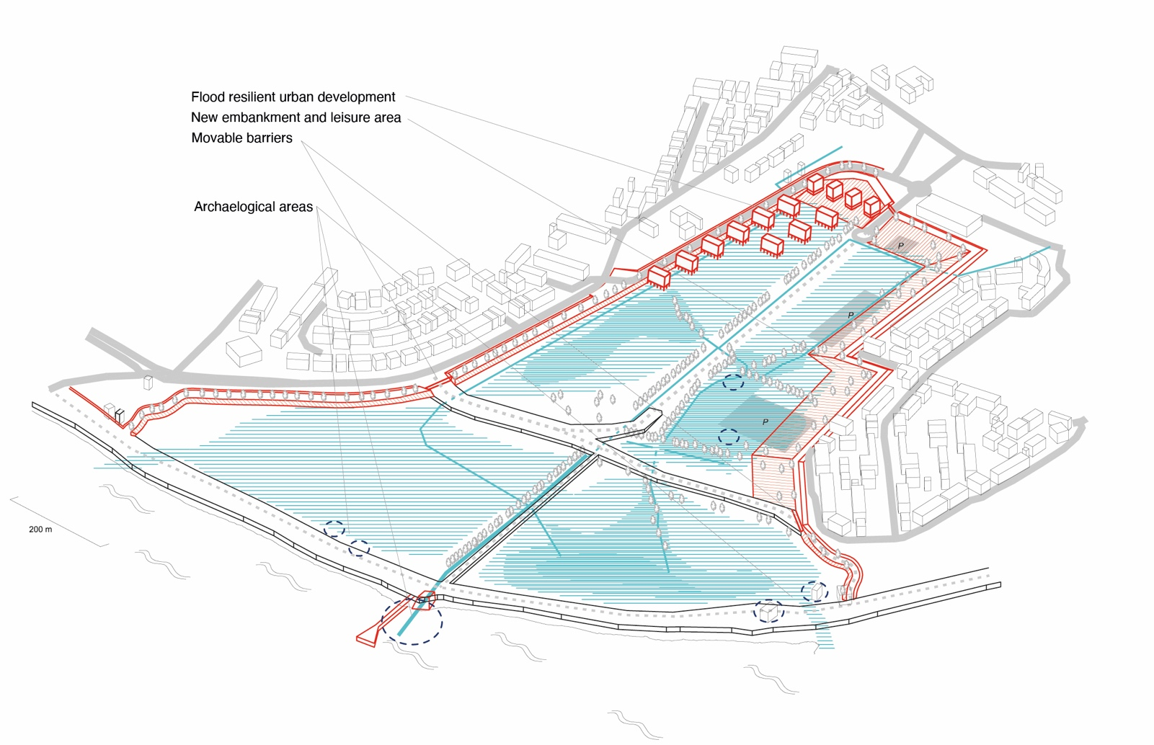
Figure 2. Making space for water. Spatial vision for Southend-on-sea. Drawn by A. Bortolotti and L. Iuorio. The strategy has been developed within the Sarcc project, TU Delft team: F. Hooimeijer, D. Wuthrich, Q. Ke, A. Bortolotti, L. Iuorio.

4. Discussion
Fitting into a 2 km by 2 km frame, we have expanded the analysis and developed a vision for these urban areas with the aim to meet the objective of better integrating flood defence with new developments, as well enhancing public spaces and recreational function. Instead of heightening the existing primary defense line, the resulting spatial scenarios recombine existing landscape features – dykes, embankments, ditches, new buildings and roads – in a way to make the pilots prone to stand a flood event in 2100 by reducing the consequences.

The two new waterfronts have many common aspects; in both cases, the dyke shapes the city as a fundamental part of it but represents only an element of the complex and broader territorial design. In contrast, the storage areas – where water, once overtopped the dyke, can be collected in – are an active part of the urban environment; the seasonal controlled floods change the configuration of the open spaces adapting urban fabric to the storm events. The design and realisation of floodable parks, moreover, give the opportunity to implement new leisure areas, public spaces, and waterproof housing developments. Coastal water infrastructures are not detached from the urban background and they are also the way to support the objective of making more space for water and living more closely with it.

In the last two centuries, dealing with water has meant “protection” (Priest et al., 2016) and so far the study concerning sea level rise has been confined to the point of view of the engineering domains. This attitude neglected the potential role of spatial design disciplines (architecture, landscape, and urban design) and conceptualised the problem from a single perspective. The two project cases presented in this paper combine hydraulic, historical, and spatial knowledge to support the need for a paradigm shift in the engineering-based probability approach to flood risk management. Designing with water also comes to terms with the spatial form of the cultural landscapes and the technical construction of urbanised areas. Innovation is achieved not only in reducing the probabilities, but also the consequences of flood risk. Working on the consequences of the risk means to involve the spatial dimension of territory as a palimpsest (Corboz, 1985) and rearticulate the relation between hydraulic engineering and urban planning to better design its transformation.

In both cases, the historized urban landscape has played a pivotal role to further design – through an interdisciplinary lens – the water defense system. Indeed, the projects deal with the big physical inheritance of the coastal built environment demonstrating how changes in building and planning infrastructures by specialists may also impact the attitude of perceiving and experiencing cities, landscape, and places by citizens.

The Vlissingen and Southend-on-sea cases show that flood defense infrastructures can be imagined and developed within a spatial approach, that they can be physical manufactures integrated into landscape and they qualitatively affect urban development also the way people interact with water through them.

5. Conclusion
This paper aims to enlighten new possible synergies between scientific domains through the role of integrated design. Many authors have pointed out the potential role of integrated and systemic design to explore and tackle the spatial challenge of climate change in its complexity (Berger, 2009; Belanger, 2016; Corner, 2006 & 2014).

Spatial design integrates social, cultural, economic, and political perspectives with natural site conditions and man-made construction to plan for sustainable urban development. Historically, the role of the designer has been related to the capacity of handling multifaceted and complex problems; today, in the light of the multiple and transcalar issues posed by climate change, there is the need to restore and reclaim this peculiar expertise.

Urban design, water management, and hydraulic engineering are the disciplines which perform as the main drivers to look at the coastal urbanisation in relation to the sea level rise challenges in its multilayered aspects, both technical and conceptual. In the aim to develop an innovative systemic awareness, a shift of the way we do research and projects on water seems to be crucial. Specific attention should be paid to the integrated design process; integrated design is a comprehensive and holistic approach to the design which brings together specialisms usually considered separately. New research may establish experimental methodologies, as well as new conceptual frameworks and innovative design approaches to find a common fertile ground and push forward the research of spatial solutions for climate adaptation.

Contributor statement
Author Contributions: Conceptualisation, L.I, A.B; methodology, L.I, A.B; software, L.I, A.B; validation, L.I, A.B; formal analysis, L.I, A.B; investigation, L.I, A.B; resources, L.I, A.B; data curation, L.I, A.B; writing—original draft preparation, L.I, A.B; writing—review and editing, L.I, A.B; visualisation, L.I, A.B; L.I, A.B. All authors have read and agreed to the published version of the manuscript.

Acknowledgments
The Interreg SARCC project is coordinated by the municipality of Southend-On-Sea (UK) in partnership with Marine Archaelogical Trust (UK), Municipality of Blankenberge (BE), City of Gravelines (FR), TU Delft University (NL), Agency for Maritime and Coastal Services (BE), City of Oostend (BE), Vives University of Applied Sciences (BE), Environmental Agency (UK), Municipality of Vlissingen (NL), Exo Environmental Ltd (UK), Flemish Government (BE), Town of Middelkerke (BE), HZ University of Applied Sciences (NL).

The TU Delft team: F. Hooimeijer, D. Wuthrich, J. Bricker, A. Diaz, Q. Ke, A. Bortolotti, L. Iuorio.

References
- Belanger, P. (2016). Landscape as Infrastructure. A Base Primer. London: Routledge
- Berger, A. (2009). Systemic Design can Change the World. New York: SUN
- Corboz, A. (1985). Il Territorio come Palinsesto, Casabella, 516. Milano: Electa
- Corner, J. (2006). Terra Fluxus. In C., Waldheim (Ed.). The Landscape Urbanism Reader, (pp. 21–33). New York: Princeton Architectural Press
- Corner, J. (2014). Recovering Landscape as a Critical Cultural Practice. In J., Corner, A., Bick Hirsch (Eds.). The Landscape Imagination. New York: Princeton Architectural Press
- Davoudi, S., Crawford, J., Mehmood, A. (2009). Planning for Climate Change: Strategies for Mitigation and Adaptation for Spatial Planners. London: Earthscan
- Foster, N.M., Hudson, M.D, Bray, S. and Nicholls, R.J. (2013). Intertidal Mudflat and Saltmarsh Conservation and Sustainable Use in the UK. A Review. Journal of Environmental Management, 126, 96–104
- Hooimeijer, F.L. (2014). The Making of Polder Cities. A Fine Dutch Tradition. Rotterdam: Jap Sam Publishers
- IPCC (2019). Special Report on the Ocean and Cryosphere in a Changing Climate
- Nillesen, A.L., Kok, M. (2015). An Integrated Approach to Flood Risk Management and Spatial Quality for a Netherlands’ River Polder Area. Mitigation and Adaptation Strategies for Global Change, 20(6), 949–966
- Priest, S. J., Suykens, C., Rijswick, H.F.M.W. Van, Schellenberger, T., Goytia, S., Kundzewicz, Z. W. (2016). The European Union Approach to Flood Risk Management and Improving Societal Resilience. Lessons from the Implementation of the Floods Directive in Six European Countries. Ecology and Society, 21(4)
- Southend-on-sea (2021). New Local Plan. Retrieved from https://localplan.southend.gov.uk
- Thames Estuary 2100 (2012). Managing Flood Risk through London and the Thames Estuary. London
- Thomas, K. (2014). Managed Realignment in the UK. The Role of the Environment Agency.
- In L.S., Esteves (ed.). Managed Realignment. A Viable Long-Term Coastal Management Strategy?, (pp. 83–94). Amsterdam: Springer
- Van der Woud, A. (1987). Het lege land, de ruimtelijke orde van Nederland 1798 - 1848. Amsterdam: Meulenhof
- Van Loon-Steensma, J.M., Kok, M. (2016). Risk Reduction by Combining Nature Values with Flood Protection?. E3S Web Conference, 7
- Van Loon-Steensma, J., Vellinga, P. (2019). How ‘Wide Green Dykes’ Were Reintroduced in The Netherlands: A Case Study of the Uptake of an Innovative Measure in Long-Term Strategic Delta Planning. Journal of Environmental Planning and Management, 62(9). London: Routledge
- Vlissingen & Ma.an (2010). Structuurvisie Vlissingen Stad aan Zee - een Zee aan Ruimte. Vlissingen

