Type of the Paper: Peer-reviewed Conference Paper / Full Paper
Track title: Metropolization and the Right to the City

Who Wins and Who Loses in the Production of Cultural Iconic Architecture?
Inge Goudsmit¹*
Names of the track editors:
Caroline Newton
Lei Qu

Names of the reviewers:
Lei Qu
Astrid Ley
Journal: The Evolving Scholar

DOI:10.24404/6166feb8cccbd9000930478c

Submitted: 13 October 2021
Accepted: 01 June 2022
Published: 23 August 2022
Citation: Goudsmit, I. (2021). Who Wins and Who Loses in the Production of Cultural Iconic Architecture? The Evolving Scholar | IFoU 14th Edition.

This work is licensed under a Creative Commons Attribution CC BY (CC BY) license.
©2021 [Goudsmit, I.] published by TU Delft OPEN on behalf of the authors.

¹* School of Architecture, The Chinese University of Hong Kong, Hong Kong, China; igoudsmit@cuhk.edu.hk ORCID ID (0000-0003-4045-4640)

Abstract: Recent studies on the role of architecture within urban restructuring processes have become dominated by narratives on neoliberal urban entrepreneurialism, which consider urban development projects as key instruments of growth-oriented regimes and urban elites. In this paper, I want to focus on the role that cultural iconic architecture can play within a community to shape a collective identity and institute an urban imaginary. This study illustrates current cultural developments in Hong Kong, where most of the cultural budget has been spent on the global megaproject of the West Kowloon Cultural District (WKCD). In contrast, the new development areas, particularly the later generations of new towns, lack almost any form of cultural infrastructure. This contrasts with the governments’ claims for creating self-contained communities. The provision of cultural buildings, when embedded in social and cultural life, can be an essential mechanism to shape a collective urban character and institute an urban imaginary. This study uses the framework of Kaika (2011) on urban imaginaries as an analytical structure to interpret the production of aesthetic symbols, based on Castoriadis’ (1987) account of the imaginary institution of society. The importance of such civic infrastructure has been largely overlooked in the evaluation of existing new towns and the plans for future urban extensions. This, too, should be considered as a right to the city.
Keywords: urban imaginary; iconic architecture; Hong Kong; Right to the City

1. Introduction
“On culture and the arts, our vision is to develop Hong Kong into an international cultural metropolis. We support the freedom of artistic expression and creation, and foster the vibrant development of our cultures. We have been actively creating an environment conducive to the diversified development of culture and the arts; providing opportunities for wide participation in culture and the arts; devoting resources to nurturing talent and encouraging innovation; and supporting the preservation and promotion of traditional cultures.”

This is the most recent vision of Hong Kong’s Home Affairs Bureau (2020) on the development of culture and the arts. However, despite the ambition to foster and develop culture, this vision seems solely applicable to the urban centre of Hong Kong. At the same time, the new towns, housing half of the city’s population, are increasingly devoid of any cultural infrastructure.

Among many Asian urban centres that developed new towns after World War II, Hong Kong has one of the oldest and largest programmes. A new town’s success is often measured by its ability to achieve ‘self-containment’ and independence (Wannop, 1999, Forsyth and Peiser, 2021). Independent new towns should offer plenty of job opportunities and leisure activities, which should arguably lead to a better work-life balance. Since the 1960s, the Hong Kong Government initiated a new town programme to alleviate the growing population in urban centres (Chan, 2001). Nine new towns were designated under three generations: today, these towns host almost half of the city’s population. New towns were planned to be self-contained, providing “public and private housing supported by essential infrastructure and community facilities” (Civil Engineering and Development Department, 2016). The New Territories Development Department in 1976 illustrated their ideal: “The new towns will provide more than just housing. They will be places where people can work and play, grow and learn. And with them will come new industries to provide new and better jobs. Planners are providing for a full range of community facilities . . . .” (Hills and Yeh, 1983).

While many scholars have since shown the limitations of Hong Kong’s new towns in attaining self-containment in job provision, as factory jobs moved away and new town residents relied on public transport to commute and work in urban centres (He et al., 2020a, Hills and Yeh, 1983, He et al., 2020b, Yeh, 1997, Yeh, 2021), few have looked into self-containment in cultural facilities provision. As Forsyth and Peiser conclude in a recent publication on new towns: “urban design strategies may help in creating a strong sense of community through greater legibility, aesthetic innovations, and the provision of public facilities that fosters community pride” (2021) (see also: Eng, 1996, Ruggeri, 2009).

In this paper, I compare the provision of cultural facilities over several generations of Hong Kong’s new towns. It will show that the newest new towns provide substantially less cultural infrastructure compared to the older ones. At the same time, almost the entire cultural budget is spent on the WKCD, a cultural megaproject along the waterfront in the urban centre. I realise that the word ‘culture’ is itself contentious. While often understood with reference to ‘high’ culture, not in the least by the Hong Kong government, in this paper, I also highlight the second meaning of ‘local culture,’ which is often overseen. Drawing on spatial observations and interviews with residents, NGO’s and district councillors of the most recent new town Tung Chung, we found that many residents miss urban activity, places to socialise, and that the new town lacks a distinct identity. The argument is that public cultural buildings can be an essential mechanism to institute an urban imaginary and help shape collective urban identity. This is then where the term ‘iconic’ is relevant; here understood as an opportunity for public architecture to create a distinct and recognisable place or ‘the only conceivable or imaginable site of collective (social) life’ (Lefebvre, 2003). As can be seen in the older new towns, local landmarks can create distinctiveness, a sense of place, a focus on community life, and a centralised urbanity. The importance of such infrastructure has been largely overlooked in the evaluation of existing new towns and in the plans for future urban extensions. This, too, should be considered as a right to the city.

2. Theories and Methods

2.1 Theory background
Several academic fields, including urban planning, urban studies, geography, and architecture, have been examining the role of iconic architectural projects in urban transformation over the past few decades. As described by Sklair, the term iconic points at a combination of fame and symbolic or aesthetic significance (2017). The neoliberal shift in urban policy from managerial to entrepreneurial strategies is seen as the key to urban development in growth-oriented regimes (Harvey, 1994, Harvey, 1989). From this perspective, iconic buildings serve to attract attention and form distinctive, recognisable images used for the cultural (re)branding of urban areas (Evans, 2003, McNeill, 2009), whether to serve brand corporations (Kaika and Thielen, 2006, Kaika, 2010), cultural institutions (Sorkin, 2002, Evans, 2005), cities (Ponzini, 2011, Zukin, 1995), or nations (McNeill and Tewdwr-Jones, 2003, Ong, 2011).

However, this focus on the political economy of the iconic building obstructs our view of the potential benefits of such icons in public space and the creation of an urban identity. Architecture has the ability to serve as an urban totem, argues Maria Kaika, as architectural icons can function as “exemplifiers of the aspirations and values of societies and as embodiments of myths and wish images for the future” (Kaika, 2011). Following Castoriadis (1987), she claims that architecture is one of society’s tools to produce a collective identity or an ‘urban imaginary.’ Not only can icons function as ‘actual imaginaries’, they can also project an image that is not there yet, a ‘radical imaginary’. Such landmark projects can encourage social interaction and public life and create ‘imageability,’ a measure of how easily an environment evokes a mental image, through which it can be understood and recognised (Lynch, 1960).

Public cultural buildings in many cities have such a totemic function: they are located in a central location and influence the building itself and the urban space around them. However, not all infrastructure can fulfil such a function. To become a truly public icon, rather than an ‘autistic’ icon, a building needs to be embedded in social and cultural urban life, engage with the city around it, enhance the urban commons and inspire civic pride (Kaika, 2011). Community icons, in particular, can ‘function as magnets of sociability, crucibles of collective opinion and repositories of shared memory,’ and form a counterbalance for monumental global icons (Ho, 2006).

2.2 Methodology
This paper first discusses the background and relationship of Hong Kong’s new town programme with the government’s direction of cultural policies. Then, this is compared to the actual provision and location of public cultural facilities across different generations of new towns in Hong Kong. Next, zooming into Tung Chung, I will review the cultural infrastructure in this new town. This is complemented by interviews conducted with Tung Chung’s local population to understand the reality of everyday life in the new town and the impacts of cultural infrastructure on people’s sense of community and identity.

The empirical data for this study was collected using several different methodologies, which were partially incorporated within a year-long Advanced Research and Design Studio for the M-Arch programme within the School of Architecture at CUHK. First, various local stakeholders were invited to give a short lecture and were interviewed by the author and the students. These stakeholders included government town planners, urban planning consultancy firms, local district councillors, civil society representatives, NGOs, and residents. In addition, approximately 25 semi-structured short interviews were performed with local entrepreneurs, residents, and government representatives. Eventually, during the event ‘Urban Politics Debate – Planning for Culture in Tung Chung’ (May 27th, 2021, at Hong Kong Arts Centre), multiple key stakeholders discussed the situation in Tung Chung with regards to the needs of cultural infrastructure. In addition to the interviews, newspaper articles on Tung Chung were analysed, and we performed ‘social listening’ (Hollander et al., 2016), reviewing social media comments on the urban life in the new town.

3. Results

3.1. History of Hong Kong cultural policies
Before the handover in 1997, there was minimal effort from the colonial government to develop arts and cultural policies. ‘The notion that the best cultural policy is no cultural policy is a direct offshoot of the general policy of laissez-faire’ (Ooi, 1995), everything was kept ‘at arm’s length’ (Ho, 2017). The city was often referred to as a ‘cultural desert’ (Cartier, 2008). The first written arts policy that outlined the blueprint for the development of the arts was published only in 1996. Nevertheless, a booming cultural infrastructure was prominent in the 1980s and 1990s due to various social and political reasons, such as to ‘soothe the society’ after political upheavals in the late 1960s (Xue, 2013), to complete self-sufficient new towns, to create a ‘sense of belonging’ (Xue, 2019), to ‘improve the image of Hong Kong’ before the handover (Ooi, 1995), and more. This led to the construction of most town halls and theatres in older new towns. As Xue (2013) observed, ‘the administration adopted a people-oriented policy and started massive and numerous civil infrastructure projects. Civic architecture, including resettlement estates, city halls, libraries, sports complexes, hospitals, and schools, eventually formed the urban landscape of the Hong Kong territory.’

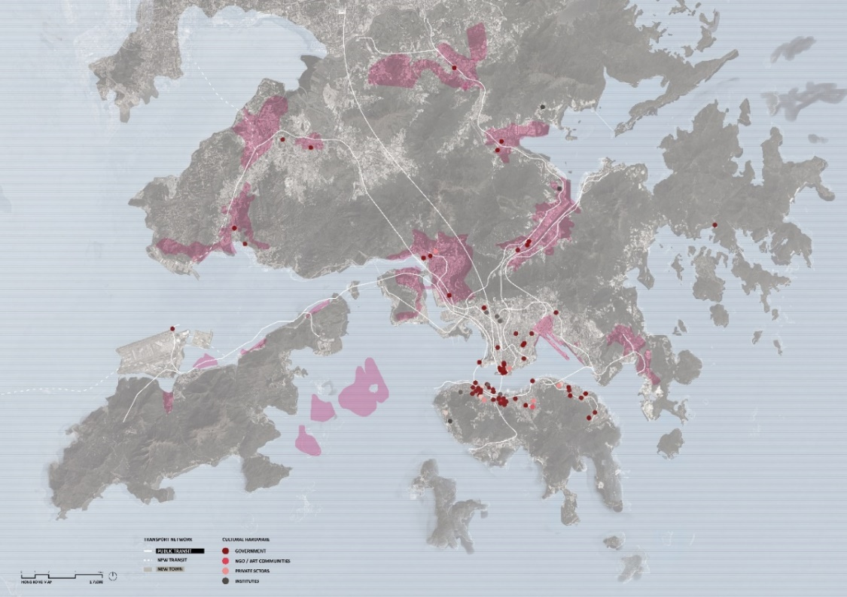
In the last two decades after the handover, however, the spread of public cultural projects is significantly reduced, leaving the later generation of new towns with barely any cultural infrastructure (see Figure 1). On arts and cultural facilities, the Hong Kong Planning Standards and Guidelines (HKPSG) only offer specific guidelines for the provision of libraries. There are no requirements for arts venues and community halls. These are to be “assessed and advised on by the Secretary for Home Affairs” (Planning Department, 2020). The focus on developing an ‘international cultural metropolis’ is evident through the budgetary emphasis on the WKCD. This 40-hectare reclaimed site aims to be an integrated arts and cultural district with world-class arts venues. The idea of WKCD was conceived in 1998 and has always been promulgated as the cultural landmark ‘to position Hong Kong as ‘Asia’s World City’ (Cartier, 2008). It hosts an Art Park, the Xiqu Centre, Freespace, and currently under construction are the Hong Kong Palace Museum, M+ museum, and the Lyric Theatre Complex, boosting state-of-the-art architecture for high culture at the heart of the city, hence far from the new towns. While WKCD was initially approved with an upfront endowment of HK$21.6 billion in 2008, the cost has spiked up to HK$70 billion by 2020 (Movius, 2020). No other cultural projects have received government funding of a similar scale, and none were located in the new towns.
Figure 1: Location of cultural infrastructure (including city/town halls; performing arts centres, museums. Source: data adapted from urbanpolitics.studio; map base: Google maps

3.2. Provision of cultural infrastructure in new towns
The overview of cultural infrastructure in new towns of different generations (see table 1) shows clearly that the first and second generations all enjoy the provision of one town hall or theatre. With the largest population of all new towns (805,000 in 2016), Tsuen Wan has both a town hall and a theatre. The cultural buildings of first-generation new towns were completed roughly 20 years after the year of designation. However, all third-generation new towns lack the provision of any cultural infrastructure. No plans to supply such infrastructure are found in government documents, despite that Tin Shui Wai and Tsuen Kwan O were designated as new towns almost 40 years ago. They have a population of 290,000 and 396,000 respectively, comparable with new towns of other generations.

Meanwhile, although all new towns are provided with libraries and community halls, and thus comply with the HKPSG. However, community halls, on average, fit fewer than 450 persons. They can hardly accommodate their respective populations to live up to their intended function of being a “focal point for local community activities undertaken by all age groups, including such activities as meetings of local community organisations; social group and civic education activities; training courses; and celebration, recreation and sport activities” (Planning Department, 2020).
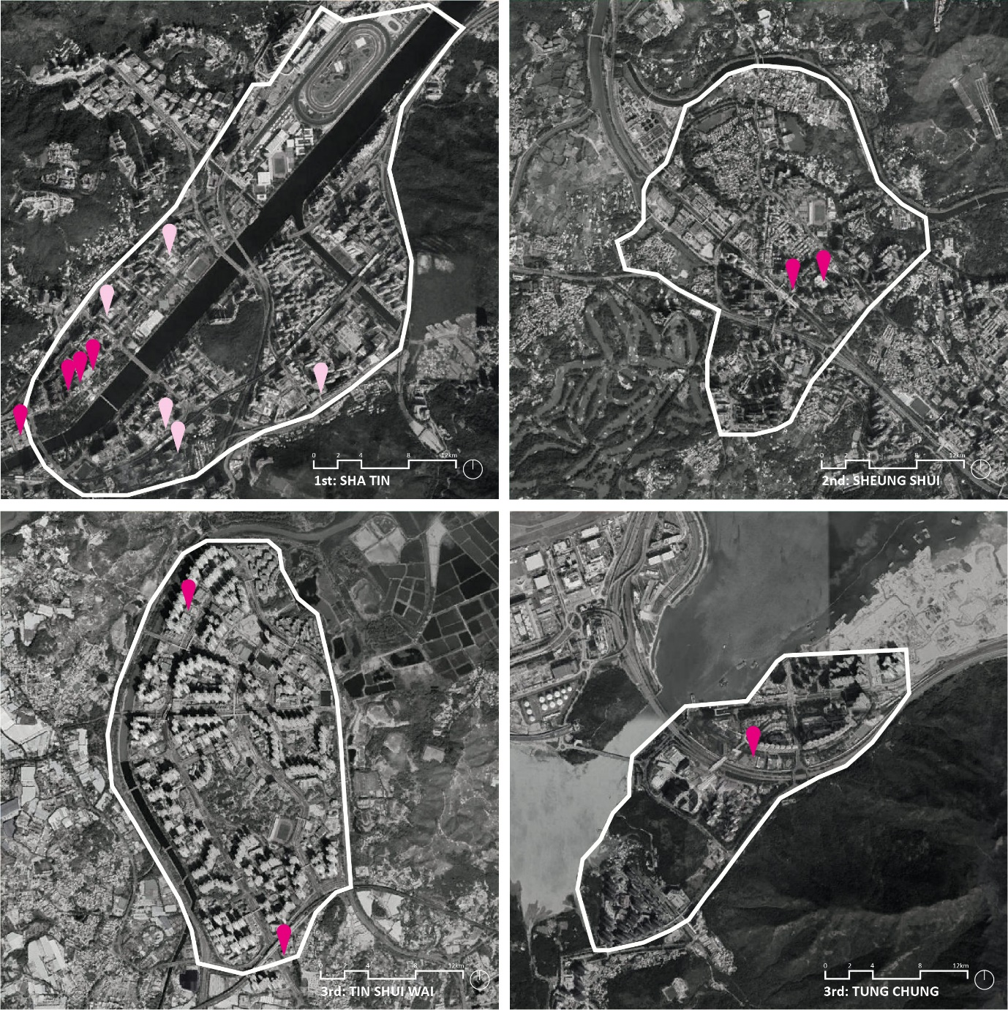
Not only is the number of cultural infrastructure important, its location within the town is also critical if these buildings are to function as truly local icons. Cultural buildings can help establish an urban centre with greater cultural diversity, contrasting with the large, segregated residential plots that most of Hong Kong’s new towns have. Indeed, in the early generations of new towns, the cultural buildings are located in the central location, often near a transportation hub. Xue (2019) observes that ‘town halls in Hong Kong are a modest part of the pedestrian bridge network’ and can easily be accessed ‘from subway or home.’ The later generations of new towns lack such a cultural centre. The maps of four of the new towns of different generations show the cultural and public provisions (figure 2).

Generation | New Town | Year  Designated | Reclamation | Area  (hectares) | Present 、population  (2016) | Planned  population | Cultural infrastructure (year of completion) | Library (year of  completion) | Number of community halls
1 | Tsuen Wan (Tsuen Wan, Kwai Chung and Tsing Yi Island) | 1961 | Yes | 3,286 | 805,000 | 866,000 | Tsuen Wan Town Hall (1980) | Tsuen Wan Public Library (1974) | 12
 |  |  |  |  |  |  | Kwai Tsing Theatre (1999) | North Kwai Chung Public Library (1984)
 |  |  |  |  |  |  |  | South Kwai Chung Public Library (1984)
 |  |  |  |  |  |  |  | Shek Wai Kok Public Library (1986)
 |  |  |  |  |  |  |  | Tsing Yi Public Library (2000)
1 | Sha Tin (including Ma On Shan) | 1965 | Yes | 3,591 | 691,000 | 771,000 | Sha Tin Town Hall (1987) | Lek Yuen Public Library (1977) | 13
 |  |  |  |  |  |  |  | Sha Tin Public Library (1987)
 |  |  |  |  |  |  |  | Ma On Shan Public Library (2005)
 |  |  |  |  |  |  |  | Yuen Chau Kok Public Library (2017)
1 | Tuen Mun | 1965 | Yes | 3,226 | 502,000 | 589,000 | Tuen Mun Town Hall (1987) | Tai Hing Public Library (1978) | 11
 |  |  |  |  |  |  |  | Butterfly Estate Public Library (1986)
 |  |  |  |  |  |  |  | Tuen Mun Public Library (1989)
2 | Tai Po | 1979 | Yes | 3,006 | 278,000 | 307,000 | Tai Po Civic Centre (1985) | Tai Po Public Library (2004) | 7
2 | Fanling/ Sheung Shui | 1979 | No | 667 | 261,000 | 290,000 | North District Town Hall (1982) | Sha Tau Kok Public Library (1990) | 6
 |  |  |  |  |  |  |  | Sheung Shui Public Library (1994)
 |  |  |  |  |  |  |  | Fanling Public Library (2003)
 |  |  |  |  |  |  |  | Fanling South Public Library (2016)
2 | Yuen Long | 1979 | No | 561 | 164,000 | 185,000 | Yuen Long Theatre (2000) | Yuen Long Public Library (1984) | 2
3 | Tin Shui Wai | 1982 | Yes | 430 | 290,000 | 306,000 | Nil | Tin Shui Wai North Public Library (2006) | 4
 |  |  |  |  |  |  |  | Ping Shan Tin Shui ai Public Library (2013)
3 | Tseung Kwan O | 1982 | Yes | 1,718 | 396,000 | 445,000 | Nil | Tseung Kwan O Public Library (2001) | 6
 |  |  |  |  |  |  |  | Tiu Keng Leng Public Library (2015)
3 | Tung Chung | 1992 | Yes | n.a | 80,000 | 124,000 | Nil | Tung Chung Public Library (2010) | 1
 | New Extension |  |  | 245 |  | 268,000

Table 1: List of cultural infrastructure in new towns (Civil Engineering and Development Department; He, Tao, et al.; Hong Kong Public Libraries)
Figure 2: Cultural infrastructure in three generations of new towns: 1st: Shatin; 2nd Sheung Shui, 3rd Tin Shui Wai and Tung Chung. Source: the author; map base: Google maps

3.3. Situation of Tung Chung
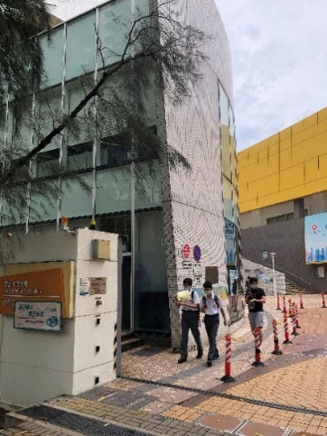
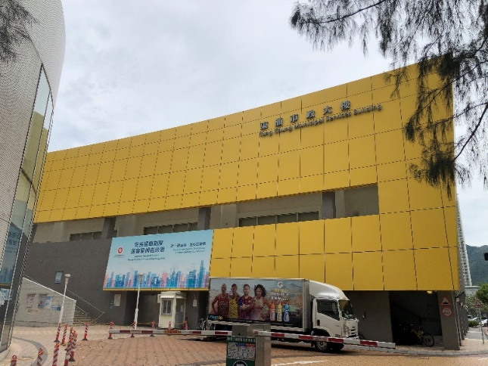
Tung Chung was designated as a new town in 1992, alongside the development of the international airport. The government intended to develop the town ‘into a hub providing commercial, cultural, community, and recreational activities serving Tung Chung and the wider area of Lantau Island’ (Planning Department, 2019). Today, the town of 80,000 (with a rapidly growing population) provides hardly any civic infrastructure, with only one district library and community hall (situated within the Municipal Services Building, see Figure 3) far from the public housing estates. Instead, these two facilities are surrounded by private estates and wide empty roads (see Figure 4) and can only be reached from the public housing estates by walking through shopping malls and bridge networks (see Figure 5). They are non-distinct in design and can accommodate only a limited capacity. In addition, the most central location of the new town, next to the public transport interchange, is formed by a shopping mall and private residential communities that developers and their management companies strictly manage. As a result, there are no public functions or cultural facilities.
Figure 3: Library and municipal services building: non-distinct design, lacking public outdoor space. Source: the author

District Councillor Mr Fong Lung-fei gave firsthand insights on the impact of the poorly-located public buildings: “the lower-income community concentrates in the west, hosting 40,000 people, which is half of the population of Tung Chung, yet the resources focus on East and North” (Fong, 2021). Mr Cheung Yan of Tung Chung Community Development Alliance, a local NGO, further suggested: “there are many low-income residents in the West. They are separated from the East with no basic facilities, such as markets” (Cheung, 2021).

Interviews with members in the local community were also revealing. They showed different needs depending on diverse groups in the population. Interestingly, all groups commented on the lack of a local wet market. These markets in Hong Kong are often incorporated as part of municipal services buildings, and supply, besides a market, sports facilities, a library, a theatre, and other public functions (Xue, 2013). They are not only important for grocery shopping, but they also form part of the wider daily life of residents.

Due to its location near to the airport, Tung Chung houses a relatively large percentage of non-Chinese speakers (21.6% compared to 6.1% in Hong Kong) (Centamap, 2016). When interviewed, members of these communities highlighted a lack of religious and gathering locations. Furthermore, private housing residents were generally satisfied with the overall facilities in their neighbourhood. This is not surprising given the generous amenities in most compounds. Public housing residents, however, responded that there is a lack of public open space, sports facilities (predominantly teenagers and young adults) and performance space for dancing practice (elderly). Furthermore, the younger groups lacked spaces for learning skills, arts, and crafts. One young resident commented strikingly: “We need places to create memories. I grew up in Tung Chung, but I have barely any memories to places there.”

Summarising, the empirical data does not directly lead to a plea for cultural facilities if these are understood as places for ‘high’ culture. Rather, or first, the new town has a need for places to gather, to recreate, to learn, and to pray. In short, places to create a local social culture and to develop a collective urban identity.

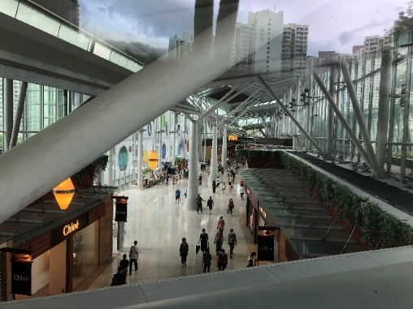
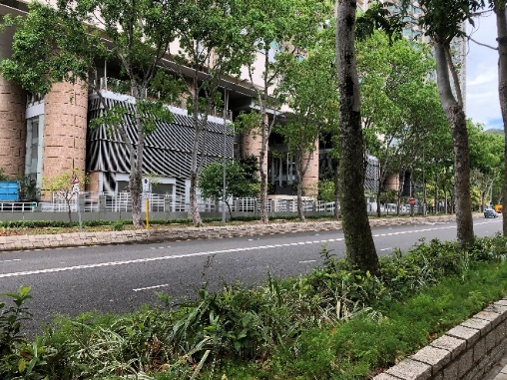
Currently, Tung Chung is undergoing a huge-scale extension that will bring the projected population to 268,000, with the first intake of new residents in 2023. In response to complaints about the poor provision and distribution of facilities in Tung Chung East and West, the Civil Engineering and Development Department (2014) proposed ‘a generous provision of GIC [Government, Institution and Community] facilities, recreational facilities and open space to serve the existing and planned population. For instance, in Tung Chung West, a sports centre, a GIC complex (for clinic and social welfare facilities), two primary schools, and two 7-a-side football pitches in Tung Chung West, together with the planned Sports Centre adjacent to the future Area 39 public rental housing site are proposed’. Still, there are no plans for any cultural facilities and infrastructure. The new town community lacks a focal point and “civic culture - the construction of town halls, museums, libraries, concert halls . . . central to identity and image” (Stobart, 2004).
Figure 5: Residents have to pass through commercial mall and bridge network to reach the library and community hall. Source: the author
Figure 4: The facility is surrounded by private estates and empty road networks. Source: the author

4. Conclusion
This paper discussed the potential role of cultural architecture in the development of a collective urban identity in new development areas. The symbolic significance of an iconic building can, when embedded in the local social and cultural life, contribute to the creation of urban identity and even function as a radical imaginary, instituting an image of a desired future. When reviewing Hong Kong’s new towns, most scholars criticize the lack of self-containment through a focus on long commutes to the new towns from the main job provisions. However, there is little attention to the need for public cultural life. In recent years, cultural funding has been predominantly assigned to the central districts of Hong Kong, while the new towns lagged behind. The lack of identifiable social places that residents describe is representative of this. New towns are planned from the top-down, focusing on quantifiable numbers only, and overlook that not only new housing is necessary, but a new community needs to be built. Incorporating distinct, well-positioned public cultural buildings provides an opportunity to create community icons and a local identity, as they can also influence the urban space. We need to learn how to build new towns that are self-contained, not only in a socio-economic sense but also in the provision of public cultural life. With the extension of Tung Chung currently under reclamation, there is an urgent need to recognise this challenge and start to incorporate the provision of cultural infrastructure as soon as possible to prevent this from becoming another ‘cultural desert.’

Acknowledgments
Thanks are due to the referees for their insightful and helpful comments on an earlier version of this paper. I would also like to thank Stephanie Cheung for her kind assistance in the collection and analysis of the data. Thanks also to Martin Lau and Marcus Ma for their help in drawing the maps.

References
- CARTIER, C. 2008. Culture and the city: Hong Kong, 1997–2007. China Review, 59–83.
- CASTORIADIS, C. 1987. The Imaginary Institution of Society, trans. Kathleen Bliemen (Cambrdige: MIT University Press, 1987), esp, 340–73.
- CENTAMAP, C. A. S. D., LANDS DEPARTMENT, 2016. 2016 Population By-census Statistics. In: DEPARTMENT, C. A. S. D. C. L. (ed.). Hong Kong
- CHAN, P. C. 2001. New Towns in Hong Kong: Planning for the Next Generation. Council on Tall Buildings and Urban Habitat 6th World Congress.
- CHEUNG, Y. 2021. Urban Politics Debate on Tung Chung 2021. Hong Kong.
- CIVIL ENGINEERING AND DEVELOPMENT DEPARTMENT 2014. Tung Chung New Town Extension Study Public Engagement Report (Stage 2) Summary of Major Issues Identified and Overall Responses.
- CIVIL ENGINEERING AND DEVELOPMENT DEPARTMENT 2016. New Towns, New Development Areas and Urban Developments. In: CIVIL ENGINEERING AND DEVELOPMENT DEPARTMENT (ed.).
- ENG, T. S. 1996. Character and Identity in Singapore New Towns: Planner and Resident Perspectives. Habitat International, 20, 279–294.
- EVANS, G. 2003. Hard-branding the Cultural City: From Prado to Prada. International Journal of Urban and Regional Research, 27, 417–440.
- EVANS, G. 2005. Measure for Measure: Evaluating the Evidence of Culture's Contribution to Regeneration. Urban studies, 42, 959-983.
- FONG, L.-F. 2021. Urban Politics Debate on Tung Chung 2021. Hong Kong.
- FORSYTH, A. & PEISER, R. 2021. Exploring the New Town Idea in Practice. In: PEISER, R. & FORSYTH, A. (eds.) New Towns for the Twenty-First Century: A Guide to Planned Communities Worldwide. University of Pennsylvania Press.
- HARVEY, D. 1989. From Managerialism to Entrepreneurialism: The Transformation in Urban Governance in Late Capitalism. Geografiska Annaler: Series B, Human Geography, 71, 3–17.
- HARVEY, D. 1994. The Invisible Political Economy of Architectural Production. In: BOUMAN, O. & TOORN, R. V. (eds.) The Invisible in Architecture. London : New York, N.Y.: Academy Editions, Distributed by St. Martin's Press.
- HE, S. Y., TAO, S., NG, M. K. & TIEBEN, H. 2020a. Evaluating Hong Kong’s Spatial Planning in New Towns from the Perspectives of Job Accessibility, Travel Mobility, and Work–Life Balance. Journal of the American Planning Association, 1–15.
- HE, S. Y., WU, D., CHEN, H., HOU, Y. & NG, M. K. 2020b. New Towns and the Local Agglomeration Economy. Habitat International, 98, 102153.
- HILLS, P. & YEH, A. 1983. New Town Developments in Hong Kong. Built Environment, 9, 266–277.
- HO, K. C. 2006. Where Do Community Iconic Structures Fit in a Globalising City? City, 10, 91–100.
- HO, L. 2017. From ‘No Cultural Policy’ to ‘Centralised Market Orientation’:The Political Economy of Hong Kong Cultural Policy (1997–2015). Global Media and China, 2, 57–73.
- HOLLANDER, J. B., GRAVES, E., RENSKI, H., FOSTER-KARIM, C., WILEY, A. & DAS, D. 2016. Urban Social Listening: Potential and Pitfalls for Using Microblogging Data in Studying Cities, Springer.
- HOME AFFAIRS BUREAU 2020. Legislative Council Panel on Home Affairs. 2020 Policy Address. Policy Initiatives of Home Affairs Bureau.
- KAIKA, M. 2010. Architecture and Crisis: Re-Inventing the Icon, Re-Imag(In)Ing London and Re-Branding the City. Transactions - Institute of British Geographers (1965), 35, 453–474.
- KAIKA, M. 2011. Autistic architecture: the fall of the icon and the rise of the serial object of architecture. Environment and Planning D-Society & Space, 29, 968-992.
- KAIKA, M. & THIELEN, K. 2006. Form follows power. City, 10, 59-69.
- LEFEBVRE, H. 2003. The urban revolution, U of Minnesota Press.
- LYNCH, K. 1960. The image of the city, MIT press.
- MCNEILL, D. 2009. The global architect: firms, fame and urban form, Routledge.
- MCNEILL, D. & TEWDWR‐JONES, M. 2003. Architecture, banal nationalism and re-territorialisation. International Journal of Urban and Regional Research, 27, 738-743.
- MOVIUS, L. 2020. Hong Kong's M+ museum delayed to autumn 2021 amid management troubles and spiralling costs. The Art Newspaper.
- ONG, A. 2011. Hyperbuilding: spectacle, speculation, and the hyperspace of sovereignty. In: ROY, A. & ONG, A. (eds.) Worlding cities: Asian experiments and the art of being global.
- OOI, V. 1995. The best cultural policy is no cultural policy: Cultural policy in Hong Kong. International Journal of Cultural Policy, 1, 273-287.
- PLANNING DEPARTMENT 2019. Tung Chung. Planning for Liveable New Towns.
- PLANNING DEPARTMENT 2020. Chapter 3 Community Facilities, Hong Kong Planning Standards and Guidelines.
- PONZINI, D. 2011. Large scale development projects and star architecture in the absence of democratic politics: The case of Abu Dhabi, UAE. Cities, 28, 251-259.
- RUGGERI, D. 2009. Constructing identity in master planned utopia: The case of Irvine New Town, University of California, Berkeley.
- SKLAIR, L. 2017. The icon project: architecture, cities, and capitalist globalisation, Oxford University Press.
- SORKIN, M. 2002. Brand aid. Harvard Design Magazine, 17.
- STOBART, J. 2004. Building an urban identity. Cultural space and civic boosterism in a 'new' industrial town: Burslem, 1761-1911. SOC HIST, 29, 485-498.
- WANNOP, U. 1999. New towns. British planning, 50, 213-231.
- XUE, C. Q. 2019. From Colonial to Global—Performing Art Space in Hong Kong. In: XUE, C. Q. (ed.) Grand Theater Urbanism. Springer, Singapore.
- XUE, Q. L., HUI, K.C., ZANG, P. 2013. Public buildings in Hong Kong: A short account of evolution since the 1960s. Habitat International, 38, 57-69.
- YEH, A. G.-O. 1997. Economic restructuring and land use planning in Hong Kong. Land Use Policy, 14, 25-39.
- YEH, A. G.-O. 2021. Successes and Failures of New Towns in Hong Kong. In: PEISER, R. & FORSYTH, A. (eds.) New Towns for the Twenty-First Century: A Guide to Planned Communities Worldwide. Philadelphia: Philadelphia: University of Pennsylvania Press.
- ZUKIN, S. 1995. The cultures of cities, Cambridge, Mass., Blackwell.

