Type of the Paper: Peer-reviewed Conference Paper / Full Paper
Track title: “Urban-rural Integration” and “Areas In-Between”

China’s Urban Growth Boundaries: Towards a Context-Responsive Method
Christian Nolf ², Yuting Xie ^{1,}* and Weishun Xu ³
Names of the track editors:
Alexander Wandl
Rodrigo Cardoso
Names of the reviewers:
Alexander Wandl
Huaqing Huang
Journal: The Evolving Scholar

DOI:10.24404/6167f3651486320009909234

Submitted: 14 October 2021
Accepted: 01 June 2022
Published: 21 November 2022
Citation: Nolf, C., Xie, Y. & Xu, W. (2021). China’s Urban Growth Boundaries: Towards a Context-Responsive Method. The Evolving Scholar | IFoU 14th Edition.

This work is licensed under a Creative Commons Attribution CC BY (CC BY) license.
©2021 [Nolf, C., Xie, Y. & Xu, W.] published by TU Delft OPEN on behalf of the authors.

¹ Institute of Landscape Architecture, College of Agriculture and Biotechnology, Zhejiang University, Hangzhou, China; xieyuting@zju.edu.cn; ORCID ID: 0000-0002-6379-8908, * (corresponding author)
² Group Landscape Architecture and Spatial Planning, Wageningen University, The Netherlands; christian.nolf@wur.nl ; ORCID ID: 0000-0003-4304-2107
³ Department of Architecture, Zhejiang University, Hangzhou, China; xuweishun@zju.edu.cn

Abstract: After four decades of fierce urban growth driven by economic development, China recently adopted a ‘three red lines’ policy to protect its permanent farmland, vital ecosystems, and to contain urban expansion. To delineate urban growth boundaries (UGBs), current methods all employ quantitative land-use suitability indicators to define a compromise between competing spatial claims. However, ignoring site characteristics and underpinned by an increasingly dualistic conception of the urban and the rural realms, these methods often result in divisive UGBs devoid of any spatial quality. This paper explores how UGBs, rather than passive borders, can be designed as context-responsive and integrative urban-rural interfaces. A brief description of the urban growth phenomenon and the authorities’ responses at the national level is followed by more specific investigations in the Yangtze River Delta (YRD) region. Six representative urban-rural edges are examined in terms of historical development, planning, policies, current challenges, and opportunities. Based on the analysis, alternative design strategies are proposed to refine the definition of UGBs from a perspective of spatial quality and programmatic innovation. A final part discusses how the design explorations in the YRD can be systematized as a qualitative context-responsive method for UGB planning in China.
Keywords: Urban Containment; Urban Growth Boundary; Three Red Lines Policy; Chinese Planning; Research-Through-Design.

1. Introduction: Containing Chinese cities

China’s recent urbanisation is unprecedented in human history. Since the economic reform of 1978, the rate of urban population has increased from 17.9% to over 60% in 2020 (National Bureau of Statistics of PRC, 2020). This massive human wave, which saw 774 million people migrate to cities, was accompanied by a fourfold increase in urban land on the national average, and up to 11-fold increase in some megacity regions (Kuang, 2020; Liu et al., 2015). Encouraged by the authorities as an engine of economic development, the creation of urban land has been officially guided by urban masterplans (Deng et al., 2010; Hsing, 2010; Chen, 2016).

However, on the ground, urban expansion has also occurred less formally. Due to a lack of coordination between administrative levels and between sectoral agencies, the creation of urban land has often exceeded actual market demand (Long et al., 2013). In particular, many speculative urban developments have been initiated by rural communes on the outskirts of cities to inflate their economic performance artificially (Verdini et al., 2016).

As a result, in most parts of China, the physical growth of cities has preceded, if not denied, official town planning. A retrospective of the successive master plans of cities like Hangzhou, Nanjing, Shanghai, and Beijing shows how the green belts supposed to contain urbanisation have each time been ignored by the voracious appetite of developers (Yang & Jinxing, 2007; Zhao, 2011; Yue et al., 2013; Wang et al., 2014; Tian et al., 2017; Shao et al., 2020).

In this hyperdynamic and semi-controlled context, the very idea of an urban edge has long been an abstract and unstable notion. Rather than a space, the urban edge in China was more synonymous with an ephemeral condition awaiting hypothetical development. Due to its inherently transient nature, China’s urban edge has until recently not been considered in terms of spatial quality.

Recently, however, the tide has turned. Several studies have highlighted the negative environmental impact of urban land expansion (He et al., 2017), as well as its predominant contribution to the dramatic loss of agricultural land. It has been estimated that the destruction of farmland has accounted for 55% of the newly-expanded urban areas in China (Liu et al., 2019). In addition, research has shown that despite national land use plans and policies promoting compact forms of development, the average intensity of urban land uses in China has steadily declined over the past decades (Chen et al., 2016).

In response to these environmental, food security, and inefficient land use issues, China adopted in 2018 a strict ‘three red lines’ policy for the protection of vital ecosystems, permanent farmland, and the containment of cities (Xu et al., 2018; Jiang et al., 2019). Framed by the national strategy of “Ecological Civilization Construction,” the three red lines policy is supported by a new integrated “territorial planning system.” It is steered by a new “super” Ministry of Natural Resources, which merges the formerly competing sectors of land resources and spatial planning (Ma & Liu, 2018; Jiao, 2019; Nolf & Xie, 2020; Liu & Zhou, 2021).

In addition, massive investments in regional transport networks have completely reconfigured the spatiotemporal relationship between cities (Chen, 2020). In the Yangtze River Delta (YRD) megacity region, it now takes less time to reach the center of Shanghai from Hangzhou by high-speed train (196 km in 50 minutes) than from Shanghai’s outer periphery by metro (42 km in 1h21). In these hyper-connected urban constellations, it is now possible and realistic to prevent peri-urban growth around certain cities and redistribute development pressure at a regional scale, in existing or new satellite towns (Mao et al., 2020).

2. Theories and Methods: re(de)fining urban growth boundaries

Containing urban growth is an old and global problem. As a country still undergoing a process of urbanisation, China has the opportunity to learn from previous experiences in other contexts. A substantial body of international literature examines and occasionally compares urban containment approaches in terms of objectives, methods, performance, and impact (Dawkins & Nelson, 2004; Millward, 2006). It shows that while most containment approaches aim to protect natural areas and farmland, and to promote compact forms of developments, they differ in the method adopted. The diversity of methods reflects the different institutional structures, planning systems, and spatial conditions specific to each context. Containment strategies obviously cannot be the same for addressing centralised metropolitan areas in the USA and Japan, or for addressing the polycentric constellation of mid-size cities and “territories-in-between” found in Western Europe (Wandl et al., 2014).

Among international precedents, the UK’s approach to urban containment is of particular interest to China. The UK not only pioneered the concept of ‘green belt’ that strongly influenced the Chinese planning system (Yang et al., 2007; Wang et al., 2014). The UK also founds its containment strategy on a strong countryside protection paradigm, and supports it with strict land-use control instruments coordinated at the national level. This approach echoes the centralised structure of Chinese planning and its new priorities for environmental protection. In this regard, the work of Nick Gallent and his colleagues on urban peripheries is worth examining: questioning the strict classification of urban and rural categories in the UK planning system, it seeks to recognise the specific value of urban-rural fringes as multifunctional areas that perform vital functions for both the city and the countryside (Gallent et al., 2004; Gallent & Shaw, 2007).

While most of the literature on urban containment focuses on land-use policies, a few precedents also address the question of UGBs in spatial and programmatic terms. Among these, the ‘Transect’ model championed by New Urbanism conceptualises the transition from the city to the countryside as a gradient in six distinct T-zones characterised by a decreasingly dense urban fabric (Duany & Talen, 2002). Used both as an analytical tool and as a code-based prescriptive planning instrument, the T-zones transect model nonetheless assumes a radio-concentric layout of the city, which only rarely corresponds to the complex reality of polycentric metropolitan peripheries.

Other spatial strategies for urban-rural boundaries have emerged through design competitions and calls for ideas. Among the most influential, the winning entry for the Dutch Green Heart by Harrison Studio in the mid-1990s imagines the urban-rural interface as a chain of wetlands to store freshwater while spatially marking the boundary (Harrison & Harrison, 1997; Tjallingii, 2000). Although not implemented, this vision inspired, in subsequent plans, the concept of an active ecological buffer zone at the edge of the Green Heart.

In 2008–2009, the international consultation for the future of the Grand Pari(s) highlighted the need to requalify the contours of the metropolitan area. Pointing out the lack of urban-rural dialogues on the outskirts of Paris, the multidisciplinary team involving Jean Nouvel and Michel Desvigne proposed widening and upgrading the urban growth boundary into an agro-urban ribbon combining small-scale agricultural programs (orchards, vegetable gardens, greenhouses) with public facilities (parcs, trails, public spaces) so that “the urban and rural worlds can benefit from (...) the qualities of the other” (Desvigne, 2009).

In any case, however, the literal transfer of urban containment models and strategies from one context to another is neither relevant nor desirable. Observing the challenges in Chinese urban-rural edges, Verdini et al. (2016) recall the importance of considering the specific institutional, cultural, and spatial conditions of each context: not only China’s dual land tenure system that governs urban and rural land fundamentally distinctly (note 1), but also the great diversity of spatial patterns found across the country.

Recently, several sophisticated methods have been elaborated and tested to define UGBs in the specific context of China. Based on indicators of land-use efficiency, connectivity, carrying capacity, ecological security pattern, and ecosystem services, these methods provide scientific support for determining the spatial needs of different functions and defining their most reasonable locations (Long et al., 2010; Zhou et al., 2014; Jiao, 2015; Ma et al., 2017, Mao et al., 2020; Wang et al., 2020). However, the outcomes of these methods remain a quantitative compromise between competing land claims. Ignoring site characteristics and underpinned by an increasingly dualistic conception of the urban and the rural realms, these methods often result in generic and inert UGBs that don’t respond to their context.

Aiming to maintain and consolidate urban-rural dialogues, our research enriches the outline of the UGBs with a perspective of spatial quality and programmatic innovation. It investigates how UGBs, rather than passive boundaries, can be conceived as context-sensitive and integrative urban-rural interfaces (Fig. 1). This objective is broken down into three sub-questions related to the past, present, and future of urban edges:

- How can the historical development pattern of urbanisation explain the current conditions of city edges?
- What specific spatial features and activities can currently be observed in urban-rural edges?
- Based on existing local resources and needs, which alternative UGBs could be imagined in the future?

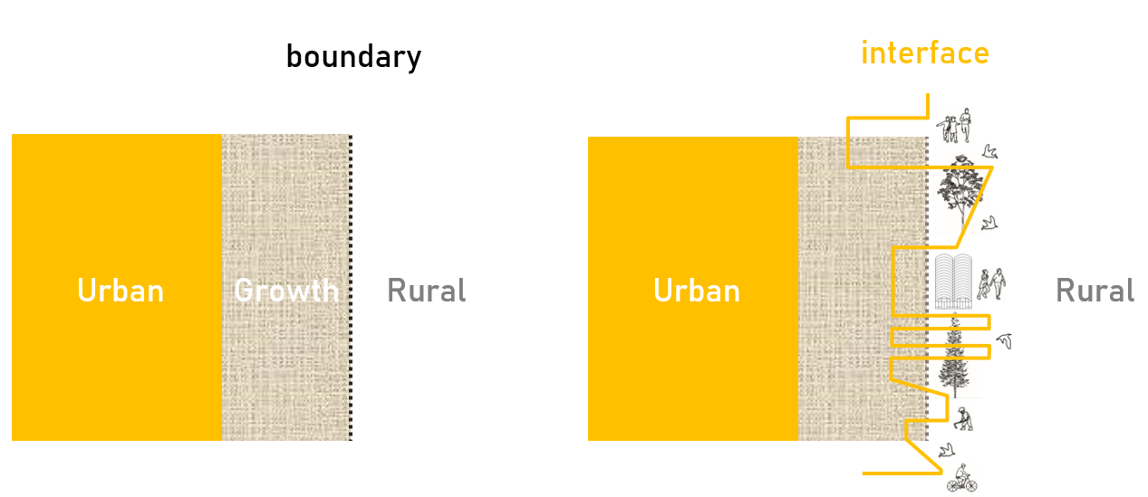Figure 1. Urban Growth Boundary: from a passive border to an active interface

To address these questions, we examined the urban edges surrounding the vast green heart of the YRD megacity region. Developed on the deltaic plain south of the Yangtze River, the YRD megacity is an extraordinarily densely populated region comprising the cities of Shanghai, Suzhou, Jiaxing, and Hangzhou (Nolf et al., 2021). Subject to an ambitious Integration Plan since 2019, the YRD is a vivid example of the urgent need to protect open spaces and contain urbanisation. Next to objectives of economic, transportation, energy, and service integration, the YRD plan also includes strict quotas for permanent farmlands, preservation of ecological space, and a vast demonstration zone for integrated ecological and green development (CPG, 2019; NDRC, 2019; DNRZP, 2020).

We sampled six study areas along the UGBs recently planned to frame this demonstration zone (Fig. 2). All study areas have the same dimensions: 20 km in length to cover diverse edge conditions; 6 km transversely to provide an in-depth overview of the urban-rural transition. The study areas are nevertheless differentiated by their urban fabric and their landscape morphology. Furthermore, study areas located near major urban centres (edges 2, 5, 6) are subject to more intense development pressure than less central areas.

For each study area, a historical analysis, a critical review of successive master plans and policies, and a field survey on foot and with aerial views by drone were carried out to define local resources, current challenges, and future opportunities. Particular attention was devoted to identifying, through interpretive mapping and modelling, the spatial characteristics of the infrastructural and landscape systems framing each study area (Fig. 3).

This diagnosis in turn inspired context-responsive strategies for the (re)definition of the UGB in each study area. The strategies consist of a vision for the 20 km-long edge and of a detailed spatial design project materialising the vision in a representative 1 x 1 km2 site (see Table 1).

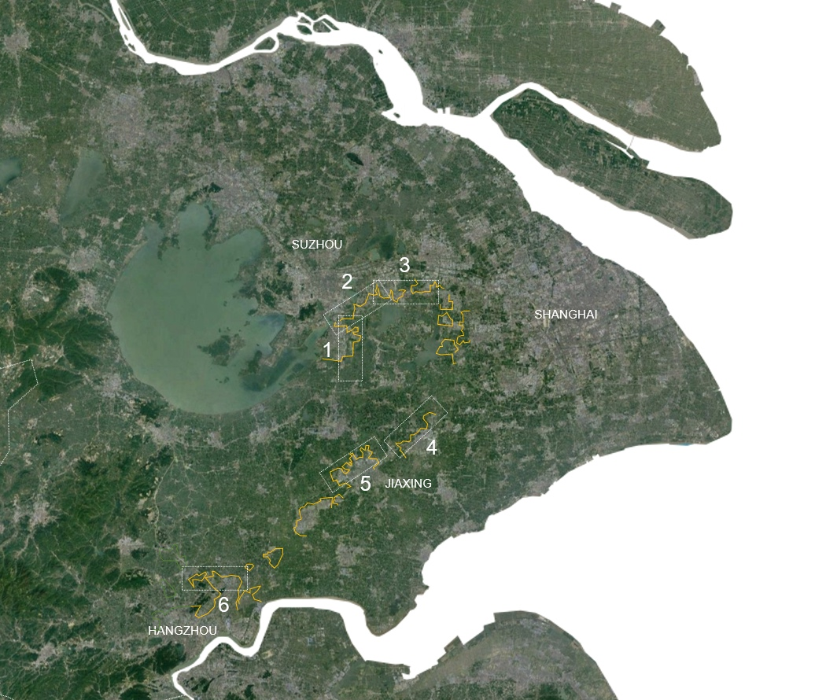

Figure 2. Study areas: 6 samples (20 km x 6 km) of urban edges were selected along the most recently planned UGBs surrounding the green heart of the YRD megacity region.

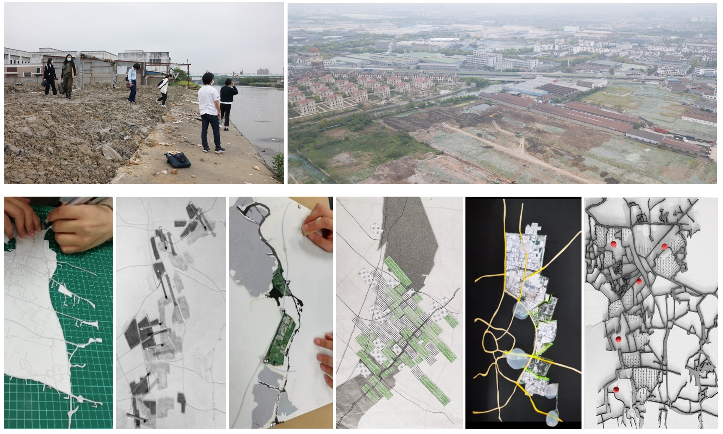
Figure 3. Methods: A set of techniques was used to identify the origin, condition, challenges, and resources of each of the six urban-rural edges in the YRD: historical analysis, field survey (pictures above), and interpretative mapping and modelling (pictures below).

3. Results

The examination of the six sample areas in the YRD generates insights on the past, present, and potential future of its urban-rural edges:

3.1. PAST: three identified types of edges

A first lesson relates to how the historical development patterns of urbanisation have conditioned the current edges. In all sites, the urbanisation process has involved a rapid and profound transformation of a preexisting rural landscape, with a peak period in 2000–2015. Three types of edges can be distinguished according to the intensity of the transformation (see Table 1, left column):

- First, sharp edges. Observed near the most densely populated areas, this type of edge results from the strict and rapid implementation of an urban masterplan. Replacing the original landscape entirely with a new grid of roads and canals, this type of edge features an hermetic urban-rural relationship;

- Second, hybrid edges. This type results from the superposition of a grid of roads on top of the original hydrological landscape. It is found in areas with less development pressure, where the means to reconfigure the water system were more limited. The combination of the road grid and the winding course of the rivers creates interesting variations within the blocks, but also more porous and diversified borders on the urban-rural edge;

- Third, organic edges. This type results from in-situ, unplanned, and incremental urban growth within the preexisting landscape structure. Observed in the least connected places, this type of urban-rural edge manifests itself through a gradual intensification of urban functions.

3.2. PRESENT: status quo and current activities

The observation of urban edges today reveals contrasting conditions. In several sites, the actual urban footprint occupies only a fraction of an overly ambitious old masterplan that has not been followed up by development (see Fig. 4). In other sites (including edge 2 and 4), a recent process of deindustrialization for integrated ecological and green development has dismantled the crown of old factories and workshops that occupied the peripheries. The result is a discontinuous and heterogeneous edge, an amalgamation of productive activities, residential functions, and large-scale urban facilities.

This environment is nonetheless the scene of various activities that opportunistically take advantage of the proximity of both the rural and the urban realms. Somehow echoing the notion of multifunctional fringe described by Gallent et al. (2004), the YRD’s urban-rural edge today features, among others++, informal vegetable gardens managed by the local communities, ancient villages transformed into affordable dormitories for the “floating population” of migrant workers, or abandoned industrial estates temporarily occupied by small businesses.

In contrast to the rich diversity of elements and emerging practices encountered on the edge today, the official plans for the future urban-rural boundaries are strikingly rigid. Guided by top-down quantitative prescriptions and ignoring local specificities, the projected UGBs of masterplans draw a strict line between monofunctional urban blocks on the one hand, and a deeply rationalised agricultural landscape on the other. As such, the planned urban-rural boundaries annihilate all possibilities for urban-rural dialogue in the future.

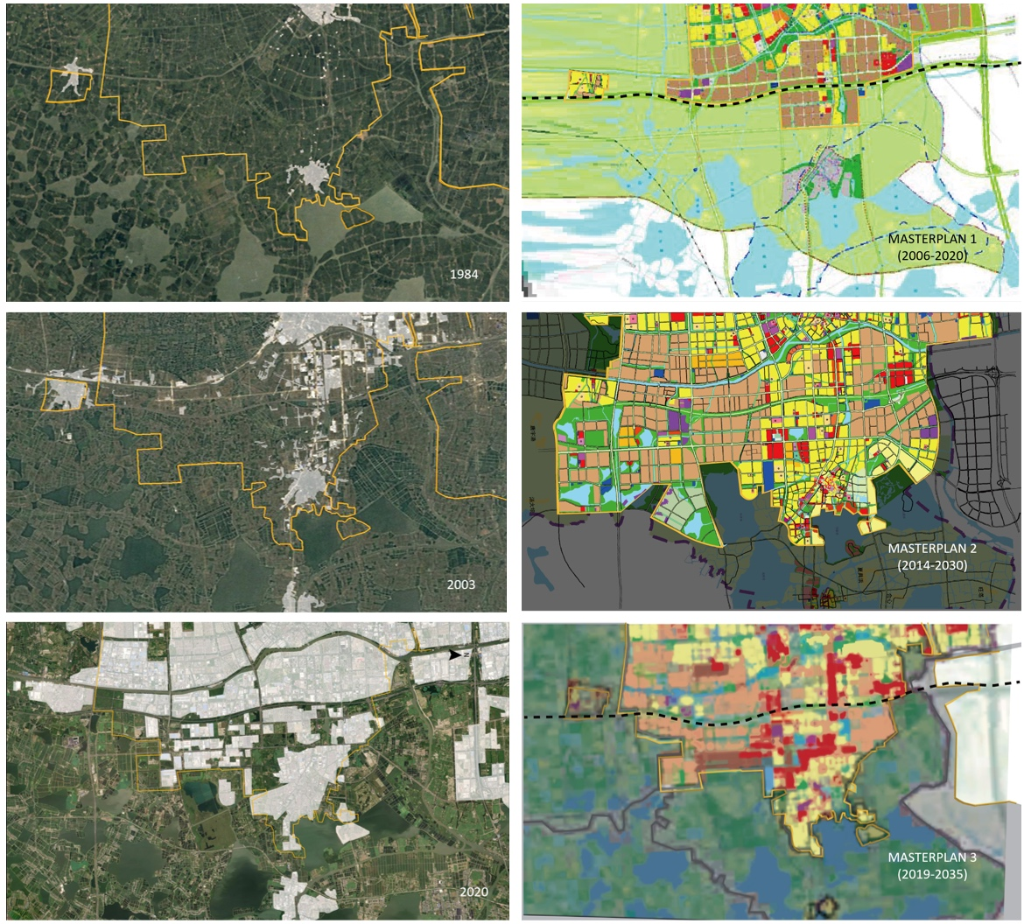
Figure 4. Plans vs. Reality: the historical review of the urban development in the different edges (here: edge 1) explains the persistence of some landscape features within the urban fabric but also shows how over-ambitious masterplans of the 2010s have been only partially occupied and recently motivated a retracted version of UGB.

3.3. FUTURE: alternative strategies for context-responsive UGBs

Based on the analysis of the six study areas, a total of 18 design projects reimagined UGBs as active urban-rural interfaces. Out of these 18 projects, three distinct but complementary contextual strategies can be synthesized (Table 1):

- Performative landscape fringes

A first strategy is to reconcile the urban edge with its bordering landscape. In all of the studied sites, the official UGB has been defined from a purely urban perspective: it determines the legal limit up to which the grid carpet of urban blocks can be unrolled. However, in several sites, this edge is bordered by a characteristic and significant landscape structure, such as the famous Wusong River (edge 2), the World-Heritage listed Grand Canal (edges 5 and 6), or the centuries-old cultural landscape of the Jiangnan polders (edges 1, 3, 4) (Vannoorbeeck et al., 2019; Wang & Nolf, 2020; Xie & Nolf, 2020).

Rather than conceiving the UGB as a dividing line, the strategy is to address the entire urban-rural fringe as a significant space in its own right. Inspired by Desvigne’s approach to “widen the edge” (2009), the purpose is to identify and select landscape or infrastructural structures capable of framing the urban border in resonance with its wider context.

Mediating between the city and the countryside, the landscape fringes can be particularly suitable for hosting large-scale environmental and recreational programs such as constructed wetlands, water storage, urban agriculture, windfarms, or riverfront parks. The projects “Farm as Frame” (edge 1) or “Wusong River Wetland Park” (edge 2) exemplify, in their own distinct way, how a performative landscape fringe can become a unifying and meaningful envelope through which city and countryside dialogue.

- Found Objects

A second principle is to take advantage of the resources and elements present on the boundary. As mentioned above, urban edges generally align functions which, due to their size or the nuisances they cause, do not fit in the heart of the city: power and waste treatments plants, logistic platforms, and industrial estates. Still in operation, underused, or decommissioned, these elements are nevertheless an integral part of the edge’s plural identity and offer multiple opportunities for (re)uses (Wood & Ravetz, 2000).

The “Found Objects” strategy consists of a selection and adaptive reuse of these unique items. Because of their history or their unconventional spatial qualities, these found objects can inspire original reconversion programs linked to education, culture, or events. Locally, they can contribute to preserving the memory and identity of the places to be urbanized, but also become a constituent element of new narratives along the future UGBs.

The project “Jiangnan Villages Cultural Route” along edge 3 proposes, for instance, to maintain and revitalise the ancient villages located on the edge and to interconnect them as relays between famous water towns. Gaining new significance as a thematic heritage route, the UGB can become a vivid linear place where old and new, big and small, and urban and rural values dialogue and interplay.

- Transverses

A third principle takes a lateral view of the urban-rural edge. It investigates the elements and structures that cross the boundary transversally: the rivers that penetrate the urban grid and the streets that end up on the rural edge. The identification, selection, and enhancement of these transverse structures – both natural and artificial– is a way to maintain a visual, functional, and symbolic link between the city and its surrounding rural landscape.

The (re)qualification of transverses offers an alternative to the current model of hermetic urban carpet that ignores the adjacent rural landscape. As carriers of ecological corridors, soft mobility networks, or articulating public spaces programs, the activation of transverses maintains the possibilities of in-depth urban-rural exchanges.

Two complementary projects for edge 1 illustrate how a transversal approach can be applied in both directions: “Intermediary Rivers” rearticulates in a blue-green network the residual spaces found along the creeks crossing the boundary. Conversely, the “Urban Balconies” project focuses on dead-end streets abutting the urban-rural boundary and magnifies them as public gateways to nature. Together, these projects form a transversal armature that enlivens the UGB as a place of dialogue between city and countryside.

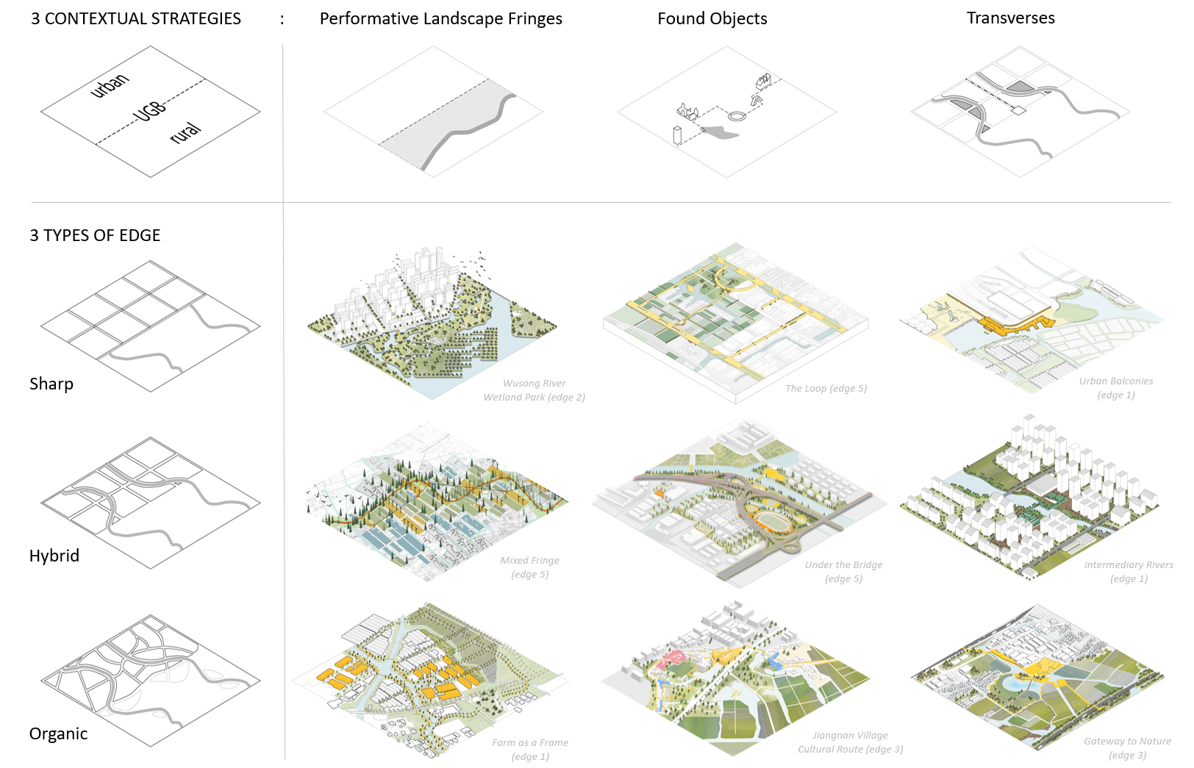

Table 1: Strategic matrix: three distinct, but complementary strategies are proposed to draw context-responsive UGBs: Performative Landscape Fringes; Found Objects; Transverses. A selection of nine design projects on 1 x 1 km2 sites illustrates how each strategy can be declined in the different edge conditions.

4. Discussion: towards a qualitative method for context-responsive UGBs

The implementation of China’s three redline policy is not only a land-use planning matter. Involving the delineation of permanent UGBs, it is also a landscape and urban design assignment that will determine for a long time how cities interact with their rural counterparts. In this regard, our research does not pretend to replace existing quantitative land-use suitability methods, but to enrich them with spatial quality and programmatic perspectives. Drawing lessons both from exemplary international precedents and from our exploration of urban-rural fringes in the YRD, three suggestions can be made for a contextual approach to UGBs:

First, to work across the scales. Most current methods proceed from the general to the local: they assess how general quantitative objectives can be implemented in local conditions. In contrast, a cross-scalar method that combines the analysis of large scale landscape systems with a sampling of typical edge conditions helps grasping how local specificities can inductively inform the definition of genuinely contextual boundaries.

Second, to inform planning with historical analysis. Current methods evaluate from today’s situation how expansion needs can be met in the future. A retrospective analysis of border areas can, additionally, elucidate their origin and development: it assesses the capacity of a site to be transformed and densified, but also identifies historic landscape features or elements that have the potential to guide site-specific developments.

Third, to think inclusively. Unlike land-use based methods that conceive UGBs in exclusive and divisive functional terms, an inclusive approach values the capacity of urban-rural fringes to accommodate a multiplicity of functions. To this end, onsite fieldwork is essential to capture the unique hybridization of activities found in fringe areas and to collect the local intelligence of stakeholders and interest groups. These insights can, in turn, inspire innovative programs for future developments.

5. Conclusions

The containment of urbanisation is a global issue that has preoccupied the discipline of spatial planning since its creation. Even more today, the demographic pressure, the environmental crises and the climate emergency urgently demand to reinvent the way we inhabit the earth while preserving its resources. In that regard, China’s ambitious three red lines policy is a milestone from which other countries can learn.

To this end, this paper reviews the phenomenon of massive urbanisation that has transfigured China in recent decades and the current policy response. Focusing on its urban containment strategy, it points out the limitations of existing quantitative land-use methodologies to generate context-responsive UGBs. By exploring the past, present, and alternative futures of representative urban-rural edges in the YRD megacity region, this study suggests three methodological shifts to guide more contextual approaches to the definition of UGBs.

As pioneering research on the spatial and programmatic quality of UGBs in China, this study nevertheless presents the limitations of empirical, site-specific, and design-led explorations. In order to validate its potential as a qualitative method applicable to other contexts, we recommend future research directions to investigate how the proposed cross-scalar, historical, and inclusive approach can be supported by, respectively, typological classifications, site character assessment, and measurable indicators of functional integration.

Notes
Note 1: “In the Chinese land tenure system, urban land belongs to the state and is given in concession to urban households for a limited period of time, according to prevalent land use; the rural land is collectively owned, belonging to the rural communes, who allocate land among the members of the community based on egalitarian principles” (Hsing, 2010; cited in: Verdini, 2016).

Contributors statement
The three authors elaborated together the present research’s concept, methodology, and development through an interdisciplinary joint studio in the Spring semester of 2020–2021. The original draft of the paper was written by Christian Nolf and amended by Yuting Xie and Weishun Xu. The figures were selected out of the studio outcomes and edited by the authors.
The investigations presented in this paper contributes to the research of Jiangnan Lab, the interdisciplinary platform for regional design in contemporary China: https://www.researchgate.net/project/JIANGNAN-LAB-Exploring-Regional-Design-in-China

Acknowledgments
The work featured and discussed in this paper was produced in the frame of an interdisciplinary joint-studio bringing together the BArch in Architecture at Zhejiang University guided by Weishun Xu (Ying Jie, Zhu Yating, Xu Ye, Lu Yue, Zhu Yijiang, Wang Chenyan), the Bachelor of Agronomy in Landscape Architecture at Zhejiang University guided by Yuting Xie (Yan Shiyi, Hu Xinyu, Wang Xinger, Huang Sichang, Lin Lukang, Lin Yuyao, Zhou Yixuan, Chen Guanyi), and the MSc of Urban Design at Xi’an Jiaotong Liverpool University guided by Christian Nolf (Liu Ming, Qian Shengdan, Shang Yuanfang, Wang Zeyu, Zhan Jingchen, Zhang Hao, Zhao Yi, Zhu Webo, Yang Yanyang).

The studio has benefited from the input and feedback of Mrs. Zhang Dou (Director at Sasaki, Guest Prof. at Tongji University); Prof. Dr. Sigrun Langner (Bauhaus-Universität Weimar); Prof. Dr. Sören Schöbel (Technical University of Munich); Prof. Dr. Shen Lei (Tianjin University); Dr. Giulio Verdini (University of Westminster); Dr. Ren Xiang (Sheffield University); and Prof. Ute M. Meyer (Biberach University of Applied Sciences).
The following funding sources have supported the preparatory research for the studio:
- Evaluation Method for Blue-Green Infrastructure Connectivity in the Polder Areas: A Case Study of the Demonstration Zone for Integrated Ecological and Green Development in the Yangtze River Delta, Nature Science Fund of Zhejiang Province (No. LQ21E080016)
- Exploring the Spatial Implications of Integrated Water Management in the Suzhou Metropolitan Area, Jiangsu Province Programme of Science and Technology (No. BK20151244)
- Towards Spatially Integrated Water Resource Management in the Yangtze River Delta Metropolis, The Research Development Fund of Xi’an Jiaotong-Liverpool University (No. RDF 14-03-23)
- Research on the Characteristics and Evolution of Rural Landscape in North Zhejiang Plain, Fundamental Research Funds for the Central Universities (No. 2019QNA6023)
- Integrating Spatial Planning and Water Management in Urbanised Deltas: A Comparison of Instruments in the Yangtze (CN) and Scheldt-Meuse-Rhine (EU) River Delta Regions, Young International Scientist Programme of the National Science Foundation of China (No. 51550110235)

References

- Chen, C. L. (2020). High-speed Rail and Its Wider Spatial-Economic Impact on Transformation of Chinese Cities and Regions: A Multi-Level Analysis. In Handbook on Transport and Urban Transformation in China. Edward Elgar Publishing.
- Chen, F. (2016). The Design Dimension of China’s Planning System: Urban Design for Development Control. International Planning Studies, 21(1), 81–100.
- Chen, Y., Chen, Z., Xu, G., & Tian, Z. (2016). Built-up Land Efficiency in Urban China: Insights from the General Land Use Plan (2006–2020). Habitat International, 51, 31–38.
- Cherry, G., (1988). Cities and Plans: The Shaping of Urban Britain in the Nineteenth and Twentieth Centuries. Edward Arnold, London.
- CPG _ Central People’s Government of the People’s Republic of China (2019, December 1): Outline of the integrated regional development of the Yangtze River Delta. Retrieved from http://www.gov.cn/zhengce/2019-12/01/content_5457442.htm
- Deng, X., Huang, J., Rozelle, S., & Uchida, E. (2010). Economic Growth and the Expansion of Urban Land in China. Urban studies, 47(4), 813–843.
- Desvigne, M. (2009). Widening the Edges – Grand Paris 2009. http://micheldesvignepaysagiste.com/en/widening-edges (accessed on December 15, 2021).
- DNRZP _ Department of Natural Resources of Zhejiang Province (2020, June 18): Masterplan of Territorial Spatial Planning for the Demonstration Zone For Integrated Ecological and Green Development in the Yangtze River Delta (2019–2035). Retrieved from http://zrzyt.zj.gov.cn/art/2020/6/18/art_1289924_47444338.html
- Duany, A. & Talen, E. (2002) Transect Planning, Journal of the American Planning Association, 68(3), pp.
245–266.
Gallent, N., Shoard, M., Andersson, J., Oades, R. & Tudor, C. (2004) Inspiring England’s Urban Fringe: Multifunctionality and Planning, Local Environment, 9(3), pp. 217– 234.
- Gallent, N., & Shaw, D. (2007). Spatial Planning, Area Action Plans and the Rural-Urban Fringe. Journal of Environmental Planning and Management, 50(5), 617–638.
- He, C., Liu, Z., Xu, M., Ma, Q., & Dou, Y. (2017). Urban Expansion Brought Stress to Food Security in China: Evidence from Decreased Cropland Net Primary Productivity. Science of the Total Environment, 576, 660–670.
- Hsing, Y-T. (2010). The Great Urban Transformation: Politics of Land and Property in China. (New York: Oxford University Press).
- Jiang, B., Bai, Y., Wong, C. P., Xu, X., & Alatalo, J. M. (2019). China’s Ecological Civilization Program – Implementing Ecological Redline Policy. Land Use Policy, 81, 111–114.
- Jiao, L. (2015). Urban Land Density Function: A New Method to Characterize Urban Expansion. Landscape and Urban Planning, 139, 26–39.
- Jiao, S. (2019, May 30). Interpretation of Guideline on Coordinating the Delimitation and Implementation of Three Control Lines in Territorial Planning: Framing “Multiple Plan Coordination” in the Territorial Planning System. Retrieved from http://www.mnr.gov.cn/dt/ywbb/201905/t20190530_2433285.html
- Kuang, W. (2020). 70 years of Urban Expansion across China: Trajectory, Pattern, and National Policies. Chinese Science Bulletin, 65(23), 1970–1974.
- Liu, F., et al. (2019). Chinese Cropland Losses Due to Urban Expansion in the Past Four Decades. Science of the Total Environment, 650, 847–857.
- Liu, Y., & Zhou, Y. (2021). Territory Spatial Planning and National Governance System in China. Land Use Policy, 102, 105288.
- Liu, Y., Chen, J., Cheng, W., Sun, C., Zhao, S., & Pu, Y. (2014). Spatiotemporal Dynamics of the Urban Sprawl in A Typical Urban Agglomeration: A Case Study on Southern Jiangsu, China (1983–2007). Frontiers of Earth Science, 8(4), 490–504.
- Long, Y., Shen, Z., & Mao, Q. (2011). An Urban Containment Planning Support System for Beijing. Computers, Environment and Urban Systems, 35(4), 297–307.
- Long, Y., Han, H., Lai, S. K., & Mao, Q. (2013). Urban Growth Boundaries of the Beijing Metropolitan Area: Comparison of Simulation and Artwork. Cities, 31, 337–348.
- Ma, S., Li, X., & Cai, Y. (2017). Delimiting the Urban Growth Boundaries with a Modified Ant Colony Optimization Model. Computers, Environment and Urban Systems, 62, 146–155.
- Ma, T., & Liu, Q. (2018, May 14). China Reshapes Ministries to Better Protect the Environment. Retrieved from https://www.chinadialogue.net/article/show/single/en/10502-Chinareshapes-ministries-to-better-protect-environment
- Mao, X., Huang, X., Song, Y., Zhu, Y., & Tan, Q. (2020). Response to Urban Land Scarcity in Growing Megacities: Urban Containment or Inter-City Connection? Cities, 96, 102399.
- Millward, H. (2006). Urban Containment Strategies: A Case-Study Appraisal of Plans and Policies in Japanese, British, and Canadian cities. Land Use Policy, 23(4), 473–485.
- National Bureau of Statistics of PRC (2018): http://www.stats.gov.cn/ (accessed on January 20, 2021)
- NDRC _ National Development and Reform Commission (2019, October 26): The Overall Plan is to Build a Demonstration Zone for Integrated Ecological and Green Development in the Yangtze River Delta Region (Report No. 1686). Retrieved from http://www.gov.cn/xinwen/2019-11/19/5453512/files/1ea2d01619194ceeadbd0160215ffb66.pdf
- Nelson, A. C., & Dawkins, C. J. (2004). Urban Containment in the United States: History, Models, and Techniques for Regional and Metropolitan Growth Management. APA Planning Advisory Service Reports, (520), 1–82.
- Nolf, C., & Xie, Y. (2020). Positioning Regional Design in Chinese Territorial Spatial Planning: An Exploratory Project in the Yangtze River Delta Megacity Region. Landscape Architecture Frontiers, 8(1), 92–107.
- Nolf, C., Xie, Y., Vannoorbeeck, F., & Chen, B. (2021). Delta Management in Evolution: A Comparative Review of the Yangtze River Delta and Rhine-Meuse-Scheldt Delta. Asia-Pacific Journal of Regional Science, 5(2), 597–624.
- Shao, Z., Bakker, M., Spit, T., Janssen-Jansen, L., & Qun, W. (2020). Containing Urban Expansion in China: The Case of Nanjing. Journal of Environmental Planning and Management, 63(2), 189–209.
- Talen, E. (2002). Help for Urban Planning: The Transect Strategy. Journal of Urban Design, 7(3), 293–312.
- Tian, L., Li, Y., Yan, Y., & Wang, B. (2017). Measuring Urban Sprawl and Exploring the Role Planning Plays: A Shanghai Case Study. Land use policy, 67, 426–435.
- Tjallingii, S. P. (2000). Ecology on the Edge: Landscape and Ecology between Town and Country. Landscape and urban planning, 48(3-4), 103–119.
- Vannoorbeeck, F., Nolf, C., & Wang, Z. (2019). The Grand Canal in Jiangnan: Origin and Development of a Multifunctional Infrastructure. Plan, Magazine of the International Society of City and Regional Planners (ISOCARP),(9), 26–33.
- Verdini, G., Wang, Y., & Zhang, X. (2016). Urban China’s Rural Fringe: Actors, Dimensions and Management Challenges. Routledge.
- Verdini, G. (2016), The Rural Fringe in China: Existing Conflicts and Prospective Urban-Rural Synergies, in Urban China’s Rural Fringe. Actors, Dimensions and Management Challenges, edited by G. Verdini, Y. Wang and X. Zhang. Farnham: Ashgate.
- Wood, R. & Ravetz, J. (2000) Recasting the Urban Fringe, Landscape Design, 294(10), pp. 13–17.
- Wang, H. B., Li, H., Ming, H. B., Hu, Y. H., Chen, J. K., & Zhao, B. (2014). Past Land Use Decisions and Socioeconomic Factors Influence Urban Greenbelt Development: A Case Study of Shanghai, China. Landscape Ecology, 29(10), 1759–1770.
- Wang, Y. W., & Nolf, C. (2020). Historic landscape and water heritage of Suzhou beyond the tourist gaze. In Suzhou in Transition (pp. 42–86). Routledge.
- Wang, W., Jiao, L., Zhang, W., Jia, Q., Su, F., Xu, G., & Ma, S. (2020). Delineating urban growth boundaries under multi-objective and constraints. Sustainable Cities and Society, 61, 102279.
- Xie Y., Nolf C. (2020). Cultural Landscape Characterization and Spatial Strategies in the Metropolitan Areas of the Yangtze River Delta. Chinese Landscape Architecture, 36(12), 73–78. https://doi.org/10.19775/j.cla.2020.12.0073
- Xiyan Mao et al. (2020). Response to Urban Land Scarcity in Growing Megacities: Urban Containment or Inter-City Connection? Cities 96 (2020), 102399
- Xu, X., Tan, Y., Yang, G., & Barnett, J. (2018). China’s Ambitious Ecological Red Lines. Land Use Policy, 79, 447–451.
- Yang, J., & Jinxing, Z. (2007). The Failure and Success of the Greenbelt Programme in Beijing. Urban Forestry & Urban Greening, 6(4), 287–296.
- Yue, W., Liu, Y., & Fan, P. (2013). Measuring Urban Sprawl and Its Drivers in Large Chinese Cities: The Case of Hangzhou. Land Use Policy, 31, 358–370.
- Zhao, P. (2011). Managing Urban Growth in a Transforming China: Evidence from Beijing. Land Use Policy, 28 (2011), 96–109
- Zhou, R., Wang, X. J., Su, H. L., Qian, X., & Sun, B. (2014). Delimitation of Urban Growth Boundary based on Ecological Security Pattern. In Urban Planning Forum (Vol. 4, pp. 57–63).

