Type of the Paper: Peer-reviewed Conference Paper / Full Paper
Track title: Human-centred and nature-based approaches in cities

Rioplatense: Archives, Surveys and the Imaginability of the Buenos Aires Shoreline
Martin Flugelman Olmeda ¹, Luisa Lerman ², Ivan Breyter³ and Sofia Frasquet Dreyer⁴
¹ martin.flugelman@fadu.uba.ar; 0000-0001-6763-7397
² lululerman@gmail.com
³ ivanbreyter@gmail.com
⁴ sofiaclarafrasquetdreyer.532a@fadu.uba.ar; 0000-0002-2055-8226

Names of the track editors:
Claudiu Forgaci
Rene van der Velde
Names of the reviewers:
Claudiu Forgaci
Ana Maria Fernandez-Maldonado
Journal: The Evolving Scholar

DOI:10.24404/61699b46fa6c3e0009de0d5d

Submitted: 15 October 2021
Accepted: 01 June 2022
Published: 12 October 2022
Citation: Flugelman Olmeda, M., et al. (2021). Rioplatense: Archives, Surveys and the Imaginability of the Buenos Aires Shoreline. The Evolving Scholar | IFoU 14th Edition.

This work is licensed under a Creative Commons Attribution CC BY (CC BY) license.
©2021 [Flugelman Olmeda, M., et al.] published by TU Delft OPEN on behalf of the authors.

Abstract: Through a visual exploration of the Rio de la Plata’s littoral zone in Buenos Aires, the project seeks to reframe the ecological and aesthetic significance of the post-natural shoreline. The aim is to bring into focus the small-scale ecosystems at stake in the large-scale destruction of River Basin ecologies, exploring the liminal littoral where hybrid ecosystems flourish. The method consists of the study of visual documents from the shoreline that enable new ways of seeing the amphibious territories we live in. The muddy, shallow shore in Buenos Aires has always presented a problem for urban planning. Deemed unattractive and featureless in conventional terms, it has been severely undervalued as both a fragile ecosystem and waterfront. The built environment has been superimposed on top of an artificial sealed surface, and the native flora and fauna has been suppressed and controlled. The identity of the autochthonous landscape has largely been lost and the city’s inhabitants never really come into contact with the wetlands. The shoreline is a valuable urban commons that supports an ever-shifting, intricate system that thrives as a forgotten margin of the city. This research focuses on the urban shoreline, understanding it as a political subject and space in conflict, and in need of new approaches to urban practices.
Keywords: urban landscapes, atlas, post-natural, amphibious cities, coastal cities, river cultures.

1. Introduction

Since the early days of colonial settlement in Buenos Aires, the city has struggled to fortify itself against the unpredictable movements of the river and its widely-fluctuating tides. In its efforts to control the shore, urban development has claimed large tracts from the river, dumping debris along its banks, contaminating its waters, and piping its streams. Although the fragile autochthonous ecosystem has been severely disrupted, pockets of ecological resilience along the shoreline offer glimpses into an alternative future for the post-natural (Institute of Post-natural Studies, 2020) landscape. The aim of this investigation is to bring into focus the complex urban ecosystems at stake in the large-scale destruction of River Basin ecologies. The project belongs to an ongoing visual exploration of the city’s shoreline through a variety of lenses that contemplate photographs, art works, and cartography through the history of the site.

The shoreline is considered a landscape, and so to study its complexities it is necessary to acquire different sorts of information, in this case both visual and written documents. For some authors of intellectual history, ‘landscape’ is considered a result of the subsequent observation and interpretation of a sum of natural and artificial elements. As Simmel (1911) describes in his book Philosophy of Landscape, the concept of art does not operate in the daily discourses and gestures of people although there are configuration models that can be classified as artistic. Only when these models become governed by their own norms, do they cease to be at the service of daily life and configure an object in itself that responds to its own logic and presents a work of art. Under this configuration is how the landscape is conceived and therefore, it must be considered as a visual composition.

The Rio de la Plata estuary is a part of the Guarani Aquifer, one of the most important water systems in South America (Secretaría del Ambiente de Paraguay, 2003). It is the city’s primary water source, sewage disposal, and the maritime route through which commodities leave the region; and it is a vital part of Latin America’s neo-extractivist (Svampa, 2017) technical infrastructure. For hosting many complex relationships, the landscape of the Río de la Plata cannot be considered one, but many.

The accumulation of visual representations from diverse historical moments and its geolocation allows the interpretation of emerging similarities and variations on these complex urban sites. The study of visual documents enhances our capacities to transcend the verbal dichotomies, a product of the translation from visual statements to verbal categories. In order to review the relationship between citizenship and it’s the territory that we must take critical looks at these visual tools to build new dialogues that approach the urban controversies for a sustainable urban practice.

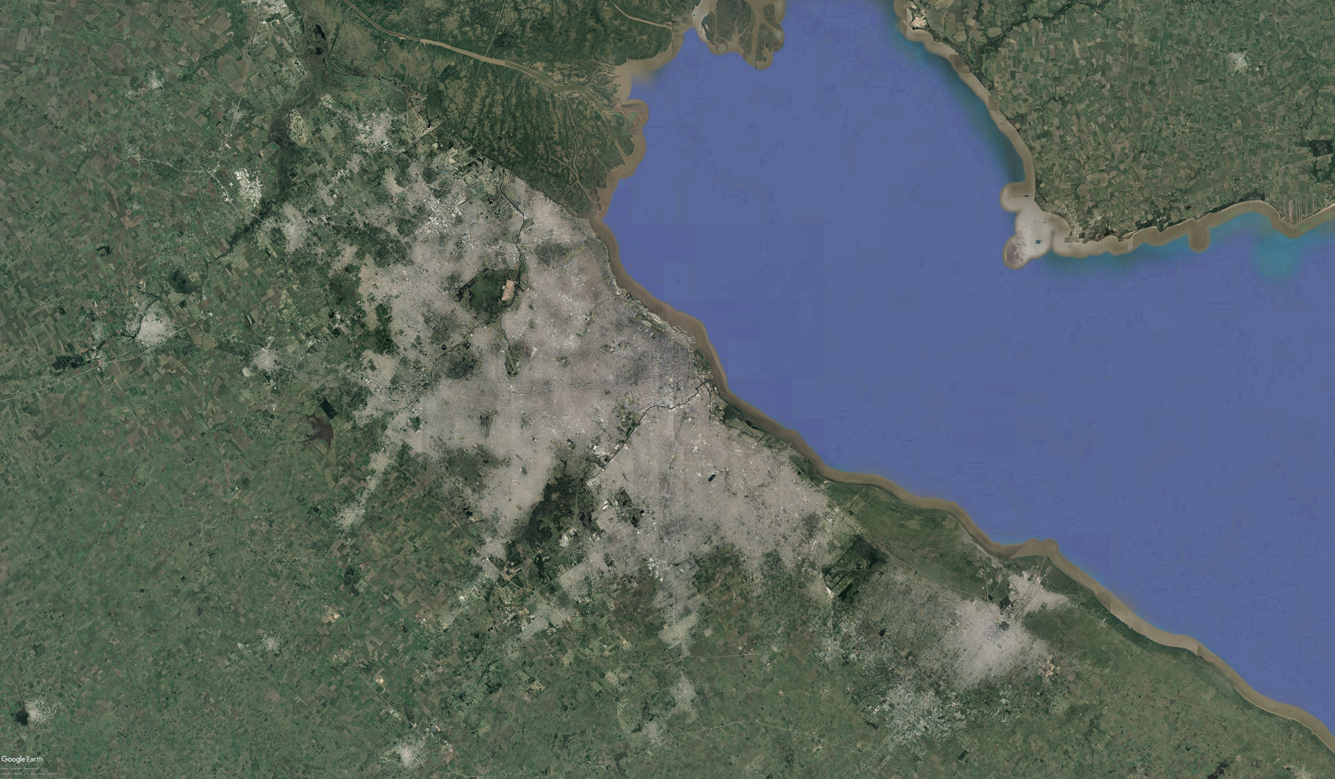
Figure 1. Rio de la Plata Basin and Buenos Aires Metropolitan area. The shoreline depicts a diverse and complex ecological and urban landscape.

2. Theories and Methods

Buenos Aires is one of the main ports in the Rio de la Plata River basin, and is home to a vast biodiversity that is largely unprotected and under unprecedented pressure from exploitative practices. Every year, thousands of hectares of land have been burnt to significantly expand arable land, agrarian enterprise, and private housing projects in the Basin. (Medio en Moron, 2022). Given the far-reaching consequences for water ecology in the region, the Argentine citizenship is pushing the Congress to discuss the Ley de humedales (Wetlands law). If discussed and passed, the law would dictate protections for the invaluable ecological asset that later, should be implemented. (Huberman, 2020) The basin needs to be addressed as an urban commons.

In the current absence of ecological stewardship and long-term vision, a wide diversity of uses have been designated along the shore, including informal settlements, private clubs, exclusive neighborhoods, commercial concessions, highways, railways, and airports. The built environment has been superimposed on top of an artificial sealed surface, and the native flora and fauna has been suppressed and controlled. Along the 200 km shoreline, the identity of the autochthonous landscape has largely been transformed and the city’s inhabitants never really come into contact with the wetlands.
The study of the landscape through images allows the articulation of various views diluted in a homogeneous historical space, enabling comparability of uses, activities, and knowledge that shape living. The urban landscapes of Río de la Plata have as their main challenge to integrate nature, rivers, and their shores with service infrastructures, industrial architectures, working-class neighborhoods, collective housing, and the various activities that take place at the river.

The approach method is carried out from a semiotic context that argues that adopting a gradualist perspective allows us to effectively address the complexities of visual statements: “In the history of visual semiotics, there have generally been developed theoretical proposals based on projecting categories of verbal language. These developments verbalize the analysis and description of the visual, and reduce and simplify it in polar terms: light-dark, straight-curved, large-small, etc. It is a logic of binary type which shares the oppositional criteria of affirmation-negation and truth-falsehood that belongs to the verbal language. However, the world is not like that, and it must be taken in consideration that every language has its limitations. A combination of different languages ​​can be a surpassing instance to address more comprehensive analysis of visual expressions.

So as to transcend the boundary of translation from visual to verbal categories, this research uses different frameworks that try to dissolve linguistic dichotomies such as artificial-natural in order to apprehend the complexities of these relations and the interconnectedness amongst humans and the environment. In this sense, the objective is to embrace all discourses that try to dialogue and broaden this non-binary and non-human-centered vision. Multiple visual sources are implemented: Firstly, the Archivo Buenos Aires, compiled at the Facultad de Arquitectura, Diseño y Urbanismo, Universidad de Buenos Aires by Lombardi's chair, enrolled as a research project. This archive is concerned with determining relevant sources to study the construction of the shape of the city ​​of Buenos Aires, organising different atlases and collections that gather cartography, images of the urban landscape, documentation of works, projects, plans and codes, public speeches in reports, and the news. It only uses public information, and shares it for training and research activities.

This project aims to develop three (3) collections that deal with the ways of collecting, cataloging and associating that information, and disseminate it on open platforms to provide feedback on the passages between archive and production of images, in order to articulate disciplinary knowledge and public interest through the study of urban form as material and cultural production: 1. Buenos Aires in historical images; 2. Buenos Aires in photography; and 3. The atlas of records and landscapes of Buenos Aires. These sets constitute a network of sources that crosses the function of the image as a historical document, artistic construction, and projectual speculation. Secondly, the Atlas/Archivo, a web atlas and archive that focuses on the cultural landscapes of the Río de la Plata, developed by Alberto Delorenzini and his team, also expands the horizons of imagenes and how to move from documents to atlases.

3. Results

The main and general result is a taxonomic categorisation of the urban landscape of the Rio de la Plata basin from studying visual documents. Thus, the research produced a revision of existing databases and the widening of current archives. This interpretation from files and sources build new gazes and a feedback loop of construction of knowledge about the study case. Furthermore, a reformulation of the working tools by expanding the Internet archive Archivo Buenos Aires. Therefore, placing the Basin into the limelight with new research categories allows us to build disciplinary relevance on how to activate the relationship between citizenship and its landscape.

As a specific result, we developed a new vocabulary to address the complex relationships of the urban landscape and make visible the hidden realities of the city of Buenos Aires, the territory we inhabit and transform. These categories emerged during the research process and came as a result of comparing visual documents from various historic moments. The categories, images, and atlases help us define the themes that make the Río de la Plata landscape so complex, bringing out unseen relationships of the city. In this sense, we recognised three (3) conditions that organise the figures, images, and narratives Buenos Aires should be addressed as: Amphibious City, Post-Natural Scenario, Coastal City.

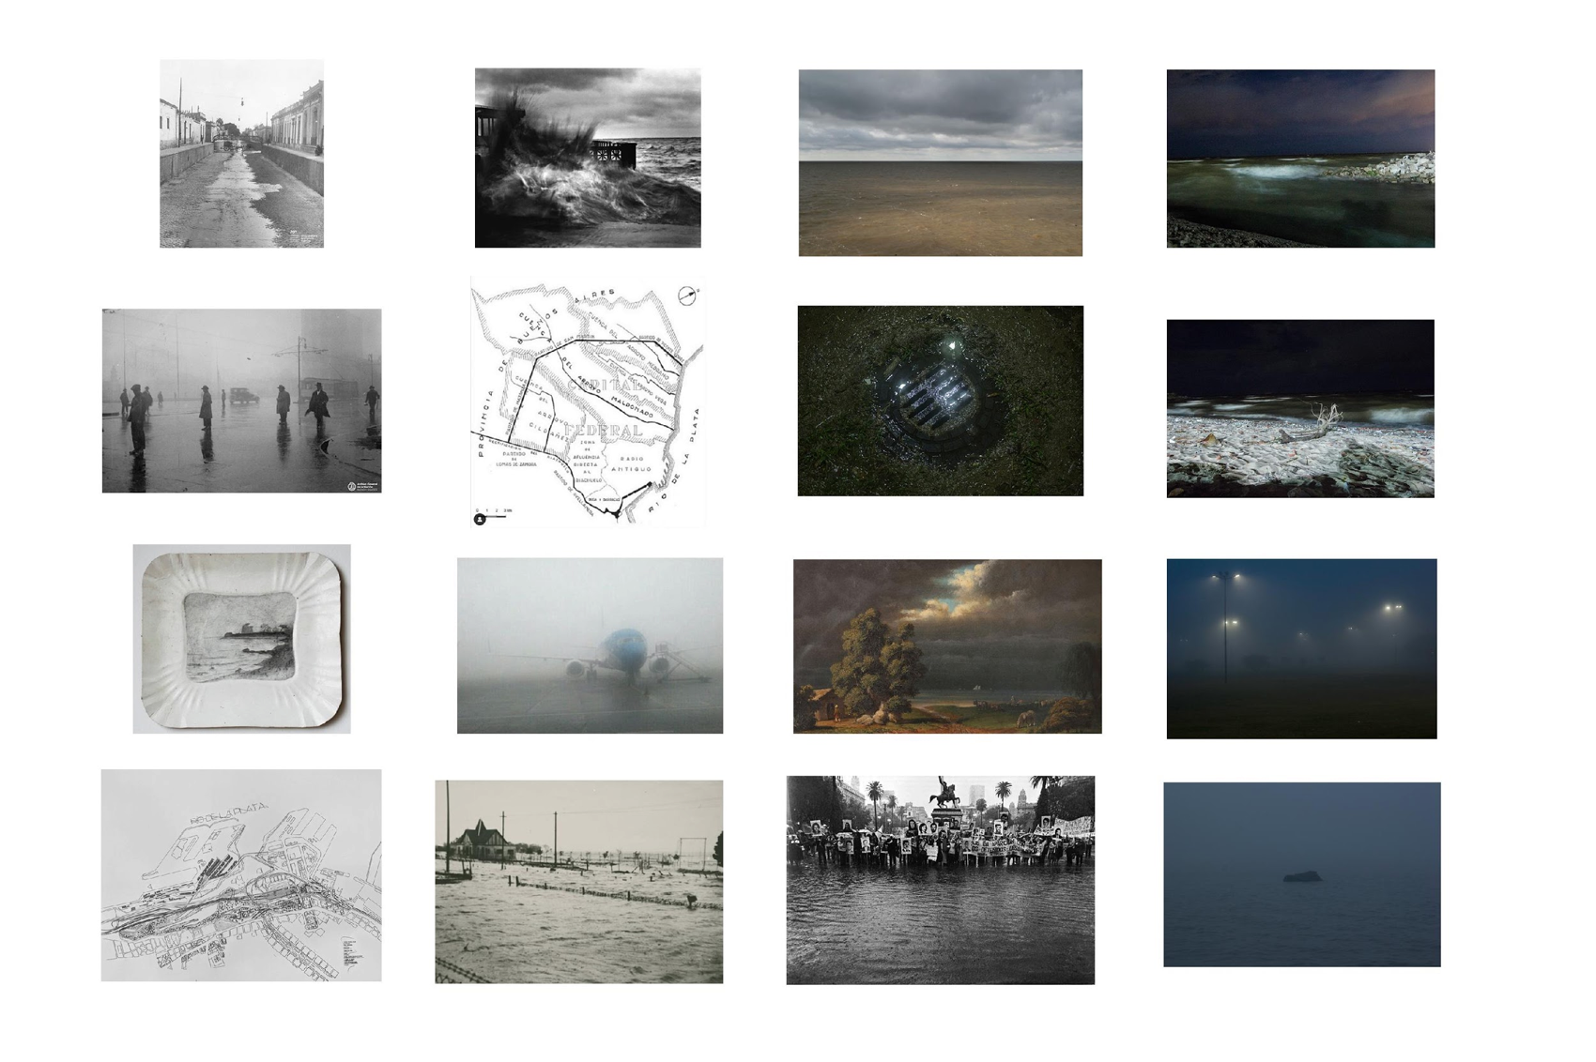
Figure 2. Visual documents representing the atmospheric condition of the landscape. Floods, Sudestada wind, fog, and rains. Rio de la Plata materializes in different ways, forms and materialities.

- Amphibious city

Buenos Aires is sited on the end of the pampa, a wetland composed of streams, a plain with a limited slope and meandering channels that flow into the river. Over this landscape, an abstract orthogonal grid was imposed, neglecting the territorial information. Cartography is not neutral, it represents matters of high political interest that account for the existence or non-existence of things. To draw something is to include it and not to do so is to exclude it. A great majority of the early cartographies about Buenos Aires deliberately omit the hydric condition of the territory. This is an act of violence and lack of sensitivity that later is transferred to the way of conceiving and inhabiting the city.

With the creation of the Virreinato de la Plata, Buenos Aires became the gateway to the continent for the Spanish empire. Its port was the engine that kept the movement going in this village. The relationship with the river has always implied commercial activity; water was and still is, the road for the flow of goods. In addition, the native landscape of Buenos Aires did not correspond with the hegemonic canons of beauty that existed towards landscape in those times (Silvestri, 2001). The absence of exotic beauty contributes to a lack of care and invisibility of the coast. The river was only seen as an infrastructure that facilitated the economical aspects of the city. The lack of controls on the industries and absent policies regarding the water issue and urban solid waste, led to an impossibility of relating in a sustainable way with the water streams. In this scenario, the hygienist modernity found in Buenos Aires a fertile setting for the intubation of urban water streams and the expansion of the city over the river wetlands.
Despite the efforts to make nature invisible, the Rio de la Plata shoreline materializes and expresses itself in the city through climate: the Sudestada, floods, humidity, and fog are the ways in which the river is present in urban life. As Mathur & Da Cunha (2014) propose, water is everywhere before it is somewhere (Mathur & Da Cunha, 2014, p.8). Figure 1 is an atlas of representations around these footprints left by the river: Prilidiano Pueyrredon paintings describe the coast in the northern part of the city in the late 19th century and the photographs of Marcos Zimmerman portray the river in its fierce behavior; waves hitting against the concrete walls of the sharp and straight edge of the North coastline. This collection also takes into account Enric Miralles’ project for Retiro in the early 1990’s in which he introduced the Río de la Plata into the city through a coastal walk.

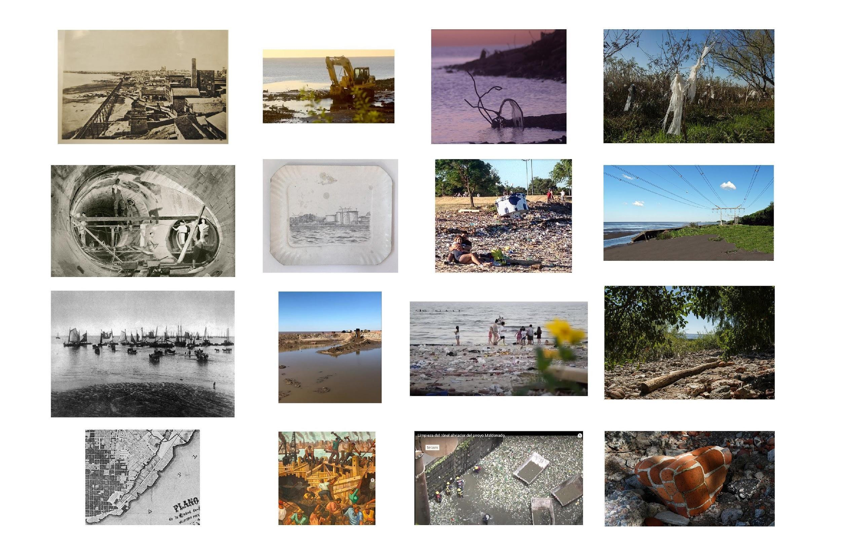Figure 3. Visual documents representing the anthropic transformations of the landscape. The shallow river water are constantly transformed and shaped to expand the city borders over the wetlands.

- Post-natural scenario

Buenos Aires has multiple growth vectors; strangely the coastline is one of them. The constant expansion of the water produced a city that seems to have no end; it extends both towards the pampas and towards the Río de la Plata. The wetlands are easy to mold. The possibility of an ever-shifting border leads to a lack of predictability in urban policies and projects that deny the native riparian landscape. The waterfront is a repository of large-scale urban infrastructure and exclusive private property perched on artificial landfills.

The various uses of the river by the citizens can be seen from the illustrations of Essex Vidal to the images of Costanera Sur. The transformation of Buenos Aires into a metropolis with poor policies of legislation regarding the natural sources meant the exposure of fresh water to contamination, affecting the recreational and productive uses associated with the La Plata basin. This is the reason why the images of people doing recreational activities in the silver waters are analogic registers from the start of the 20th century. Currently, the coastline shows the post-natural condition of the city. The natural environment cannot continue to be observed as a material that we can get rid of. The binomial relation between nature and culture has to be transcended, to build a look that understands the complexity of the interactions.
Of the entire coastline filled with rubble, dirt and garbage, the Costanera Sur Ecological Reserve is the greatest exponent. (Observatorio Metropolitano, 2020) What was the historic center of the city, one of the points with the greatest history with the river, where empires and immigrants arrived, the Military Junta of the 1970’s dumped tons of material to bury the memory. What was a river beach is now a continent. The project to expand the central area of ​​Buenos Aires, made from rubble and bodies of disappeared people, implied covering centuries of cultural heritage. Like many other Argentine urban projects, it was left unfinished and abandoned, and all kinds of vegetation from the region grew on this massive sculpture of dictatorial land-art. In Figure 2, we can see this symbiosis between artifice and nature, pollution, and vegetation, also waste and waste polished by water. The records allow us to understand the resilience of the native landscape that sprouts in the few interstices that are vacant.

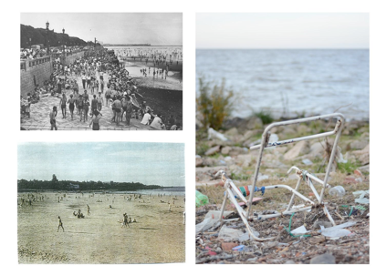
Figure 4. Visual documents representing the transformations of the coastline. From urban baths for recreation to debris and contaminated beaches.
- Coastal City
The river beaches from the first half of the 20th century, bring us closer to an imaginary scenario where the population embraces the principles of the amphibian city by having contact with fresh water from bathing in the ecological heritage. The State’s infrastructural works that had been designed for the southern waterfront, inaugurated in 1918 and made the riverside recreation possible for the porteños public. The river was transformed into a popular space for leisure, and it meant the possibility of a coastal landscape accessible to crowds that began to thicken the city. Afterwards, contamination and the discontinuity of policies for maintenance of this type of spaces, deteriorated the promenades and the Río de la Plata began to move away from the community landscapes to become a forgotten border.

Currently, these beaches are shores of rubble and of waste that convert the Río de la Plata into a hostile cemetery of destroyed materials and trash. However, community efforts are emerging to continue to build a bond on these deteriorated margins. The riparian space is a disputed place, constantly attacked by real estate development and urbanisation: as an example, the recent episode of the contest Buenos Aires y el Río, Costa salguero, carried out by government institutions, the Argentine architectural association and the public university of architecture (GCBA, SCA, FADU, and FADEA), for a project to privatise the public land of a sector of the city shoreline for the construction of apartments and commercial centers. (Observatorio del Derecho a la Ciudad, 2020) This contest was promoted under the slogan of bringing the city closer to the river. Again, partial, fragmentary, and exclusive logics are imposed on riparian planning. In turn, in the delta and the lowlands of the northern area, the construction of private neighborhoods on native forests is deteriorating the wetland condition of these territories.

The figures gather editorial and family photographs, journalistic notes of people enjoying the river and the overcrowded river beaches. The city had its coastline and its beaches and continues to have them. These figures seek to articulate the recreational practices of the past and the coastal present to show the current landscape in parallel to the productive shoreline landscape. The atlas seeks to reorient the vectors of the past, towards new past horizons that are more muddy, swampy, flourishing, and wetter, and above all, more accessible to the population.

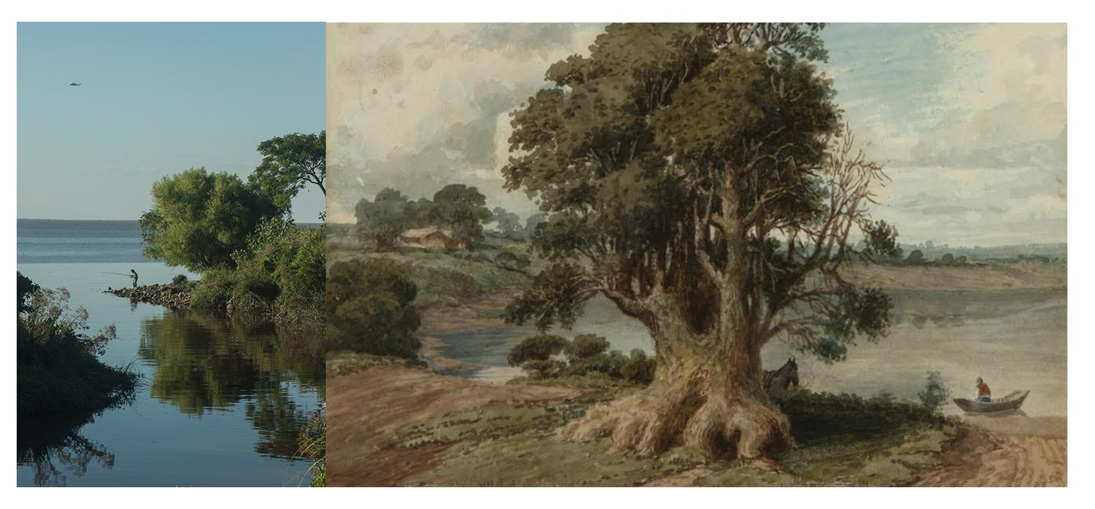
​​Figure 5. Composition of paint and current photographs of the riverside. Photo collage regarding past representations of a less anthropic landscape and new urban riversides.

4. Conclusions
The records of these footprints document the behavior of the basin and allow us to visualise and understand the facets of the environment. Assuming and studying them is essential for the projection of a city that takes into account the conditions of its territory and landscape. An action that is imminent to face the global ecosystem crisis that we are beginning to experience.

Researching the current state of the city’s edge and its history enables us to project it into new scenarios and allows us to understand the importance of stopping the expansion of the city with the prevailing logic up to now, reviewing previous modes of use and building new ways of linking with the native landscape. It is time to think about the rights of the environment, an approach that harbors non-violent ways of incorporating the subjugated minority, which in this case is the native environment, and to carry out measures so that the future of the natural heritage is not determined by policies in favor of economic and private interests.

The images aim to address the possibility of a future that embraces the environment, reviewing experiences from an amphibious past and sustainable projects from the present.

​​Figure 6. Composition of paint and current photographs of the riverside. Photo collage regarding past representations of inhabiting the riversides and the same recreational practices done today.

5. Discussion
To begin with, the research project faced the challenge of looking in different databases to gather the information, process it, categorise it, and upload it to digital platforms for public access. This was done within the Chair Lombardi in FADU-UBA and with assistance of multiple collaborators during the years. What began as informational databases for student assignments, within the years transformed into an ambitious project for studying and producing feedback loops of knowledge between databases, analysis, student projects, and lecturer’s research.

Furthermore, discontinuous and insufficient financial resources made the project ran a slow pace and rhythm disabling consistent progress and visualisation of data a hard task.

Currently, the riverside is on the limestone, the urban, and rural exploitation is obscene and hardcore. Communities and citizenship are fighting to introduce sustainable agendas and to shift decision-making. The research project has been exploring these possibilities, thinking, producing information, and research that are increasing public awareness about these issues. A wide range of actors and stakeholders, ranging from architects, urban experts, and non-experts, visual artists, performers, and musicians have been introducing a river-oriented view to their practice. We understand that the discussion should be done in educational frames and in the territory, connecting with organisations and communities, and making research expand the limits and be part in the transformation of landscape.

Data Availability Statement
Research results: Archivo Buenos Aires (Lombardi, Flugelman, 2019). Compilation of historic visual documents of the City of Buenos Aires. Retrieved September 15, 2021, from https://sites.google.com/view/ba-imagenes-historicas/inicio
Contributor statement
Conceptualisation: Martin Flugelman Olmeda.
Data Curation: Martin Flugelman Olmeda, Luisa Lerman, Ivan Breyter, Sofia Frasquet Dreyer.
Funding Acquisition: Martin Flugelman Olmeda.
Investigation: Ivan Breyter, Sofia Frasquet Dreyer.
Methodology: Martin Flugelman Olmeda, Sofia Frasquet Dreyer.
Project Administration: Martin Flugelman Olmeda.
Resources: Roberto Lombardi.
Visualisation: Martin Flugelman Olmeda, Luisa Lerman, Ivan Breyter, Sofia Frasquet Dreyer.
Writing - Original Draft: Martin Flugelman Olmeda.
Editing: Martin Flugelman Olmeda, Sofia Frasquet Dreyer.

References

- Archivo Buenos Aires. (2019). Cátedra Lombardi, Facultad de Arquitectura, Diseño y Urbanismo. Universidad de Buenos Aires. https://sites.google.com/view/archivobuenosaires/inicio
- Caivano, J. (2020). Problemáticas del color y la apariencia visual en el área de los diseños y la arquitectura, desde una perspectiva gradualista. Facultad de Arquitectura Diseño y Urbanismo. Universidad de Buenos Aires.
- Día de la Educación Ambiental: La Ley de Humedales no fue incluida en sesiones extraordinarias y perdió estado parlamentario. (2022, Jan. 26). Medio en Morón. Retrieved from: https://unmedioenmoron.com.ar/2022/01/26/dia-de-la-educacion-ambiental-la-ley-de-humedales-no-fue-incluida-en-la-agenda-de-sesiones-extraordinarias-y-perdio-estado-parlamentario/
- Delorenzini, A. et al. (2019). Atlas Archivo. https://atlasarchivo.com.ar/
- Huberman, M. (2020, Aug. 19). Todo esto antes era río. Revista Panamá. Retrieved from: https://observatorioamba.org/opinion/todo-esto-antes-era-rio-1
- Institute of Post-Natural Studies. (2020) Post-nature and Contemporary Creation.
https://instituteforpostnaturalstudies.org/Postnaturaleza
- Kozak, D. et al (2020). Blue-Green Infrastructure (BGI) in Dense Urban Watersheds. The Case of the Medrano Stream Basin (MSB) in Buenos Aires. MDPI. Retrieved from: https://www.mdpi.com/2071-1050/12/6/2163
- Lucero, H. (2020, Oct. 10). El fuego arrasó 300 mil hectáreas y devastó flora y fauna de los humedales. Telam. Retrieved from: https://www.telam.com.ar/notas/202010/523320-el-fuego-arraso-300-mil-hectareas-y-devasto-fauna-y-flora-de-los-humedales.html
- Mapa del borde costero en CABA. Propuestas e intervenciones (2020). Observatorio Metropolitano. CPAU. Retrieved from: https://observatorioamba.org/mapeos/mapa-del-borde-costero-en-caba-propuestas-e-intervenciones-1/ficha
- Secretaría de Ambiente (2020). La Reserva. Gobierno de la Ciudad de Buenos Aires. Retrieved from: https://www.buenosaires.gob.ar/reservaecologica/la-reserva
- Mathur, A; Da Cunha, D. (2014). Design in the terrain of water. Applied Research + Design Publishing. University of Pennsylvania, School of Design.
- Secretaría del Ambiente de Paraguay, Dirección General de Protección y Conservación de los Recursos Hídricos (2003) El Acuífero Guaraní. Retrieved from: https://www.bgr.bund.de/EN/Themen/Wasser/Projekte/abgeschlossen/TZ/Guarani/sag-py_boletin01_seam_pdf.pdf?__blob=publicationFile&v=2
- Silvestri, G. (2001). El lugar común. Editorial Edhasa, Buenos Aires.
- Sobre el concurso nacional de ideas para Parque Salguero. (2020). Observatorio del Derecho a la Ciudad. Retrieved from: https://observatoriociudad.org/sobre-el-concurso-nacional-de-ideas-para-el-parque-salguero/
- Svampa, M. & Viale, E. (2017). Sobre el neoextractivismo en América Latina. MALBA. Retrieved from: https://www.malba.org.ar/sobre-el-neoextractivismo-en-america-latina/

