Type of the Paper: Peer-reviewed Conference Paper / Full Paper
Track title: Human-centred and nature-based approaches in cities

Designing Reflexive Spaces with Human Waste: Communities of Resourcefulness in Brussels, Berlin, and Hong Kong
Markus Wernli ¹*
Names of the track editors:
Claudiu Forgaci
Rene van der Velde
Names of the reviewers:
Machiel van Dorst
Verena Balz
Journal: The Evolving Scholar

DOI:10.24404/61729a5c7e18910008ca2929

Submitted: 22 October 2021
Accepted: 01 June 2022
Published: 19 August 2022

Citation: Wernli, M. (2021). Designing reflexive spaces with human waste: Communities of resourcefulness in Brussels, Berlin, and Hong Kong. The Evolving Scholar | IFoU 14th Edition.

This work is licensed under a Creative Commons Attribution CC BY (CC BY) license.
©2021 [Wernli, M.] published by TU Delft OPEN on behalf of the authors.

School of Design, The Hong Kong Polytechnic University; mswernli@gmail.com;
orcid.org/0000-0002-8027-7354
Abstract: This paper compares eco-sanitation interventions in Hong Kong, Berlin, and Brussels by applying a structurally extended SWOT matrix for evaluating their transformative relations and capabilities in their respective contexts. The enablers and barriers underlying these human waste cycling communities are assessed by combining qualitative-quantitative data collection and multiform analysis. By complementing the Strengths, Weaknesses, Opportunities, and Threats (SWOT) analysis with the emergent framework of Ideas-Arrangement-Effects (I-A-T), the study assesses the explorative potential manifested in these cases. The eco-toilet communities address unsustainable food systems by acting in concert with people, places, and microbes in a profoundly self-implicating process that stems from an oscillation between actionable immersion and perspectival detachment. This dynamic creates a reflexive conduit for counter-intuitive doing and thinking that diversifies dominant and hegemonic perspectives. The three cases demonstrate how cultivating a rich, interactive context on the physical, social, and psychological levels is conducive to the suspense and exchange of positions and a plurality of perspectives on the world, both human and nonhuman. Community acceptance and individual satisfaction with urban eco-toilets stems from balancing this unsettling repositioning with supportive involvement, whereas disrupting bathroom routines, group debates, and agroecological experimentation makes people act in better-attuned relations with unknowable otherness.
Keywords: Agroecological urban toilets, regenerative waste integration, Terra Preta fermentation, Structural SWOT, collectivized resourcefulness.

1. Introduction
What does it mean to work with communities on ecological revitalization when designers abandon the single-minded paradigms of efficiency and crisis response? What is implied in the more-than-human collaboration when designers accept their complicity in the environmental and societal precarity that now prevails? Addressing this complexity, how can a wide range of positions be invited for manifesting unprecedented perspectives as the premise for actionable creativity? These questions are considered by examining what spaces of reflexivity emerge when perspectives of humans and nonhumans are placed in direct dialogue, whereas situations become multidimensional and open to change. This paper argues that attention oriented at material engagement with ordinary experience, including bodily defecation, expands the capabilities and collective action. Co-learning processes in profound exchange with the given eco-social context has been described as ‘resourcefulness’ (MacKinnon and Driscoll, 2013) and evolve from the reorientation of internal priorities in person and institution, expressed in locally manifested value creation and social relations. Resourcefulness is often neglected from reporting in urban design in favor of externally imposed ‘resilience’ (ibid). Although previous research, particularly debates on ‘infrastructuring,’ have noted the importance of engaging the messiness of social entanglements (Mang and Reed, 2012; Karasti, Baker, and Millerand), recognising uncertainty and incompleteness as catalytic opportunity in communities are largely missing (Mosleh and Larsen, 2020; Akama and Light, 2020; DiSalvo, Clement, and Pipek, 2012).
This article focuses on designing for and with curiosity. The aim is to provoke reflection about the mental models underpinning reality formation and sensibility since it can radically ground, liberate, or hamper creative perspective-taking. Discussion about the importance of iteratively examining the instructive relationships with the world is emerging in design (Luján Escalante, 2019). The argument is that the mode of design needs to change – from the impartial, discipline-centric projecting onto the world, towards becoming ‘equipment for social learning’ for how to live with the contingencies inside the damaged biosphere (Bonnet et al., 2020). It requires exploring practices aimed at generative inconsistencies for asking what such emotive accounts can contribute to discourses in design. For this, the article presents three eco-toilet cases of productive uncertainty, then evaluates related observations with a causal framework, and concludes with overarching implications.

2. Designing for collectivized resourcefulness
Increasingly, grassroots-level design engages with productive uncertainty for restoring local food systems, reviving communitarian links in the city, and defending alternative ways of inhabiting the world. This passion for locally enacting social change in the face of an ever-deepening techno-economic mediation of reality mobilizes communities worldwide to practice the ‘autonomous design of themselves’ (Escobar, 2018, p. 5). Communities here revolve around the environmental context they intend to transform while designing their capacity for a plurality of social life they truly want (Lobenstine, Bailey, and Maruyama, 2021). Increasingly, concerned urban communities wonder how future generations will grow sufficient food on a drastically smaller ecological footprint. Humus-rich, healthy soil ecologies are critical here since they provide vital storage capacities for water, nutrients, and carbon dioxide (Schneider and McMichael, 2010). This section introduces collectivized resourcefulness cases in Brussels, Hong Kong, and Berlin where regenerating soil ecologies and disrupting deep-seated urban unsustainability implies that communities formed around bringing their excrement to fruition in the city.

2.1. Brussels: L’Usine du Trésor Noir
In the Belgian capital, human waste upcycling gravitates around architects and artists affiliated as Collective Disaster. The group formed in response to a call in 2014 by the Belgian Ministry of Environment to revitalize a derelict downtown park (Amaya 2016). In collaboration with two dozen neighbors, over the summer of 2015, Collective Disaster realized a community-run, ecological public toilet facility (Figure 1). Uniquely here, the respective composting processes dictated the spatial and organisational arrangement of the placemaking initiative. The onsite treatment of excrement as a publicly accessible process triggered consideration of what could be encountered, experienced, and learned. The community consolidated the insights gained into a comprehensive, open-source manual for all involved to carry out the maintenance involved.

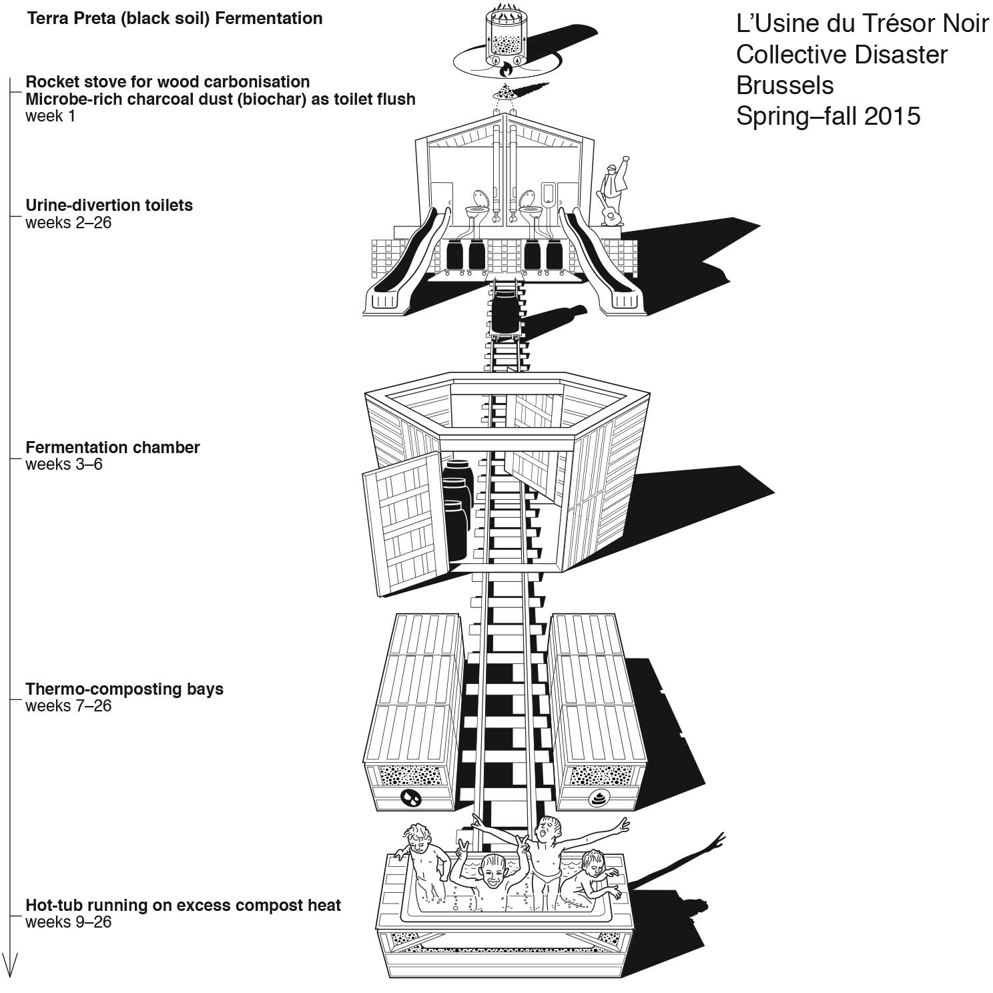
Figure 1. Architecturally arranged composting experience.
The resurrection of excrements through materially performative structures and novel social constellations became known as L’Usine du Trésor Noir. To overcome resentment, the collective involved neighbors in planning, building, and operating facilities that incorporated spacious, urine-separating toilets and heat-capturing composting for powering public hot-tubs. This closed-circuit between waste and leisure in the open public was unprecedented, and entailed unknown possibilities and risks. It required from all involved a healthy dose of trust and responsiveness to difference.
The pyramid-like toilet facilities operated over six months and were built on top of an elevated platform with spacious front stairs that doubled as a stage for performances. On the backside, visitors exited the toilets on slides, one for females, one for males. The platform’s interior stored the sealed collection barrels to separate urine from solids and preprocess them with microbially activated charcoal dust. Using the multi-stage fermentation process of the Terra Preta method, pathogens can be eliminated, nutrients retained, and human waste can be made into fertilizer within one year. From the collection chamber, narrow-gauge tracks connected to the adjoined composting site for swiftly transferring full barrels on trolleys for harnessing the excess heat. The park-enlivening public toilet garnered several awards and international acclaim. In its downtown setting, the Trésor Noir community exemplifies empathetic exploration of the possible and unknown based on imaginative and material repositioning of issues like urban wastefulness, land access, and multi-ethnic cohabitation. It brought together soil experts, authorities, and concern groups to reconceive, at least temporarily, operational infrastructures for sanitation, composting, and recreation, crossing divides between resource conservation and social capabilities.

2.2. Hong Kong: Anthroponix
The university-endorsed community of urine-cycling citizens in Hong Kong responded to mounting food safety and environmental health concerns. The initiative was instigated by the author and offered urbanites deprived of balconies and land access to growing plants indoors (Figure 2). Following a public call in 2017, 22 households of diverse sociocultural backgrounds joined this Urban Ecology Adventure to ferment their urine – with the addition of sauerkraut brine – into a fertilizer substrate to grow edible plants. The simple material relationship between participants’ urine and the environment constituted a provisional ecological proposition since the possibility of the fertilized plants was interlinked with the person feeding it.

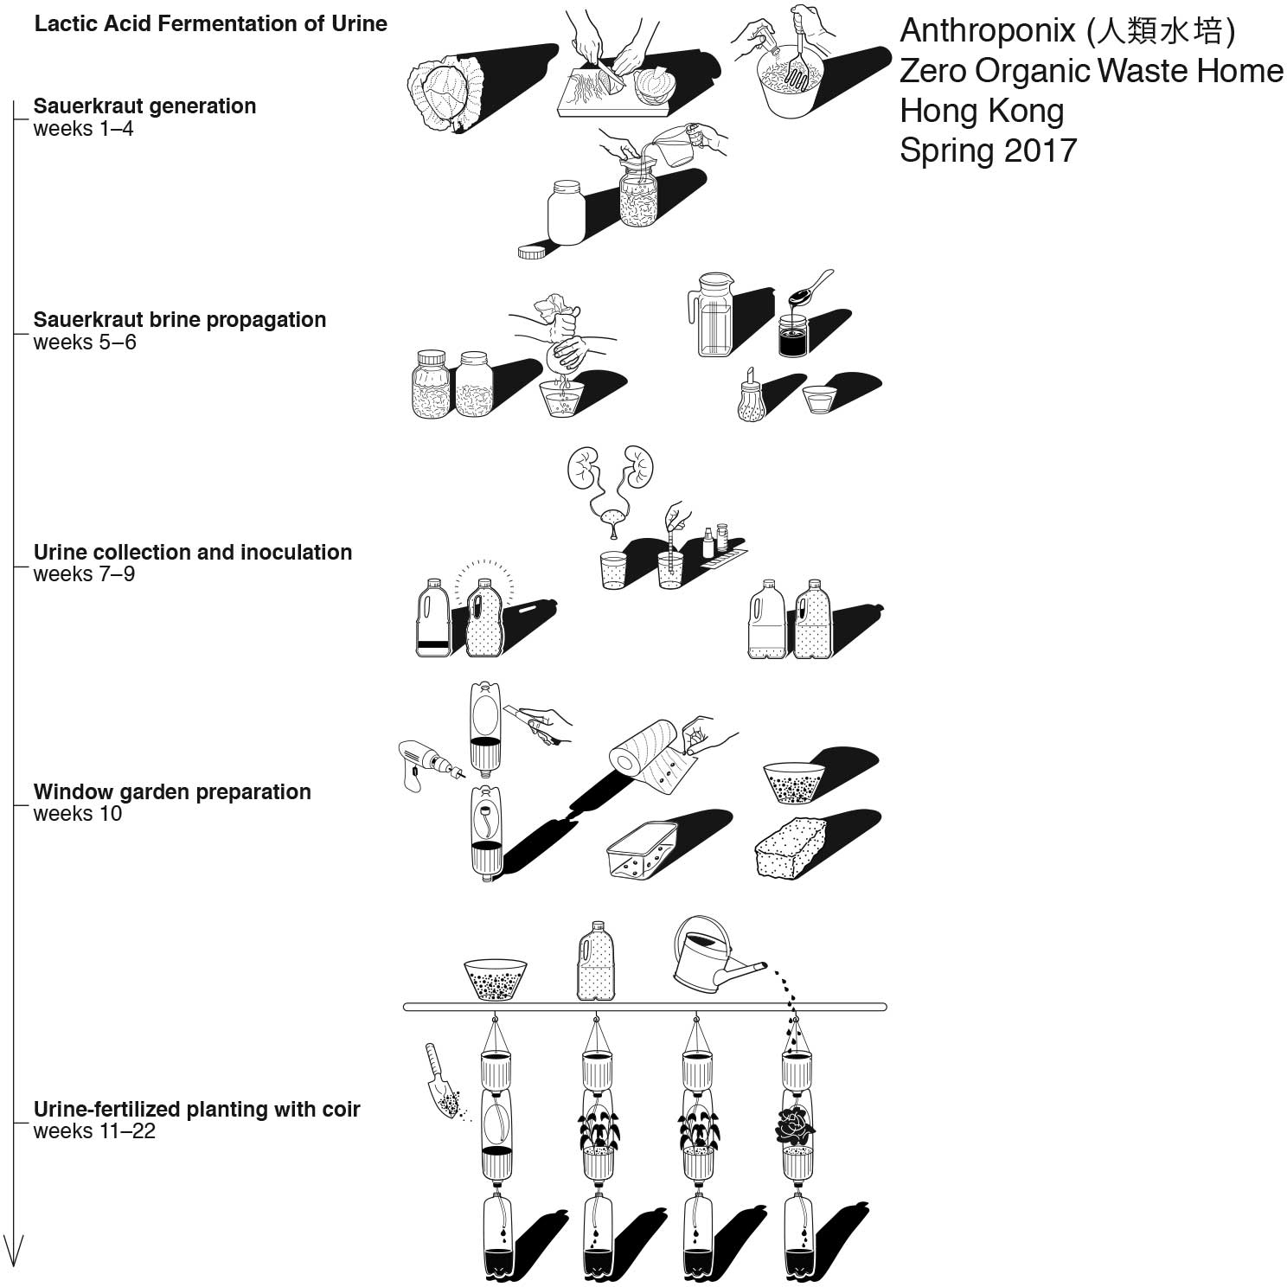
Figure 2. Fermenting urine inside collective food pedagogy.
Each fermenting urine specimen became part of an annotated self-examination passage that involved medical dipstick testers, diet monitoring, and botanical tracking. Participants consolidated all data into an intricate Mutual Thrivability journal. The community spearheaded an untested closed-loop resource system that required participants to jointly overcome technical and affective ambiguities. The imperfect technical setup invited tinkering, instructive failing, and social curiosity – all forms of excitement stemming from responding to unsettling relationships that ignited unifying purpose, social engagement, thus captivating participants’ inventiveness for over three months. The empathetic exploration led many to continue their fermentation experiments or join garden groups long after the project ended.
The agroecological experiment reframed human waste as a responsibility-triggering agent. It countered visions of the urban as an inevitable nutrients’ sink, instead reimagined the household as a resource hub between human and environmental circulations.

2.3. Berlin: DYCLE (Obst aus Babywindeln)
Responding to severe soil degradation and water shortages in the German capital region, an artist-led human waste reuse program has evolved in recent years. Under the name DYCLE, the communal start-up pioneers the eco-friendly transformation of baby nappies into fertile soil for fruit orchards since 2014 (Figure 3). The proposition is to cultivate fruit tree orchards along the city’s outskirts led by diaper-upcycling families. Building on revenue from tree adoptions rather than the sale of diapers, the DYCLE enterprise entails custom production of biodegradable diaper inlays and communal composting into Terra Preta black soils, to grow heirloom fruit trees. The engaged families meet weekly at a central processing point to exchange soiled inlays with fresh ones (Debatty and Matsuzaka, 2019).

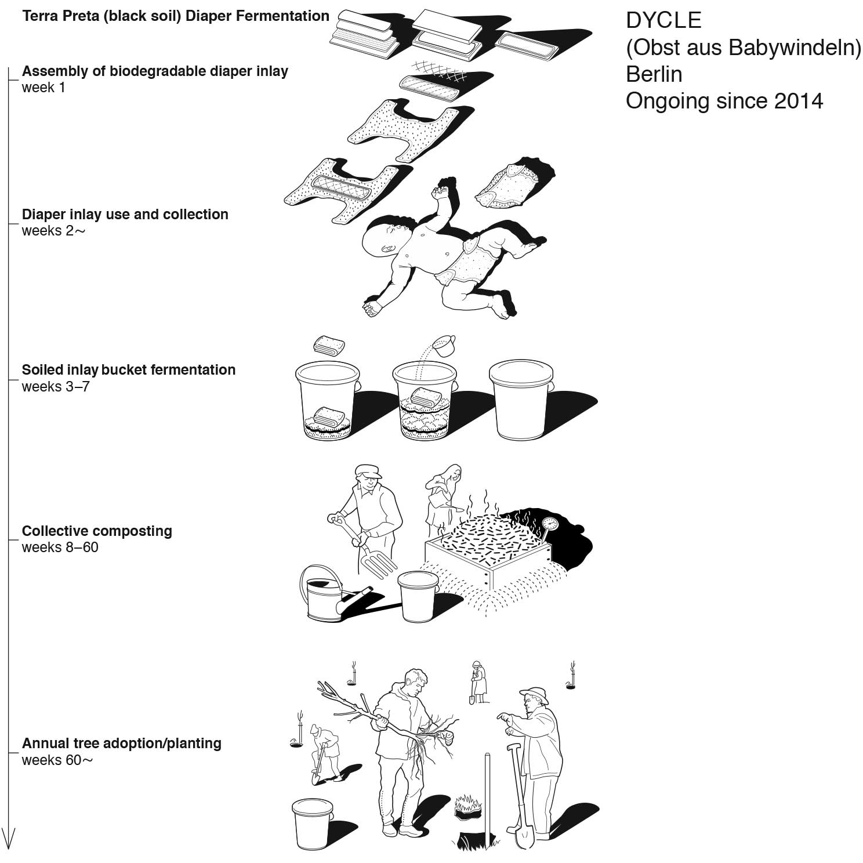
Figure 3. Tree adoptions supports the social enterprise.
DYCLE established a value-creating local economy that spans community, soil care, food forests, and livelihoods. Advancing this biosocial enterprise required that all elements and procedures be custom-configured to serve the larger purpose. It took the DYCLE team six years of trial and error to develop diaper inlays that would satisfy both the needs of the baby and the soil. Several hackathons and maker occasions provided gradual breakthroughs for incorporating local plant fibers into appropriate diaper inlays. While the community around DYCLE’s core team fluctuates, its empathetic exploration inspires communities increasingly beyond Berlin to adopt the diaper-to-orchard economy. Generations growing up with diaper-fertilized orchards help normalize the agroecological use of human waste and affirm humanity’s role in Earth’s shared metabolism.
All three excrement upcycling communities demonstrate, in their respective context, how advancing commitment, practices, and capabilities prompted curiosity about the human function of replenishing the biophysical foundation. With this disposition, the author wished to further probe the value of productive uncertainty in communal experimentation by diverse citizens inside their daily lives. The following section introduces how the research was conducted with these actors.

3. Methods and analysis
This research presents three urban eco-toilet communities to evaluate the enablers and barriers to collaboration under uncertainty. The research responds to the need to justify urban eco-toilet experiments, find ways to sustain them, and tailor follow-up interventions. The author wanted to examine the characteristic features and frames of reference in communities that equip communities with agency to self-manage their place-bound arrangements.

3.1. Gathering research material
The study integrated participant observation, document review, and interviews into a multiform analysis. Based in Hong Kong, the author knew the organisers of the cases in Brussels and Berlin from eco-sanitation networks, but was neither involved in planning these projects nor implementing them. The research material was collected by the organisers of each case and compiled by the author. In Hong Kong, the author conducted 54 interviews, while the organisers in Brussels and in Berlin held retrospective focus groups, each with 15 participants. All field notes highlighted the position and possible influence of the respective organisers, also drafts of the manuscript were subjected to validation of respondents. The stronger analytical attention towards the shorter-term Hong Kong case was intended to balance its perceived impact against the two longer-term cases in central Europe. Detailed data sets are available in the author’s dissertation (Wernli, 2020).

3.2. Analyzing creative productivity under uncertainty
To evaluate the data, the author adopted SWOT analysis, whereby the internal Strengths and Weaknesses of an organisation are correlated to the external Opportunities and Threats for determining fruitful future directions. However, design innovation studies indicate how SWOT analysis is limited to account for novelty, since it takes existing organisations and contexts as point of reference (Dorst, 2005, p. 145). Also, the terms ascribed to Strengths, Weaknesses, Opportunities, and Threats predefine assumptions that delineate the examination. To evaluate the precedence-setting eco-toilet cases, each of the four SWOT terms were correlated with the three dimensions of the Idea-Arrangement-Effect (I-A-E) framework used in systems design (Lobenstine, Bailey, and Maruyama, 2021). For assessing the Strengths and Weaknesses, participants of the eco-toilet interventions walk themselves through the given Arrangements (A) at play then relate them to the Ideas (I) embedded in those Arrangements to be able to contextualize the systemic Effects (E) thereof. The subsequent Structural SWOT analysis thus focuses on reflecting upon the arrangements of one’s reality to change for improving the prospects of thriving coexistence.

3.3. Coding and Structural SWOT analysis
Research materials were summarised in text descriptions and analyzed inductively using open coding to give voice to the diverse actors and permit themes to emerge. The Structural SWOT analysis was used to render connections among (non)human actors, material practices, emergent perspectives, and symbolic discourses. Guided by criteria from the Idea-Arrangement-Effect (I-A-E) framework, the following questions assessed Ideas (I), Arrangement of value creation (A1), Arrangement of practices (A2), and systemic Effects (E) in regard to the cases Strengths (S-):
- (S-I) what collective vision work well in pursuing the initiative?
- (S-A1) what is unique about the community’s self-validation?
- (S-A2) what is specific to the community’s practices?
- (S-E) what are benefits for (nonhuman) actors stemming from the initiative?
Regarding Weaknesses (W-), the questions were:
- (W-I) what conventions hamper the progress?
- (W-A1) what forms of validation are underperforming and why?
- (W-A2) what practices are detractive and why?
- (W-E) what resources could improve contributions to overall thriving?
Regarding Opportunities (O-), the questions were:
- (O-I) what are future ambitions?
- (O-A1) where are offering gaps of contributions?
- (O-A2) what synergies can be accessed to address weaknesses?
- (O-E) how do proliferating effects create synergies?
Regarding Threats (T-), the questions were:
- (T-I) what trends of thought are on the horizon?
- (T-A1) what techno-economic counterforces are outperforming the initiative?
- (T-A2) what are the behavioral barriers to change?
- (T-E) what macro-level changes are cause for concern?

The following section discusses the results by correlating the pluralization of perspectives generated from dialogue with Structural SWOT with subjecting ordinary experience to what initially might have been unthinkable.

4. Results: Productive uncertainty of urban eco-toilets
The following chart (Table 1) summarizes the Structural SWOT analysis of the research material. In this analysis, the Strengths, Weaknesses, Opportunities, and Threats components are specified with narratives (vision), value creation (economic arrangements), practices (work arrangements), and systems’ functioning (effects) to better account for the enablers and barriers underlying them. Comparing the eco-toilet communities, side by side, allows acknowledging the overall propensities, and link the results back to existing conceptions as listed in the right-most column.
Table 1. Structural SWOT of urban eco-toilet cases to identify their enablers and barriers.
 | BERLIN | BRUSSELS | HONG KONG | Enablers/Barriers
Strengths
(S-I) Collective vision | Intergenerational resource sovereignty (joint enterprise) | Regenerative placemaking (joint purpose) | Human/plant health interactions (joint discovery) | Collective imaginary
(S-A1) Arrangement: Value creation | Periurban resourceful economy | Neighborhood resourceful economy | Peer-to-peer resourceful economy | Collaborative economies
(S-A2)  Arrangement: Practice | Self-implication in food forest cultivation | Self-implication in urban park revitalization | Self-implication in interspecies alliance | Distributed responsibilities
(S-E)  Effects: Functioning | Fulfillment from intergenerational links and cross-sector technology innovation | Fulfillment from coevolution with biophysical foundation | Fulfillment from failure-tolerant learning and cohesion | Living environmental citizenship and technology development
Weaknesses
(W-I)  Collective vision | Elimination-driven focus | Confrontational, activist design | One-off research cycle | Single-minded framing of dichotomies
(W-A1)  Arrangement: Value creation | Prohibitive property rights (inaccessible land use rights) | Weak institutional and legal framework | Expertise silos | Challenge to divert resources away from vested interests
(W-A2)  Arrangement: Practice | Reliance on volunteer labor (competitions) | Reliance on migrant workers (inequality) | Reliance on goodwill (tokenism) | Challenge to engage commitment over time
(W-E)  Effects: Functioning | Active policy engagement | Cross-sector compensation and funding | Scientific priority and educational credit-bearing | Social recognition leading to the food-enabled city
Opportunities
(O-I)  Collective vision | Pan-urban resource proliferation | Public/private coevolution | Mutualist caregiver | Coproducing food sovereignty
(O-A1)  Arrangement: Value creation | Local resourcefulness hubs (convivial conservation) | Upcycle waste with waste (not pristine resources) | Consumer/producer tie-ups (urine to fodder production) | Collectivised esourcefulness
(O-A2)  Arrangement: Practice | Eco-regenerative industry (localization) | Eco-entrepreneurial provider (infrastructuring) | Eco-literate household network (platforming) | Multiplying local efforts planetwide
(O-E)  Effects: Functioning | Convivial afforestation and conservation program (eco-city development) | Provision of eco-regenerative toilets in urban margins (participatory urban metabolism) | Community-supported resource recovery (right to reintegrate human waste) | Radically participative food systems
Threats
(T-I)  Collective vision | Reclusive ‘nature’ conservation | Perfectionism (purity ideals) | Immunity from decay (mortality fear) | Hegemony and defensiveness
(T-A1)  Arrangement: Value creation | Market substitutions (underpriced external resources) | Convenience standards | Dehumanization of work | Singular path dependencies
(T-A2)  Arrangement: Practice | Routine use of disposable diapers | Routine use of flush toilets | Routine use of external fertilizer | Inertia to change
(T-E)  Effects: Functioning | Ecological breakdown (extreme events) | Social distancing  (labor shortage) | Biophobia (Nature Deficiency Disorder) | Breaching tipping points

4.1. Strengths
Propelled by the Terra Preta movement, municipal revitalisation, and pro-environmental discourse, the eco-toilet initiatives in all three cases made human waste upcycling into an attractive, social proposition responding to its urban context. The interventions sparked a collective imaginary spanning intergenerational enterprise, regenerative placemaking, and human/plant health interactions for transcending stigmas associated with human waste. This shared narrative translated in the social arena into prototypical collaborative economies that stimulate value chains between city and countryside, neighbors and visitors, or peers and mentors. It means that conventionally segregated roles (like consumers and producers) could be fluidly exchanged, thus use-values questioned and redefined. Such community mobilisation spurs cross-sector technology development and environmental citizenship as manifested in inventive appropriations of organic resource reintegration tailored to the site-specific needs on the level of landscape, neighborhood, and household. The intergenerational purpose, biophysical linkage, and cohesion in a failure-tolerant group of learners made what is commonly relegated to ‘sanitation services’ into fulfilling experiences. Essentially such ‘defamiliarization as social activity’ (Cohen, 2000, p: 97) was about experientially embedded, negotiating material responsibilities that triggered in participants ‘what else/how else’ mode of thinking and multiple perspective-taking essential to intersubjective creativity (Glăveanu, 2020). In effect, these emergent, more-than-human alliances can candidly suspend the prerogatives of domination (Borda, 2006, p: 27) in the rich context of multiform exchanges between humans and nonhumans.

4.2. Weaknesses
The eco-toilet initiatives face societal obstacles that can hamper their advancement. Regarding conventions, the ‘humanure’ communities find themselves working against unhelpful dichotomies that make it challenging to break new ground. Long-standing urban sanitation regimes reduce (human) waste to a matter of efficient elimination forgoing its regeneration potential. Obstacles are also self-imposed, like in the Brussels case when overambition on the organisers’ side posits a confrontational activist proposition, or, in the Hong Kong case, a one-off, short research cycle impedes longer-term prospects. Regenerative eco-toilets demand receptive soils, negotiable frameworks, and evolutionary thinking before they come to fruition. Property privileges make nutrients-deprived lands inaccessible, legal frameworks mandate eco-toilets to be connected to the resource-wasting sewers, and there is a stubborn lack of willingness to interlock waste management with resource proliferation. For the lack of mainstream support, the cases rely on hackathons, migrants’ employment programs, service learning schemes, and neighbors’ goodwill – that can be short-lived. The self-perpetuating cause behind these weaknesses is the absence of social recognition for the ‘food-disenabled city’ (Tornaghi, 2017) unfit to reintegrate organic resources, including human waste. Thus, the cases need to go past awareness and perceive themselves as alternative models for addressing the politics of food-energy-water nexus and top-down control mechanisms. Since operating eco-toilets demand temporal and spatial resources of caregiving labor the three cases ‘biosocial protocols’ (Galloway, 2004) brought renewed and self-disclosing purpose for human waste that need to be stipulated to much larger segments of society.

4.3. Opportunities
All three cases create multiform opportunities in their respective urban settings, ranging from landscape proliferation, employment prospects, socio-material capabilities, and environmental subjectivities. As manifestations of an alternative urban narrative,
city dwellers experience themselves as part of a long-range urban/rural evolution, participative park revitalization, or human/plant co-cultivation, whereas conventional roles are blurred for unexpected, ever-emergent capabilities to spring up. Opportunities arise when eco-toilets in the global north are not just considered gap-fill approaches, but models to be scaled-out anywhere metabolizing humans are present. Diaper upcycling aimed at grassroots conservation manifests a nourishing node in a network of resourcefulness, eco-toilets harnessing multiform energies, and the consumer/producer tie-ups fostered in these metabolic economies create use-value in direct alignment with their biophysical foundation. Perceived beyond arborist diapers, jacuzzi-heating toilets, and urine ferment, the cases represent applied strategies of bringing ecologically regenerative literacy to practices of localized industries, entrepreneurship, and households. The life-proliferating productivity of bio-energy, regenerative greening, carbon-sequestering, and synergetic world-participation from circular humanure systems cannot be emphasized enough especially vis-à-vis tightening government budgets. In a rapidly destabilizing world where all life forms inescapably coexist because they feed on each other, eco-toilet routines become part of the ‘provisional proposition’ (Glăveanu, 2020) of more-than-human health interactions that intimately reflects both opportunity and crisis of concurrent human/environment relations.

4.4. Threats
In the face of accelerating climatic disruption, resource depletion, and rampant social inequality, the impulse for command-and-control ‘solutions’ is on the rise whilst cementing the complete faith in human domination, narrow purity regimes and market-driven solutions. Eco-toilet designers find themselves in the paradox of being challenged, as well as affirmed by the socio-ecological functioning and dysfunctions of our times. The eco-toilet cases do not trade purity for messy existence or deny creature comforts to humans on the move. They attempt to incorporate both by balancing the needs of humans and nonhumans towards regenerative and just landscapes. Weather extremes may potentially nullify the diaper-fertilized afforestation efforts, while ensuing migration streams will increasingly demand low-cost and ambulant, thus inventive eco-toilet approaches. Pandemic fears may discourage urbanites from fermenting and composting while such probiotic citizen agency may provide valuable insights for the sedentary, dirt-averse lifestyles of our times. The impediment for eco-toilets is continuing the narrative that further detaches ‘human development’ from ‘natural environment’ as to ‘protect’ them from each other. Following this vision, capitalist production is propagated with market and state substitutions, that defer the environmental costs of external inputs like fuels, feeds, and fertilizers to future generations, thus entirely undermining the regenerative value of locally recovered biomass including human waste (Tornaghi, 2017). And what is considered ‘nature’ is securely placed into sanctuaries to eliminate the frictions between conservation efforts and capitalist production (Büscher and Fletcher, 2019). This binary thinking is also behind the widespread ignorance for how the dirt-expelling bodies and the impure otherness inside humans is what enables them to live.

5. Conclusion
While the eco-toilet cases in Berlin and Brussels are underpinned by activist urban soil care in the face of environmental degradation, the Hong Kong case strongly resonates with its biosocial inheritance of its (recent) past that emphasizes collectivized resourcefulness and food sovereignty through the reintegration of human waste. Assessing three cases of urban eco-toilets in Brussels, Berlin, and Hong Kong highlights the following:
- Strengths: Collectivized urban eco-toilets become increasingly essential as complementary approach for responding to resource shortages, fluctuating sanitation needs and city dwellers’ disconnect to their biophysical foundation;
- Weaknesses: Eco-toilet alternatives operate in the unregulated territory outside of elimination-driven sanitation regimes – it makes them over-reliant on the goodwill and labor input of concerned citizens;
- Opportunities: Thriving urban eco-toilet communities balance unsettling bathroom routines, group debates, and agroecological experimentation with a rich interactive context to embrace the unknowable;
- Threats: Historical demonization of bacteria and social experimentation, augmented in the context of a global pandemic, can make it challenging to engage citizens in the material implications of their own sanitation;
- Reflexivity: The applied Structural SWOT analysis can better account for the inventive potential of precedent-setting eco-toilets through its focus on systemic functioning and multi-perspectival inventiveness.
The social creativity in the three cases stems from the fact that human waste can be reimagined and used in multiple ways, as health indicator, worm food, soil conditioner, intergenerational arc, or civic resistance. The task then for designers is not only to include the perspectives of (unwanted) otherness but also problematize the lack of recognition for the diminished creative potential of such marginalized, human or nonhuman – that ultimately hampers the advancement of humanity overall.

Acknowledgments
The author is grateful for the support and advice from Sarah Daher, Benson Law, Britta Boyer, Noel Benson, Timothy Jachna, Gerhard Bruyns, Nathan Felde, Vlad Glăveanu, Tang ManYi, and the anonymous reviewers who contributed generously to this paper.

References

- Akama, Y., & Light, A. (2020). Readiness for Contingency: Punctuation, Poise, and Codesign. CoDesign, 16(1), 17–28. https://doi.org/10.1080/15710882.2020.1722177
- Amaya, S. (2016, October). An Interview with Collective Disaster. MVT Journal, Art x Architecture x Landscape. Retrieved from http://www.mvt-journal.com/collective-disaster
- Bonnet, E., Landivar, D., Monnin, A., & Allard, L. (2019). Le design, une cosmologie sans monde face à l’Anthropocène. Sciences Du Design, 10(2), 97–104. https://doi.org/10.3917/sdd.010.0097
- Borda, O. F. (2006). Participatory Action Research in Social Theory. Handbook of Action Research, 27–37. (P. Reason and H. Bradbury, Eds.). London: Sage.
- Büscher, B., & Fletcher, R. (2019). The Conservation Revolution: Radical Ideas for Saving Nature beyond the Anthropocene. London: Verso.
- Cohen, I. J. (2000). Theories of Action and Praxis. The Blackwell Companion to Social Theory, 2nd ed., 73–111. https://doi.org/10.1080/09297049.2013.863272
- Debatty, R., & Matsuzaka, A. (2019, August). Turning Human Waste into Beer and Fruit Trees. We-Make-Money-Not-Art. Retrieved from https://we-make-money-not-art.com/turning-human-waste-into-beer-and-fruit-trees/
- Dewey, J. (1934). Art as Experience. New York: Wideview/Perigee.
- DiSalvo, C., Clement, A., & Pipek, V. (2012). Communities: Participatory Design for, with and by Communities. In J. Simonson & T. Robertson (Eds.), Routledge International Handbook of Participatory Design (pp. 182–210). Oxford. https://doi.org/10.4324/9780203108543
- Dorst, K. (2005). Frame Innovation: Create New Thinking by Design. Cambridge, MA: The MIT Press.
- Escobar, A. (2018). Designs for the Pluriverse: Radical Interdependence, Autonomy, and the Making of Worlds. Durham & London: Duke University Press.
- Galloway, A. R. (2004). Protocol: How Control Exists after Decentralization. Control. Cambridge: MIT Press. https://doi.org/10.1016/j.enbuild.2011.05.014
- Glăveanu, V. P. (2020). Wonder: The Extraordinary Power of an Ordinary Experience. London: Bloomsbury Academic.
- Karasti, H., Baker, K. S., & Millerand, F. (2010). Infrastructure Time: Long-Term Matters in Collaborative Development. Computer Supported Cooperative Work, 19(3–4), 377–415. https://doi.org/10.1007/s10606-010-9113-z
- Lobenstine, L., Bailey, K., & Maruyama, A. (2021). Ideas, Arrangements, Effects: Systems Design and Social Justice. Colchester: Minor Compositions.
- Louv, R. 2008. Last Child in the Woods: Saving Our Children from Nature-Deficit Disorder. Chapel Hill: Algonquin.
- Luján Escalante, M. A. (2019). Framework of Emergence: From Chain of Value to Value Constellation. CoDesign, 15(1), 59–74. https://doi.org/10.1080/15710882.2018.1563616
- MacKinnon, D., & Derickson, K. D. (2013). From Resilience to Resourcefulness: A Critique of Resilience Policy and Activism. Progress in Human Geography, 37(2), 253–270. https://doi.org/10.1177/0309132512454775
- Mang, P., & Reed, B. (2012). Designing from Place: A Regenerative Framework and Methodology. Building Research & Information, 40(1), 23–38. https://doi.org/https://doi.org/10.1080/09613218.2012.621341
- Mosleh, W. S., & Larsen, H. (2020). Exploring the Complexity of Participation. CoDesign, 1–19. https://doi.org/10.1080/15710882.2020.1789172
- Schneider, M., & McMichael, P. (2010). Deepening, and Repairing, the Metabolic Rift. Journal of Peasant Studies, 37(3), 461–484. https://doi.org/10.1080/03066150.2010.494371
- Tornaghi, C. (2017). Urban Agriculture in the Food-Disabling City: (Re)defining Urban Food Justice, Reimagining a Politics of Empowerment. Antipode, 49(3), 781–801. https://doi.org/10.1111/anti.12291
- Wernli, M. (2020). Adventurous Homemaking: Exploring Collaborations toward Agroecological Probabilities (Doctoral dissertation, The Hong Kong Polytechnic University, Hong Kong). Retrieved from http://hdl.handle.net/10397/87408.

