Type of the Paper: Peer-reviewed Conference Paper / Full Paper
Track title: A Review of Post Pandemic Design of Hospitals

A Review of the Framework for Post Pandemic Design of Hospitals
Priya Boby ¹ Prabjot Sugga² Anil Dewan³
¹ PhD scholar SPA Delhi1; priya.boby@outlook.com; 0000-0001-5158-6193
² Associate Professor, School of Planning and Architecture, New Delhi
³ HOD department of Architecture, School of Planning and Architecture, New Delhi

Names of the Topic editors:
Clarine van Oel
Names of the reviewers:
Grant Mills
Journal: The Evolving Scholar

DOI:10.24404/620f68305d583d481a24ddbf

Submitted: 15-07-2022
Accepted: 22-08-2022
Published: 28-07-2023
Citation: Boby, P., Dewan, A. & Sugga, P. (2022). A review of post pandemic healthcare design. The Evolving Scholar | ARCH22.

This work is licensed under a Creative Commons Attribution BY (CC BY) license.
© 2022 [Boby, P., Dewan, A. & Sugga, P.] published by TU Delft OPEN on behalf of the authors.

Abstract: The COVID-19 virus outbreak called for the redesign of hospital infrastructure to be resilient for possible future outbreaks. Before the pandemic, there was a causal link between the design of hospitals and the spread of nosocomial infections. Also, previous studies have revealed associations between climate change and the increased rate of the spread of infectious diseases. Hence, this review created a framework of strategies for pandemic-resilient and sustainable hospitals while emphasizing the role of architects in health promotion. The study conducted a qualitative content analysis of existing studies on the design of healthcare facilities post pandemic to build the framework of strategies. The research was organised into short, medium and long-term measures for pandemic resilience. The study has demonstrated that the framework for the space planning, ventilation, and material specification of hospitals must be revised for pandemic-resilient hospitals. The findings reveal that most of the design strategies that can control the spread of infection in a healthcare facility could also be a panacea for decreasing the carbon footprint of hospitals. Nonetheless, the paper has established the need for further interdisciplinary study on design strategies for impending pandemics that are applicable to all building typologies.
Keywords: Covid-19 virus, pandemic resilient hospital, health promotion, healthcare facilities post pandemics, future pandemics

1. Introduction
1.1 What is the need for the study
The association between wellbeing and architecture was identified before the COVID-19 pandemic (Guenther & Vittori, 2008 & Logan et al., 2010). In fact, in every 100 hospitalised patients, 7 in developed countries and 10 in developing countries get one healthcare-associated infection (WHO,2020). The past pandemics inspired sanitary, housing, and urban planning reforms, while SARS-CoV-1 initiated changes in building design and drainage in Hong Kong (Pinheiro & Luís, 2020).
The COVID-19 infected patients in Wuhan, China, may have spread the virus in hospitals which progressed to stress the healthcare infrastructure in 2020 (Capolongo et al., 2020c; Dietz et al., 2020). Eventually, the fear of contracting COVID-19 in hospitals, led to patients postponing their hospital appointments (Emmanuel, 2020).
The pandemic timeline depicts a surge in the frequency of infectious pandemics. Since 2000, humanity has faced 5 pandemics, while in the 20th century only 4 pandemics occurred (Le Pan, 2020). Studies have demonstrated that global warming has changed the epidemiology of the vectors and caused rapid mutations (Epstein, 2002; Priyadarsini et al., 2020; Wu et al., 2016). Also, the changes in climate patterns have modified crop yield patterns and accelerated the development of the pathogens (Priyadarsini et al., 2020). In fact, on 13th May, 2022, the Monkeypox virus was detected in 12 countries, emphasizing the need for pandemic-resilient hospitals (WHO, 2022).
1.2 Current gap in the Literature
The study created a framework of strategies for pandemic-resilient and sustainable hospital design while highlighting the role of architects in health promotion. Previous research explored design guidelines post-COVID-19 (Amran et al., 2022a; Emmanuel, 2020; Luis, 2020), but further research is needed to strengthen the framework of health-promoting design (Amran et al., 2022a; Miedema et al., 2019). This review creates a hierarchical framework for pandemic resilience and sustainable hospitals.
2. Theories and Methods
The Dimensions database identified 155 architecture journals using the search string “post pandemic design of hospitals”, published from 2010 to 2022. Figure 1 shows the bibliometric network generated using the VOS viewer, which depicts the common keywords were Covid, space and architecture. Navaratnam et al., (2022) utilised a similar methodology to visualise literature on healthy buildings. Hence, this research elaborates on the keywords: pandemic, architecture, space, and ventilation to create a framework for pandemic-resilient hospitals.
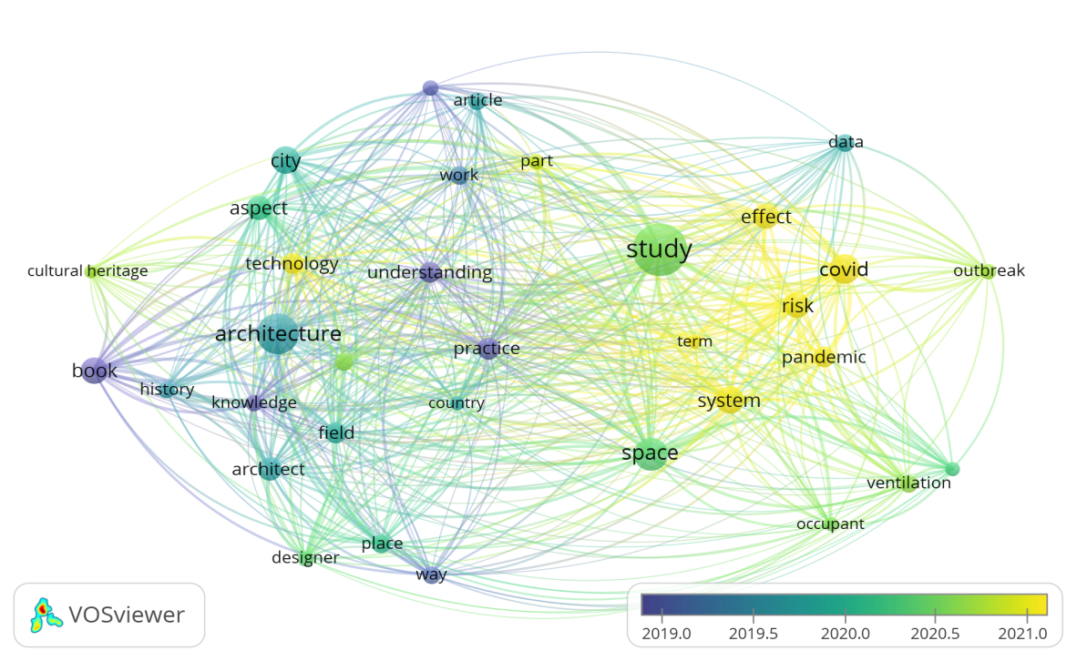
Figure 1: Bibliometric network for keywords “post pandemic design of hospitals Source: VOS viewer
The PRISMA technique was used to understand the literature review (Figure 2). The criteria for paper selection were that the research should focus on the design of hospitals and be published in the past decade. The themes of ventilation, space planning, and
materials were used to address the most pressing problems regarding hospital design.
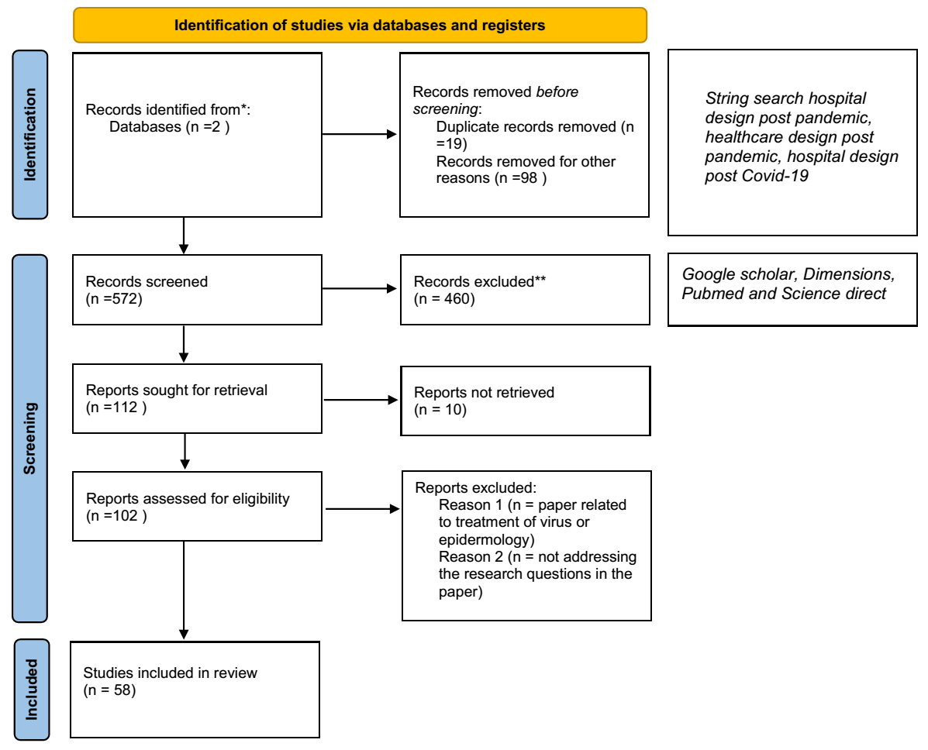
Figure 2: PRISMA technique (Source: authors)
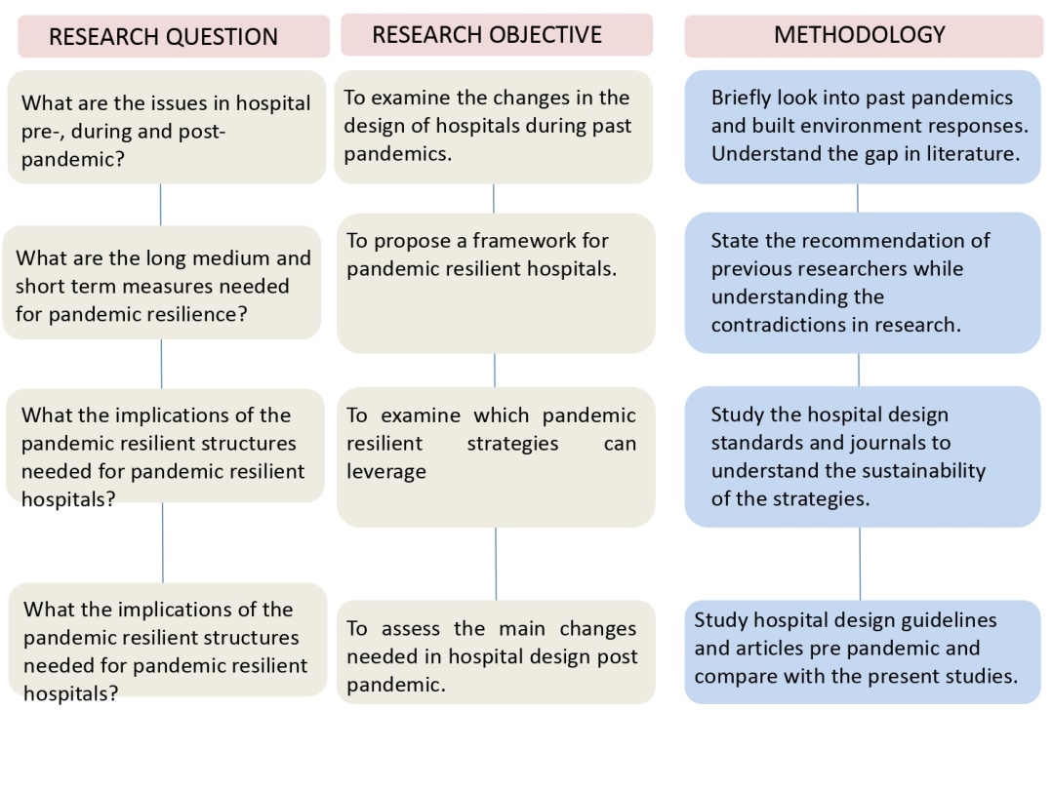
Figure 3: Steps in the Methodology (Source: authors)

3 Results: History of past epidemiological disease
3.1 Short-term measures
- Conversion of structures to healthcare units for pandemics
During the peak of the coronavirus pandemic, the healthcare facilities were unable to accommodate the large influx of patients, thus, countries such as the United Kingdom transformed buildings into temporary healthcare structures (Gbadamosi et al., 2020). However, the probability of cross-infection increased as the HVAC did not meet the ventilation requirements of a hospital: fresh air, individual thermal comfort control, and air filtration (Morawska et al., 2020; Xu et al., 2020). Hence, future public spaces will need more efficient HVAC and flexibility for conversion into emergency healthcare spaces (Megahed & Ghoneim, 2020).
3.2 Medium-term measures
- Ventilation in hospitals
To reduce the spread of viruses through the air while reducing carbon dioxide build up, air should not be recirculated. Instead, HVAC systems should use air from outside (Popovich et al., 2019). Notably, HVAC that uses 100% outdoor air may use more energy than a system that uses recirculated air (Morawska et al., 2020). However, (Megahed & Ghoneim, 2020)(Memarzadeh et al., 2004) point out that the ingress of outdoor air into space may bring in virus-containing particles that may cause infections. Hence, the fresh air intake needs to be filtered before entry and sourced from an uncontaminated outdoor area. ASHRAE (2020) recommends that the supply air intake be located near the doorway or adjacent to the exterior window with a ceiling mounted supply to allow the air to flow from the entry where the workers are to the visitor area.
Mixed ventilation is recommended as it reduces energy use and allows flexibility. To reduce cross-contamination, uniform ventilation is not recommended; instead, each room must have its own ventilation system (Smolova & Smolova, 2021). Numerous authors recommend the implementation of a high air change rate and low-level openings to reduce air contamination (Bhatti & Wahab, 2021; Emmanuel, 2020; Morawska et al., 2020).
The corridors in hospitals should be open-ended to allow ventilation. To further promote ventilation, an upper ventilation opening in the dividing wall in the corridor and a ventilation louvre on the doorstep can curb the circulation of hot air. Additionally, the courtyard layout is recommended to enhance ventilation, create an ecological space that speeds up recovery, and admits daylight (Emmanuel et al., 2020).
- Typology Configuration for Enabling Disease Containment
By avoiding vertical and horizontal connections, there should be minimal contact to curb spread of pathogens. Capolongo et al., (2020a) recommend that hospitals should have pandemic treatment areas :the main body connecting to supporting areas with separate vehicle access. However, the increased land use, energy consumption, and material consumption for the larger floor area are disadvantages.. Hence, the authors recommend that facilities for Covid-negative patients can have multiple levels, but the COVID-19 treatment zones should be a stand-alone building with different access and separate sanitization points for staff and COVID-19 patients.

Epidemiological disease | Regions affected | Social behavior and recommendations | Built environment response | Citation
Infections and ailments in the Roman Empire | _ | _ | Introduction of infrastructure  Isolation tents near hospitals | Belfiglio (2017); Pinheiro & Luís (2020)
Black death in the 14th century | Worldwide pandemic with a mortality rate of 50–75 million people worldwide. | The quarantine protocol was enforced, and travel was restricted. | Creation of dedicated hospitals to separate the patients infected with plaque. | Murphy et al., (2022); Pinheiro & Luís (2020)
Cholera in the 19th century | Between the 19th and 20th centuries it caused millions of deaths. | Quarantine measures were enforced at the ports. | More focus on sanitation with improved sewerage systems.  Florence Nightingale proposed pavilion models with more ventilation, daylight and hygiene. | Emmanuel  (2020);Tappero and Tauxe (2011)
Tuberculosis (TB) | Emerged in the 19th century with a mortality rate of 2 billion people. | Social isolation was enforced. | Sanatoriums were introduced for treating patients with TB.  The usage of natural and mechanical ventilation. Install UVGI fixtures with ceiling fans for air mixing. | WHO (2018); Pinheiro and Luis (2020)
1918 influenza pandemic (influenza) | Mortality rate of 50 million people during 1918-1919. | Social distancing and the use of masks. | The gyms, state armouries, parish halls, and other facilities were converted into wards. | Horimoto & Kawaoka (2005)
SARS-Cov-1 | Prevailed between 2003-2004 with an infection rate of 8000 cases and 800 mortalities. | Quarantine and social distancing | Improved ventilation and drainage systems. | Pinheiro & Luís (2020)
Ebola virus disease | 2014-2015 affected West Africa. | CDC tool kit was used to assess the readiness of the hospital to an infectious disease.  Early diagnostic procedures.  Provide self-selected staff that treats and isolates Ebola patients. | Designated treatment centres for treating Ebola virus.  one way traffic flow: PPE donning room to patient room and exit to PPE doffing room.  Negative pressure ventilation and high efficiency particulate filters, | Meyer et al., (2018)
Nipah virus | Predominated in south Asia from 2018-2019. | Ensure the availability of medication.  Notably, zoo nautical surveillance is necessary, and epidemiological and lab data need to be shared globally. | Point-of-care labs were built for screening the public. | Menon & George (2021)
Table 1: Lessons for hospital design from past pandemics Source: Authors
- Functional Programme, Access, and Flows Management
To reduce the spread of infections, the hospitals must have different routes for COVID-19 infected patients, suspected COVID-19 patients, and non-infected patients. However, signage to guide patients on which route to use may not be sufficient, so an access card system may be introduced to ensure the segregation of footfall in corridors. Furthermore, the corridor width should be a minimum of 2600mm, allowing for 1000mm of social distancing and 300mm of freeboard as people do not move in a straight line (Emmanuel, 2020). Additionally, benches and ledges must be avoided in a corridor to discourage conversation, and poorly ventilated corridors and waiting areas must be avoided. Instead, the priority should be to reduce waiting times in hospitals to avoid the spread of viruses Emmanuel et al., 2020).
- Selection of antivirus materials
Studies have demonstrated that the COVID-19 virus has different survival times on various surfaces (Emmanuel, 2020; Garg, 2021; van Doremalen et al., 2020). Doremalen et al. (2020) retort that COVID-19 can last up to 3 days on plastic and steel, while on cardboard it can last up to 1 day and survives for 4 h on copper surfaces. Hence, frequently touched surfaces such as balcony rails, staircase handrails, and bed rails should have copper-infused or -plated materials. However, the cost of copper may discourage designers from specifying it. Hospitals must use antibacterial paints and prefabricated furniture, while sensor-controlled lifts, sinks, and taps can avoid contact altogether (Garg, 2021; Emmanuel et al., 2020). Also, carpets and rugs should be avoided as they harbour viruses and their cleaning products reduce indoor air quality (Pinheiro & Luís, 2020). To allow flexibility, electric wiring should have polyvinyl chloride (PVC) conduit to enable the installation of electrical points and appliances (Garg, 2021).
- Air filtration
The air filters reduce the viral particles concentration in the air and curb the deposition of viruses on surfaces (Horning and Davis, 2020; Memarzadeh et al., 2010). Also, the filtration of the air in the COVID-19 wards may reduce the viral load and speed the recovery process. The HEPA (high-efficiency particulate air) filters can remove 99.97% of particles larger than 0.3 microns, but ULPA (Ultra-low Penetration air) filters can capture 99.99% of particles larger than 0.12 microns. Additionally, air filtration will remove any other pollutants in the air but requires frequent replacement, and the used filters must be carefully disposed of to avoid the spread of the virus.
- Ultraviolet germicidal irradiation
Ultraviolet germicidal irradiation (UVGI) has a wavelength of 253.7 nm and possesses antimicrobial properties. However, it should be used carefully as it poses a health risk to the eyes and skin. Nonetheless, while more research is conducted to determine the effectiveness of this technology in irradiating the COVID-19 virus, UVGI may be installed in unoccupied areas to minimise adverse health effects (Megahed & Ghoneim, 2021). Hence, UVGI may be mounted in deep louvre enclosures at a height from the floor to reduce exposure to the eyes and excess reflection from the ceiling and in the duct of the HVAC for disinfecting contaminated air.
- Humidification
Indoor humidity levels are a significant factor in the spread of infections. The low relative humidity in a cool climate may prompt the droplets to evaporate at a fast pace, creating particles with smaller sizes that may move longer distances and infect more people (He et al.,.2022;Feng et al., 2020). On the other hand, in humid conditions, the size of the viral drops increases and falls from the atmosphere, reducing the chance of transmission. Ahlawat et al., (2020) retort that humidity below 40% reduces the respiratory immunity of humans as the mucus in the throat and nose turns dry and viscous, reducing the ability to eliminate viral aerosols. Hence, a relative humidity of 40%-60% is recommended for the health of occupants and reducing the survival of pathogens (Condair Ltd., 2007; Mousavi et al., 2021).
3.3 Long-term measures
- The location of hospitals
Green building codes deduced that the location of a hospital defined its accessibility and is preferably located in the centre of the city (USBGC, 2017). But locating hospitals along the edges of the city reduces crowded areas, while allowing access (Capolongo et al., 2020a). However, the distance should be maintained to reduce GHG emissions (USGBC, 2017).
4. Discussion
Table 3 summarizes the measure that can be implemented for Covid-19 benefits with its implications on sustainability.

Built Environment system | Measure | Covid-19 benefits | Implication on sustainability | Recommendation by authors
Structure | Conversion of structures to healthcare units for pandemic | During the wave of infections, countries converted unused public spaces into treatment centres (Gbadamosi et al., 2020). However, these spaces were not designed with the requirements of a treatment facility in mind. | The use of existing facilities is sustainable as it requires minimal resources, reducing the carbon footprint. | The existing hospitals can have spaces for expansion to utilise during emergencies.
Space planning | Functional Programme, Access, and Flows Management | Avoid vertical and horizontal connections (Capolongo et al, 2020). Instead, separate treatment areas are recommended. | Increase in carbon and building footprint due to the increase in materials and energy (Pinheiro & Luís, 2020). | The minimum dimensions of the treatment areas must be revised to curb airborne transmission.  Introduce courtyards and atriums to encourage ventilation without increasing material requirements.  Movable partitions can be used to demarcate treatment at existing facilities.  Retain online consultations for mild illnesses to reduce overcrowding in hospitals.  Asymptomatic patients with an airborne illness may be transferred to temporary medical facilities or self-contained at home.
 | Circulation | Studies demonstrate that the width of corridors must be increased to 2.6 m (Emmanuel et al., 2020). | Increased materials required for construction. | The length of the passage must be minimal for easy movement.
 | Flexible design | Create lung spaces to accommodate expansions, reconfigurations, or isolation areas (Capalongo et al., 2020). | USGBC (2017) recommends the use of shell and soft space for the flexibility of the hospital. | The challenge is to ensure that the spaces are not underused (Garg and Dewan, 2020). Hence, further study is needed to establish the area required for the flexible spaces.
 | Evidence based design | Biophillic design strategies: views to nature, fresh air, and natural sounds are encouraged for speeding the recovery process (El Sayed et al., 2021). The improvement in IEQ may be effective against many infectious diseases similar to COVID-19 (Lai et al., 2009). | At least 50% of the site area’s vegetation, excluding the building area, should be restored or protected with native vegetation (LEED, 2009).  Derive health benefits for patients and staff by providing 5 sq m per inpatient for at least 75% of inpatients (LEED, 2009). | The existing terraces can be converted to gardens.
Services | Conveyance | Provide signage on elevators to implement social distancing and reduce airborne transmission (Luis, 2020). | Increased energy usage from the increased number of trips (Pinheiro and Luis, 2020). | Use touch free controls for lifts with separate lifts for movement of patients and medical personnel.
 | Humidification | Authors recommend a 40-60% humidity to reduce aerosol transmission (Condair Ltd., 2007; Mousavi et al, 2019; Gola et al., 2018). | Improves indoor air quality (USGBC, 2020). | The building codes for hospitals must be updated to account for post pandemic issues.
 | Aeration in hospitals | Avoid recirculation of air (Popovich et al., 2019).The ventilation for each room must be separate to avoid cross contamination (Smolova & Smolova, 2021). Avoid close ended corridors (Emmanuel et al, 2020).  Heat recovery units make sure that the air inside and outside are completely separate(Morawska et al., 2020). | Natural ventilation is encouraged to reduce energy demand and improve the comfort and mental health of patients (USGBC, 2017; (Eijkelenboom et al., 2021).  Dedicated elements such as a wind cowl, wind catcher, and double skin may be used to enhance airflow (Creurer, 2020.).  The pollutants and microorganisms are also eliminated, improving the indoor air quality (Pinheiro & Luís, 2020).  The view from the window improves wellbeing ( Pinheiro & Luis, 2020).  USGBC (2017) suggests that optimum PM2.5 is 15 µg/m or lower and optimum PM (particulate matter): 50 µg/m or lower. | When designing the HVAC, the site's climate and the amount of space needed should be taken into account. However, in extreme climates hybrid ventilation is required. The wall window ratio can be used for designing the openings.  The BIM simulation can assist the design of HVAC early in the design process (Luo et al., 2020).  The air changes per hour should be 24 ACH to reduce the concentration of the pathogens in 10 minutes rather than 12 ACH which takes 20 minutes (Qian et al., 2010).
 | Air filtration | Use HEPA filters of MERV 17 or higher to remove viruses and other particles (Elias & Bar-yam, 2020; Mousavi et al., 2021). | The HEPA filters remove dust and other pollutants; improving the indoor air quality (Horning and Davis, 2020; Memarzadeh et al., 2010). | The filters must be maintained and replaced frequently for maximum performance.
 | Bipolar ionisation | This can reduce the pathogens in the air (Navaratnam et al., 2022). | It is less costly, can be installed easily, and causes a pressure drop in the AHU (Zeng et al., 2021).
 | Ultraviolet germicidal irradiation | Can be installed in the HVAC ducts and PPE lockers to eliminate the virus. | The UVGI increases energy demand and may be harmful to eyes if not installed well (Chen & Keeffe, 2020).  However, UV light is less expensive than mechanical ventilation and more effective than ionisation (Escombe et al., 2009). | Hence, further studies are required on the height at which the UVGI lamps should be mounted, the wavelength of the UV light, and the installation of the light (Escombe et al., 2009).
 | HEPA filters | It is effective in removing bioaerosols but MERV is a safer option. | It needs frequent maintenance, high pressure drops, and increased energy consumption (Tellier, 2006).  The filters may reemit the virus during replacement (Assadi et al., 2022).
Indoor environmental quality | Encourage daylighting | Atkinson et al. (2016) found that different studies have come to different conclusions about how well sunlight kills viruses. Amran et al. (2022b), on the other hand, say that adding windows to the wards and passageways could help control and stop infections.. | A minimum of 10 footcandles (fc) (110 lux) and a maximum of 500 fc (5,400 lux) in a clear sky condition on September 21 between 9 a.m. and 3 p.m (USGBC, 2017). Introducing apertures for daylight will also afford occupants a view of the outdoors. | UVC light of 260-265 mm has the most germicidal effectiveness and is eliminated from natural daylight (Kowalski, 2009; Antoino and Sanmartín, 2018). Hence, the use of UVGI lamps is an alternative.
Interior finishes | Selection of anti-virus materials | The material specifications must use materials such as copper, antibacterial paints, and prefabricated furniture, while sensor controlled lifts, sinks, and taps can avoid contact altogether (Garg,2021; Emmanuel et al, 2020). | The manufacturing process for metals is carbon intensive (Liu et al, 2017).  A copper finish has high cost and a high maintenance cost (Navaratnam et al., 2022). | Hence, further research is needed on the materials that are antibacterial and low carbon.
Site | The location of hospitals | Put hospitals along the edges of the city to avoid overcrowding (Capolongo et al., 2020d). | The GHG emissions from the vehicles pose a risk to the environment as longer distances have to be travelled.  LEED (2009) encourages development with ½ miles of services. | Create a 15 minute city that allows access to amenities via bicycle or foot to reduce carbon emissions.
Table 3: Thematic analysis of literature Source: Authors

The authors have produced a graph depicting the duration for the strategies from short-, medium- and long-term measures. The pandemic resilience and sustainability are quantified on the scale 0 to 4, where 0 depicts the least contribution, 1 reduces the risk of spread, 2 signifies reduction of transmission among people, 3 means reduce transmission through surface, and 4 depicts pandemic resilient solutions that are sustainable.

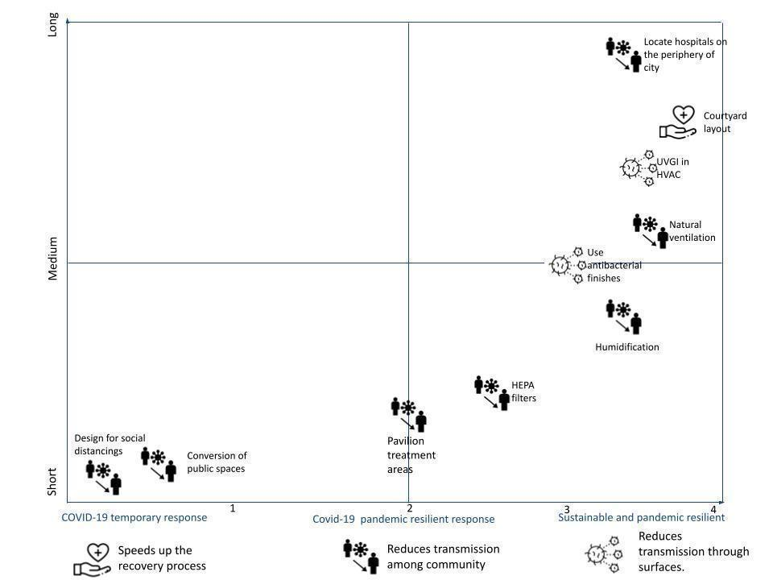
Figure 4: Covid 19 reduction strategies that are sustainable (Source: authors)

5. Conclusions
During the 14th to the 19th centuries, the world responded to pandemics through urban renewal, sanitary reforms, and housing renewal (Piret & Boivin, 2021). The strategies, such as the creation of dedicated spaces for treating infectious diseases, the incorporation of UVGI into ventilation systems, the prioritisation of daylight, and the creation of point-of-care labs, were effective in controlling cholera and tuberculosis. The challenge is to avoid overdesigning pandemic-resilient hospitals to avoid escalating costs and underuse of facilities (Garg and Dewan, 2022). The authors recommended that the building codes should add a framework of design strategies for pandemic resilient hospitals.
The main challenge in post pandemic design is maintaining social distance without increasing energy demand and GHG emissions. The authors recommend a courtyard layout to separate spaces while providing ventilation and day lighting (figure 4). The circulation space can be along the courtyard to encourage cross ventilation, and buffer zones before entry can reduce the transmission of viruses. Also, the perimeter around the courtyard can be an open-air waiting area to reduce airborne transmission while creating a biophilic link. However, the courtyard must be designed after considering the climatic conditions of the area.

Nevertheless, the challenge is to design hospitals that foresee an impending pandemic. Hence, further interdisciplinary research and simulations must highlight:
- the minimum dimensions of rooms required to reduce cross contamination;
- humidity levels;
- air change units for reducing viral particles in the air;
- low cost materials with antibacterial properties;
- The wavelength and voltage of UVGI required to eliminate the virus.
The authors recommend that the research on pandemic resilient design should be extended to all building typologies and that the framework of design strategies for hospitals be constantly updated.
In conclusion, the authors view the Covid-19 pandemic as a motivation for the design community to rethink hospital design and implement strategies that are resilient.

Requirement | Hospital Design Pre- Pandemic | Hospital Design Post Pandemic
Location | The early hospital design was frequently a courtyard, often located at the edge of settlements (Burpee, 2008; Tesler, 2018). | Reintroduce the courtyard layout for ventilation and a link to nature (Emmanuel, 2020).  Spacing in hospitals should be at least 2000 m to maintain social distancing.  Li et al (2020) recommend designing multi-level hospitals to replace the single level hospitals that depend on major hospitals, which should be distributed with lower density within a certain distance.  The emergency department may be a pavilion to act as an independent unit in the event of a pandemic (Łukasik & Porębska, 2022) .
Material selection | Safety; access; fire evacuation; patient care, and environmental design were the selection criteria for finishes in the hospitals (Department of Health, 2014). | Materials such as copper based alloys should be used fortheir anti-bacterial properties to reduce transmission via contact (Garg, 2021; Emmanuel et al, 2020). Hence, the anti-bacterial properties of materials must be prioritised in the selection criteria.
Ventilation | All wards shall be provided with positive ventilation (except the isolation ward) and fans (Ministry of Health and Family Welfare, 2012).  Hospitals should use natural ventilation (IS 2433, 2001). | Induce negative pressure in infected wards in cold climates, while positive pressure should be induced in warm climates (WHO, 2020)  Use anterooms to dilute air that moves when a door is operated (WHO, 2020).  WHO (2021) recommends hybrid ventilation, but Wang et al(2013) retort that operable windows achieving 12 ACH prevented infections in Chinese hospitals during SARS.
Space planning | The waiting areas in the outpatient department had seating areas to make waiting comfortable (Peng, 2022).  There was less focus on the comfort of the patient and they were given rooms with numerous beds (Szafranowicz et al., 2015). | Benches and ledges must be avoided in a corridor to discourage conversation, and poorly ventilated corridors and waiting areas must be avoided (Emmanuel et al, 2020).  Individual rooms are recommended to reduce transmission.  The trend is to follow evidence based design that prioritises air quality, lighting, and materials to speed up the recovery process (Capolongo et al., 2020b; Nioi et al., 2021).

Table 4: Hospital Design Requirements, Pre-, and Post-Pandemic (Source: authors)

Contributor statement
The main author was Priya Rachel Boby with co-authors Prof Dr. Prabjot Sugga and Prof Dr. Anil Dewan.

References
- Ahlawat, A., Wiedensohler, A., & Mishra, S. K. (2020). An overview on the role of relative humidity in airborne transmission of sars-cov-2 in indoor environments. Aerosol and Air Quality Research, 20(9), 1856–1861. https://doi.org/10.4209/aaqr.2020.06.0302
- Amran, M., Makul, N., Fediuk, R., Borovkov, A., Ali, M., & Zeyad, A. M. (2022a). A Review on Building Design as a Biomedical System for Preventing COVID-19 Pandemic.
- Amran, M., Makul, N., Fediuk, R., Borovkov, A., Ali, M., & Zeyad, A. M. (2022b). A Review on Building Design as a Biomedical System for Preventing COVID-19 Pandemic. In Buildings (Vol. 12, Issue 5). MDPI. https://doi.org/10.3390/buildings12050582
- ASHRAE. (2020). Ultraviolet lamp systems. ASHRAE, CHAPER 17.
- Assadi, I., Guesmi, A., Baaloudj, O., Zeghioud, H., Elfalleh, W., Benhammadi, N., Khezami, L., & Assadi, A. A. (2022). Review on inactivation of airborne viruses using non-thermal plasma technologies: from MS2 to coronavirus. In Environmental Science and Pollution Research (Vol. 29, Issue 4, pp. 4880–4892). Springer Science and Business Media Deutschland GmbH. https://doi.org/10.1007/s11356-021-17486-3
- Belfiglio, V. J. (2017). Control of epidemics in the Roman army: 27 B.C. - A.D. 476. International Journal Of Community Medicine And Public Health, 4(5), 1387. https://doi.org/10.18203/2394-6040.ijcmph20171745
- Bhatti, A. Q., & Wahab, A. (2021). Analysis and design of emergency field isolation hospital building using innovative rapidly construction prefabricated units to treat patients infected with COVID ‑ 19. Innovative Infrastructure Solutions, 6(2), 1–22. https://doi.org/10.1007/s41062-020-00453-1
- Burpee, H. (2008). History of Healthcare Architecture. Integrated Design Lab Puget Sound, 1–3. http://www.mahlum.com/pdf/historyofhealthcarearchburpee.pdf
- Capolongo, S., Gola, M., Brambilla, A., Morganti, A., Mosca, E. I., & Barach, P. (2020a). COVID-19 and healthcare facilities: A decalogue of design strategies for resilient hospitals. Acta Biomedica, 91, 50–60. https://doi.org/10.23750/abm.v91i9-S.10117
- Chen, T., & Keeffe, J. O. (2020). COVID-19 in indoor environments — Air and surface disinfection measures Prepared by Current approaches to risk mitigation in indoor spaces. 1–25.
- Condair Ltd. (2007). Healthy air humidity. The importance of air humidification in hospitals and in outpatient settings. Retrieved from: https://www.condair.com/m/0/importance-of-health-airhumidity- in-hospitals-1.pdf
- De Ridder-Le Creurer, M. (n.d.). ASSESSING NATURAL VENTILATION AND PASSIVE CLIMATE CONTROL POSSIBILITIES IN A HOSPITAL BUILDING IN THE NETHERLANDS.
- Department of Health. (2014). Health Building Note 00-01: General Design Guidance for Healthcare Buildings. Department of Health, March, 77. https://www.gov.uk/government/uploads/system/uploads/attachment_data/file/316247/HBN_00-01-2.pdf
- Dietz, L., Horve, P. F., Coil, D. A., Fretz, M., Eisen, J. A., & Van Den Wymelenberg, K. (2020). 2019 Novel Coronavirus (COVID-19) Pandemic: Built Environment Considerations To Reduce Transmission. MSystems, 5(2). https://doi.org/10.1128/msystems.00245-20
- Eijkelenboom, A., Ortiz, M. A., & Bluyssen, P. M. (2021). Preferences for indoor environmental and social comfort of outpatient staff during the COVID-19 pandemic, an explanatory study. International Journal of Environmental Research and Public Health, 18(14). https://doi.org/10.3390/ijerph18147353
- El Sayed, S., Gomaa, S., Shokry, D., Kabil, A., & Eissa, A. (2021). Sleep in post-COVID-19 recovery period and its impact on different domains of quality of life. The Egyptian Journal of Neurology, Psychiatry and Neurosurgery, 57(1), 172. https://doi.org/10.1186/s41983-021-00429-7
- Elias, B., & Bar-yam, Y. (2020). Could Air Filtration Reduce COVID-19 Severity and Spread ?
- Emmanuel, U. (2020). Architectural design strategies for infection prevention and control ( IPC ) in health-care facilities : towards curbing the spread of Covid-19. 1699–1707.
- Emmanuel, U., Osondu, D., & Kalu, K. C. (2020). Architectural design strategies for infection prevention and control (IPC) in health-care facilities: towards curbing the spread of Covid-19. https://doi.org/10.1007/s40201-020-00580-y/Published
- Epstein, P. R. (2002). Climate Change and Infectious Disease : Stormy Weather Ahead ? 13(4), 373–375.
- Escombe, A. R., Moore, D. A. J., Gilman, R. H., Navincopa, M., Ticona, E., Sheen, P., Ramirez, R., Quino, W., Mitchell, B., Noakes, C., Martı, C., Gonzalez, A., Friedland, J. S., & Evans, C. A. (2009). Upper-Room Ultraviolet Light and Negative Air Ionization to Prevent Tuberculosis Transmission. 6(3). https://doi.org/10.1371/journal.pmed.1000043
- Garg, A. (2021). Preparedness of Hospitals Post COVID-19 Era. 2(1), 22–25.
- Garg A. & Dewan A. (2022) Manuel of hospital planning and design.
- Gbadamosi, A.-Q., Oyedele, L., Olawale, O., & Abioye, S. (2020). Offsite Construction for Emergencies: A focus on Isolation Space Creation (ISC) measures for the COVID-19 pandemic. Progress in Disaster Science, 8, 100130. https://doi.org/10.1016/j.pdisas.2020.100130
- He, L., Lu, F., Du, X., Long, D., Sang, C., Tang, R., Dong, J., Guo, M., & Ma, C. (2022). Impact of COVID-19 Pandemic on Hospital Admissions of Acute Coronary Syndrome: A Beijing Inpatient Database Study. The Lancet Regional Health - Western Pacific, 19, 100335. https://doi.org/10.1016/j.lanwpc.2021.100335
- Horimoto, T., & Kawaoka, Y. (2005). Influenza: Lessons from past pandemics, warnings from current incidents. In Nature Reviews Microbiology (Vol. 3, Issue 8, pp. 591–600). https://doi.org/10.1038/nrmicro1208
- Lai, A. C. K., Mui, K. W., Wong, L. T., & Law, L. Y. (2009). An evaluation model for indoor environmental quality (IEQ) acceptance in residential buildings. Energy and Buildings, 41(9), 930–936. https://doi.org/10.1016/j.enbuild.2009.03.016
- Logan, C., Willis, J., Logan, C., & Willis, J. (2010). International Travel as Medical Research : Architecture and the Modern Hospital Published by : Australian and New Zealand Society of the History of Medicine , Inc International Travel as Medical Research : 12(2), 116–133.
- Luis, P. and. (2020). COVID-19 Could Leverage a Sustainable Built Environment.
- Łukasik, M., & Porębska, A. (2022). Responsiveness and Adaptability of Healthcare Facilities in Emergency Scenarios: COVID-19 Experience. International Journal of Environmental Research and Public Health, 19(2). https://doi.org/10.3390/ijerph19020675
- Megahed, N. A., & Ghoneim, E. M. (2020). Since January 2020 Elsevier has created a COVID-19 resource centre with free information in English and Mandarin on the novel coronavirus COVID- 19 . The COVID-19 resource centre is hosted on Elsevier Connect , the company ’ s public news and information . January.
- Megahed, N. A., & Ghoneim, E. M. (2021). Indoor Air Quality: Rethinking rules of building design strategies in post-pandemic architecture. Environmental Research, 193. https://doi.org/10.1016/j.envres.2020.110471
- Memarzadeh, F., Jiang, Z., & Xu, W. (2004). Analysis of efficacy of UVGI inactivation of airborne organisms using Eulerian and Lagrangian approaches. IAQ Conference, 2002, 1–6.
- Memarzadeh, F., Olmsted, R. N., & Bartley, J. M. (2010). Applications of ultraviolet germicidal irradiation disinfection in health care facilities: Effective adjunct, but not stand-alone technology. American Journal of Infection Control, 38(5 SUPPL.). https://doi.org/10.1016/j.ajic.2010.04.208
- Menon, V., & George, L. (2021). Response of the health system in Nipah outbreak in Ernakulam district: A qualitative analysis. Journal of Family Medicine and Primary Care, 10(9), 3355. https://doi.org/10.4103/jfmpc.jfmpc_801_21
- Meyer, D., Kirk Sell, T., Schoch-Spana, M., Shearer, M. P., Chandler, H., Thomas, E., Rose, D. A., Carbone, E. G., & Toner, E. (2018). Lessons from the domestic Ebola response: Improving health care system resilience to high consequence infectious diseases. American Journal of Infection Control, 46(5), 533–537. https://doi.org/10.1016/j.ajic.2017.11.001
- Miedema, E., Lindahl, G., & Elf, M. (2019). Conceptualizing Health Promotion in Relation to Outpatient Healthcare Building Design: A Scoping Review. Health Environments Research and Design Journal, 12(1), 69–86. https://doi.org/10.1177/1937586718796651
- Ministry of Health and Family Welfare. (2012). Guidelines for District Hospitals (101 to 500 Bedded) . 2017(25 November). http://nhm.gov.in/images/pdf/guidelines/iphs/iphs-revised-guidlines-2012/district-hospital.pdf
- Morawska, L., Tang, J. W., Bahnfleth, W., Bluyssen, P. M., Boerstra, A., Buonanno, G., Cao, J., Dancer, S., Floto, A., Franchimon, F., Haworth, C., Hogeling, J., Isaxon, C., Jimenez, J. L., Kurnitski, J., Li, Y., Loomans, M., Marks, G., Marr, L. C., … Yao, M. (2020). How can airborne transmission of COVID-19 indoors be minimised? Environment International, 142(May). https://doi.org/10.1016/j.envint.2020.105832
- Mousavi, E. S., Kananizadeh, N., Martinello, R. A., & Sherman, J. D. (2021). COVID-19 Outbreak and Hospital Air Quality: A Systematic Review of Evidence on Air Filtration and Recirculation. Environmental Science and Technology, 55(7), 4134–4147. https://doi.org/10.1021/acs.est.0c03247
- Murphy, A., Kirby, A., Lawlor, A., Drummond, F. J., & Heavin, C. (2022). Mitigating the Impact of the COVID-19 Pandemic on Adult Cancer Patients through Telehealth Adoption: A Systematic Review. Sensors (Basel, Switzerland), 22(9), 3598. https://doi.org/10.3390/s22093598
- Navaratnam, S., Nguyen, K., Selvaranjan, K., Zhang, G., Mendis, P., & Aye, L. (2022). Designing Post COVID-19 Buildings: Approaches for Achieving Healthy Buildings. Buildings, 12(1). https://doi.org/10.3390/buildings12010074
- Nioi, M., Napoli, P. E., Finco, G., Demontis, R., Fossarello, M., & D’aloja, E. (2021). Fear of the covid-19 and medical liability. Insights from a series of 130 consecutives medico-legal claims evaluated in a single institution during sars-cov-2-related pandemic. Signa Vitae, 17(4), 79–85. https://doi.org/10.22514/sv.2021.098
- Pinheiro, M. D., & Luís, N. C. (2020). COVID-19 could leverage a sustainable built environment. Sustainability (Switzerland), 12(14). https://doi.org/10.3390/su12145863
- Piret, J., & Boivin, G. (2021). Pandemics Throughout History. In Frontiers in Microbiology (Vol. 11). Frontiers Media S.A. https://doi.org/10.3389/fmicb.2020.631736
- Popovich, K. J., Calfee, D. P., Patel, P. K., Lassiter, S., Rolle, A. J., Hung, L., Saint, S., & Chopra, V. (2019). The centers for disease control and prevention strive initiative: Construction of a national program to reduce health care-associated infections at the local level. Annals of Internal Medicine, 171(7), S2–S6. https://doi.org/10.7326/M18-3529
- Priyadarsini, S. L., Suresh, M., & Huisingh, D. (2020). What can we learn from previous pandemics to reduce the frequency of emerging infectious diseases like COVID-19 ? Global Transitions, 2, 202–220. https://doi.org/10.1016/j.glt.2020.09.003
- Qian, H., Li, Y., Seto, W. H., Ching, P., Ching, W. H., & Sun, H. Q. (2010). Natural ventilation for reducing airborne infection in hospitals. Building and Environment, 45(3), 559–565. https://doi.org/10.1016/j.buildenv.2009.07.011
- Smolova, M., & Smolova, D. (2021). Emergency architecture. Modular construction of healthcare facilities as a response to pandemic outbreak. E3S Web of Conferences, 274. https://doi.org/10.1051/e3sconf/202127401013
- Tellier, R. (2006). Review of aerosol transmission of influenza A virus. Emerging Infectious Diseases, 12(11), 1657–1662. https://doi.org/10.3201/eid1211.060426
- Tesler, N. (2018). Evolution of medical architecture. MATEC Web of Conferences, 170. https://doi.org/10.1051/matecconf/201817003015
- van Doremalen, N., Bushmaker, T., Morris, D. H., Holbrook, M. G., Gamble, A., Williamson, B. N., Tamin, A., Harcourt, J. L., Thornburg, N. J., Gerber, S. I., Lloyd-Smith, J. O., de Wit, E., & Munster, V. J. (2020). Aerosol and surface stability of HCoV-19 (SARS-CoV-2) compared to SARS-CoV-1. MedRxiv : The Preprint Server for Health Sciences. https://doi.org/10.1101/2020.03.09.20033217
- WHO. (2020). Severe Acute Respiratory Infections Treatment Centre. World Health Organization Publications, March, 120. https://apps.who.int/iris/bitstream/handle/10665/331603/WHO-2019-nCoV-SARI_treatment_center-2020.1-eng.pdf?sequence=1&isAllowed=y
- WHO (2022) COVID-19 Weekly Epidemiological Update. Available at: https://www.who.int/publications/m/item/weekly-epidemiological-update-on-covid-19---18-may-2022 Retrivedon 27th May, 2022.
- WHO(2022) Multi-country Monkey pox outbreak in non-endemic countries. Avaailable at: https://www.who.int/emergencies/disease-outbreak-news/item/2022-DON385 Retrived on 29th May, 2022
- Wu, X., Lu, Y., Zhou, S., Chen, L., & Xu, B. (2016). Impact of climate change on human infectious diseases : Empirical evidence and human adaptation. Environment International, 86, 14–23. https://doi.org/10.1016/j.envint.2015.09.007
- Xu, Z., Shi, L., Wang, Y., Zhang, J., Huang, L., Zhang, C., Liu, S., Zhao, P., Liu, H., Zhu, L., Tai, Y., & Bai, C. (2020). Since January 2020 Elsevier has created a COVID-19 resource centre with free information in English and Mandarin on the novel coronavirus COVID- research that is available on the COVID-19 resource centre - including this for unrestricted research re-use a. January.
- Zeng, Y., Manwatkar, P., Laguerre, A., Beke, M., Kang, I., Ali, A. S., Farmer, D. K., Gall, E. T., Heidarinejad, M., & Stephens, B. (2021). Evaluating a commercially available in-duct bipolar ionization device for pollutant removal and potential byproduct formation. Building and Environment, 195. https://doi.org/10.1016/j.buildenv.2021.107750

