Type of the Paper: Peer-reviewed Conference Paper / Full Paper

Design for enabling movement behavior of seniors with dementia: design (process) requirements based upon person-centered behavioral mapping technique
Leonie van Buuren¹* and Masi Mohammadi²
¹ Eindhoven University of Technology; l.p.g.v.buuren@tue.nl; ORCID ID 0000-0003-1201*
² Eindhoven University of Technology; m.mohammadi@tue.nl
* Use * to indicate the corresponding author.

Names of the Topic editors:
Clarine van Oel

Journal: The Evolving Scholar
DOI:10.24404/621c931cb866263c923ea96b

Submitted: 7 Jul 2022
Revised: 7 Jul 2022
Accepted: 7 Jul 2022
Citation: van Buuren, L. & Mohammadi, M. (2022). Design for enabling movement behavior of seniors with dementia: design (process) requirements based upon person-centered behavioral mapping technique. The Evolving Scholar | ARCH22.

This work is licensed under a Creative Commons Attribution BY license (CC BY).

© 2022 van Buuren, L. & Mohammadi, M. published by TU Delft OPEN on behalf of the authors.

Abstract: This research aims to provide design (process) requirements based upon insights into the relationship between the spatial layout and the daily movement behavior of seniors with dementia in the common living room of a nursing home. Currently, 28% of seniors with dementia in the Netherlands live in a nursing home and spend most of their time in the common living room. To design a user-centered living room, knowledge about the behavior during the day of this special target group is necessary. A spatial analysis combined with fly-on-the-wall observation and person-centered behavioral mapping has been performed in two living rooms with a varying number of residents in one care organization in the Netherlands. The behavioral (movement) patterns of twenty-one residents with severe dementia (n=21) have been observed. Although the same features were present in the living rooms, the rooms were shaped differently. Some places in the living room were unused during the observation, while other spaces were used frequently. Results show that the same types of movements (e.g. none, direct, or wandering) occurred in both living rooms during similar periods. This study detected three diverse movement behaviors, predominantly bound to time. As design (process) requirements for the living room, behavioral patterns (e.g., scheduled activities) during the day and night should be considered. Furthermore, the expected dominant walking patterns (based upon the entrances and zoning areas of the living room) should be determined during the design process. These barrier-free paths should enable different means of movement (e.g., wheelchair, walker).
Keywords: movement patterns; dementia; spatial lay-out; design requirements

1. Introduction
In this current ageing society, the number of seniors with dementia is rising as well (WHO, 2021). Dementia comes with multiple degenerative symptoms which interfere with daily life (Jonker, Slaets & Verhey, 2009). When the syndrome progresses, it becomes difficult to continue living independently at home and at a certain stage, these seniors need to move to a nursing home (Den Draak, et al., 2016). Currently, 28% of seniors with dementia in the Netherlands lives in a nursing home (Alzheimer, Nederland, 2020). This article focuses on seniors with advanced stages of dementia living in nursing homes.
Many Dutch nursing homes are organized in a similar manner (van Buuren & Mohammadi, 2022; van Liempd, et al., 2009). A group of seniors with advanced stages of dementia is living together in a department (i.e., ward). The department can be part of a larger setting combining multiple departments in an indoor environment, or it can be shaped in small scale housing units. The seniors with dementia have a bedroom (often individual, sometime shared with another senior with dementia) and a bathroom (individual, shared with another senior with dementia, or shared with more than two seniors with dementia). The group size varies from six to sixteen-twenty seniors with dementia and they share a common living room with a kitchen, dining area, and lounge area.
When moved to a nursing home, seniors with dementia spend most of their time living inside these facilities. According to Torrington (2007), the physical environment impacts the users’ quality of life and well-being. Due to their dementia, it becomes more difficult to adapt to this new living environment (Lawton & Simon, 1968). These seniors are more dependent on their physical environment. This spatial environment should be designed to meet the needs of seniors with dementia (Marquardt & Schmieg, 2009).
One of the first symptoms of dementia is spatial disorientation (Pai & Jacobs, 2004), which could express itself by being unable to recognize familiar places (Rizzo & Nawrot, 1998) and getting lost. Finding your way around and reaching your destination influences the level of autonomy in performing activities of daily life. This contributes to the well-being of seniors with dementia (Andersen, et al., 2004; Marquardt, 2011). Besides the symptom of spatial disorientation, seniors with dementia experience behavioral and psychological symptoms. These are associated with wandering behavior (Howard, et al., 2001).
Wandering behavior – ‘the most problematic, frequent, and dangerous behaviour’ (Teri, et al., 1988 in Lin, et al., 2014; p49) – is linked to spatial disorientation and wayfinding, and can be defined as: “A syndrome of dementia-related locomotion behaviour having a frequent, repetitive, temporally-disordered and/or spatially-disoriented nature that is manifested in lapping, random and/or pacing patterns, some of which are associated with eloping, eloping attempts or getting lost unless accompanied” (Algase, et al., 2007, p696). This behavior could lead to a decrease in well-being, because of e.g. getting lost, falls, and emotional distress (e.g., Ballard, et al., 2003; Buchner & Larson, 1987; Cohen-Mansfield, et al., 1991; O’Connor, et al., 1990; Rowe & Bennet, 2003; Siders, et al., 2004).
Wandering behavior of seniors with dementia results in a wandering movement pattern. Wandering movement patterns can be divided into lapping, pacing, and random (Martino-Saltzman, et al., 1991). Overall, three types of movement patterns exist: direct movement pattern, wandering movement pattern, and no movement (Martino-Saltzman, et al., 1991). Many existing studies focus on distinguishing the type of movement patterns using GPS-tracking devices (e.g., Vuong, et al., 2014; Andersen, et al., 2021). Some researchers add the variable ‘time of the day’ to their studies (e.g., Algase, et al., 2009; Makimoto, et al., 2008). Some research is focused on the location of movement patterns in day care centers (e.g., Hou & Marquardt, 2015). However, the combination of type of movement, time of the day, and location of the movement patterns in the layout of nursing home spaces has not been considered sufficiently in existing research. Understanding the daily movement patterns could support safety for seniors with dementia (Makimoto, et al., 2008). In this study, we will examine the following variables next to each other: type of movement pattern of seniors with dementia, time of the day, and the location of the movement patterns in the building.
This research aims to provide design (process) requirements for the common living room in nursing homes of seniors with dementia. Following the Empathic Design Framework (see chapter 2.1), therefore, insights are needed into the relationship between the spatial layout and daily (movement) behavior of seniors with dementia in the common living room of a nursing home.

2. Theories and Methods

2.1. Theories
As mentioned above, the spatial environment impacts the well-being of its user (Torrington, 2007). The ‘Person-Environment Fit’ theory (PE-fit) supports a balance between the user’s physical, mental, and social competences and the design of the physical environment (Kahana & Kahana, 1983). However, when a person becomes more vulnerable in cognitive capacities, adapting oneself with special needs to the environment becomes more difficult. These vulnerable people are even more dependent on their (physical) environment. This is stated in the Environmental Docility Hypothesis (Lawton & Simon, 1968). This hypothesis indicates that the environment should be designed to meet the particular needs of seniors with advanced stages of dementia.
Designing suitable living environments for seniors with dementia is a difficult task. The Empathic Design Framework (EDF) could help in designing these environments (Mohammadi, 2017). By going through four phases – explore, translate, elaborate, validate – rational research becomes sympathetic and user-centered. The first phase of the framework (explore) explores the needs, wishes, and daily patterns of the user (i.e., seniors with dementia) and explores spatial opportunities for the design (i.e., the spatial design of a nursing home). In the second phase (translate) these insights into both human behavior and spatial characteristics will be translated into design recommendations. After that, these design recommendations will be elaborated and implemented in an actual design (third phase: elaborate) and tested in the final phase (validate).
To study the relationship between environment and behavior, the methods of Zeisel (1981) described in his book ‘Inquiry by design’ have been used to observe physical traces and behavioral actions in space. To analyze these traces and actions, Zeisel (1981) suggest looking into (1) objects indicating the use of spaces, (2) barriers, connections, and separations in the studied space, and (3) fields in the space.
In this particular paper, daily movement patterns were observed. Andrienko & Andrienko (2007) developed a set of factors which might influence movement behavior: properties of space (e.g., terrain characteristics, objects, function, meaning), properties of time (e.g., temporal cycles, daylight), properties and activities of the moving entities (e.g, health condition, ways of movement, means of movement), and ‘various spatial, temporal, and spatiotemporal phenomena’ (p.123) (e.g., weather). Movement behavior results into movement patterns. Both are important to study.

2.2. Methods
Two complementing methods have been used to gain insight into the spatial context and daily movement (patterns) of seniors with dementia: spatial analysis and fly-on-the-wall observation with person-centered behavioral mapping techniques. A spatial analysis using floorplan layouts and photo-analysis of objects has been performed on two common living rooms with a varying number of residents of two different nursing home departments of one care organization in the Netherlands (Zeisel, 1981). Afterwards, a fly-on-the-wall observation with person-centered behavioral mapping techniques as a recognizable outsider (Zeisel, 1981) was performed in these two common living rooms. During two days of observation from 8:30h to 21:00h per department, the researcher was positioned in a location that allowed for overseeing the complete common living room. The observation list consisted of the behavioral actions taking place in the living room. Each resident’s action (e.g., movement, activity), including mobility characteristic, was listed and marked on a floorplan (i.e., person-centered behavioral mapping). In addition, sketches and pictures were made. Important aspects observing were ‘behavioral potentials of settings’ (e.g., objects, props), ‘relational design decisions’, ‘barriers’ (e.g., walls, objects), and ‘fields’ (e.g. shape, size) (Zeisel, 1981; p131-132).
A sample of n=21 residents of two departments was observed. Case A houses fifteen residents; however, only fourteen residents were present in the common living room during the observation. The fifteenth resident stayed in their room for the entire two days. Case B houses seven residents. Table 1 shows the mobility characteristics of the sample as a possible factor influencing movement patterns (Andrienko & Andrienko, 2007).
During the observation, an important contextual factor was the time of the year and coherent weather conditions (Andrienko & Andrienko, 2007). In June 2017, all observation days took place. The mean temperature during both observation days in Case A was 15,2°C on a cloudy day. The mean temperature on the first observation day in Case B was 16,3°C and on the second day 18,9°C both on sunny days.

Table 1. Mobility characteristics of the observed residents (based upon Mobiliteitsklassen, 2017)
Mobility | Case A | Case B
Walking with stick | 3 seniors with dementia | 3 seniors with dementia
Walking with walker | 4 seniors with dementia | 2 seniors with dementia
Manual wheelchair | 2 seniors with dementia | -
Electric wheelchair | 4 seniors with dementia | 2 seniors with dementia
Bed | 1 senior with dementia | -

2.3. Ethical concerns
At the time of the observation, the Eindhoven University of Technology was not equipped with an ethical review board. Therefore, it was not possible to gain ethical approval from this official board. However, the Departmental Board of the Department of Built Environment gave permission for this study. In addition, the involved care organization approved the study as well. Both caregivers and families of the residents were notified beforehand about the research activities via email. The researcher introduced herself during the observation days and answered questions of caregivers and family. She also had a badge of the care organization.
Each senior with dementia was anonymized using letters (i.e., resident A, resident B, etc.) in the observation list during the observation. No key exists, therefore, the data cannot be matched to persons. The data was stored on a secured drive of the Eindhoven University of Technology.

3. Results and analysis

3.1. Spatial context of the common living room
Case A. The department is part of a larger indoor complex of four departments connected via a continuous loop corridor. The common living room is shaped in an elongated trapezium of 82m². The wall separating the continuous loop corridor and the common living room (left side of the floorplan, Figure 1) contains a high positioned window. The curtains were closed during the observation. The wall separating the living room from the corridor to the bedrooms is partly glass, including a glass door (top side of the floorplan). Two common living rooms are situated back-to-back and they share a garden. A large glass façade visually connects the living room with the garden, and a glass door connects these spaces physically (right side of the floorplan). The door can be opened with a code. The garden and the large glass window are positioned towards the North.
The common living room has two dining tables and a lounge area with a sofa, some easy chairs, and a television. The kitchen is partially closed with a lockable gate. This gate can be opened by residents who still do understand the system. The kitchen also has a bar area where two residents can eat their meal. In this way, various seating areas have been created. The space offers room to create several seating areas, including isolating oneself.

Case B. The department is part of a block consisting of four departments; two psychogeriatric departments at the ground floor (for seniors with advanced dementia) and two departments for seniors with somatic problems. The two psychogeriatric departments are connected via a door in the common living room and they share a garden. The living room has a Z-shape of 64m². (see Figure 1).
The lounge area is located on the street side and has large windows to visually connect the living room to the public street (top side of the floorplan). The lounge area is equipped with multiple easy chairs, a regular chair, a number of side tables, and a television. The dining area is located near the common garden (bottom part of the floorplan) and has a large glass façade visually connecting the living room to the garden and a glass door to physically connect these spaces. The dining area is equipped with two dining tables pushed together, a stool, and a spot for the CD player. The open kitchen is situated toward the wall. This means that while the care professional is cooking, the residents are seated towards his back. The space between the dining and seating area is equipped with two cabinets and a painting of cows. The garden and the large glass window are positioned towards the East.
The living room has six different doors: 1) to the entrance hall, 2) to the corridor with bedrooms, 3) to the staff office, 4) to the pantry, 5) to the garden, and 6) to the neighboring living room. The doors to the office and the garden have glass, and the other doors are made of a solid material.

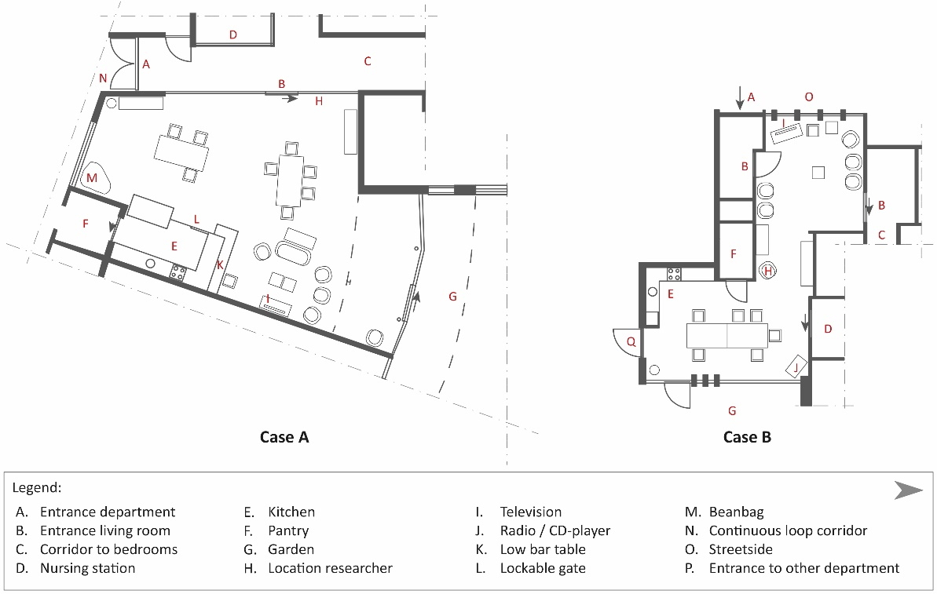
Figure 1. Floorplan of the common living room of both cases
Although the same features were present in the living rooms, the rooms were shaped differently (i.e., elongated trapezium vs Z-shape). The Z-shaped living room provided a spatial division between the dining area and the seating area, while this type of division was made via a cabinet and the back of the sofa in the rectangular shaped living room. The Z-shaped space (part of the category ‘fields’ (Zeisel, 1981)), provides two visual spaces rather than one. In addition, the square meters available for each resident varies greatly (i.e., 5m² per resident in Case A, and 9m² per resident in Case B).

3.2 Behavioral patterns including movement behaviour

3.2.1. Daily program in the common living room for Case A and Case B.
The daily program of the residents is defined mainly by the common activities in the living room. The day starts for the residents with individual breakfast. After that, an activity outside the department room is organized. The residents have lunch around 12:00h. After lunchtime, some residents take a nap; either in the common living room or in their bedroom. During the afternoon, a common activity is organized; sometimes in the living room and sometimes outside the department. After this activity, around 15:00 to 16:00h, the residents drink something together in the common living room. Dinner is served between 17:00 and 18:00h. In the evening, family and friends visit often their relatives.

3.2.2. Movement patterns in the common living room
Case A. The maps displayed in Figures 2 and 3 show the movements per person per hour. The hourly maps are important to gain insight into the movement patters during the time of the day. The thicker the line, the more often this walking path was used. The results of the first observation day show a direct movement pattern from the living room to the corridor with the bedrooms around 10:00h and 15:00h, because the majority of the residents are engaged in an activity outside the department. In between these time stamps, fewer movement patterns are visible; relatively a few people are present in the common living room. The same type of movement pattern is visible during the second observation day, between 10:00h and 11:00h, because of an activity outside the department. In the afternoon, less movement of residents is noted. Some residents show wandering behavior in the common living room before and after dinner on both days.
Case B. The first observation day in Case B shows a direct movement pattern from the living room to the hallway around 10:00h and 12:00h, because most of the residents are engaged in an activity outside the department. During both observation days, little or no movement is registered in the afternoon, because of activities in the common living room and visits to the garden. Also, little to no movement was registered before dinner time (17:00h). During both days, some residents show wandering behavior in the common living room after dinner.

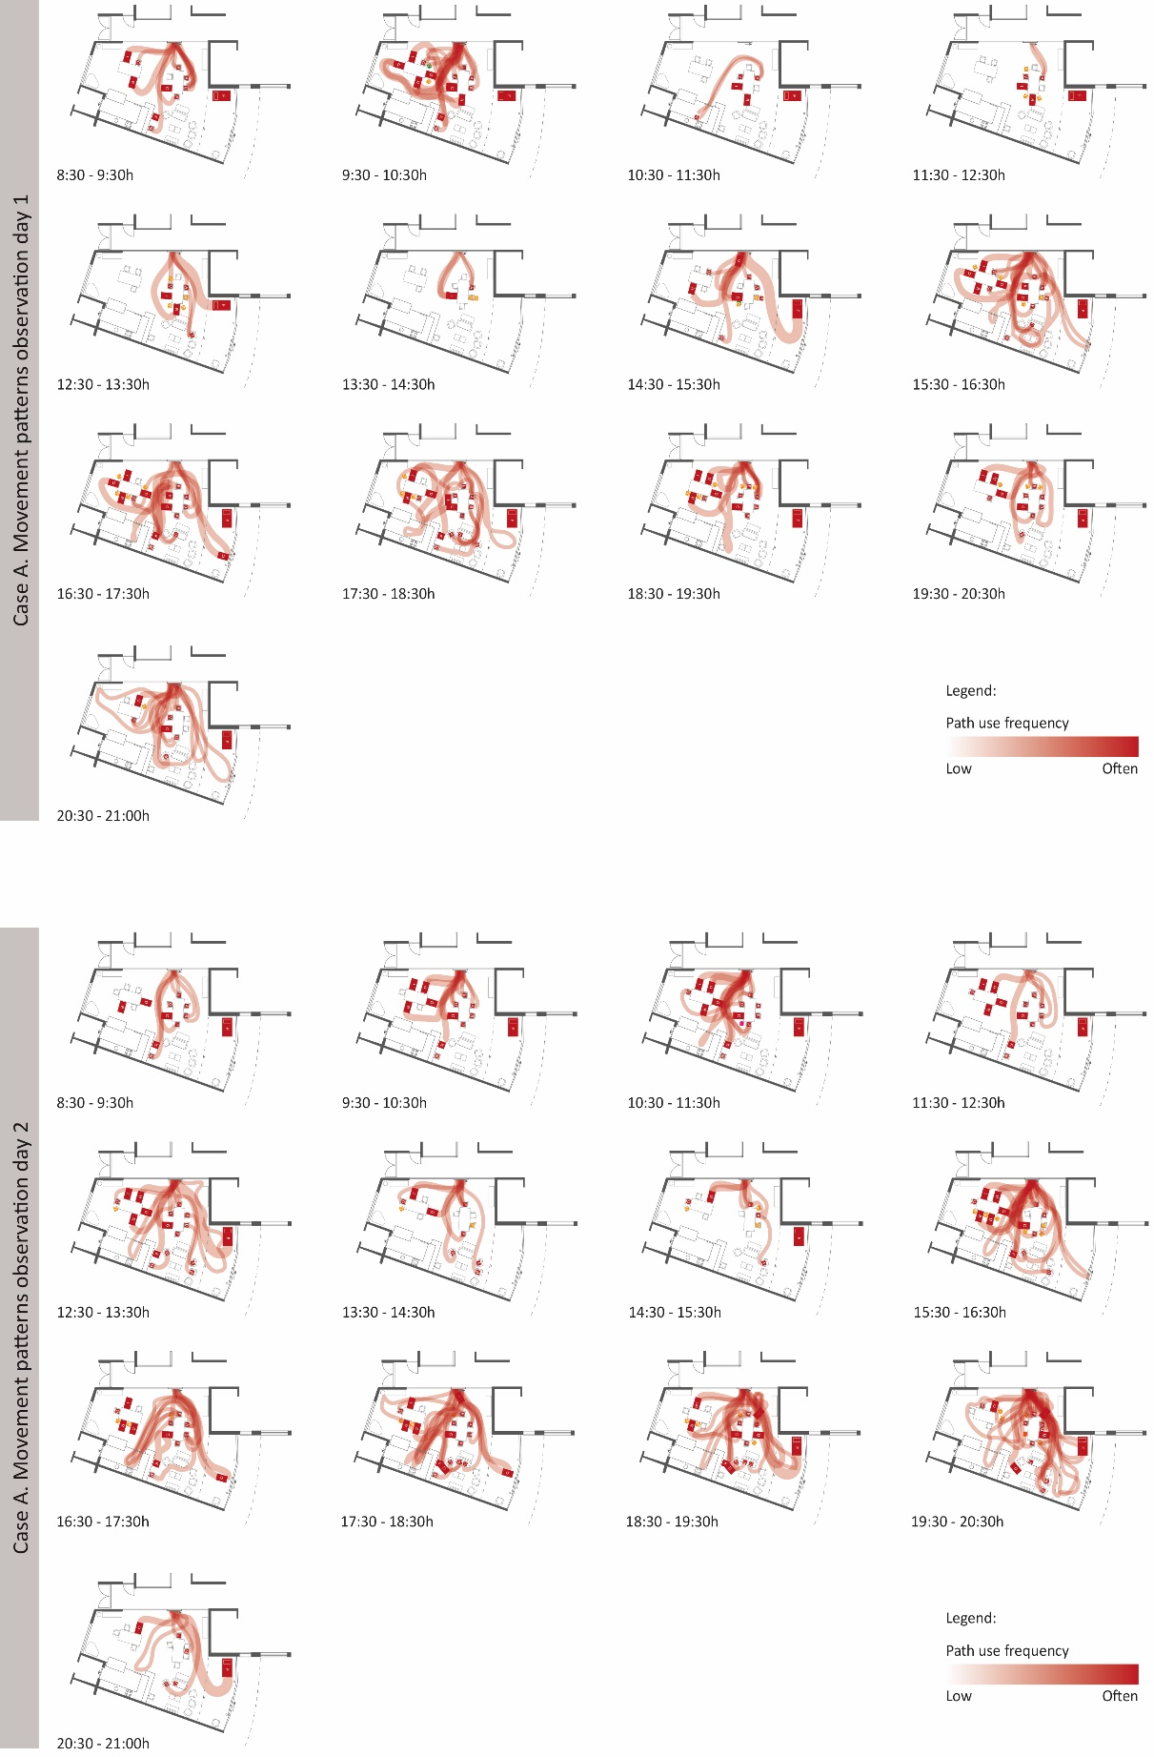
Figure 2. Movement pattern of the seniors with dementia, per day, per hour of Case A
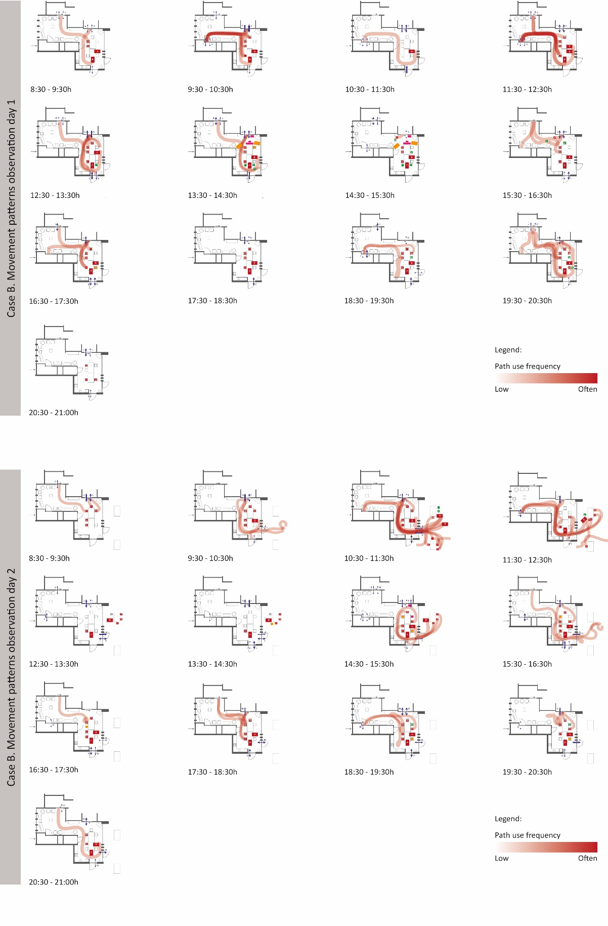
Figure 3. Movement patterns of the seniors with dementia, per day, per hour of Case B

3.3. Behavioral patterns in the spatial context
In both cases, a dominant walking path is visible. For Case A, this dominant walking path runs from the kitchen straight to the door towards the corridor, whereby the left and right side of the floorplan is separated. This dominant walking path traverses through the dining zone (Figure 4). For Case B, this path is a Z-shaped pattern connecting the kitchen area to the seating area. This is a rather small passage. (Figures 4 and 5). The position of the entrances shapes these dominant walking paths towards the living room, crossing and connecting different zones (i.e., dining and seating). In addition, the positioning of furniture plays also a role in defining the dominant walking paths.
Also, in both cases some spaces were not used during observations. Within Case A, these are the open space without furniture on the left side of the floorplan and the space near the door to the garden at the right side. This could be due to cloudy weather. The seating area in Case B was not used during both observation days, and this could be due to the sunny weather and outdoor possibilities. (Figure 4)
Both cases also show some bottlenecks. Two of these bottlenecks in Case A are situated between one of the dining tables and the seating area; only small passages are available. In Case B also bottlenecks appeared around the dining table and the glass wall and kitchen (Figure 4). These objects act as ‘barriers’ (Zeisel, 1981).

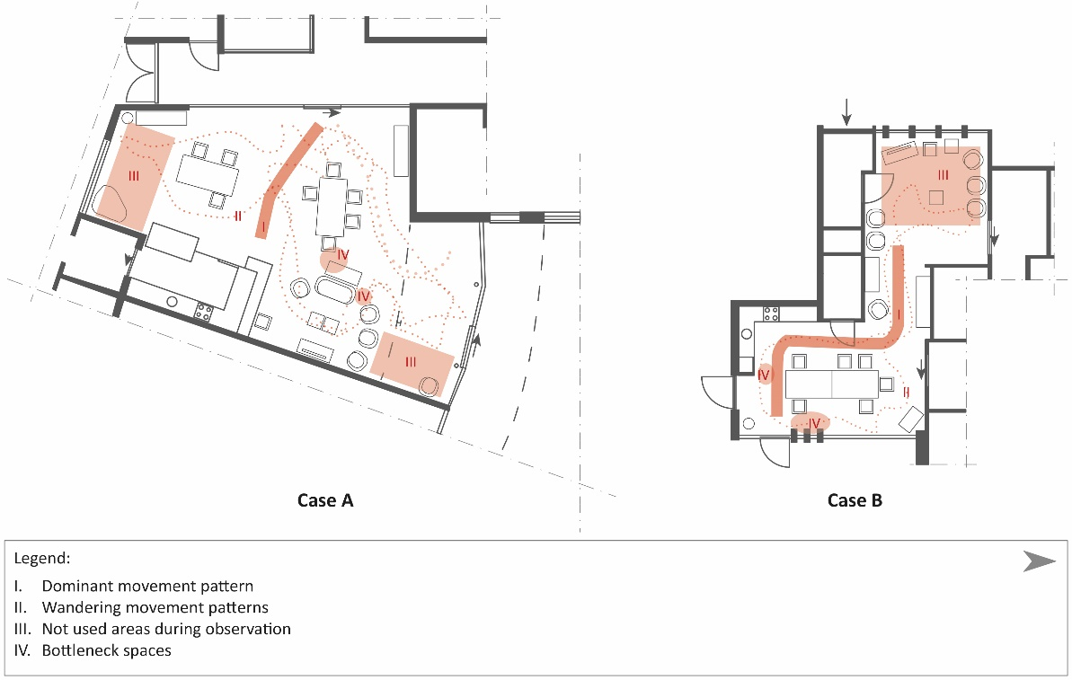
Figure 4. Movement patterns in the spatial context
Figure 5 shows a visual summary of the results and analysis, showing both the floorplan and the timeline for each case for each observed day. In the floorplan, the dominant walking path (solid red line) and the wandering pattern (dotted line) is drawn for the particular observed day. The timelines include the daily communal meal schedules (e.g., lunch, dinner, coffee) and common scheduled activities in the living room (e.g. music session and sport games). In addition, the dominant type of movement at a particular time of day has been added below each timeline. A straight line is used to express the direct movement pattern, a dotted infinity-diagram is used to express the wandering movement pattern, and a cross is used for the none movement pattern.

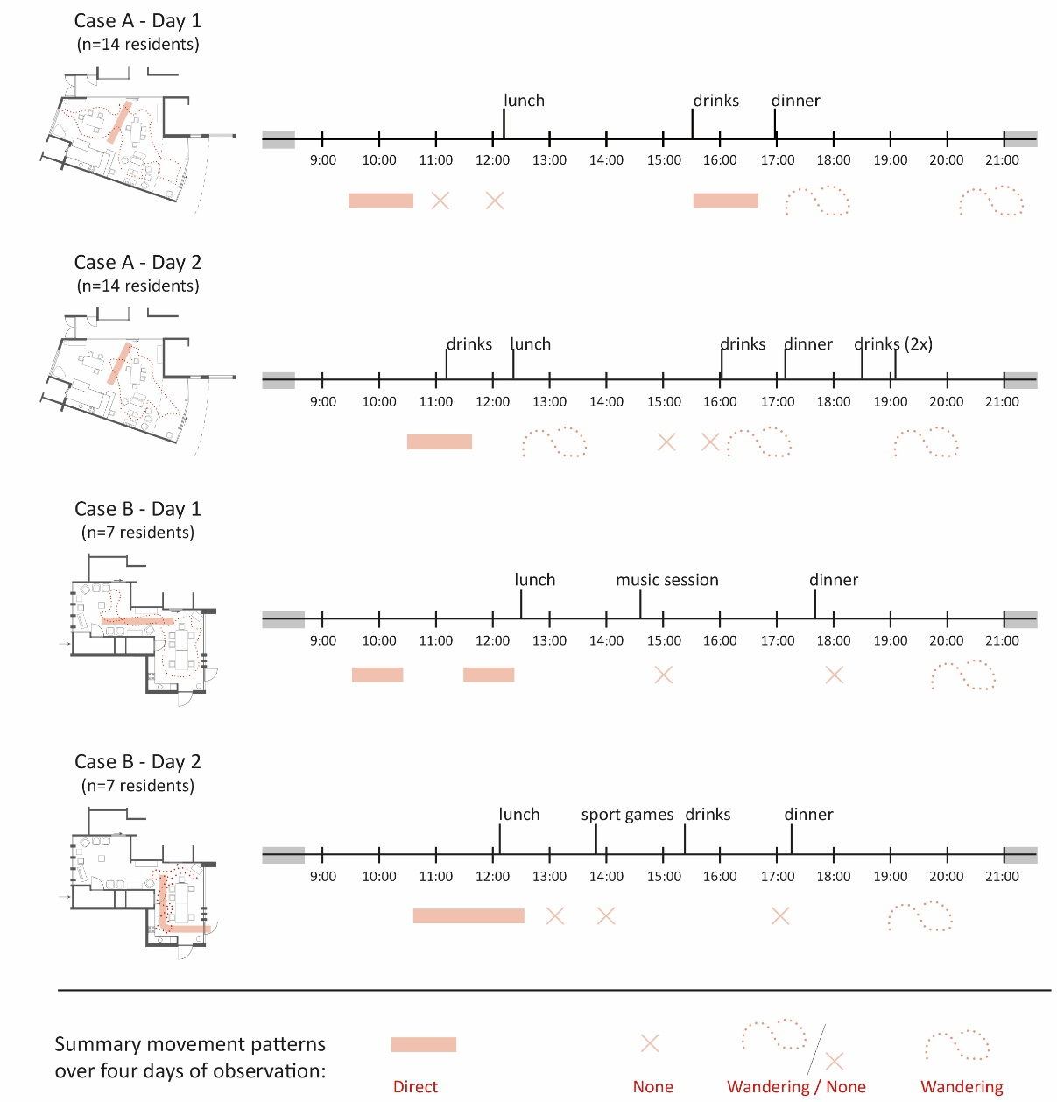
Figure 5. Behavioral patterns in spatial context over time

4. Discussion
This study examined the type of movement, time of the day, and the location of movement patterns in two common living rooms in two nursing homes. Results show that the same type of movements (e.g., none, direct, or wandering) occurred in both living rooms at similar time periods (Figure 5). This finding confirms the classification of the Martino-Saltzman-Model (Martino-Saltzman, et al., 1991).
Wandering behavior occurred in both living rooms after dinner, confirming the research of Makimoto, et al. (2008). However, our findings contradict with the findings of the research of Algase, et al. (2007), who registered wandering behavior around 15:00h. Interestingly, wandering movement patterns appeared in our study, in Case A, before dinner.
Concerning the location of wandering patterns, it can be mentioned that residents showing wandering behavior used the complete layout of the living room. Residents tried to move around certain objects (e.g., dining tables, seating furniture in the lounge area). As regards to the location of direct movement patterns – dominant walking paths – in the living room, it was noticeable that the dominant walking path in Case A traverses through the dining zone (Figure 4). The effect of this type of direct walking path on the emotion of the residents could be studied in future research.
The square meters available for each resident varies greatly: i.e., 5m² per resident in Case A, and 9m² per residents in Case B. Adequate space to move around with wheelchairs and walkers is important to reduce perceived barriers (van Liemd, et al., 2009).
A couple of limitations of this study can be mentioned. Only four days of observation were conducted, two days per department, in Spring. Different weather conditions were noticed, resulting in different activities inside and outside. In addition, the observations took place in only two departments with different shapes, while many shapes of common living rooms exist in nursing homes in the Netherlands (van Buuren & Mohammadi, 2022). We recommend fly-on-the-wall observations with person-centered behavioral mapping techniques in different shapes of common living rooms for further research, with a varying number of residents, during multiple weather conditions for each case.
In the current study, fly-on-the-wall observations with person-centered behavioral mapping provide information on movement patterns and activities of the residents in the common living room, but this method cannot provide information about how people objectively experience these movement patterns and activities. This is important because how we experience architecture, influences how we find our way around (e.g. Delgrange, et al., 2020; Ruotolo, et al., 2019).

5. Conclusions
In order to provide design requirements for common living rooms in nursing homes of seniors with dementia, it is important to understand the relationship between the spatial layout and daily behavior, in this case: movement behavior.
This study detected three diverse movement behavior patterns (e.g., none, direct, wandering) were detected. These patterns seemed predominantly bound to time. Direct movement was observed in the morning, due to an activity outside the common living room. Little to no movement was detected during lunchtime, afternoon, and during dinner; due to an activity in the common living room. Lastly, wandering behavior patterns were discovered in the evening, after dinner; and in the large-scale common living room (n=15 residents) just before dinner time. Therefore, as a design (process) requirement, behavioral patterns during the day and evening should be considered in the design, taken into account daily scheduled activities in the living room (e.g., meals, music sessions or sport games) and outside the common living room (e.g. music sessions, church visits).
These daily behavioral patterns often result into dominant walking paths. Dominant walking paths are generated by the entrances to the living room and the features of a zone in the living room, often the dining table. This indicates that special attention should be paid to the determination of dominant walking paths. Also, take into consideration the position of the outside terrace in relation to the dining and lounge area. This could be as well a dominant walking path. As a design requirement, easy routes without too many turns should be designed for these dominant walking paths.
Barriers disturbing movement patterns could be the furniture placement related to the edges of a space, seen in both Case A and B. Attention should be paid to the placement of movable furniture in relation to static edges in the design. Residents tend to move around objects. Therefore, as a design requirement, providing adequate space around these objects is necessary. Adequate space needs to be interpret in the space required by different means of movement of seniors with dementia (e.g., wheelchairs, walkers). For example a turning radius of 1500mm should be implemented.

Contributor statement
Author 1: Conceptualization; formal analysis; investigation; methodology; project administration; visualization; writing – original draft.
Author 2: Conceptualization; funding acquisition; methodology; supervision; writing – review & editing.
Acknowledgments (optional)
This research was supported by RSZK ZorgProfessionals.

References
- Algase, D. L., Moore, D. H., Vandeweerd, C., & Gavin-Dreschnack, D. J. (2007). Mapping the maze of terms and definitions in dementia-related wandering. Aging & mental health, 11(6), 686-698.
- Algase, D. L., Antonakos, C., Beattie, E. R., Beel‐Bates, C. A., & Yao, L. (2009). Empirical derivation and validation of a wandering typology. Journal of the American Geriatrics Society, 57(11), 2037-2045.
- Alzheimer Nederland (2020). Factsheet. Cijfers en feiten over dementie. [Factsheet, Numbers and facts on dementia]. Retrieved from: https://www.alzheimer-nederland.nl/factsheet-cijfers-en-feiten-over-dementie
- Andersen, C. K., Wittrup-Jensen, K. U., Lolk, A., Andersen, K., & Kragh-Sørensen, P. (2004). Ability to perform activities of daily living is the main factor affecting quality of life in patients with dementia. Health and quality of life outcomes, 2(1), 1-7.
- Andersen, N. S., Chiarandini, M., Jänicke, S., Tampakis, P., & Zimek, A. (2021, December). Detecting Wandering Behaviour of People with Dementia. In 2021 International Conference on Data Mining Workshops (ICDMW) (pp. 727-733). IEEE.
- Andrienko, N., & Andrienko, G. (2007). Designing visual analytics methods for massive collections of movement data. Cartographica: The International Journal for Geographic Information and Geovisualization, 42(2), 117-138.
- Ballard, C. G., Mohan, R. N. C., Bannister, C., Handy, S., & Patel, A. (1991). Wandering in dementia sufferers. International Journal of Geriatric Psychiatry, 6(8), 611-614.
- Buchner, D. M., & Larson, E. B. (1987). Falls and fractures in patients with Alzheimer-type dementia. Jama, 257(11), 1492-1495.
- Cohen-Mansfield, J., Werner, P., Marx, M. S., & Freedman, L. (1991). Two studies of pacing in the nursing home. Journal of Gerontology, 46(3), M77-M83.
- Delgrange, R., Burkhardt, J. M., & Gyselinck, V. (2020). Difficulties and Problem-Solving Strategies in Wayfinding Among Adults With Cognitive Disabilities: A Look at the Bigger Picture. Frontiers in human neuroscience, 14, 46.
- Den Draak, M., Marangos, A. M., Plaisier, I., & de Klerk, M. (2016). Wel thuis? Literatuurstudie naar factoren die zelfstandig wonen van mensen met beperkingen beïnvloeden. [Good at home? Literature study into factors influencing living independently for seniors with disabilities]. Sociaal en Cultureel Planbureau.
- Haq, S., & Luo, Y. (2012). Space syntax in healthcare facilities research: A review. HERD: Health Environments Research & Design Journal, 5(4), 98-117.
- Hou, C., & Marquardt, G. (2015). Spatial layout and spontaneous behaviour for people with dementia: A study of adult day-care centres. In 10th International Space Syntax Symposium, SSS 2015. Space Syntax Laboratory, The Bartlett School of Architecture, University College London.
- Howard, R., Ballard, C., O'Brien, J., & Burns, A. (2001). Guidelines for the management of agitation in dementia. International Journal of Geriatric Psychiatry, 16(7), 714–717.
- Jonker, C., Slaets, J. P. J., & Verhey, F. R. J. (2009). Handboek dementie. [Handbook dementia]. Bohn Stafleu van Loghum.
- Kahana, E., & Kahana, B. (1983). Environmental continuity, futurity, and adaptation of the aged. In G. D. Rowles, & R. J. Ohta (Eds.), Aging and milieu: Environmental perspectives on growing old (pp. 205–228). New York: Academic Press.
- Lawton, M. P., & Simon, B. (1968). The ecology of social relationships in housing for the elderly. The Gerontologist, 8(2), 108–115.
- Lin, Q., Zhang, D., Chen, L., Ni, H., & Zhou, X. (2014). Managing elders’ wandering behaviour using sensors-based solutions: a survey. International Journal of Gerontology, 8(2), 49-55.
- Makimoto, K., Lee, E. A., Kang, Y., Yamakawa, M., Ashida, N., & Shin, K. R. (2008). Temporal patterns of movements in institutionalized elderly with dementia during 12 consecutive days of observation in Seoul, Korea. American Journal of Alzheimer's Disease & Other Dementias®, 23(2), 200-206.
- Marquardt, G. (2011). Wayfinding for people with dementia: a review of the role of architectural design. HERD: Health Environments Research & Design Journal, 4(2), 75-90.
- Marquardt, G.,& Schmieg, P. (2009). Dementia-friendly architecture: Environments that facilitate wayfinding in nursing homes. American Journal of Alzheimer’s Disease & Other Dementias, 24(4), 333–340.
- Martino-Saltzman, D., Blasch, B. B., Morris, R. D., & McNeal, L. W. (1991). Travel behaviour of nursing home residents perceived as wanderers and nonwanderers. The Gerontologist, 31(5), 666-672.
- Mohammadi, M. (2017). Empathische woonomgeving (Empathic environment]. Eindhoven University of Technology
- Mobiliteitsklassen. (2017, 30 augustus). Retrieved from: http://www.arjohuntleigh.nl/kennis/ mobiliteits-wijzer/
- O'connor, D. W., Pollitt, P. A., Roth, M., Brook, C. P. B., & Reiss, B. B. (1990). Problems reported by relatives in a community study of dementia. The British Journal of Psychiatry, 156(6), 835-841.
- Pai, M. C., & Jacobs, W. J. (2004). Topographical disorientation in community‐residing patients with Alzheimer's disease. International journal of geriatric psychiatry, 19(3), 250-255.
- Rizzo, M., & Nawrot, M. (1998). Perception of movement and shape in Alzheimer's disease. Brain: a journal of neurology, 121(12), 2259-2270.
- Rowe, M. A., & Bennett, V. (2003). A look at deaths occurring in persons with dementia lost in the community. American Journal of Alzheimer's Disease & Other Dementias®, 18(6), 343-348.
- Ruotolo, F., Claessen, M. H. G., & van der Ham, I. J. M. (2019). Putting emotions in routes: the influence of emotionally laden landmarks on spatial memory. Psychological research, 83(5), 1083-1095.
- Siders, C., Nelson, A., Brown, L. M., Joseph, I., Algase, D., Beattie, E., & Verbosky-Candena, S. (2004). Evidence for implementing non-pharmacological interventions for wandering. Rehabilitation Nursing, 29(6), 195-206.
- Teri, L., Larson, E. B., & Reifler, B. V. (1988). Behavioural disturbance in dementia of the Alzheimer's type. Journal of the American Geriatrics Society, 36(1), 1-6.
- Torrington, J. (2007). Evaluating quality of life in residential care buildings. Building Research & Information, 35(5), 514-528.
- van Buuren, L. P. G., & Mohammadi, M. (2022). Dementia-friendly design: A set of design criteria and design typologies supporting wayfinding. Health Environments Research & Design Journal, 15(1), 150-172.
- van Liempd, H. M. J. A., Hoekstra, E. K., Jans, J. M., Huibers, L. S., & Van Oel, C. J. (2009). Evaluatieonderzoek naar de kwaliteit van de huisvesting van kleinschalige woonvormen voor ouderen met dementie. Eindrapportage. Vilans en AKTA.
- Vuong, N. K., Chan, S., & Lau, C. T. (2014). Automated detection of wandering patterns in people with dementia. Gerontechnology, 12(3), 127-147.
- WHO (2021). Dementia Key Facts. Retrieved from: WHO : https://www.who.int/news-room/fact-sheets/detail/dementia
- Zeisel, J. (1981). Inquiry by design. Tools for environmental-behaviour research. Cambridge University Press

