Type of the Paper: Peer-reviewed Conference Paper / Full Paper
Track title: Engagement – co-creation, co-design, design and stakeholder management processes

Valuing Processes and Outcomes: A framework for planning co-design in complex systems of health design
Aaron Davis¹*, Niki Wallace², Ian Gwilt¹, Michelle R. Tuckey¹
¹ University of South Australia, Adelaide, Australia; Aaron.Davis@unisa.edu.au; 0000-0002-1477-7406
² University of the Arts London, London, UK
* corresponding author.

Names of the track editors:
Clarine van Oel

Journal: The Evolving Scholar
DOI:10.24404/621cb2143aa4c8889c8a79ed

Submitted: 22 Mar 2022
Revised: 17 May 2022
Accepted: 30 May 2022
Citation: Davis, A., et al.(2022). Valuing Processes and Outcomes: A framework for planning co-design in complex systems of health design. The Evolving Scholar | ARCH22.

This work is licensed under a Creative Commons Attribution CC BY (CC BY) license.
©2022 Davis, A., Wallace, N., Gwilt, I. & Tuckey, M. published by TU Delft OPEN on behalf of the authors.

Abstract:
Purpose: This paper sets out a framework for planning co-design processes for complex systems-based projects typical in healthcare settings.
Background: Healthcare systems and environments are complex. Innovation often requires the redesign of physical spaces or objects, social processes, and the complex associated layers of service systems. Co-design is an established methodology for catalysing innovation in products and services because the scope is often well-defined but can be more challenging when working in systems where complexity impacts boundary definition. Co-design uses interdisciplinary and multi-level engagement with diverse stakeholders to catalyse innovation at the intersection between disciplines, experiences, and knowledge sets. The evaluation of these processes often utilises control over decision-making as a defacto measure of participation quality, reflecting potential for stakeholders to influence key outcomes. Yet there are also practical and theoretical reasons to value well-designed participatory processes in their own right.
Methods: The framework presented in this paper combines the evaluation of participation in co-design processes and in decision-making as two distinctive activities, applied to real-world and hypothetical case studies that demonstrate the potential of this framework as a transparent planning and evaluation tool.
Results: The framework allows participation to be planned and valued independently without defaulting to control over decision-making processes as the (only) valued option. The case studies demonstrate its potential in structuring a range of collaborative processes that suit different types of system innovation.
Conclusions: The formalisation of a framework for planning co-design activities that values participation in co-design processes in parallel with participation in decision-making provides a more transparent and beneficial way to structure co-design for complex systems-based challenges that recognises the humans at the heart of co-design.
Keywords: Co-design, stakeholder management, participatory processes, systems design

1. Introduction
Co-design, co-production, patient-led projects, and other ‘end-user’ engaged approaches are increasingly being called for in healthcare innovation projects (Steen et al., 2011). This kind of participation is seen as the gold standard for how we work on a wide range of healthcare projects, from the redesign of a process, to the overhaul of a model of care, or even the design of a new healthcare facility (Stewart, 2001).
These approaches are not new and can be traced back to the participatory design movement in Scandinavia in the 1970s (Sanders & Stappers, 2012; Davis, 2019a). Perhaps the most fundamental shift associated with the recent focus on co-design practices in healthcare is the recognition that different people have different needs, and that the only way to design systems for people is to design them with people (Stewart, 2001). However, as will be argued later in this paper, this fundamental shift to working with rather than for or on brings some complex methodological and evaluative challenges.
In this paper, we introduce two key frameworks as exemplars of two ways of defining and measuring participation as an independently-valued outcome, before then proposing a new framework that brings together some of the fundamental elements of both. The paper then explores the hypothetical application of this framework before discussing how it may be implemented in the planning and evaluation of co-design in health.

2. Theories and Methods
Arnstein’s Ladder (Arnstein, 1969) is often cited as the beginning of our understanding of the challenges and pitfalls of working with people on projects. This framework emerged from Sherry Arnstein’s work in the US Federal Government Department of Housing and Urban Development. In it, she sets out eight levels or ‘rungs’ of participation, ranging from ‘manipulation’ to ‘citizen control’ (Figure 1).

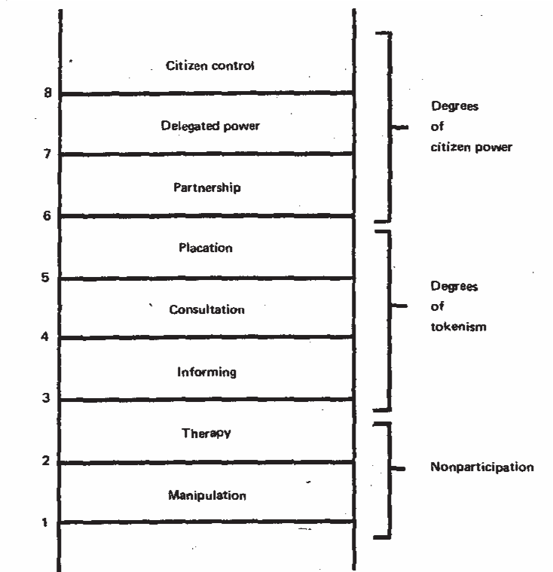
Figure 1. Eight Rungs on a Ladder of Citizen Participation (Reproduced from Arnstein, 1969, p. 217).
The lower levels on the Ladder are associated with forms of what Arnstein terms ‘nonparticipation’ and describe two hostile uses of public consultation processes. The first, manipulation, describes a process where public consultation is structured in such a way that it can manipulate or control contributions to suit a preformed agenda (Arnstein, 1969). The second, therapy, is again a form of manipulation, but rather than seeking to manipulate an outcome, the processes involved are designed to change and reform the attitudes, perspectives and beliefs of participants in the consultation process. These levels do not necessarily reflect malicious intent, but instead describe ill-conceived processes that are designed in a way that excludes participants from meaningfully contributing to a project.
The middle levels, termed ‘degrees of tokenism’ by Arnstein describe three forms of consultation processes that engage citizens in processes to different degrees. Informing is focused on engaging with the intent of allowing participants to know what is going on but not necessarily have a say, while consultation is described as capturing people’s thoughts and perspectives without any commitment to incorporating them into project decision-making processes. Placation, at the top of these three levels, allows the contributions of citizens to be included in processes for the purpose of ‘keeping them happy’ rather than because they are necessarily seen as a positive contribution to the overall project.
The Ladder then moves up to ‘degrees of citizen power’ where citizens are elevated to various levels of responsibility within projects. Here three levels are described, one that is focused on processes, while the other two shift to thinking about decision-making. The ‘partnership’ level describes the treatment of citizen stakeholders as equal partners in a project, with their contributions taken as seriously as those of other stakeholder groups. However, when shifting to the ‘delegated power’ and ‘citizen control’ levels, the role of the citizen groups shifts to the point that they have increased power in comparison to other stakeholder groups.
Where the ‘partnership’ level establishes citizens as equal to other stakeholders, the highest two levels represent processes that redistribute power in favour of citizen concerns over and above those of other stakeholder groups. This idea of rebalancing or redistributing power leads to the second framework that forms the basis for the proposition in this paper, the International Association of Public Participation’s Spectrum of Public Participation (Figure 2).
Figure 2. IAP2 Spectrum of Public Participation (SA Health, 2018).
The International Association of Public Participation’s Spectrum of Public Participation has been widely adopted in Australia and internationally as a default way of defining and measuring public participation. The Spectrum features in numerous government policies, particularly with regard to consultation in healthcare practices.
The Spectrum picks up on many of the key ideas introduced by Arnstein (1969) but frames its definitions around ‘impact on the decision’. This focus on the potential to influence the outcome of a project is very useful when seeking to understand the power relationship between people (citizens) and governments or industry, and gives further nuance to the ‘delegated power’ and ‘citizen control’ levels of Arnstein’s Ladder. But, the hierarchy of focus and the push toward increasing impact on decisions can mean that processes can be structured to meet the decision-making criteria without necessarily undertaking what might be termed a good participatory process. In earlier explorations of the relationship between this framework and Arnstein’s ladder, the authors noted that projects that met a particular level on the IAP2 spectrum were able to be aligned with almost all of the rungs of Arnstein’s Ladder, depending on the processes that were carried out that led to the decision-making process that is measured by the IAP2 spectrum (Davis & Andrew, 2017). Put simply, process is a key ingredient, worthy of focus in its own right.
The IAP2 Spectrum and Arnstein’s Ladder are not the only frameworks for evaluating engagement of people in co-design or consultation processes, but they are illustrative of two very different approaches. On the one hand, the majority of Arnstein’s Ladder focuses on describing processes of working together, while on the other, the IAP2 spectrum focuses exclusively on control over the decision-making process. This may seem a small difference, but the value of many co-design processes cannot simply be captured by how much of the control over decision-making was given to the ‘end-user’ participants. Calvo and Sclater (2021), for example, describe significant social learning that can come from engaging in co-design, while in our previous work, we have looked to Max-Neef’s (2017) needs and satisfiers framework to identify a number of very significant forms of value that relate to both participation in decision-making and participation in “good” processes (Wallace, Davis & Gwilt, 2021). In particular we highlighted that, irrespective of the outcomes, co-design processes can be directly beneficial for participating stakeholders by aiding the satisfaction of fundamental human needs. To this end, we have developed a conceptual framework that, instead of arguing the merits of one approach or the other, brings together these approaches into a field of practices that can describe a wide variety of processes and approaches (Figure 3). This integrated framework is presented as a catalyst for discussion and for the scenario-based experimentations presented in the next section of this paper. As this framework is still under development, it uses an abstracted nomenclature on its axes, but is aligned with Arnstein’s Ladder (Arnstein, 1969) and the IAP2 spectrum (IAP2, 2018) to help explain the concepts. In future versions of this framework, it is intended that specific descriptors be developed for both the axes and the fields.
The ‘citizen control’ and ‘delegation’ models of Arnstein’s Ladder have been presented as part of the matrix, but are not included in the framework because, as previously discussed, the ideas captured by these two levels focus predominantly on decision-making rather than participation. Should these be included in future versions of this model, they would form two subsets of ‘empower’ on the x-axis.
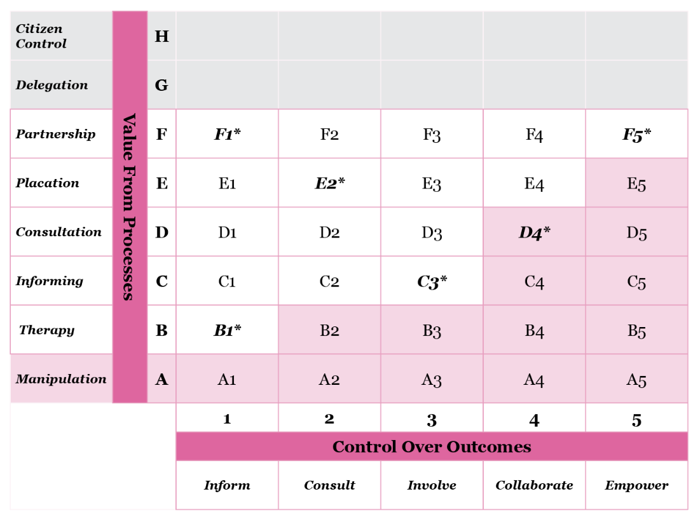
Figure 3. An integrated conceptual framework for planning and evaluating co-design processes. Regions highlighted with an asterisk are developed further in the results section below.
This conceptual framework has been tested using a Design Fictioning process (Dunne & Raby, 2013) to build a series of experiential descriptions of what a process based on a particular location within the framework may look like. Where appropriate, the authors link the discussion with real case study projects that demonstrate some of the particular qualities of these approaches in practice. This begins to triangulate between the imagined and the experiential data to add depth and rigor to the explorations.

3. Results
A series of online discussions between authors were held to discuss the merits, opportunities, and challenges of each of the potential approaches described by the framework. From these discussions, eight scenarios were explored through design fictions to further extrapolate the relationship between involvement in processes and involvement in decision-making.
Five scenarios from these design fictions are discussed in the sub-sections below. Some have been augmented with real examples from practice to further contextualise these provocations. Each has been selected to illustrate a tension or complexity within the framework and to encourage critical thinking about how we might approach co-design and engagement.
For ease of reading, subsections have been named to match the position on the framework (e.g., F1 to denote the intersection of a partnership approach to participation and inform as the level of influence over decision making). They have also been labelled with the guiding level from Arnstein’s Ladder (labelled as process) and the IAP2 spectrum (labelled as outcomes). However, it is intended that in a future version of this framework, these descriptors will be decoupled from the precedent structures.

3.1. B1: Therapy (process) and Inform (outcomes)
Cheryl has been diagnosed with type 2 diabetes but has been struggling to come to terms with her diagnosis. In a meeting with her GP, Dr Kumar, she was advised that diet and exercise would be a large part of her health strategy. Dr Kumar used a game-based approach that engaged Cheryl in a playful process to help her understand how her diet and exercise regime would change. The game’s rules define it as a form of therapy and informing that engages the patient in the process whilst allowing them to feel some agency in the outcomes that the game informs.
In this scenario, the outcome is already decided upon (reducing sugar and increasing physical exercise), but the engagement helps people to understand the thinking processes behind this decision. Although this form of consultation is typically considered very poor because it limits decision control, value can be derived from being open, transparent and honest with participants. In a group setting, there are also opportunities to facilitate social learning. Importantly in this approach, it must be clear upfront that outcomes are controlled, and these outcomes (or the rules of the game in the example) cannot be changed.

3.2 F1: Partnership (process) and Inform (outcomes)
Sarah is part of a group of new mothers, midwives, and obstetricians who come together to collaboratively build knowledge around the experience of childbirth at Flinders Hospital. There are no plans to make any changes to the service, but Sarah participates in a series of deep conversations that allow participants to co-construct knowledge about the experience of childbirth.
This approach is similar to B1, in that participants are not likely to have any control over decision-making. However, unlike B1, the engagement with participants is an equal partnership where a shared learning and open exploration process is undertaken. This provides a unique opportunity to co-construct knowledge and to explore issues together without any promise of involvement in decision-making. The value for all participants is therefore generated through interacting and learning from one another, and realized through social connection, learning, expression, and validation, rather than control over a particular decision.

3.3. E2: Placation (process) and Consult (outcomes)
Sean was eager to attend an event being hosted by a local health research institute in partnership with local government to explore the role of green space on mental health. When he got there, he looked at all the options in the room, and chose to sit at a table that would be talking about trees that encouraged birdlife. He sat with a group of 5 other participants and a small group facilitator who listened to the groups discussions and helped to document their ideas. At the end of the event a report was prepared by the researchers and distributed to local councillors for their consideration.
This approach is one where a process is focused on allowing people to have the opportunity to contribute their perspectives and to sit and listen. Although placation may assume the contributions that are received are not likely to be of use to the project decision-making process, the act of listening and allowing participants to be heard can deliver significant value. When paired with consulting—seeking feedback on rather than allowing a role in—the decision-making process relies on the decision makers to interpret and evaluate the contributions that were made. This in some ways mirrors the famous example described by Forester (2013) in outlining his theory of Critical Pragmatism.

3.4. C3: Informing (process) and Involve (outcomes)
A new healthcare clinic is being constructed in Bessy’s neighbourhood and as a council ratepayer she receives updates on the progress of the project and the services it will provide to the community once completed. Bessy is a potential patient of the clinic and is very interested in the project so really likes getting the information in her mailbox. During the late stages of the project Bessy is invited to complete a survey to share her thoughts on some of the artworks being purchased for the waiting area and doctors’ rooms. She finds landscape paintings soothing so votes for a series of landscapes by a local artist. After the clinic opens Bessy arrives for her appointment. When she sits down in the waiting room she smiles as she notices one of the paintings she voted for is on display.
Although the protagonist in this story did not have much of a say in the decision-making about the project, she felt well informed and as though she was being provided with regular updates and information about the project. Her involvement was relatively tokenistic in that the decision she was involved in may be regarded as relatively inconsequential. But, paired with the regular provision of information and clear communication to the community that they were being informed not consulted, this approach may be considered appropriate. This story also highlights the potential value of feedback regarding participation, even though direct decision-making control was low.

3.5. D4: Consultation (process) and Collaborate (outcomes)
Sinah has been invited to attend a Town Hall meeting held by her local council to discuss a new development that will turn a public space in her neighbourhood into a new healthcare and sporting facility. When she arrives there is a small crowd forming, and she takes her seat and reads the leaflet she was handed upon entry. The leaflet describes the proposal for the new development, including artist renderings and a clear vision statement. During the meeting, it becomes clear to Sinah that these plans are not being questioned, only some minor details about operating hours. Sinah and other attendees are asked for their opinions and ideas. They are invited to give whatever contributions they like and are told that these will all go into the project database, then at the end of the meeting are asked to vote for the opening hours they would most like to see. The request for feedback does not seem to permit any real contributions towards the end-outcomes of the project, making meaningful contribution feel impossible. Given the project has already broken ground, and the powerful medical practice that will be opening at the centre, they don’t get the sense anything will come from their contributions.
This example is the only provided that illustrates a pairing we do not consider appropriate and is included here to explore the edges of acceptable process. It highlights the potential for a fundamental misalignment between involvement in decision making and deeper participation. The establishment of false hope around the scope of influence the community could have, such as allowing the community to elect a representative or group to be part of earlier discussions and decisions, makes the collaborative decision-making process problematic. Despite influencing a core decision, engaging in this type of process misses the opportunity to fulfil basic needs, foster trust, and motivate ongoing participation and is likely to lead to a range of poor outcomes for participants.

3.6. F5: Partnership (process) and Empower (outcomes)
Laurie has been diagnosed with terminal cancer and has been exploring their end-of-life options with their Oncologist, Dr Jameson. Throughout this process Laurie and Dr Jameson have engaged as partners in setting the agenda for discussions on Laurie’s care preferences. Dr Jameson has worked closely with Laurie to understand Laurie’s end-of-life preferences and to ensure all the options are clear. Laurie feels empowered by this process and though this decision is the hardest one they've ever made, they feel armed with all the information needed to choose the most appropriate end-outcome.
The empowerment to define and control the process is key in this example to the full empowerment of the patient in their decision-making. It illustrates the value of maximising both process and outcome considerations in a synergistic way to achieve the best outcomes.

4. Discussion and Conclusions
What is immediately evident in Figure 3 is that the two antecedent frameworks upon which our integrated propositional framework is based are geared toward the discrete measurement of either participation in co-design processes, or increasing control over the decision-making process. However, by establishing the visual field of reference, a new range of practices and processes can be imagined that do not privilege the “highest” or “greatest” in the same way. Rather, tensions between participation and decision-making control might actually undermine the potential for positive outcomes for participants.
The premise of this paper is that decision-making control and participatory processes are independent factors that should be considered separately and together when planning co-design for complex health systems. Though we stand by this proposition, we can now advance a more nuanced view. It is interesting that as we constructed and explored the framework, a diagonal pattern emerged which revealed where processes can become problematic by creating tension with decision-making control. The disconnection between depth of participation and influence over decision-making led to questions about the ethics of participation being arranged in this manner. Discussions explored the negative repercussions of running a ‘bad’ process and then including participants in decision-making as compared to running a ‘good’ process and then excluding participants from decision-making. What emerged from these discussions was the role of agenda setting fore-fronting a ‘good’ process and the influence this kind of set-up can have on the continuing processes and their outcomes.
Writing the design fictions allowed further critical engagement with the potential trade-offs in focus by considering multiple combinations of processes and outcomes, and where different approaches might be most appropriate. In fictional scenarios where technical or specialist knowledge is required for informed decision-making, citizen control over decision-making could pose a risk. However, their inclusion and participation in ‘good processes’ at earlier stages of a project permits a level of influence and engagement that is inclusive, appropriate and safe. Conversely, the inclusion in decision-making without participation at earlier stages of a project can feel hollow and lacks the influence and benefits achievable through engagement in ‘good’ processes.
In other words, the integrated framework proposes (a) that the quality of participation and the value that is derived from participation should indicatively match or exceed the level of control over decision-making and (b) be brought forward as early as possible in advance of decision-making. Where these two conditions are not achieved, we would suggest there are likely to be significant problems with the processes being undertaken and the missed opportunity to realise significant benefits irrespective of the final decisions made.
The proposed framework continues to be explored by the researchers. Its early conceptual state suggests a unique opportunity for people working in co-design in health to increase the value generated through high-quality design and engagement processes without relying on delivering political engagement and control over decision-making.

Contributor statement
Conceptualization: Aaron Davis, Niki Wallace, Ian Gwilt; Writing – Original Draft: Aaron Davis, Niki Wallace; Writing – Review and Editing: Aaron Davis, Niki Wallace, Ian Gwilt, Michelle Tuckey

References

- Arnstein, S. R. (1969). A ladder of citizen participation. Journal of the American Institute of planners, 35(4), 216-224.
- Calvo, M., & Sclater, M. (2021). Creating spaces for collaboration in community co‐design. International Journal of Art & Design Education, 40(1), 232-250.
- Davis, A & Andrew, J 2017 “From Rationalism to Critical Pragmatism: Revisiting Arnstein’s Ladder of Public Participation in Co-Creation and Consultation” Proceedings of the State of Australian Cities 2017 Conference, Adelaide, Australia 28-30 November.
- Davis, A. (2019a). Co-creation in the built environment: An exploration of end-user engagement in the urban living laboratory. (PhD Thesis). University of South Australia, Adelaide, Australia.
- Davis, A., Niki, W., Langley, J., & Ian, G. (2021). Low-Contact Co-Design: Considering more flexible spatiotemporal models for the co-design workshop. Strategic Design Research Journal, 14(1).
- Dunne, A., & Raby, F. (2013). Speculative everything: design, fiction, and social dreaming. MIT press.
- Forester, J. (2013). On the theory and practice of critical pragmatism: Deliberative practice and creative negotiations. Planning theory, 12(1), 5-22.
- IAP2 International Federation (2018) Spectrum of Participation https://iap2.org.au/wp-content/uploads/2020/01/2018_IAP2_Spectrum.pdf
- Max-Neef, M. (2017). Development and human needs. In Development Ethics (pp. 169-186). Routledge.
- Rodela, R 2011, 'Social learning and natural resource management: the emergence of three research perspectives', Ecology and Society, vol. 16, no. 4, pp. 1-18.
- SA Health (2021). Engaging Consumers, Carers and The Community. Government of South Australia. https://www.sahealth.sa.gov.au/wps/wcm/connect/public+content/sa+health+internet/resources/engaging+with+consumers+carers+and+the+community+guide+and+resources
- Sanders, E. B. N., & Stappers, P. J. (2012). Convivial design toolbox. BIS Publishers.
- Sanders, E.B.B., & Stappers, P.J. (2008). Co-creation and the new landscapes of design. Co-design. 4(1). 5-18.
- Sangiorgi, D., Prendiville, A. (2017) Designing for Service: key issues and new directions. UK Bloomsbury Press
- Steen, M., Manschot, M. & Do Knoing, N. (2011). Benefits of co-design in service design projects. International Journal of Design. 5(2). 53-60.
- Stewart, M. (2001). Towards a global definition of patient centred care: the patient should be the judge of patient centred care. BMJ, 322(7284), 444-445.
- Wallace, N., Davis, A., & Gwilt, I. (2021). Wellbeing through participation: Creativity and co-design as processes of "welldoing". NiTRO, 35.

