Type of the Paper: Peer-reviewed Conference Paper / Full Paper
Track title: Classification of (communal) housing typologies for independently living seniors in social housing

Classification of (communal) housing typologies for independently living seniors in social housing; a TwoStep Cluster analysis
Kim Hamers ¹*, Nienke Moor ² and Masi Mohammadi ^{3,}
¹ Architecture in Health, HAN University of Applied Sciences; kim.hamers@han.nl
² Architecture in Health, HAN University of Applied Sciences; nienke.moor@han.nl
³ Eindhoven University of Technology; Architecture in Health, HAN University of Applied Sciences; m.mohammadi@tue.nl
* Use * to indicate the corresponding author.

Names of the Topic editors:
Clarine van Oel

Journal: The Evolving Scholar
DOI:10.24404/621ced6bb368a4577d493054

Submitted: 28 Feb 2022
Revised: 10 Jun 2022
Accepted: 12 Jun 2022
Citation: Hamers, K., Moor, N. & Mohammadi, M. (2022). Classification of (communal) housing typologies for independently living seniors in social housing; a Two Step Cluster analysis. The Evolving Scholar | ARCH22.

This work is licensed under a Creative Commons Attribution CC BY license (CC BY).

© 2022 Hamers, K., Moor, N. & Mohammadi, M. published by TU Delft OPEN on behalf of the authors.

Abstract: Dutch housing associations focus on communal living with the aim of stimulating social interaction between (older) residents and strengthening cohesion. Although the added value of communal living for social interaction between residents has been discussed in the literature, there is still little known about the broad range of types of communal living for seniors in the social rented sector. Therefore, it seems relevant to explore how socio-spatial factors of communal living that may stimulate social interaction are reflected in different types of communal living in the Netherlands. Based on relevant influencing factors from the scientific literature, we performed an explorative cluster analysis in order to distinguish between types of communal living with quantitative data from national housing association Woonzorg Nederland. As a result, four types of social communal housing for seniors were identified. Some types distinguish themselves mainly on the basis of spatial factors, while other types mainly differ with regard to social and organizational factors. Strikingly, only two of these types resemble the more intensive forms of communal living as described in the literature. There seems to be a discrepancy between communal living as described in the scientific literature and communal living as it occurs in Dutch social housing. The question of how the different types of communal living relate to social interaction has yet to be answered.

Keywords: communal living; cluster analysis; typology; seniors; social housing

1. Introduction
Dutch housing associations are investing in new housing typologies for seniors, among which communal living, to facilitate ageing in place (Witter, 2018). It is assumed that communal living, due to its strong social component, can stimulate social cohesion and co-reliance among residents, and therefore support ageing in place. Communal living can be described from a social, organizational, and spatial perspective regarding the extent to which residents 'live together' (Williams, 2005). For example, in high level communal living, such as cohousing, residents share common space(s), make joint decisions regarding collective life, and are involved in its organization. From literature, there are indications that this high level communal living can provide a socio-spatial context that stimulates social interaction, cohesion, peer support, and possibly provide a buffer against social loneliness (Choi, 2004; Fromm, 2000; Glass, 2020; Glass & Plaats, 2013; Markle et al., 2015; Pedersen, 2015). Nevertheless, less evidence can be found about the effects of different types of communal living on the social wellbeing of seniors in the social rented sector. How spatial, social and organizational factors of communal living are reflected in Dutch social housing for older residents has been little researched.
Therefore, this paper addresses the question: how do spatial, social and organizational factors cluster together in types of communal living for seniors? We first identified from the literature, relevant spatial, social and organizational factors of communal housing in relation to social interaction. Based on this selection of influencing factors, we performed a explorative cluster analysis to gain more insight into the different types of communal housing for seniors that can be distinguished in the social rented sector. Data has been collected in collaboration with the Dutch housing association Woonzorg Nederland, which is committed to facilitating pleasant and meaningful living for seniors with the aim of supporting independent living. Woonzorg offers approximately 30,000 housing units for independently living seniors (+55) with national coverage.
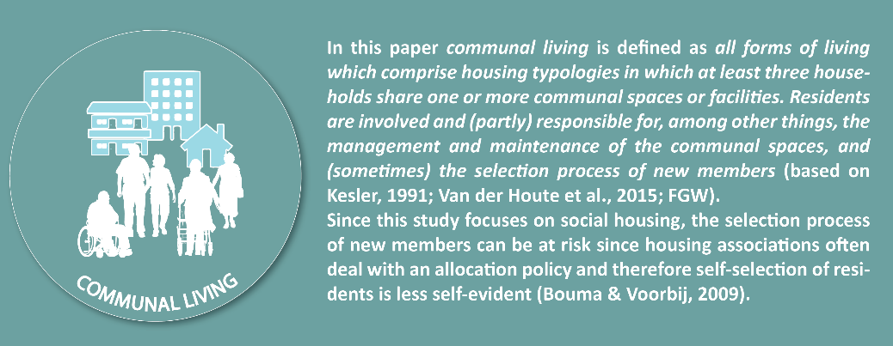

Figure 1. Definition communal living.

2. Theories and Methods

2.1 Social, organizational, and spatial factors of communal housing in relation to social interaction
Various studies discuss the social component of communal living in relation to influencing variables, such as the composition of the resident group, the organization of the community, and spatial characteristics of communal housing (e.g. Abu-Ghazzeh, 1999; McCamant, & Durret, 1994; Torres-Antonini, 2001). From this perspective, Williams (2005) presents a framework in which (the potential for) social interaction is related to social, organizational, and spatial factors of communal living, in addition to the personal characteristics of residents. Based on this model and additional literature regarding communal housing, we distinguish between these factors of communal living, whereby the combination of these underlying factors results in different types of communal housing.
Social factors relate to variables about the connection between residents and the extent to which the resident group is close-knit, such as the composition of the resident group, the size of the group, and the lifespan of the community (Williams, 2005). For example a homogeneous composition of the resident group regarding similar values, attitudes, socio-cultural background, or age can create a mutual bond (Glass & Plaats, 2013; Labit, 2015). However, several authors discuss the importance of a healthy mix of (older) ages in order to prevent all residents from being confronted with vulnerabilities at the same time which may affect the extent to which residents can participate in collective life (Fromm, 2012).
Organizational factors reflect the (in)formal organization within the community regarding, among other things, the management and maintenance of common areas, participation in (the organization of) activities and tasks, participation of (future) residents in the developing process, decision making process, and selection of future residents (Williams, 2005). For example, involvement and responsibility regarding aspects of the collective life ensure residents work together building and maintaining the community, which provides possibilities for social interaction (Jarvis, 2011; Pfaff & Trentham, 2020; Sanguinetti, 2014; Tyvimaa, 2011). However, involvement can also result in conflict and social disharmony (Bouma & Voorbij, 2009; Williams, 2005). Also, residents involvement in the selection process of new residents can offer the opportunity, from both the existing resident group and potential new residents, to explore a mutual (social) connection. In addition, the collaboration between (future) residents and relevant stakeholders, such as the housing associations and welfare organizations, can be relevant for creating opportunities for building a community (Bresson & Labit, 2019; Glass, 2016).
With regard to the spatial factors, multiple studies refer to the ‘social contact design principles’ which are often applied in cohousing communities to create a context for social interaction. Factors such as proximity of the housing units, the division between private and communal spaces including the existence of buffer zones, parking on the periphery, and shared pathways can facilitate social interaction between residents. Also central, well-designed, and accessible (indoor and outdoor) communal spaces with opportunity for surveillance can facilitate and stimulate planned or spontaneous encounters between residents (Abu-Ghazzeh, 1999; Marcus, 2003; McCamant & Durrett, 2011; Torres-Antonini, 2001; Williams, 2005). Although the role of technology in communities still seems underexposed, some scholars discuss its (possible) functionalities, such as the application of communication boards or a virtual network within the community, in relation to stimulating social interaction between residents (Bouma et al., 2015; Jarvis, 2011).
Figure 2 shows our modified and more comprehensive model regarding the relationship between personal, social, organizational, and spatial factors of communal living and (the opportunity of) social interaction between residents.

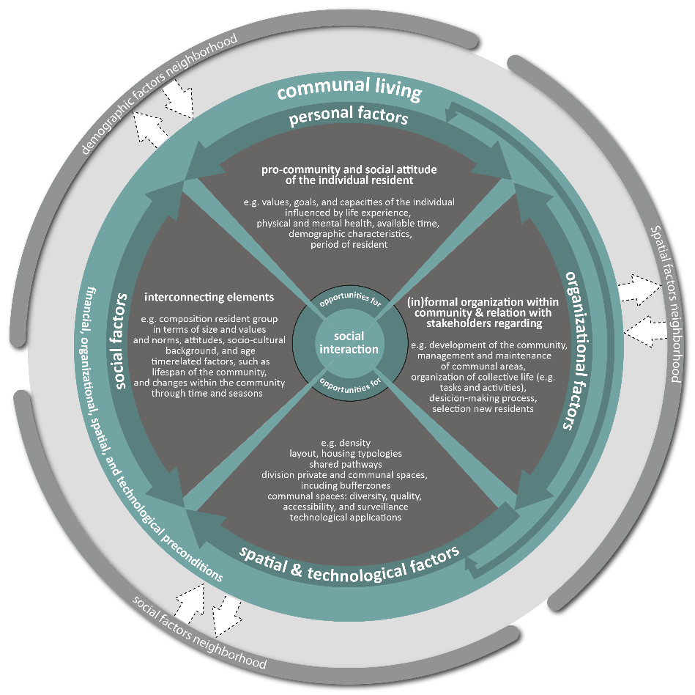
Figure 2. The interaction between personal, social, organizational, and spatial factors of communal living and its impact on social interaction (based on Williams, 2005, Fig 8, p. 221).

2.2 Method
To answer our research question, we performed an explorative cluster analysis to distinguish between types of communal living based on its underlying social, organizational, and spatial factors. The TwoStep Cluster analysis seems a suitable method to use in the exploratory phase of research in which, based on relevant factors, homogeneous clusters of cases within a datafile can be differentiated (Bacher et al., 2004; Chiu et al., 2001). Besides, the TwoStep Cluster analysis allows using both categorical and continuous variables (Bacher et al., 2004). In this study, each case represents a technical complex within the housing stock of the housing association Woonzorg Nederland. Cases with (partly) similar social, organizational, and spatial characteristics will be assigned to a cluster (group of cases) and each cluster will represent a type of (communal) housing. Figure 3 illustrates the underlying factors of the cluster analysis based on fictious data.

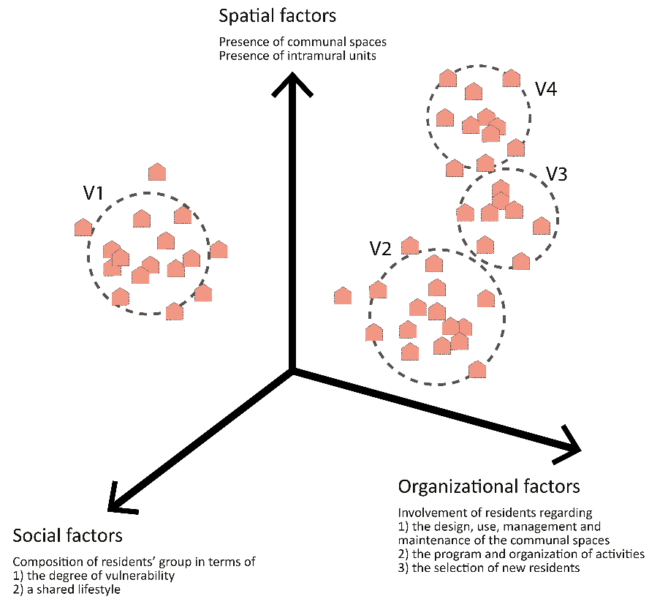

Figure 3. Graphical illustration of the underlying factors of the cluster analysis based on fictious data.

To explore these factors within the housing stock of Woonzorg Nederland, data was collected through 1) a survey among building managers (employees of the housing association who are familiar with daily practices and residents on location) and 2) existing real estate data of the housing association. We collected data on the level of the technical complex, which relates to a unit on which the housing association manages its (real estate) data and, from a spatially point of view, usually consists of a building with apartments or a demarcated area with terraced houses. The data collection only included housing for independent living tenants of the housing association. The two data files, regarding survey data and real estate data, were merged into one file using a linking variable. Based on this merged file, the explorative cluster analysis was performed. The number of clusters can be extracted automatically, but the software also allow for testing alternative solutions. We selected the best appropriate solution based on the statistical solutions of the cluster analysis combined with our knowledge from influencing factors from the literature regarding communal housing. Figure 4 illustrates the data collection and methods used in this study for distinguishing types of (communal) housing within the housing stock of Woonzorg Nederland.

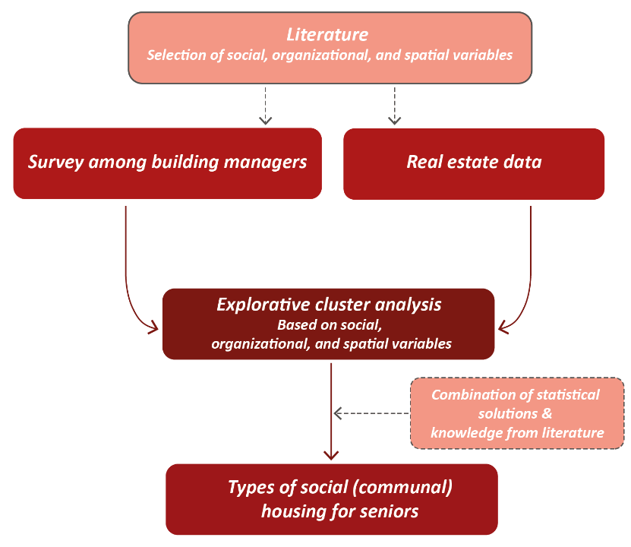

Figure 4. Illustration of the data collection and methods used in this study.

2.3 Data & operationalizaton
For each technical complex for independent living seniors within the housing stock of Woonzorg Nederland, social, organizational, and spatial factors were collected. Real estate data on the technical complex level was used for one of the spatial variables, namely the presence of intramural units. In addition, data regarding a selection of social, organizational, and spatial factors was collected by means of a survey among building managers.
133 Building managers received, from their employer, for each technical complex within his/her portfolio an invitation to participate in the survey by e-mail. They were asked to fill in a separate (online) questionnaire for each technical complex (with an unique login code). Ultimately, a questionnaire was completed for 466 technical complexes (table 1).

Table 1: Survey amongst building managers
Technical  complexes (n) | Response rate | Period
466 | 87% | July till medio September 2020

The social factors that we include in the explorative cluster analysis relate to the composition of the resident group of the technical complex regarding vitality and lifestyle. Vitality was measured by asking building managers about their perception of the degree of vulnerability of the resident group (1. mostly vital residents, 2. a mix, with more vital than vulnerable residents, 3. about as many vulnerable as vital residents, 4. a mix, with more vulnerable than vital residents, 5. mostly vulnerable residents). In addition, we asked building managers about the absence or presence of a shared lifestyle among the residents (0. no shared lifestyle among residents, and 1. a shared lifestyle among (some of the) residents).
The organizational factors that we included relate to the involvement of residents in the (in)formal community organization. The involvement of residents regarding the common areas was measured by asking building managers to indicate to what extent they (dis)agree to the following three statements (1. completely disagree – 5. completely agree): ‘Residents have a significant influence on the layout of the common areas’, ‘Residents have a significant influence on the use of the common areas’, and ‘Residents are responsible for the management and maintenance of (part of) the common areas’. The Cronbach’s alpha of the newly constructed variable based on the three items is 0.852. The involvement of residents regarding the (organization) of activities was measured by asking building managers to indicate to what extent they (dis)agree to the following two statements: ‘Residents have a significant influence on the program of organized activities’ and ‘Residents are responsible for the organization of activities’ (1. completely disagree – 5. completely agree). The Cronbach’s alpha of the newly constructed variable based on these two items is 0.888. The involvement of residents regarding the selection of future residents was measured by asking building managers to indicate to what extent they (dis)agree to the following statement: ‘Residents have a significant say in the selection of new residents’.
The spatial factors that we include in our analysis all relate to the presence of communal spaces. We divided the communal spaces in a technical complex into three categories. The first category relates to spaces aimed at planned encounters and recreation, such as a common meeting and/or recreation room (0-1). The second category relates to spaces and facilities aimed at facilitating the daily routine and (household) activities, such as a common kitchen and/or dining area (0-1). And the third category concerns functional facilities that can stimulate spontaneous encounters between residents, such as a common laundry room, library, and/or gym (0-1). These dichotomous variables are newly constructed based on the following variables. Firstly, when they scored 1 on the variable common meeting space(s) and/or recreation room(s), respondents were asked about the facilities within this area (1. library, 2. bar, 3. sitting area, 4. kitchen, and 5. dining area, 6. otherwise, namely…). Secondly, respondents were asked about additional shared facilities, services or common areas within the building(s), such as kitchen, dining room, gym, library, guestroom, and laundry. The different categories can be present separately or together in a technical complex.

3. Results
In this section, the results of the explorative cluster analysis are described. Each type of (communal) housing is defined regarding its social, organizational, and spatial characteristics.

3.1 Types of (communal) housing in the social rented sector
In almost half of the cases (47% of the 459 technical complexes; n=214) no communal space is present in its own technical complex. Therefore, this group ‘No shared spaces’ is not labeled as communal living. However, in about a quarter of these cases a meeting room is present in a nearby technical complex for independently living seniors.
The types of communal housing are formed by means of an explorative cluster analysis. When performing the cluster analysis, a total of four clusters was generated automatically. Based on our knowledge from the literature regarding communal living, this seemed indeed the most optimal number in which the types of communal housing can be clearly defined. Figure 5 shows the distribution of all four types of communal housing, besides the cases in which residents do not share space. Below, these types are briefly described based on their characteristics.
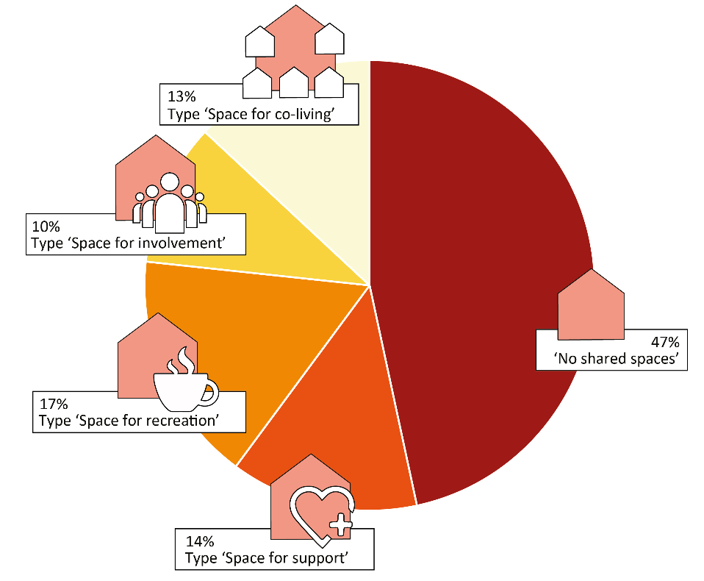

Figure 5. Distribution of types of (communal) housing according to the number of technical complexes (n=459).

3.2 Type ‘Space for support’
The first type ‘Space for support’ relates to 14% of the technical complexes (n=62). This variant in particular is characterized by its social factors; building managers perceived the resident group as relatively vulnerable compared to the other types. Additionally, the involvement of residents in the (in)formal organization of the shared spaces, activities, and selection of new residents is experienced as (very) low by the building managers. Spatially, most of the cases which include intramural units belong to this variant. Moreover, different types of communal areas are present; spaces aimed at organized encounters, the daily routine, and casual encounters between residents. Although it seems that the spatial context provides different types of social interaction between residents, the involvement of residents in the (in)formal organization seems (very) low. The shared spaces and activities, therefore, seem to be managed and organized mainly for than by residents.

3.3 Type ‘Space for recreation’
The type 'Space for recreation' relates to 17% of the 459 technical complexes (n=76). All cases have a meeting and/or recreation room and in approximately one-third of the cases, a kitchen and/or dining area is available. Compared to the type ‘Space for support’, building managers indicate the involvement of residents in the (in)formal organization as higher, in particular regarding (organized) activities. In this type, there seems to be a focus on creating a spatial context that is primarily aimed at stimulating organized encounters or recreation, whereby residents to a greater or lesser extent are involved in the program and organization of activities.

3.4 Type ‘Space for involvement’ & ‘Space for co-living’
The types ‘Space for involvement’ (10% of all technical complexes; n=47) and ‘Space for co-living’ (13% of all technical complexes; n=60) seem more difficult to distinguish from each other. These two types seem to resemble most the concept of communal housing from a social, organizational, and spatial point of view. This is reflected in the perceived involvement of residents in the (in)formal organization of shared spaces and activities, which seem to be on average (slightly) higher compared to other types. Also, building managers experience the resident group as relatively vital. However, we do see that the latest type is mainly characterized by its spatial factors; in all cases at least one of the different categories of communal spaces is present. So the spatial context seems to support organized activities and recreation, facilitate the daily routine of residents, and stimulate spontaneous encounters between residents. The type 'Space for involvement' appears to be somewhat more distinct with regard to the perceived degree of involvement of residents in the (in)formal organization. For example, the few cases in which residents seem to have a say in the selection of new residents belong to this type. Additionally, in about a quarter of the cases, building managers indicate that (some of) the residents have a shared lifestyle.

4. Discussion
Previous studies have explored the relationship between communal living and social behavioral aspects. However, these findings often relate to forms of resident-led communal housing, in which residents share common space(s) and make joint decisions regarding collective life. The types of communal living in Dutch social housing show a slightly different picture. Our findings demonstrate that four types of communal living can be distinguished, where residents share common spaces with each other to a certain extent. Some of these types are characterized by social or organizational variables, whereas others are characterized more by spatial characteristics.
First, our findings demonstrate that almost half of the residential complexes in our study does not belong to the four types of communal living. In these complexes, no common space is shared between residents. Secondly, the type of communal living ‘Space for support’ is characterized by a relatively vulnerable resident group and (very) low involvement of the residents in the (in)formal community organization. Thirdly, the type ‘Space for recreation’ refers to residential complexes in which residents share space for (organized) social activities, but not so much for functional activities. Fourthly, the third type ‘Space for involvement’ and fourth type ‘Space for co-living’, that are somewhat similar, represent more intensive forms of communal living, in which communal spaces are shared, the group of residents is relatively resilient, and residents, to some extent, seem to be involved in the organization.
Although the findings of this exploratory cluster analysis provide a preliminary typology of social communal housing for seniors, some relevant data is still missing. First of all, we need more data to determine whether the third and fourth type of communal living differ from each other on essential spatial, social and organizational variables. For now, it is still uncertain whether the distinction between the two types of communal living is justified. Secondly, it would be interesting to refine the typology of communal living based on additional data about the composition of the resident group according to relevant personal characteristics and information about the use of the communal spaces by the residents.
Further, our findings show that the organizational aspects of communality remain underexposed in the four different types of communal living. If residents do play a role in the community organization, it turns out that self-organization usually focuses on planning and organizing common activities, and not so much on the design, use, management and maintenance of communal spaces. Involvement in the selection of new residents rarely occurs. When we compare our findings with the concept of communal living in the scientific literature, we can conclude that only the third and fourth types of communal living show some significant similarities.
Summarized, the findings indicate a discrepancy between expectations about communal housing based on the scientific literature and the actual situation in Dutch social housing. Nonetheless, despite the (e.g. legal, organizational, and financial) limitations that housing associations face when realizing and maintaining housing for seniors, our findings show that encounters between residents are facilitated in several ways. How the different types of communal living promote social interaction and cohesion is a question that still needs to be answered.

5. Conclusions
Based on an explorative cluster analysis, based on combinations of relevant social, organizational, and spatial factors in the current practice of social housing, we propose a preliminary typology of communal housing. The findings show that a large part of the sample does not relate to the concept of communal living, since no communal space is present. The other part of the sample relates to four types of communal housing which vary from each other regarding the presence of social and functional communal spaces, the degree of residents involvement, and the composition of the resident group in terms of vitality and lifestyle. Only two types resemble for a significant part the concept of communal living as described in the literature. This seems to indicate a discrepancy between the current situation regarding communal living in Dutch social housing and the knowledge about the communal living based on scientific studies. For future research, the question remains to what extent these types are able to support their residents in social interaction and community building.

Contributor statement

Author Statement
Author 1 | Conceptualization; Formal analysis; investigation; project administration; visualization; writing – original draft
Author 2 | Conceptualization; Formal analysis; investigation; project administration; supervision; writing – review & editing
Author 3 | Conceptualization; funding acquisition; supervision; writing – review & editing

Acknowledgments
This article was written as part of a collaborative research project between the housing association Woonzorg Nederland, HAN University of Applied Sciences (Research Group Architecture in Health), and Eindhoven University of Technology (Chair Smart Architectural Technologies). Within this project, research is being done into communal living for seniors in the social rental sector. The data presented was collected in collaboration with Woonzorg Nederland.

References

- Abu-Ghazzeh, T. M. (1999). Housing layout, social interaction, and the place of contact in Abu-Nuseir, Jordan. Journal of Environmental Psychology, 19(1), 41–73. https://doi.org/10.1006/jevp.1998.0106
- Bacher, J., Wenzig, K., & Vogler, M. (2004). SPSS TwoStep Cluster—A first evaluation (Vols. 2004–2). Universität Erlangen-Nürnberg, Wirtschafts- und Sozialwissenschaftliche Fakultät, Sozialwissenschaftliches Institut Lehrstuhl für Soziologie.
- Bouma, J., and Voorbij, L. 2009. Factors in social interaction in co-housing communities. Retrieved from https://research.hanze.nl/ws/files/15924123/119.FactorsInSocialInteractionInCohousingCommunities_1_.pdf
- Bouma, J. T., Poelman, W. A., & Voorbij, A. I. M. (2015). Supporting social contact design principles in common areas of cohousing communities.
- Bresson, S., & Labit, A. (2019). How Does Collaborative Housing Address the Issue of Social Inclusion? A French Perspective. Housing, Theory and Society. Retrieved from https://www.tandfonline.com/doi/abs/10.1080/14036096.2019.1671488
- Choi, J. S. (2004). Evaluation of community planning and life of senior cohousing projects in northern European countries. European Planning Studies, 12(8), 1189–1216. https://doi.org/10.1080/0965431042000289296
- Chiu, T., Fang, D., Chen, J., Wang, Y., & Jeris, C. (2001). A robust and scalable clustering algorithm for mixed type attributes in large database environment. Proceedings of the Seventh ACM SIGKDD International Conference on Knowledge Discovery and Data Mining - KDD ’01, 263–268. https://doi.org/10.1145/502512.502549
- Fromm, D. (2000). American cohousing: The first five years. Journal of Architectural and Planning Research, 17(2), 94–109
- Fromm, D. (2012). Seeding Community: Collaborative Housing as a Strategy for Social and Neighbourhood Repair. Built Environment, 38(3), 364–394. https://doi-org.dianus.libr.tue.nl/10.2148/benv.38.3.364
- Glass, A. P. (2016). Resident-Managed Elder Intentional Neighborhoods: Do They Promote Social Resources for Older Adults? Journal of Gerontological Social Work, 59(7–8), 554–571. https://doi.org/10.1080/01634372.2016.1246501
- Glass, A. P. (2020). Sense of community, loneliness, and satisfaction in five elder cohousing neighborhoods. Journal of Women & Aging. Retrieved from https://www.tandfonline.com/doi/abs/10.1080/08952841.2019.1681888
- Glass, A. P., & Plaats, R. S. V. (2013). A conceptual model for aging better together intentionally. Journal Of Aging Studies, 27(4), 428–442. https://doi.org/10.1016/j.jaging.2013.10.001
- Jarvis, H. (2011). Saving Space, Sharing Time: Integrated Infrastructures of Daily Life in Cohousing. Environment and Planning A, 43(3), 560–577. https://doi.org/10.1068/a43296
- Kesler, B. (1991). Centraal Wonen in Nederland. Retrieved from http://repository.cohousing.nl:8080/jspui/handle/20.500.12011/342
- Labit, A. (2015). Self-managed co-housing in the context of an ageing population in Europe. Urban Research & Practice, 8(1), 32–45. https://doi.org/10.1080/17535069.2015.1011425
- Marcus, C. C. (2003). Shared outdoor space and community life. Places, 15(2), pp. 32–41. Retrieved from https://escholarship.org/uc/item/5jz7d921
- Markle, E. A., Rodgers, R., Sanchez, W., & Ballou, M. (2015). Social support in the cohousing model of community: A mixed-methods analysis. Community Development, 46(5), 616–631. https://doi.org/10.1080/15575330.2015.1086400
- McCamant, K., & Durrett, C. (2011). Creating cohousing: Building sustainable communities. New Society Publishers.
- McCamant, K., & Durret, C. (1994). Cohousing: A contemporary approach to housing ourselves. Ten Speed Press.
- Pedersen, M. (2015). Senior Co-Housing Communities in Denmark. Journal of Housing For the Elderly, 29(1–2), 126–145. https://doi.org/10.1080/02763893.2015.989770
- Pfaff, R., & Trentham, B. (2020). Rethinking home: Exploring older adults’ occupational engagement in senior cohousing. Journal of Occupational Science. https://www.tandfonline.com/doi/abs/10.1080/14427591.2020.1821755
- Sanguinetti, A. (2014). Transformational practices in cohousing: Enhancing residents’ connection to community and nature. Journal of Environmental Psychology, 40, 86–96. https://doi.org/10.1016/j.jenvp.2014.05.003
- Torres-Antonini, M. (2001). Our common house: Using the built environment to develop supportive communities. PhD diss., Graduate School of the University of Florida.
- Tyvimaa, T. (2011). Social and physical environments in senior communities: The Finnish experience. International Journal of Housing Markets and Analysis, 4(3), 197–209. https://doi.org/10.1108/17538271111152997
- Van der Houte, K., Ryckewaert, M., Delbeke, B., & Oosterlynck, S. (2015). Gemeenschappelijk wonen. Leuven: Steunpunt Wonen. Retrieved from https://archief.steunpuntwonen.be/Documenten_2012-2015/Onderzoek_Ad-hoc-opdrachten/Ad_hoc_13_Gemeenschappelijk_wonen.pdf
- Williams, J. (2005). Designing Neighbourhoods for Social Interaction: The Case of Cohousing. Journal of Urban Design, 10(2), 195–227. https://doi.org/10.1080/13574800500086998
- Witter, Y. (2018). Zijn woningcorporaties klaar voor de vergrijzing? Geron, 20(1), 48–51.

