Type of the Paper: Peer-reviewed Conference Paper / Full Paper
Track title: Stream user-needs – design of therapeutic spaces

Waiting areas as places of encounter between therapy and society
Martina Di Prisco ¹*
¹ University of Trieste (Italy), Department of Engineering and Architecture (DIA), Piazzale Europa 1,
Trieste, PhD course in Civil-Environmental Engineering and Architecture (associated with the University of Udine), XXXV cycle, Supervisor Giuseppina Scavuzzo; martina.diprisco@phd.units.it;
martinadiprisco@gmail.com
* corresponding author.

Names of the Topic editors:
Clarine van Oel
Names of the reviewers:
Yifat Rom
Ira Verma
Journal: The Evolving Scholar
DOI:10.24404/62bdae676d4a43a537fb99a8
Submitted: 12 July 2022
Accepted: 22 August 2022
Published: 08 January 2024
Citation: Di Prisco, M. (2022). Waiting areas as places of encounter between therapy and society [preprint]. The Evolving Scholar | ARCH22.

This work is licensed under a Creative Commons Attribution BY license (CC BY).

© 2022 Di Prisco, M. published by TU Delft OPEN on behalf of the authors.

Abstract: Numerous debates have emerged on the role of architecture in physical and mental health, especially in the wake of the pandemic emergency. It became clear that the design and planning of our homes and cities influenced dealing with emergencies at an individual and collective level, facing the limits of the physical and social body and of their way of life. The physical body was forced to acquire a new spatial dimension, new proxemics, emphasising the difficulties of adaptation for those who, every day, beyond the pandemic, have to deal with a different perception of the environment surrounding them. This invites us to reflect on the importance of rethinking public spaces as a process of inclusion, both for people with atypical sensitivity and as a form of empathic openness to meeting others. The paper illustrates some theories and design examples, taken from a PhD research study in progress, in which this double empathy can manifest itself. The study identifies the waiting rooms of certain therapeutic facilities for individuals with cognitive disabilities (and mental disorders). The aim is to lead to a reflection on how we could imagine new forms of proximity and redistribution of care services that would guarantee different degrees of integration according to individual needs: possible meeting points between therapy and society, learning to consider deficiencies, as they are often understood, as mere differences and manifestations of alterity.

Keywords: Architecture and mental health; threshold spaces; empathy; waiting area; therapeutic design

1. Introduction. Different interactions with the environment
Recognizing that some architectural and urban structures may not be adequate to accommodate all residents in their heterogeneity, how can a city deal with those with diverse sensitivity to enable society to host everyone in their uniqueness? Numerous debates concerning the role of architecture in physical and mental health have emerged, especially in the wake of the pandemic emergency. We were faced with limits that led to new forms of proxemics, emphasising the difficulties of adaptation for those who, beyond the pandemic, live with a different sensory perception of their surroundings daily. Beyond the limits of the physical body, we wondered how much the situation was affecting the mental state, leading us to reflect on the importance of places concerning mental and not only physical well-being. When we talk about an ideal healthy city, we do not mean a model city that has reached a particular level of its inhabitants' health; instead, we refer to a city that is aware of the importance of public health and adopts strategies that continuously improve opportunities in the built and social context (Holt-Lunstad, 2020). Therefore, it becomes essential to observe the quality of the space as a set of elements that influence human behaviour and contribute to the well-being of individuals, considering their diversity (Capuano, 2020). It is necessary to rethink public spaces (interior and exterior) where different people are together and relate to their mental, physical, and perceptive differences. And since different sensitivities result in different interactions with the environment (Bogdashina, 2011), a multidisciplinary approach may be required that takes into account the various sensory experiences that may occur within the same environment. The following paper presents a brief part of the analyses conducted as part of the doctoral research, where the focus is on the conscious and empathetic design of mental health spaces. Some studies are reported on the relationship between the concept of empathy and architecture and then introduce different design strategies used for the creation of waiting spaces within therapeutic facilities for people with cognitive disabilities. The projects illustrated have in common the sensitivity to welcome with greater empathy the most diverse needs of users and those who, for whatever reason, pass through these places. The focus is on waiting spaces, as they are places considered in research as potential meeting points between therapy and society. Where people wait, meet, spend time, or simply pass by. But that, for a given moment, represents places of interaction between people with different environmental perceptions and different needs. The studies conducted on theories of the different perceptions of interaction with the environment have been deepened in the autism spectrum, thanks to the free collaboration during the PhD studies with the SENSHome Research Project (conducted by the University of Trieste and financed by the European Union). Through the SENSHome Research Project (conducted by the University of Trieste and financed by the European Union), it was possible to verify and confirm the central role that these spaces (waiting, transition) play in the physical and social adaptation of individuals living in an atypical sensory way in residential design (Ahrentzen & Steele, 2015). Therefore, we can say that to improve the quality of the environments experienced by individuals in their heterogeneity, it is necessary to consider the different sensitivity of perception and response to stimuli present in some forms of cognitive disability as well as physical. Not only understanding differences as a reason for exclusion but rather considering them an opportunity for coexistence and encounter.

2. The problem of double empathy
Let us consider the environment as a high source of stimuli to which the individual is constantly subjected and is led to respond in a dynamic of exchange and mutual adaptation (Fumagalli & Arrigoni, 2013). We can affirm that the environment affects the individual, and the individual acts on the environment according to how he can perceive it through an empathic process.
In its literal exception, the concept of empathy describes how the nervous system works to "feel into" or simulate something, how we make contact with the world. It brings us back to the topic of architecture as it involves the activation of sensory-motor and emotional circuits in interacting with a built environment. When we perceive, we simulate on a neurological level the environment around us, and the interaction with the built environment involves the physical body responding to the spatial conditions we experience (Mallgrave, 2013).
It is no coincidence that the earliest examples of neuroarchitecture were applied to hospital design. Architect Roger Ulrich, a professor of architecture at Chalmers University in Sweden, has dedicated his career to improving the design of health care facilities, discovering that patients enjoying a room with a window and a view of a park or a large natural landscape can accelerate the healing process and improve their mental and physical well-being (Ulrich, Zimring, Joseph, Quan, & Choudhary, 2004). In the '90s, the Evidence-Based Design Approach spread in America, which investigates how the healthcare environment's spatial, functional, relational, and psycho-perceptual characteristics can contribute to accelerating the care pathway, reducing the causes of clinical complications, and maximising the safety conditions. Gradually, the focus expands beyond therapeutic spaces to residential, work, and educational spaces. Therefore, it is fundamental that neuroscientific research on architectural experiences is based on interdisciplinary dialogue. This interdisciplinary dialogue opens a new chapter in the history of modern architecture and in the theories of architectural composition, inserting a scientific component into the debate between the form and function of buildings and urban space. The goal is to create public and private spaces that can ensure psycho-physical well-being and positively impact the perception of sensitive data that each individual puts in place when he comes into contact with the surrounding environment (Schena, 2020). Thus, recognising the diversity among individuals, given the same tools at their disposal, each individual can achieve a level of well-being that depends on his or her ability to convert these tools into well-being (Sen, 2000).
According to the Theory of Mind, conditions such as autism (Baron-Cohen, Leslie & Frith, 1985) and schizophrenia (Sprong, Schothorst, Vos, Hox & Van Engeland, 2007) are interpreted as a specific deficit of these skills. In fact, according to ToM, people with mental disorders or autism are unable to perceive the intentions and emotions of others and therefore live with "mind-blindness," a condition that separates them from other human beings (Duffy & Dorner, 2011).
Sociologist Damian Milton, in his studies about the autism spectrum, makes a critique of the ToM, arguing that the lack of understanding between people who exhibit different perceptions of their environment is a mutual problem, defining it as "the problem of double empathy: a disconnect in reciprocity between two differently disposed people" (Milton, 2012, p. 884). One group can consider themselves normal while the other group is classified as abnormal based on a social deficit, due to the power imbalance (Belek, 2019).
The problem of double empathy is therefore emphasised when society tends to consider cognitive disabilities as neurological disorders from which attempts at treatment aim to “normalise” and modify the person to make them better, to fit the mainstream culture that society imposes. In addition, being defined as abnormal potentially means to be seen as “pathological” in some way and to be socially stigmatised and avoided (Tajfel & Turner, 1979) without considering the lack of empathy and the divergence of perception, which, although inevitable, occur in a twofold direction. Moreover, often, neurotypical people do not have the tools necessary to understand the mind of the autistic person unless they have a close social relationship with them. Conversely, the need for adaptation to a "normal" culture has likely led neurodiverse people to develop a greater level of understanding of neurotypical society and customs (Milton, 2012).

Empathic design: the first approaches
One of the first research projects on the relationship between autism and the design of space dates back to 1971: Playroom for Children (Richer & Nicoll, 1971), intending to define the spatial characteristics of a prototype playroom for children with autism that could accommodate and facilitate therapeutic paths. Autism in those years was interpreted in the belief that it was a form of defence for the child from the absence of affection from the parents, with the consequence of avoiding social interaction. While refuting this thesis, some of the author’s spatial requirements, particularly the need to provide a space of refuge within the environment (a retreat box), are repurposed in more recent contributions.
The growing interest in the topic over the last fifteen years has seen a high development of research and design applications, particularly in the design of enclosed spaces, or bounded open spaces, dedicated to people with autism and mental health issues (schools, learning spaces, treatment centres, assisted living, sensory gardens). Thus, a series of public places that are experienced daily by people with a variety of sensory needs but that somehow aim to meet the needs of a group of people living with their heterogeneity.
Some theoretical and design contributions refer to the relationship with the context, not only from a physical but also a social point of view. Several authors and designers provide a series of contributions that aim to explore the adaptation of space based on the multiple atypical sensory perceptions that people with autism experience, supporting the need to design spaces that mitigate sensory stimuli and reduce perceptual overload (hyper- or hyposensitivity). Atypical sensory perception may be accentuated by the need to adhere to a routine of temporal sequences that support actions or the need to communicate using an imaging system (Talu & Tola, 2018). Sometimes, even crossing a threshold and accessing an unpredictable location can help increase your stress and anxiety levels.

For this reason, when designing therapeutic facilities, it may be useful to rethink the places as places able to give domesticity and a sense of welcome and comfort to those who live or attend them, ensuring privacy while at the same time allowing socialisation and sharing. It is important to consider a gradual transition between the external urban environment—typically more public or socially open—and the typically more closed and medicalized internal hospital environment. Waiting, entrance, and reception spaces can therefore play an important role in the inclusion process if they are considered filters between the external environment (society) and the internal environment (therapy). They become places where different people ("healthy" and "sick", normotypical and neurodiverse) sit next to each other, see each other, and need to fit in and tell their identity.

3. Case studies: waiting area
The size and shape of waiting spaces can influence the anxiety of patients and family members; splitting these areas into smaller areas can help guarantee both privacy and social interaction; rearranging the chairs into circular groups can increase the possibility of socialisation; an outward-facing look reassures and reduces feelings of closure and isolation, affecting positively the perception of waiting time; the visual ability towards the medical staff and the access to therapy areas can be reassuring and support orientation; reduce the need for asking for information; and decrease the feeling of understanding what is happening around (Del Nord & Peretti, 2012).

Case 1. Emergency Department of Careggi, Florence, 2016

The first multisensory waiting room designed in Italy and specifically addressed emergency admissions for people with cognitive disabilities has been tested in the Emergency Department of Careggi, Florence (Figure 1). The waiting room contains curved counter walls and soft, not overstimulating colours that allow both patients and carers to reduce the discomfort generated by crossing a new and unpredictable environment. Furthermore, a device installed at the entrance and a facilitated communication system govern the autonomous adjustment of lights, sounds, and smells in the room. The user can therefore manage and control the physical characteristics of the space and, consequently, the sensory stimuli. It could be considered a public space that can change and adapt to personal needs.
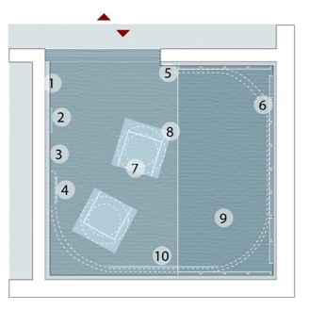

- Acoustic isolation
- Time Timer
- Video cameras
- Interaction I-Pad
- Aromatherapy
- Velcro strap
- Armchairs
- Light cones
- Vibrating Platform
10. Video screening

Figure 1: A multisensory waiting room in the Emergency Department of Careggi, Florence. Drawing by Martina Di Prisco. The project was born from the collaboration between the University Hospital Careggi, the Centre for Autism P.A.M.A.P.I., and the startup DU IT, through an interdisciplinary research process centred on the links between the spatial characteristics and the clinical status of people with disabilities referred to as autism.
Case 2. Edgecliff Medical Centre, New South Wales, Australia, 2012

The common areas and waiting rooms of the Edgecliff Medical Centre (Figure 2), a small daycare centre for children with autism, have been designed and conceived as central places, not separated from the therapeutic space. Therapy and formal and informal meetings between parents and doctors are encouraged in these spaces to make the child feel free to move and explore in a non-hospital-looking environment. It includes a place to play and talk, organised between reception and play activity rooms, characterised by circular geometries, soft furnishings, indirect lighting, and colours that can create a calm and relaxing atmosphere. At 150 square metres, the project was modest in its footprint but set a clear example of digitally fabricated interiors and a prototype to see how these projects perform.

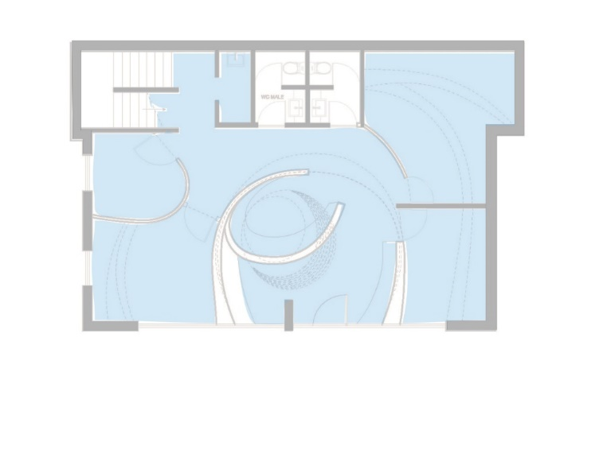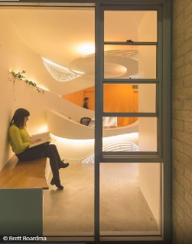

Figure 2. Left: The waiting room of Edgecliff Medical Centre. Enter Architecture; Photo by © Brett Boardman; http://enterprojects.net/project/edgecliff-medical-centre Right: the receptionist. Downstairs plan of Edgecliff Medical Centre. Drawing by Martina Di Prisco.

Case 3. New Royal Hospital for Children and Young People (RHCYP), Edinburgh, Scotland, 2021

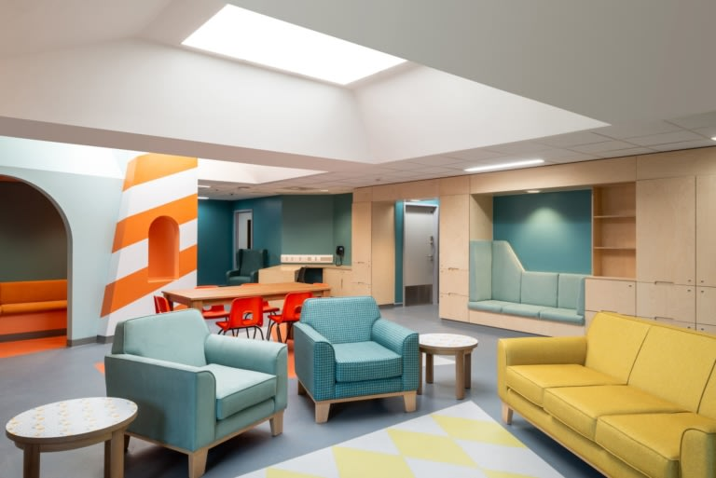

Figure 3. Waiting Area of the Royal Hospital for Children and Young People, Edinburgh, 2021. Project Office Architects; Photo by © French + Tye; https://www.projectsoffice.co/. The new Royal Hospital for Children and Young People (RHCYP) brings together departments from across Edinburgh into a new purpose-built building. This project is part of an art and therapeutic design programme delivered by Ginkgo Projects for NHS Lothian.

The Projects Office, working in collaboration with artist James Leadbitter, was appointed to design the interiors of the Child and Adolescent Mental Health Services (CAMHS) unit within the new hospital, which comprises outpatient facilities for 5–18-year-olds and an inpatient unit for 12–18-year-olds. An approach based on user-centred design, with a series of workshops and interviews with young patients, their parents, and staff, helps architects understand many of the subtle details that can make a big difference in the way patients feel in a space. In answer to the question "How does good mental health feel?" many workshop participants described a coastal environment. From here came the idea of designing the interiors by interweaving the theme of the sea, adapting them to age, and gradually transforming them from bright colours and sea motifs for younger children to a harsher offshore theme for teenagers. We conceived the common places in a non-institutional way, while also making them distinct from a home environment: like "a third space that is neither home nor hospital" but has its own identity.

4. Discussion
The following examples have been selected for the different architectural types and design strategies used for waiting areas. Moreover, the different age groups of the user involve demands of a different nature, which is not insignificant in a therapeutic conception. What unites us is the intent to create environments for mental health through a process of listening and empathy towards the various ways of interacting with the environment that can manifest. For this reason, waiting areas could become a meeting point if they are not overly medicalized but made more welcoming and comfortable. The space and time of waiting is a factor that is often underestimated, despite the numerous guidelines and experimental methods that attest to its importance, because often the focus on the medical aspect prevails, forgetting that the environment has a weighty effect on the healing aspect.
In the case of Careggi Hospital first aid, we are in an existing sanitary building, where the main function is to accommodate people who need all kinds of care. Designing an entrance area for the reception of people with cognitive disorders is not a common practice, except in structures specifically dedicated to mental health. Being inside a building already structured, it is an adaptation of an existing space, easily accessible thanks to a signposted path at the entrance, which uses a facilitated digital system to compensate for the difficulty of understanding and/or rebalance the state of anxiety that may increase in these contexts. The waiting area, which represents a place of refuge and comfort, is clearly delineated and separated from the medical area. It is included in the hospital complex but accessible only in case of need, then with a certain awareness. This represents a strong attempt to accept and confront diversity.
The Edgecliff Medical Centre, on the other hand, is a structure built from scratch in which it was possible to carry out all the studies on the importance of the environmental aspect in the therapeutic path of the child. The waiting room here is not conceived as a well-defined and localised environment in a precise point of the structure and is separated from the medical environment but is totally integrated into the therapeutic aspect. The entire centre, small and cosy in size, revolves around the common spaces, simplifying the process of interaction not only between the parent and the doctor but also between children and their parents. The child does not consciously choose to go to that place to carry out therapies, so the functional intent is to make him feel comfortable, in a playful and domestic atmosphere, where the parent or carer can find a space of privacy to talk to the doctor but at the same time can interact with and confront other adult people living similar realities.
However, for economic or other reasons, it is not always possible to design a building from scratch or adapt it to requirements by using high technology. In this case, it becomes necessary to devise a different strategy that, with due care to the details, is able to respond to the needs. One example is the semi-residential institution of the Royal Hospital for Children and Young People. Through the study based on user-centred design, the architects were able to meet the demands of specific users, families, doctors, and employees. They then listened and undertook with them a process of renewal aimed at general well-being. They conceived the decision to incorporate the waiting room into the common areas in order to create a less institutional, yet not overly domestic, look. Defining this sort of third area with the aim of clearly distinguishing therapeutic functions from those of sharing. A user is often aware of facing a therapeutic period; therefore, it is important that they have the opportunity to choose where and how to spend time inside the structure. The division of the environments and the choice to create a third area distinct from the therapeutic and domestic functions, in this case, help the boy in the therapeutic process to realise that hopefully, it will be a transitional period. While the choice of colours and unusual design—very far from the indications often given in the guidelines—leads to customisation of the environment that can help in feeling comfortable and facilitate interaction accordingly.

5. Conclusions
The examples show that there is not a single solution, unique, right or wrong, in designing certain therapeutic environments, but different methods: more or less combined with technology, with design, or with the simple ideal of home comfort. They could be small steps to make a difference in the hospital aspect, simplifying communication and the relationship between people with different needs and perceptions, for example, by enhancing the waiting and reception spaces that show how different abilities can meet and accept each other.
Given the wide range of cognitive and behavioural atypicalities, it is clear that some facilities and utilities may not be adequate to accommodate all residents. For this reason, the construction of "empathic" environments becomes essential, and it is the task of designers to re-conceptualize disability in social terms rather than exclusively medical terms to realise the important change from inclusion to reciprocity.
The aim is therefore to lead to a reflection on how to imagine new forms of proximity and redistribution of care services, which guarantee different degrees of integration according to individual needs: building possible meeting points between therapy and society, and learning to consider the deficiencies, as they are often understood, as simple differences and manifestations of alterity.

Contributor statement
All the contributions to this paper are part of the analyses conducted in the doctoral research of the author.

References
- Ahrentzen, S., & Steele, K. (2015). At Home With Autism: Designing for the Spectrum. Bristol: Bristol University Press.
- Baron-Cohen, S., Leslie, A.M., & Frith, U. (1985). Does the autistic child have a "theory of mind"?. Cognition, 21(1), 37–46.
- Belek, B. (2019). Autism. The Cambridge Encyclopedia of Anthropology. Retrieved from https://www.anthroencyclopedia.com/entry/autism
- Bogdashina, O. (2011). Sensory perceptual issues in autism: why we should listen to those who experience them. Annales Universitatis Paedagogicae Cracoviensis. Studia Psychologica, 4(1), 145-160.
- Capuano, A. La dimensione terapeutica urbana e le architetture per la cura. Uno sguardo sull’evoluzione del concetto di cura e sugli spazi che la supportano. In P., Miano (Ed.). (2020). HealthScape: nodi di salubrità, attrattori urbani, architetture per la cura. (pp. 65-83). Macerata: Quodlibet.
- Del Nord, R., & Peretti, G. (2012). L’umanizzazione degli spazi di cura. Le linee guida. Firenze: TESIS.
- Dougherty, B., & Arbib, M. (2013). The evolution of neuroscience for architecture: introducing the special issue. Intelligent Buildings International, 5. Retrieved from Taylor & Francis.
- Duffy, J., & Dorner, R. (2011). The Pathos of “Mindblindness” Autism, Science, and Sadness. “Theory of Mind” Narratives. Retrieved from Journal of Literary & Cultural Disability Studies.
- Fumagalli, M., & Arrigoni, F. (2013). Dove l’acqua si ferma: la cura e il benessere degli anziani fragili con il metodo Gentlecare. Rimini: Maggioli editore.
- Gaudion, K., Mcginley, C., & Kew, A. (2014). Designing living environments with adults with autism. Tizard Learning Disability Review, 19. doi.10.1108/TLDR-01-2013-000
- Hall, E.T. (1966). The Hidden Dimension. Garden City, NY: Doubleday
- Hamilton, D. K. (2007). The Four Levels of Evidence-Based Practice. The American Institute of Architects. Retrieved from www.aia.org
- Holt-Lunstad, J. (2020). Social Isolation and Health. Health Affairs Health Policy Brief. Retrieved from https://www.healthaffairs.org/do/10.1377/hpb20200622.253235/full/
- Mallgrave, H.F. (2013). Architecture and Embodiment: The Implications of the New Sciences and Humanities for Design. London: Routledge
- Mcallister, K., & Maguire, B. (2012). A design model: The Autism Spectrum Disorder Classroom Design Kit. British Journal of Special Education, 39.
- Milton, D. (2012). On the ontological status of autism: the “double empathy problem”. Disability & Society, 27(6), 883-887.
- Mostafa, M. (2008). Architecture for autism: Built environment performance in accordance to the autism ASPECTSS™ design index. Design Principles and Practices, 8
- Richer, j., & Nicoll, S. (1971). The physical environment of the Mentally and handicapped: a playroom for Autistic children, and its Companion Therapy Project. British Journal of Mental Subnormality, 2 (33), 132-143.
- Riby, D. M., & Hancock, P.J.B. (2008). Viewing it differently: Social scene perception. Williams syndrome and Autism. Neuropsychology, 46, Issue 11, 2855-2860.
- Sen, A.K. (2000). Lo sviluppo è libertà. Perché non c’è crescita senza democrazia. Milano: Mondadori
- Schena, F. (2020). Neuroarchitettura: quando le neuroscienze incontrano il design, per un mondo a misura d’uomo. MondoInternazionale. Retrieved from https://mondointernazionale.com/academy/neuroarchitettura-quando-le-neuroscienze-incontrano-il-design-per-un-mondo-a-misura-duomo
- Sprong, M., Schothorst, P., Vos, E., Hox, J., & Van Engeland, H. (2007). Theory of mind in schizophrenia. British Journal of Psychiatry, 191(1), 5–13.
- Tajfel, H., & Turner, J. An integrative theory of intergroup conflict. In D., Langbridge & S., Taylor (eds). (1979). Critical Readings in Social Psychology. Milton Keynes: Open University
- Talu, V., & Tola, G. (2018). La città per immagini. Verso la definizione di un insieme di requisiti spaziali per la progettazione di città autism friendly. Milano: LISt Lab
- Türkkan, S. Other/Alterity. In Ryan, M & Castle, G (eds). (2011). The Encyclopedia of Literary and Cultural Theory, Literary Theory from 1966 to the Present, 2. Malden, MA: Wiley- Blackwell
- Ulrich, R., Zimring, C., Joseph, A., Quan, X., & Choudhary, R. (2004). The role of the physical environment in the hospital of the 21st century: A once-in-a lifetime opportunity. Report to The Center for Health Design

