Type of the Paper: Peer-reviewed Conference Paper/ Short Paper

Track title:

Designing the nursing wards for a university hospital: a multifaceted approach on how architecture can stimulate care, education and research

Klara Geltmeyer1, Tineke Brits2, Lynn Pieters1,2, Rik Verhaeghe1,3, Veerle Duprez1 and Simon Malfait 1,3,*

|  |
| --- |
| **Names of the track editors:**  Firstname Lastname  Firstname Lastname  **Names of the reviewers:**  Firstname Lastname  Firstname Lastname  **Journal:** The Evolving Scholar  **DOI:**10.24404/621dc58b66b1050aaa11df0b  Submitted: 8 Jul 2022  Accepted:  Published:  **Citation:** Geltmeyer, K., Brits, T., Pieters, L., Verhaeghe, R., Duprez, V. & malfait, S. (2022). Designing the nursing wards for a university hospital: a multifaceted approach on how architecture can stimulate care, education and research [preprint]. The Evolving Scholar | ARCH22.  This work is licensed under a Creative Commons Attribution (CC BY-ND) license.   © 2022 [Geltmeyer, K., Brits, T., Pieters, L., Verhaeghe, R., Duprez, V. & Malfait, S.] published by TU Delft OPEN on behalf of the authors |

1 Ghent University Hospital, Nursing Department

2 Ghent University Hospital, Infrastructural Team

3  Ghent University, Faculty of Medicine and Health Sciences

* Corresponding author; [simon.malfait@uzgent.be](mailto:simon.malfait@uzgent.be)

|  |
| --- |
| **Research highlights**  1) Knowledge on evidence-based design is scarce and insufficient as a single source for designing nursing wards;  2) A systematic, evidence-based process has to be used to integrate different data points about the ward design;  3) The optimal ward design should firstly take into account and facilitate the (future) nursing care model. Secondly, future evolutions and developments, legal and environmental boundaries, the strategy of the hospital and evidence-based design should also be taken into account.  4) The optimal ward design is relative, dependent of several factors, and will be different between hospitals. |

**Keywords:** Nursing organization; ward design; hospital architecture; co-design process

1. Introduction

In 2029, the Ghent university hospital aspires to complete a new hospital building which houses all nursing wards (with exception of pediatric care, medical revalidation and psychiatry). However, it was unclear what the lay-out, format and size of these nursing wards should be, and it was difficult to base the plan on international literature. While the international literature on the architecture of nursing wards provides some indications on preferable elements, no conclusive advices can be found. The absence of a comprehensive body of knowledge on this is mainly the result of the fact that (1) hospitals are not often built, meaning that research is scarce and that, (2) when hospitals are finally build, the architecture may already be outdated in comparison to new technologies and insights (Pilosof, 2021). Moreover, while the body of knowledge about evidence-based design (and architecture) is structurally increasing due to a surge in hospital building in the USA(Ulrich et al., 2008), these ideas are to a lesser extend adoptable to European Healthcare systems with a different form of funding. Solely turning towards the literature in order to design the new hospital and its ward proved insufficient. Other approaches had to be searched.

One of the adagio’s that is often referred to in building design is that “we shape our buildings, and that afterwards our buildings shape us”. While not covering the entire truth, it has to be acknowledged that culture, structure and strategy are closely intertwined with the environment in which they take place (Miller, 1993). Therefore, it was concluded that the design of the nursing wards and the overall hospital lay-out should be based upon a theoretical idea about how nursing will be performed in the future. In other words, in order to determine this design lay-out, the future nursing care model is to be seen as a primordial choice.

Determining this future nursing care model does however not stands on its own. First, the model should be futureproof, taking into account possible evolutions and developments in the nursing profession. Second, there are both legal and environmental boundaries to the possibilities. Third, the nursing care model should interlock with the strategy of the hospital. Fourth, any knowledge about evidence-based design concerning nursing ward architecture and lay-out should be taken into account.

Based on the fact that different elements are to be taken into account on a systematic manner, it was decided that an evidence-based process had to be developed and executed to determine the nursing ward design and hospital lay-out.

2. Theories and Methods

The designing process consisted of five phases, showing similarities with the concept of co-design. In the concept of co-design, a systematic approach is used to bring together different perspectives from different levels (base/corporate) on the same issue, gradually building towards a widely supported idea resulting in developing a plan that takes into account all or most of the demands from the different stakeholder groups in the trade-off towards the final plan (Castro et al., 2018). The difference with the regular process of co-design is that in this case the different groups did not consist of patients and healthcare workers, but consisted out of people who focused on the same subject. Several scientific approaches to guide these phases were used: systematic literature review, expert panels, focus groups, brainstorm sessions using the thinking aloud method and peer-review. An overview of the process is given in Figure 1.

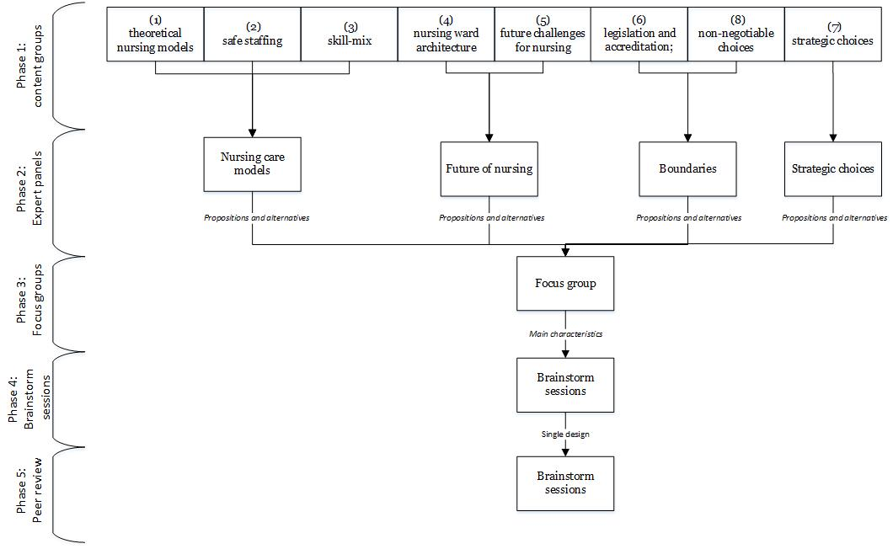

Figure 1. An overview of the co-design process towards the final nursing ward layout.

In phase 1, several literature reviews and systematic analyses of documents were made by separate content groups, consisting of different people (‘young potential’ nurses, ward managers, staff members, etc.). There were eight groups in this phase: (1) theoretical nursing models; (2) safe staffing; (3) skill-mix; (4) nursing ward architecture; (5) future challenges for nursing; (6) legislation and accreditation; (7) strategic choices; and (8) non-negotiable choices.

In phase 2, several groups were brought together in expert panels to combine their findings into overall propositions concerning their themes. Several alternative propositions were formulated. Groups (1), (2) and (3) were combined in an expert panel concerning nursing care models. Groups (4) and (5) were combined in a group about the future of nursing. Group (6) and (8) combined their findings to define the boundaries between which the plans should take shape. Group (7) remained aside and did not undertake any action in this phase.

During phase 3, a single focus group was formed in order to determine the final theoretical characteristics of the nursing ward design, taking into account the compatibility of all the propositions made by the expert panels. The focus group consisted of different stakeholders, such as physicians, head nurses, the ‘construction’ team and members of the board of directors. Several meetings were held, using a qualitative content analysis approach (White & Marsh, 2006). First, the propositions of each expert panel were presented and discussed. Second, choices were made, resulting in a checklist of the main characteristics for the ward design. This list was send to the architects in order to design a plan for the nursing wards.

Phase 4 consisted of several brainstorming sessions using the thinking aloud method with the members from the focus group to evaluate the plans made by the architects. Architects based their plans on former experiences and examples of ward designs from other hospitals. Plans were either rejected, adapted or withheld until a single plan was accepted by all members and fulfilled all the demand of the identified characteristics.

In phase 5, the finalized plans were peer-reviewed by a number of stakeholders in the hospital. These stakeholder included, amongst others, the board of directors, the physician, and the head nurses. The design process took place from January until May 2020.

3. Results

The results from phase 1, 2 and 3 are reported together, due to their connectedness. The results focus on the process for acquiring data and the main characteristics that were taken into account to design the wards. In the results of phase 4 the actual ward design and hospital lay-out are reported.

3.1. Phase 1, phase 2 and phase 3:

In order to determine the input for the nursing care models a systematic literature review (Geltmeyer et al., 2022) was undertaken about theoretical nursing care models (e.g. how nurses work together), the needed skill-mix in the team (e.g. composition of different degrees in nursing) and safe-staffing (number of beds per nurse). A broad search was executed on Pubmed®, Cinahl® and WoS® resulting in 8206 papers, of which after screening 303 were included in the review. These were screened using the standards of systematic reviews (Holly, Salmond, & Saimbert, 2021). Overall, the decentralized nursing systems of primary nursing (Adams, Bond & Hale, 1998) and modular nursing (Magargal, 1997) were withheld, but no definite choice could be made. The design should therefore be able to support both: decentralized, small units that could be clustered. Based on the literature concerning safe-staffing, the units should be sized with a minimum of 12 beds as the smallest piece of the puzzle. Skill-mix did not influence the architecture. A centralization of administrative functions (e.g. role head nurse, research, …) is added to make these systems of nursing possible (Mannekens et al. 2022)

An explorative review concerning the design on nursing wards and its impact on nursing, as well as a search of the grey literature concerning future evolutions was also performed, resulting in an additional 4020 papers to screen. Concerning the design of the ward, radial lay-out, open nursing stations, increased visibility, and acuity-adaptable design was put forward. Moreover, in order to stimulate flexibility and transferability, a single unit design was advised. When it comes to future evolutions, work health promotion (short running lines, minimal lift environment, and healing environment), technology (remote monitoring, telemedicine, central telemetry, wearables & robotics and augmented reality) and patient and family participation should be facilitated. This is translated, amongst others, in broad hallways with room to implement new technology, a new design of the mobile nursing workstation and a minimalisation of separate desks (Van Meenen, 2021).

The results of the above described reviews, executed by the expert panels, were then discussed in focus groups. Where a hospital lay-out with 192 beds on each floor was chosen, taken into account the legal and environmental registration. The 192 beds are clustered in four areas (48 beds), each comprising four units of 12 beds.

Overall, the strategic choice of the hospital is to focus on specialized high quality, highly differentiated and highly technological care, differentiated by the hospitals unique position in education and research, leading to innovation. All the elements above are directly linked to these strategic choices. Small units enable the hospital to provide highly differentiated care (focus), change fast (innovation) and enable a nursing care system that can focus on specialization, training (eduction) and enable research in a highly controlled area. By use of technology, high staffing ratios and open space, time is created for both patients and family.

3.2. Phase 4: brainstorm sessions

In order to finalize the final design of the nursing wards, all the essentials elements as decided upon in the focus group were used. In total, three elaborate brainstorm sessions took place in which designs were proposed, discussed, evaluated on the recommendations made and rejected, adapted or withheld. The final lay-out of the nursing ward design and the overall lay-out of the hospital can be found in Figure 2 and Figure 3.

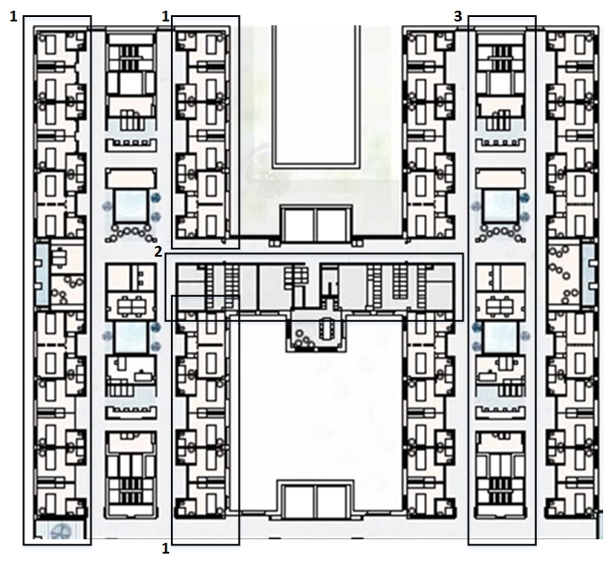

Figure 2. The lay-out of the nursing ward, consisting of four units of 12 beds (1: patient rooms, 2: technical areas; to be determined, 3: central area; to be determined)

Figure 3. The overall hospital lay-out (preliminary)

3.3. Phase 5: peer review

No additional suggestions or remarks were made in this phase, meaning that the overall plans for the ward design did not need any alternations. The lay-out of the patient room however, needed further refinement. This was explored, discussed and designed in another process (De Meester et al., 2022).

4. Discussion and conclusions:

Due to the absence of a comprehensive body of knowledge on Evidence-Based design concerning nursing wards, other sources had to be consulted in order to design the nursing wards in the new hospital of the Ghent University Hospital. A systematic, evidence-based approach was used.

From the start it became clear that no clear-cut answer could be found in the literature. Most of the extensive studies on which the choices were made had to be done by the research team themselves and could not be found in literature. This was the case for (almost) all the topics and elements included in this study. This provides two insights. First, because each hospital has its own focus and identity, the questions posed are unique. Therefore, investments are needed. Second, there remains a lack in knowledge on many topics related to nursing ward design. This should be addressed.

Also, this case study showed, in contrast with some points made in this discussion, that each hospital should focus on creating their own design. This means that a universal truth about the best nursing wards design (within a time and context) is perhaps not possible, and even not needed nor desired. It also seems important to provide the possibility to scale up if needed, or change the care trajectories of patients in a fast and fluent matter (i.e. in case of a pandemic) (Brambilla et al., 2021; Geltmeyer et al., 2022)

Due to the extensive work done by the hospital itself, the specific focus of the studies, and the fact that most studies are not yet published and therefore lack peer-review, a form of bias is a possibility. Moreover, this also compromises the transferability of these insights. However, apart from the created content, this case study shows that it is worthwhile to invest in an extended, systematic, evidence-based approach in designing the nursing wards. If any lessons can be learned, the presented approach could be an inspiration for other hospitals.

In the future, there should be contemplation of creating a learning network in Europe and worldwide about the design of nursing wards. The focus of such a network should be on pro-actively sharing insights and conducting research on nursing, linked to specific ward design. As was learned throughout this case study, there should be an ever-remaining focus on the theory of nursing, both in design and overall.

The process does not end with the finished design of the hospital. The hospital lay-out will also be evaluated after realization. Possible methods could be tracking nurses’ ‘walking lines’, tracking the time spent with the patient and patient- and staff satisfaction.

Overall, three conclusions can be made, based on this case study. First, there is no clear-cut answer on which design is best for the nursing ward of the future. Based on their experience, each hospital should look for a design that articulates the strategic choices of the hospital concerning nursing care. Second, vision should be placed before design. Before designing a nursing ward, main principles and core values about care need to be determined in order to facilitate decision-making about a definitive design. Third, most of the knowledge to make a well informed choice has to be created by the stakeholders themselves and is difficult to find elsewhere. This means that the process of designing a new hospital starts long before the actual drawing of the plans.

**Data Availability Statement**

Some of the study to which there are references in this paper, have not yet been published. Readers who would like to gain more insight in these results can contact the corresponding author. The authors are more than willing to share any available draft papers.

**Contributor statement**

All authors contributed significantly to the conception of this paper. SM, KG, VD completed most of the study, which SM also supervised. TB, LP, RV contributed significantly to the content in the process.

**Acknowledgments**

The authors would like to thank the scientific fund of the Ghent University Hospital for providing the necessary funds for conducting this study. The funds had no involvement in the design, conception and execution of this study. Furthermore, the authors would like to thank all the employees of the Ghent University Hospital who participated in this process.

**References**

Adams, A., Bond, S., & Hale, C. A. (1998). Nursing organizational practice and its relationship with other features of ward organization and job satisfaction. Journal of Advanced Nursing, 27(6), 1212-1222.

Brambilla A, Sun TZ, Elshazly W, Ghazy A, Barach P, Lindahl G, Capolongo S. Flexibility during the COVID-19 Pandemic Response: Healthcare Facility Assessment Tools for Resilient Evaluation. Int J Environ Res Public Health. 2021 Oct 31;18(21):11478. doi:10.3390/ijerph182111478.

Castro, E. M., Malfait, S., Van Regenmortel, T., Van Hecke, A., Sermeus, W., & Vanhaecht, K. (2018). Co-design for implementing patient participation in hospital services: a discussion paper. Patient education and counseling, 101(7), 1302-1305.

De Meester E., Delforge L., Malfait, S., Pieters L., Duprez V. (2022). Designing a patient room: the process of stakeholders’ involvement. Conference proceedings. ARCH22 – the 5th Architecture Research Care and Health conference, Rotterdam.

Geltmeyer, K., Eeckloo, K., Dehennin, L., De Meester, E., De Meyer, S., Pape , E., Vanmeenen, M., Duprez, V., Malfait, S., (2022) What do we know about nursing models? An evidence map. Under review.

Geltmeyer K, Neyrinck D, Benoit D, Malfait S, Goedertier H, Duprez V. Implementing mixed nursing care teams in intensive care units during COVID-19: A rapid qualitative descriptive study. J Adv Nurs. 2022 Jun 28. doi: 10.1111/jan.15334.

Holly, C., Salmond, S., & Saimbert, M. (Eds.). (2021). Comprehensive systematic review for advanced practice nursing.

Magargal, P. (1987). Modular Nursing: Nurses Rediscover Nursing: Skillful planning puts the caregiver close to the patient to provide service. Nursing management, 18(11), 98-105.

Mannekens, K., Duprez, V., Rowies, AS., Van der Hasselt, H., Verhaeghe, R. Malfait, S. (2022) The job content of head nurses and its association with job satisfaction, burnout and intention to leave: A cross-sectional study. Under review.

Miller, D. (1993). The architecture of simplicity. Academy of Management review, 18(1), 116-138.

Pilosof NP. Building for Change: Comparative Case Study of Hospital Architecture. HERD. 2021 Jan;14(1):47-60. doi: 10.1177/1937586720927026. Epub 2020 Jun 15.

Ulrich, R. S., Zimring, C., Zhu, X., DuBose, J., Seo, H. B., Choi, Y. S., ... & Joseph, A. (2008). A review of the research literature on evidence-based healthcare design. HERD: Health Environments Research & Design Journal, 1(3), 61-125.

Van Meenen, M. (2021). Towards a new concept of the mobile workstation. Personal communication.

White, M.D., & Marsh, E.E. (2006). Content Analysis: A Flexible Methodology. *Library Trends* *55*(1), 22-45. [doi:10.1353/lib.2006.0053](http://doi.org/10.1353/lib.2006.0053).