Type of the Paper: Peer-reviewed Conference Paper / Full Paper
Track title: please fill in you track title here

The association between the shape of Long-Term Care Units and residents’ wellbeing
*Yifat Rom¹, Yuval Palgi², Eliyahu Greenberg³, *Michal Isaacson⁴
Names of the track editors:
Clarine van Oel
Names of the reviewers:
Malavika Nair
Ira Verma
Journal: The Evolving Scholar
DOI: https://doi.org/10.24404/62257f1976cff8c5d2559df3
Submitted: 07 March 2022
Accepted: 22 August 2022
Published: 20 November 2023
Citation: Rom, Y., Plagi, Y., Greenberg, E. & Isaacson, M. (2022). The association between the shape of Long-Term Care Units and residents’ wellbeing [preprint]. The Evolving Scholar | ARCH22. https://doi.org/10.24404/62257f1976cff8c5d2559df3
This work is licensed under a Creative Commons Attribution BY license (CC BY).
© 2022 Rom, Y., Plagi, Y., Greenberg, E. & Isaacson, M. published by TU Delft OPEN on behalf of the authors.
*1yifatrom@gmail.com ; ORCID ID 0000-0002-5498-8777
² yuvalpalgi@gmail.com
³ e.greenberg86@gmail.com
*⁴ misaacson@univ.haifa.ac.il

Abstract: The increasing number of older adults and the ones needing 24-hour assistance and hence living in long-term care facilities (LTCFs) has led to the development of well-being models that acknowledge the environment as an important factor the influences well-being. Acknowledging this importance, numerous studies on the effects of the environment in LTCFs on well-being among older residents have enriched the knowledge on environmental variables affecting well-being. These studies have yielded conflicting results on topics such as the recommended hallway shape and optimal nursing-station position. Moreover, complying environmental assessment tools that rely on different amounts and combinations of the researched variables were formed. Most of these tools assess the variables in a dichotomous manner (either the variable is present or not); thus, the significance and weight of each variable are overlooked. A need for an additional quantitative measurement tool led to the development of the Psycho-Social Evaluation Tool (PSET) (Rom et al., 2022), which measures the effect of the units’ physical layout on well-being. By analyzing architectural plans from 40 long-term care units with the PSET, the current study demonstrates how the effect of physical layout on well-being is related to various variables in different domains. To demonstrate this, this paper focuses on conflicting recommendations regarding hallway shape, which affects the overall unit layout during the design process. We argue that all physical layout variables related to well-being should be measured during the design process and viewed as a part of the bank of resources since one variable (like hallway shape) is not sufficient to predict how LTCF units support residents’ well-being.

Keywords: Long-term care units; well-being; assessment tools; the Social Production Function

- Introduction
When planning long-term care facilities (LTCF), architects strive to design buildings that support the well-being of those who live and work there. They base this work on their subjective impressions of similar institutions, personal experience, subjective assumptions about what residents and caregivers may consider desirable, as well as guidelines based on published research, which often present conflicting results (regarding, e.g., the recommended shape for hallways or the optimal position of the nursing station). Hence, to properly produce a design that supports well-being in LTCFs, architects need an assessment tool that will help them improve the physical layout optimally throughout the design process.
Most existing tools that measure the physical layout’s support of well-being address different amounts of variables in a wide variety of combinations, assuming that each variable has a dichotomous (yes/no) effect on a single domain of well-being. Thus, the significance and weight of each variable are overlooked. Furthermore, the tools are not based on an accepted model but are chosen based on the preferences and assumptions of the researchers. The Psycho-Social Evaluation Tool (PSET) (Rom et al., 2022) is a quantitative assessment tool based on the social production function (SPF) model (Lindenberg, 1996).
The SPF, unlike other well-being models, asserts that age-related deterioration in terms of health, cognition, and functionality does not affect everyone’s well-being in the same way. Therefore, people use different available resources in diverse ways to improve and achieve their well-being and living conditions. The SPF model refers to five well-being goals (domains) achieved through a symbiotic relationship between a bank of resources, where one resource compensates for the lack of others.
By analyzing plans from 40 long-term care units using the PSET, the current research demonstrates that the physical layouts' support of well-being is related to a combination of variables. Focusing on the conflicting recommendations regarding hallway shape, which affects the overall unit layout during the design process, the current research demonstrates that a single variable cannot predict the physical layouts' support of well-being. It is therefore recommended to view the variables contributing to well-being as a bank of resources, with each one measured and assessed during the design process. The present research contributes to improving the quality of planning long-term care units, benefiting residents and caregivers alike.

2. Theories and Methods
The increasing average age of the population is accompanied by a growing number of adults needing 24-hour assistance and being admitted into LTCFs, which has led to theadaptation of well-being models (Alborz, 2017). Lawton (1983) was the first to create a new model of the “good life” in old age. This unique model embedded new ideas centered on the importance of the environment in supporting well-being of older adults.
Since then, research has examined the effects of environmental variables on the subjective well-being of older adults, particularly among LTCF residents (e.g., privacy, autonomy, institutional versus home-like atmosphere, and orientation). These important studies have enriched the field but have also yielded inconsistent results, highlighting the need for uniform measurement tools. The impact of hallway shape on residents’ well-being has been a subject of conflicting research(Ferdous, 2020; Kleibusch, 2018; Lee et al., 2016; O'malley et al., 2017; van Buuren & Mohammadi, 2022; Van Hecke et al., 2019). Elmståhl and Annerstedt (1997) concluded that L-shaped hallways positively affected the psychiatric symptoms of residents, while I-shaped hallways provided the worst results. In contrast, Marquardt and Schmieg (2009) concluded that I-shaped hallways allow better orientation and are preferable for residents with dementia. Still, other studies have argued that I-shaped hallways increase the residents’ negative experience of living in an institution (Bowes, A., Dawson, 2019).
Additional studies have focused on the effects of different physical layout components on cognition, analyzing the architectural plans of existing long-term care units. Using Space Syntax (Bafna, 2003), the analysis compared quantitative levels of visuality, orientation, and movement in space. Despite the importance of these measurements, it has been argued that Space Syntax cannot be used as an individual assessment tool to examine the physical layouts' support of well-being in these units. The attempt to cross-reference Space Syntax with other assessment tools (Quirke et al., 2021) has again led to the conclusion that a combined methodological tool is needed.
The vast knowledge accumulated from these studies has led to new assessment tools addressing the environmental variables that support well-being. Many are based on observations and dichotomously examine the existence of hundreds of environmental variables that include, in addition to the physical layout variables, general environmental variables (e.g., odors, garden, home-like environment). As a part of the assessment procedure, the observed variables in each tool (e.g., 181 variables measured in the DDAT, 337 in the SCEAM) (Elf et al., 2017)) are grouped into different well-being domains (presumed to affect only a single domain). However, the amount and nature of these domains vary from tool to tool.
Furthermore, the tools do not examine absolute quantitative variables of the physical environment (such as walking distances, the density of specific areas, and visibility related to autonomy and privacy), nor do they analyze the architectural plans quantitatively. Therefore, insight is limited regarding the contribution of each variable and to efficient possible improvements. The importance of quantifying the physical layout lies in the fact that although certain environmental factors can be improved (e.g., interior design to improve the atmosphere, improve lighting by replacing lighting fixtures), changing the physical layout itself (i.e., the walls) of the long-term care unit is costly. It is therefore essential to assess plans during the design process. And for existing long-term care units, the units' benefits and disadvantages must be considered when aiming to improve the well-being of residents.
To our knowledge, the only quantitative methodological assessment tool is the PSET (Rom et al., 2022). The PSET is based on the SPF model (Lindenberg, 1996; Ormel et al., 1997) that provides tools for optimizing well-being in LTCF (D. L. Gerritsen, N. Steverink, 2004). The SPF addresses well-being as a universal goal achieved by five domains (“instrumental goals”): comfort, stimulation, status, behavioral confirmation, and affection. According to the theory, diverse resources (“means of production” that include the physical layouts) comprise these five domains. Thus, contrary to other frameworks, the SPF treats these five domains as a bank of resources. The resources are characterized by a symbiotic relationship that supports physical well-being (physical-wb) and social well-being (social-wb), where one resource (or one of the domain’s variables) may compensate for the lack of others.
The current study aimed to address the contradicting finding of studies regarding the relationship between the shape of the corridor and well-being. First, the forty long-term care units' plans were analyzed using the PSET evaluation tool. The results of the "L" shaped long-term care facility corridors were compared to the effects of other shapes of corridors. Secondly, the variance between all L-shaped corridors was compared.
The results demonstrated that the physical layout’s support of well-being is related to a combination of variables, and highlighted the need to view the variables contributing to well-being as a bank of resources to be assessed during the design process since a single variable is not sufficient to predict how LTCF units support residents’ well-being.
Participants: Forty randomly chosen architectural long-term care units, either already built or in the building process, with different shapes of corridors ("L" n=14, "I" n=5, "O" n=7, "T" N=7, other shapes of corridors n=7). Inclusion criteria: 1) housing between 20-36 residents; 2) designed according to the Israeli Ministry of Health guidelines and regulations.
Tool(s): PSET is a methodological assessment tool based on the SPF model (see above) (Rom et al., 2022). The tool evaluates twenty-eight quantitative variables of the physical layout (using CAD files and Space Syntax). The variables are measured according to their support of the five domains:
Comfort (physical-wb) is measured by computing nine physical aspects: 1) area per person (1); 2) distance from the bedrooms to the formal public rooms such as day room and dining room (1); 3) distance from the bedrooms to the nursing station (NS) (-1); 4) distance from the bedrooms to the kitchen (1); 5) distance from the doors of smell hazard rooms (e.g., diaper disposal or garbage rooms) to the main public hallway (1); 6) percent of parallel bedrooms' doors (-1); 7) visibility from nursing-station (1); 8) visibility from the bedrooms' entrance (-1);9) visibility from the main entrance into the bedrooms (-1).
Stimulation (physical-wb) is measured by computing twelve physical aspects: 1) number of formal public-rooms (1); 2) total perceived area of the formal public-rooms per person (-1); 3) distance from the bedrooms to the formal public-room (-1) ;4) distance from bedroom to kitchen (-1); 5) maximum visual distance (-1); 6) type of nursing-station (1); 7) integration of public spaces (1); 8) choice of formal public-rooms (-1); 9) choice of spaces adjacent to formal public-rooms (-1); 10) intelligibility (1); 11) visibility from nursing-station to the formal public-rooms (1); 12) visibility from formal public-rooms (-1).
Status (social-wb) is measured by computing four physical aspects: 1) distance to the formal public-rooms (1); 2) maximum visual distance (1); 3) visibility from the bedroom entrance (1); 4) visibility from the main entrance into the bedrooms (-1).
Behavioral confirmation (social-wb) is measured by computing seven physical aspects: 1) distance from bedroom to nursing-station (-1); 2) distance from nursing-station to all support rooms (-1); 3) type of nursing-station (-1); 4) integration of formal public-rooms (1); 5) integration of nursing-station (1); 6) visibility from nursing-station (1); 7) visibility from formal public-rooms to nursing-station (1).
Affection (social-wb) is measured by computing twelve physical aspects: 1) number of internal formal social interaction spaces (1); 2) number of internal informal social interaction spaces (1); 3) number of external social interaction spaces (1);); 4) distance from the bedrooms to nursing-station (-1); 5) distance from nursing-station to formal public-rooms (-1); 6) distance from nursing-station to all support rooms (-1); 7) distance between the door of the closest smell hazard room and main entrance (1); 8) integration of nursing-station (1); 9) visibility from nursing-station (1); 10) visibility from main entrance to the formal public room (-1); 11) penetration experience (-1); 12) distance from closest nursing-station to the main entrance (-1).
The tool yields two complementary outcomes. The first outcome is a division of the physical layout into four typologies according to their support of physical-WB and social-WB. The second outcome, used in this paper, quantifies each plan’s attributes in the five domains and gives information (presented as a unique footprint) about their deficiencies and reserves (copies of the PSET are available upon request from the corresponding author).
Procedure:
A: analyzing unit shape (the independent value): The forty plans were divided into five groups by shape of the main hallway ("L", 'I", "O", "T", and "other"). L-shaped plans include a double-winged hallway connected to a formal public-room. The angle between the wings must be over 30-degrees, and the shortest wing should include a minimum of four rooms. I-shaped plans include a single or double-winged hallway with an angle up to 30-degrees. The formal public-rooms are positioned anywhere along the hallway. O-shaped plans include a single hallway that allows residents to walk in circles. T-shaped plans include a three-winged hallway. The three wings are connected to a formal public room. Only two of the wings are used for bedrooms; the third wing is used for service or paramedical rooms. Designated as “Other” are all plans with hallways that do not follow the above.
B: analyzing the long-term care units using the PSET (the dependent value): The forty randomly chosen long-term care units' plans received an identification number used throughout the research. The CAD architectural plans (provided to the researcher by the LTCF management) were analyzed according to their support of five well-being domains using the PSET (detailed above).
C: Data analysis: A one-way ANOVA was performed to determine whether there were differences in the scores for the five domains of well-being according to long-term care units' hallway shape.

3. Results
A one-way ANOVA was conducted to determine if the shape of the corridors is related to each one of the five social and physical wb SPET outcomes (comfort, stimulation, status, behavioral confirmation, and affection). The current study has referred to five shapes of corridors ("L" (n=14), "I" (n=5), "O" (n=7), "T" (N=7), other shapes of corridors (n=7)). Data is presented as means ± standard deviation. The five social and physical wb SPET outcomes were not significantly different between the five shapes of corridors. (p>0.05). As predicted based on the SPF model, the results found no significant correlation between hallway shape and the scores for the five well-being domains. These results confirm the PSET tool’s claim that a single physical layout variable cannot predict its support of well-being. The results also highlight the importance of quantifying these variables in order to be able to focus on each domain’s footprint as the long-term care units' bank of resources and deficiencies.

3.1. Comparison of L-Shaped Plans
A detailed comparison is presented between different pairs of L-shaped plans to demonstrate the lack of correlation between hallway shape and well-being scores in the five domains, demonstrating how they differ from one another. We have chosen two L-shaped plans that scored very differently for each domain. By examining these pairs of plans below, we demonstrate the nuances that differentiate them.

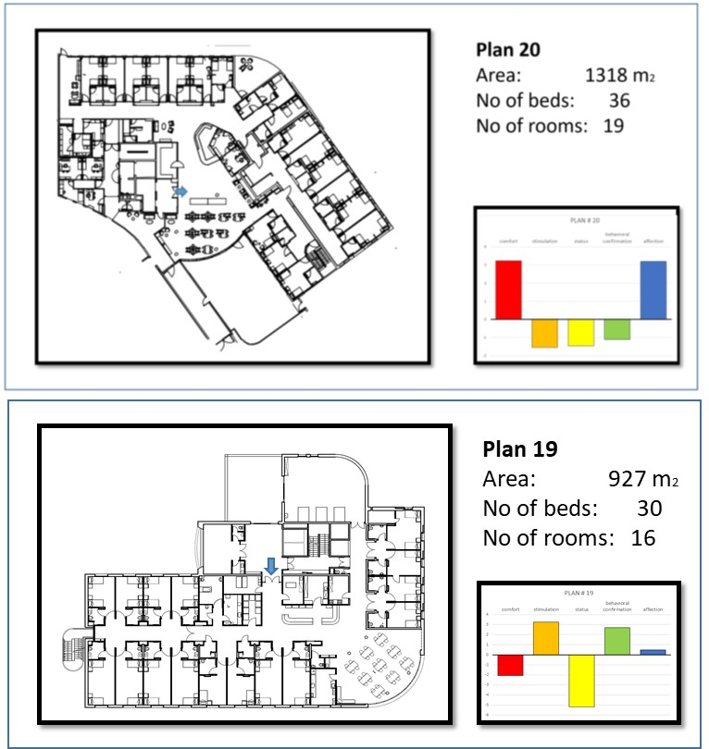

Figure 1–Comparing plan#19 and plan#20

Support of Comfort: The physical layout of long-term care units can support comfort by controlling visual, noise, and smell intrusions in bedrooms. Plans #19 and #20 scored very differently in their support of comfort (Figure 1). The cause of this difference lies in the location of the unit’s main entrances and the visual intrusion created by this choice. In plan #19, the main entrance directly overlooks some of the bedrooms, while in plan #20, this is not the case. The sight from the nursing-station to the bedroom doors may support a feeling of safety and security. Thus, plan #19 has lower visibility from the nursing-station (#19=20.11 %<#20=26.51%), and provides lower visual control from the bedroom doors (#19=3.76 %<#20=12.16%). Privacy also differs between the two plans, expressed in the percent of parallel bedroom doors, which allow for visual penetration which allows individuals to see into other bedrooms (#19=50%>#20=11%).
Noise intrusion and foul smells also affect comfort. Noise is measured by the proximity of bedrooms to the nursing-station and the formal public-rooms, both sources of noise. The bedrooms in plan#19 are closer to the nursing-station and are distant to the formal public-rooms. The intrusion of foul smells is represented by the proximity of bedrooms and other public spaces to foul smell sources. The bedrooms in plan#19 are closer to the kitchen, and rooms with smell hazards (e.g., diaper disposal or garbage rooms) are close to public spaces. The area per person may moderate the feeling of crowdedness in the formal public-rooms and promote privacy in double bedrooms, offering more options for spacious sitting arrangements. Although guidelines limit the minimum area per room according to activity, each unit’s total area differs (#19=30.9 sqm/person<#20=36.6 sqm/person). In conclusion, plan #20 provides better support for comfort.
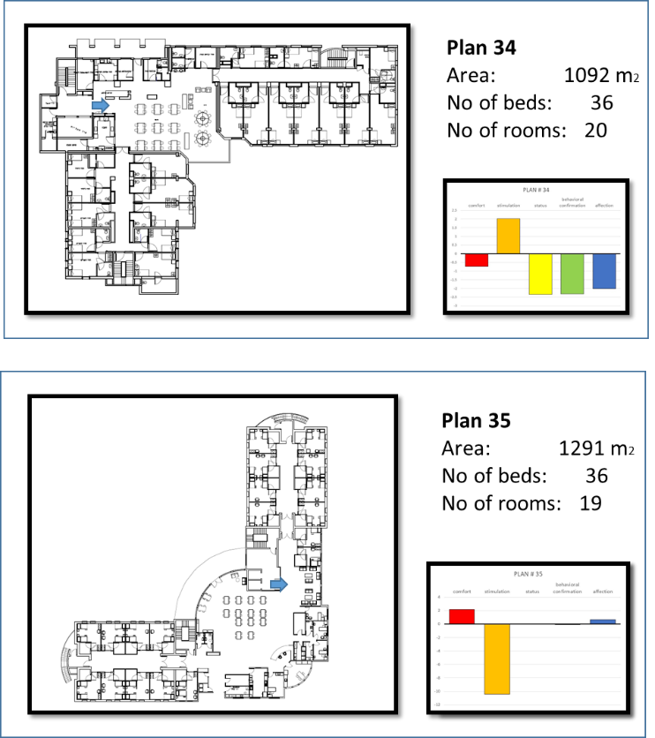

Figure 2–Comparing plan#34 and plan#35

Support of Stimulation: Stimulation optimally supports well-being both negatively and positively: Over-stimulation may affect residents’ concentration, leading to frustration and agitation, while lack of stimulation creates stagnation. However, the right amount of stimulation can encourage growth and thriving. Plans #34 and #35 represent polarity in their support of stimulation (Figure 2).
Visual over-stimulation is mainly related to the areas visible from the formal public-rooms, including adjacent hallways and other spaces with long overlapping edges, and to the overall visibility of the entire unit. The outcomes present a difference between the perceived formal public-room’s area per person (#35=7.5 sqm/person>#34=4.16 sqm/person), and the visibility (#35=35.4%>#34=26%), which measures the percentage of the unit’s floor area visible from the formal public-room; a higher percentage of visible space can be overstimulating.
Two additional "choice" variables associated with overstimulation are measured with Space Syntax. The first Space Syntax choice variable represents the amount of exposure to the formal public-room’s adjacent hallway and the heavier movement probability through that part of the hallway. Plan #35’s formal public-room is significantly more exposed to the hallways (#35=41,788>#34=15,452). The second Space Syntax choice variable represents the probability of people walking through the formal public-room as a shortcut or to reach a specific room (#35=11218>#34=16,169).
Positive stimulation relates to the support of autonomy by improved wayfinding, orientation, shorter walking distances, and other stimuli like proximity to food smells or noises from exciting activity. Wayfinding and orientation are measured by the presence of landmarks (such as a prominent NS), and the intelligibility of the physical layout, which is correlated with hallway shape (calculated using Space Syntax). The nursing-station is emphasized as a landmark by its overall visibility and visual characteristics (protrusive, i.e. Surrounded by three walls/intrusive, i.e. Surrounded by one or two walls) (#34=13.5% < #35=39.9%). The added distance per room from the kitchen refers to food smells as a positive stimulus (#34=21.55m/bedroom<#35=31.87m/BR).
Encouraging autonomous behavior is associated with the formal public-rooms’ integration level (calculated using Space Syntax). Positioning the formal public-rooms at the center of the unit creates positive stimulation, which may lead to a willingness to participate in activities and a feeling of being part of the unit’s community (#34=1.08 >#35=0.88). In conclusion, plan#34 provides better support for Stimulation, while Plan#35 Scores Exceptionally Low.
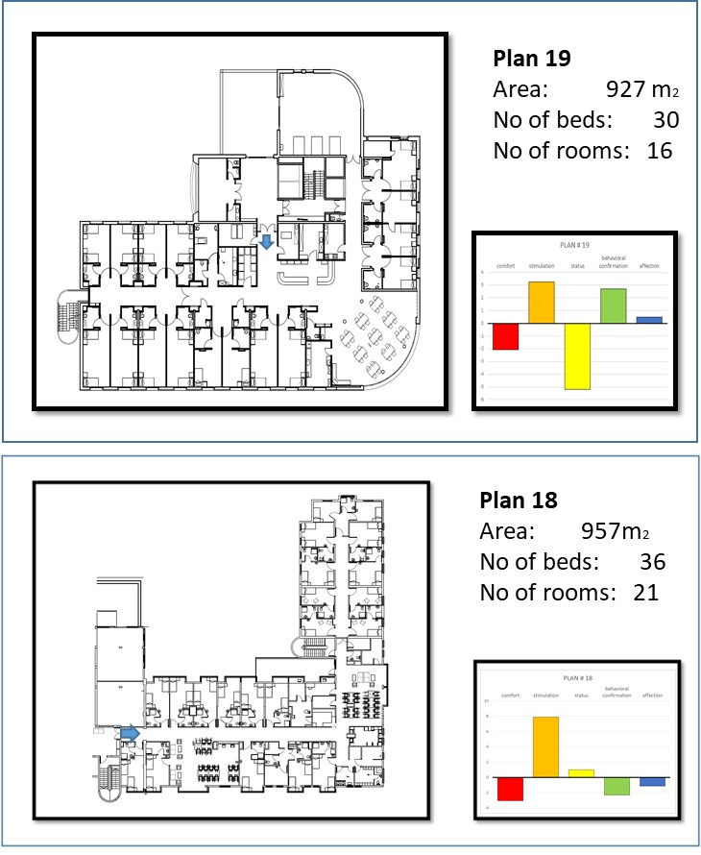

Figure 3–Comparing plan#18 and plan#19

Support of Status: The physical layout creates hierarchies (close/far, front/rear) within the unit. For example, the bedrooms’ relative location in the unit may be perceived by visibility to/from bedrooms, or by walking distance to/from landmarks. The causes for these differentiations were examined through plans #18 and #19, representing polarity in their support of status (figure 3). The added distance from the bedroom doors (per bedroom) to the formal public room is larger in plan 18 (#18=22.5>#19=21.38). Despite the longer maximum visual distance r in plan 19 (#19=42m>#18=37m) the visibility from the bedrooms (measured with Space Syntax) in plan #18 is higher (measured with Space Syntax) (#18=8.13>#19=3.79). In addition, the visibility from the main entrance to bedroom doors which is measured as a negative status symbol is higher in plan 19. (#19=-5.11>#18=-0.07). In conclusion, plan #18 provides better support for status (Figure 3).

Support of Behavioral Confirmation: Behavioral confirmation refers to residents being able and likely to establish eye contact with staff members, to get non-verbal confirmation of one’s actions. To demonstrate how this manifests in a plan, we examined plans #18 and #19 (figure 3). The research refers to eye-contact with staff members at a clear, noticeable nursing-station as informal communication, a positive attribute that benefits the residents (Campo & Chaudhury, 2012; Machiels et al., 2017; Real et al., 2018; Stephan et al., 2015). Plan#19 has a protrusive nursing-station that is directly visible from a large area of the unit whereas plan #18 has a semi-intrusive nursing-station and thus lower visibility (#18=8.64<#19=20.11). In addition, plan #19 has much higher visibility to the formal public room (#18 =2.46<#19=78.9). When routine walking distances between bedrooms and support rooms is greater, random eye contact with staff members (as they pass by bedrooms or formal public-rooms) decreases. Plan #19 has a shorter added distance from the nursing-station to bedrooms per bedroom (#18=20.43m>#19=15.06m) and a shorter added distance to the support rooms (Plan#18=78m<Plan#19=47m). The integration level of the nursing-station and formal public-rooms, representing their centrality within the unit and, therefore, the probability of eye contact, is slightly higher in plan#19. In conclusion, plan #19 provides better support for behavioral confirmation.
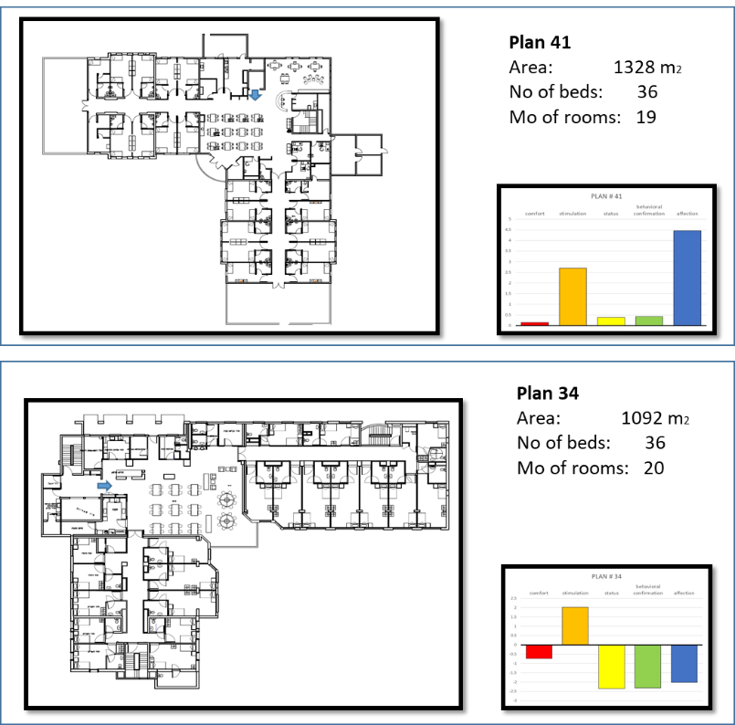

Figure 4–comparing plan#41 and plan#34

Support of Affection: The physical layout supports affection by supporting residents’ ability to spend “quality time” with staff members and guests. The caregivers' mental and physical condition, which will allow them to offer the residents personal support, attention, and affection by careful placement of the nursing station and eliminating long walking distances that can lead to fatigue (Lee et al., 2016) was measured as part of the PSET evaluation of affection (Rom et al., 2022) . To demonstrate aspects of plans that support this dimension, we examined plans #34 and #41, representing polarity in their support of affection (figure 4). In plan #34, the staff's insufficient quality time with residents may result from long, time-consuming walking distances within the unit. Plan#34 presents a shorter added distance per room from nursing-station to bedrooms (#34=19.7m/b<#41=26m/b) and longer added distance from nursing-station to the support room (#34=60m<# 41=86m). Lack of visual control from the nursing-station (integration and visual abilities) may cause excessive movement by the staff, requiring greater vigilance and possibly causing fatigue, which may affect their ability to behave affectionately (Becker, 2007; Hendrich et al., 2009). In addition, the nursing-station in plan# 34 has a lower level of integration (#34=0.72<#41=1.2) but lower visibility throughout the unit (#34=19.83<# 41=85.67).
Quality time spent with guests may be affected by guests’ visitation experience, which likely depends on their impressions upon entering the unit, including visibility from the main entrance to the formal public-rooms (plan#34=0.62<plan#41=41.1) and smell hazards next to the main entrance (both plan's garbage room is far from the main entrance). Visitation experience may also be affected by the availability to choose between different kinds of meeting places. Plan #41 has three balconies (plan#34 has none) and one formal public-room (plan #41 has two). In conclusion, plan #41 provides better support for affection.

4. Discussion
Building on the traditions established by environmental gerontologists, who see the environment as a silent partner in supporting well-being in older adults, the current study sought to add to the existing knowledge. With a methodological analysis of 40 LTCF plans using the PSET tool, this study presented the ways in which plans that seem similar in shape and size actually can be quite different from one another, as in the L-shaped plans described above. The research demonstrated that, when planning LTCFs, a single physical layout variable cannot predict the environment’s support of well-being. In order to maximize the ways in which a physical layout can support residents in achieving the desired well-being, there is a need to evaluate all variables as a symbiotic bank of well-being resources. The current research brings empirical evidence into an area that has been predominantly ruled by architects’ intuition combined with institutional or governmental codes.

5. Conclusions
The fact that individual physical layout variables cannot predict the physical layouts' support of well-being highlights the need to use quantitative research tools to examine a unit’s bank of resources and deficiencies throughout different planning stages. Based on outcomes from using these tools, future research can focus on complementary solutions to compensate for deficiencies in each domain, especially when upgrading existing facilities. Solutions may include, for example, small building changes (e.g., relocating the garbage room, or building a visual partition), interior design changes (e.g., adding elements that make orientation easier and support stimulation), or changes in workplace policies. Such research would benefit long-term care residents and staff, as well as the general population of older adults.
.

Contributor statement
The authors confirm contribution to the paper as follows
Y. Rom and M. Isaacson: study conception and design
Y. Rom and E. Greenberg: data collection
Y. Rom and M. Isaacson: analysis and interpretation of results:
Y. Rom: draft manuscript preparation
Y. Rom, Y. Palgi, E. Greenberg, and M. Isaacson reviewed the results and approved the final version of the manuscript.

References

Alborz, A. (2017). The Nature of Quality of Life: A Conceptual Model to Inform Assessment. Journal of Policy and Practice in Intellectual Disabilities, 14(1), 15–30. https://doi.org/10.1111/jppi.12225
Bafna, S. (2003). Space syntax: A brief introduction to its logic and analytical techniques. Environment and Behavior, 35(1), 17–29. https://doi.org/10.1177/0013916502238863
Becker, F. (2007). Nursing unit design and communication patterns: what is “real” work? Herd, 1(1), 58–62. https://doi.org/10.1177/193758670700100115
Bowes, A., Dawson, A. (2019). Designing environments for people with dementia (first edit). emerald Publishing Limited Howard House, Wagon Lane, Bingley BD16 1WA, UK.
Campo, M., & Chaudhury, H. (2012). Informal social interaction among residents with dementia in special care units: Exploring the role of the physical and social environments. Dementia, 11(3), 401–423. https://doi.org/10.1177/1471301211421189
Elmståhl S, Annerstedt L, A. O. (1997). How should a group living unit for demented elderly be designed to decrease psychiatric symptoms? Alzheimer Disease and Associated Disorders., 11(1), 47–52. https://doi.org/10.1097/00002093-199703000-00008.
Elf, M., Nordin, S., Wijk, H., & Mckee, K. J. (2017). A systematic review of the psychometric properties of instruments for assessing the quality of the physical environment in healthcare. Journal of Advanced Nursing, 73(12), 2796–2816. https://doi.org/10.1111/jan.13281

Ferdous, F. (2020). Positive Social Interaction by Spatial Design: A Systematic Review of Empirical Literature in Memory Care Facilities for People Experiencing Dementia. Journal of Aging and Health, 32(9), 949–961. https://doi.org/10.1177/0898264319870090
Kleibusch, K. (2018). Dementia: How Design Can Improve Navigation Among Older Adults in Assisted-Living Facilities. SPNHA Review, 14(1), 25–41. https://scholarworks.gvsu.edu/spnhareview://scholarworks.gvsu.edu/spnhareview?utm_source=scholarworks.gvsu.edu%2Fspnhareview%2Fvol14%2Fiss1%2F5&utm_medium=PDF&utm_campaign=PDFCoverPagesAvailableat:https://scholarworks.gvsu.edu/spnhareview/vol14/iss1/5
Lee, S.-H., Jeon, G.-Y., Choi, J.-H., Na, W.-J., & Hong, W.-H. (2016). Study on effect Size of Walking Speed According to Corridor Shape. Indian Journal of Science and Technology, 9(24). https://doi.org/10.17485/ijst/2016/v9i24/96074
O’Malley, M., Innes, A., & Wiener, J. M. (2017). Decreasing spatial disorientation in care-home settings: How psychology can guide the development of dementia friendly design guidelines. Dementia, 16(3), 315–328. https://doi.org/10.1177/1471301215591334
O’Malley, M., Innes, A., & Wiener, J. M. (2017). ‘All the corridors are the same’: a qualitative study of the orientation experiences and design preferences of UK older adults living in a communal retirement development. Ageing &amp; Society, 1–26. https://doi.org/10.1017/S0144686X17000277
van Buuren, L. P. G., & Mohammadi, M. (2022). Dementia-Friendly Design: A Set of Design Criteria and Design Typologies Supporting Wayfinding. Health Environments Research and Design Journal, 15(1), 150–172. https://doi.org/10.1177/19375867211043546
Van Hecke, L., Van Steenwinkel, I., & Heylighen, A. (2019). How Enclosure and Spatial Organization Affect Residents’ Use and Experience of a Dementia Special Care Unit: A Case Study. Health Environments Research and Design Journal, 12(1), 145–159. https://doi.org/10.1177/1937586718796614
Gerritsen, D. L., Steverink, N., Ooms, M. E., & Ribbe, M. W. (2004). Finding a useful conceptual basis for enhancing the quality of life of nursing home residents. Quality of Life Research, 13(3), 611–624. https://doi.org/10.1023/B:QURE.0000021314.17605.40
Hendrich, A., Chow, M. P., Bafna, S., Choudhary, R., Heo, Y., & Skierczynski, B. A. (2009). Unit-related factors that affect nursing time with patients: spatial analysis of the time and motion study. Herd, 2(2), 5–20. https://doi.org/10.1177/193758670900200202
Lawton, M. P. (1983). Environment and other determinants of well-being in older people. The Gerontologist, 23(4), 349–357. https://doi.org/10.1093/geront/23.4.349
Lindenberg, S. (1996). Continuities in the Theory of Social Production Functions. Doctoral Dissertation, Thesis Publication, 1989, 169–184.
Machiels, M., Metzelthin, S. F., Hamers, J. P. H., & Zwakhalen, S. M. G. (2017). Interventions to improve communication between people with dementia and nursing staff during daily nursing care: A systematic review. International Journal of Nursing Studies, 66, 37–46. https://doi.org/10.1016/j.ijnurstu.2016.11.017
Marquardt, G., & Schmieg, P. (2009). Dementia-Friendly Architecture: Environments That Facilitate Wayfinding in Nursing Homes. American Journal of Alzheimer’s Disease & Other Dementiasr, 24(4), 333–340. https://doi.org/10.1177/1533317509334959
Nordin, S., McKee, K., Wijk, H., & Elf, M. (2017). The association between the physical environment and the well-being of older people in residential care facilities: A multilevel analysis. Journal of Advanced Nursing, 73(12), 2942–2952. https://doi.org/10.1111/jan.13358
Ormel, J., Lindenberg, S., Steverink, N., & Vonkorff, M. (1997). Quality of life and social production functions: A framework for understanding health effects. Social Science and Medicine, 45(7), 1051–1063. https://doi.org/10.1016/S0277-9536(97)00032-4
Real, K., Santiago, J., Fay, L., Isaacs, K., & Carll-White, A. (2018). The Social Logic of Nursing Communication and Team Processes in Centralized and Decentralized Work Spaces. Health Communication, 1–13. https://doi.org/10.1080/10410236.2018.1536940
Rom, Y., Palgi, Y., & Isaacson, M. (2022). Analyzing the Layout of Long-Term Care Facilities: A Psycho-Spatial Approach. Health Environments Research & Design Journal, 15(2), 22–42. https://doi.org/10.1177/19375867211064538
Stephan, A., Möhler, R., Renom-Guiteras, A., & Meyer, G. (2015). Successful collaboration in dementia care from the perspectives of healthcare professionals and informal carers in Germany: Results from a focus group study. BMC Health Services Research, 15(1), 1–13. https://doi.org/10.1186/s12913-015-0875-3

