Type of the Paper: Peer-reviewed Conference Paper / Full Paper
Track title: Translation of Therapeutic Architecture as a Guideline for Residential Design

Translation of Therapeutic Architecture as a Guideline for Residential Design
Malavika S Nair ^{1 *}
¹ KMEA College of Architecture; malavikas2016@kmeacoa.ac.in; ORCID ID 0000-0003-4624-1486

Abstract: Therapeutic architecture creates evidence-based healing environments, which is predominantly used in healthcare spatial design at present. But the worsening mental health scenario of the world highlights the need for this branch to extend beyond the medical field. The onset of COVID-19 further amplifies the need of residential spaces to be conducive of a healthier lifestyle.
Names of the Topic editors: Clarine van Oel

Journal: The Evolving Scholar
DOI:10.24404/622f600ae091bea1bcd6b436

Submitted: 14 Mar 2022
Revised: 8 May 2022
Accepted: 30 May 2022
Citation: Nair, M. (2022). Translation of Therapeutic Architecture as a Guideline for Residential Design. The Evolving Scholar | ARCH22.

This work is licensed under a Creative Commons Attribution CC BY license (CC BY).

© 2022 Nair, M. published by TU Delft OPEN on behalf of the authors.

The research addresses this need by designing strategies for translating the principles of therapeutic architecture to residential spatial design, to thereby fit the user requirements of residents instead of patients. Literature review and case study methods are used to understand the theories and models of therapeutic architecture, its current applications, and the impact of its design elements on human psychology and physiology. The analysis of the theories is used to build an evaluation tool, which is used to analyse the spatial design of the literature case studies, as well as the survey answers. Survey of psychiatrists and psychologists give first-hand information of healthcare spatial design for healing patients. Survey of 100 individuals gives insight into their mental health and design of their current residential spaces. The results of these surveys are analysed according to the evaluation tool to compare the spatial design of healthcare centres to those of residential spaces, and how they promote or deter better health. Findings from these are evaluated in this research to generate new guidelines for appropriately integrating therapeutic architecture to residential spaces, to positively reinforce the health of its residents and expose them to spaces that support their well-being.
Keywords: therapeutic architecture; mental health; residential design; healing spaces

1. Introduction
Declining mental health is a global phenomenon today with 1 in 4 adults experiencing mental illnesses every year and half of all chronic mental health issues starting by the age of 14 and 3/4th by age 24 (National Alliance on Mental Illness). Furthermore, mental health issues are still treated as a taboo topic, especially in India, and are consequently not treated properly with professional psychiatric help. Increasing technological dependency, societal pressure, debilitating environment, etc. have all figured into the growing amount of people suffering from psychiatric problems like mental illnesses, emotional disturbances, depression, anxiety, abnormal behavior, etc.

The World Health Organization (2004) defines mental health as the ability of an individual to achieve well-being by coping with the stresses of life, which enables them to realize their abilities, work productively and contribute to their community. When a person has mental illnesses his/her ability to cope with the normal stresses of life becomes lesser, thereby turning even small stresses into huge hurdles that effect their life. Every human spends much of their time in the built environment that they are exposed to, which is primarily their residences and their place of work/education. This brings in question the stresses that the built environment creates on the wellbeing of a person. It leads us to the branch of architecture called therapeutic architecture which is specifically tailored to design evidence-based healing environments. A therapeutic environment is one that takes into consideration the substantial relationship between physical environment and wellness of a person. This specificity of therapeutic architecture has resulted in it being applied predominantly in spatial design of healthcare centers, primarily catered to the needs of patients. But the potential of therapeutic architecture extends much beyond the medical field.
Now especially with the onset of the COVID-19 pandemic, the importance of having therapeutic design incorporated into residences has become evident, as people are forced to quarantine in their homes for months on end. The pandemic and the subsequent economic downturn have had derailing impacts on people’s mental health and has increased the stresses of people already suffering from mental illnesses. (Palosky, 2020) Furthermore, as the measures taken to decrease the spread of the virus are steps like social distancing and work from home, it leads to greater isolation and even financial instability, which has made anxiety and stress a common part of every household. Thus, an understanding of how residential spaces can be designed to promote better health will help increase the chances for people to remain hopeful, productive, and happy in their residences.
This research addresses this knowledge gap and attempts to bring the science of therapeutic architecture to the design of residential spaces, to expose every human to healing environments in their daily life. The present research contributes to translate the principals of therapeutic architecture as new guidelines in residential spatial design to act as a catalyst for improving mental health and wellbeing.

2. Theories and Methods
Therapeutic architecture evolved from medical architecture. This precursor mainly dealt only with controlling and restricting patients and paid no heed to the actual physical environment. It was only when the medical community noticed the built environment that it led to a collaboration between them and architects (Owens, 2020).
Kate Johnstone (2020), who is one of the few architects in the world with a PhD in ‘healthcare architecture’ was the first one to coin the term ‘therapeutic architecture’ when she was working on a project in Greece to reintegrate patients from the asylum of Leros into the community (Owens, 2020). Johnstone (2020) further explains that it was the unfair practice of spaces designed for vulnerable people not taking into consideration their own vulnerabilities which led her to further her research of therapeutic architecture. Thus, the genesis of therapeutic architecture was in response to the stigma that existed then about the treatment of psychiatric patients. The stigma today, however, is the hesitancy in seeking treatment for mental health issues and accepting how common they are. This shows the potential future evolution of therapeutic architecture as a response to improving public wellbeing.
The former half of the literature review studies existing models of healing environments, and elements of design used in therapeutic architecture, to thereby build foundational knowledge of it. The latter half of the literature review focuses on human perception of built spaces and its stresses, and the difference in this perception between patients and non-patients. This helps understand the differing requirements of residents compared to patients to cater to the target group of the research.

2.1. Theories
This section investigates existing models of design that work on similar core principles as those of therapeutic design. This helps gain an understanding of how these models and theories have approached spatial design with the primary purpose of rehabilitation, with the built space acting as a healing environment. The models and theories studied in this chapter are:
- Ulrich’s Theory of Supportive Design: (Ulrich, 2014) explains that the primary focus of design of healthcare facilities should be to address the stresses that might be imposed on all the target groups that are exposed to the space including patients, healthcare staff, and visitors. It should be designed to foster the ability to cope with stress. Ulrich defines 3 parameters of study which are: (a) Sense of Control, (b) Social Support, (c) Positive distraction in environment.
- Antonovsky’s Theory of Salutogenesis: (1979) explains that instead of focusing on the question of what causes diseases or the spread of pathogens in our environment we should instead focus on how we can promote health and wellbeing. Antonovsky’s parameters are: (a) Comprehensibility, (b) Manageability, (c) Meaningfulness (Antonovsky, 1979). Dilani compared Antonovksy’s principles to elements of the built space so that it can be applied to healthcare design and proposed the concept of the ‘Psychosocially Supportive Design’. (Dilani, 2006)
- Optimal Healing Environments (OHE): This framework defines 8 ideologies within 4 environments that act as the guidelines to improve the healing potential of all the previously mentioned user groups. The 4 environments are: (a) Internal, (b) Interpersonal, (c) Behavioral (d) External (Sakallarix, 2015).

Elements of therapeutic architecture
Therapeutic architecture uses Evidence-based design (EBD) as a tool for healthcare planning which has become an integral part of the theoretical concept of healing environments. Various research papers discuss creating healing environments by philosophical and intangible elements (Iyendo, 2016) as well as tangible elements (Schweitzer, 2004) of design. In this paper the following elements were studied in-depth to understand how each effects the psychology and physiology of a person to understand how to appropriately use them in design- (1) Natural & artificial light, (2) Color, (3) Experiencing nature, (4) Viewing nature, (5) Auditory environment & Music, (6) Materials & Furniture layout, (7) Art & entertainment.
Human perception of built environment
Perception relates to the multitude of manners in which an individual gets cues from their environmental factors which helps them comprehend their space. Human perception of the built environment is based on the capacity to decipher the environmental factors around and how they influence the body’s functions. (Barker, 1968) (Youssef, 2014)
Built environment vis-à-vis patients & non-patients
As therapeutic architecture has been primarily used to design healing environments for psychiatric patients till now, it is important to understand this difference between patients and non-patients before we can truly translate this branch of architecture to cater to the latter user group. This means understanding how the requirement from space differs for patients diagnosed and suffering from mental illnesses as opposed to the requirements of a common resident who faces the day-to-day stresses of modern life. Many similarities and dissimilarities as well as their implications were noted, such as staircases being a huge stress for patients while it is a good source of natural exercise for non-patients in their daily circulation.

2.2. Evaluation Tool
The basis for the evaluation tool is formed by the pattern that emerged while comparing the models of therapeutic architecture that were studied. This relationship is illustrated in the figure below.
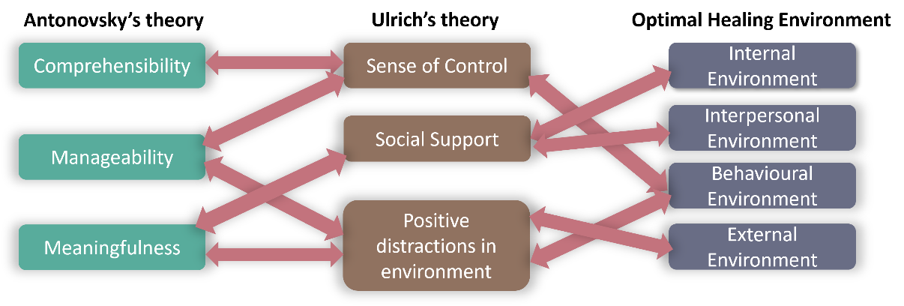
Figure 1. The pattern of relationship derived from the 3 models of therapeutic architecture studied.

This correlation pattern that emerged is used to derive the final evaluation tool of this research which is further subdivided into the various elements of design studied under the theories. This evaluation tool becomes the basis for analyzing the case studies and surveys of this research.
Table 1. Evaluation tool generated by author from literature review
Control & Choice | Privacy & Sociability | Positive Stimulation
- Light  - Natural  - Artificial | - Auditory environment | - Nature  - Access  - View
- Furniture  - Type  - Layout Flexibility | - Zones of spaces  - Private  - Semi-private  - Public | - Colour  - Art  - music
- Materials | - Activities  - Private  - Interactive | - Animals  - Culture
- Temperature | - Scale & proportion | - Opportunities for physical exercise

2.3. Methods
Literature case studies and surveys are used as the main methods for further analysis using the evaluation tool. The case studies included – (1) Helsingor Psychiatric Hospital, (2) Maggie’s Center Manchester, (3) Vidya Sagar Institute of Mental Health (VSIMH), (4) IN MIND Institute for Mind and Brain. The 1st & 3rd cases and the 2nd & 4th cases have similarly large and small scales of spaces respectively. The 1st & 2nd cases are of international context while the 3rd & 4th are of Indian context. The 2nd case is selected to learn about the application of architectural placebo in spaces as well. The evaluation tool is used to generate an extensive comparative table of the case studies for the application of the various factors mention in table.1.
Survey 1 was filled by 15 psychiatrists/psychologists (including a telephonic interview). This is used to obtain insight into perception of built environment by patients with mental health issues and how their spaces should be designed to promote healing. Survey 2 was a 2-part survey filled by a sample group of 100 random individuals. Part 2(A) aims at understanding their current mental health and Part 2(B) delves into the design of their residential spaces. Charts of Surveys 1 and 2 are compared to understand how the current residential spaces have elements that promote or hinder health using the principles of therapeutic architecture. (Copies of all charts and evaluation tables are available upon request from the author). The information analyzed from the final comparative evaluation of case studies and surveys helps formulate new guidelines that translate the principles of therapeutic design to residential spaces to make healing spaces accessible to the public thereby providing a built environment that supports better mental health.

3. Results

3.1. Mental health scenario
The results of the comparative evaluation of the case studies showed their various approaches to healthcare design and their various similarities and dissimilarities were noted. The similarities like abundant access to natural light and experiencing nature in the built space were noticed in all the 4 cases. While there were many differences, the starkest was the approach of Case study 3 (VSIMH) which separates patients from society and offers them no control or autonomy while the other case studies provided patients control and focused on rehabilitating them into society. This difference sheds light on the stigma existing in the country for mental health treatments.
This is further supported by the results of Survey 2(A) which showed that 26% of the sample group wanted to get treatment for mental health but didn’t, while only 6% got any treatment. Survey 2(A) also showed that 42% of the sample group admitted that their mental health has been ‘somewhat’ to ‘very much’ negatively affected since the quarantine of COVID-19. Statistics of Survey 2(A), generated as 13 pie charts and 4 bar graphs, highlighted the need of residential spaces to support healing environments.

3.2. Elements of therapeutic architecure in spatial design
Results of Survey 1 are generated as 19 pie charts each of which give insight into the requirements to be kept in mind when designing for patients of mental illnesses. One such result answering what needs to change in the spatial design for patients is shown in Figure.2.
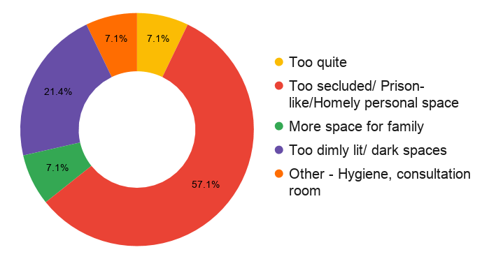
Figure 2. A change required in spatial design for better healing environment

Results of Survey 2(B) are generated as 16 pie charts and 1 bar graph each of which gathers information about the residential spatial design of the participants. It analyses the ability of the spaces to support a healthy lifestyle using elements of therapeutic architecture according to the factors of the evaluation tool. Survey 2(B) also collected images from the 18 participants (2 of which are shown in Figure.3) of their favorite space in their residence. These are used to analyze which elements of therapeutic architecture are present or absent in these spaces. To demonstrate the insights gained of residential special design and their alignment or misalignment to the principles of therapeutic architecture, three such results have been detailed below.

3.2.1. Elements Simulating a Prison
The most restated primary requirement established through the literature review and the results of Survey 1, for a space to be therapeutic, is the lack of any elements that simulate a prison, inducing feelings of being trapped or decreased control over their own spaces, and a feeling of seclusion.
Comparing this to the results of Survey 2(B) showed that almost all residential spaces, especially multistoried apartments, have these elements of grills adorning every window, most often in the interior side, making it not only difficult to open and close windows but also acting as an obvious element of decreased control and access in their own home. The images collected in Survey 2(B) showed how even the most favorite residential spaces of some participants had elements that deter the therapeutic quality of those spaces.

Figure 3. Presence of grills in residences – Images from participants of Survey 2(B)

3.2.2. Role of light
The healing powers of natural sunlight and their ability to make a patient’s body trigger its inbuilt healing abilities, improve mood and well-being is discussed at length in the literature review. The results of Survey 1 show psychologists and psychiatrists naming sunlight and ventilation repeatedly for requirement of spaces that focus on healing (25% votes, 2nd highest voted factor) and as a tool for reducing stress in the built environment (23.5%, tied for most voted factor). This further highlights the importance of having access to open spaces with abundant natural sunlight. Light is also one of the only factors which has been commonly utilized in the 4 case studies to the maximum degree to create a therapeutic and supportive space for patients.

3.2.3. Incorporating Nature
Literature review discusses various studies (Zohby) (Ulrich, 2014) (Franklin, 2012) (Iyendo, 2016) which prove at length the integral role of experiencing and viewing nature in creating a therapeutic space by decreasing anxiety & stress, boosting recovery, soothing senses and decreasing required amount of medication. The role of nature as the best tool for attention restoration has also been discussed through various studies (2012) (Karaca, 2018) to combat mental exhaustion, reduce stress and induce positive emotions which is further supported by the results of Survey 1 and 2(B) and case studies.

Various such patterns of correlations were observed and analyzed from the results of the Surveys and case studies to formulate the guidelines of this research.

4. Discussion
All the observations and analyses from the results of the surveys are compared to the results of the case studies and the information gathered through the literature review. This is used to translate the discipline of therapeutic architecture to the user group of residents to bring healing spaces to their residences.
One core difference noticed in the results of the research is that the design of spaces for patients have various undefined spaces of ambiguous functions which is not as accessible to residents. The main purpose of these is to provide opportunities for the patients to engage in activities, in private or in groups, or as spaces that they can retreat to for introspection and restoration. This is different when compared to the design of residences where each space of the residence has a specific function and name, like bedroom, dining room, kitchen, etc., with a lack of options between spaces with ambiguous and flexible functionality.
This is what led to the idea of designing residential spaces to cater to this requirement of flexibility in combination to the requirements of functionality. By analyzing the case studies a pattern that emerged is the availability of various sources to receive positive stimuli that keep the body and mind healthy. Residential spaces are often designed to fulfill the requirement of the specified ‘rooms’ without much attention to how each of these rooms should further be designed to truly cater to a healthy environment for the people residing in that room. The case studies compared to Survey 2 highlighted the availability of ‘zones’ in healing environments over just ‘rooms’.
This becomes the core of the new guidelines formulated in this research. It led to the formulation of the core zones that should be addressed while designing residences for the spaces to emulate the properties of a healing environment through therapeutic architecture. These zones which form the core of the guidelines from the case studies and surveys are represented below.
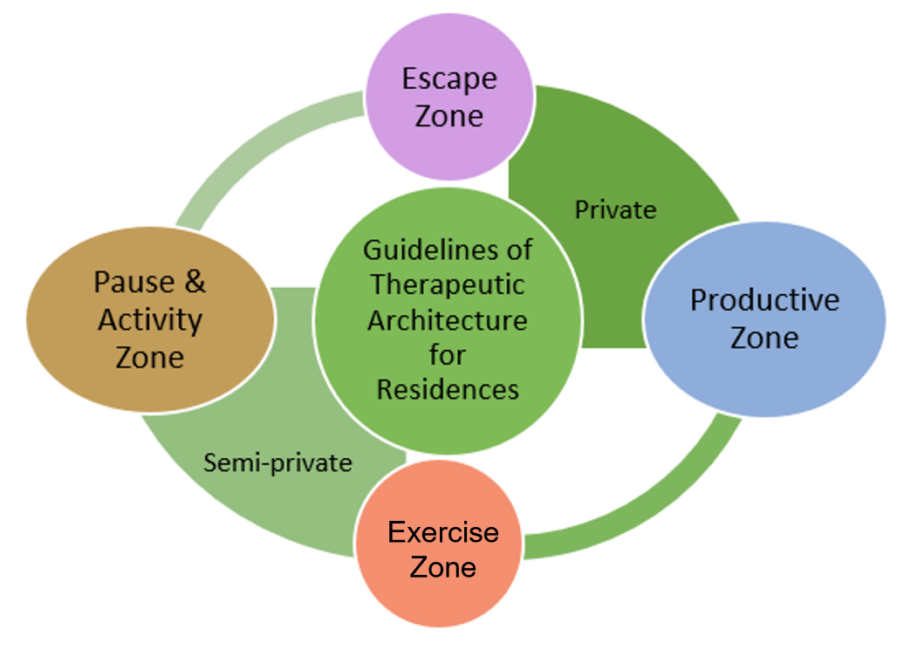
Figure 4. Core guidelines for therapeutic architecture in residences

- Escape Zone: As the name suggests, escape zone is the space that every individual can retire to, to reboot and restore their mind, body, and soul. It is a retreat space, defined by elements that create a peaceful atmosphere of introspection and privacy.

- Productive Zone: Like the escape zone, this is also a private space. But unlike the escape zone, this zone has elements of design catering to an atmosphere of alertness and productivity. It is a personal space where everyone can engage in their preferred activity of study or work with elements designed to make the space comfortable and catered to this need.

- Exercise Zone: This zone is the space that provides opportunities for everyone to engage in physical activities like sports & fitness training. This is a semiprivate zone created for people to maintain their physical health by engaging in the required activities either alone or with others.

- Pause & Activity Zone: This is a semi-private zone which creates opportunities for more than one person to pause together in that space. This common space of pause is meant to provide opportunities for interactions in the family. It can also be thought of as an escape zone that is not private but instead a space where the family can retreat to together and engage in common activities.

The guidelines generated in this research for using the spatial elements to design the private and semi-private areas, to achieve the optimal ambiance of each zone is defined in detail. The design, spatial and environmental requirements of each zone have been extensively detailed with over 10-25 design cues defined for each zone. These extensive guidelines are summarized into the most important design elements and represented in Fig.5.
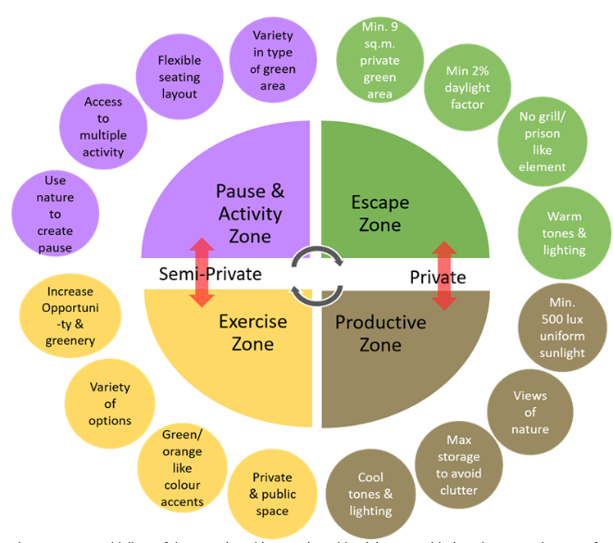
Figure 5. Core guidelines for therapeutic architecture in residential spaces with primary requirement for each zone.

Mental health issues and the stigma surrounding their treatment is an age-old fact prevalent all over the world. Stresses and variations in mental health are not limited to an isolated part of society. This research hopes to be the first step in addressing this need of the hour of creating a healthier home for every human’s mind and body. It attempts to bridge the gap between utilizing the marvels of architecture to not just heal and cure patients but also to prevent the genesis of more patients and equip individuals with the opportunity to live a healthier life. Recognizing the role that the built environment plays in the health of its inhabitants and designing to cater to this requirement for all public is the step that this research hopes to aid towards. Including these guidelines as necessary policies of built space requirements can drastically improve the ability of residents to sustain healthier lifestyles.

5. Conclusions
The fact that our fast-paced world and its consequent stresses are only going to increase the health issues of future generations is undeniable. This amplifies the need to design residences that provide more opportunities for the residents to have better health and wellbeing. This thought is what drove the intention of this research to understand how every individual’s home can be better designed to promote a healthy mind, body, and spirit. The principles of therapeutic architecture and its current application in the healthcare industry has already proven the benefits of this science and its future potential. By generating the idea of creating ‘zones’ of healing in residences, this research charts out the ways in which healing elements can be incorporated for each resident. The guidelines detail out an extensive list of design elements that can be used to increase the probability for the residents to maintain this healthy lifestyle. After all, prevention is better than cure.

References
Antonovsky, A. (1979). Health, Stress, and Coping: New Perstectives on Mental and Physical Well-being. San Fransico: Jossey-Bass.
Barker, R. (1968). Ecological Psychology: Concepts and Methods for Studying the Environment of Human Behaviour. Stanford University Press.
Dilani, A. (2006, February 6). Psychosocially Supportive Design. 1st International Conference on Sustainable Healthy Buildings.
Franklin, D. (2012). How Hospital Gardens Help Patients Heal. San Francisco: Scientific American, A division of Springer Nature America, Inc.
Geneva: World Health Organization. (2004). Promoting mental health: concepts, emerging evidence, practice (Summary Report) . 88.
Iyendo, T. O. (2016). The therapeutic impacts of environmental design interventions on wellness in clinical settings: A narrative review. Complementary Therapies in Clinical Practice, 16.
Johnstone, K. a. (2020, January). 'This is a great time for therapeutic architecture'. Thr Psychologist, p. 4.
Karaca, E. (2018). Salutogenic Approach for Designing Restoratove Environments. ASOS Journal. The Journal of Academic Social Science, 17.
National Alliance on Mental Illness. (n.d.). Mental health. Social Work License Map.
Owens, T. (2020, January). The new sciense of 'Therapeutic' architecture - and what it could mean for your workplace. Work in mind, p. 3.
Palosky, C. (2020, April 21). Brief Examines the COVID-19 Crisis’ Implications for Americans’ Mental Health. KFF.
Sakallarix, B. &. (2015, May 1). Optimal Healing Environments. Global Advances in Health and Medicine, p. 12.
Schweitzer, M. a. (2004). Healing spaces: Elements of Environmental Design that make an Impact on Health. The Journal of Alternative and Complementary Medicine, 13.
The Therapeutic Benefits of Salutogenic Hospital Design. (2012, March). HealthManagement.org.
Ulrich, R. S. (2014). Effects of Interior Design on Wellness: Theory and Recent Scientific Research. Journal of healthcare design, 14.
Youssef, O. (2014). Therapeutic Architecture Design Index. The Value of Design: Design & Health (p. 13). Washington, D.C: The American Institute of Architects.
Zohby, A. (n.d.). Therapeutic Architecture: Role of Architecture in Healing Process. Rethinking The Future.

