Type of the Paper: Peer-reviewed Conference Paper / short Paper
Track title: Topic 3: engagement – co-creation, co-design, design and stakeholder management processes

Conducting user research for development of gait assessment interface for incomplete spinal cord injury through user-centered design approach
Rebekah Kempske ¹, Herwin Horemans ^{2,3}*, Karin Postma^{2,3}, and Daniel Lemus Perez³
¹ Faculty of Industrial Design Engineering, Delft University of Technology, Delft
² Rijndam Rehabilitation Center, Rotterdam, The Netherlands
³ Dept. Rehabilitation Medicine, Erasmus MC University Medical Center Rotterdam, Rotterdam, The Netherlands
* Corresponding author: Herwin Horemans (h.l.d.horemans@erasmusmc.nl)

Research highlights
1) Use user-centered design to develop a user interface to assess the gait of patients with incomplete spinal cord injuries
2) Conduct user research through incorporating interactive activity boards into focus groups
Keywords: user-centered design; spinal cord injury; user interface design; gait analysis; rehabilitation
(to be completed by the editors)

Names of the Topic editors:

Names of the reviewers:

Journal: The Evolving Scholar
DOI:10.24404/622f989a3b8923372335f04a

Submitted: 31 Jul 2022
Accepted:
Published:
Citation: Kempske, R., et. al. (2022). Conducting user research for development of gait assessment interface for incomplete spinal cord injury through user-centered design approach [preprint]. The Evolving Scholar | ARCH22.

This work is licensed under a Creative Commons Attribution CCBY license (CC BY).

© 2022 [Kempske, R., et. al.] published by TU Delft OPEN on behalf of the authors.

1. Introduction

1.1. Background
Spinal cord injuries (SCI) occur when damage to the spinal cord is sustained. SCI can stem from traumatic or non-traumatic causes. A spinal cord injury may result in paraplegia or tetraplegia, depending on the level of injury. Within paraplegia and tetraplegia, a SCI is classified as neurologically complete or incomplete. After sustaining a spinal cord injury, the patient must undergo rehabilitation ("Symptoms of Spinal Cord Injury," 2021; Kirshblum et al., 2011). For incomplete SCI patients, a part of their rehabilitation is improving their mobility skills through gait training (Post et al., 2017). Physicians and physiotherapists use observational gait analysis and laboratory gait analysis methods to assess a patient's gait.
However, these methods have drawbacks. Observational gait analysis is subjective (Toro et al., 2003). Laboratory gait analysis is time-consuming, with the test reports containing irrelevant information, often too complex for novice users to understand (Simon, 2004). Therefore, we initiated a study to develop a gait assessment interface that solves these problems. The users of the interface are physicians and physiotherapists who treat incomplete SCI patients and patients with other neurological disorders. The interface is to be user-friendly, time-efficient, and based on objective data and intuitive data visualizations helps physicians and physiotherapists select and evaluate interventions, such as orthoses and spasticity treatment. This will lead to an improvement in the patient’s quality of care. The interface utilizes inertial measurements units (IMUs) technology to collect gait data.

1.2. Aim of Study

The design process undergone to develop the gait assessment interface consisted of four phases (Figure 1): (1) user research to identify physicians and physiotherapists' needs, expectations, and the context wherein the system will be used; (2) analysing and interpreting user research results; (3) conceptualization of initial concepts for the layout of the gait assessment interface and visualization of the gait parameters; (4) developing and evaluating the final design of the interface. The design process was adapted from the Double Diamond Model (Melles et al., 2021).

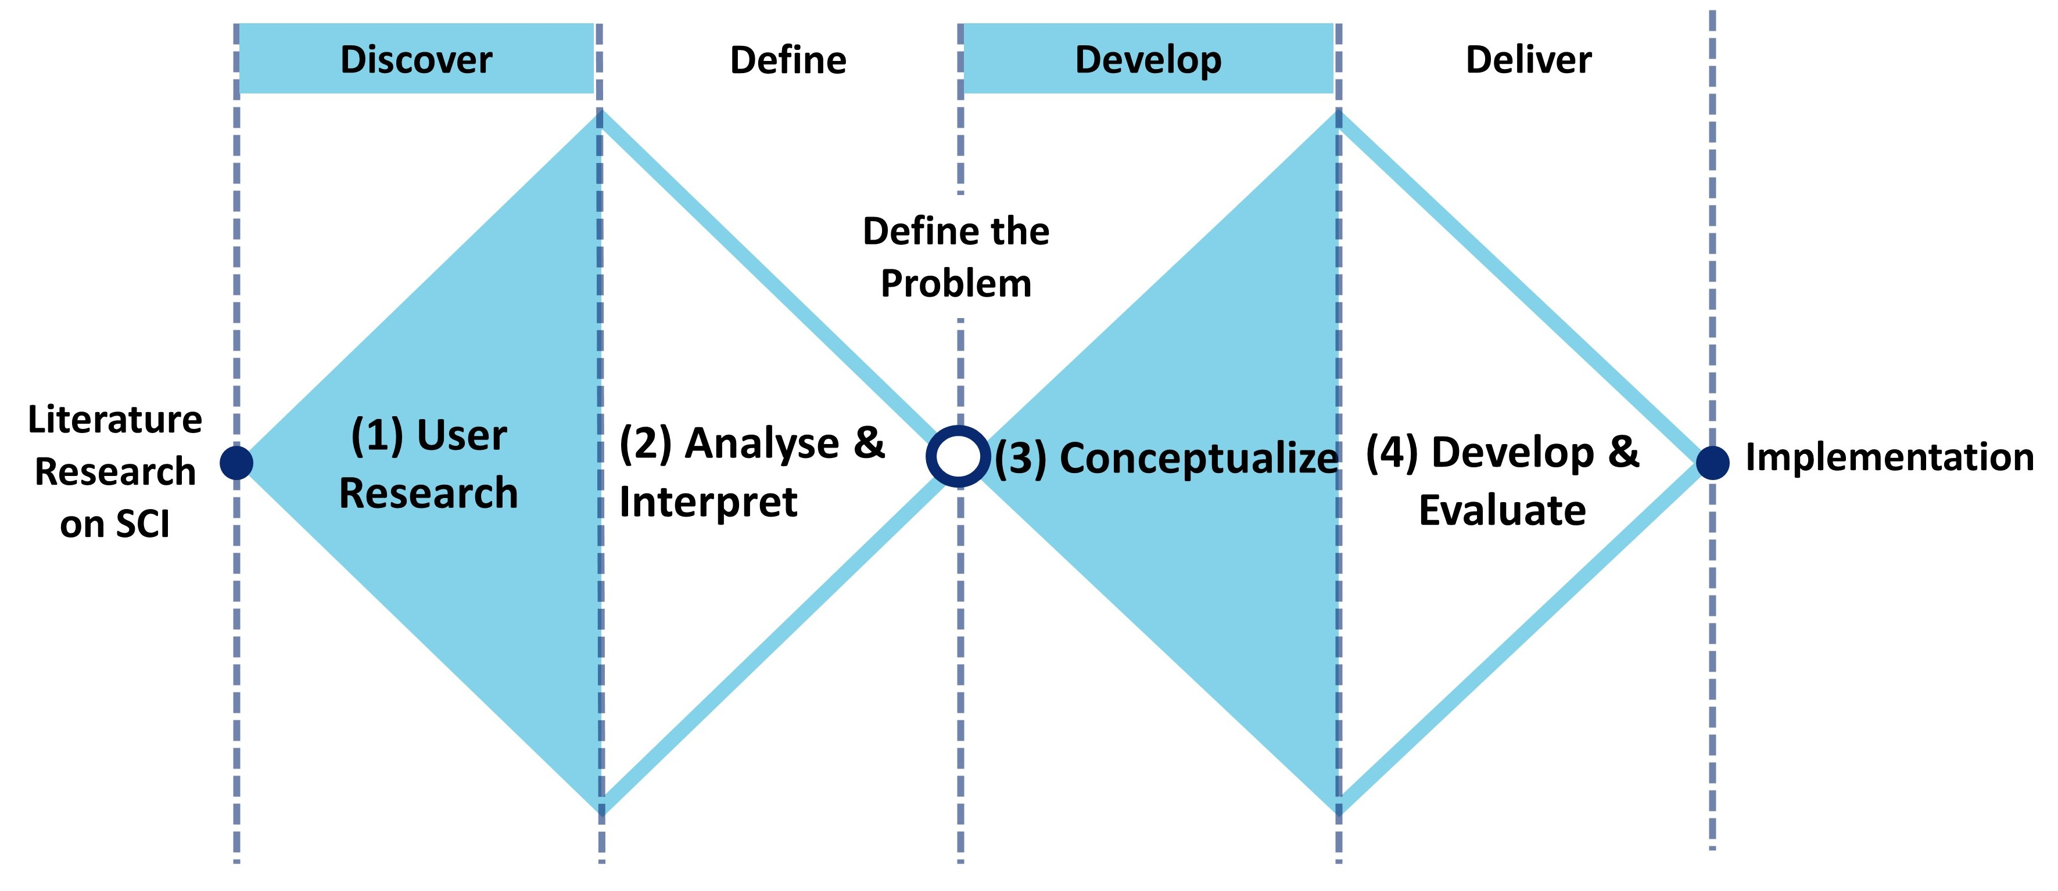
Figure 1. The user-centered design process for the development of the gait assessment interface is divided into four phases: (1) User Research; (2) Analyse & Interpret; (3) Conceptualize; (4) Develop & Evaluate. This paper will focus on phase (1) User Research.

This paper is methodological and will focus on phase one of the design process, user research, and how user-centered design was used to identify the users' needs.

2. Theories and Methods
User-centered design was utilized in every stage of the design process to better understand and assess user needs and adapt the design to these needs. For this project, the users were physicians and physiotherapists who work with patients with an incomplete spinal cord injury. Through involving users throughout the whole design process, this approach allows designers to develop a more usable and accessible product (Melles et al., 2021).
Before designing the user interface, it was important to identify users' needs, expectations, and the context wherein the gait assessment interface would be used. To determine the needed content, user research was conducted to examine how physiotherapists and physicians currently assess gait, what features and gait analysis parameters they would like to be present in the user interface, and how these parameters should be visualized. This was done by conducting focus groups.
Physiotherapists and physicians who work for Rijndam Rehabilitation and treat patients with neurological disorders, including incomplete SCI, were recruited to participate in the focus groups. A majority of participants had limited to no experience with laboratory gait analysis. Therefore, a focus group format was selected, rather than a questionnaire, to avoid confusion regarding terminology surrounding gait analysis parameters and allow for discussion between participants.
The focus groups ranged in size to fit participants' schedules, with a maximum of six participants in a session. The focus groups were conducted in person and over video teleconferencing. They took place over two weeks, and each lasted one hour. There was a total of 18 participants, six physicians and twelve physiotherapists.
At the beginning of each session, a short presentation was given to explain the project's purpose and how the session would be conducted. The presentation also briefly explained what IMUs are and how they would be used in the operation of the user interface.
The participants then completed a series of interactive activities on a digital board through the platform Miro (Figure 2) ("Miro," 2022). Each participant was assigned their own board and could access the board via a link sent by the principal designer. The board was broken down into three sections: (1) Selecting gait analysis parameters; (2) Selecting how the parameters should be visualized; (3) Additional features wanted to be included in the user interface. Each activity was first explained, and then after the participants completed it, there was a discussion on why the participants formed those answers.
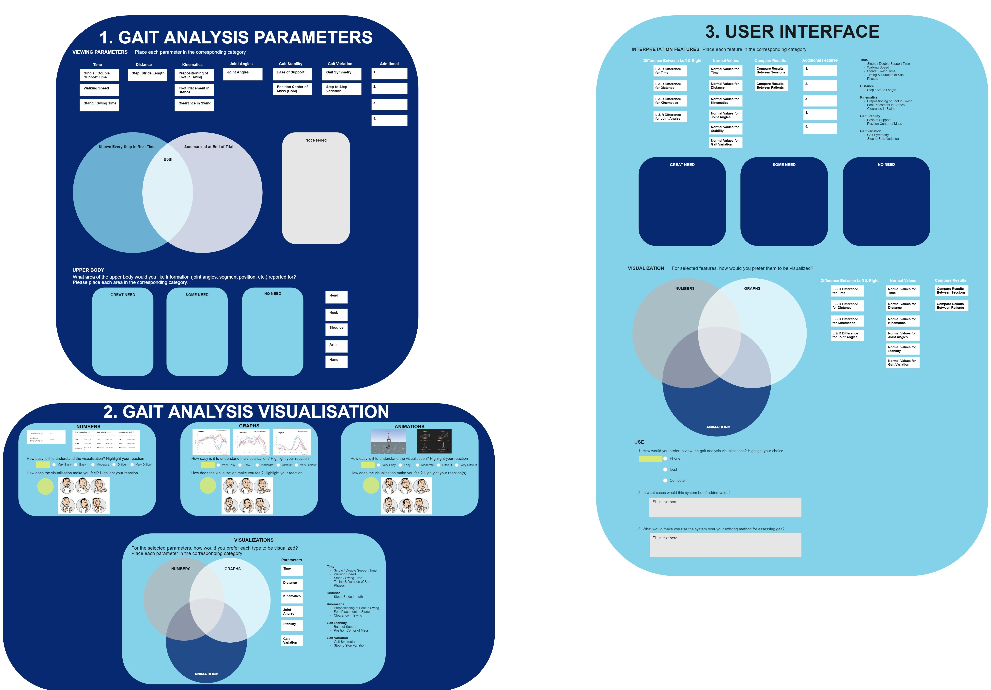
Figure 2. During the focus group sessions, each participant had their own Miro activity board. The activity board consisted of interactive questions and was divided into three sections: (1) Gait Analysis Parameters, (2) Gait Analysis Visualizations, and (3) User Interface.
Questions asked in the interactive activities on the board include:
- Place each gait analysis parameter in the corresponding category: Great Need, Some Need, or No Need
- For the selected gait analysis parameters, how would you prefer each type to be visualized? Place each parameter in the corresponding category: Numbers, Graphs, or Animations
- What would make you use the system over your existing method for assessing gait?
The activity board format was selected as it facilitated group discussion but still allowed for answers to be collected from every participant. Interactive elements were incorporated into the activity board, which included moving blocks into boxes and Venn diagrams based on preferences and highlighting their answers. Miro was chosen rather than the alternative of a paper activity, as the sessions were conducted over video teleconferencing and in person.
During each focus group session, notes were taken by the principal designer. The audio of each session was recorded and later transcribed. Answers to the quantitative questions were analysed using Excel. Responses to the qualitative questions were collected and categorized using the Affinity Diagram method. In this method, ideas are clustered into similar groups and themes. These groups are then broken down into smaller groups to evaluate the relationship between the ideas (Beyer and Holtzblatt, 2016).

3. Results
At the beginning of each session, it took the designer about five to ten minutes to ensure that all participants were on their respective activity board and to explain how to operate it. Once the participants understood the basic workings of the board, only minor technical assistance was needed throughout the remainder of the session.
The participants found that using the interactive activity boards was a more enjoyable experience than in a previous survey when they answered questions regarding gait assessment only through an online questionnaire. Participants appreciated being able to discuss their answers with each other if they were confused about how the question applied to the context of their work. It also allowed for discussion to be facilitated about why participants chose their answers.
By having the participants fill out the boards during the session, the designer could answer any questions regarding the content on the boards and provide technical assistance in real-time. If the designer was confused about any participant's answers, they could ask the participants to clarify their answers.

4. Discussion

4.1. Focus Group Results
In a previous survey related to this project, there was confusion about how some of the questions were worded and the terminology used, as most participants had limited experience with technical gait analysis. To avoid this confusion, it was decided to talk with the participants. A focus group format was initially selected, as it allowed the designer to answer any of the participants' questions and provide answers in real-time, while also letting participants talk through questions with each other. Through discussion and asking follow-up questions, the designer understood participants' answers more extensively and comprehended the why behind their answers. This also saved the designer and participants a lot of time, as follow-up meetings were not needed to be scheduled to ask any additional or clarifying questions.
The interactive components of the Miro activity board, such as moving the blocks to preference categories and highlighting their answers, allowed the designer to keep the participants' attention and interest throughout the hour-long session. Each participant having their own board permitted for individual answers to be collected while still having a group discussion and for detailed explanations from every participant to be gathered within a short amount of time. This would not have been possible if only questions were asked through a group discussion format.

4.2. Future Recommendations
Since the sessions were only one hour each, the designer needing to take five to ten minutes to set up and explain how to use the interactive activity board took away valuable time. This led to the participants rushing to answer the final questions. In turn, the quality of these answers was lower than the questions asked at the beginning of the session and only allowed for limited discussion of these final questions.
If this study were conducted again, it would be recommended to send a tutorial or short video to the participants ahead of time demonstrating how to access and operate the activity board. This would allow the participants to start answering the questions in the activity board at the very beginning of the session.
Also, there was only one designer present per session. In doing, there was a limitation in the designer being unable to take extensive notes during the session and having to rely on the audio recordings. In the future, it would be recommended to have an additional designer present in each session. The additional designer can take more extensive notes during the session and solve any technical difficulties had by participants.

4.3. Implementation of User-Centered Design in Project
User-centered design was continued throughout the remainder of the project. From the results and insights from the focus groups, a design vision was formed, followed by developing concepts of the gait assessment interface. These concepts were evaluated with the users through concept test sessions. In the sessions, the concepts were assessed regarding usability, functionality, and level of understanding. From the feedback from these sessions, the final design of the user interface was created. Lastly, users tested an interactive prototype of the interface to evaluate to obtain feedback on usability, aesthetics, intuitiveness of use, and functionalities of the developed design.

5. Conclusions
In the development of the gait assessment interface, user-centered design was utilized in the user research phase to identify the users' needs, expectations, and the context wherein the interface would be used. This was done through conducting focus group sessions with physicians and physiotherapists and using interactive activity boards to obtain answers and facilitate discussion. Through the focus group sessions and interactive activity board, in-depth and extensive information was obtained. This information, as well as user-centered design practices, will be used throughout the further development of the gait assessment interface.

Contributor statement
Rebekah Kempske was the principal designer who developed and led all user tests in this project. She also developed the final design of the gait assessment interface and was the primary author of the article.
Herwin Horemans contributed to the conception of the work, the acquisition of data, the interpretation of data, and drafting and revising the manuscript.
Karin Postma contributed to the conception of the work, organizing the group sessions, interpretation of data, and drafting and revising the manuscript.
Daniel Lemus Perez contributed to the conception of the work, interpretation of data, and drafting and revising the manuscript.
Acknowledgments
The authors would like to thank all of the physicians and physiotherapists who participated in this project and aided in its development.

References
Beyer, H., Holtzblatt, K. (2016). Contextual Design: Design for Life. Netherlands: Elsevier Science.
Kirshblum, S. C., Burns, S. P., Biering-Sorensen, F., Donovan, W., Graves, D. E., Jha, A., ... & Waring, W. (2011). International standards for neurological classification of spinal cord injury (revised 2011). The journal of spinal cord medicine, 34(6), 535-546.
Melles, M., Albayrak, A., & Goossens, R. (2021). Innovating health care: key characteristics of human-centered design. International Journal for Quality in Health Care, 33(Supplement_1), 37-44.
Miro. (2022). Retrieved 2 January 2022, from https://miro.com/
Post, M. W., Nooijen, C. F., Postma, K., Dekkers, J., Penninx, F., van den Berg-Emons, R. J., & Stam, H. J. (2017). People with spinal cord injury in the Netherlands. American Journal of Physical Medicine & Rehabilitation, 96(2), S93-S95.
Simon, S. R. (2004). Quantification of human motion: gait analysis—benefits and limitations to its application to clinical problems. Journal of biomechanics, 37(12), 1869-1880.
Symptoms of Spinal Cord Injury. (2021). Retrieved 25 February 2021, from https://stanfordhealthcare.org/medical-conditions/back-neck-and-spine/spinal-cord-injury/symptoms.html
Toro, B., Nester, C., & Farren, P. (2003). A review of observational gait assessment in clinical practice. Physiotherapy theory and practice, 19(3), 137-149.

