ARCH22 ‘Enabling health, care and well-being through design research'
5th Architecture Research Care and Health conference
Delft / Rotterdam – the Netherlands – 22nd until 24th of August 2022.

Type of the Paper: Peer-reviewed Conference Paper / Full Paper

Track title: Stream user needs

Wayfinding in a hospital environment: proposing a methodology to impact the well-being of patients, visitors, and staff positively
Ann Petermans 1*, & Luciana Mattiello 2

1 Faculty of Architecture and Arts, Hasselt University, Belgium; ann.petermans@uhasselt.be; ORCID 0000- 0001-7023-4628
2 /STUDIOMDA wayfinding design, Belgium; luciana@studiomda.be
* Corresponding author

Journal: The Evolving Scholar
DOI:10.24404/622fa20a06178a1
cb8717a6b

Submitted: 15 Jul 2022
Accepted: 15 Jul 2022

Citation: Petermans, A. & Mattiello, L. (2022). Wayfinding in a hospital environment: proposing methodologies to impact positively well-being of patients, visitors, and staff. The Evolving Scholar | ARCH22.

This work is licensed under a Creative Commons Attribution BY license (CC BY).

© 2022 Petermans, A. & Mattiello, L. published by TU Delft OPEN on behalf of the authors.

Abstract: When in a hospital environment, whether for medical consultation, to visit a loved person, or even to start a new job, many people might experience stress and frustration. Those negative feelings and emotions impact well-being and are not necessarily or solely the consequence of the motive people go to the hospital. They often are instigated by the experience of people not finding their way through the hospital campus or in the hospital buildings themselves. Although many healthcare environments and hospitals often invest a lot of money and effort to implement a proper signage system, as it represents one of the critical aspects of their "identity", many challenges remain.

In this paper, we highlight the importance of wayfinding as a crucial element for a comfortable hospital atmosphere and, consequently, a positive experience for their public. A good wayfinding strategy is fundamental to all users involved in the daily functioning of a healthcare environment, as it can dramatically impact their well-being. We illustrate our point-of-view by discussing the methodology that was applied to gain insight in the wayfinding system of a Belgian hospital in order to nurture the design process of developing a new wayfinding strategy for this client.

Different perspectives will be highlighted considering the understanding of various user groups and their difficulties and challenges encountered when trying to find their way in hospitals: the public, the architecture, the local culture, complex buildings and sites, stress and vulnerability of the people, routes and many other aspects. Together, these insights nurtured the strategy and design of an effective wayfinding system for the concerned healthcare facility.

Keywords: wayfinding design; healthcare design; well-being; positive experiences; hospital signage

https://doi.org/10.24404/622fa20a06178a1cb8717a6b

Introduction

  - Importance of a user-centred focus when designing wayfinding in hospitals
Upon entering a hospital, users expect to be able to find their way intuitively. Wayfinding is a tool to assist them in a way that they can recognize where they are, where to go, and how they can get there. In his seminal work "The Image of the city", Kevin Lynch wrote about the anxiety and fear people can suffer when they cannot find their way (1960, p.
4):

To become completely lost is perhaps a rather rare experience for most people in the modern city. We are supported by the presence of others and by special wayfinding devices: maps, street numbers, route signs, bus placards. But let the mishap of disorientation once occur, and the sense of anxiety and even terror that accompanies it reveals to us how closely it is linked to our sense of balance and well-being. The very word "lost" in our language means much more than simple geographical uncertainty; it carries overtones of utter disaster.

Proper wayfinding design is crucial in this respect, as a good-quality wayfinding system can enable users to move around independently, safely and intuitively, so they have positive experiences.

Hospitals have only relatively recently recognized the importance of servicescape
elements as factors that can possibly impact users’ satisfaction (Suess & Mody, 2018;
Vigolo et al., 2020). In her seminal paper of servicescapes, Bitner (1992) already
indicated that ‘a complex mix of environmental features constitute the servicescape and influence internal responses and behaviors. Specifically, the dimensions of the physical surroundings include all of the objective physical factors that can be controlled by the firm to enhance (or constrain) employee and customer actions’ (p. 65).

To date, a lot of studies have investigated the effect of isolated servicescape elements (i.e., by focusing on one particular variable of the servicescape) on customer satisfaction and behavior in numerous settings, but few studies have focused on the role of signage and wayfinding on satisfaction with the concerned servicescape in general, and hospitals in particular (Hamed et al., 2019; Vigolo et al., 2020).

In 2018, Suess & Mody demonstrated that four servicescape elements (that is,
atmosperhics of the healthcare environment, staff’s service delivery, the environment’s design, and wayfinding) significantly impacted on patients’ overall satisfaction with the healthcare experience. Also, patients’ satisfaction predicted their loyalty intentions and willingness to pay expenses for healthcare services. Such insights can be highly relevant for healthcare management in an increasingly competitive market, where the experience of stakeholders continuously is a key consideration for management. However to date, in Belgian hospital contexts, many challenges still stand in this respect, both from a hospital managerial point-of-view, and from a research point-of-view. The approach we describe in this paper is an example of an explorative attempt to address this concern.

  - Importance of engaging multiple stakeholders' points of view
Reflecting about the spatial aspects of the places where 'care' and 'experience' are offered to users and where a dialogue between a 'space' and a 'user' is automatically createdbrings up the need to involve various stakeholders in a research process. In the context of this paper, we can think of relating to patients' experiences with wayfinding in a hospital, but also insights of healthcare providers, hospital managers, visitors, etc. The needs and expectations of diversified players involved in experiencing navigation in hospitals can align with each other, but they can also generate specific dilemmas or conflicts. It can happen, for example, that certain decisions made with the best intentions during the design phase of a new hospital wayfinding system have an impact on the well-being experienced by particular users after the project’s conclusion. A simple

example makes this clear: the use of coloured sticker lines on the floors throughout various hospital buildings, for example, can seem like an optimal solution to users who are familiar with the concerned spaces and routes, but due to the architectural reality of various hospitals (e.g., with many buildings interlinked with each other, a set of connected buildings built in different stages, with many corridors, corners, and staircases) many users might lose track on their way to a particular destination.

From the point of view of the 'objective well-being' a user might encounter, specific design interventions may thus be entirely justified. However, people who circulate through the environment in question may have a completely different experience concerning their 'subjective well-being' (Petermans & Cain, 2020).

Such considerations impact research methodologies that can be used to gather insights into these matters. Understanding wayfinding experiences resulting from these methodological approaches can nurture the design process of wayfinding design. In the next section, we discuss the methodology that was applied to gain insight in the wayfinding system of a Belgian hospital in order to nurture the design process of developing a new wayfinding strategy for this particular client.

Theories and Methods
By collecting insights of various users involved in the daily 'functioning' and 'living' / 'staying' in a hospital setting, we aim to draw a consistent comprehension that can ultimately inspire designers and other actors involved in wayfinding projects' development. In what follows, four steps are explained that we took in a design process to gain insights into different users’ perspectives regarding wayfinding.

  - A first site visit
The aim is to experience the hospital from the perspective of someone who has never visited the space. This person can be a patient, a visitor, a student looking for their internship department, or any other professional. In this way, the wayfinding in the specific hospital can be tracked and experienced from a so-called 'neutral' perspective. During the site visits, notes and pictures of the environment are collected. After that survey, the site visit is documented in a report.

  - Thematically focused site visits
These site visits aim to experience the hospital from a specific lens. Considering that the typological focus of the research project refers to a hospital, it is valuable to set up site visits focusing on accessibility and inclusive design. Hospitals need to accommodate and welcome diverse users with individual needs and wishes. We can think of older people, people with visual impairments (color weakness) or maybe people in wheelchairs, parents who come by for a doctor's visit with a child in a baby stroller, people with impairments, etc. During thematically focused site visits, researchers experience the site from the users’ point of view, putting themselves in their shoes. A researcher can bring a wheelchair and experience the site as such. Another researcher brings a baby stroller and tries to find their way. Another one can wear customized glasses which help to simulate particular visual impairments. Moreover, experiencing the hospital as such, via these users' (simulated) viewpoints, can teach researchers a lot regarding experiences and wayfinding in a hospital.

  - Survey with hospital staff
A survey is prepared to interview hospital staff (among others) (i) in which department they worked, (ii) how their experiences with that specific hospital's wayfinding design went during the first weeks they started working there, (iii) their thoughts about the current wayfinding system, (iv) their perceptions about the clarity of the current wayfinding system to outsiders, (v) their perceptions about the sign system leading to the main exit, (vi) their experiences regarding how often they needed to guide visitors or patients to find their way in the hospital, (vii) their thoughts on the possibilities of improvement of the current wayfinding system, considering understanding and trust from the public who will interact with it.

  - Installing a prototype with a wayfinding system on a heavily used corridor

The new wayfinding system Concept Phase is presented to the hospital Direction board. The Design company comes up with a unique concept of suspended signs, square- shaped, bringing the possibility of having eight panels to organize information in four directions. A prototype allows the teams to verify and approve the solution on-site (see Figures 1-2-3).
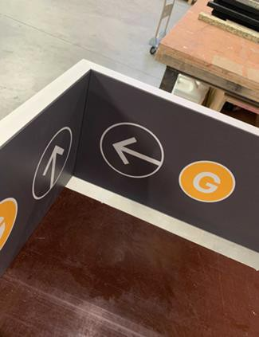

Figure 1. Prototype, inside view upon finalisation in workplace Source: /STUDIOMDA

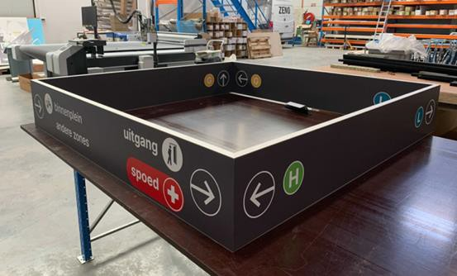

Figure 2. Prototype, outside view upon finalisation in workplace Source: /STUDIOMDA

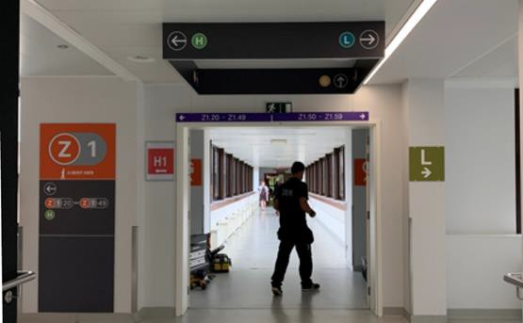

Figure 3. Prototype installed in situ Source: /STUDIOMDA
A prototype is thus produced and hung in a principal intersection in the main central corridor of the hospital. That way, it is possible to check the effectiveness of its concept and graphic/formal resolution.

Results and discussion

The descriptive data collected during the research phase helped the design team to understand how people behaved, how they moved about, and where the problems regarding wayfinding were more evident. The insights helped us learn more about the existing system and the logic of the structure of the facilities. The team also gathered information concerning the various stakeholders' issues concerning accessibility, comprehension of the built environment that multiple actors have, and, not less important, the personality and principles of the hospital. It is evident that these also have an essential role to play in the new wayfinding design.

In the end, the collected insights nurtured the design process of the new wayfinding system. Indeed, after the research phase, the design team learned more about four key topics related to developing a new wayfinding system for the concerned hospital.

First, regarding the technique of Progressive Disclosure (Society for Experiential Graphic Design, 2014), the performed research helped to check how to deliver information throughout the hospital, only when and where needed. Applying a step-by-step strategic approach can provide information to people in digestible pieces in the correct spots. A small number of clear and well-placed signs will be more effective than a multiplicity of them. In that way, wayfinding establishes a sense of legibility and order, making the system intuitive and trustable.

Second, the research insights helped to check the best visibility in each space to ensure that the wayfinding information would be easy to find on every key spot of the circulation for a diversity of users. For example, a study of the use of colours was performed to encourage future choices in the design process regarding a proposition for a new colour palette to be used in the system. The proposal for a new standard needed to be aesthetically pleasing but also readable and understandable for users with visual weaknesses. Figures 4 and 5 show the colour palette that was proposed at the end of the design process:

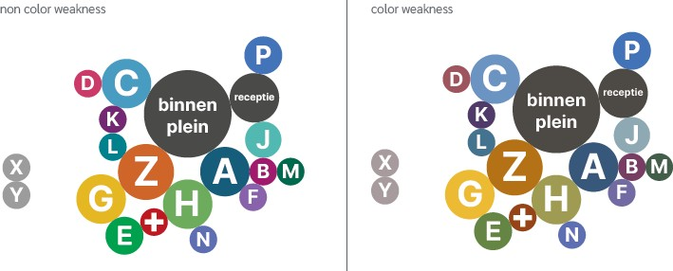

Figure 4-5. Color palette with vision perception for people with no color weakness at the left, and for people with color weakness at the right

Third, the data facilitated an understanding of where the decision points of various routes were located. In that way, during the design process of the new wayfinding system, through the planned strategy, we could ensure that destinations could be easily searched, and that the navigation throughout the various routes in the hospital would be straightforward, spontaneous and reliable.

Fourth, the research insights helped to define paths throughout the hospital, which nurtured the design process by assisting the design team in deciding how and where clear ways could lead users. Also, where and how paths could be given in a sequenced way.

The concrete wayfinding design strategy which has come out of this research shall be able to translate differentneeds and complexities into a system that will focus on being trusted by all people, as a tool for an independent and self-confident journey from one point to the other. This way, the collected research insights contributed to a concrete design intervention in practice. As such, the research adds to the body of theory on wayfinding design in healthcare facilities by demonstrating how research in situ can nurture actual design practice.

Conclusions
Considering that 'well-being' has been one of the UN Sustainable Development Goals for some years and is gaining increasing resonance in a lot of countries' policies, economy and society, it seems an opportunity to state that the well-being of future and current users of spaces should preferably receive as much attention as other issues have received over the years.

Specifically for hospitals, where wayfinding is crucial for a comfortable atmosphere, investing in design for a smart, friendly, clear and flexible wayfinding system is fundamental. Integrating various stakeholders' perceptions of wayfinding has brought much input to the design team that works on the strategy and design of an effective wayfinding system for a healthcare facility.

Looking at training programs in design, we are ready to educate spatial designers and train professionals who can make a difference in the spatial practice of healthcare environmental design, so they could be better trained and informed on such matters.

Contributor statement
Ann Petermans is the leading researcher on this project. Together with /STUDIOMDA, she presented the project to students, whom she helped to guide throughout the research process. She analyzed the data of the study, evaluated the students, and wrote the paper.
Luciana Mattiello is creative director and founder of /STUDIOMDA, a Belgian-Brazilian studio specializing in strategies for wayfinding design. For this paper in particular, she facilitated collaboration with the design team who worked on this project, and the collaborating students. Together with her team, she contributed to the research process the students went through, and she also assisted in writing this paper.

Acknowledgments (optional)
We would like to thank all students who participated in the research phases, the team of
/StudioMDA and the hospital involved with whom we collaborated for this project.

References
Bitner, M.J. (1992). Servicescapes: the impact of physical surroundings on customers and employees. Journal of Marketing, 56, 57-71.

Hamed, S., El-Bassiouny, N. & Ternès, A. (2019). Hospital servicescape design for inpatient wellbeing. Services Marketing Quarterly, 40(1), 1-32.

Lynch, K. (1960). The image of the city. Cambridge, Massachusetts: Harvard University Press. Petermans, A. & Cain, R. (2020). Design for Wellbeing: an applied approach. London: Routledge.
Society for Experiential Graphic Design (2014). Wayfinding is where place meets information design. Available at https://segd.org/wayfinding-where-place-meets-information-design, Accessed on March 13, 2022.

Suess, C. & Mody, M. (2018). The influence of hospitable design and service on patient responses. The Service Industries Journal, 28(1-2), 127-147.

Vigolo, V., Bonfanti, A., Sallaku, R. & Douglas, J. (2020). The effect of signage and emotions on satisfaction with the servicescape: an empirical investigation in a healthcare service setting. Psychology & Marketing, 37, 408-417.

