Type of the Paper: Peer-reviewed Conference Paper / Full Paper
Track title: Healthcare design and change – future-proofed, resilient and crisis-adapted (pre-, post- and now) design

Telemedicine for Inpatient Psychiatric Care: Remote Care in a COVID-19 Mental Health Unit
Nirit Putievsky Pilosof ^{1,2,}*, Michael Barrett ^{2,3}, Eivor Oborn ⁴, Galia Barkai ⁵, Eyal Zimlichman ⁵, and Asaf Caspi ⁵
¹ Cambridge Digital Innovation - CJBS & Hughes Hall, University of Cambridge; nirit.pilosof@gmail.com; ORCID ID 0000-0002-2790-0792
² Centre for Digital Built Britain, University of Cambridge; m.barrett@jbs.cam.ac.uk
³ Cambridge Judge Business School (CJBS), University of Cambridge
⁴ Warwick Business School, The University of Warwick; eivor.oborn@wbs.ac.uk
⁵ Sheba Medical Center, Israel Ministry of Health; galia.barkai@sheba.health.gov.il, galia.barkai@sheba.health.gov.ilEyal.Zimlichman@sheba.health.gov.il, asaf.caspi@sheba.health.gov.il
* The corresponding author.

Names of the Topic editors:
Clarine van Oel

Journal: The Evolving Scholar
DOI:10.24404/622fc1031994d67c6891933d

Submitted: 14 Mar 2022
Revised: 7 May 2022
Accepted: 27 May 2022
Citation: Pilosof, N., et al. (2022). Telemedicine for Inpatient Psychiatric Care: Remote Care in a COVID-19 Mental Health Unit. The Evolving Scholar | ARCH22.

This work is licensed under a Creative Commons Attribution CC BY license (CC BY).

© 2022 Pilosof, N., et al. published by TU Delft OPEN on behalf of the authors.

Abstract: The study examines the implementation of a new model of remote care by telemedicine technologies at a COVID-19 acute psychiatric unit. Remote care by telemedicine technologies accelerated during the COVID-19 crisis, not only for outpatient care but also for hospital inpatient care. To enhance the safety of the staff in the COVID-19 units, conserve PPE, and provide a method for communication with experts and families, hospitals developed a new model of inpatient telemedicine. The model was implemented in an acute psychiatric unit for COVID-19 patients in Israel with a control room and audio-video system to remotely supervise, communicate, and treat the patients in the contaminated unit. The study is based on semi-structured interviews of medical staff, architects and digital technology directors, and observations in the COVID-19 unit in June - December 2020. The study illustrates the impact of the built environment on the implementation of telemedicine technologies for inpatient care. It demonstrates limitations caused by the location of the audio-video system to avoid vandalism and the complexity of the system due to the dynamic movement of patients in the unit. The results indicate the system's dependency on the collaboration of patients and the need for coordination between caregivers. While inpatient telemedicine holds potential to enhance the quality of care and safety of patients and staff in COVID-19 units, its implementation in acute psychiatric units requires further development in the integration of digital technologies with the design of the built environment to address unique challenges of mental health.
Keywords: model of care, COVID-19, inpatient telemedicine, psychiatric care, mental health.

1. Introduction
The COVID -19 pandemic has forced healthcare systems to rapidly develop new models of care. The need to protect medical personnel from contamination while continuing to provide quality of care for COVID-19 patients led to innovative strategies for remote care by telemedicine technologies (Wosik et al., 2020), overcoming technical and logistic restraints, organisational resistance, and psychological barriers (Zimlichman, 2005). In addition to remote home care, telemedicine was found to be ideally suited to meet the demands of inpatient care while at the same time reducing virus transmission, stretching human and technical resources, and protecting patients and healthcare workers in the inpatient care setting (Dhala et al., 2020; Igra et al., 2020; Vilendrer et al., 2020). Inpatient telemedicine provided a solution to avoid physical contact with COVID-19 infected patients, significantly increasing the chance of illness transmission and the need to quarantine exposed healthcare workers.
Inpatient telemedicine was implemented during the pandemic in various medical units for critical care and internal medicine (Pilosof et al., 2021b; Vilendrer et al., 2020). The integration of the new model for psychiatric care was based on the understanding that isolation of patients in psychiatric hospitals in the context of the COVID-19 pandemic posed an ethical, legal, and practical challenge for the purposes of infection control (Brown et al., 2020). Psychiatric patients often lack the ability to understand or properly appreciate the risks of the disease and the necessary behavioural modifications to stay well (e.g. physical distancing, frequent effective handwashing) making them particularly vulnerable in psychiatric inpatient settings (Zhu et al., 2020). The new model aims to advance the proposal that patients could be moved to a unit which is designated only for those with confirmed COVID-19, while the unit activities would proceed fairly normally in a cohort environment – with staff wearing Personal Protective Equipment (PPE) (Brown et al., 2020), and by integrating telemedicine technologies to provide remote care from a safe location outside of the unit.
Remote psychiatric care, named telepsychiatry, accelerated during the pandemic and demonstrated its capacity to become an important modality of care in the future as demand, technology, and acceptable models evolve (Garofalo et al., 2021). Yet, the outcomes of remote care for acute psychiatric inpatients also depend on the built environment of the unit. Research on the design of psychiatric units indicates the impact of the built environment on psychiatric patients' treatment outcomes, experience, and behavior (Sheehan et al., 2013). Ulrich describes the influence of the design of psychiatric units on patients' aggression (Ulrich et al., 2018), and Lundin illustrates the challenge in designing 'healing architecture' while enhancing patients and staff safety (Lundin & Msa, 2021). Accordingly, the US Facility Guidelines Institute has specified that spaces used for telemedicine communications should be designed to provide patients' privacy, safety, quality of care, and patient experience, at the same standard as for communication taking place in person (FGI, 2018). As such, examining the manner in which telemedicine technologies were implemented in the built environment for inpatient acute psychiatric care during COVID-19 is important to explore.

2. Theories and Methods
The exploratory case study involved qualitative inquiry, aiming to analyse the new model of inpatient telemedicine for psychiatric care and examine the stakeholders' interpretive understanding of its impact on patient care. The case study received approval from the institutional review board at the Sheba MC in Israel as part of a broader research project studying the smart hospital's strategic development and planning. Sheba MC provided the first author access to the collected data in collaboration with co-authors from the hospital. The case study was conducted from June to December 2020, based on formal semi-structured interviews with Sheba medical staff, telemedicine experts, the architectural design team, and observations at the COVID-19 Psychiatric Unit. Based on principles of naturalistic inquiry (Lincoln & Guba, 1985) and a grounded approach to conceptual development (Golden-Biddle & Locke, 2007), thematic qualitative data analysis was adopted to identify emerging themes from the interviews and observations. Related and similar ideas were clustered together through the field notes and coding of interviews, eliciting supporting quotes as evidence for the case analysis (Emerson et al., 2011). At the end of the data analysis phase, the validity of the themes was checked and confirmed with clinical leaders having oversight of the care processes.

3. Results

3.1. The case of Sheba Medical Center in Israel
The Sheba Medical Center (MC) at Tel HaShomer, the largest tertiary hospital in Israel, rapidly developed inpatient telemedicine units during the COVID-19 outbreak (Bar-On et al., 2021; Leshem et al., 2020). The new model of care, designed to reduce infection exposure of the staff while preserving a high quality of care, was implemented in different medical units, including a COVID-19 Intensive Care Unit (ICU) and COVID-19 Internal Medicine Unit (Pilosof et al., 2021a, 2021b). Early in the pandemic, the Israeli Ministry of Health decided to open a National COVID-19 Psychiatric unit at Sheba MC, and transfer psychiatric patients diagnosed with COVID-19 from all other Mental Health facilities. "At the beginning of COVID, it became clear that psychiatric units are very crowded, and many of our patients, because of their psycho-pathology, do not keep social distancing or hygienic recommendations. We were all concerned that in crowded, closed wards, one positive patient for corona would get everyone ill" (Medical director).
The management of the hospital decided to locate the COVID-19 Psychiatric unit in an existing acute closed unit that was renovated and equipped in only four days to hospitalise the first patients (Mental Healthcare in the Corona Era at Sheba Medical Center, n.d.). Since there was only one COVID-19 Psychiatric unit, the unit was planned to facilitate men and women in different mental health conditions. The design of the unit, similar to the other COVID units, divided the space into a contaminated zone and a clean zone using double-door vestibules for the donning and doffing of PPE, with special infrastructure for audio and visual communication devices. The design transformed the nurse station in the clean zone into a control room with telemedicine devices to remotely supervise, communicate, and control the operations in the contaminated zone. The remote audio-visual technologies were also installed in all the patient rooms, day room, and outdoor garden in the contaminated zone, as well as in the conference room, and offices in the clean zone (Figure 1).

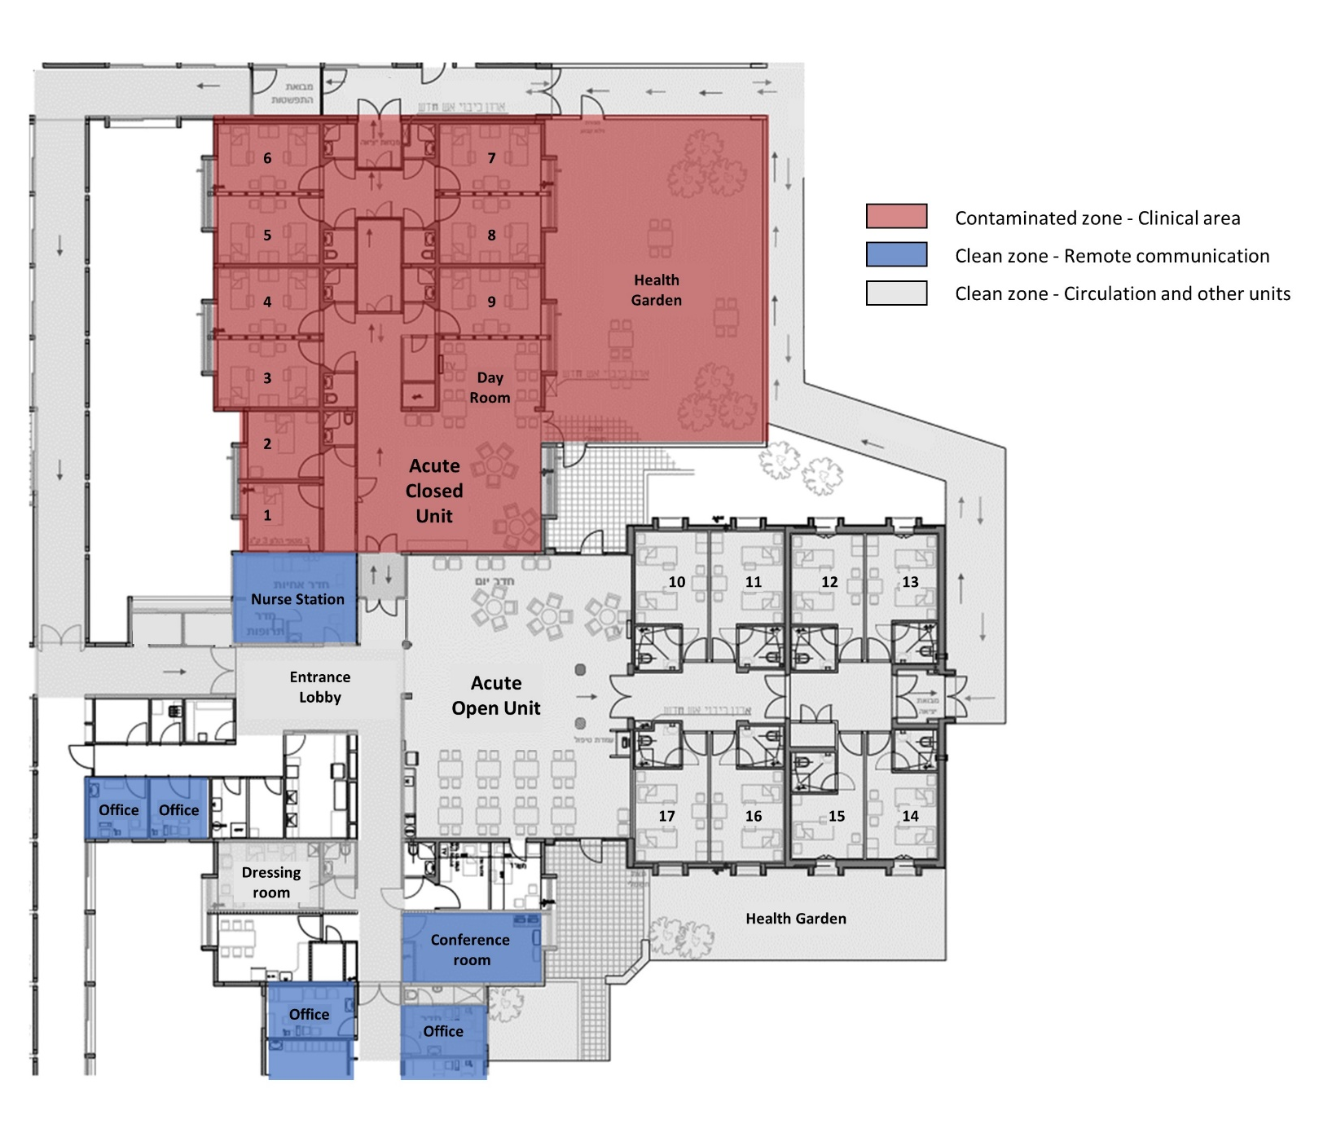
Figure 1. Architecture plan of the COVID-19 Psychiatric Unit illustrating the clinical contaminated zone in the acute closed unit (in red) and the diverse remote communication rooms in the clean zone (in blue). Source: Sheba MC.

3.2. Inpatient Telemedicine in the Acute COVID-19 Psychiatric Unit
The new model of inpatient telemedicine combined in-person care with remote virtual care. The nurses went into the contaminated zone, wearing PPE, twice a day or in case of need or emergency, while the physicians and therapists stayed in the clean zone and remotely communicated with the patients and nurses inside the unit. They also used the system to talk with family members at home that were not allowed to visit. Remote care was mainly used for psychiatric treatment and control of patients' behavior (Figure 2). The remote psychiatric treatment included 1:1 sessions with psychiatric physicians, social workers, occupational therapists, and group therapy. "The PPE and masks of the staff extended patients' paranoic feelings. For this reason, we thought that remote care would be helpful for providing psychiatric care that requires communication with facial expressions and eye contact" (Psychiatric physician). The remote care also aimed to reduce staff fatigue and challenges of concentration when working with PPE (Oborn et al., 2021). "Since there were accidents of violence where patients tore caregivers PPE, the management decided that we will wear two sets of PPE one over the other. This made our work even more difficult as it was very hot and sweaty inside (Head nurse).
While the new model of inpatient telemedicine aimed to improve care and prevent contamination, it was conceived by many of the staff as unsuccessful. "Here and there, we were able to have short, elementary conversations with patients, but the system, in general, didn't work. Doctors, nurses, aides, supplementary staff, sanitation workers went in. It was a good idea, but it didn't work in our unit "(Medical director). "In many cases, since the remote system did not work as we envisioned, we felt out of control of what was happening inside the unit. We realised we need to go physically inside, wearing the PPE, to gain control" (Psychiatric physician).

Limitations in implementing inpatient telemedicine for acute psychiatric care, can be divided into three main challenges: Technical Issues caused by the need to prevent patient vandalism, dependency on User Collaboration on the side of the patients, and Spatial Complexity to manage care from multi-locations at the hospital.

3.2.1. Technical Issues
One of the main issues in the design of the telemedicine system was how to protect it from vandalism. "Hard-core psychiatric patients are at times capable of purposely destroying everything around them" (Medical director). "The experience of isolation in the unit cased some patients a regression in their mental condition" (Psychiatric physician). "Some of the patients had the potential of being violent, staff could only go in at least in pairs, and we have security involved. And it was quite eerie" (Medical director). "The patients were aware they were being watched remotely, but many forget or chose to disregard it" (Psychiatric physician).
The protection from vandalism rendered the system difficult to use. The screens were installed with a protective box and a Plexiglas cover, located close to the ceiling. "The patient had to stand or sit looking up high, which made the communication very hard. The caregiver did not see them well because of the Plexiglas. We were also not able to leave a remote control with the patients, in fear of damage, so there was a challenge to operate the system" (Medical director). "Psychologists and social workers were supposed to operate remotely from separate rooms. We installed systems so they could speak to their patients via microphone with a screen, but the camera and the microphone were too far away, so instead of quiet conversations, they had to shout to be heard, and that, of course, is not an ideal setting for psychotherapy" (Medical director). "In some cases, I felt as if we were babysitting the patients in the unit. The remote system was mainly used as a surveillance system to supervise the patients were not hurting themselves or others" (Psychiatric physician).
Inpatient remote psychiatric care showed significant technical limitations. "It's one thing to have a short conversation in a system that is not ideal, but when you have a 50-minute psychotherapy session, even just a delay between the audio and video creates a major problem" (Medical director). The remote limitations due to technical difficulties were also evident in the group therapy, where the caregivers could not see the patients distant from the static cameras. Although the communication between the staff in the contaminated zone and the staff in the clean zone was necessary, it was limited. "The intercom and audio systems did not work, so in the end, we communicated via walkie-talkie" (Medical director).

3.2.2. User Collaboration
The operation of the new model of care in the COVID-19 Psychiatric unit, using remote technologies for psychiatric treatment and control of active patients moving in space, depended on the patients' participation and their will to collaborate and learn to use the system. "In general, the main issue was that the system requires active participation on both sides, and we could not rely on the participation of the patients. We tried different solutions, having a staff member inside operating the system for the patient, holding a Walkie-Talkie beside them. Still, it was unsuccessful, and most caregivers had to wear the PPE and go inside the unit "(Medical director). The challenges in operating the system were also based on the patient population. "We were hospitalising very severe patients from all over the country who needed psychiatric treatment in a closed, locked ward, and most of the patients, the majority, I think, were involuntarily hospitalised. There wasn't a lot of psychological work that could be done with these patients; they needed to take their medication; many were very paranoid had disordered thought processes. One patient had difficulty communicating, just sitting there. What exactly do you want to do with your fancy online remote technologies with this patient? We just had to go in and give him an injection because he wasn't taking his pills. So, in that respect, the psyche is less appropriate for inpatient telemedicine" (Medical director).

3.2.3. Spatial Complexity
The system was managed from multi-locations in the contaminated zone - patient rooms, day room, and garden- and from the clean zoon - nurse station, conference room, doctors' offices, and remote places at the hospital (Figure 1). The complexity of the spatial configuration caused challenges in operating the system. The staff had to coordinate the use of the technologies from multi-locations by different team members while the patients were active moving around in the unit. This coordination was especially challenging in cases such as Sectioned Committees to decide if the involuntary hospitalisation was seemed legal and should continue. This process, which usually takes place in person in the unit with the patient and a family member, required the committee members to assess the patient's condition remotely while they were in diverse locations in the hospital. "The Sectioned Committees process did not work remotely. The cameras and the audio weren't working well, and at some point, they were looking at the patient from the camera, but they couldn't hear, so somebody had to communicate with a walkie-talkie or cell phone from within" (Medical director). "It was challenging to locate the patient in the unit and coordinate communication with the committee members in diverse rooms" (Head nurse).

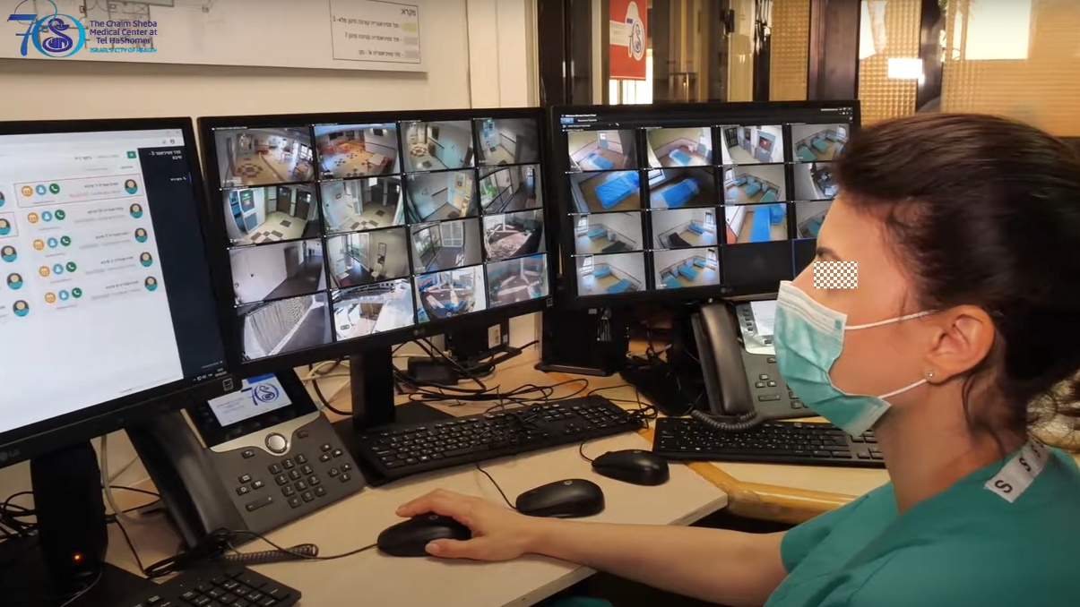
Figure 2. The head nurse in the clean control room communicating with patients in the clinical contaminated zone. Photo: Sheba MC, May 2020.

4. Discussion
The study explored the implementation of telemedicine for inpatient care in COVID-19 acute psychiatric unit in Israel, focusing on the integration of digital technologies within the hospital-built environment and its impact on the operation of the system. The new model, developed initially to prevent staff contamination with COVID-19 and maintain quality of psychiatric care by communication without protective gear, making facial expressions visible, had an impact on the operation of the unit and the experience of both the patients and the staff. The remote system enhanced the supervision of the patients and supported rapid response in cases of emergency. However, the use of the system for psychiatric treatment showed significant limitations caused by technological difficulties resulting from inconsistency with the unique needs of acute inpatient psychiatric care.
The results of the study indicate three main challenges in implementing inpatient telemedicine for acute psychiatric care, including technical issues caused by prevention of patient's vandalism, dependency on user collaboration of patients to operate the remote system in the unit, and spatial complexity to manage the remote care system in coordination from multi-locations by multi-team members. All the challenges, associated with the specific context of acute inpatient psychiatric care, are interrelated to the design of the system within the built environment of the hospital. The location of the cameras and their height, aimed to prevent vandalism, decreased the usability of the system and the wiliness of the patient to collaborate. The complexity of the system operated from different places by multiple users, dynamically moving in space, was not supported by the technology that was initially designed to connect two persons in a static location. Whereas technical difficulties can be improved in the future, the success of the model depends on an integrated design considering the specific needs of the people, processes, and places in the acute inpatient psychiatric unit.
The study introduces an innovative solution for inpatient telemedicine during the outbreak of COVID-19, yet, further work is needed to compare and evaluate different solutions for psychiatric care using digital technology. More studies on the implementation of remote technologies in different layouts of hospital units are required, as well as various levels and models of care. Further research on the impact of inpatient telemedicine on the design of healthcare facilities in diverse social, cultural, and economic contexts will enhance the knowledge base needed for the future development of healthcare architecture and digital technologies for remote care.

5. Conclusions
The integration of remote care for inpatient care during the COVID-19 crisis disrupted conceptions of healthcare services and presented an opportunity to develop and test new models of care. While inpatient telemedicine for critical and intermediate care enhanced patients and staff safety and supported teamwork and management of the units (Pilosof et al., 2021a, 2021b), the study showed the inadequacy of the model for acute psychiatric care. The limitations were caused by technological difficulties resulting from inconsistency with the unique needs of acute inpatient psychiatric care, including dependency on the collaboration of patients, prevention of patients' vandalism, and management of the system from multi-locations. The remote system was primarily used for surveillance of patients and less for psychiatric and therapeutic care.
As inpatient telemedicine holds potential to develop beyond the challenges of the corona virus crisis, to deal with lack of staff, changes in patient loads, and need for ongoing infection control, it is essential to recognise the limitations of the model for different medical fields and levels of care. The study illustrates that the model's success depends on an integrative design of the digital technologies with the built environment, considering the specific needs of the users. Advancement of the model should also address patient and staff privacy, patient control, and human experience lacking in the rapid development during the crisis. Developing insights from inpatient telemedicine, with attention on psychiatric care, can inform methods for home hospitalisation with supervision by the hospital. This approach can help support future transformations of the healthcare eco-system integrating hospital care with more remote locations such as the community and home care.

Contributor statement
Conceptualisation, NPP, MB, and EO; methodology, NPP, MB, and EO; validation, GB, EZ, and AC..; formal analysis, NPP, MB, and EO; investigation, NPP; resources, NPP, GB, and ZC; data curation, NPP; writing—original draft preparation, NPP; writing—review and editing, MB, EO, GB, EZ, and AC..; visualisation, NPP; supervision, MB and EO All authors have read and agreed to the published version of the manuscript.
Acknowledgements
The authors would like to thank the directors and staff at Sheba Medical Centre and the ARC Innovation Centre for their collaboration in the research.

References

Bar-On, E., Segal, G., Regev-Yochay, G., Barkai, G., Biber, A., Irony, A., Luttinger, A., Englard, H., Grinberg, A., Katorza, E., Rahav, G., Afek, A., & Kreiss, Y. (2021). Establishing a COVID-19 treatment centre in Israel at the initial stage of the outbreak: Challenges, responses and lessons learned. Emergency Medicine Journal, 38(5), 373–378. https://doi.org/10.1136/emermed-2020-209639
Brown, C., Ruck Keene, A., Hooper, C. R., & O'Brien, A. (2020). Isolation of patients in psychiatric hospitals in the context of the COVID-19 pandemic: An ethical, legal, and practical challenge. International Journal of Law and Psychiatry, 71. https://doi.org/10.1016/j.ijlp.2020.101572
Dhala, A., Sasangohar, F., Kash, B., Ahmadi, N., & Masud, F. (2020). Rapid implementation and innovative applications of a virtual intensive care unit during the COVID-19 pandemic: Case study. Journal of Medical Internet Research, 22(9), e20143. https://doi.org/10.2196/20143
Emerson, R. M., Fretz, R. I., & Shaw, L. L. (2011). Writing Ethnographic Fieldnotes. In The University of Chicago Press (Ed.), Writing Ethnographic Fieldnotes. https://doi.org/10.7208/chicago/9780226206851.001.0001
FGI. (2018). Guidelines for Design and Construction of Hospitals.
Garofalo, M., Vaithilingam, S., & Ferrando, S. (2021). Telemedicine for Psychiatry and Mental Health. In Telemedicine, Telehealth and Telepresence (pp. 365–378). Springer International Publishing. https://doi.org/10.1007/978-3-030-56917-4_23
Golden-Biddle, K., & Locke, K. (2007). Composing Qualitative Research. In Composing Qualitative Research. SAGE Publications, Inc. https://doi.org/10.4135/9781412983709
Igra, A., McGuire, H., Naldrett, I., Cervera-Jackson, R., Lewis, R., Morgan, C., & Thakuria, L. (2020). Rapid deployment of virtual ICU support during the COVID-19 pandemic. Future Healthcare Journal, 7(3), 181–184. https://doi.org/10.7861/fhj.2020-0157
Leshem, E., Klein, Y., Haviv, Y., Berkenstadt, H., & Pessach, I. M. (2020). Enhancing intensive care capacity: COVID-19 experience from a Tertiary Center in Israel. In Intensive Care Medicine. Springer. https://doi.org/10.1007/s00134-020-06097-0
Lincoln, Y. S., & Guba, E. G. (1985). Naturalistic Inquiry. Sage Publications.
Lundin, S., & Msa, S. /. (2021). Can Healing Architecture Increase Safety in the Design of Psychiatric Wards? Health Environments Research & Design Journal, 14(1), 106–117. https://doi.org/10.1177/1937586720971814
Mental Healthcare in the Corona era at Sheba Medical Center. (n.d.). Retrieved February 20, 2022, from https://www.youtube.com/watch?v=UtXeBBm_DsU&t=1s
Oborn, E., Pilosof, N. P., Hinings, B., & Zimlichman, E. (2021). Institutional logics and innovation in times of crisis: Telemedicine as digital 'PPE.' Information and Organization, 31(1), 100340. https://doi.org/10.1016/j.infoandorg.2021.100340
Pilosof, N. P., Barrett, M., Oborn, E., Barkai, G., Pessach, I. M., & Zimlichman, E. (2021a). Telemedicine Implementation in COVID-19 ICU: Balancing Physical and Virtual Forms of Visibility. Health Environments Research and Design Journal, 14(3), 34–48. https://doi.org/10.1177/19375867211009225
Pilosof, N. P., Barrett, M., Oborn, E., Barkai, G., Pessach, I. M., & Zimlichman, E. (2021b). Inpatient telemedicine and new models of care during covid-19: Hospital design strategies to enhance patient and staff safety. International Journal of Environmental Research and Public Health, 18(16), 8391. https://doi.org/10.3390/ijerph18168391
Sheehan, B., Elizabeth Burton, D., Wood, S., Stride, C., Henderson, E., & Wearn, E. (2013). Evaluating the Built Environment in Inpatient Psychiatric Wards. Psychiatric Services, 64, 789–795. https://doi.org/10.1176/appi.ps.201200208
Ulrich, R. S., Bogren, L., Gardiner, S. K., & Lundin, S. (2018). Psychiatric ward design can reduce aggressive behavior. Journal of Environmental Psychology, 57, 53–66. https://doi.org/10.1016/j.jenvp.2018.05.002
Vilendrer, S., Patel, B., Chadwick, W., Hwa, M., Asch, S., Pageler, N., Ramdeo, R., Saliba-Gustafsson, E. A., Strong, P., & Sharp, C. (2020). Rapid Deployment of Inpatient Telemedicine In Response to COVID-19 Across Three Health Systems. Journal of the American Medical Informatics Association, 1–8. https://doi.org/10.1093/jamia/ocaa077
Wosik, J., Fudim, M., Cameron, B., Gellad, Z. F., Cho, A., Phinney, D., Curtis, S., Roman, M., Poon, E. G., Ferranti, J., Katz, J. N., & Tcheng, J. (2020). Telehealth transformation: COVID-19 and the rise of virtual care. Journal of the American Medical Informatics Association, 27(6), 957–962. https://doi.org/10.1093/jamia/ocaa067
Zhu, Y., Chen, L., Ji, H., Xi, M., Fang, Y., & Li, Y. (2020). The Risk and Prevention of Novel Coronavirus Pneumonia Infections Among Inpatients in Psychiatric Hospitals. Neuroscience Bulletin, 36(3), 299–302. https://doi.org/10.1007/S12264-020-00476-9/TABLES/1
Zimlichman, E. (2005). Telemedicine: Why the delay? Israel Medical Association Journal, 7(8), 525–526.

