Type of the Paper: Peer-reviewed Conference Paper / Full Paper
Track title: Stream inclusive design/health promotion – communal living (4A2)

Designing living environments for older people to age well in place: perspectives from architectural education
Gwendoline Schaff ^{1*}, Ann Petermans ², Fabienne Courtejoie ³, Catherine Elsen ⁴ and Jan Vanrie ⁵
¹ Faculty of Architecture, University of Liège, Belgium & Faculty of Architecture and Arts, Hasselt University, Belgium; g.schaff@uliege.be; ORCID 0000-0002-6253-6770
² Faculty of Architecture and Arts, Hasselt University, Belgium; ann.petermans@uhasselt.be; ORCID 0000-0001-7023-4628
³ Faculty of Architecture, University of Liège, Belgium; fcourtejoie@uliege.be; ORCID 0000-0002-4120-3408
⁴ Faculty of Applied Sciences, University of Liège, Belgium; catherine.elsen@uliege.be; ORCID 0000-0003-1433-3298
⁵ Faculty of Architecture and Arts, Hasselt University, Belgium; jan.vanrie@uhasselt.be; ORCID 0000-0003-2633-5194
* Corresponding author

Names of the Topic editors:
Clarine van Oel

Journal: The Evolving Scholar
DOI:10.24404/622fc83f70ceb1afe482d828

Submitted: 14 Jul 2022
Revised: 14 Jul 2022
Accepted: 14 Jul 2022
Citation: Schaff, G., Petermans, A., Courtejoie, F., Elsen, C. & Vanrie, J. (2022). Designing living environments for older people to age well in place: perspectives from architectural education. The Evolving Scholar | ARCH22.

This work is licensed under a Creative Commons Attribution BY license (CC BY).

© 2022 Schaff, G., Petermans, A., Courtejoie, F., Elsen, C. & Vanrie, J. published by TU Delft OPEN on behalf of the authors.

Abstract: A large majority of older people wish to live in non-institutionalized housing for as long as possible. However, current homes are generally not suitable for later life, leading us to rethink our living environments to support health and wellbeing. Architects, in that regard, have a key role to play. Yet, to date, they seem to have a limited knowledge of emotion-related users’ preferences, which could be the consequence of a frequent lack of care perspectives in design teaching, as well as a difficulty to pick up and translate research findings into practice. This study therefore sought to understand how (interior) architecture students design housing that facilitates ageing well in place, when they are prompted to consider older people’s needs/aspirations more holistically. We conducted design exercises with 16 students from two architecture schools and we fed their reflections with theoretical “themes” and “personas”. These inputs were nurtured by a literature review on “ageing well in place” and by focus groups organized with multidisciplinary experts. At the end of the exercise, the students completed a questionnaire to summarize their design considerations. The results focus on the preeminent spatial features designed by students to meet inhabitant’s needs, as well as some pedagogical aspects of the workshops. They highlight links between themes/personas and design strategies/choices. The paper concludes by recommendations to train future architects to design living environments with an eye for ageing well in place.
Keywords: architectural education; older people; home; ageing well in place; design

1. Introduction
Our societies are facing unprecedented demographic changes (United Nations, 2019). Population ageing, in particular, significantly impacts the design of living environments (Boulmier, 2012). In many European countries, both governments and older people themselves favour “ageing in place” rather than moving into institutionalized housing (e.g., nursing home), mainly for wellbeing and economic reasons (Delvenne et al., 2014). Yet, many houses are unsuitable for later life (Dagnies, 2016). Moreover, in recent years, new forms of “alternative” housing have emerged (Nowik et al., 2016). They explore the boundaries between private and institutional spheres, allowing both intimacy and sharing within the same place.
Taking this into account, how can we, as designers, enable older people to live as long and as pleasantly as possible in a (shared) home? How to promote their health, care and well-being through the architecture of their living spaces? To shed light on these questions, we focused this study on tomorrow’s (interior) architects (i.e., current students), through design workshops, for two main reasons. First, there is a frequent lack of care perspectives in design teaching (Fry, 2010). Although (future) architects design ‘for others’ on a daily basis, they seem to have limited knowledge of emotion-related users’ needs (Chrysikou et al., 2016). Understanding other people's requests and experiences remains relatively complex (Imrie & Kullman, 2016). Yet, raising awareness of students on older people’s aspirations is becoming a pressing necessity, given the societal contexts they will all work in, in the coming decades. Second, research shows the difficulty to translate research findings into practice, i.e., to know how the built environment should be designed differently to optimize wellbeing (Burton et al., 2011).
Therefore, with these workshops, we aimed to understand how, based on ‘personas’ and ‘theoretical dimensions and themes’ nurtured by our previous research (see section 2), young (interior) architects might design new ways of living specifically adapted to the needs/wishes of older people, in order to trigger ageing well in place.
2. Theories and Methods
The theoretical foundations of the workshops came forth from two prior studies with a different spatial (i.e., international & local) and temporal (i.e., past & current) focus. The first study consisted of an international narrative literature review on housing for older people, through the lens of ‘ageing well in place’ and architectural design (see Schaff et al., 2022). This analysis revealed five essential and intertwined dimensions to be taken into account by architects in order to intervene on the relationships between older people and their home: health, affective, social, built and contextual dimensions. It also confirmed the need to contextualize studies related to housing for older people in a specific geographical and temporal situation. Therefore, the second study aimed to enrich the understanding of the current housing situation of older people in Wallonia (south part of Belgium): two focus groups were organized, bringing together Walloon stakeholders specialised in ageing and/or housing (see Schaff et al., 2019). Each of the five dimensions identified in the literature review was supported by experts invited to each focus group (e.g., for the social dimension, at least one sociologist per focus group). The results of these focus groups (study 2) enabled us to associate the five dimensions from the literature review (study 1), with 36 themes (as illustrated in Figure 1), giving us a global vision of important topics to be taken into account by architects in the design of housing for older people. These dimensions and themes formed the theoretical foundation of the pedagogical experimentation presented in this paper. They are purposely presented as non-hierarchical, since architects accentuate themes more strongly or slightly according to the future inhabitants they are designing for and the specific context.
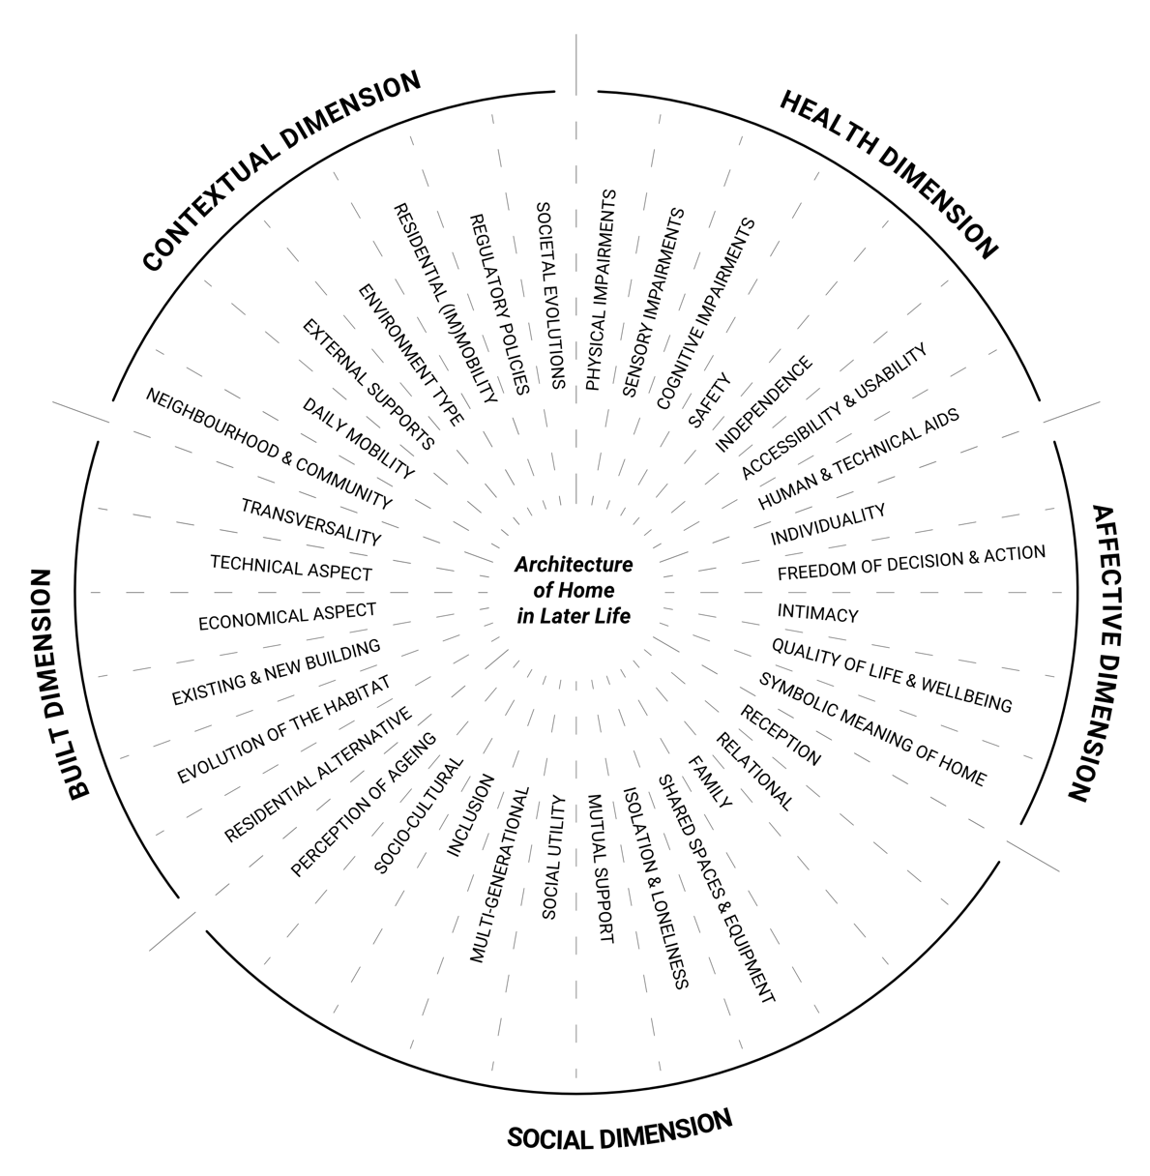
Figure 1. Theoretical framework used for the students’ workshops (with the five main dimensions in bold, structured in 36 additional themes).
The pedagogical experimentation was conducted in design studios with students in (interior) architecture. Two workshops were set up, each with their own constraints, requirements and challenges, but with the same objective: to understand how, based on building data (i.e., an existing building to be transformed), human data (i.e., personas to be considered), as well as objective and subjective inputs (i.e., dimensions and themes introduced above), future (interior) architects reflect on housing for older people. The first workshop took place at the Faculty of Architecture and Arts at Hasselt University (Belgium). During three months in 2019, one day per week, seven Master students in interior architecture worked on the renovation of a monastery based in Ghent (Belgium), with the intent to transform it into a cohousing project for people aged 55 and over. The second workshop took place at the Faculty of Architecture at the University of Liège (Belgium). During one week in 2020, every day, nine Master students in architecture worked, in groups of three, on the transformation of a single-family house based in Lochau (Austria) into a home for an older couple/person. Due to Covid-19, this second workshop was held virtually.
During the workshops, the students were supervised by the teachers, but also by the first author for five design sessions. In both faculties, a similar methodology was used. At the beginning of the exercise, the theoretical framework (Figure 1) was presented through an illustrated PowerPoint, in order to raise students’ awareness about the issues. Then, during the project, “personas” (see Miaskiewicz & Kozar, 2011) were used by students in order to address specific human needs and aspirations. The personas applied by the students of Hasselt University took the form of an explanatory text produced by the future inhabitants of the building. They communicated their gender, their family situation, their daily activities, their hobbies, the activities for which they may need space, what they would like to do in the cohousing project, their main spatial concerns, their care questions, and their wishes for the private housing units. The personas applied by the students of the University of Liège came from a documentary illustrating older people wishing to continue living at home (Delsalle & Rapey, 2014). In this short movie, the interviewees were filmed in their living place while describing what was important to them there, what they liked, as well as their daily difficulties. Finally, at the end of the workshop, all 16 students completed a questionnaire in order to link their project to the theoretical framework. The questionnaires included six main parts, as illustrated in Figure 2. The data collected in these questionnaires were analysed by the first author alongside the final graphic documents produced by the students.
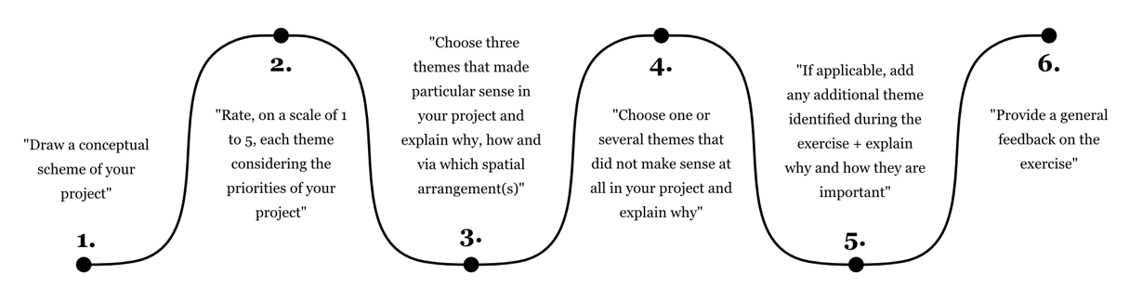
Figure 2. Questionnaire completed by the students, including visual, close-ended and open-ended questions.
3. Results
The first and main part of the findings highlighted in this paper relates to the preeminent spatial features designed by the students. In a second and shorter part, we focus on pedagogical aspects of the experimentation.
3.1. The spatial aspects
For each dimension of the theoretical framework (Figure 1), we detail the main intentions of the students while also identifying the main spatial arrangements they created to meet these intentions (questions 1-3-4-5 of the questionnaire). The themes that were addressed by the students are highlighted in italics in the text and the architectural features are abstracted into numerated schemes (S1-26) presented in Figure 3. In addition, Table 1 provides further information on the importance of the themes in the students' projects (question 2 of the questionnaire), depending on their personas, the existing building and the surrounding context.
3.1.1. Health dimension
Regarding the health dimension, the students paid particular attention to the themes of “physical impairments” and “accessibility & usability”. Their two main intentions were to facilitate the (future) sometimes-difficult walk of inhabitants and to plan for the (future) potential use of a wheelchair, in order to stay in the home for as long as possible. To address these issues, they designed the following spatial arrangements: all rooms at the same level and no thresholds between inside and outside (S1’); toilet and bathroom meeting accessibility regulations (S2’); wide and direct circulation with rotation spaces and few (or sliding) doors (S3*); possibilities of leaning or sitting down when circulating in the dwelling (S4’); sitting position in a wheelchair taken into account for views or furniture (no high furniture, as inaccessible, or touching the ground, as being an obstacle for the feet) (S5’); and light walls/furniture to easily transform the interior (S6*).
These intentions are in line with the theme of "independence", which was also addressed. In order to avoid dependence on an external person to carry out daily tasks, a student designed furniture that was adapted for a wheelchair, by paying attention to the height of the storage units, as well as creating a shower bench and movable shelves (S7*).
However, sometimes, “human & technical aids” remain essential. Therefore, to allow a caregiver to assist the inhabitants with daily tasks, some students created wide corridors to move around with two people, and a bathroom divided into two subspaces (S8’).
Finally, “sensory impairments” were less explored, except for one student who reflected on acoustics for a hearing-impaired person by: separating the living room and the kitchen/dining room; using acoustic material for ceilings; and using curtains, cushions and padded chairs/stools to reduce resonance (S9*).
3.1.2. Affective dimension
A first theme addressed by the students was the “freedom of decisions & actions”. They sought to allow inhabitants to do “what they want, when they want”, through: a private kitchen and bathroom (even if this building also included common areas); or direct access to a private outdoor space.
Some students focused on the theme “quality of life & wellbeing” with two main objectives. First, they aimed to avoid stigmatizing or making the inhabitant's disability visible through the design, by, for instance, designing circulations with only occasional rotation widths (being functional but not disproportionate) (S10*). Second, they tried to take into account the inhabitant’s hobbies and activities by, for example, designing open and communicating spaces (one of the inhabitants expressed the desire to live like “in an artist’s studio”) (S11’).
These intentions closely relate to the "symbolic meaning of home”. Indeed, to provide a familiar environment and maintain certain ways of living, some students created: spaces that include furniture from the former home (those who were dear to the inhabitants) (S12’); or walls with enough space to be customized.
Finally, to maintain a personal affective dimension even when living close to other people, the theme of “intimacy” was addressed by: a curtain that could occlude a glazed gallery (S13*); or wooden battens that partially filtered the views from outside (S14’).
3.1.3. Social dimension
In the cohousing project, the “relational” aspect was considered primordial. Students tried to foster social relationships with the neighbours while maintaining privacy by, for example: graduating spaces from the most public (at the beginning of the flat) to the most intimate (at the end of the flat) (S15*); and creating semi-private/semi-collective front door areas (S16*) or semi-open interior gardens that encourage interactions (S17*).
The intention to avoid "isolation & loneliness” was also mentioned. Students addressed this issue by: including communal spaces into the cohousing building (S18*); separating the single-family home into multiple housing units for additional people (S26’); or designing a street-facing patio to capture social life (S19’).
Sometimes, “multi-generational” relationships were also considered by: dedicating some spaces for offices, students and/or families (S26’); or designing a common terrace for all the inhabitants (S20’).
Finally, relationships with the “family” were particularly addressed. A first objective was to be able to gather the loved ones at home. In that regard, students included: an additional room and/or a bunk bed in the living room for a child’s stay (S21*); a wide dining room with a large table and free spaces for children to play on the floor (S21*); and a common guest bedroom directly next to the apartment (S21*). A second objective was to enable a couple to do activities with their partner or to isolate themselves according to their desires/needs. To fulfil this wish, the living room, kitchen and dining room were gathered in a single space allowing several activities at the same time, but the night area was separated from the day area for isolated activities (S22’).
3.1.4. Built dimension
Regarding the built dimension, beyond all the spatial features already explored above, the “evolution of the habitat” was addressed in order to offer possibilities of several living scenarios. For example, in some projects, the living room could be transformed into a guest room with a curtain (S23*); or a dedicated multi-functional space was included in the apartment (this space could be used as, e.g., (grand)children's room, friend's room, office, storage, etc.) (S24*).
3.1.5. Contextual dimension
Regarding the contextual dimension, the theme of “neighbourhood & community” was explored. As in the social dimension, the aim was to enable inhabitants to meet other people while also preserving quiet moments. However, the reflection here focused at the scale of the site by creating: common walking paths on a further part of the site (S20’), and three terraces (a private one linked to the bedroom, another private one linked to the living room but with views on more collective areas to enable contacts with other people, and a collective one for all inhabitants, further down on the field) (S20’).
Finally, students considered the “environment type” of the location. They took into account the surroundings of the habitat in the design reflection by, for instance, designing windows framing certain views and landscapes, or rooms facing the creek and the vegetation (S25’).
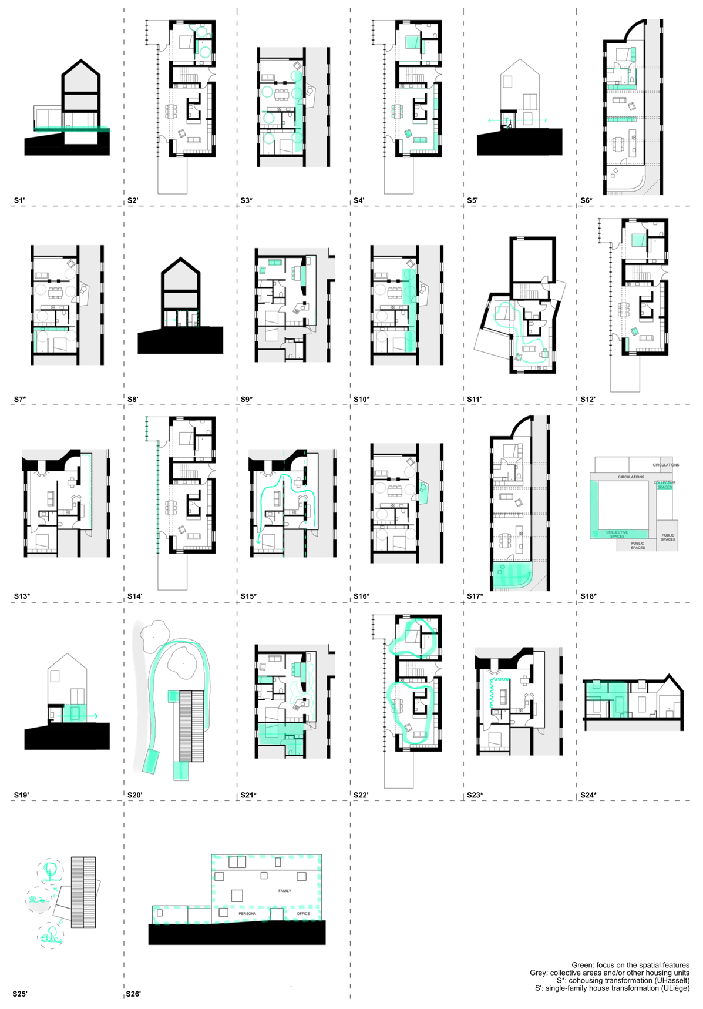
Figure 3. Schemes of spatial features implemented by the students to support ageing well at home.

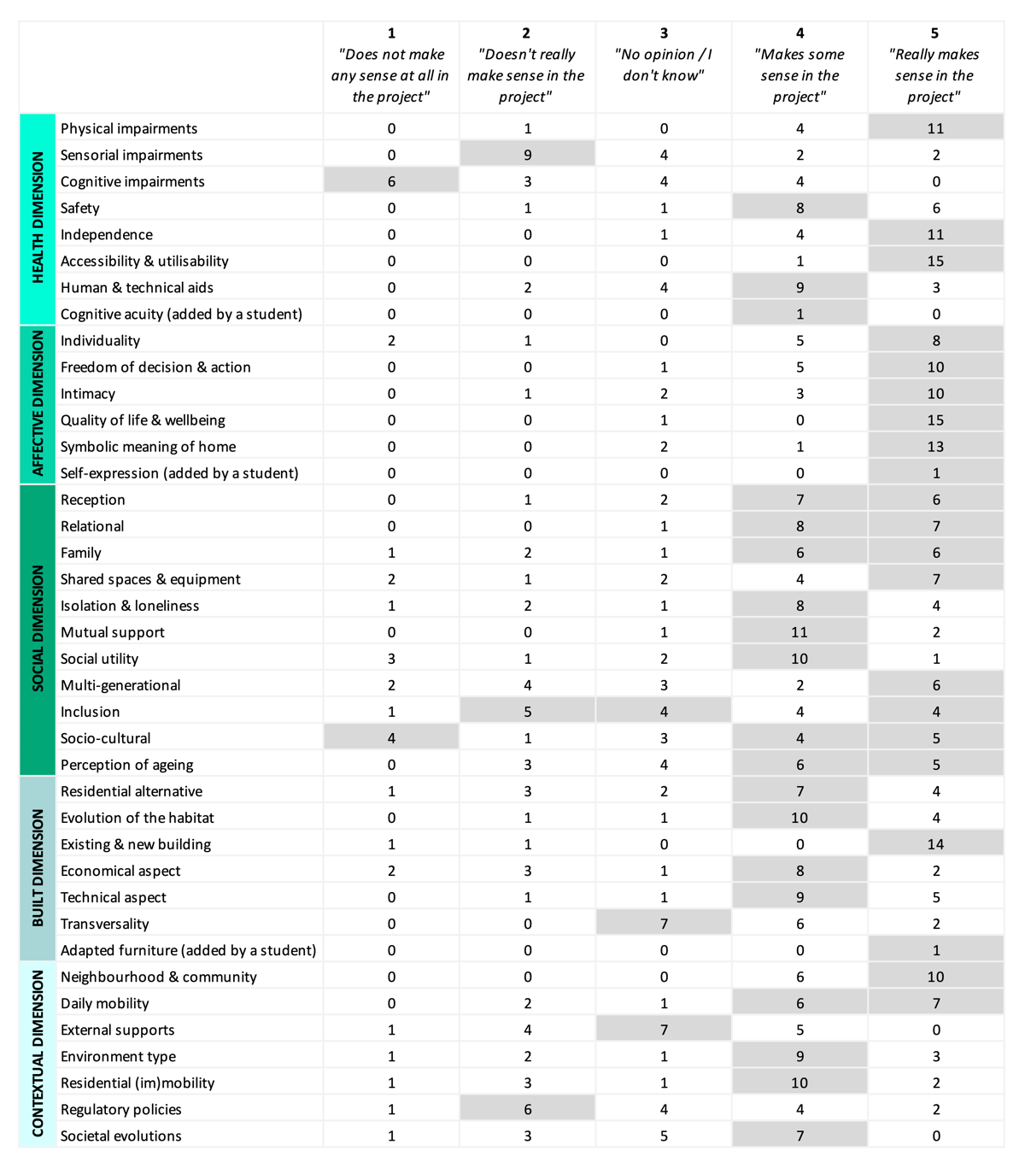Table 1. Importance of the themes in the projects, by number of students (question 2 of the questionnaire).
3.2. The pedagogical aspects
In parallel to the spatial settings, we also pinpointed two main findings related to the pedagogical settings. The first one is the strong impact that visual and human representations had on students. Students underlined the usefulness of the images and the diagrams included in the introductory presentation, as to deepen their understanding of the theoretical dimensions and themes. In their opinion, additional visual documentation would even also have been valuable, especially in terms of similar architectural references (i.e., examples of architectural projects with the same scale and/or program in order to understand the spatial arrangements adopted by other architects).
However, even though the visuals gave the students a better grasp of the issues involved in such a project, they were all the more impactful when they projected students into specific real-life situations. For example, the use of personas in the form of filmed sequences particularly influenced them and sometimes fuelled a form of empathy for the users, as expressed by this student: “It helped me realize how difficult, even hellish, it can be for a person to live in a completely inadequate home. The thing that struck me the most was to see that some older people, with no help, are forced to almost climb to reach certain places or reach a window just to close or open it” (author’s translation). Some even connected these short movies to their own personal situations, wondering whether their own grandparents were also experiencing such difficulties.
The second one is that, among the collected feedback, some students expressed the need for more exercises of this type through architectural studios. Designing with a greater focus on users seems to be appreciated by students; some even wished to broaden these reflections to various social, economic, cultural or generational horizons. However, some reflections (e.g., a student mentioning that this was the first design exercise with a focus on user well-being since the beginning of her studies) suggest that these approaches are still quite rare, or perhaps not widely used/remembered by the students.
4. Discussion
Due to its exploratory nature, this study has limitations. For instance, two different workshop settings (University of Liège and Hasselt University) with two different exercises (a cohousing project and a single-family home project) were addressed; “desirability bias” were probably involved towards the main researcher who deliberately orientated her inquiries and could be associated with the teaching staff; and the use of questionnaires may have led to shorter, less nuanced, and perhaps less candid feedback than other in-depth methods. However, these limitations were tempered by common objectives and methods between the workshops, follow-up of students in the studios and analysis of their projects and presentation materials. Multiple lessons can be drawn from this study and are explained below.
At the spatial level, the importance of a holistic approach (i.e., a global consideration of the health, affective, social, built and contextual perspectives) to design housing for older people (which we had observed in our previous research) was confirmed through this study: indeed, according to the students and our analyses, not only numerous themes made sense in the developed projects (28/36 themes for the majority of students, in Table 1, boxes 4-5 added together), but they also turned out to be relatively interlinked. This interconnection was particularly well observed through relational aspects: all students reflected on family and neighbourhood relationships within the living spaces (i.e., social and contextual dimensions) while always combining them with the possibility of withdrawing from others and preserving privacy (i.e., affective dimension). These double intentions were translated into (subtle) delimitations between private, semi-private, semi-collective, collective and public spaces. Moreover, similar spatial features were sometimes used for different purposes, illustrating again the numerous interrelationships between architectural elements and living intentions. For example, curtains were designed either to isolate the inhabitants from the views of others (used with a large opening, s13) or to transform a room into another function (used within a delimited space, s23), meeting simultaneously visual, acoustic and functional aims. However, an application of all themes from the theoretical framework was never applied at once by any student: in general, the health dimension was more emphasized (14/16 students chose one or several of the themes of the health dimension, in question 3) and, within that dimension, a strong consideration for physical conditions was made at the expense of other conditions: both in Hasselt and Liège, all students stated that physical impairments made more sense in their project (15/16 students, in Table 1) than sensory or cognitive impairments (4/16 students, in Table 1).
Two main reasons were mentioned for this preponderance and are of significance at the pedagogical level. First, students did not specifically take into account sensory/cognitive difficulties as they weren’t mentioned through the personas, in contrast to physical difficulties. This approach could suggest a lack of projection and anticipation, beyond the directly available information. It also opens up reflections on the choices of personas and their characteristics (e.g., in terms of age, gender, health, socio-cultural situation, financial condition, habits, hobbies, etc.). Second, they stated that physical problems already represented a lot of research for them, leaving little time to look at other types of impairments. A hierarchy was therefore established, placing physical impairments first. This highlights the load of the various factors to be taken into account by (future) architects and the need for users to define priorities. Moreover, this exercise also opened up questions on visual and referential representations in architecture and their links with users. Raising awareness of students through illustrations and stories seems promising. In parallel, architectural and experiential references exemplifying user-diversities would seem to be welcome to create empathy towards (older) people and to offer spaces that meet their (future) realities.
This pedagogical experimentation provides some initial indications and raises several interesting questions about how themes/personas and design strategies/choices are related. It shows how the use, the definition and the form of personas, as well as the awareness of themes influencing the well-being of these people, have an impact on the architectural design. This study invites further research in this direction, in order to more closely understand these links and decision factors.
5. Conclusions
This study sought to understand how, based on building data (i.e., an existing building), human data (i.e., personas), as well as objective and subjective inputs (i.e., theoretical dimension and themes), future (interior) architects reflect on housing for older people to trigger ageing well in place.
Through spatial features designed by students, our analyses highlighted the importance of a holistic approach, not only at the level of the environment (from interior design to outdoor landscape), but also at the level of the person itself (with its physical, affective and relational components). It emphasized the strong links between introduced themes and the various spatial possibilities for addressing inhabitants’ needs. An effective method for enhancing students' empathy and understanding of ageing issues seems to be the use of visual documentation and projections.
However, these workshops also revealed some difficulties for students, such as the non-consideration of the issue as a whole due to a prioritization of the addressed factors and what could be a lack of projection.
Finally, it seems that rethinking the ways some architects are trained (e.g., by familiarizing them with specific societal issues and equipping them with methods favouring empathy and understanding of users) would be welcomed to support designing with an eye for health, wellbeing and care of (older) people.

Contributor statement
Gwendoline Schaff is the lead researcher on this project. She conducted the two preliminary studies aiming at a theoretical framework for the workshops. She presented the identified themes to the students and assisted them during several sessions of the design workshops. She also produced and collected the questionnaires completed by the students. Finally, she analysed the data of the study, wrote the paper and realized the presented figures.
Ann Petermans is co-supervisor of G. Schaff’s work. For this paper in particular, she facilitated collaboration with the design studio of Hasselt University. In collaboration with the other co-supervisors, she methodologically advised G. Schaff and contributed to her research process, up to assisting in writing this paper.
Fabienne Courtejoie is co-supervisor of G. Schaff’s work. With the other co-supervisors, she advised G. Schaff on the realities of the architectural profession. She facilitated the collaboration with the students for the workshop at the Faculty of Architecture of the University of Liège.
Catherine Elsen is co-supervisor of G. Schaff’s work. Together with the other co-supervisors, she methodologically advised G. Schaff through her research question formulation; data collection; data analysis and discussion. She also directly contributed to the writing of the paper.
Jan Vanrie co-supervises the work of G. Schaff in collaboration with the other members of the supervisory team by advising and providing feedback during the different phases of the research.

Acknowledgments
We thank the F.R.S.-FNRS for funding this doctoral research, as well as the workshops’ students and teachers for their collaboration in this study.
References
- Boulmier, M. (2012). Bien vieillir à domicile, enjeux d’habitats, enjeux de territoires. In Paris : la Documentation française (Ed.), Rapport au secrétaire d’Etat chargé du Logement et de l’Urbanisme.
- Burton, E. J., Mitchell, L., & Stride, C. B. (2011). Good places for ageing in place: Development of objective built environment measures for investigating links with older people’s wellbeing. BMC Public Health, 11(839).
- Chrysikou, E., Rabnett, R., & Tziraki, C. (2016). Perspectives on the Role and Synergies of Architecture and Social and Built Environment in Enabling Active Healthy Aging. Journal of Aging Research, 2016, ﻿Article ID 6189349.
- Dagnies, J. (2016). Adapter l’habitat pour favoriser la qualité de vie des seniors. La démarche “ABCD.” Rapport cepess.
- Delsalle, M., & Rapey, P. (2014). J’y suis j’y reste. Retrieved from https://www.youtube.com/watch?v=HcOGvTOIJBM&t=1480s
- Delvenne, P., Parotte, C., & Rosskamp, B. (2014). Le futur du vieillissement de la population en Wallonie. Rapport final de l’Atelier scénario. Université de Liège, Centre de recherches SPIRAL.
- Fry, T. (2010). Design as Politics. London: Bloomsbury Publishing.
- Imrie, R., & Kullman, K. (2016). Designing with Care and Caring with Design. Care and Design, April, 1–17.
- Miaskiewicz, T., & Kozar, K. A. (2011). Personas and user-centered design: How can personas benefit product design processes? Design Studies, 32(5), 417–430.
- Morgan, D. L. (1998). The Focus Group Guidebook: Focus Group Kit 1. California: SAGE Publications.
- Nettleton, S., Buse, C., & Martin, D. (2018). Envisioning bodies and architectures of care: Reflections on competition designs for older people. Journal of Aging Studies, 45, 54–62.
- Nowik, L., Labit, A., Thalineau, A., & Herpin, L. (2016). L’habitat de demain : les habitats intermédiaires pour personnes âgées. Rapport de recherche. Université François-Rabelais de Tours - UMR 7324 CITERES ; Université d’Orléans - EA CEDETE 1210.
- Paré, G., Trudel, M. C., Jaana, M., & Kitsiou, S. (2015). Synthesizing information systems knowledge: A typology of literature reviews. Information and Management, 52(2), 183–199.
- Schaff, G., Courtejoie, F., Vanrie, J., Elsen, C., & Petermans, A. (2019). A multidisciplinary approach of ageing well in place: perspectives and experiences from six related key fields. ENHR:Housing for the next European Social Model.
- Schaff, G., Petermans, A., Vanrie, J., Courtejoie, F., & Elsen, C. (2022). Architecture of home in later life: towards a fivefold theoretical model. Archnet-IJAR: International Journal of Architectural Research, 16(2), 413–433
- United Nations. (2019). Profiles of Ageing 2019.

