Type of the Paper: Peer-reviewed Conference Paper / Full Paper
Track title: please fill in you track title here

Co-Creating Space for Mental Health: Collaboration, Creativity, and Communication
Ro Spankie ¹, Alastair Blyth ², Diony Kypraiou ³ Wing May Kong ⁴
Names of the track editors:
Firstname Lastname
Firstname Lastname
Names of the reviewers:
Firstname Lastname
Firstname Lastname
Journal: The Evolving Scholar
DOI: https://doi.org/xxxxx/xxxxx

Submitted: 01 January 2021
Accepted: 01 June 2021
Published: 02 June 2021
Citation: name of authors [if more than 3 authors use the name of the 1st author followed by et al. e.g smith et al.], title of the article, name of the journal, volume, year, DOI

This work is licensed under a Creative Commons Attribution xxx (CC xxxx) license.
©year [name of the author(s)] published by TU Delft OPEN on behalf of the authors

¹ University of Westminster; R.Spankie@westminster.ac.uk
² University of Westminster; A.Blyth@westminster.ac.uk
³ University of Westminster; D.Kypraiou@westminster.ac.uk
⁴ Imperial College London; W.Kong@imperial.ac.uk

Abstract: This paper will describe a unique cross-disciplinary collaboration between the Medical School at Imperial College London and the School of Architecture and Cities at the University of Westminster, which explored the relationship between design, mental health and wellbeing, using a co-design paradigm. The collaboration included 650 students from across six courses, four under-graduate and two postgraduate namely; BSc Medicine, BA Architecture, BA Interior Architecture, BSc Architectural Technology, Master of Architecture and RIBA Part III as well as 40+ members of staff. Three years in the planning, this innovative project consisted of two one-day co-design workshops, during which 64 cross-disciplinary groups of students reflected on four defined mental health conditions to identify problems and propose solutions for the design of four existing NHS mental healthcare sites.
The terms co-creation, co-design and co-production all describe an open design process that empowers a wide range of stakeholders to make a creative contribution to the formulation and solution of a problem. This paper aims at demonstrating the power that co-design entails in fostering an immersive and experiential learning experience that challenges the ‘conventional’ pedagogy of designer-client / expert-user, by putting forward the notion of the ‘experts by experience’. While acquisition of discipline-specific skills and competencies was an expected outcome, the structure of the workshops fostered consideration of broader qualities such as ethics, empathy and duty-of-care. This paper will describe both the workshop itself and an evaluation of feedback from students, staff and other stakeholders who took part.
Keywords: co-design; collaboration; experiential learning; stakeholder; empathy

1. Introduction
Psychiatric outcomes are profoundly influenced by patient experience and yet NHS mental health facilities remain relatively neglected (Ford, 2019). This paper describes an innovative response to this gap in UK mental health care provision that aimed to equip young medics and architects with the knowledge, skills and attitudes to improve services; by teaching them the importance of listening to service users, clinicians and other stakeholders in order to meaningfully respond through a design proposition.

As part of this novel educational experience that architectural staff from the University of Westminster and medical colleagues from Imperial College London developed and facilitated, collaboration, creativity, and communication were identified as key skills that both doctors and architects alike need in their professional practice. For the architect, the notion of creativity is perhaps obvious. However, on the face of it, creativity is not the first thing people think of when they approach their doctor for treatment of an illness. Devi (2015) points out that “creativity confers the ability to practice individualised good medicine, as opposed to formulaic safe medicine”. For the architect or interior designer, developing a spatial solution to a client or user need demands the ability to work with a variety of stakeholders and in particular users of the space to identify and understand the nature of the problem they are trying to solve as well as the kind of solution that may be appropriate.
The paper, firstly, introduces the scope of this large-scale educational initiative by describing the design and planning of the workshop in each of its different cycles. A cycle consists of two workshops held within one academic year. During the first workshop participants develop a user centred vision and User Brief for the spaces they have been allocated, and in the second workshop they put forward a design proposition in the form of a Design Poster. So far, there have been two cycles, the first in the academic year 2020-21 and the second in 2021-22. A third cycle is being planned for the next academic year. Secondly, this paper provides a comparative reflection on the two modes of delivery employed (online vs in person) alongside an evaluation of participants’ feedback, to finally argue that however large in ambition, complicated in structure and challenging in application such cross-institutional and cross-disciplinary initiatives might be, they formulate a unique learning experience for all participants involved. As such, the paper identifies the benefits of lived-experience in education and the need for further engagement and participation of students in co-designing their own learning experiences.

2. Theories and Methods
‘Tell me, and I will forget. Show me, and I may remember. Involve me, and I will understand.’ (Confucius, 450BC,)
Originating from an informal discussion in 2018 reflecting on how the lived experience might be a fruitful way to allow students from different disciplines to consider questions of empathy and ethics as well as how to communicate and collaborate with others from very different fields of expertise than their own, the design of the workshop was three years in the planning. The first iteration was for 50 interior architecture students to work alongside 350 medical students to identify problems and propose solutions for the design of four existing NHS mental healthcare sites. The final iteration grew in ambition and involved 650 students, drawn from six undergraduate and postgraduate medicine and architecture-related courses, working together in two one-day co-design workshops, supported by 40+ members of staff and 20 postgraduate helpers from both institutions.
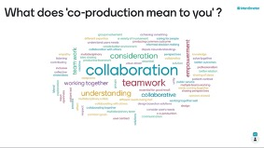

Figure 1: Showing Word Cloud exploring the language of co-production.
The workshops were designed around a series of tangible tasks that stimulated discussion and restated the importance of ‘hands-on skills’ in both medicine and architecture. These included asking groups to create word-clouds of what co-production meant to them, image-mapping emotional responses on to different sites, and representing in modelling clay what an ideal mental healthcare space should smell, feel, sound, and taste like. The discussions these activities generated were summarised into a User Brief at the end of the first workshop, and then underpinned a Design Poster made in the second workshop, illustrating students' creative responses to that brief. Both workshops involved keynote speakers, interviews with clinicians, patients, carers, and other service users, as well as live Q&A panels offering feedback from architects, clinicians, and patient advocates.
Although the workshops were originally conceived as face-to-face workshops, due to the pandemic, the 2020/1 cycle was delivered online to facilitate the project's ambitious scale, and enable a genuine shared co-production experience, as envisioned by the core team working across the two institutions.
To enable organisation, four mental health conditions were identified and the students were each assigned to one of the four conditions: Dementia, Stroke, Neurodevelopment and Family Therapy. Along with 160 students assigned to each health condition, two teaching teams made up of clinician and architecture tutors were set up, each covering eight groups. Each health condition had its own Zoom plenary space along with Zoom break-out spaces for the individual groups to meet, and each group had access to a board on an online whiteboard programme called Miro. This 40-second video (http://tiny.cc/8u8xtz) shows how Miro enabled 650 students, working remotely across multiple time-zones, to collaborate synchronously in 64 cross-disciplinary design groups. This was facilitated virtually by the 40+ tutors working across 4 parallel Zoom meetings on each workshop day.
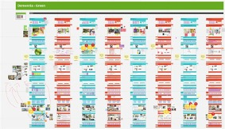
Figure 2: Showing eight Miro boards working simultaneously and enabling the 80 students working on spaces for dementia to view each other’s work as it was created, facilitating peer learning.
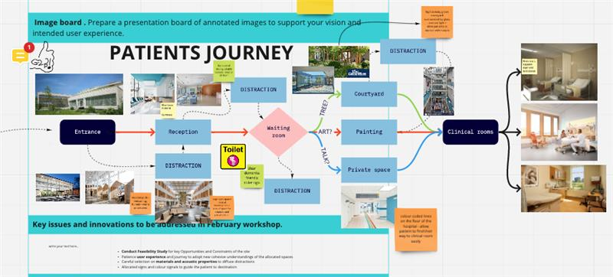
Figure 3: left; Detail of Miro board showing students considering a patient’s journey.
The Miro boards enabled individuals in each group to share ideas, pose solutions either as text or using images and diagrams in a visual and organic way. The boards were designed with a provocative mix of text and image to signpost the brief and activities. Embedded links to pre-recorded videos of keynote speakers, as well as video tours of the sites, were live-streamed to the parallel meetings. Additional expert input was provided by creating a video and audio library of interviews with mental health and design experts again accessible through links on the Miro boards. Patients and carers were placed centre stage through 2-hours of video interviews and testimonials.
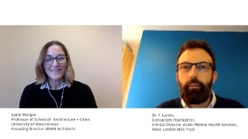
Figure 4: Example of expert input as ‘talking heads’ showing Professor Sadie Morgan (Architect) in dialogue with Dr Fin Larkin (Consultant Psychiatrist).

3. Results
Provoking both disciplines out of their comfort zone, the participatory nature of the workshops offered students a positive reframing of their expectations of what it means to be a ‘professional’ architect or doctor, as well as reconsidering the language and methods through which they communicate: the word design comes from the Italian word ‘disegno’ meaning a drawing, but also the drawing out of an idea; an etymology that emphasises the importance of thinking through doing.
3.1. Co-Designing Participation
So far, the workshop has been run in two cycles the first in November 2020 and February 2021, and the second in November 2021 and February 2022. In 2020/21 due to the pandemic the workshop was successfully held on-line as described above, as was the User Brief workshop in November 2021. By November 2021 however both the architecture and medical students were beginning to return to campus teaching and staff noticed Zoom/Miro fatigue and less enthusiastic student engagement.
In February this year with the British government relaxing pandemic restrictions, we took the decision to hold the design workshop ‘in person’ on the University of Westminster Campus spreading the students across the architecture studios and a large exhibition space called P3. The mapping of an online pedagogy back into real space was challenging; the four Zoom meetings being spread across seven physical spaces. For the medical students it meant a day spent in a ‘studio environment’ – for most of them an unfamiliar typology of creative teaching space, while for architects the space encouraged a much more hands on experience that included physical model making. While during the online version of the workshop participants could turn their cameras off, and some did, when they were on campus that was not an option and students had to be ‘100% in the room’ which led to a sense of deeper engagement. Exhausting but much more stimulating, the delivery of the workshop in person required staff to accept losing some control of the timetable and the outputs, as the sixty-four groups of students literally took matters into their own hands. Experiential learning theory tells us that if we are aiming for transformative perspective shifts and cognitive reframing, we cannot tell students what to think but rather must let them see problems and consider solutions for themselves (Kolb, 2015). With this in mind and reflecting on the workshop delivery, it was clear to us that such co-design experiences, particularly when performed in person may offer an example of transformative learning by ‘thinking through doing’.
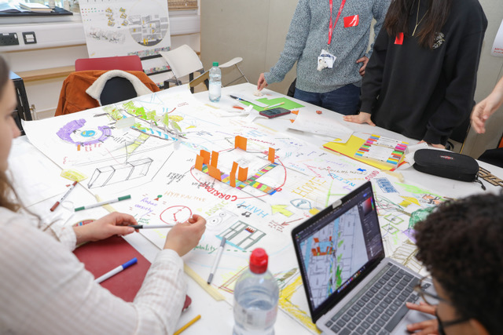
Figure 5: Showing one of the groups looking at dementia in person.
Compare to Image 2 of the same group on a Miro board.

3.2. Student Engagement and Post Evaluation
Student engagement was enabled by making the workshop a compulsory component of the Professional Practice modules of the five different architecture courses taking part and the Ethics and Law module for the medical students. In each case, following the second workshop students were asked to write a reflective piece on their experience. Each course framed the feedback to suit its specific learning outcomes, but in all cases, students were asked to reflect on the process of collaboration in terms of innovation, creativity, empathy, and use of language, rather than on the final outcome.
The quotes below have been extracted from student feedback received in reflection to the 2020/21 workshop to include comments from student partners from both University of Westminster and Imperial College alike:
‘This design project has taught me the importance of co-production, especially in the field of mental health and well-being. It is only when the stakeholders come together, that we can think of innovative, creative and effective user-centred solutions.’ (Medical student)
‘It’s surprising how often co-production doesn’t happen, and how much difference it can make, in terms of innovation, creativity, and better patient outcomes, when it’s done effectively.’ (Medical student)
‘Collaborating together with complete strangers was a true exercise in empathy and one that made me fall in love with healing people all over again. I rediscovered how healthcare has the power to touch people's hearts and how creativity is the key to achieving that.’ (Medical student)
‘Further to the workshop, I believe I have become more aware of the need to place my design thinking in the patient's eyes to create an innovative space that helps put mental health patients at ease. I have also found that working alongside medical professionals have helped me understand the space in more depth.’ (Architecture student)
‘This project has allowed me to really think in-depth about how to create a better conducive environment for those with special needs and how to put myself in their shoes and empathise with them.’ (Architecture student)
‘The Mental Health and Wellbeing project was a brilliant chance to appreciate that the role of a doctor is sometimes understanding how a patient feels, rather than objectively treating the immediate problems they can see.’ (Medical student)
‘Mental Health and Architecture are closer than many people may think. The collaboration between these two sectors is essential in order to provide an innovative approach to healing.’ ‘The design project demonstrated that a shared goal of helping others facilitates collaboration like nothing else.’ (Architecture student)
‘Collaborating with the architecture students was a wonderful opportunity to explore the non-medical side of the profession. Sharing ideas to create a sustainable, efficient and welcoming environment for patients, relatives and healthcare workers alike is essential to provide optimal care and a smooth recovery.’ (Medical student)
‘It was really eye opening how collaborating with other people from a different educational background would result in something I would have never come up with on my own, or with only people studying medicine.’ (Medical student)
‘The Mental Health and Wellbeing design project was a fantastic collaboration. We learnt that architecture and design are also an important part of a patient’s recovery, offering safe and comfortable spaces.’ (Architecture student)

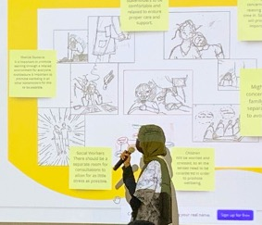
Figure 6: Showing a student talking through the group’s storyboard describing the experience of different stakeholders.

4. Discussion
While the focus of the Co-Design Workshop was clearly set on the process and methods that encouraged and enabled the practice of collaboration rather than the end result, participants co-produced and suggested design proposals that provided key insights into the potential regeneration and reuse of existing hospital spaces which are to be disseminated in the next phase of this project in progress.
As educators, when considering the scarcity of opportunities, particularly during lockdown, for collaboration between distinct courses and across institutions, we reflected on the important benefits of working across disciplines while relating the questions the workshop posed to ‘real life’ societal issues that prevail outside the university sphere. Working directly with stakeholders and patient advocates as part of a synchronous teaching activity, challenged the way staff and students alike perceived co-design as well as the creative design process. The student feedback clearly shows that interdisciplinary learning and co-design is highly valued by learners, as it supports the acquisition of transferrable skills, and has enduring impacts on learning and practice including transformational reframing. Selected student feedback highlights the key lessons learnt when reflecting on the notions of co-production, empathy, and collaboration in the fields of education and practice, while identifying changes in perception before and after the completion of the project.
In regards to the planning and actuation of the workshop, the challenges were present in both expected, due to the project’s scale and innovative approach to collaboration, and in less expected ways. In particular, the sharing of student e-mails and the access to videos shared across the two institutions, required close collaboration (and good humour) to meet the unforeseen General Data Protection Regulation requirements, which required a formal data sharing agreement as well as additional consent to record and store interviews. For all participants, despite national and international lockdown, this co-design project provided an opportunity to grow new networks, friendships, and ways of working.
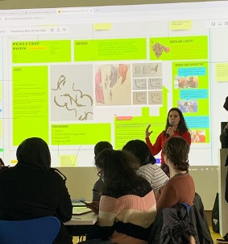
Figure 7: Showing a student presenting the group’s final Design Poster to her classmates.

5. Conclusion
Ambitious in scale and provocative, the Mental Health, Design and Wellbeing Co-design Workshop, taught us that a key part of being an architect or a clinician is the ability to listen with care to service users, health professionals and other stakeholders. Co-design requires collaboration, communication and creativity. The partnership between the two universities transformed existing pedagogies in both disciplines. Following reflections from students and staff, who all whole-heartly embraced the challenges of the process of conceiving, setting up and delivering such a large-scale educational workshop across institutions and disciplines, the overall partnership was identified by all actors involved as an extremely rewarding experience.
The partnership is an ongoing collaboration demonstrating excellence in education, innovation in relation to the design of mental health settings and spaces, and commitment to service user and patient involvement, setting a paradigm which has already won the Association for Medical Education/General Medical Council Excellent Medical Education Award (2019).
This particular co-design paradigm offers an immersive and experiential learning experience and supports students to develop complex transferable skills relevant to future practice, with the next cycle about to run in 2022/23, aiming at facilitating both phases of the workshops ‘in person’; it is an evolving process.
In The Good Ancestor: How to Think Long Term in a Short-Term World (2020) Roman Krznaric suggests the way to a more regenerative future is through transformation (rather than breakdown or reform). A project such as this does not offer an immediate solution to poor NHS mental health facilities in the UK. The design solutions described in the posters should not be seen as the final result or end point but rather as seeds. If 650 ambitious, inquisitive, and talented young architects and medics go out into the world each year ‘armed’ with an enhanced knowledge of collaboration, creativity, and communication, they will be better placed to address the healthcare issues of tomorrow. It is this transformative reframing of their professional practice which is the real outcome.

Data Availability Statement (if applicable)
Following the 2020/21 workshop we held an Online Exhibition as a dynamic artefact: http://www.openstudiowestminster.org/co-production-2020-2021/
The project has generated a widespread interest from architects and health care professionals alike. Staff and students presented at two public panel discussions that followed the project, the first organised by Dementia Action Alliance called ‘Reframing Dementia Through Co-Production and Design’ (21.06.21) and the second ‘Practices of Care’ organised as part of the London Festival of Architecture (11/06.21). We invited student participants to speak at both events, as well as to join the audience.
https://www.eventbrite.co.uk/e/reframing-dementia-through-co-production-and-design-panel-discussion- tickets-154840065805
https://www.westminster.ac.uk/events/practices-of-care-a-cross-disciplinary-discussion-on-designing-for- mental-health-and-wellbeing

Contributor statement
The authors acknowledge the contribution of Kay Leedham-Green from Imperial College London in the co-design of the workshop and the writing of this paper.

Acknowledgments (optional)
Acknowledge any other support which cannot be covered by the contributor statement.

References

Arnove, R.F, (2020). Imagining what education can be post-COVID-19. London, England: My Publisher.
Cohen, J. (2007) Humanism & Professionalism
https://journals.lww.com/academicmedicine/fulltext/2007/11000/viewpoint__linking_professionalism_to_humanism_.5.aspx
Devi, G. (2015). Creativity in medicine. Neurology, 84(8) e53-e54.
https://doi.org/10.1212/WNL.0000000000001298
Doneto, (2014) Experience-based co-design
https://www.pointofcarefoundation.org.uk/resource/experience-based-co-design-ebcd-toolkit/?gclid=CjwKCAiA1JGRBhBSEiwAxXblwRbGoaZEP-8qtq9oFnr-SlhrLPlDQs8mEKMlzUkItnor65WoKGnQOhoCLacQAvD_BwE
Ford, M., (2019) Warning over ‘long-term neglect’ of mental health NHS estate, in Nursing Times.
Kolb, D., (2015). Experiential Learning: Experience as the source of learning and development (2nd ed.). Pearson Education.
Krznaric, R., (2020). The Good Ancestor: How to Think Long Term in a Short-Term World. Penguin Random House
Thompson, J.,(2019). Narratives of Architectural Education: From Student to Architect. United States: Taylor & Francis.
Leitch R,. Day, C.,(2000) Action research and reflective practice: towards a holistic view, Educational Action Research, 8:1, 179-193.
Trayner, W. (2015) Evaluating communities of practice https://wenger-trayner.com/introduction-to-communities-of-practice/

