Type of the Paper: Peer-reviewed Conference Paper / Full Paper
Track title: Topic 1: integration of needs – inclusive, integrated design enabling health, care and well-being.

Safe housing for a meaningful everyday life
Development of housing for people with drug addiction, psychiatric disorders and violence risk

Solvår Wågø ^{1,}*, Melina Røe and ² Stina Svendsen ²
¹ SINTEF Community; solvar.wago@sintef.no; ORCID: 0000-0002-6574-5316
² NTNU Social Research; melina.roe@samforsk.no; ORCID: 0000-0003-4071-5265
² NTNU Social Research; stina.svendsen@samforsk.no
* Corresponding author.

Names of the Topic editors:
Clarine van Oel
Names of the reviewers:
Federica Romagnoli
Birgit Jürgenhake
Journal: The Evolving Scholar
DOI:10.24404/6230943244461baae6961522

Submitted: 23 March 2022
Accepted: 22 August 2022
Published: 08 March 2024
Citation: Wågø, S., Røe, M. & Svendsen, S. (2022). Safe housing for a meaningful everyday life. The Evolving Scholar | ARCH22.

This work is licensed under a Creative Commons Attribution CCBY license (CC BY).

© 2022, Wågø, S., Røe, M. & Svendsen, S. published by TU Delft OPEN on behalf of the authors.
Abstract:
Objective: establishing a safe and worthy place to live is an important step for people struggling with substance abuse and psychiatric disorders. In this project, we have followed Trondheim Municipality in the process of establishing a new housing model that contributes to safety and mastery for people with combined disorders and violent behaviour.
Background: providing comprehensive services to people with violent behaviour affected by drug use is challenging. Trondheim Municipality aims to develop a breadth of housing and services for this target group. One of the plans in that context is to establish a home for 6–8 people in close physical proximity to the mental health-care department at St. Olav's hospital.
Methods: an action research approach is suitable when the goal is to create change and the intention is to create new solutions to current problems (Levin, 2017). Qualitative interviews with professionals in the field, user representatives, workshops, participation in the planning process, and literature studies have been conducted.
Results: the need for safety, fixed routines, positive impulses, and the opportunity to influence one's own everyday life are pointed out as crucial for people with a behaviour that either scares or is exploited. Several emphasise the importance of activities and food- service to ensure that nutritional status is maintained.
Conclusion: Rethinking housing models for the target group is necessary but difficult in practice. There is a need for innovative solutions, designs, and services for individuals that secure employees and neighbours.

Keywords: Housing; dignity; architecture; mental health; quality of life

1. Introduction
People with drug-related disorders, substance abuse, and the risk of violence have persistent and complex problems and are often experiencing challenges in life as a result of drug addiction and mental disorders. This is a group that is perceived as challenging to help, as they often do not take advantage of the offers that exist or are offered. At the same time, it is also a matter of lacking suitable housing and services (Wågø, Høyland & Bø, 2020). Therefore, it is necessary to see services, activities, and housing in context. This requires close cooperation between the mental health service in the municipality and between the municipality and the specialists in mental health care.
This paper is based on a collaboration between SINTEF Community and NTNU Social Research, where a grant from the Norwegian State Housing Bank made it possible for us to follow and contribute knowledge in the development of a new housing and mental health care solution for people with drug addiction, psychiatric disorders, and violent behaviour in Trondheim Municipality. The municipality was in the process of planning eight co-located rental homes with a service base. The selected plot is located on Østmarka in Trondheim, close to St. Olav Division of Mental Health Care and the newly established security building where patients subject to compulsory mental health care are hospitalized. This was a conscious choice from the municipality’s perspective, since Trondheim Municipality wanted to look at the possibility of giving the residents of the future apartments better services. Easy access to expertise from the St. Olav Division of Mental Health Care and physical proximity to staff and expertise in the security building were seen as benefits.
The municipality also has a long-term plan to develop and “normalise” the area with both housing, kindergartens, and other functions. Through close collaboration with the municipality, the goal of the research team was to follow the development of new housing and a safe and secure solution for a meaningful everyday life for these people, who are the most difficult to settle. Our aim was to contribute knowledge and competence during the first phase of the planning work to support the establishment of better housing and service solutions, which should be able to work well for both employees, neighbours, and users.
Our main task has been to provide input to the process and also contribute knowledge about key factors in the development of a new and tailored housing and service solution. People with complex disorders and violent behaviour need comprehensive services that include care, activation, security, and safety. The findings are useful for Trondheim municipality but will also provide input to similar processes in other municipalities.

2. Theories and Methods
The research design in this research project has been to follow a process and to be close to practice. We, as researchers, have entered into a research and learning community with non-researchers who are problem owners or have interests and obligations in the field. This is a working method that is often referred to as follow-up research (Levin, 2017). By being close to the process, researchers gain a deep understanding of the situation (Reason & Bradbury, 2008). At the same time, it will be important to consciously take a critical distance from the process in order to be able to reflect analytically on the phenomenon being investigated (Johansson & Lindhult, 2008).

To shed light on the issues, the project consisted of several parts:
- participation and observation of the process work in the municipality (participation in meetings regarding the area and function programme and then the scheme design, interviews, a site visit and a visit to the newly established security building close to the plot, discussions, etc.);
- collecting knowledge from relevant research and initiatives, mainly Norwegian;
- obtaining experiences and input through semi-structured group interviews in five large cities with key informants from the housing and service area (the Norwegian State Housing Bank's metropolitan network) and conducting qualitative interviews with key informants from the field of practice, managers, and employees in housing and mental health care in Trondheim municipality;
- knowledge sharing and knowledge development along the way through presentations and dialogue.

An innovative research approach that seeks innovative solutions and development can be illustrated by Figure 1.
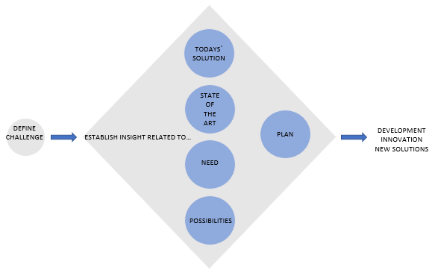
Figure 1: an innovation-driven research approach is based on recognising a defined challenge and then establishing insight into current solutions, established knowledge in the field, needs, and opportunities, and through this, creating a plan for further development that can create new innovative solutions. Illustration: SINTEF Community.
Participation in the municipal process
The research group had planned to conduct two workshops on the project. Due to COVID, restrictions, and infection control, we set up general meetings digitally. In two of the digital meetings, the research group presented earlier research related to the target group. A physical meeting was later held where Trondheim municipality invited the Division of Mental Health Care at St.Olav Hospital. This meeting was led by Trondheim Municipality.
During spring 2021, Trondheim municipality arranged a series of meetings with a working group that worked on the functional brief. This working group had representatives from various municipal units who are responsible for housing for users with substance abuse and mental challenges (both managers and employees), employee representatives, safety representatives, and chief safety representatives for health and welfare. There are ten employees. From the user side, one representative of a user- and relatives' organisation and one representative of Mental Health Trøndelag participated. Three advisors and project managers in the municipal director's professional staff also participated. Two of the researchers in the research group (one from SINTEF Community and one from NTNU Social Research) followed this work with the functional brief for the new housing initiative (meeting series spring 2021) and then the municipality's start of work with the scheme design (meeting series autumn 2021). The work resulted in the functional brief, which formed a knowledge base for the work in the scheme design where the architect (two persons) was involved.
Two user representatives participated in the work on the functional brief. Potential residents were not interviewed during this follow-up research project. This was a conscious choice, as a study had recently been done on user experiences in housing for the target group in Jarleveien (Bjørgen et al., 2021). In previous projects, the research team has also interviewed residents about their experiences with existing housing and service solutions (Røe, Woods & Jæger, 2014; Wågø, Høyland & Bø, 2019; Wågø, Bø & Høyland, 2021). These sources are used in this research work.

3. Results

Who are the new residents?
The municipality of Trondheim, like other large cities, experiences that there are often major challenges associated with providing housing and services to people with drug addiction, psychiatric disorders, and violence risk. What is often defined as one group, "people with combined disorders," is in fact a very complex and heterogeneous group of people. Here you will find people who pose a serious risk of violence and people who are at great risk of being exploited, abused, and exposed to violence.
Most of the employed staff we interviewed state that they experience that the target group needs more help than before, that they intoxicate themselves more and with stronger drugs, and that they are often sicker. They believe this is partly due to premature discharge from psychiatry (SIFER, 2020). It is also pointed out that some in the target group have a developmental disability or developmental disorder, which may or may not be diagnosed. This is a group that is associated with extra-great concern.
Women are another group that is described as particularly vulnerable. Several say they could wish for their own women's initiatives. One reason is that it is often perceived as more unstable when there are women and men together. Another reason is that women may be in an extra vulnerable position in the user community.
In addition, there will also be other groups that are extra vulnerable within an already vulnerable group. In other words, there are many different individual needs within the target group. Changes may also occur over time. One informant pointed out:

“People are not static, and the situation and needs can change.”

All such factors are important to take into account when discussing who should be included in the new housing.

What should the new housing offer?
The aim of the new housing solution is to provide a safe home that contributes to coping and improvement for people with serious combined disorders and a risk of violent behaviour. The project aims to:
- provide housing suitable for people with combined disorders in need of a specially reinforced and adapted round-the-clock service offer;
- ensure the safety of employees and the environment;
- and contribute to users receiving comprehensive services from the municipal and specialist health services.

The municipality outlines that there should be a staff base associated with the housing, in addition to the residents being able to receive services from ambulant teams.
Generally, society desires the highest degree of normalization. This means that as many people as possible should live in ordinary homes in ordinary neighbourhoods and have the opportunity to live independent and active lives. It is therefore limited to the degree to which the municipality should facilitate supporting the residents. Some informants state that the support may also take place through ambulant teams.
At the same time, many of those we interviewed who work in various housing measures are sceptical about cutting the 24-hour staffing. One says that

“Full-time staffing is the alpha and omega for the housing solution to work.”

They want to avoid "wrapping up" the residents and contributing to their helplessness. On the other hand, informants warn against having unrealistic expectations of the residents.

Resident composition is important for the residents' experience of security
The employees' advice to ensure safety, stability, well-being, and quality of life for both employees and residents can be summarized as follows:
- do not put women and men together;
- be careful not to put bitter enemies together; the drug environment is harsh;
- avoid putting people who go on different drugs together. For instance, individuals addicted to amphetamines may seem too high-energy for opiate addicts who are typically more relaxed;
- combining young people with older drug addicts can lead to the young individuals becoming heavy drug addicts themselves..

Location
It has been argued that the new homes will be located at Østmarka to take advantage of the proximity to the expertise from the St. Olav Division of Mental Health Care. The municipality points out that the location provides proximity to quick health care. The goal, as described by the municipality, is that there should be close follow-up with a methodical, professional approach based on everyone being different and needing different solutions.
Several employees in the specialist health service and the municipality highlight what they consider to be clear disadvantages of the location, as the homes will represent easy access to drugs and cause noise for patients at Østmarka who need security. It is also pointed out as well-known that many of the possible residents express that they have had bad experiences with mental health care services and may find it stigmatising to live next door to the mental health care hospital.

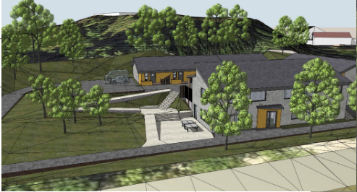
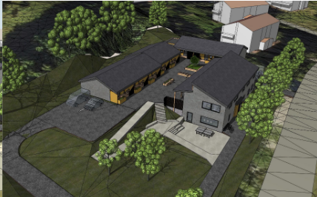
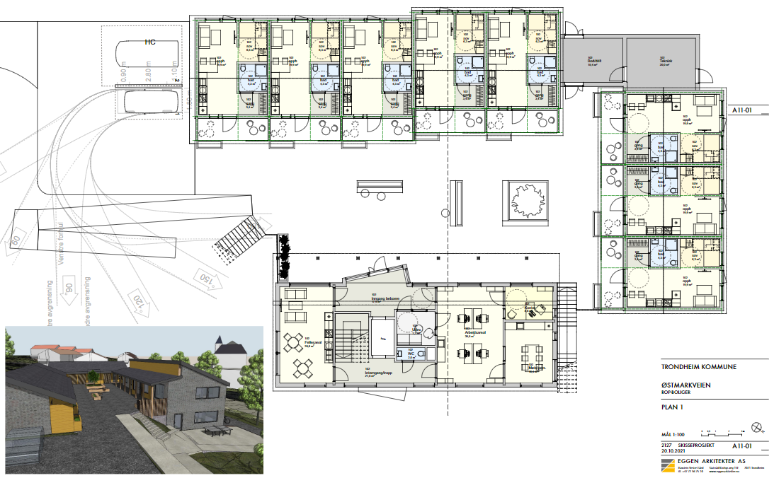
physical design can affect people's activity, choices, and, not least, security and well-being (Thaler & Sunstein, 2008; Ulrich et. al., 2018).
Service- /common area
Service- area (Ground floor)
Housing
View to courtyard/from south
View from north-east
Courtyard

Figure 2: the scheme design dated 20th October 2021. Drawings: Eggen Architects as.
Homely, safe, robust
Physical design can affect people's activity, choices, and, not least, security and well-being (Thaler & Sunstein, 2008; Ulrich et. al., 2018).
Members of the target group prefer to avoid visual access, and proponents argue that residing on a high ground floor or second floor can enhance residents' sense of security. Many people in the target group prefer windows placed high up on the wall rather than windows that go all the way down to the ground.
Several point out that the apartments should have their own direct exit and not exit via a corridor. In terms of safety (both for residents and staff), it may be appropriate for apartments to be on a high ground floor with exits at both the front and the back, as this can also constitute escape routes. There should be clear lines of sight to the entire apartment, including the escape route, from the front door, and one should avoid kitchen drawers with access to knives right at the entrance.
There is a balance between reinforcement and homemaking for a target group that can periodically be violent. Examples of home reinforcement include replacing plaster walls with harder boards, removing mouldings, laying floor coverings that go up the walls, removing cabinet doors, and installing steel sinks and toilets. A manager points out that considering the living experience will also impact how the home is experienced. Steel furnishings can be stigmatizing and more expensive to replace than porcelain toilets and sinks. The materials used and fixtures installed should be affordable, not easy to injure themselves or others with, and easy to replace. Visible vandalism generates more vandalism, triggering aggression, dissatisfaction, and mistrust.
When it comes to the size of the housing units, there are many who point out that 50 square metres appears to be too large for some residents and that 35 square metres will be large enough for most. Several people can be collectors, filling up apartments with things that others would describe as rubbish. At the same time, there were some informants who emphasised that the apartments must be large enough to handle a person who needs help.

Service areas and common areas
When planning service areas and any common areas, it should be clear what the needs on the service side will be, residents’ needs, and staff needed. Clarify the staff plan, which outlines the functions that are to be covered in these areas, whether common meals, activities, or the like, before outlining the measure's physical design.
Participants also discussed the need for common areas. Some believed that there should not be many activities "on the house" and that the residents, to a greater extent, should use existing activities in the city. Others thought that activities related to the common areas of the home were important for low-threshold activities and contact between the residents and employees. Meeting points, such as meals or hobby activities, can help to create good moments.

Staff visual overview
In interviews, several express that it is important that the employees have a good overview of the area and can see who is coming and going. Some residents need help with protection from visitors or other residents and may have difficulties setting boundaries for their own and others' behaviour. Other residents may feel monitored. Technological solutions such as doors, locks, and monitoring may be necessary to ensure the safety of both staff and users. Assess these solutions, considering the residents' freedom and wishes. There is a lot to gain from a design that can provide an overview instead of control.

Activities
A consistent and clear message in the interview material is a desire for more activities related to housing solutions for the target group. Employees, experience consultants, and user representatives emphasized this. Many individuals in the target group exhibit creativity and artistic talents. Many of them have a large amount of energy that they are unable to use constructively. Getting to know the residents, their interests, and uncovering forgotten hobbies is crucial. This is an unused field, the informants believe.
Relationship building is important. Activities can then function as an important "interaction pretext"—you get a reason to interact with each other. Activities and trips create relationships between staff and residents (and between the residents), and they give variation to the residents' everyday lives—an everyday life that is otherwise largely about hunting for drugs (Hope & Anthun, 2021). Activities also provide good observation opportunities and the chance to create shared memories. According to experiences from housing and services for the target group in Oslo (Oslo municipality, 2020), talking about an activity rather than "you and your problems" lowers the threshold for building a relationship.

4. Discussion
A recurring question in our follow-up research has been:

- Does the planned housing solution and service offer represent something new?
- Is the location on Østmarka appropriate?

Several of those we interviewed want a greater degree of innovative thinking about the collaboration between mental health care and the municipality, as well as a discussion on how to utilise the location on Østmarka.
In the interviews, we asked employees if they could briefly say what they wanted the new housing to include and what was most important in establishing new housing for the target group. One of the leaders we interviewed gave the following answer, which actually summarises many of the points we have looked at in this report:

“I hope that it will be a home with the physical prerequisites to provide good services, at the same time as I want there to be activities employees can bring people with them, both at the house and in the city. At the same time, the composition of the residents must be well thought out. And of course, there must be good cooperation with the specialist health service and with the ambulatory teams.”

In order to create new housing, there is a need for innovative solutions, both in terms of the home's design, surroundings, activities, and service models, but also of the planning process itself.
Unlike traditional meetings, which have been held digitally due to the pandemic, workshops and dialogue conferences are suitable forms of work that allow for interdisciplinary discussions and the assessment of different perspectives and input. Such working methods are not intended to inform participants, but rather to work together to create new knowledge, new solutions, and innovative service solutions. A wide range of actors may have better conditions for creating something that can represent something innovative and new.
Trondheim Municipality points out that the proximity to Østmarka could provide opportunities for closer collaboration on service models with the specialist health service. Planned housing will impact the area in various ways. It will therefore be critical that the location be used to create new and strengthened forms of collaboration between the municipality and the specialist health service, as well as gains that outweigh any disadvantages that the housing measure may entail.

5. Conclusions and lessons learned
Interviewees emphasised the need to facilitate relationship work. This requires time, a secure framework, stability, and predictability. Many informants highlight key elements such as access to activities, positive impulses, and the opportunity to influence their own everyday lives. Several emphasise the importance of food servings to maintain a certain nutritional status, and medication is well taken care of.
At the same time, the housing must be a good place to live for the residents, as well as a safe and attractive workplace for employees. The safety of employees and neighbours must be taken seriously. A close collaboration between the municipality and the specialist health service is absolutely crucial.
Activity is an untapped field for this target group, and a greater degree of innovation around this topic is welcomed. Based on completed interviews, we recommend new thinking related to recruiting employees. In addition to health and social work staff, there are good experiences with hiring craftsmen and musicians to get more perspectives on how to work environmentally, therapeutically, and actively. There are also several examples of good experiences gained by hiring experienced consultants and further developing the role of environmental caretakers. The goal, from a longer perspective, will be for the residents to be able to make greater use of the general services that are available to everyone in the municipality.
Finally, the physical environment has an impact on behaviour. The physical design of the homes can help to prevent stigma and unwanted incidents while also contributing to security and well-being for residents, employees, relatives, and neighbours. The design can help to shield and protect both from visual impressions that can trigger or give positive visual, sensory, and tactile impressions (green surroundings, access to a garden, materials, airiness).
By following the process of this project, an important lesson is learned: a better point of departure for municipalities and other initiators would have been to start with what kind of housing this should be and what the housing and services connected to it should contribute to for the residents. When being too busy with the building, construction projects often become out of step with what, e.g., the housing should be and lead to for the residents. This is potentially transferable to other building projects and contexts in other parts of society.

Acknowledgments
This research is financed by the Norwegian State Housing Bank. We would also like to thank our partners in Trondheim municipality for their good collaboration and interesting discussions. We thank everyone who volunteered for the interviews and shared their experiences and input with us.

References

- Bjørgen, D., Småvik, G., Klevstuen, L. & Johansen, K.J. (2021): Jarleveien 10 –Beboernes erfaringer med boligløsning for rusavhengige. Kompetansesenter for brukererfaring og tjenesteutvikling (KBT).
- Hope, S. & Anthun, K. S. (2021): Et godt Dagsverk? En kvalitativ evalueringsstudie av dagsverkets virksomhet, med vekt på deltakernes opplevelse av tilbudet. Trondheim: NTNU og Stavne KF.
- Johansson, A.W. & Lindhult, E. (2008): Emancipation or workability? Critical versus pragmatic scientific orientation in action research. Action Research, 6(1), p.95-115.
- Levin, M. (2017): Aksjonsforskning som forskning – epistemologiske og metodiske utfordringer. I: Grøtterud et al (2017) Aksjonsforskning i Norge: Teoretisk og empirisk mangfold, Oslo: Cappelen Damm Akademisk.
- Oslo kommune, Velferdsetaten (2020): Bosetting av personer med sikkerhetsproblematikk i egne boliger. "Sammen om bolig"; et innovasjonsprosjekt utarbeidet av seks bydeler i Oslo.
- Reason, P., & Bradbury. H. (2008): The SAGE Handbook of Action Research, Participative Inquiry and Practice. Second Edition. London: SAGE.
- Røe, M., Woods, R. & Jæger, I. (2014): Stolt beboer- Folk og hus i Tollåsenga. Trondheim: NTNU Samfunnsforskning.
- SIFER (2020): Utskrivningsklare pasienter i sikkerhetspsykiatrien – en kartlegging av utskrivningsprosessen fra sikkerhetsavdeling til kommune. https://sifer.no/wp-content/uploads/2020/11/Utskrivningsklare-pasienter-i-sikkerhetspsykiatrien-en-kartlegging-av-utskrivelsesprosessen-fra-sikkerhetsavdeling-til-kommune.pdf
- Thaler, R. H. & Sunstein, C. R. (2008): Nudge. Improving decisions about health, wealth and happiness. Penguin books.
- Ulrich, R. S., Bogren, L., Gardiner, S. K. & Lundin, S. (2018): Psychiatric ward design can reduce aggressive behaviour. Journal of Environmental Psychology, 57 (2018) p.53-66. https://www.sciencedirect.com/science/article/pii/S0272494418303955
- Wågø, S., Bø, L. A. & Høyland, K. (2021): Småhus – hjem og verdig botilbud? Kommunenes erfaringer og beboernes stemmer i 14 norske kommuner. Trondheim: SINTEF Community.
https://www.sintefbok.no/book/index/1279/smaahus_hjem_og_verdig_botilbud_for_personer_med_ruslidelser_og_psykiske_lidelser_kommunenes_erfaringer_og_beboernes_stemmer
- Wågø, S., Høyland, K. & Bø, L. A. (2019): Bokvalitet og verdighet -en evaluering av boliger for mennesker med rus- og psykiske lidelser. Trondheim: SINTEF Community.
https://www.sintefbok.no/book/index/1210/bokvalitet_og_verdighet_en_evaluering_av_boliger_for_mennesker_med_rus_og_psykiske_lidelser

