Type of the Paper: Peer-reviewed Conference Paper / Full Paper

Architects’ perspective on the implementation of natural blue elements (sky and water) in CT scan environments
Fatemeh Amirbeiki Tafti ^{1,}*, Gesine Marquardt ²
¹ TU Dresden; fatemeh.amirbeiki_tafti@tu-dresden.de;
² TU Dresden; gesine.marquardt@tu-dresden.de;

Abstract:(1)Objectives: This paper explores architects’ opinions on the implementation of natural blue elements (sky and water) in windowless areas of healthcare facilities specifically computerized tomography (CT) scan environments (2)Background: Compared to green elements, there exists little evidence about the beneficial aspects of exposure to blue elements in healthcare facilities. (3)Methods: Participants were architects involved in designing healthcare settings and an online photo questionnaire was distributed among them: 25 responses were analyzed. It was followed by 6 semi-structured interviews. All participants evaluated the restorative qualities of 1)Sky panel on the ceiling of CT room, 2)Water pool adjacent to the wall between CT and control room, 3)Sky panel on the wall in front of the door to the CT room, 4)Water pool behind the glass wall in CT room, 5)Sky panel on the ceiling of changing room, 6)Sky panel on the wall of changing room.(4)Results: According to architects’ opinion, exposure to the sky panel on the ceiling of CT room and exposure to water pool behind the glass wall in CT room might create a more restorative environment. Furthermore, architects regarded implementing interventions such as adding movement to the content of blue elements, considering specific architectural layouts, considering specific size of sky panel and adding water wall are capable to increase the positive influences of blue elements on reducing patients’ stress. (5)Conclusions: The findings aim to increase the awareness regarding blue elements’ role specifically water among architects as a group who design environments that cater to the patients’ needs.

Keywords: Blue elements, Sky, Water, Restorative influences, CT scan environments.

(to be completed by the editors)

Names of the Topic editors:

Names of the reviewers:

Journal: The Evolving Scholar
DOI:10.24404/62309f56625209e3a42b1803

Submitted: 2 Jun 2022
Accepted:
Published:
Citation: Amirbeiki Tafti, F. & Marquardt, G. (2022). Architects’ perspective on the implementation of natural blue elements (sky and water) in CT scan environments [preprint]. The Evolving Scholar | ARCH22.

This work is licensed under a Creative Commons Attribution CC BY license (CC BY).

© 2022 [Amirbeiki Tafti, F. & Marquardt, G.] published by TU Delft OPEN on behalf of the authors.

1. Introduction
Healthcare facilities are generally characterized by fear, anxiety, stress, and uncertainty for patients (Ulrich, 2001), and psychological health, as an important aspect of human health (WHO, 1946), is negatively affected when people encounter healthcare situations (Huisman, Morales, van Hoof, & Kort, 2012). However, with the development of evidence-based design, it has been demonstrated repeatedly that applying some specific design strategies in the built environment of healthcare facilities, can bring about significant health benefits for various groups of patients (Marquardt, Bueter, & Motzek, 2014; Ulrich et al., 2008). Nature exposure, especially plants and green areas, is known as one of these effective design strategies which can produce many psychological health benefits. Indeed, it has been indicated that providing nature exposure in various forms such as views to green spaces through the windows (Ulrich, 1984), having indoor plants in different areas of healthcare settings (Beukeboom, Langeveld, & Tanja-Dijkstra, 2012), installing posters of natural environments on the walls (Beukeboom et al., 2012), using motion nature in the CT scan environments (Zijlstra, Hagedoorn, Krijnen, van der Schans, & Mobach, 2017) have been capable to bring about positive influences on patients.
The research today, however, has tended to focus on green elements rather than blue elements. Even though sky and water are substantial parts of what humans perceive as “nature” and both have considerable value in terms of restorative effects in various environments (Amirbeiki & Khaki Ghasr, 2020; Ottosson & Grahn, 2008; Tafti, Rezaeian, & Razavi, 2018; White, Elliott, Gascon, Roberts, & Fleming, 2020), research on their role in healthcare facilities has been restricted to limited numbers. Yet despite the scarce evidence about their role, they have been applied in such environments.

Already in the nineteenth century, with using large windows and skylights, exposure to nature, especially the sky was provided in hospitals. In order to use the maximum amount of sunlight, large windows facing south were designed (Sternberg, 2010) which consequently led to the sky exposure. In addition to the sky exposure through windows which might occur unintentionally, sky panels located on the ceiling, sky projection on the ceiling and walls (Zijlstra et al., 2017), and skylight implementation are among other design strategies that have brought sky into the healthcare settings in recent times (Pati, Freier, O’Boyle, Amor, & Valipoor, 2016; Pati et al., 2014).
Water has been also used in healthcare settings in various forms and its’ implementation is not limited only to the outdoor environments. There have been several forms of exposure to water in indoor environments of healthcare settings as well. Indirect exposure such as window views to water in various parts, water projection, water paintings on walls, grounds, and even ceilings, and aquariums are the existing design strategies (Annerstedt et al., 2013; Barker, Rasmussen, & Best, 2003; Edwards & Beck, 2002).
Noticing the aforementioned studies and applications, however, there exists a main gap in this research area. Not only research on blue elements has been mostly restricted to a limited number but also they have been scarcely merged within the indoor environment as an architectural form.
The mentioned gap becomes more evident considering windowless or minimally windowed spaces of healthcare facilities such as the radiology department. With emerging advanced equipment in some departments, new hospitals have been mainly designed to accommodate these expensive medical instruments rather than considering patients’ health. Radiology departments containing delicate instruments such as CT devices have been affected by this notion in which there is still special attention on the care of CT devices. Further, due to radiation protection, several limitations for the application of windows in these areas have been materialized. Therefore, such departments have remained mostly windowless and lack nature exposure (Verderber, 2010). All these aspects trigger the stress level, fear, and unpleasant feeling of patients in CT scan environments who are simultaneously affected negatively by their diseases. Therefore, providing a better experience for patients supported by the design of the environment shows the necessity of considering CT scan environments as the case study.
Considering the gap, this study, therefore, is aimed at clarifying architects’ perspectives on the implementation of natural blue elements in CT scan environments. It intends to answer these questions:
- - How to bring blue elements into the CT-scan environments?
- - Which interventions associated with blue elements have higher potentials to decrease patients' stress and make more restorative CT-scan environments?
It is necessary here to clarify although patients’ role as one of the main user groups is important for designing healthcare facilities, their perspectives are not investigated in this paper. Since architects operate as an advocate for the patients’ needs, this study investigates particularly their perceptions on how to design the CT-scan environments associated with blue elements. However, further research will aim at bringing both architects’ and patients’ perspectives together.

2. Theories and Methods

2.1. Theories
This study relies on three core theories. “Ulrich’s Psycho-evolutionary theory” (Ulrich et al., 1991) as pioneering research showed that preferences and positive psychophysiological responses are associated with natural elements since cognitive capabilities evolved in natural environments. Further, Ulrich developed “supportive of design” (Ulrich, 1997) which focused on healthcare facilities and promoting patients’ wellbeing. Ulrich argued that the physical environments of healthcare facilities should support patients in coping with stress and having natural elements can play a major role in this regard. The third theory pointing to the restorative effects of nature has been proposed by Kaplan (Kaplan, 1995) which is widely cited in the research and similar to the psycho-evolutionary theory, it shows people have restorative experiences in natural environments.
All these three theories contribute to much and still growing research which has emphasized that compared to the built elements, exposure to the natural elements can bring about greater positive influences on human beings (Tzoulas et al., 2007; Ulrich et al., 2008).

2.2. Method

The research design for this study included two phases both evaluating architects' preferences for the same photo set. In the first phase, a photo questionnaire was distributed as an online survey. It was followed by semi-structured interviews in order to get more in-depth knowledge and to have further detailed discussions regarding the participants’ points of view.

2.2.1. Participants

The participants were mainly architects in practice and the majority of them were recruited from the organization “AKG-Architekten für Krankenhausbau und Gesundheitswesen”, who are German architects specialized in healthcare design. The photo questionnaire was sent using the Lime survey to the email address of 101 members of AKG. They were asked to answer the questionnaire themselves and/or distribute the survey among their colleagues who are involved in the design of CT-scan environments. 25 participants responded who 8 of them gave further comments with more detailed information regarding their responses. The semi-structured interviews were carried out over zoom with an additional 6 architects who were not involved in the online survey.

2.2.2. Photo questionnaire

Based on typical room layouts found in CT-Scan environments in German hospitals, a set of visual assessments including design strategies associated with blue elements, and interventions altering the perception of design strategies was developed. The designs were presented as a questionnaire including thirteen questions (in English) and an open-comment section.

The first item investigates architects' preferences regarding the fundamentals of spatial organization, regardless of any specific design feature associated with blue elements. Hence, it presents four common layouts of CT environments in which the designs vary with regard to the location of the CT room, control room, and changing room. The architects were asked to select one layout and give the reason for their preference (see Figure 1).

The next six items each consists of two parts. The first one introduces one of the design strategies, represented graphically by a perspective and the floor plan of a specific CT scan room including 1) Sky panel on the ceiling of CT room, 2) Water pool adjacent to the wall between CT and control room, 3) Sky panel on the wall in front of the door to the CT room, 4) Water pool behind the glass wall in CT room, 5) Sky panel on the ceiling of changing room, 6) Sky panel on the wall of changing room.
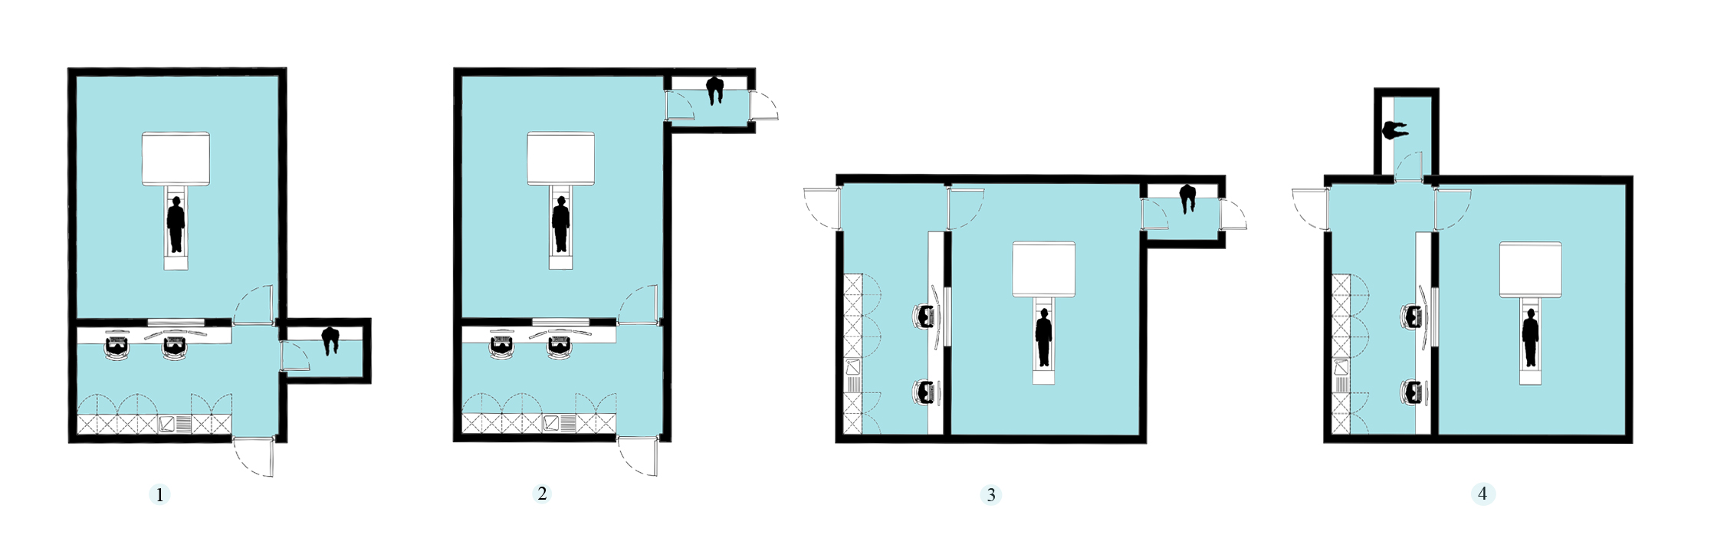
Figure 1. First item of photo questionnaire

The second part offers several interventions of the original design strategy such as changing the location of blue elements, adding movement to the content of blue elements, adding water wall, adding green elements, adding a skylight, changing the color of the wall containing the design strategy (See Table 1). Each item included the same questions for assessment. For the design strategy introduced in the first part, it was asked: “Please evaluate this environment on a scale of 1-5 (1-low, 5-high), in terms of its‘ restorativeness and how effectively it can help to decrease patients' stress?”. For the interventions in the second part, the question was: “Considering your rating to the previous question, please write down the number of top three interventions that can enhance the influence of design strategy on reducing patients' stress.” As the last item, an open-comment section for suggestions and concerns was presented.
Table 1.
Design strategies | Interventions
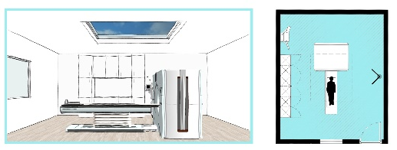  1. Exposure to Sky panel located on the ceiling of CT room | 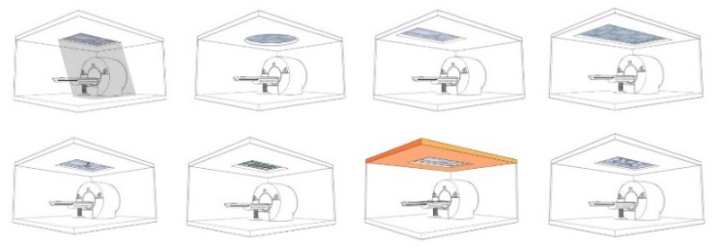
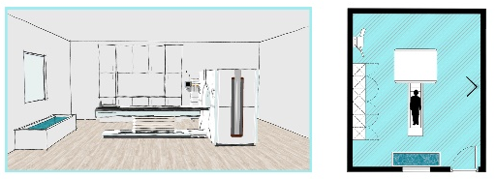  2. Exposure to Water pool located adjacent to the wall between CT and control room | 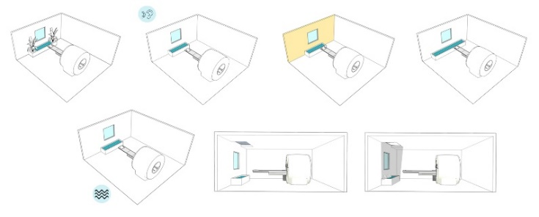
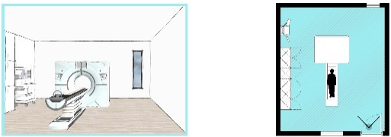  3. Exposure to Sky panel located on the wall in front of the door to the CT room | 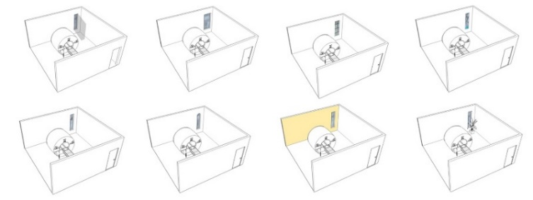
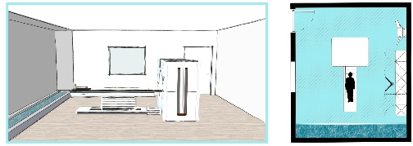  4. Exposure to Water pool located behind the glass wall in CT room | 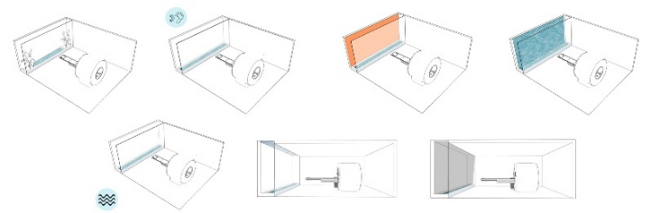
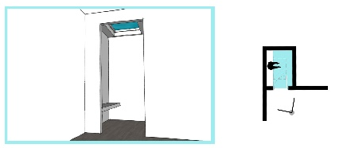  5. Exposure to Sky panel located on the ceiling of changing room | 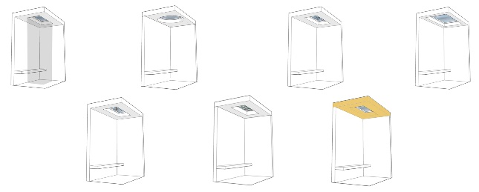
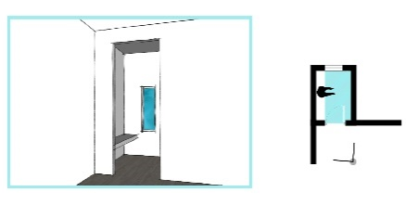  6. Exposure to Sky panel located on the wall of changing room | 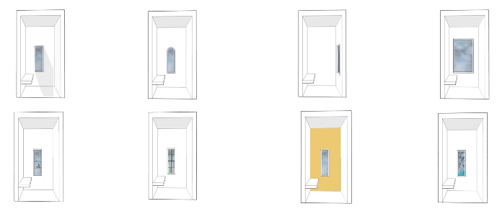

2.2.3. Online survey

The starting page of the online survey not only included an explanation of the project but also outlined how the blue elements are presented in feasible forms for healthcare settings (such as panels and projections).

2.2.4. Date analysis
For both phases, the frequency of responses was considered for the analysis since the sample groups were small.

2.2.5. Semi-structured interviews

The interviewer (FA) showed the photo questionnaire, while instead of the starting page, an explanation about the whole project was given and four existing implementations of blue elements which are applicable in healthcare settings were presented. Furthermore, interviewees were requested to explain their answers and they were allowed to change their responses during the interviews. Contrary to the online survey, for questions related to the interventions, they could select as many interventions as they intended.

3. Results

3.1. Results of online survey
The preference of the participants for the 4 alternatives (see figure 1) was primarily for floor plans 1 and 2 (n=8), then plan 4 (n=5) and plan 3 (n=4).
The mean scores for questions related to the design strategies revealed architects’ estimation of the design strategies’ capability to provide a restorative and stress-reducing environment. Table 2 shows the mean differences between each pair of items (from the highest mean score to the lowest one), as well as the top three selected interventions. The highest rating with a mean score of 4,20 on a scale of 1 (worst) to 5 (best) received by the design strategy number 1, featuring patients’ exposure to a sky panel located on the ceiling of the CT room. It was followed by the design strategy number 5 (mean score of 3.72), including exposure to sky panel located on the ceiling of changing room. Design strategies number 3 (Sky panel on the wall in front of the door to the CT room) and number 6 (Sky panel on the wall of changing room) were selected as the next effective strategies and got the mean scores of 3.00 and 2.72 respectively. Both design strategies providing exposure to water were given the lowest ratings (2.20 for water pool behind the glass wall and 1.96 for water pool adjacent to the wall between CT and control room). Therefore, the analysis shows that only two design strategies (sky panel on the ceiling of the CT room (#1) and exposure to sky panel on the ceiling of changing room (#5)) associated with sky exposure got higher mean scores than 3 as the neutral point. Accordingly, architects did not agree with the restorativeness of any design strategy associated with water exposure (water pool behind the glass wall (#2) and water pool adjacent to the wall between CT and control room (#4)). These results indicate that the participants rated water to be less helpful to create a restorative environment and decrease patients' stress.
In the open-comment section of the survey, 6 architects stated that due to technical and hygienic reasons, water cannot be applied to CT scan environments.
For design strategy number 1, the top three selected interventions were: adding artificial skylight (n= 16), changing the size of sky panel (n=15), and adding motion to the content of sky panel (n=15). For design strategy number 5, the top three interventions were: adding artificial skylight (n=20), changing the size of the sky panel (n=16), and changing the color of the ceiling (n=12). The last three preferred design strategies and the related top three interventions are shown in table 2.
Table 2. Summary of online survey on preferred design strategies associated with blue elements in CT environments
Design strategies | Top three interventions
Strategy 1: Exposure to sky panel located on the ceiling of CT room(mean score: 4.2) | -Adding artificial skylight: 16 participants  -Changing the size of sky panel: 15 participants  -Adding motion to the content of sky panel: 15 participants
Strategy 5: Exposure to sky panel located on the ceiling of changing room  (mean score:3.72) | -Adding artificial skylight: 20 participants  -Changing the size of sky panel: 16 participants  -Changing the color of the ceiling: 12 participants
Strategy 3: Exposure to sky panel on the wall in front of the door to the CT room 3.00 | -Adding green element adjacent to the sky panel: 19 participants  -Adding artificial skylight: 14 participants  -Changing the size of sky panel: 11 participants
Strategy 6: Exposure to sky panel located on the wall of changing room  (mean score: 2.72) | -Changing the size of sky panel: 13 participants  -Adding artificial skylight: 12 participants  -Changing the color of the wall in the background: 12 participants
Strategy 4: Exposure to water pool behind the glass wall (mean score:2.20) | -Adding water wall: 17 participants  -Adding a source of light and creating water reflection on ceiling and wall: 16 participants  -Adding water flowing sound to the environment: 10 participants
Strategy 2: Exposure to water pool located adjacent to the wall between CT and control room  (mean score:1.96) | - Adding a source of light and creating water reflection on ceiling and wall:19 participants  -Adding green elements adjacent to the water pool: 14 participants  -Adding water flowing sound to the environment: 11 participants

  - Results of semi-structured interviews
In the interviews on the preference for CT-scan room layout, four of the interviewees preferred floor plan 2. They mentioned that it may support patients’ contact with medical staff better and this human contact can provide a more restorative journey for the patients. Two participants selected plan 3 as it provides better control over patients for medical staff and consequently, it would be reassuring for patients to go through the CT procedure.

Table 3. Summary of semi-structured interviews on preferred design strategies associated with blue elements in CT environments
Design strategies | Top three interventions
Strategy 4: Exposure to water pool behind the glass wall (mean score:4.60) | - Adding water wall: 6 interviewees  - Adding water sound: 3 interviewees  - Adding sky panel on top of water pool: 3 interviewees
Strategy 1: Exposure to sky panel located on the ceiling of CT room(mean score: 4.00) | -Adding motion to the content of sky panel including clouds movement and birds’ flight: 4 interviewees  - Adding an artificial skylight: 3 interviewees  - Changing the size of the panel: 3 interviewees  - Changing the location of the panel: 3 interviewees
Strategy 6: Exposure to sky panel located on the wall of changing room (mean score: 3.00) | -Changing the size of sky panel: 4 interviewees  -Adding green element: 3 interviewees  -Adding motion to the content of sky panel: 3 interviewees
Strategy 3: Exposure to sky panel on the wall in front of the door to the CT room (mean score: 2.60) | -Adding green element adjacent to the sky panel: 4 interviewees  -Adding artificial skylight: 2 interviewees  -Changing the size of sky panel: 2 interviewees
Strategy 5: Exposure to sky panel located on the ceiling of changing room (mean score:2.60) | -Changing the size of sky panel: 3 interviewees  -Adding artificial skylight: 2 interviewees  -Adding green element to the content of sky panel: 2 interviewees
Strategy 2: Exposure to water pool located adjacent to the wall between CT and control room (mean score:2.00) | -Adding a source of light and creating water reflection on ceiling and wall: 3 interviewees  -Adding water flowing sound to the environment: 3 interviewees  -Adding green elements adjacent to the water pool: 2 interviewees

Results of the semi-structured interviews showed that, contrary to the outcomes of the online survey, five participants regarded that a water pool behind a glass wall (#5) has the highest potential to create a restorative environment. It should be noted that two participants from the beginning selected the highest rating for this design strategy, while the other three initially selected a low rating for it and changed their opinions to a higher rating after observing the water wall as the intervention.
The sky panel on the ceiling of CT room (#1) was selected as the second design strategy by four interviewees to bring about restorative influences on patients. For interventions related to the water pool behind the glass wall, experts declared that adding water wall (n=6), adding water sound (n=3), adding sky panel on top of the water pool (n=3), and creating a reflection on the ceiling and walls (n=2) can enhance the positive influences on patients. For exposure to the sky panel located on the ceiling, experts stated that adding motion to the content of the sky panel including clouds movement and birds’ flight (n=4), adding an artificial skylight (n=3), changing the size of the panel (n=3), and changing the location of the panel (n=3) are capable to bring about patients’ stress decrease.

4. Discussion

This paper aimed to clarify architects’ perspectives on the implementation of natural blue elements in CT-scan environments to be able to provide a better experience for patients through the visual design of CT environments. The results showed that according to the architects’ opinion, exposure to the sky panel on the ceiling of CT room and exposure to water pool behind the glass wall in CT room might create a more restorative environment for patients.

Generally, architects signified the role of medical staff for the preferred layout. Considering the overlaps between the results of the online survey and semi-structured interviews, they both selected floor plan number 2 (see Fig.1) where the window of the control room is in front of the CT device and subsequently, it provides a better overlook through the gantry during the CT process. One of the interviewees emphasized that for stress relief of patients, the environment should support a good connection with medical staff and floor plan number 2 is the most supportive one in this regard. Furthermore, while plan number 1 provides the possibility of patients passing through the control room, plan number 2 limits patients’ access only to the CT room. Two interviewees pointed out the better integration of floor plan number 3 with blue elements which lead to a more restorative CT environment. This remark revealed that specific architectural layouts are capable to increase the positive influences of blue elements on patients in such environments, and layout should thus be taken into consideration for better implementation of blue elements.
This study showed that architects may not yet consider water as part of blue elements, nor restorative influence of it in CT rooms. Actually, the responses of architects to the survey (online survey and its’ open-comment section) highlighted the impracticability of water in CT-scan environments and that they have not considered the water as high potential in making restorative healthcare spaces. On contrary, they argued due to hygienic reasons, it is not possible to have it in the CT environments. These remarks suggest there is the possibility that some of the participants skipped the starting page and lacked experience with feasible forms of implementing water in the healthcare setting. Consequently, water exposure is not considered a strategy for restorative healthcare environment by architects and it has not found its’ place among them.

However, during the semi-structured interviews, interviewees stated that the design strategy associated with water is the most effective one to be implemented in a CT-scan environment. They argued that, with the glass wall, water is well-integrated into the environment and it gets in stronger contact with the environment. Furthermore, the role of the water wall, which is the only intervention selected by all six interviewees, was highlighted since they declared as it is in the view direction of patients, the attention of patients is drawn to it more significantly. Also, one interviewee, who personally was not interested in water and disagreed initially with having any forms of water in the CT environment, stated water wall is a piece of art and can make multisensory experiences (visual and auditory) for patients and can lead to the better restorative CT environment. For exposure to the sky panel on the ceiling of the CT-scan room, both groups of participants agreed that it might be an effective design strategy in making the CT environment more restorative.

Interestingly, about the interventions that can alter positively the perceptions of design strategies, both groups agreed that adding natural light, adding motion to the content of the sky, and changing the size of the panel are helpful. During the semi-structured interviews, interviewees revealed more details about their selection. Regarding the size of the sky panel, two of them stated that on one hand, being too big might create the feeling of getting lost in the sky. On the other hand, when it is too small, it cannot attract the attention of patients in the short-term stressful CT-scan procedure. One of the interviewees also pointed out that changing the location of the sky panel and placing it in a better view direction of patients not only can improve the better relationship between the sky and the environment but also can highlight less the CT device.

5. Conclusions
This study showed that architects consider the implementation of blue elements in the healthcare environment as restorative for patients. Even though the majority of architects are aware of sky potential, water has not found its’s place in debates on the healthcare facilities, especially in windowless areas such as CT scan environments. However, after an explanation of ways to implement water inside of health care settings, architects seem very interested in pursuing water exposure and interventions altering perceptions towards it.
The findings intend to increase the awareness regarding blue elements’ role specifically water among architects as a group who act on the patients’ behalf and design environments that cater more efficiently to the patients’ needs.
Further research is needed to elucidate the perspective of patients in order to inform architects and therefore to have more holistic designs of healthcare environments associated with blue elements.

Contributor statement

The authors confirm their contribution to the paper as follows: study conception and design: Both authors; data collection: First author; analysis and interpretation of results: Both authors; draft manuscript preparation: First author. All authors reviewed the results and approved the final version of the manuscript.

Acknowledgments

The authors disclosed receipt of the following financial support for the research, authorship, and/or publication of this article: Scholarship Program for the Promotion of Early-Career Female Scientists of TUD.

We would like to thank all the architects of the organization “AKG-Architekten für Krankenhausbau und Gesundheitswesen” who distributed the online survey among their members. Special thanks goe to the six architects who contributed to further elucidate the topic during the interviews.

References

Amirbeiki, F., & Khaki Ghasr, A. (2020). Investigating the Effects of Exposure to Natural Blue Elements on the Psychological Restoration of University Students. Iran University of Science & Technology, 30(1), 1-10.
Annerstedt, M., Jönsson, P., Wallergård, M., Johansson, G., Karlson, B., Grahn, P., . . . Währborg, P. (2013). Inducing physiological stress recovery with sounds of nature in a virtual reality forest—Results from a pilot study. Physiology & behavior, 118, 240-250.
Barker, S. B., Rasmussen, K. G., & Best, A. M. (2003). Effect of aquariums on electroconvulsive therapy patients. Anthrozoös, 16(3), 229-240.
Beukeboom, C. J., Langeveld, D., & Tanja-Dijkstra, K. (2012). Stress-reducing effects of real and artificial nature in a hospital waiting room. The Journal of Alternative and Complementary Medicine, 18(4), 329-333.
Edwards, N. E., & Beck, A. M. (2002). Animal-assisted therapy and nutrition in Alzheimer’s disease. Western journal of nursing research, 24(6), 697-712.
Huisman, E. R., Morales, E., van Hoof, J., & Kort, H. S. (2012). Healing environment: A review of the impact of physical environmental factors on users. Building and environment, 58, 70-80.
Kaplan, S. (1995). The restorative benefits of nature: Toward an integrative framework. Journal of environmental psychology, 15(3), 169-182.
Marquardt, G., Bueter, K., & Motzek, T. (2014). Impact of the design of the built environment on people with dementia: an evidence-based review. HERD: Health Environments Research & Design Journal, 8(1), 127-157.
Ottosson, J., & Grahn, P. (2008). The role of natural settings in crisis rehabilitation: how does the level of crisis influence the response to experiences of nature with regard to measures of rehabilitation? Landscape research, 33(1), 51-70.
Pati, D., Freier, P., O’Boyle, M., Amor, C., & Valipoor, S. (2016). The impact of simulated nature on patient outcomes: A study of photographic sky compositions. HERD: Health Environments Research & Design Journal, 9(2), 36-51.
Pati, D., O'Boyle, M., Amor, C., Hou, J., Valipoor, S., & Fang, D. (2014). Neural correlates of nature stimuli: an FMRI study. HERD: Health Environments Research & Design Journal, 7(2), 9-28.
Sternberg, E. M. (2010). Healing spaces: The science of place and well-being: Harvard University Press.
Tafti, F. A., Rezaeian, M., & Razavi, S. E. (2018). Sunken courtyards as educational environments: Occupant's perception and environmental satisfaction. Tunnelling and Underground Space Technology, 78, 124-134.
Tzoulas, K., Korpela, K., Venn, S., Yli-Pelkonen, V., Kaźmierczak, A., Niemela, J., & James, P. (2007). Promoting ecosystem and human health in urban areas using Green Infrastructure: A literature review. Landscape and urban planning, 81(3), 167-178.
Ulrich, R. S. (1984). View through a window may influence recovery from surgery. Science, 224(4647), 420-421.
Ulrich, R. S. (1997). A theory of supportive design for healthcare facilities. Paper presented at the Journal of healthcare design: proceedings from the... Symposium on Healthcare Design. Symposium on Healthcare Design.
Ulrich, R. S. (2001). Effects of healthcare environmental design on medical outcomes. Paper presented at the Design and Health: Proceedings of the Second International Conference on Health and Design. Stockholm, Sweden: Svensk Byggtjanst.
Ulrich, R. S., Simons, R. F., Losito, B. D., Fiorito, E., Miles, M. A., & Zelson, M. (1991). Stress recovery during exposure to natural and urban environments. Journal of environmental psychology, 11(3), 201-230.
Ulrich, R. S., Zimring, C., Zhu, X., DuBose, J., Seo, H.-B., Choi, Y.-S., . . . Joseph, A. (2008). A review of the research literature on evidence-based healthcare design. HERD: Health Environments Research & Design Journal, 1(3), 61-125.
Verderber, S. (2010). Innovations in hospital architecture: Routledge.
White, M. P., Elliott, L. R., Gascon, M., Roberts, B., & Fleming, L. E. (2020). Blue space, health and well-being: A narrative overview and synthesis of potential benefits. Environmental research, 191, 110169.
WHO, I. (1946). Preamble to the constitution of th World Health Organization as adopted by the International Health Conference. New York, 19-22.
Zijlstra, E., Hagedoorn, M., Krijnen, W. P., van der Schans, C. P., & Mobach, M. P. (2017). Motion nature projection reduces patient's psycho-physiological anxiety during CT imaging. Journal of Environmental Psychology, 53, 168-176.

