Type of the Paper: Peer-reviewed Conference Paper/ Short Paper
Track title: please fill in your track title here

Is the therapeutic value of hospital waiting areas recognised and endorsed by healthcare design guidelines?
Eleni Tsiantou ¹, Evangelia Chrysikou ² and Hina Lad ^{3,}
Names of the track editors:
Firstname Lastname
Firstname Lastname
Names of the reviewers:
Firstname Lastname
Firstname Lastname
Journal: The Evolving Scholar
DOI: https://doi.org/xxxxx/xxxxx

Submitted: 01 January 2021
Accepted: 01 June 2021
Published: 02 June 2021
Citation: name of authors [if more than 3 authors use the name of the 1st author followed by et al. e.g smith et al.], title of the article, name of the journal, volume, year, DOI

This work is licensed under a Creative Commons Attribution xxx (CC xxxx) license.
©year [name of the author(s)] published by TU Delft OPEN on behalf of the authors

¹ The Bartlett School of Sustainable Construction, UCL, London, UK; elenatsiantou@gmail.com
² The Bartlett School of Sustainable Construction, UCL, London, UK; e.chrysikou@ucl.ac.uk
³ The Bartlett School of Architecture, UCL, London, UK; hina.lad.13@ucl.ac.uk

Research highlights
- There is a range of information offered through the different guidelines but the majority of them is focused on the functionality of waiting areas.
- The research indicates that the therapeutic qualities of physical design elements in hospital waiting areas have been ignored by regulators.
- Actions to improve healthcare design guidelines could be beneficial for patients’ wellbeing.

Keywords: waiting areas; healthcare design guidelines; evidence-based design; therapeutic environment; hospitals

- Introduction

The waiting area is an indispensable part of the healthcare experience. It belongs to the non-clinical spaces of a hospital where people spend many ‘in-between moments’ such as waiting until their appointment begins, waiting to receive results, having a medical procedure or seeing a family member that is hospitalized (Harkness, 2019). Patients usually have increased biological metrics when entering healthcare environments as a response to stress. The waiting area acts as a priming experience for them and priming them with nice settings before consultation or procedure might benefit their health.
According to Goelitz & Kahn (2008), humans are connected and influenced by their external environment without consciously realising it. Psychological stress except for the anxiety about the unknown can be provoked by a poorly designed physical environment (Zraati, 2013). That is why it is considered important a therapeutic environment that strengthens the self-healing capacity of patients, improves staff efficiency, alleviates stress, reduces pain, and enhances patient comfort and safety (Iyendo, Uwajeh, & Ikenna, 2016). There are plenty of studies proving that specific design elements have a positive effect on patients and occupants, and value the healing atmosphere of a hospital waiting area even if that happens unconsciously sometimes.
A healing environment works complementary to medical care by enhancing it and not substituting it (Henderson, 2008). There is a growing body of research that surpasses the functional value of healthcare facilities and examines the intangible value of their environment and the impact on patients. One good example is the evidence-based design approach which focuses on the significance of interior physical elements and how they connect to patients’ wellbeing. The evidence-based design was developed by Ulrich (1991) and in the last years, many healthcare stakeholders acknowledge the benefits of its implementation.
Many countries provide architects and designers of healthcare facilities with guidelines which intend to support the design process as well as to give examples of best practices and guidance on the design and planning of newly constructed healthcare buildings or renovations in existing buildings (HBN 00-01 Department of Health, 2014, p.4). Usually, these documents focus on the clinical areas such as consulting and treatment rooms, patient rooms, operating theatres etc. which is a result of the limitation of studies that are usually restricted to clinical areas of healthcare facilities.
The aim of this study is to identify if the design of the non-clinical spaces of hospitals, particularly the waiting areas, is considered equally important in the healing process as the clinical areas by regulators as well as if the therapeutic value of waiting areas is endorsed through healthcare design guidelines.

- Theories and Methods

A trustworthy way to examine if the therapeutic value of waiting areas is recognised by regulators and endorsed by healthcare design guidelines was an analysis and juxtaposition of three different countries' healthcare design guidelines under the scope of specific evidence-based design features. The selected guidelines were all written in English, from countries with no significant cultural differences because culture plays an important role in the design of waiting spaces. In particular, the three chosen countries were the UK, USA and Australia. The documents used for each are for the UK; Health Building Note 00-01 General design guidance for healthcare buildings, for the USA; guidelines for design and construction of hospital and healthcare facilities and for Australia: Australasian Health Facility Guidelines.
The first part of the methodology was to find out if there are equally detailed descriptions for the design of waiting areas as for clinical spaces in hospitals in the healthcare design guidelines. Followed by an analysis among the chosen documents as far as the type of information and instructions given to architects about the design of waiting areas scoping in finding references to specific physical features that the therapeutic concept emphasizes such as natural light, artwork, good air quality, plants, views to the landscape, nice shooting colours, comfortable furniture etc. (Iyendo, Uwajeh, & Ikenna, 2016).

3. Results

There is a range of information offered through the different guidelines, with the UK being the most inclusive, Australia being limited to functional requirements and the USA ignoring the waiting spaces design in the guidelines of healthcare facilities.

1. UK’s healthcare design guidelines

In the Health Building Note, 00-01 General design guidance for healthcare buildings document there is one page that is dedicated to waiting areas design. This page includes many recommendations for waiting areas design features and in particular, a variety of comfortable seating and tables to ease individuals perform their duties and different arrangements to give the opportunity of choice between privacy and social interaction recommended (Figure 1). Also, double-height space is suggested to provide a view of the external environment and if there is the possibility that should be a natural landscape to enhance calm. In the HBN 00-01, some complementary amenities that are considered significant are proposed such as a connection to the reception area, the existence of a telephone view to a clock, internet access, refreshments and toilets available near the waiting area (Department of Health, 2014, p.35). Moreover, there is an image which illustrates a mock-up of a waiting area (Figure 1) and two existing waiting spaces as visual examples to help architects that use the guidelines in their projects as a visual display of the important design features is easier understandable than written recommendations.

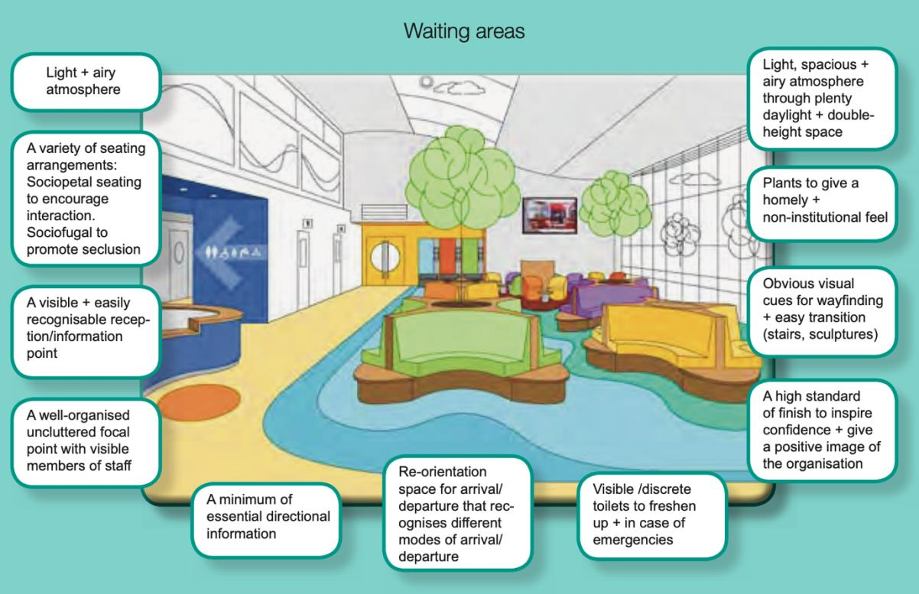
Figure 1. Mock-up of a waiting area (Health Building Note 00-01, p.35)

2. USA’s healthcare design guidelines

In comparison to the UK guidance, the American document Guidelines for design and construction of hospital and health care facilities (The AIA, 2001) is structured differently. There is no dedicated chapter for waiting areas, instead within each section, describing individual departments such as intensive care units, surgical facilities, emergency services etc. design principles about specialist service waiting areas were described. Within these, there are recommendations about size, capacity, and extra amenities like access to toilets, drinking fountains, telephones, separate children waiting spaces or separate inpatient and outpatient waiting spaces. Also, good ventilation to avoid airborne infections if needed in some departments, wheelchairs access only to the rehabilitation therapy department and privacy are suggested but no design guidance about any features that could be recognised as therapeutic such as shooting colours, comfortable furniture etc.

3. AUSTRALIA’s healthcare design guidelines

The Australasian Health Facility Guidelines (AusHFG) (AHIA, 2016) are a series of documents where there are five different examples of waiting area design categorized by their capacity. The therapeutic elements that are identified in the principles for all the sizes of waiting areas are the views of the outside and daylight through the window but also there is a detailed description of the type of artificial light that is needed. There is an indirect reference to positive distractions as in equipment section bracket for the TV screen, fixed noticeboard and rack for magazines and pamphlets are proposed. There are no principles about the therapeutic value of colours, artwork and plants in a hospital setting. As far as furniture is concerned there is only a list of them and no important features of them like comfort or any proposed arrangement. Moreover, an amenity that is of paramount importance and is referred to in all sizes of waiting areas is wheelchair access. There are some diagrams (Figure 2 and 3) that display a design suggestion of two different size waiting areas, in particular, 10 m² and 20 m², using a 3d model and a plan for each to be easily understandable. The diagrams are black and white so no conclusions about suggested colours, textures and materials can be made but from the type of furniture and their arrangement, the atmosphere seems institutional (AHIA, 2016, p.29).
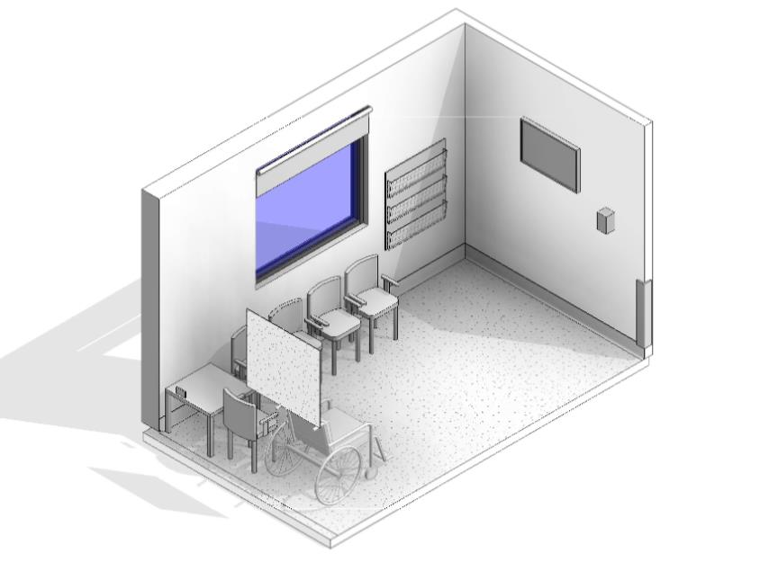
Figure 2. 3d perspective of proposed 10m² waiting area
(Australasian Health Facility Guidelines)

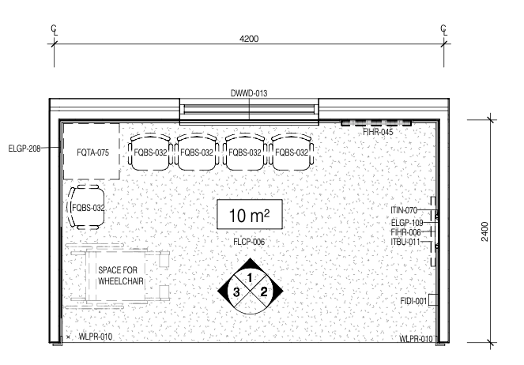
Figure 3. Floor plan of proposed 10m² waiting area
(Australasian Health Facility Guidelines)

- Discussion

Not all regulators seem to recognise the therapeutic aspect of waiting areas. In particular, in the USA guidelines, even a reference to the influence that design features such as natural light, artwork, colours, nature etc. have on patients’ wellbeing would provoke architects to think over that aspect of evidence-based design in their projects. The UK regulators, on the other hand, seem to value the positive outcomes that the physical environment can have on occupants. As for the Australasian Health Facility Guidelines (AusHFG) more descriptive recommendations and the use of existing examples would ease architects’ work on creating a healing environment.
The welcoming factor of health spaces pre-consultation has been ignored by regulations. Healthcare design guidelines as far as the waiting spaces are concerned are focused on functional characteristics like size and access to amenities and do not introduce enough therapeutic features which could take part in the healing process (Selami Cifter & Cifter, 2017). As Ulrich states, “many healthcare facilities are functionally effective but missing the psychological support aspect” (Ulrich, 1991, p. 97) and often they are considered institutional, stressful and unsuitable for occupants’ emotional needs (Salonen et al., 2013).

5. Conclusions

Even if regulators have theoretical knowledge of healing environments, they do not effectively guide architects by instructions and principles during the design process. Actions to improve them could be beneficial for architects during the design process and consequently for the waiting areas environment and patients’ wellbeing. They could even have longer-term benefits supporting early detection of disease by reducing the fear and stigma that people feel when engaging with healthcare services.
For further research related to waiting areas, I propose that more countries' healthcare design guideline documents could be analysed taking into consideration the factor of cultural differences. Also, on an even broader scale, similar research and review on the guidelines about other non-clinical parts of hospitals such as cafés, restaurants, doctor offices etc. could be interesting as a comparison to the design guidance offered for clinical spaces.

Data Availability Statement

All the healthcare design guideline documents that were used for this paper are open to public access and can be found in the following links: for the UK; Health Building Note 00-01 General design guidance for healthcare buildings link: https://www.england.nhs.uk/wp-content/uploads/2021/05/HBN_00-01-2.pdf, for the USA; guidelines for design and construction of hospital and healthcare facilities link: https://fgiguidelines.org/wp-content/uploads/2015/08/2001guidelines.pdf and for Australia: Australasian Health Facility Guidelines under the scope of specific evidence-based design features used as a method to demonstrate the consideration given to the design of waiting spaces are accessible through the following link: https://healthfacilityguidelines.com.au.

Contributor statement

ET conceived the original idea of this paper which was discussed with EC. All authors contributed to the design of the study. ET discussed the methodology with HL. ET conducted the analysis of the data and drafted the first manuscript. EC and HL revised the manuscript multiple times. ET wrote the final paper. All authors read and approved the final version of the manuscript.

Reference

- Australasian Health Infrastructure Alliance (AHIA) (2016). Australasian Health Facility Guidelines, North Sydney, Australasian Health Infrastructure Alliance (AHIA). Retrieved from https://healthfacilityguidelines.com.au.
- Department of Health (2014). Health Building Note 00-01:General design guidance for healthcare buildings. London, Crown copyright. Retrieved from https://www.england.nhs.uk/wp-content/uploads/2021/05/HBN_00-01-2.pdf
- Goelitz, A., & Kahn, A. S. (2008). Therapeutic use of space: One agency's transformation project. Journal of Creativity in Mental Health, 2(4), 31-44. Retrieved from: https://www.tandfonline.com/doi/abs/10.1300/J456v02n04_04
- Harkness, N. R. (2019) BETWEEN MOMENTS Using virtual reality with participatory processes to design healthcare waiting places, Master thesis, Victoria University of Wellington, New Zealand. Retrieved from: http://hdl.handle.net/10063/8273
- Henderson, W. M. (2008) ‘User Satisfaction in PFI and Non-PFI Hospitals in the UK: In Particular the Outpatients’ Department Reception/Waiting Areas’, Phd thesis,University of Bedfordshire, Bedfordshire. Retrieved from: https://uobrep.openrepository.com/handle/10547/300624
- Iyendo, T., Uwajeh, P., & Ikenna, E. (2016) The therapeutic impacts of environmental design interventions on wellness in clinical settings: A narrative review. Complementary Therapies in Clinical Practice, 24, 174-188. Retrieved from: https://www.sciencedirect.com/science/article/abs/pii/S1744388116300536
- Salonen, H., Lahtinen, M., Lappalainen, S., Nevala, N., Knibbs, L. D., Morawska, L., & Reijula, K. (2013) Physical characteristics of the indoor environment that affect health and wellbeing in healthcare facilities: A review. Intelligent Buildings International, 5(1), 3-25. Retrieved from: https://www.tandfonline.com/doi/abs/10.1080/17508975.2013.764838
- Selami Cifter, A. & Cifter, M., (2017) A Review on Future Directions in Hospital Spatial Designs with a Focus on Patient Experience, The Design Journal, 20(1), 1998–2009. Retrieved from: https://www.tandfonline.com/doi/abs/10.1080/14606925.2017.1352719
- Ulrich, R. S. (1991) Effects of interior design on wellness: Theory and recent scientific research. Journal of health care interior design, 3(1), 97-109. Retrieved from: https://www.researchgate.net/publication/273354344_Effects_of_Healthcare_E nvironmental_Design_on_Medical_Outcomes
- Zraati, P. (2013) Color consideration for waiting areas in Hospitals. International Journal of Advancements in Research & Technology, 1(3), 1369-1379. Retrieved from: http://www.ijoart.org/docs/Colour-Consideration-for-Waiting- areas-in-hospitals.pdf
- The American Institute of Architects, Academy of Architecture for Health, the Facility Guidelines Institute with assistance from the U.S. Department of Health and Human Services (2001). Guidelines for design and construction of hospital and health care facilities. Washington, D.C., The American Institute of Architects. Retrieved from https://fgiguidelines.org/wp-content/uploads/2015/08/2001guidelines.pdf

