Type of the Paper: Peer-reviewed Conference Paper / Full Paper
Track title: Stream inclusive design/health promotion – inclusive communal living

Home and Healthcare. The prospect of home adaptation through a computational design decision-support system
Federica Romagnoli ¹, Pirouz Nourian ², Tiziana Ferrante ³, and Teresa Villani ⁴
¹ Department of Civil, Constructional and Environmental Engineering, Sapienza University of Rome, Italy ; federica.romagnoli@uniroma1.it; 0000-0001-5520-3356
² Department of Architectural Engineering & Technology, Faculty of Architecture and the Built Environment, TU Delft; p.nourian@tudelft.nl; 0000-0002-3817-7931
³ Department of Planning, Design, and Technology of Architecture, Sapienza University of Rome, Italy; tiziana.ferrante@uniroma1.it; 0000-0002-0625-4453
⁴ Department of Planning, Design, and Technology of Architecture, Sapienza University of Rome, Italy; teresa.villani@uniroma1.it; 0000-0003-3665-1609

(to be completed by the editors)

Names of the Topic editors:

Names of the reviewers:

Journal: The Evolving Scholar
DOI:10.24404/6230c7305e57b895ac66bc74

Submitted: 21 Mar 2022
Accepted:
Published:
Citation: Romagnoli, F., et al.(2022). Home and Healthcare. The prospect of home adaptation through a computational design decision-support system [preprint]. The Evolving Scholar |

This work is licensed under a Creative Commons Attribution CC BY-ND license (CC BY-ND ).

© 2022 [Romagnoli, F., et al. ] published by TU Delft OPEN on behalf of the authors.

Abstract: This paper presents an ongoing research to define the framework of a computational design approach based on the idea of spatial analysis and spatial synthesis to implement multi-criteria evaluations and provide evidence of the performance of the design alternatives in the specific case of home adaptation for healthcare at home. The European health systems place among the priority objectives the strengthening of the provision of healthcare at home to guarantee the aging in place of elderly people and to limit, at the same time, the unnecessary use of resources. Therefore, existing homes must provide adequate safety, comfort, and accessibility features to ensure a high quality of life for the care receivers and facilitate the caregivers' tasks. To address the complexity of the requirements to be met, we propose a spatial decision support system (SDSS) to implement multi-criteria assessments to ergonomic design problems at a spatial scale of apartment homes. The system is intended to streamline and assist designers and homeowners in planning interventions for home adaptations for healthcare. Such design problems can be formulated as decision problems with costs and benefits modeled within constraints of validity and quality criteria/objectives. Concerning the specific field of study, the system evaluates the degree of compliance with the accessibility and visibility quality criteria of each design alternative. The reiteration of the evaluation mechanism allows for the classification and supports the selection of satisfactory technical solutions identified with an in-formed and well-balanced trade-off between the relevant quality criteria.
Keywords: healthcare at home; home adaptation; human-centered design; evidence-based design; multi-criteria decision-making.

1. Introduction
This paper describes the intermediate results of an ongoing research that intends to contribute to the strategies for the adaptation of the built environment in response to the new health needs of the elderly population (according to the 11th Sustainable Development Goal SDG11 of UN 2030 Agenda for Sustainable Development and aligned with the United Nations Decade of Healthy Ageing 2021-2030). Observing the demographic trends expected for the next decades, in 2050 the percentage of people over 65 will reach 24.4% of the European population (Eurostat, 2020). This will also lead to an increase in the demand for long-term care for the treatment of chronic diseases, which mainly affect the older population. Since, as we age, we are generally witnessing a reduction in autonomy and mobility, there are many European health systems that, according to the 18th Pillar of European Pillars of Social Rights, promote the strengthening of home care services within the territorial care network (European Union, 2017). This is encouraging, in many countries, the development of new housing models for assisted living, and, at the same time, the implementation of adaptation strategies to make existing homes more accessible, safe, and suitable for the aging in place of inhabitants, to save resources and land consumption. The introduction of nursing activities (personal care, medication, etc.), rehabilitation, and assistance in daily life tasks (toileting, dressing, feeding, etc.) requires the home environment to meet several requirements through an adequate configuration and physical characterization of the architectural components (Ferrante & Cellucci, 2021). Adapting housing to accommodate care at home means simultaneously considering multiple technical, economic, psychological, etc. aspects, which often make it challenging to identify a unique solution. This multi-dimensional complexity (Azadi & Nourian, 2021) makes it necessary to apply tools and methods to implement multi-criteria assessments from the early-stage design to support the technical choices of intervention in response to the specific needs of all involved users.
The generative formulation of the project can be considered a chain of discrete choices that can be supported and informed by evaluation procedures utilizing computational simulations and analyses. Starting from the definition of a spatial model, it is possible to associate a home renovation plan with a layout problem where the goal is to find the configuration (in terms of spaces, objects, and architectural elements) that meet several predetermined quality criteria. As shown in Figure 1, domestic indoor space can be abstracted as a coherent overlay of a geometrical model and a topological model. The geometrical model represents spaces, furniture, and architectural components in terms of their boundary shapes; the topological model describes their relation in a multi-layered graph where elements are nodes and edges express their functional or physical connections.
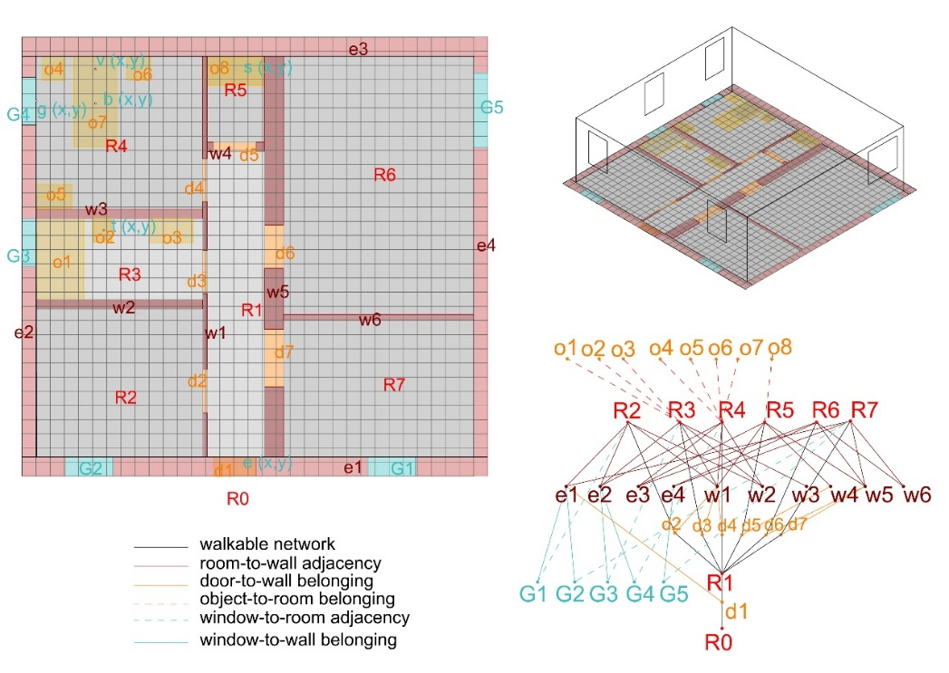
Figure 1. Scheme of the spatial data model.
In compliance with what has been mentioned, the research aims to define a spatial decision support system (SDSS) capable of analyzing the ergonomic characteristics at a spatial scale of a given configuration of spaces and objects represented by a spatial data model containing topological and geometrical information. In the following sessions, we describe the definition of several analyses to establish a multicriteria evaluation mechanism to support selecting technical intervention choices in the specific field of adaptation of housing for home care.

2. Theories and Methods
As a preliminary step, following a human-centered design approach, we have identified and categorized into a set of requirements that the domestic space must guarantee to be supportive and therapeutic for the care receiver and facilitate the caregivers' tasks. This phase has been conducted through direct observation, semi-structured interviews with caregivers, and based on a study of literature sources such as Wright et al. (2017) and Piatkowski et al. (2019). To reduce the field of investigation, we considered the case of high-intensity home care for totally dependent people. Although the extreme variability of specific cases (due to each individual's particular functional and pathological state) makes it impossible (and not so valuable) to establish the prioritized spatial requirements for all exhaustively, some recurring aspects can be observed. In particular, some layout features such as the proximity of the assisted room to a toilet or storage area of medicines are valid for most cases. In addition, some features of physical accessibility of the spaces are necessary to allow the performance of all the activities of care and assisted walking within the living space. Finally, some visibility features are also fundamental, such as the daylight availability that helps the correct alternation of sleeping and waking cycles, and visual access to preferential views that psychologically support the care receiver to bear the symptoms (Ulrich, 1984).
In our approach, the selected requirements represent the quality criteria to be pursued with the home adaptation project. As shown in Table 1, they were divided into three macro-categories: layout proximity (spaces closeness), accessibility, and visibility criteria.
Table 2. Summary of quality criteria
 | Quality criteria
Layout (closeness) | Criterion 1.a: The storage area for equipment and medicines must be close to the care-receiver’s bedroom.
 | Criterion 1.b: The care-receiver’s bedroom must be close to a toilet.
Accessibility | Criterion 2.a: The width of passages should never be less than 80 cm, or 120 in the case of assisted walking.
 | Criterion 2.b: There must be a free space with a diameter of 150 cm in the care-receiver’s bedroom and bathroom.
 | Criterion 2.c: It must be possible to approach the care-receiver's bed on three sides, ensuring a 120 cm wide band on at least one long side.
Visibility | Criterion 3.a: A daylight factor greater than 3% (or at least 2%) must be guaranteed in the care-receiver's bedroom.
 | Criterion 3.b: The care-receiver must be able to see out the window from the bed.

Then, the key features of an ideal SDSS for our purpose have been defined as follows:
1) The tool has to verify the respondence of a given spatial configuration model to the set of quality criteria. Therefore, each criterion needs to be formally defined as an aggregation of the results of a spatial analysis. To this end, a series of spatial quality functions need to be defined to measure the degree of satisfaction of the requirement set.
2) The evaluation mechanism has to consider the logistical and functional constraints of existing housing that influence the convenience of the intervention alternatives. Since the subject of the study concerns the adaptation of existing dwellings, these factors involve some characteristics that must remain unchanged (i.e., the perimeter of the floor plan, the windows' location, the main entrance location, the drains' location, etc.) and others that, although modifiable, represent a burden for the owners (i.e., walls rebuilding, floors renovation, etc.).
3) The tool has to be designer-friendly to make the decision-making process participatory and customizable according to user preferences. Therefore, the evaluation mechanism should be transparent and flexible in defining different priorities for each quality criterion (which can be established on a case-by-case basis) and allow real-time interaction with the design team.
According to these required features, we explored some computer-aided tools applicable in the residential environment by studying recent systematic reviews such as (Nisztuk & Myszkowski, 2018) (Zhang et al., 2019). This phase led to the identification of previous approaches mainly based on two research areas that have deepened the potential of Computational Design to solve "spatial allocation problems" experienced for video games and applicable to housing architectural design. The first area concerns the "architectural floorplan optimization" (Merrell et al., 2010) (Veloso et al., 2018) (Keshavarzi et al., 2021), while the second relates to "automated furniture arrangement" (Merrell et al., 2011) (Yeh et al., 2012) (Yu et al., 2011) (Kán & Kaufmann, 2017).
Many of the observed techniques adopt the approach proposed by Merrell et al. (2011) in which ergonomic and functional requirements derived from design guidelines are modeled as terms of a cost function associated with a configuration of spaces and furnishings. Each term of the function is multiplied by a factor that defines its priority concerning the whole set of considered criteria. However, existing tools are aimed primarily to design new buildings within a predefined perimeter and with known context conditions (Sönmez, 2018). To date, according to the authors' knowledge, none of the available tools can support the decision-making process in the case of the renovation of existing housing to maximize accessibility and visual comfort features. This specific field of study presents particular complexities, due not to the size in terms of the extent of the intervention to be carried out, but to the heterogeneity of the ergonomic, functional, and technical requirements to meet and the specificity of the contextual constraints (structural, plant, economic, etc.) to comply (National Research Council, 2011) together with the subjective preferences of users for the customization of their living space.
Therefore, a literature search has been undertaken focusing on specific computer-aided methods based on the three main categories of defined quality criteria. The goal was to identify the most appropriate techniques for modeling the quality criteria functions and allowing an objective measurement of the performance provided by a given spatial configuration. The following subsections report the identified methods and techniques, particularly those considered most promising for future implementation.

2.1 Layout (closeness) criteria
Criterion 1.a: The storage area for equipment and medicines must be close to the patient’s bedroom.
Criterion 1.b: The patient’s bedroom must be close to a toilet.

Both criteria are associated with the shortest path problem between two points on a grid generated by floorplan discretization. For our proposal, the most promising methods seem to be the Dijkstra algorithm and its extension A*Algorithm, which have been used in many previous applications (Goldstein et al., 2020) (Goel et al., 2017) and whose popularity has been largely documented (Abd Algfoor et al., 2015) (Madkour et al., 2017) (Kumawat et al., 2021). In the illustrative diagram in Figure 2, the necessary input data has been isolated. The system overlays the spaces with a regular grid. Then, the shortest paths between the relevant points are calculated in terms of the minimum number of touched nodes on the network formed by the grid cells.
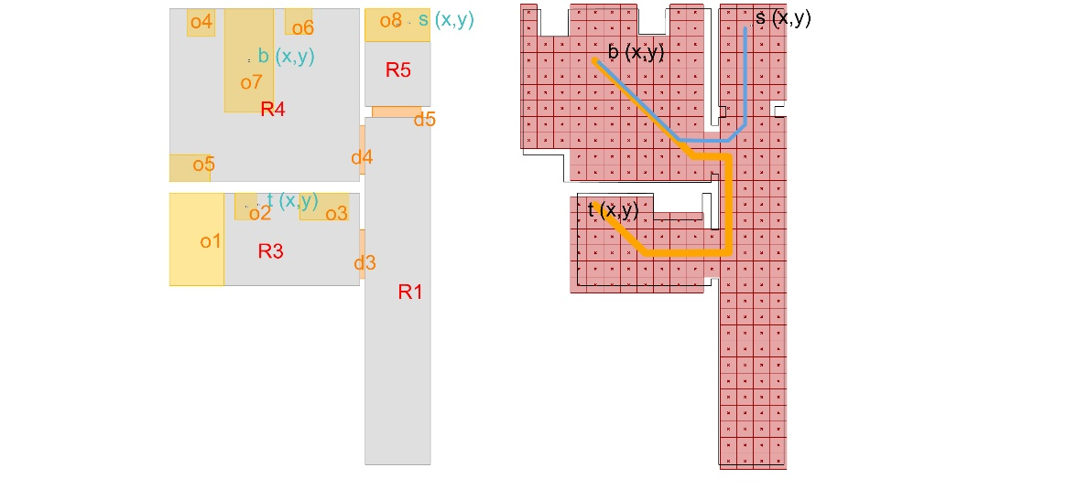
Figure 2. Example of the calculation of the shortest paths between relevant points on a grid.

2.2 Accessibility Criteria
Criterion 2.a: The width of passages should never be less than 80 cm, or 120 in the case of assisted walking.

Except as described for criteria 1.a and 1.b, the paths taken in the domestic space during the care activities are too vague to establish for all the care activities the points of departure and arrival. Moreover, the distance between the objects is not sufficient to describe the actual reachability for those who, for example, is in a wheelchair. For these reasons, we preferred to evaluate other aspects relating to the accessibility characteristics of the spaces, such as the maximum walkable surface within the spaces most involved in the care activities. Referring to studies proposed in the simulation of the flow of people along navigation paths, (van Toll et al., 2018) (Ghosh et al., 2020) (Naderpour et al., 2019), we chose to model free space with skeletonization techniques that capture the topological skeleton of a bounded space through medial axis transformation technique (Lee, 1982). All the feasible navigation paths are identified by searching for the topological skeleton (or medial axis) of the mesh formed by the inner perimeter of the housing to which obstacles (such as walls or furniture) are subtracted. Since the topological skeleton is the locus of the centers of the circles inscribed within a given polygon, it is possible to select only the circles with a diameter greater than 80 cm (or 120 cm) to calculate the walkable surface as the union of the regions formed by all selected circles. (see Figure 3 (a)).

Criterion 2.b: Presence in the bedroom and in the bathroom of a free area with a diameter of 150 cm.

In a similar way to what was done for criterion 2.a, we can calculate the area of the region formed by the union of the circles inscribed inside the selected spaces with a diameter greater than 150 cm (see Figure 2 (b)).

Criterion 2.c: Possibility to approach on three sides of the bed, ensuring a band of width 120 cm on at least one long side.

In this case a quality parameter is given by the free area near the bed, defined by the 120cm offset of the ground projection of the bed, minus the projection of the obstacles on the ground, as shown in Figure 3 (c).

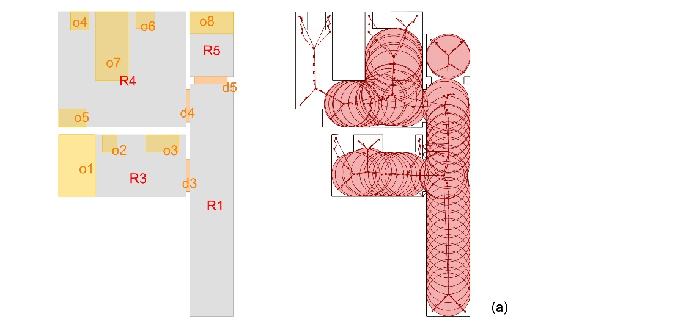
(c)
(b)
Figure 3. (a): Calculation of the area formed by the union of the circles with a diameter greater than 80 cm inscribed within the portion of the surface free from obstacles. (b): Calculation of the area formed by the union of the circles with a diameter greater than 150 cm inscribed within the portion of the surface of the bedroom free from obstacles. (c): Calculation of the area resulting from the difference between the surface around the bed (within a perimeter of 120cm offset from it), minus the area on the ground of the obstacles.

2.3 Visibility Criteria

Criterion 3.a: Ensure a daylight factor greater than 3% (or at least 2%) within the care receiver's room.

The percentage of daylight factor is calculated by adding to the model input data the geographical location of the project, the height of the patient's bedroom, the position, the size of the openings, the type of glass, and the chromatic characteristics of the internal cladding surfaces. The calculation is performed through available open-source tools.

Criterion 3.b: Guarantee the possibility for the care receiver to view out of the window from the bed.

To measure the performance against this requirement, we referenced an analysis of the isovists property defined as the area (or volume) of space visible from a given point in space (Benedikt, 1979). These represent a measurement of a spatial quality also taken from the Space Syntax methodology (Hillier & Hanson, 1984) for the objective measure of the visibility among each observation points. According to this methodology, several studies have proposed tools for configurational analyses (including the isovists analysis) implemented within VLP applications for CAD environments. In this case, the parameter that describes the response to the quality criterion is the angle of the horizontal view that encloses the visual rays that intersect the window. A more sophisticated analysis could be implemented through better structured open-source tools to verify compliance with daylight availability requirements and "view out" quality, such as the one proposed by Brembilla et al. (2021).

Figure 4.(a): 2D Isovists analysis; (b) Daylight factor calculation.

2.4 Minimum Intervention Criteria
In the previous sessions, some possible ways to define the quality criteria functions to assign a score to a given spatial configuration have been identified. Based on the analysis results, the design team could hypothesize “n” alternative configurations to increase the score. However, in the case of home modification, the decision-making process could be heavily influenced by the cost and impact of the transformations on the building components required to achieve the desired configuration. For this reason, the tool should be able to compare the alternative configurations with respect to a starting one (assumed as the existing state of the housing) and penalize the design alternatives that involve the greatest intervention burden. Therefore, we consider the building transformations a fourth quality criteria category that design alternatives should meet.

Criterion 4.1 Minimizing demolition
Criterion 4.2 Minimizing new construction
Criterion 4.3 Minimizing the refurbishment of flooring
Criterion 4.4 Minimizing the distance of bathroom fixtures from pre-existing drains
For that purpose, the system could calculate the demolished and new walls length and the area of new paving needed, as well as the Euclidean distance between the old and the new position of the bathroom fixtures.

3. Results
Based on the described methods and techniques tested in other fields of application, the flowchart for the framework of a new spatial decision support system (SDSS) specific to implement multi-criteria assessments of the different design alternatives in the case of domestic adaptation for home care is illustrated in Figure 5. The system is designed to measures the correspondence of a housing spatial model to a set of predefined quality criteria that refer to requirements of proximity between specific spaces, accessibility, and visibility. Each criterion is represented by a success indicator which give an objective measurement of the model’s performance, as summarized in Table 2. The weighted sum of the success indicators define a function that establishes a score associated with a specific configuration of spaces, objects and architectural components.
The system workflow includes the following steps:
- Input and weights acquisition:
The designer defines the spatial model of the housing to analyze. This model shall contain inputs necessary for the system to process the automated analyses. By assigning a variable multiplier factor, the designer can decide the "weight" of the different criteria regarding the entire set.
- First assessment and starting score:
Based on the inputs and weights entered, the system calculates the scoring function and shows the overall and partial results for each criterion. The result of each measurement will be normalized to a range between zero and one, according to high or low performance. The weighted sum of the results of the functions will determine the score associated with a specific spatial configuration.
- Implementation of n design alternatives:
The design alternatives are manually implemented by the designer.
- Evaluation and classification of n design alternatives:
All alternative configurations are compared with the starting one (assumed as an existing state). The system re-evaluates the scoring function. This time, the system also evaluates the fourth category of minimum intervention criteria. The reiteration of the evaluation mechanism provides a dynamic response to the variation of the assumed configuration and facilitates the classification of design alternatives.
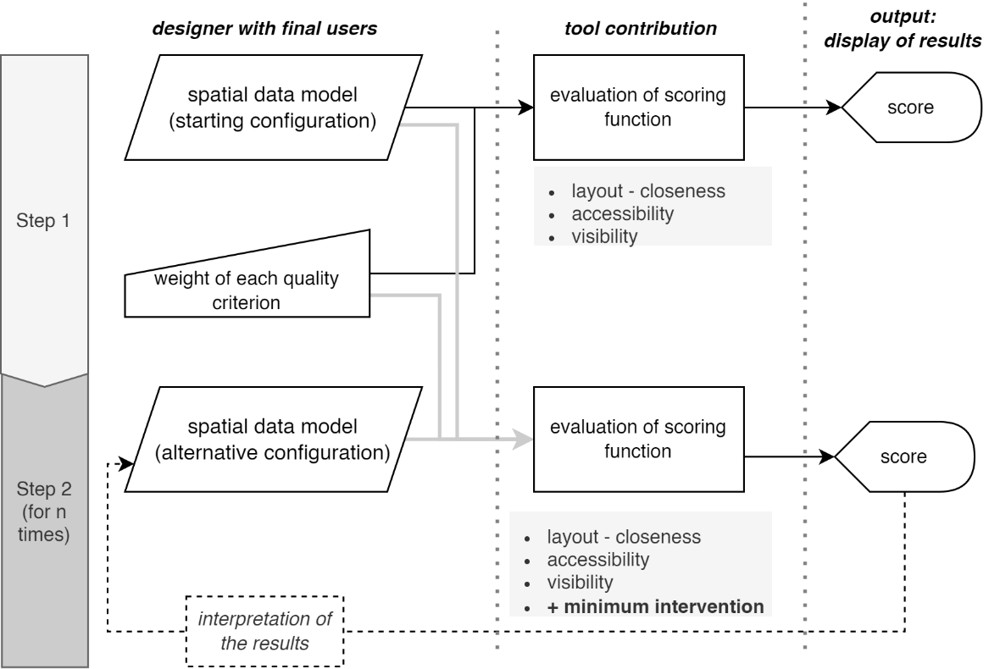
Figure 5. Workflow of the proposed SSDS for home modification designs.
Table 2. Summary of quality criteria and success indicators.
 | Quality criteria | Success indicators
Layout (closeness) | Criterion 1.a: The storage area for equipment and medicines must be close to the care-receiver’s bedroom. | Length of shortest path between bed and storage area.
 | Criterion 1.b: The care-receiver’s bedroom must be close to a toilet. | Length of shortest path between bed and toilet.
Accessibility | Criterion 2.a: The width of passages should never be less than 80 cm, or 120 in the case of assisted walking. | Walkable floor area.
 | Criterion 2.b: There must be a free space with a diameter of 150 cm in the care-receiver’s bedroom and bathroom. | Area of inscribed disc with a diameter greater than 150cm within free area of the room.
 | Criterion 2.c: It must be possible to approach the care-receiver's bed on three sides, ensuring a 120 cm wide band on at least one long side. | Free area around the bed.
Visibility | Criterion 3.a: A daylight factor greater than 3% (or at least 2%) must be guaranteed in the care-receiver's bedroom. | Percentage of daylight factor.
 | Criterion 3.b: The care-receiver must be able to see out the window from the bed. | Angle of the horizontal view that intersect the window.
Minimum  Intervention | Criterion 4.1 Minimizing demolition | Length of demolished partitions.
 | Criterion 4.2 Minimizing new construction | Length of new built partitions.
 | Criterion 4.3 Minimizing the refurbishment of flooring | Area of new flooring.
 | Criterion 4.4 Minimizing the distance of bathroom fixtures from pre-existing drains | Euclidean distance between the old and the new bathroom fixtures location

4. Discussion
The proposed framework aims to provide designers with a new SSDS to support the home adaptation project for healthcare at home. It is meant to be compatible with the most used software for architectural design and able to base the decision-making process on clear performance specifications to increase the effectiveness and quality of interventions. Moreover, it attempts to offer a possible solution to bridge a gap in the available CAD tools by assessing the building transformations impact (by modeling them as penalty terms of the scoring function).
We believe that the complexity of constraints in home modifications makes it less advantageous to let artificial intelligence propose feasible solutions. To maximize the effectiveness of human-computer interaction, we opt for a mechanism able to provide real-time feedback on the compliance of the design choices manually implemented by the designer. This quick response based on objective spatial analysis of a spatial model makes the workflow more interactive and participatory, and supports selecting satisfactory technical solutions identified by an informed and balanced compromise between the relevant quality criteria. The assessment mechanism's open structure allows a flexible and customizable use according to the specificities of the individual cases. Moreover, its transparency increases the ease of control of expected performance.
One of the limits identified is that, to date, we have been able to consider only a minimum number of requirements that do not constitute a faithful representation of the characteristics that the home must possess in order to be suitable for home healthcare. At present, the framework does not consider the characteristics of the technical elements (i.e., finishing materials, shading devices, windows' performances, etc.). However, since they are not neutral qualitative factors, the subsequent developments will concern their modeling by converting the expected performance in scores added to the criteria already defined for the scoring function. This aims to increase the accuracy of the analyses and, consequently, the evaluations carried out by the design team.
Some potential of our approach is that although it is proposed for a specific design sector, the SDSS could be applied in similar contexts: renovations or new buildings for assisted living, or other contexts in which it is necessary to maximize the project’s compliance with ergonomic requirements in an inclusive, and for all way (Villani, 2013). Finally, the objective measurement of the adaptability of pre-existing housing could orient the real estate market by increasing the resources allocated to adapt the housing stock in an age-friendly and care-friendly perspective.

5. Conclusions
Due to social and demographic trends, the demand for housing adaptation to enhance the accessibility, safety, and comfort of spaces to allow home care will increase. This design area will substantially impact the construction sector, and its multidimensional complexity will require a more transparent and participatory decision-making process. Although there are numerous tools derived from computerized design approaches that implement multi-criteria evaluation techniques in the literature, there is still no one that can support the selection of technical choices useful for the adaptation of housing for frail people. To bridge this gap, the paper illustrates the structure of a spatial decision support system (SDSS) to implement multi-criteria analysis to support decision-making and project design in the specific field of home modification for healthcare at home. The tool is based on modeling quality criteria in computable functions that define a scoring function that measures the project’s compliance with the desired quality objectives, considering the impact of the necessary transformations. The ultimate goal is to improve the quality of domestic adaptation interventions by structuring a repeatable and flexible process, supporting technical choices, and allowing stakeholders to make informed and evidence-based decisions.
Together with the actual implementation of the framework outlined, the limitations highlighted in the discussion section will be the starting point for pursuing the next research trajectories.

Contributor statement
Writing-Original draft : Federica Romagnoli
Writing – Review & Editing : Pirouz Nourian, Tiziana Ferrante, Teresa Villani

References
- Abd Algfoor, Z., Sunar, M. S., & Kolivand, H. (2015). A Comprehensive Study on Pathfinding Techniques for Robotics and Video Games. International Journal of Computer Games Technology, 2015, 1–11.
- Azadi, S., & Nourian, P. (2021). A modular generative design framework for mass-customization and optimization in architectural design. 39th eCAADe Conference 2021, Towards a new, configurable architecture, Novi Sad, Serbia
- Benedikt, M. L. (1979). To take hold of space: Isovists and Isovist fields. Environment and Planning B: Planning and Design, 6(1), 47–65.
- Brembilla, E., Azadi, S., & Nourian, P. (2021). A Computational Approach for Checking Compliance with European View and Sunlight Exposure Criteria. ArXiv:2109.11037
- European Union. (2017). European pillar of social rights.
- Eurostat. (2020). Ageing Europe: Looking at the lives of older people in the EU : 2020 edition. Publications Office.
- Ferrante, T., & Cellucci, C. (2021). Impact of Aging: The New Frontier of Healthcare at Home. Advances in Human Factors and Ergonomics in Healthcare and Medical Devices, 263, 485–492.
- Ghosh, M., Thomas, S., & Amato, N. M. (2020). Fast Collision Detection for Motion Planning Using Shape Primitive Skeletons. In M. Morales, L. Tapia, G. Sánchez-Ante, & S. Hutchinson (Eds.), Algorithmic Foundations of Robotics XIII (Vol. 14, pp. 36–51). Springer International Publishing.
- Goel, S. K., Ansari, M. S., & Kuwalekar, T. (2017). Using A* algorithm to find shortest path in Indoor positioning system. 04(06), 3.
- Goldstein, R., Breslav, S., Walmsley, K., & Khan, A. (2020). SpaceAnalysis: A Tool for Pathfinding, Visibility, and Acoustics Analyses in Generative Design Workflows. 8.
- Hillier, B., & Hanson, J. (1984). The Social Logic of Space. Cambridge University Press.
- Kán, P., & Kaufmann, H. (2017). Automated interior design using a genetic algorithm. Proceedings of the 23rd ACM Symposium on Virtual Reality Software and Technology, 1–10.
- Keshavarzi, M., Parikh, A., Zhai, X., Mao, M., Caldas, L., & Yang, A. Y. (2021). SceneGen: Generative Contextual Scene Augmentation using Scene Graph Priors. 0(0), 20.
- Kumawat, S., Dudeja, C., & Kumar, P. (2021). An Extensive Review of Shortest Path Problem Solving Algorithms. 2021 5th International Conference on Intelligent Computing and Control Systems (ICICCS), 176–184.
- Lee, D. T. (1982). Medial Axis Transfrmation of a Planar Shape. Medial Axis Transfrmation of a Planar Shape, 4, 363–369.
- Madkour, A., Aref, W. G., Rehman, F. U., Rahman, M. A., & Basalamah, S. (2017). A Survey of Shortest-Path Algorithms. ArXiv:1705.02044.
- Merrell, P., Schkufza, E., & Koltun, V. (2010). Computer-generated residential building layouts. ACM SIGGRAPH Asia 2010 Papers on - SIGGRAPH ASIA ’10, 1.
- Merrell, P., Schkufza, E., Li, Z., Agrawala, M., & Koltun, V. (2011). Interactive furniture layout using interior design guidelines. ACM SIGGRAPH 2011 Papers on - SIGGRAPH ’11, 1.
- Naderpour, A., Johnson, B., & Anderson, A. (n.d.). A2B: A Toolkit for Computing Circulation Metrics in Buildings. 2576–2583.
- National Research Council. (2011). Health Care Comes Home: The Human Factors (p. 13149). National Academies Press.
- Nisztuk, M., & Myszkowski, P. B. (2018). Usability of contemporary tools for the computational design of architectural objects: Review, features evaluation and reflection. International Journal of Architectural Computing, 16(1), 58–84.
- Piatkowski, M., Abushousheh, A., & Taylor, E. (2019). Healthcare at Home: A white paper supporting the Center for Health Design Interactive Diagrams. The Center for Health Design.
- Sönmez, N. O. (2018). A review of the use of examples for automating architectural design tasks. Computer-Aided Design, 96, 13–30.
- Ulrich, R. S. (1984). View Through a Window May Influence Recovery from Surgery. Science, 224(4647), 420–421.
- van Toll, W., Iv, A. F. C., Kreveld, M. J. V., & Geraerts, R. (2018). The Medial Axis of a Multi-Layered Environment and Its Application as a Navigation Mesh. ACM Transactions on Spatial Algorithms and Systems, 4(1), 1–34.
- Veloso, P., Celani, G., & Scheeren, R. (2018). From the generation of layouts to the production of construction documents: An application in the customization of apartment plans. Automation in Construction, 96, 224–235.
- Villani, T. (2013). Design for All. In Lezioni di Design (pp. 232–241). Design Press.
- Wright, C. J., Zeeman, H., & Whitty, J. A. (2017). Design principles in housing for people with complex physical and cognitive disability: Towards an integrated framework for practice. Journal of Housing and the Built Environment, 32(2), 339–360.
- Yeh, Y.-T., Yang, L., Watson, M., Goodman, N. D., & Hanrahan, P. (2012). Synthesizing open worlds with constraints using locally annealed reversible jump MCMC. ACM Transactions on Graphics, 31(4), 1–11.
- Yu, L.-F., Yeung, S.-K., Tang, C.-K., Terzopoulos, D., Chan, T. F., & Osher, S. (2011). Make it Home: Automatic Optimization of Furniture Arrangement. 11.
- Zhang, S.-H., Zhang, S.-K., Liang, Y., & Hall, P. (2019). A Survey of 3D Indoor Scene Synthesis. Journal of Computer Science and Technology, 34(3), 594–608.

