ARCH22 ‘Enabling health, care and well-being through design research' 5th Architecture Research Care and Health conference
Delft / Rotterdam – the Netherlands – 22nd until 24th of August 2022.

Type of the Paper: Peer-reviewed Conference Paper / Full Paper

Track title: please fill in your topic title here

Investigating impacts of Interior design variables on employee’s wellbeing in the UK workplace.
Nadine Fayyad 1,*, Busayawan Lam 2, and Youngok Choi 2

1 Brunel Design School, College of Engineering, Design and Physical Sciences, Brunel University London, Ux- bridge UB8 3PH, UK; Nadine.fayyad@brunel.ac.uk (N.F.); https://orcid.org/0000-0002-8600-2618
2 Brunel Design School, College of Engineering, Design and Physical Sciences, Brunel University London,
Uxbridge UB8 3PH, UK; Busayawan.lam@brunel.ac.uk (B.L.); youngok.choi@brunel.ac.uk (Y.C.)
* Correspondence: nadine.fayyad@brunel.ac.uk

Names of the Topic editors:
Clarine van Oel

Names of the reviewers:
Annemarie Eijkelenboom

Journal: The Evolving Scholar
DOI:10.24404/623113153b6762f0ec7
b732b

Submitted: 15 Mar 2022
Revised: 7 May 2022
Accepted: 16 Jul 2022

Citation: Fayyad, N., Lam, B. & Choi,
Y. (2022). Design for Wellbeing: Investigating impacts of Interior design variables on employee’s wellbeing in the UK workplace. The Evolving Scholar | ARCH22.

This work is licensed under a Creative Commons Attribution BY license (CC BY).

© 2022 Fayyad, N., Lam, B. & Choi, Y. published by TU Delft OPEN on behalf of the authors.
Abstract: Workplace environments have a significant impact on mental health and wellbeing. The field of wellbeing research has gained increasing importance over the past decade, as it contributes to a person's health, reduces stress, and improves performance. A number of factors, including globalization, short-term contracts, outsourcing, and mergers, have adversely affected employee psychological wellbeing levels. Consequently, interior design has gained tremendous importance. Designing environments with a focus on both physical and psychological well-being has become increasingly important for interior designers. In this paper, we investigate the extent to which the physical environmental variables (e.g., layout) affect employees' psychological wellbeing by re- porting on the findings of methods which included a systematic literature review, field observa- tion, and an online survey. (25) participants who were chosen upon criteria of inclusion (i.e., UK worker) and exclusion (i.e., working remotely) in an open-plan office layout. Findings show par- ticipants responding positively to an open layout; however, this may have negative effects in terms of privacy, control, and noise. Natural materials and elements were found to be a demand by em- ployees as the majority claimed that these affect their wellbeing positively.

Keywords: Design for Wellbeing; Interior Design; Workplace design; Office setting, design vari- ables

Introduction
Space components, lighting, surface treatments, furniture, and accessories are all factors involved in the design of a workplace, which all contribute to the appropriate function and visual aspect of the workplace (Ching & Binggeli, 2018). It is relatively easy to change the interior elements of the workplace to reflect the psychological well-being of its inhabitants (i.e., employees).
Throughout the past decades, interior designers have performed extensive studies on the link between workplace environment and employee wellbeing. By enhancing health, safety, and welfare, interior designers are responsible for improving human well-being, according to the definition set by the Council for Interior Design Qualifica- tions (CIDQ). In accordance with the CIDQ (2019), human experience is an interplay between physical and sensory elements of occupants' interior spaces that impacts their emotions, health, and well-being (Definition of Interior Design, 2019). Similarly, Vischer's conclusions suggest that buildings should offer occupants more than just health and safety; they should promote a psychological and physical environment that facili- tates learning and growth (Vischer, 2008). Thus, the interior design considers how peo- ple are created, and how that creation supports or hinders the tasks and wellbeing of the users. To design the next generation of workplaces, designers should use high-level measurements that take into account how the workplace can potentially benefit workers (Clements-Croome et al., 2019).

https://doi.org/10.24404/623113153b6762f0ec7b732b

Extant literature shows that interior design elements (e.g., furniture) affect occu- pants' functionality and emotional responses towards a setting or environment (Karol and Smith, 2019). Building design, material selection, Indoor Environmental Quality (IEQ), and other aspects of the built environment can cause a wide range of impacts on user health and well-being, as well as ergonomic design issues. (Attaianese & Duca, 2012). Since corporate real estate practices are generally geared toward saving costs, ef- ficiency is prioritized over effectiveness. Consequently, open-plan offices have become increasingly prevalent around the world (Harris, 2019; Haynes, 2007), which has led to a perceived change in working life across nations (Cox & Griffith, 2005; Schabracq & Cooper, 2000). The increasing rate of change means that employees are increasingly re- quired to compete, adapt, and learn new skills (Cox & Griffith, 2005), which adversely affects their well-being. As a result of the limited theoretical understanding, there was more harm than good (Ashkanasy et al., 2014; Sander et al., 2019). As a result, a positive design that serves the wellbeing needs of employees has been difficult to achieve.
The aim of this paper is to advance on previous studies by investigating to what ex- tent the physical environmental variables affect workers wellbeing. Offices at the Design department at Brunel University London acted as a case study. This paper reports on data collected through literature review, field observation and online questionnaire.

Methods
To address the key research question related to the data collection, the literature was approached systematically to gain wider insights of the topic. Afterwards, two methods were used in phase one of the primary data collection. To begin with, non-participant field observation was conducted to gain an in-depth exploration into the office setting. afterwards, an online survey was distributed to help gather participants, and build a reference for collecting qualitative data for the next step (i.e., semi-structured interviews).

  - Literature Review
Essentially, the development of knowledge depends heavily on previous findings. Literature reviews enable researchers to gain insight into the breadth and scope of the existing body of work, identifying areas that require further exploration (Pare, et al., 2015).
Through adopting a systematic approach to reviewing the extant literature on work- place wellbeing and interior design, the researcher used the guidelines of Preferred Re- porting Items for Systematic Reviews and Meta-Analyses (PRISMA) to approach the lit- erature systematically. In order to establish a foundation for academic inquiry, it was es- sential to gain a comprehensive understanding of the topic. Therefore, multiple data- bases were searched (e.g., Scopus). The collation of reference material was managed us- ing Mendeley Reference Manager, allowing the researcher to organise referenced mate- rial and create bibliographies instantly. (Details on the literature conducted is included in an upcoming publication).

  - Non-participant field observation
McQuarrie et al., 1990 define observation as the systematic description of events, behaviors, and artifacts occurring in the social environment of study. By observing and taking photographs, the researcher creates a written description of the situation under study (Erlandson, 1993).
In order to understand the field, a researcher's observations enable them to identify what may have been overlooked during the process of gathering the data (literature re- view), which in turn allows them to add data to surveys from his perspective.
Choosing this site for conducting the field observation is ascribed to multiple rea- sons. Given the fact that the researcher works in one of the offices, eased her access to other office environments studied and extinguished a kind of familiarity for the re- searcher helping her to identify and explore different variables.
Multiple pictures were taken inside the offices which comprised three semi-similar environments. Further explanation is in the results section.

  - Online questionnaire
    - Sampling strategy

Emails were sent to potential participants detailing the information of the study with consent form attached for them to opt whether to participate. They could read it at their own convenience. Reasons for the study were explained verbally for those that made such enquiry. Prior to participating, they must sign and return the consent form with emphasis being placed on that they have the right to not participate at any time without explanation. Thirty people initially agreed to take part in the data collection, but five later declined due to lack of interest and/or time commitments. While Inclusion cri- teria included being over 18 years old, work in an office environment in the United Kingdom, and their length of service; the study excluded anyone who work remotely or have any mental health conditions. Due to the fact that remote employees are not in touch with their environment, they are unable to respond to questions as needed. As for people with stress or anxiety diagnoses, their results will not be accurate as they have al- ready been exposed to stress.

2.3.2. The online questionnaire
Based on the observation conducted inside the offices, information regarding space physical environmental variables (e.g., layout) were collected to help build an online closed-ended questionnaire which targets variables employees interact with using 5-point multiple choice Likert scales and forced responses. Length of the survey was kept to a minimum to achieve a satisfactory response-rate as possible. Although this research adopts qualitative methods, this survey was used to helps extract the qualitative data needed for conducting the research.
Before releasing the questionnaire to participants, it was tested with five random people (pilot test) to get feedback. Among the goals of survey piloting, as outlined by Larossi (2006), are the evaluation of the competency of the questionnaire, estimation of the length of the questionnaire or duration of time required for the survey and assessing the quality of the surveyor. The questionnaire was revised in response to recommenda- tions made by participants in the pilot test. It was recommended that the questionnaire be refined and made more precise and clearer, that the wording be modified, introduc- tory definitions be provided, and that the length of the questionnaire be reduced. After revising the questionnaire, it was piloted among two design researchers and academics as well as a researcher in the social sciences with the objective of checking the overall presentation, structure, and clarity of the questionnaire. Additionally, respondents were asked to estimate the time it took them to complete the survey. Following the completion of the survey, all respondents were asked to share their comments and thoughts on the design of the survey, as well as any issues pertaining to accuracy, relevance, and us- er-friendliness. A second revision to the survey was made in response to the feedback received and the responses to the questionnaire. As a result, further revisions were made to the wording, the definitions, and introductions, as well as the order in which the ques- tions were asked. The final questionnaire had five main sections and could be completed within less than 10 minutes.
Section one of the questionnaire was an introduction to the main aim of the study and the questionnaire. As the researcher intend to exclude people with mental health conditions (e.g., depression and anxiety), the second section of the survey was an eligi- bility criteria to identify whether participants have any mental health issues, for those who does, the survey will be terminated. Additionally, as part of the eligibility criteria, participants were asked if their workplace design affects their wellbeing. The survey will be terminated for those who believe their workplace does not negatively impact their wellbeing, but if they disagree, they will move to the next section. The third section of the survey concerned space interaction and comprised three questions. These were to de- termine how many hours they work weekly in the mentioned workplace, their level of ac- tivity, and level of interest in making changes in their office setting. The second section concerned the physical environmental variables in their office setting. It was designed to test the effect of those variables that may or may not affect their psychological wellbeing at work. The final section focused on demographics to help classify answers and make statistical comparisons. At the end of the survey, participants were asked to provide their email address if they would like to be contacted to take part in the semi-structured inter- views.
Information about the survey was distributed via email invitations in English that explained the survey's purpose, provided informed consent forms, and included a link to the survey questions.

In order to collect the data for the closed-ended questionnaire, the researcher used "Google Forms". Using Google forms, the researcher was able to create and develop a web-based questionnaire (Raju and Harinarayana, 2016). A web-based instrument has the advantage of automatically storing all data in a Google spreadsheet, which enables the data to be tabulated and presented graphically once the web questionnaire has been completed online. The quantitative analysis of data collected through the closed-ended questionnaire was accomplished through descriptive analysis. In descriptive analysis, constructs of interest are described, aggregated, and presented statistically.

  - Ethical Consideration
The researcher applied for and granted Ethical approval from the College of Engi- neering, Design and Physical Sciences (CEDPS) Research Ethics Committee prior to re- cruiting participants and collecting data.

Results
  - Results from the Literature review
Relevant literature was collected between (July- December 2021). A total of 54 studies out of 471 were evaluated in the initial review, which examined factors related to interior space that affect workplace wellbeing. The researcher performed a content anal- ysis to group interior design workplace variables into those with negative, positive, and neutral effects. Data collected in this method was combined to build basis for next steps (e.g., non-participant field observation). Variables identified included but not limited to, light, nature, and noise. (Details on the literature conducted is included in an upcoming publication).

  - Results from the field observation
The researcher conducted the observation based on data gathered from the litera- ture regarding the physical environmental variables (e.g., light), but kept an open mind from new data that may emerge from the observation.
Based on photographs taken in the 3 offices shown in figures 1-3, a preliminary analysis was conducted. This included pinning and categorizing variables inside the of- fices to help in building the online survey targeting participants working in these envi- ronments.
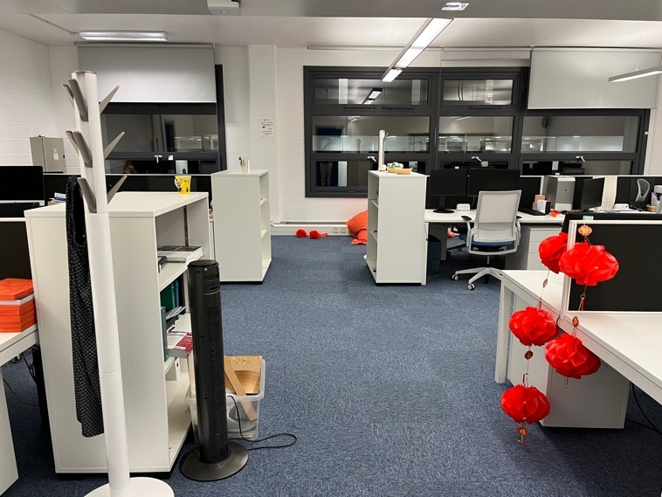
Figure 1. Office1 setting

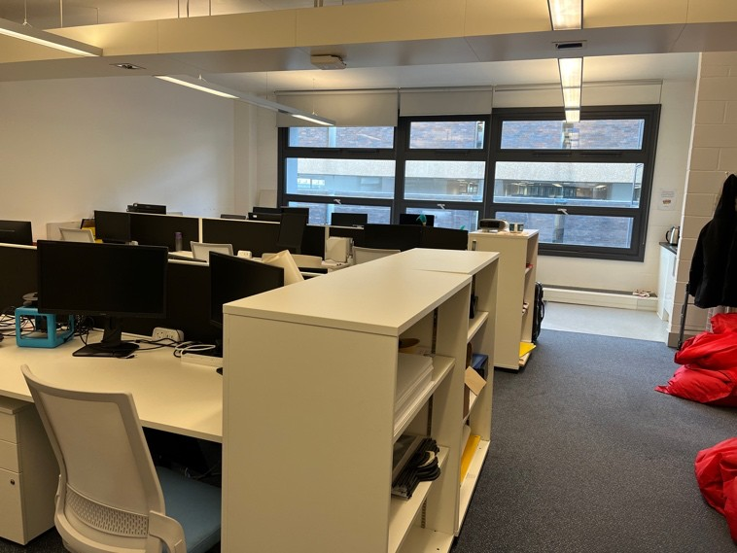
Figure 2. Office2 setting
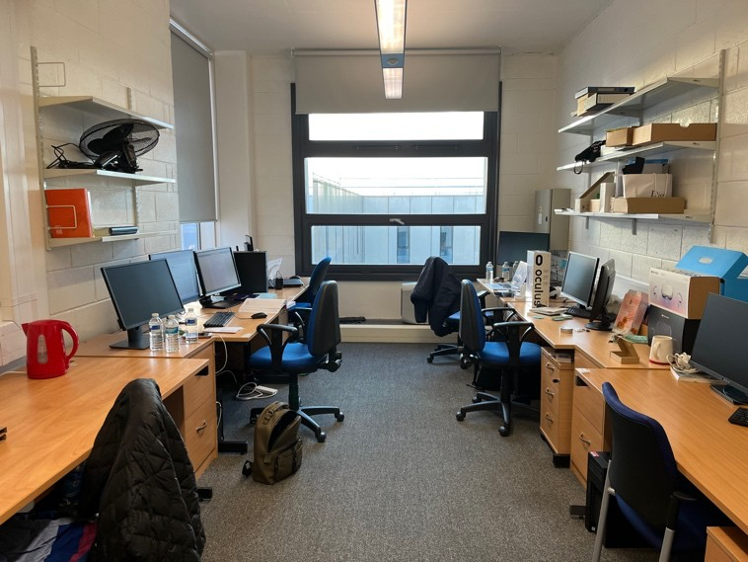
Figure 3. Office3 setting.

Observation revealed that participants worked in an open-plan office layout. office1 had 20 staff members, office2 had 15 staff members, while office3 had 6 staff members. Office2 had a sink/kitchen in it, while offices 1 and 3 did not.
Design of the offices was minimal with linear furniture arrangement. Walls were all painted white, and in some areas artificial stone was used. White plastic cable/wire tray were visible in different parts on the walls.
As for furniture, all desks were rectangular with aluminum shared legs and wooden tops with a set of drawers’ underneath. They all had an under top cable tray with a flexi- ble slinky link to the lower high-capacity pass through cable tray. All desks had front framed-mount dividers except for desks in office 3 and desks facing the windows in of- fice2. Desks in offices 1 and 2 had white wooden tops while in office three they were beige.
Chairs had a white body with an upholstered blue fabric and a white mesh backs. They had an adjustable seat depth and height and a lower back support with controls. They also had a rotational three-stage travel limiter for more back adjustability.
Floors in the three offices were covered with carpet except for the sink/kitchen area in office2.
All offices had large windows enough to bring in daylight and provide views to the outside, they were well-sealed providing good isolation levels for average noise coming from outside with drop light-grey blinds. However, direct access to windows was not available to all desks.
Artificial light fixtures were single-suspended linear lighting providing the space with good amount of light, they were also provided with movement sensors.

As for noise, it was clear while observing that sounds (i.e., people talking) were au- dible between office 1 and 2. Office3 had loud noise caused by ventilation system.

  - Results from the online questionnaire
    - Demographics
25 participants are from a design-focused office environment and work primarily with computers.
A purposeful sampling technique was initially used to collect primary data. The re- searcher used her expertise to target participants suitable for the study. As a result, the questionnaire was sent to many researchers in order to gather preliminary data. In order to increase the number of participants, the researcher used the Snowball strategy in the second step by asking participants to forward the survey to other colleges that had not been identified by the research.
Respondents age range varied between 25-44. However, length of service varied between 6 months and 3 years.

    - The Online questionnaire
Staff members from the Design department were surveyed in a UK office setting between January and February 2022. The researcher surveyed 25 participant and asked key questions related to space interaction, and their interest of having changes made to the office interior. More than half of the participants worked for over 30 hours per week inside the office setting mentioned, the majority of their daily tasks require them to sit at their computers all-day. While 94% were interested in having some changes in the office interior, only 6% were neutral about it, and no lack of interest was recorded.
Participants' perceptions of certain variables varied according to results collected. It is therefore necessary to conduct further qualitative analysis (such as semi-structured interviews) to understand why each variable is perceived in this way. See figure 4.

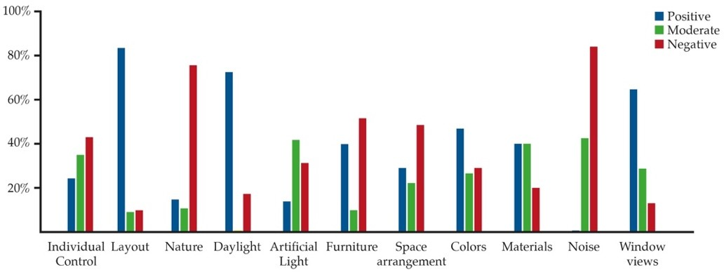

Figure 4. Interior Design variables survey results (Bar-chart developed by the first author).

When asked about levels of individual control they have over their environment and desk space being able to personalize, 22% claimed having full control and 52% claimed having no control, only 13% had moderate control. This left different effects on them, meaning that even when some had no control over their environment it left positive ef- fects on them, and vice versa. However, the majority were affected negatively when they had no control, and positively when having full control.
As for Layout, participants worked in an open-plan office layout as noted from the field observation. Effects of such layout, resulted in 82% being positively affected, and only 10% being negatively affected, and only 8% had no effect at all.
When asked about nature and biophilic elements it was noted from the field obser- vation that offices did not include any natural elements or materials, the question was asked to make sure that they perceived nature in the same way. All participants assured not having any natural elements. While 75% were affected negatively, and 15% were af- fected positively by it, only 10% had no effects about all.
As for lighting, participants were asked about daylight and artificial light. When it came to daylight, 18% had negative effects, while 72% had positive effects. However, arti-

ficial light was perceived differently. 35% were affected negatively, and only 14% were affected positively. Being moderately affected had 41% response.
When it came to furniture, 40% reported being positively affected by furniture in their working environments (e.g., chairs). And while 9% were neutral about it, 51% re- ported negative effects caused by furniture.
In regard to space arrangement, opinions varied between having 49% of the partic- ipants affected negatively, 29% being affected positively, and 22% not being positively nor negatively affected.
Colors used in the offices affected 29% of the participants negatively, and 47% posi- tively. However, 26% were neutral not being affected by colors around them.
Materials which form an important aspect of how we perceive our surrounding en- vironments had 20% participants being affected negatively, 40% positively, and 40% not having effects at all.
All participants answered with a ‘yes’ to being affected by noise. However, this was perceived differently when asked about its effects. 83% were affected negatively while 17% were not affected positively nor negatively. This will be further explored in the semi-structured interviews to identify what is perceived as noise.
Finally, participants were asked about their window views. Those who worked in of- fices overlooking the urban environment of the building including the library and yards which had some greenery claimed that such views affected them positively. However, those working an office (i.e., office3) which overlooked the interior of the building, and another building were affected negatively.

Discussion
This study was designed as part of a Ph.D. thesis to establish links between physical environmental variables (e.g., layout) and employees wellbeing in the UK workplace. 25 staff members were surveyed. All participants included in this study worked in an open office layout, and were aged between 25-44.
According to Diener & Lucas, 2000, if people have positive experiences more often, they are more likely to report higher levels of wellbeing, such positive experiences can be provided through well designed environments. Therefore, positive interactions with sur- roundings can contribute to a sense of wellbeing in offices.
The majority of results collected from the survey matched data from the literature. On the one hand, noise was the variable which recorded the highest negative effects, while having nature inside recorded the least negative effect on employees’ wellbeing in- side the workplace. On the other hand, open layout appeared as the variable with the highest positive effect on employees and control being to lowest positive effect (See fig- ure 5).
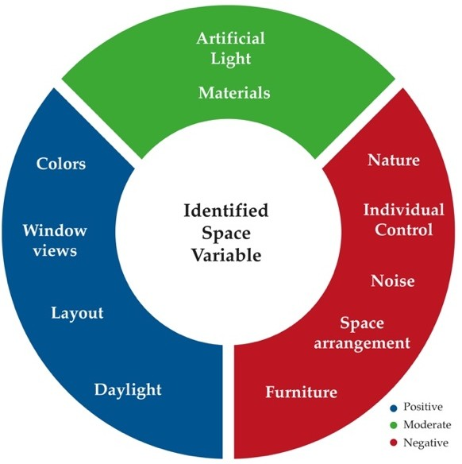

Figure 5. Space variables grouping based on effects on occupants (Figure developed by the first author).

In terms of natural elements and materials inside the workplace, the literature sug- gests that when data was collected from employees, they reacted to natural elements and materials either positively or had no reaction. However, data collected from the online survey in this paper suggests that 15% of staff members responded negatively to having nature inside. This calls for more exploration into why they were affected negatively by natural elements.
Moreover, the literature indicates that higher sound levels increase physiological stress (Shafiee Motlagh et al., 2018). This can be demonstrated at the cognitive level by increased involuntary attention to auditory stimuli, difficulties refocusing after interrup- tions leading to increased noise interference, and time wasted due to noise in the office workspace (Kaarlela-Tuomaala et al., 2009). This explains results in which 83% partici- pants responded with being negatively affected by noise and no one being affected posi- tively.
According to data collected from the field observation, employees worked in an open-plan office layout. On the one hand, this allows for idea exchange as suggested in the literature and better communication (Bernstein & Turban, 2018). On the other hand, it promotes higher levels of distraction, and dissatisfaction resulting in lower levels of wellbeing (James et al., 2021; Shafaghat et al., 2014). Results from the survey suggested that only 10% were affected negatively by it. Moreover, in open-plan work environments, a bad result on employees' wellbeing has been linked to little or no control over certain elements (e.g., desk personalization, light and ventilation) (Kwon et al., 2019).
From the observation conducted, it was noted that the space could use some flexi- bility in terms of furniture, materials, and space arrangement with a use of some vibrant colors.
Natural and artificial sources of light influence the quantity and quality of light in an individual workspace. It was noted that good amount of daylight is provided through windows installed in the office. However, artificial light suffered from lack of adjustabil- ity, which according to the literature if available, increases the sense of psychological wellbeing (Preto & Gomes, 2018).

Conclusions
Environmental variables play a vital role in creating a well-designed workplace be- cause they determine how much energy people have to live and work. This paper classi- fied physical environmental variables into positive, negative, and moderate effects on wellbeing levels. By doing so, we hoped to clearly understand how working in similar en- vironments affects us. While all variables were individually tested, some may overlap in some way in their effects on occupants.
Limitation included not being able to reach higher numbers of participants due to COVID-19. Additionally, some participants had personal commitments forcing them to withdraw before the study begun.
The next stage of this research is to provide an expanded exploration, building upon data collected from methods mentioned in this paper (e.g., online survey) to provide a wider understanding of how and why variables are perceived in certain ways by partici- pants, and find links between different variables, to see which ones work better together through conducting semi-structured interviews which should be structured at the broadest level possible so that all participants are able to contribute to the discussion talking about issues they consider important, rather than answering specific questions.

Contributor statement
Author Contributions: Conceptualization, N.F., B.L. and Y.C.; methodology, N.F.; formal analysis, N.F.; investigation, N.F.; data curation, N.F.; writing—original draft preparation, N.F.; writ- ing—review and editing, N.F., B.L. and Y.C.; supervision, B.L. and Y.C. All authors have read and agreed to the published version of the manuscript. See Policies (tudelft.nl)

References

- Ashkanasy, N. M., Ayoko, O. B., & Jehn, K. A. (2014). Understanding the physical environment of work and employee behav- ior: An affective events perspective. Journal of Organizational Behavior, 35(8), 1169–1184. https://doi.org/10.1002/job.1973.

- Attaianese, E., & Duca, G. (2012). Human factors and ergonomic principles in building design for life and work activities: an applied methodology. Theoretical Issues in Ergonomics Science, 13(2), 187–202. https://doi.org/10.1080/1463922x.2010.504286.
- Bernstein, E. S., & Turban, S. (2018). The impact of the “open” workspace on human collaboration. Philosophical Transactions of the Royal Society B: Biological Sciences, 373(1753), 20170239. https://doi.org/10.1098/rstb.2017.0239.
- Ching, F. D. K., & Binggeli, C. (2018). Interior design illustrated. John Wiley & Sons, Inc.
- Clements-Croome, D., Turner, B., & Pallaris, K. (2019). Flourishing workplaces: a multisensory approach to design and POE. Intelligent Buildings International, 11(3-4), 131–144. https://doi.org/10.1080/17508975.2019.1569491.
- Cox, T., & Griffith, A. (2005). The Nature and Measurement of Work Stress: Theory and Practice. In In Evaluation of Human Work: A Practical Ergonomics Methodology. Taylor Francis.
- Definition of Interior Design. (2019). Council for Interior Design Qualification. 9fc10b986bd6e2ca.filesusr.com/ugd/0784c1_35be22acfef44bb3987190f333ac3af9.pdf
- Diener, E., & Lucas, R. E. (2000). Subjective emotional wellbeing. In Handbook of emotions (2nd ed.). New York.
- Erlandson, D. A. (1993). Doing naturalistic inquiry: a guide to methods. Sage.
- Harris, R. (2019). Defining and measuring the productive office. Journal of Corporate Real Estate, 21(1), 55–71. https://doi.org/10.1108/jcre-05-2018-0016.
- Haynes, B. P. (2007). Office productivity: a shift from cost reduction to human contribution. Facilities, 25(11/12), 452–462. https://doi.org/10.1108/02632770710822562.
- James, O., Delfabbro, P., & King, D. L. (2021). A Comparison of Psychological and Work Outcomes in Open-Plan and Cellular Office Designs: A Systematic Review. SAGE Open, 11(1), 215824402098886. https://doi.org/10.1177/2158244020988869
- Kaarlela-Tuomaala, A., Helenius, R., Keskinen, E., & Hongisto, V. (2009). Effects of acoustic environment on work in private office rooms and open-plan offices – longitudinal study during relocation. Ergonomics, 52(11), 1423–1444. https://doi.org/10.1080/00140130903154579
- Karol, E., & Smith, D. (2018). Impact of Design on Emotional, Psychological, or Social Well-Being for People with Cognitive Impairment. HERD: Health Environments Research & Design Journal, 12(3), 193758671881319.
https://doi.org/10.1177/1937586718813194.
- Kwon, M., Remøy, H., van den Dobbelsteen, A., & Knaack, U. (2019). Personal control and environmental user satisfaction in office buildings: Results of case studies in the Netherlands. Building and Environment, 149, 428–435. https://doi.org/10.1016/j.buildenv.2018.12.021.
- Larossi, G. (2006), The Power of Survey Design: A User’s Guide for Managing Surveys, Interpreting Results, and Influencing Respondents. , The World Bank, Washington, D.C.
- McQuarrie, E. F., Marshall, C., & Rossman, G. B. (1990). Designing Qualitative Research. Journal of Marketing Research, 27(3), 370. https://doi.org/10.2307/3172595.
- Paré, G., Trudel, M.-C., Jaana, M., & Kitsiou, S. (2015). Synthesizing information systems knowledge: A typology of literature reviews. Information & Management, 52(2), 183–199. https://doi.org/10.1016/j.im.2014.08.008.
- Preto, S., & Gomes, C. C. (2018). Lighting in the Workplace: Recommended Illuminance (Lux) at Workplace Environs. In Ad- vances for Design for Inclusion. International Conference on Applied Human Factors and Ergonomics.
- Raju, V. and Harinarayana, N.S. (2016), Online Survey Tools: A Case Study of Google Forms, available at: https://www.researchgate.net/publication/326831738.
- Sander, E. (Libby) J., Caza, A., & Jordan, P. J. (2019). Psychological perceptions matter: Developing the reactions to the phys- ical work environment scale. Building and Environment, 148, 338–347. https://doi.org/10.1016/j.buildenv.2018.11.020.
- Schabracq, M. J., & Cooper, C. L. (2000). The changing nature of work and stress. Journal of Managerial Psychology, 15(3), 227–241. https://doi.org/10.1108/02683940010320589.
- Shafaghat, A., Keyvanfar, A., Lamit, H., Mousavi, S. A., & Abd Majid, M. Z. (2014). Open Plan Office Design Features Affecting Staff’s Health and Well-being Status. Jurnal Teknologi, 70(7). https://doi.org/10.11113/jt.v70.3583.
- Shafiee Motlagh, M., Golmohammadi, R., Aliabadi, M., Faradmal, J., & Ranjbar, A. (2018). Empirical Study of Room Acoustic Conditions and Neurophysiologic Strain in Staff Working in Special Open-Plan Bank Offices. Acoustics Australia, 46(3), 329–
338. https://doi.org/10.1007/s40857-018-0143-x.
- Vischer, J. C. (2008). Towards an Environmental Psychology of Workspace: How People are Affected by Environments for Work. Architectural Science Review, 51(2), 97–108. https://doi.org/10.3763/asre.2008.5114.

