Type of the Paper: Peer-reviewed Conference Paper / Full Paper
Track title: healthcare design and change

Preferences and satisfaction with social comfort of outpatient workers in six hospitals before and during the COVID-19 pandemic
AnneMarie Eijkelenboom ^{1,2,*}
¹ EGM Architects, Dordrecht, Netherlands.
² Architectural Engineering + Technology, Faculty of Architecture and the Built Environment, TU Delft, Delft, Netherlands.
* Correspondence: annemarie.eijkelenboom@egm.nl; ORCID ID 0000-0002-7998-8773

Names of the Topic editors:
Clarine van Oel
Names of the reviewers:
Evangelia Chrysikou
Milee Herweijer
Journal: The Evolving Scholar
DOI:10.24404/6232471c68135cebc564ffe4
Submitted: 16 Mar 2022
Revised: 7 May 2022
Accepted: 30 May 2022
Published: 6 Mar 2024
Citation: Eijkelenboom, A. (2022). Preferences and satisfaction with social comfort of outpatient workers in six hospitals before and during the COVID-19 pandemic. The Evolving Scholar | ARCH22.

This work is licensed under a Creative Commons Attribution BY license (CC BY).

© 2022 [AnneMarie Eijkelenboom] published by TU Delft OPEN on behalf of the authors.
Abstract: A PhD study was conducted on comfort and health of workers in outpatient areas because hospital workers are less satisfied with comfort than patients and outpatient areas were understudied. To better understand differences in preferences and satisfaction of individuals, profiles were produced with Two-Step Cluster Analysis, based on a questionnaire responded by 556 outpatient workers and building inspection of six hospital locations. Thereafter, interviews were performed to explain the preferences. As the COVID-19 pandemic started after the production of the profiles, changes due to the pandemic were included. A gap between preferences and satisfaction was identified for all profiles. Also, those with similar preferences for social comfort (privacy, interaction, and distraction) performed similar activities. Contact with others was for all profiles important, while satisfaction was overall high before the COVID-19 pandemic. Due to the shift to digital care during the COVID-19 pandemic, impoverished interaction was a main concern of the outpatient workers. In conclusion, the profiles for social comfort show that preferences for social comfort are associated with work-related aspects and can change. The profiles may open a new horizon to accommodate flexibility and variety beyond standardized solutions.
Keywords: social comfort, hospital staff, COVID-19 pandemic, preference

1. Introduction
While the pressure on hospital staff is increasing due to staff shortages and the increasing complexity of tasks (Barker, 2011), staff are less satisfied with comfort than patients (Eijkelenboom and Bluyssen, 2019). Satisfaction with comfort can vary between different departments, such as inpatient wards or outpatient areas, due to different activities, duration of stay, and building characteristics (Rashid and Zimring, 2008). As limited studies were found in outpatient areas, a PhD study was carried out on health and comfort of workers in outpatient areas.
Comfort was defined in this PhD study as a multifactorial construct, including indoor environmental quality (IEQ) and social comfort. This was done because several authors suggested that both the physiological perception of IEQ (thermal, indoor air, acoustic, lighting aspects) and social comfort aspects (privacy, crowding, distraction) contribute to satisfaction with the physical environment (Visscher, 2007; Shin, 2016). Also, personal, work and building-related aspects were included to capture a view that justifies the complexity of the outpatient workers’ perceptions. The PhD study identified differences in satisfaction with room types between IEQ and social comfort, associations of building-related aspects with health complaints, changes in comfort due to the COVID-19 pandemic and profiles for IEQ and social comfort. As the social comfort profiles were mostly related to work activities and these can change in future, this paper focusses on social comfort.

2. Theories and Methods

2.1. Rationale
It is important to understand differences between individuals for improved wellbeing in hospitals, as the sensitivity to environmental stimuli can vary between individuals. For example, in a study on the perception of acitvity-based offices, Hoendervanger, Ernst, Albers, Mobach, and Van Yperen (2018) indicated that satisfaction with the physical environment was related to differences in preferences for privacy between individual occupants. To justify differences in preferences and satisfaction between individuals, profiling can be used (Bluyssen, 2019). While previous studies in hospitals mostly focussed on satisfaction with comfort aspects, understanding of the preferences can contribute to the design practice. Therefore, this paper aims to provide insights into differences in perceived importance and satisfaction between groups with similar preferences (profiles). Furthermore, changes in social comfort due to the COVID-19 pandemic are explained.
This paper presents detailed information on social comfort and discusses the main results of social comfort, which were part of the PhD study.

2.2. Study design
A field study was conducted in two phases: a quantitative phase in the spring of 2019 and a qualitative phase in the autumn of 2020. This mixed methods approach was used to gain broad and in-depth insights into comfort and health of staff in hospitals. Only teaching hospitals were included to avoid bias due to organizational differences between academic, general, and teaching hospitals. Three hospitals participated, all including the main and one smaller location.
In the spring of 2019, the hospital organizations distributed a digital questionnaire among 1.694 outpatient workers at six hospital locations. The questionnaire included validated questions on IEQ and health based on OFFICAIR (Bluyssen et al. 2016), a translated set of questions on the perceived esthetical quality (Fisher, 1974), and a new set of questions on social comfort. These questions were based on literature. Also, the questionnaire comprised a new set of questions on preferences, related to the questions on IEQ and social comfort. The questionnaire was evaluated in a pilot study with outpatient workers at a general hospital. These outpatient workers were not included in the main study. Also, checklists were used to collect data on building-related aspects such as the enclosure of rooms, the direction of lighting, finishing materials, HVAC-systems, potential pollutants, etc.
A representative group of the participants from the first phase was recruited for the qualitative follow-up. Semi-structured interviews were conducted in the autumn of 2020, during the COVID-19 pandemic. The semi-structured interviews included explanations of work activities, changes during the COVID-19 pandemic, preferences for IEQ and social comfort, and ranking of preferences. For comparison with the survey, the outpatient workers were asked to rank the comfort aspects that were used to produce the profiles.
Before the interviews, the participants were instructed to send photos of comfort aspects in their most frequently used rooms. These were used to support communication of experiences and preferences (Wilhoit, 2017). A pilot test was performed with outpatient workers who did not participate in the main study. The interviews were audio-taped with Microsoft Teams and transcribed verbatim.

2.3. Ethical approval
Participation was voluntary. The participants could only participate after their approval of informed consent. The data was stored on a secured server. The study design was approved by the Ethics Committee of Delft University of Technology in October 2018.

2.4. Data analysis
Data from the questionnaire was imported from Qualtrics XM platform into IBM SPSS Statistics 25. Data from the building inspection was manually put into IBM SPSS Statistics 25. Building-related aspects were assigned to the respondents when the inspected variables were consistent. Consistency was identified with crosstabs of building-related aspects on different scale levels, such as organization, location, building-wing, room type, presence of a facade window, etc. The interviews were transcribed verbatim. Meaningful text fragments were manually put into Microsoft 365 Excel.
The main preferences and satisfaction were identified through descriptive statistics. Two-Step Cluster Analysis was used to produce clusters, which were differentiated by preferences and satisfaction with comfort. This was done for IEQ and social comfort separately. For the profiles, all preferences, satisfaction, personal, work, and building-related aspects, were compared between the clusters.
Inductive analysis, according to the steps defined by Gioia (2013), was used to identify changes due to the COVID-19 pandemic. The codes from the inductive analysis were compared with the data of the individuals from the survey. See Eijkelenboom and Bluyssen (2020) and Eijkelenboom, Ortiz, and Bluyssen (2021) for detailed information on the study design and analysis.

3. Results
The questionnaire was responded by 556 workers from outpatient areas at six hospital locations in the spring of 2019. The preferences and perceptions of those working at the various locations could be compared, as personal aspects, such as age or sex, did not vary between them. See for detailed information about the participants Eijkelenboom, Kim, and Bluyssen, 2020.

3.1. Preferences before the pandemic
Figure 1 shows the main preferences of the outpatient workers for social comfort aspects. Also, physical aspects, such as the size of the workplace and the size of the storage place, are included. The importance of the distinct aspects varied between the outpatient workers. For example, two-thirds of the outpatient workers regarded contact with colleagues and patients as one of the three most important aspects of their work performance, while less than 2% regarded the size of the storage place or the lack of crowding in the building as important. Another aspect that was only important to a minority (less than 10%) was the length of the walking distances. Aspects that were important for a large group were a safe workplace (over 50%), patient privacy (over 40%), and no distraction by noise (over 25%).

Figure 1. Preferences of the outpatient workers
The questions on satisfaction with social comfort were reduced with Principal Component Analysis to three components: interaction (contact and proximity), disturbance (distraction by noise, visual distraction, crowding at workplace and building, privacy of self), and sense of space (short walking distances, size of storage place, size of workplace, safe workplace) (Eijkelenboom and Bluyssen, 2020).

Figure 2 shows the satisfaction and preferences for social comfort of those in different clusters, i.e. SC1, SC2, SC3. The aspects that vary statistically were previously shown in Eijkelenboom et al. (2020). Overall, the differences between the clusters in preferences related to the principal component disturbance are larger than for the components related to interaction and sense of space. Dissatisfaction with interaction was lower than the importance for all clusters, while dissatisfaction with sense of space, except for a safe workplace, was higher than the importance for all clusters. Dissatisfaction with disturbance varied (P-value <0.05) between the clusters, except with crowding in the building. Dissatisfaction with contact varied, while dissatisfaction with proximity did not vary. Dissatisfaction with sense of space did not vary, except for walking distances.

Figure 2. Preferences and dissatisfaction of the clusters
The social comfort profiles varied for work-related aspects, such as activities (based on Chi Square with Bonferroni correction, P-value <0,05), while only a few building-related aspects and personal aspects varied (Eijkelenboom et al. 2020). Those in SC1, who regarded a quiet workplace (no distraction by noise, no visual distraction, no crowding) as more important than those in other clusters, were more likely to do concentrated office work and meetings (Figure 3). Those in SC2, who regarded the privacy of patients as more important than the others, were more likely to work directly with patients on medical treatment, physical examination, diagnosis, and consultation. Those in SC3, who found a safe workplace most important, were more likely to do routine office work.

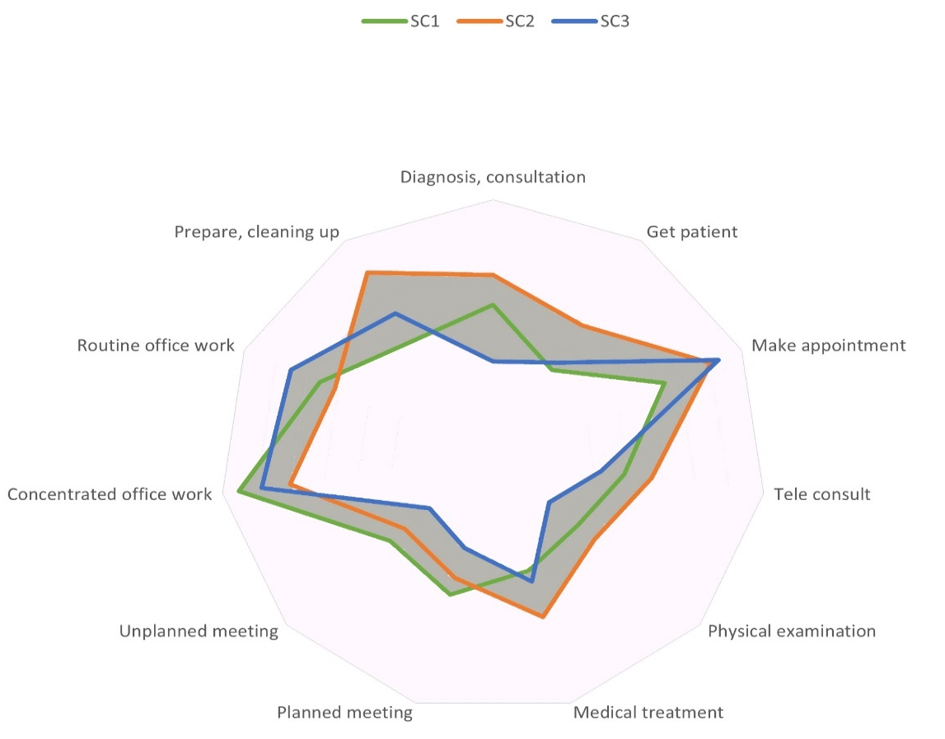
Figure 3. Differences in activities between the clusters. Detailed information can be found Eijkelenboom et al. (2020)

3.2. Preferences during the pandemic
In the autumn of 2020, during the COVID-19 pandemic, seventeen outpatient workers were interviewed to explain their preferences. This was done because of the heavy weight of preferences in the clusters, the gaps between satisfaction and preferences, and the limited literature on preferences. Outpatient workers from all clusters and all hospital locations participated to gain a representative overview.
Due to the COVID-19 pandemic, the number of patients, visitors, and staff in the hospitals was reduced, and social distancing and mouth-face masks were required in the hospitals. Outpatient care was partly digital, using videocalls. Face-to-face contact occurred for physical investigation and consultation with seriously ill patients and depended on the department, such as oncology or paediatric care (Eijkelenboom, Ortiz, and Bluyssen, 2021).

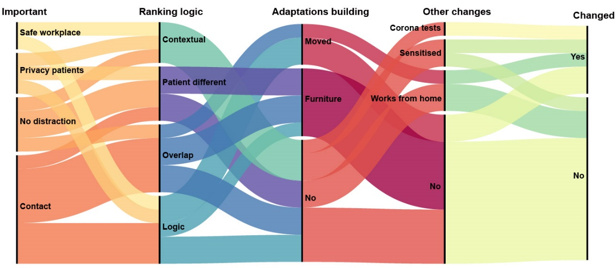Figure 4. Main preferences, logic of ranking, and changes
Figure 4 shows the changes of social comfort preferences during the COVID-19 pandemic, logic of ranking, adaptations of the building and other changes. The Figure shows that all these aspects could vary between the participants. For example, the caption ‘’Ranking logic’’ shows that all four social comfort aspects were for some of the participants most important. And the caption “Changed” shows that he main preference of some outpatient workers had changed since 2019, while for others it did not.
For some outpatient workers ranking of the importance of social comfort aspects was logic, while others perceived an overlap of contact with privacy, safety, or distraction. For them differentiation was illogical because they regarded these social comfort aspects as interrelated or equally important. Furthermore, the importance of distraction, privacy, and safety depended on the context, such as the different room types and activities. For example, limited distraction could be unimportant in the morning when working at the reception desk and important in the afternoon when working in the back office, before and during the lockdown.
To limit infection risk during the COVID-19 pandemic, some small physical adaptations of furniture were executed, such as stanchions in front of the reception desk or a splash guard at the reception (Eijkelenboom, Ortiz, and Bluyssen, 2021). Therefore, those working at a reception desk found it more difficult to support the privacy of the patients because they had to talk louder. Outpatient workers were concerned that personal information was audible for others in the waiting room. Those who moved to a renovated area or who were relocated were more satisfied with comfort than in 2019.
Other changes, not related to the building characteristics of the outpatient area, were sensitization and working in other areas, e.g., testing for corona infections or working at home. Those who worked from home and others who worked at the hospital, were missing face-face contact with patients and colleagues (Eijkelenboom, Ortiz and Bluyssen, 2021). They found face-to-face contact especially important because it contributed to their work satisfaction. Also, face-to-face contact was important for the quality of care. Nurses and physicians were worried to miss physical cues and to miss means to show their involvement. Reception workers were concerned that they could not help vulnerable patients when they only had contact via a telephone call. Also, the limited number of colleagues at the hospital was perceived to decrease safety for some outpatient workers. This occurred when patients showed aggressive behaviour or were impatient when colleagues were not nearby.

4. Discussion
The results provide insights into preferences and satisfaction with social comfort and changes during the COVID-19 pandemic. The results clearly show a gap between satisfaction and preferences, also within the profiles that justify differences between individuals.
The number of participants was sufficient for the Two-Step Cluster Analysis, according to simulation studies by Dolnicar, Grün, Leisch, and Schmidt (2014). A sample size of at least forty participants per included variable was needed, with a separation level of 0.0 between clusters. 538 participants were included for the production of the social comfort clusters, while at least two hundred were needed (product of 5 variables included and 40 participants per variable, separation level 0.0). The sample of the interviews was representative, including outpatient workers of all social comfort clusters, divergent functions, room types, and all hospital organizations. The sample size was sufficient, according to Guest, Bunce, and Johnson (2006), for saturation of the data, i.e., analysis of changes due to the COVID-19 pandemic. However, the explanation of the profiles was complex due to the changes caused by the COVID-19 pandemic. Caution is needed for the interpretation of the results because the methods used did not allow for the determination of causal relations. However, the study shows that main preferences for social comfort can change when measures to reduce the infection risk during an epidemic are taken. Also, the study design in two phases allowed for the inclusion of data during the pandemic, in contrast to the parallel collection of qualitative and quantitative data.
As the preferences for social comfort of outpatient workers changed during the COVID-19 pandemic, it can be suggested that social comfort preferences can be influenced by contextual changes. Hoeffler and Ariely (1999) suggested that a strong experience can contribute to the formation of a stable preference, while a flaw experience is more changeable. This might explain why the main preference of only a part of the outpatient workers had changed, while the same measures to reduce infection with the SARS-CoV-2 virus were taken in all hospitals. To increase the validity and usability of the profiles, it is recommended to further study the stability and strength of preferences for social comfort.
The differences in activities between the clusters, especially for concentrated or routine office work, versus diagnosis, consultation, treatment, and physical examination, show that social comfort preferences can vary among those who perform different (combinations 0f) activities. For those who did not find it logical to rank social comfort aspects, the importance of social comfort depended on the context. It could be suggested that satisfaction with social comfort can be improved by careful determination of requirements and design that supports the different activities. A previous study with the same data set showed that the activities varied also between the different room types, i.e., receptions, offices, consultation rooms, and treatment rooms. Satisfaction with social comfort was more likely to vary between room types than satisfaction with IEQ (Eijkelenboom, Kim, and Bluyssen, 2020). For example, those who work most frequently in a consultation room were more satisfied with their own privacy than those in offices. However, while those in SC2 were more likely to work in consultation rooms than the others, and those in SC1 and SC3 were more likely to work in offices, their satisfaction with privacy did not vary. Furthermore, those in SC1 perceived more distraction by noise than those in SC2 and SC3, while there was no difference in the perception of distraction by noise (P-value >0.05) between those working in offices or consultation rooms. Also, those in SC1 regarded it as more important to have no distraction than those in SC3, while in both clusters they were more likely to work in offices. Furthermore, while those in SC2 were more satisfied with the aesthetic quality than those in SC1, those in SC3 were similarly satisfied with the aesthetic quality as those in SC2. Therefore, it can be stated that accounting for differences between room types in the design is relevant, but profiles are also needed to optimize social comfort.
Contact with others was important for those in all clusters and the dissatisfaction was low before the pandemic. As digital care increased during the COVID-19 pandemic, and face-to-face contact decreased, the outpatient workers experienced impoverished interaction. While there is yet limited information (Crawford and Serhal, 2020), this is in line with suggestions of previous studies. For example, Romanick-Schmiedl and Ragu (2020) suggested that face-to-face contact could support trust of the patients. The worries of the outpatient workers to miss physical cues, such as trembling fingers, were also found in this study. In contrast, Rosen, Joffe, and Kelz (2020) suggested that the quality of care could be improved by digital care, as the patients could receive the diagnosis in the familiar environment of their home. These suggestions show that further study is needed on social comfort of patients and staff in relation to face-to-face and digital care, as digital care might continue because of future epidemics or other organizational reasons. Investigation of changes in work processes and the occupants’ preferences for social comfort can contribute to design for an optimal fit of individuals and outpatient areas. New layouts can be designed, simulated, and evaluated iteratively, to assess whether the design supports the care processes and comfort. This can be done through collaboration between outpatient workers, policymakers, health sociologists, and architects.
Furthermore, it can be suggested that places that accommodate safely for face-to-face contact of hospital workers and patients need to be included in outpatient areas. These places can support informal exchange and trustful relations. Places for interaction with others may contribute to decreased work stress (Karanikola, Tampakis, Tsolakidou, 2020). For a safe place, that enables social distancing and face-to-face contact, it is important to take the occupant density into account during the design process (Awada, Becerik-Gerber, Hoque, O’Neill, Pedrielli, Wen and Wu, 2021).

5. Conclusions
This study offers detailed insights into the preferences of outpatient workers for social comfort. The three profiles, which were strongly differentiated by distraction, safety, and privacy for patients, show differences in preferences and satisfaction before the COVID-19 pandemic. For all profiles, the importance of contact and satisfaction with contact were high. Furthermore, it was shown that multiple factors had changed during the COVID-19 pandemic. The satisfaction or preferences for social comfort had changed as well, especially the satisfaction with contact, which decreased. Overall, the profiles for social comfort show that preferences for social comfort are associated with work-related aspects and can change. The profiles may open a new horizon to accommodate flexibility and variety beyond standardized solutions.

Data Availability Statement (if applicable)
The dataset is not publicly available because of the personal information of the participants. For information, please contact the author.

Acknowledgments
The main study was supported by Daikin Nederland and EGM architects and performed at Delft University of Technology, Faculty of the Built Environment, at the chair of Indoor Environment.

References

- Awada, M.; Becerik-Gerber, B.; Hoque, S.; O’Neill, Z.; Pedrielli, G.; Wen, J.; Wu, T. (2021). Ten questions concerning occupant health in buildings during normal operations and extreme events including the COVID-19 pandemic. Building and Environment. 188. https://doi.org/10.1016/j.buildenv.2020.107480.
- Barker, R., (2011). 2030; The future of medicine, avoiding a medical meltdown. New York: Oxford University Press Inc. 118.
- Crawford, A., Serhal, E. (2020). Digital Health Equity and COVID-19: The Innovation Curve Cannot Reinforce the Social Gradient of Health. Journal of Medical Internet Research. 22(6): p. e19361. https://doi.org/10.2196/19361
- Bluyssen P.M. et al. (2016). Self-reported health and comfort in ‘modern’ office buildings: first results from the European OFFICAIR study. Indoor Air. 26:298-317. https://doi.org/10.1016/0092-6566(74)90019-1.
- Bluyssen, P.M. (2019). Towards an integrated analysis of the indoor environmental factors and its effects on occupants. Intelligent Buildings International. 12(3): p. 199-207. https://doi.org/10.1080/17508975.2019.1599318.
- Dolnicar, S., Grün, B., Leisch, F., Schmidt, K. (2014). Required Sample Sizes for Data-Driven Market Segmentation Analyses in Tourism. Journal of Travel Research. 53(3): p. 296-306. https://doi.org/10.1177/0047287513496475.
- Eijkelenboom, A., Bluyssen, P.M. (2019). Comfort and health of patients and staff, related to the physical environment of different departments in hospitals: a literature review. Intelligent Buildings International. https://doi.org/10.1080/17508975.2019.1613218
- Eijkelenboom, A., Kim, D.H., Bluyssen. P.M., (2020). First results of self-reported health and comfort of staff in outpatient areas of hospitals in the Netherlands. Building and Environment. 177: p. 106871. https://doi.org/10.1016/j.buildenv.2020.106871.
- Eijkelenboom, A. and Bluyssen, P.M. (2020) Profiling outpatient staff based on their self-reported comfort and preferences of indoor environmental quality and social comfort in six hospitals. Building and Environment. 184 https://doi.org/10.1016/j.buildenv.2020.107220.
- Eijkelenboom, A., Ortiz, M.A., Bluyssen, P.M., (2021). Preferences for indoor environmental and social comfort of outpatient staff during the COVID-19 pandemic, an explanatory study. International Journal of Environmental Research and Public Health 18 p.7553. https://doi.org/10.3390/ijerph18147353
- Fisher, J.D. (1974). Situation-specific variables as determinants of perceived environmental aesthetic quality and perceived crowdedness. Journal of research in personality. 8: p. 177-188. https://doi.org/10.1016/0092-6566(74)90019-1.
- Guest, G., Bunce, A., Johnson, L. (2006). How Many Interviews Are Enough? An Experiment with Data Saturation and Variability. Field Methods. 18(1): p. 59-82. https://doi.org/10.1177/1525822x05279903.
- Gioia, D.A., Corley, K.G., Hamilton, A.L. (2012). Seeking Qualitative Rigor in Inductive Research: Notes on the Gioia Methodology. Organ. Res. 16(1): p. 15-31. https://doi.org/10.1177/1094428112452151.
- Hellgren, U.M., Reijula, K. (2006). Indoor-air-related complaints and symptoms among hospital workers. SJWEH Supplements. 2(2) 47-49.
- Hoendervanger, J.G., Ernst, A.F., Albers, C.J., Mobach, M.P., VanYperen, W. (2018). Individual differences in satisfaction with activity-based work environments. PLoS ONE. 13(3): p. 1-15. DOI: https://doi.org/10.1371/journal.pone.0193878.
- Hoeffler, S. and Ariely, D. (1999) Constructing Stable Preferences: A Look into Dimensions of Experience and Their Impact on Preference Stability. Journal of consumer psychology, 18(2): p. 113-139. https://doi.org/10.1207/s15327663jcp0802_01.
- Karanikola, P.; Andrea, V.; Tampakis, S.; Tsolakidou. (2020). A. Indoor and Outdoor Design in Healthcare Environments: The Employees’ Views in the General University Hospital of Alexandroupolis, Greece. Environments. 7(8): p.61. https://doi.org/10.3390/environments7080061.
- Rashid, M. and Zimring, C. (2008). A review of the empirical literature on the relationships between indoor environment and stress in health care and office settings. Problems and prospects of sharing evidence. Environment and Behavior. 40(2): p. 151-190. https://doi.org/10.1177/0013916507311550.
- Romanick-Schmiedl, S. and Raghu, G. (2020). Telemedicine — maintaining quality during times of transition. Nature Reviews Disease Primers. 6(1): p. 45. https://doi.org/10.1038/s41572-020-0185-x.
- Rosen, C.B., Joffe S., and Kelz R.R. (2020). COVID-19 Moves Medicine into a Virtual Space: A Paradigm Shift from Touch to Talk to Establish Trust. Annals of surgery. 272(2): p. e159-e160. https://doi.org/10.1097/sla.0000000000004098.
- Shin, J. (2016). Toward a theory of environmental satisfaction and human comfort: A process-oriented and contextually sensitive theoretical framework. Journal of Environmental Psychology. 45: p. 11-21. https://doi.org/10.1016/j.jenvp.2015.11.004.
- Vischer, J.C. (2007). Towards an Environmental Psychology of Workspace: How People are Affected by Environments for Work. Architectural Science Review. 51(2): p. 97-108. https://doi.org/10.3763/asre.2008.5114.
- Wilhoit, E.D. (2017). Photo and Video Methods in Organizational and Managerial Communication Research. Management Communication Quarterly. 31(3): p. 447-466. https://doi.org/10.1177/0893318917704511.

