Type of the Paper: Short Paper
Track title: healthcare design and change – futureproofed, resilient and crisis-adapted (pre-, post and now) design.

Beyond the Rhetoric: A New Sustainable Health System
Gunther De Graeve¹, Dr. Richard Ashby, Jodi Hallas, Anthony Colwell
^{Destravis Group, Australia}
¹ gunther.degraeve@destravis.com ORCID 0000-0001-5626-6041

Research highlights
- Government and regulator and operator in Australia sought more sustainable approach to health service planning and health facility design in response to increasing burden of care
- Pilot project for health system reform demonstrates more sustainable system outcomes
- Digitally enabled health service supports improved integration of care across the network
- New types of health facilities support more salutogenic, sustainable, accessible care.
Keywords: health system reform, new health facilities, digital healthcare, salutogenic
Names of the Topic editors:
Clarine van Oel

Journal: The Evolving Scholar
DOI:10.24404/623284d465a2c14e24399ade

Submitted: 17 Mar 2022
Revised: 7 May 2022
Accepted: 2 Jun 2022
Citation: De Graeve, G., et al. (2022). Beyond the Rhetoric: A New Sustainable Health System. The Evolving Scholar | ARCH22.

This work is licensed under a Creative Commons Attribution CC BY license (CC BY).

© 2022 De Graeve, G, published by TU Delft OPEN on behalf of the authors.

1. Introduction

This pilot project for the Australian Health System has demonstrated exciting results achieving a sustainable, salutogenic and integrated health system. It now forms part of a new strategic plan for health services across the State of Queensland and is informing planning in other jurisdictions.

Sustainability of the health system has been a topic of increasing awareness and focus for many years. Where previous studies have fallen short of quantifying actual outcomes, this planning study has articulated the new health system. A more sustainable system due to reduced capital and recurrent cost, more integrated with the community, and more accessible for patients.

Enabled by an advanced digital health network which supports virtual care and navigation, this jurisdiction can realise a reduction of 30% demand on their acute hospitals over the next decade.

New, more appropriate care typologies were developed to suit the defined health need. These were positioned in the right location to improve access and experience. Adaptability was a key focus for facility design to respond to a community health profile changing over time.

Keeping the patient need at the centre of the planning and design process is at the heart of creating a truly integrated, sustainable and salutogenic health system.

2. Theories and Methods
Hospitals and health systems globally have been challenged to meet health outcomes. For decades, our health systems have focused on a pathogenic (disease) rather than a salutogenic (wellness) approach, which in turn has contributed to the worldwide burden of disease. The challenges are well known and include an ageing population, significant comorbidities, chronic disease and changing patient expectations. Together with growing inequities in social determinants of health and wellbeing, these are contributing to demand on acute health care services that outstrip supply and are no longer affordable.

Modelling of future health care demand is typically based on historic activity trends and traditional models of acute care delivery. This approach continues to proport a pathogenic approach to care and over-reliance on super-sized hospitals and acute care systems.

A reformed approach to system planning has a Salutogenic focus. It is bespoke to ascertain and address specific health needs of the local community and distribute services through facilities best placed to deliver appropriate care. Bespoke, responsive planning conducted in the new planning approach allows future orientated service scenarios to be explored in direct response to changing health, social and population health needs. This ability was lacking in the traditional approach.

This new approach has recently been tested in a pilot project in Australia. In this pilot, a new sustainable approach to planning was used to model a future health system. The modeling results of the new approach were compared with outcomes generated from a traditional planning approach to the same population and health need.

The new approach transforms service planning to focus on delivering care aligned to future models of care and underpinned by digital care and new technologies. This transformative change informs clinical demand projections that are reviewed and tested with clinicians to determine implications locally and on the system as a whole.

Clinical demand projections then inform supply requirements that consider the most appropriate service setting and facility typology for care delivery. This can include care at home, in the community, in an ambulatory care centre and acute hospital environment.

3. Results
In the pilot project, service modelling was based on the use of digital technology to support early intervention and modified models of care for defined ‘high priority areas’ (e.g., chronic disease, ED presentations, endoscopy), as well as to encourage a significant shift in the delivery of care to the home and community. The modelling resulted in a projection that significantly reduced acute treatment space need and varied the location that care was delivered.

Figure 1 demonstrates the difference in hospital inpatient beds required. Under the traditional planning approach (base case) the modelling indicates the hospital will grow by 291 acute beds by 2036. With our new approach, care is delivered in alternative settings including the home, in the community and in ambulatory care. The current hospital beds (2024) can meet future growth projections with no new or expanded hospital.

Figure 1 Pilot program results demonstraing reduced hospital demand
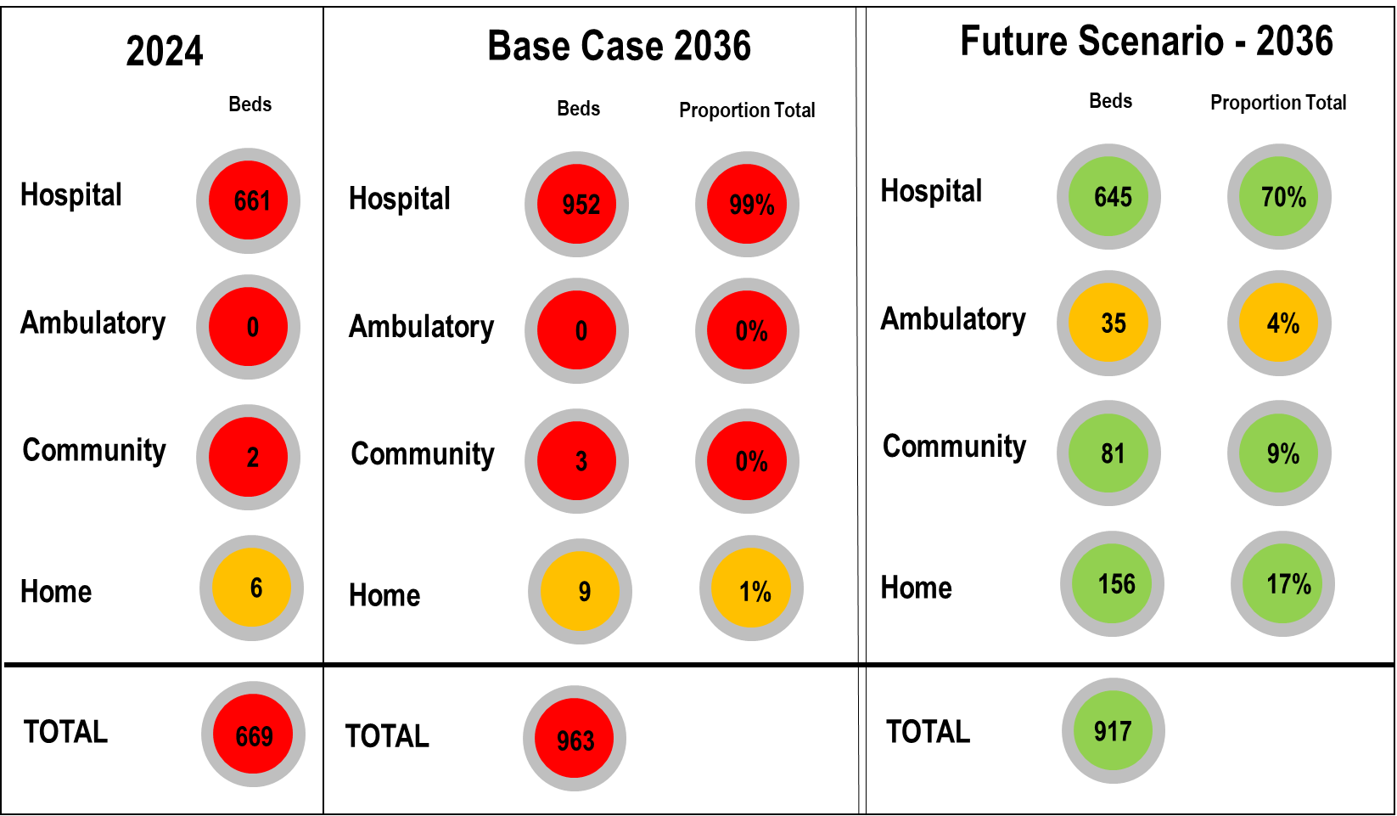

4. Discussion
The application of this method as a line of enquiry through service planning in processes will allow Care providers to develop salutogenic service scenario’s that are tailored to their specific situations. It will also benefit Policy makers by providing a standard format to review incoming information and to compare strategies proposed across providers.

The changes in approach and outcomes require a re-think of the way health services in Australia are funded to enable the delivery of digital health initiatives and changes to models of care. Many of the strategies identified for the pilot project could not easily be enacted under current funding models. This creates a barrier to the adoption of these practices which in turn limits the ability to meet patient demands, and to improve the financial performance of health services.

Further, the change in health facility typology will require changes to health facility design. A new approach to built form in the community, and in the home will need to support the delivery of care via digital means new models of care.

5. Conclusions
The pilot project demonstrated a substantial shift is possible from super-hospitals to accessible, appropriate, less costly health care facilities through a net reduction in future need of more than 200 hospital spaces in this project alone. Growth in bed equivalent (e.g., hospital in the home services) activities offsetting the need to construct significant additional acute hospital infrastructure over the planning period.

Early capital cost estimates demonstrate significant capital savings to deliver alternative care facilities with compared to new hospital buildings.

Data Availability Statement (if applicable)
A complete paper on the pilot project has been printed in Ecological and Salutogenic Design for a Sustainable Healthy Global Society, 2021. Cambridge Scholars Publishing. https://www.cambridgescholars.com/product/978-1-5275-7992-7
Contributor statement
Contributors to this study included pilot project team members: Gunther De Graeve, Dr. Richard Ashby, Jodi Hallas, Anthony Colwell.
Acknowledgments (optional)
This pilot project had the support of Queensland Health and Metro South Hospital and Health Service.

References

- De Graeve, G. Asbhy R. (2021). In K Yeang, A Dilani (Ed.). Ecological and Salutogenic Design for a Sustainable Healthy Global Society (1st ed., pp. 44-66). Newcastle upon Tyne, UK: Cambridge Scholars Publishing

