Type of the Paper: Peer-reviewed Conference Paper / Short Paper
Track title: integration of needs, inclusive, integrated design enabling

Integration of EBD principles in a futureproof academic hospital from campus to bed
AnneMarie Eijkelenboom^{1,2,*}, Iris Hobo³, René Bleeker³, Daniël van den Berg¹
¹ EGM Architects, Dordrecht, Netherlands.
² Architectural Engineering + Technology, Faculty of Architecture and the Built Enviroment, TU Delft, Delft, Netherlands.
³ Projectbureau Bouwzaken, Radboudumc, Nijmegen, Netherlands.
* Correspondence: annemarie.eijkelenboom@egm.nl; ORCID ID 0000-0002-7998-8773
Research highlights
1) This paper explains how EBD principles in the design of an academic hospital were integrated in the design
2) Design solutions, based on EBD principles, were integrated on different scale levels.

Names of the Topic editors:
Clarine van Oel
Names of the reviewers:
Andrea Brambilla
Liesbeth van Heel
Journal: The Evolving Scholar
DOI:10.24404/6235dc9ff8c7f611fcf363e8
Submitted: 19 Mar 2022
Revised: 19 Jul 2022
Accepted: 19 Jul 2022
Published: 6 Mar 2024
Citation: Eijkelenboom, A., Hobo, I., Bleeker, R. & Van den Berg, D. (2022). Integration of EBD principles in a futureproof academic hospital from campus to bed. The Evolving Scholar | ARCH22.

This work is licensed under a Creative Commons Attribution BY (CC BY)

© 2022 [Eijkelenboom, A., Hobo, I., Bleeker, R. & Van den Berg, D.] published by TU Delft OPEN on behalf of the authors.
Abstract: Design solutions bases on Evidence Based Design (EBD) principles vary due to the context and organizational aspects of hospitals. This paper explains how EBD principles were included during the design process of an academic hospital, including design guidelines that were developed with a representative group of key stakeholders from the organization. The hospital comprises several buildings on a campus, that also includes several university buildings. Some of the hospital buildings are connected through “the main axe.” The principles were applied on different scales in the design of a new main building and transformation of an existing building and the main axe, connecting other buildings. Specific design solutions for daylight access, connection to nature, art, privacy, and interaction are discussed.
Keywords: Evidence Based Design, Hospital, Architecture

- Introduction
Previous studies showed that the physical environment can affect wellbeing of patients, visitors, and staff in hospitals (Huisman, Morales, van Hoof, Kort, 2012; Eijkelenboom and Bluyssen, 2019). For hospital organizations, it is important to apply evidence-based design solutions due to the large and long-term investments in renovation and new buildings. Findings from previous academic studies on wellbeing in relation to building characteristics can contribute to appropriate design decisions. As multiple factors, such as sustainability, maintenance, technical, and functional requirements, can influence the design process, it is important that hospital organizations, architects, and all designers that are involved have a strong vision that guides the design process.
An academic hospital, which strived for excellent care with and for patients, included a checklist on healing environments (Herweijer, 2016) in the design brief. An academic hospital is a large hospital, which is connected to a university, where patients receive specialized care, physicians and other hospital staff are educated, and academic research is conducted. The architect was familiar with evidence-based design through design and research. This resulted in design interventions on different scale levels, aiming to support excellent care from the first arrival at the campus to, e.g., informal meetings in a niche of the corridor.

2. Theories and Methods

2.1. Rationale
Evidence based design (EBD) allows for the development of design solutions that fit in the context of a hospital (Alfonsi, Capolongo, Buffoli, 2014). The context can vary between hospitals. Therefore, design solutions are needed that fit the specific models of healthcare and environmental characteristics. To contribute to further development of EBD, it is important to provide information on design solutions that account for EBD principles in a specific context. EBD principles that were used in the design were improving wellbeing and reducing stress through daylight access, views and access to nature, control of the indoor environment, privacy, and clear wayfinding. This paper aims to provide insights into the design solutions for the transformation of the care organization, hospitality, and sustainability of an academic hospital in the Netherlands.

2.2. Methods
The hospital comprises buildings of different building years that are mutually connected through a main axis/corridor. It is located on a campus that comprises also university buildings and is surrounded by a green area. The university was established in 1905 and the medical faculty in 1951, which was designed in 1948 (Mens and Tijhuis, 1999). Since 1951, the main corridor and buildings have been added. The two most recent buildings, which are discussed in this paper, were designed between 2015 and 2020.
One building needed to be transformed and extended to an “experience centre’’, that will be used for education, exchange of information and innovation. A variety of rooms was required, including teaching rooms, meeting and conference rooms, a library, skills, and simulation as well as innovation labs.
Also, a new main building was needed. It formed the main entrance of the hospital and accommodated inpatient and outpatient areas. This building replaced buildings that did not meet the standards of the modern hospital organization anymore. Furthermore, the new building enabled to reduce the total size of the hospital complex.
The hospital organization aimed to express the ambition for excellent care through an appealing architectural quality. Design principles were established in a document called the Radboudumc Design Guidelines (Hobo and Kroon, 2017), which aim to uphold the ambitions and quality in new design ventures for the hospital. These were developed with a representative group formed from different key stakeholders in the organization (staff, patients, doctors, and nurses). The stakeholders represented all disciplines of the hospital (care, education, and research). A vision, including keywords, was developed during six sessions, which were discussed and subsequently adjusted by different committees. Then, all representatives were involved in the selection of images that supported the keywords.
During the design process, the Radboudumc Design Guidelines and EBD principles were included, interpreted, and evaluated. Also, these principles were integrated with the requirements for a BREEAM Excellent Certificate. While BREEAM focusses mainly on life cycle costs and energy consumption, and includes few architectural features (Brambilla, Buffoli and Capolongo, 2019), the Radboudumc Design Guidelines were included in BREEAM as part of the healthy environment section (HEA 19).
One of the main EBD principles that was integrated into the design was orientation. The starting points to support orientation and wayfinding were clear view lines and a clear definition of outdoor and indoor spaces (theme “open” of the Radboudumc Design Guidelines). Also, this design principle was upheld through a design brief innovation theme called “Always Light, Always a View.” This was elaborated in the design, from the urban scale to the interior. Furthermore, privacy was a main EBD principle that was integrated on different scales. Therefore, privacy was defined as the regulation of social interaction and seclusion by individuals or groups (Altman,1976). Places for interaction (to regulate the privacy of a group) were specifically designed, as the hospital organization aims to support innovation through the exchange of knowledge between students, professionals, and patients. The EBD principles of daylight access, art, and nature were integrated into the design, which was in line with the BREEAM requirements and Radboudumc Design Guidelines.

3. Results
This section describes how the main EBD principles were integrated into the design as well as the reasons behind design solutions.

3.1. The main axis
On the large scale, orientation within the complete hospital along the main corridor will be improved due to compact design. The main axis will be shortened from 1.200 m to 200 m. The main axis is connected to the atrium and entrance of the hospital. New staircases and clearly defined meeting points (“hubs’’) are realized. There are several types of hubs, for education, knowledge, public and a special hub. The hubs vary in enclosure, materials, colour, and shape to support orientation. In the special hub is a living room for parents and their ill children in the shape of floating pebbles, see Figure 1. The curved shapes provide intimate places for private conversation and intimacy. Furthermore, the pebbles provide an orientation point through their extraordinary shape and scale. The hubs are designed to support orientation, privacy, interaction.

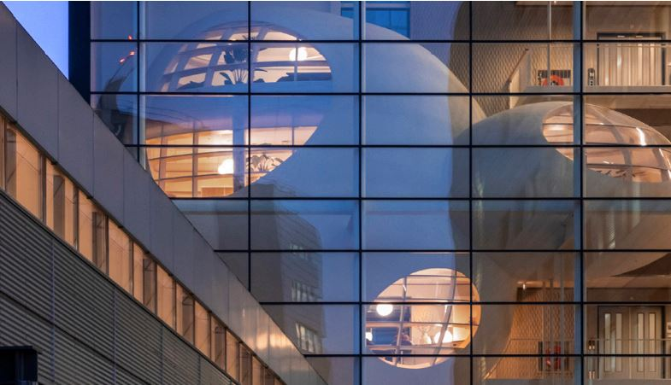
Figure 1. The special hub designed as floating pebbles.

3.2. Experience centre
To improve orientation on campus, the extension of the experience centre aims to increase the consistency of the surrounding outdoor spaces. Therefore, the existing building and extension are visually connected with a large horizontal roof, which covers the different heights and shapes of the existing building (see Figure 2). On the ground floor, a curved façade emphasises the entrance. A new atrium, which forms the centre of the building, is added. Through the atrium, views to other levels improve orientation in the building. As the curved façade of the atrium is two levels high and fully glazed, the daylight access and view of the nearby gardens are ample. To further improve the lighting quality, art works that supply artificial lighting are used. The building facilitates places for meeting and knowledge exchange indoors and outdoors to support optimal interaction.
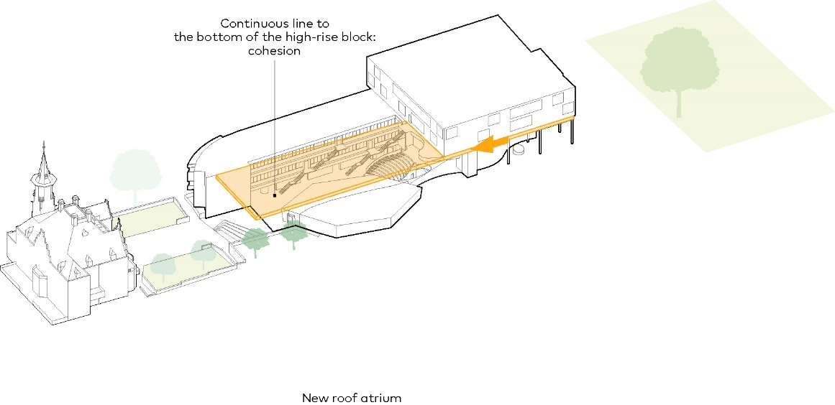Figure 2. Concept of the experience centre

3.3 Main building
The main building consists of ten levels organized around a central atrium and two smaller atria for the outpatient wards, both connected to an inner garden. Two levels are beneath the ground floor, and seven levels are on top of it.
To accommodate for organizational changes due to future innovations in care, a generic structure was designed, while the departments have their own identities to support orientation. Furthermore, orientation is supported in the main building both vertically and horizontally. The open structure and atrium in the centre provide views from all levels on the ground floor to support orientation and interaction. The four wings along the atrium are differentiated by colours related to the four seasons: summer, autumn, winter, and spring. The wings are vertically differentiated (per level) through landscaping themes, which are incorporated in the interior design. For example, the theme of the ground floor is water plants; on level three flowers; on level seven a large foliage.
Furthermore, the dimensions and layout of single corridors enable daylight access and a view from every room where patients or staff stay. The dimensions of the façade windows vary between the building levels to improve orientation indoors. The façade design is based on local architecture, i.e. Bossche School. The Bossche School aimed to connect the large building and human scale by including different scale steps that are related in proportion. Views on nature are maximized by green roofs and clear connection of the landscape with the buildings. The campus will accommodate several gardens, which vary in smells, colours, enclosure, and seasons.
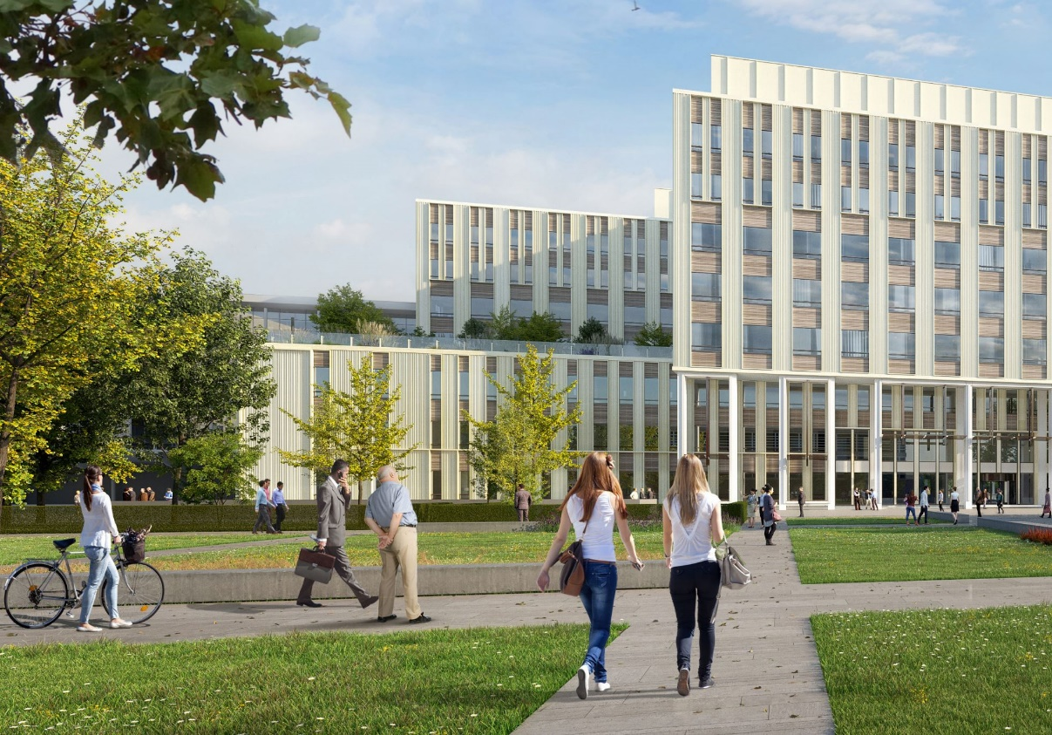Figure 3. Impression of the entrance of the main building, which integrated the EBD principles of daylight, nature, orientation.
For the design of the inpatient rooms two separately funded studies were conducted to inform the design. The findings of these studies were applied in the design of the patient rooms. The studies were called “Ban Bed centricity’’ (Koenders et al., 2018) And “Room with a View/R4HEAL” (Hesselink et al., 2020). The studies focussed on better recovery of the patients, through integration of systems that enable patients to adjust the conditions of their rooms to their personal needs. The patients can regulate environmental stimuli such as lighting, shading, distraction through audio-visual entertainment. Also, their close relatives can stay (rooming in) for support.

4. Discussion and conclusions:
The design integrated the main EBD principles, which might contribute to the improved wellbeing of patients, visitors, students, and staff.
Some EBD principles are well known and therefore generally considered during the design process, leading to a variety of solutions. For example, an academic hospital in the centre of a large city in the Netherlands applied large roof terraces to provide access to appealing outdoor places and a view of nature for those who are not able to go outdoors. A green roof was applied because previous studies showed that a view of nature can improve health outcomes (Ulrich, 1984), and access to gardens can reduce stress (e.g., Ulrich, 1984; Shukor et al., 2012) and improve self-reported quality of life (Cooper Marcus, 2007). The hospital discussed in this paper is surrounded by nature. However, while the gardens and terraces on the campus are accessible, the accessibility of the roofs is also included in the design. This was done to provide hospital workers with access to the outdoors during a short break, as the time needed to go to the campus will be too long. This is an example of a contextual solution to an EBD principle.
The hubs, which intend to reduce stress by providing privacy and supporting orientation, are design solutions that are specifically based on the vision of the hospital organization and academic setting (including students). The COVID-19 pandemic, which started when the design of the hubs was established, showed the importance of face-to-face contact in hospitals. For example, impoverished interaction was one of the main complaints of hospital workers during the COVID-19 pandemic and was associated with the quality of care and work satisfaction (Eijkelenboom, Ortiz, and Bluyssen, 2021). As the experience centre was delivered recently (2021) and the main building will open in September 2022, evaluation of wellbeing in relation to the EBD principles is not yet possible. As the hubs are a specific design solution to support interaction and privacy and have not been evaluated extensively before, it is important to study how the hubs contribute to interaction and orientation. This can be done through a mix of qualitative and quantitative studies, including observations, interviews, and questionnaires, to gain broad and in-depth insights. Furthermore, recovery in relation to the autonomy of the patients in the inpatient rooms needs to be evaluated.
In conclusion, EBD principles were integrated into the design of an academic hospital. Design solutions were used that included EBD principles simultaneously, as well as BREEAM Excellent measures and the hospital design guidelines. Future studies are needed when the buildings are in use for at least one year to evaluate the application of the design solutions.

Data Availability Statement (if applicable)
For information on the Radboudumc Design Guidelines, IH can be contacted. Images from EGM architects | Scagliola+Brakkee. It is not allowed to reuse the images in any form without prior permission from EGM architects.

Contributor statement
Writing original draft AE, editing AE, IH, DB, visualization DB, conceptualization AE, IH, RB, DB.

References

- Alfonsi, E., Capolongo, S., Buffoli, M. (2014). Evidence Based Design and healthcare: an unconventional approach to hospital design Ann Ig 26, pp. 137-143
- Altman, I. (1976). Privacy, a conceptual analysis. Environment and Behavior, 8(1), pp. 7-30
- Beukeboom, C., Langeveld, D., Tanja-Dijkstra, K. (2012). Stress-Reducing Effects of Real and Artificial Nature in a Hospital Waiting Room. Journal of alternative and complementary medicine, 18. pp. 329-33
- Brambilla A, Buffoli M, Capolongo S. (2019) Measuring hospital qualities. A preliminary investigation on Health Impact Assessment possibilities for evaluating complex buildings. Acta Biomed. 90(9-S) pp.54-63
- Cooper Marcus, C. (2007) Healing gardens in hospitals Interdisciplinary Design and Research e-Journal 1 (1)
- Eijkelenboom, A., Bluyssen, P.M. (2019). Comfort and health of patients and staff, related to the physical environment of different departments in hospitals: a literature review. Intelligent Buildings International.
- Eijkelenboom, A., Ortiz, M.A., Bluyssen, P.M., (2021). Preferences for indoor environmental and social comfort of outpatient staff during the COVID-19 pandemic, an explanatory study. International Journal of Environmental Research and Public Health 18 p.7553.
- Herweijer, M.H. (2016). Evidence Based Design in Nederlandse Ziekenhuizen. [Doctoral dissertation, Delft University of Technology], ABE TU Delft
- Hesselink, G., Smits, M., Doedens, M., Nijenhuis, S. M. T., van Bavel, D., van Goor, H., & van de Belt, T. H. (2020). Environmental Needs, Barriers, and Facilitators for Optimal Healing in the Postoperative Process: A Qualitative Study of Patients’ Lived Experiences and Perceptions. HERD: Health Environments Research & Design Journal, 13(3), pp. 125–139.
- Huisman, E.R.C.M., Morales, E., Van Hoof, J., Kort, H.S.M. (2012). Healing environment: A review of the impact of physical environmental factors on users. Building and Environment. 58, pp. 70-80.
- Hobo, I., Kroon, E., (2017) Radboudumc Design Guidelines
- Koenders et al. (2018) “I’m not going to walk, just for the sake of walking…”: a qualitative, phenomenological study on physical activity during hospital stay. Disability and Rehabilitation 42(1) pp.78-85
- Mens, N., Tijhuis, A. (1999) De architectuur van het ziekenhuis, Rotterdam, The Netherlands: Nai Uitgever
- Ulrich, R. (1984) View through a window may influence recovery from surgery. Science 224(4647) pp 420-421
- Shukor, S. F. A., Stigsdotter, U. K., Lottrup, L., & Nilsson, K. (2012). Employees’ use, preferences, and restorative benefits of green outdoor environments at hospitals. Alam Cipta, 5(2), 77–92.

