Type of the Paper: Peer-reviewed Conference Paper / Short Paper
Track title: Integration of needs

Integrated careful homes for differentiated needs
AnneMarie Eijkelenboom^{1,2,*}, Rosanne Alkema¹, Heleen Meinsma¹, Willemineke Hammer¹
1 EGM Architects, Dordrecht, Netherlands.
² Architectural Engineering + Technology, Faculty of Architecture and the Built Environment, TU
Delft, Netherlands
* Correspondence: annemarie.eijkelenboom@egm.nl; ORCID ID 0000-0002-7998-8773
Research highlights
Future elderly are willing to share facilities and take care of each other, as long as they do not have to help others with getting dressed, washing or going to bed.
The preferences for ways of living and receiving care vary between future elderly.
Concepts for shared living are elaborated that may contribute to suitable environments that fit with the specific needs of future elderly.

Names of the Topic editors:
Clarine van Oel
Names of the reviewers:
Clarine van Oel
Journal: The Evolving Scholar
DOI:10.59490/62379e26a50b240408e63536

Submitted: 20 Mar 2022
Revised: 6 Jun 2022
Accepted: 6 Jun 2022
Published: 6 Mar 2024
Citation: Eijkelenboom, A.., Alkema, R., Meinsma, H. & Hammer, W. (2022). Integrated careful homes for differentiated needs. The Evolving Scholar | ARCH22.

This work is licensed under a Creative Commons Attribution BY license (CC BY).

© 2022 [Eijkelenboom, A., Alkema, R., Meinsma, H. & Hammer, W.] published by TU Delft OPEN on behalf of the authors.
Abstract: Due to the ageing society, policy focuses on independent living of elderly in need for care. While the preferences of the elderly to live autonomously vary, there is limited information on variation in needs for the physical environment, e.g., shared and private places. A pilot study was done to develop insights into preferences for social and physical environment of the elderly in need for care. A questionnaire (N=52) and workshop (N=22) were conducted with future elderly. The study showed that preferences for ways of living largely varied. Many were willing to share facilities and help each other, although they did not want to provide somatic care. Based on the results two new concepts were explored, i.e. farm like housing in the city centre and small-scale housing with friends. The concepts, resulting from the questionnaire and workshop, suggest that the method can be used to further explore connections between preferences and design.
Keywords: social comfort, hospital staff, COVID-19 pandemic, preference

1. Introduction
Due to the ageing population and economic factors, a transformation of care provided at healthcare organizations, e.g., nursing homes, towards integration of care and home environments in the Netherlands is needed. Starting points for the transformation are improved quality of care, increased involvement of society (e.g., care from relatives), and financial sustainability (VWS, 2013). This policy was based on the need of the elderly for autonomy and self-sufficiency. A previous study on elderly of the future in the Netherlands indicated differences between those who are self-sufficient and consider it important and others who do not perceive autonomy as important or prefer care of health care professionals (Doekhie et al., 2014). However, the availability of information on the differences in preferences for the physical and social environment in combination with the design of housing concepts for future elderly in practice is limited. A pilot study was conducted with a questionnaire on the preferences for future elderly to assist architects and healthcare organizations in the development of the most appropriate physical environment. As previous studies indicated that elderly relate their sense of home to psychological, social, and physical factors, these factors were included in this study (Rijnaard et al., 2016).

2. Theories and Methods

2.1. Rationale
While the preferences and abilities of the elderly to live autonomously vary, there is limited information on differences in needs for the physical environment, e.g., shared and private places, in relation to preferences for care. Involvement of the future elderly through investigation of their individual needs is important to help architects, in collaboration with healthcare organizations and private enterprises that provide elderly care, design the most suitable physical environments. This paper provides the results of a pilot study with future elderly on the integration of care and home. Results and figures have been shared previously in Dutch (EGM, 2021).

2.2. Methods
The questionnaire was composed to study the preferences of (future) elderly for the physical aspects of their homes and surroundings. The questionnaire consisted of twenty-four open questions and twenty-nine closed questions. It was based on sets of questions that had been used previously by the municipality and new questions. The questionnaire was developed in collaboration with a housing corporation and a healthcare organization. They accounted for the intensity of care, preferences for ways of living, and economic factors. As the questionnaire was used during the COVID-19 pandemic, questions on interaction with vulnerable relatives during the lockdown were included. The questionnaire was based on two parts: the first part about current personal and social aspects of the participant, and the second part about future expectations and preferences for the physical and social environment. For the questions about the future, one scenario was defined: in need of somatic care and widowed or single.
A postcard with the invitation to participate was sent to employees of an architecture company to assess the questionnaire and use the results for the development of innovative housing concepts. The questionnaire was digitally distributed in the spring of 2020 among eighty-eight persons; fifty-two persons responded. Participation was voluntary. All participants had to sign a consent form in advance and confirm participation at the end of the questionnaire. The data were only accessible by the researchers. Data were stored in Microsoft Excel and analysed manually.
Subsequently, the four most preferred housing concepts were discussed and elaborated in a workshop with twenty-two participants who responded the questionnaire. After the workshop, the two concepts that were most distinctive were selected for further elaboration.

3. Results
This section provides an overview of personal aspects and examples of social and physical aspects in relation to private and shared living.

3.1. Main results of the questionnaire

Table 1 shows that 27% of the participants were female and that education of the participants varied. While most participants owned their homes (87%), the types of houses in which they lived varied. Their ages varied from 19 to 64; the mean age was 47 years.

Table 1. Personal aspects of the participants
 |  | Mean | Min/max
Age |  | 46.8 | 19/64
 |  | N | %
Sex | Female  Male  Other (?) | 14  37  1 | 27%  71%  2%
Education | University  Applied university  Intermediate  Secondary  Other | 23  16  11  -  2 | 44%  31%  21%  -  4%
Property | Rent  Buy | 6  43 | 12%  87%
Living situation | Row houses  Semi-detached home  Single-family home  Apartment  Other | 23  4  7  11  4 | 47%  8%  14%  22%  9%

All participants preferred to have contact with family and friends (100% first or second preference). Contact with animals was more likely to be important than with care professionals. While contact and interaction with others enhance the quality of life privacy and being alone were important as well. For example, one participant answered the questionnaire as follows:

“Being alone is no nightmare, in contrast to being lonely.”

The preferences for care of the future elderly varied; 22% preferred care from relatives, 67% care from professionals at their home (extramural), and 11% care at a healthcare organization (intramural). The main reason to prefer care from a professional was to not be a burden for family and relatives but to have relaxing moments with them.

Two-thirds (67%) preferred to live in a small-scale setting, while 10% did not, and 23% did not know yet. Figure 1 shows which rooms the future elderly were willing to share. All preferred a private bedroom (100%), and three-quarters of the future elderly preferred a private bathroom (79.2%). They were willing to share the kitchen (35.4%), dining room (41.7%) and living room (17%). Others preferred to share the kitchen (54.2%), dining room (50%), and living room (55.3%) and have these rooms additionally private as well. Also, the garden, storage, laundry room, and front door could be shared, while some preferred to have these rooms additionally private as well. Furthermore, three-quarters of the participants were willing to share activities or help others, such as cleaning (79.6%), buying groceries (81.6%), walking together (93.9%), cooking (93.9%), dining (93.9%), watching television (70.8%), or playing games (91.8%). Almost none of them wanted to help with getting dressed (4.1%), washed (4.3%) or to bed (8.2%).
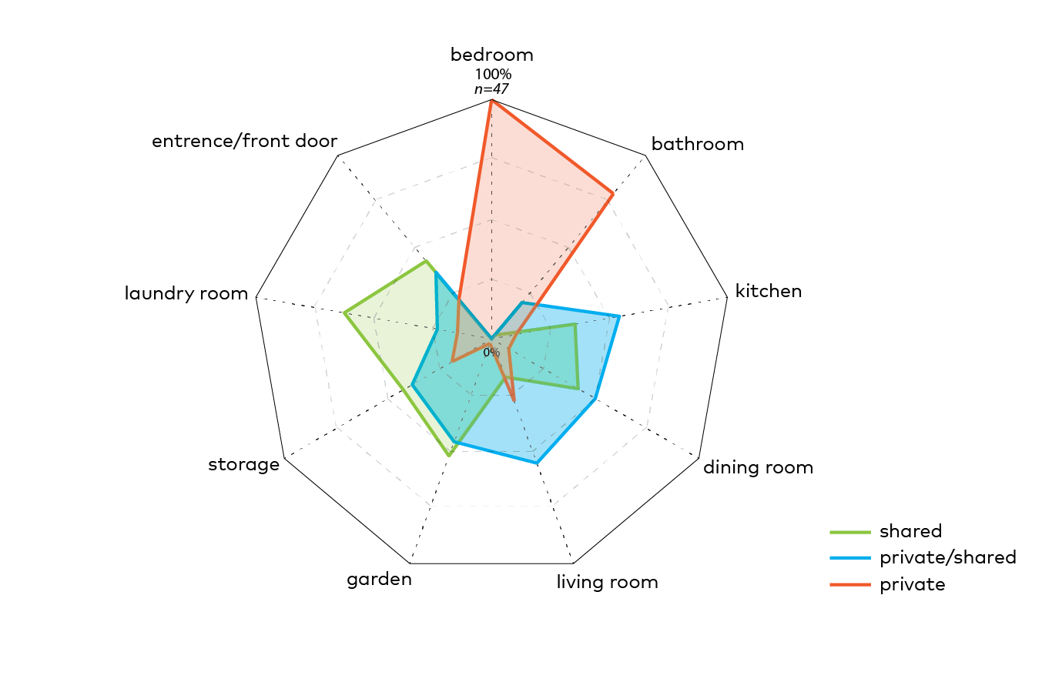
Figure 1. Preferences for shared and private rooms

The preferences for styles of living varied largely. Living together with friends in a farm-like setting, living independently in a courtyard, or living in an apartment in a building for care were preferred by a large group. Only a few preferred a house for assisted living, an intergenerational family house, a single family house, an apartment in an apartment building, or shared living with elderly and different generations. Also, the preferences for the proximity of services, such as shops, nature, healthcare facilities, and museums, varied largely.

Based on the comparison of the preferred ways of living with preferences for the proximity of services, four concepts were defined and elaborated in the workshops. These concepts were: an apartment in a building for care in a small village together with other elderly; a courtyard home in a rural area with persons of different ages; a farm-like home in the city centre with friends; small-scale housing in the city together with friends.

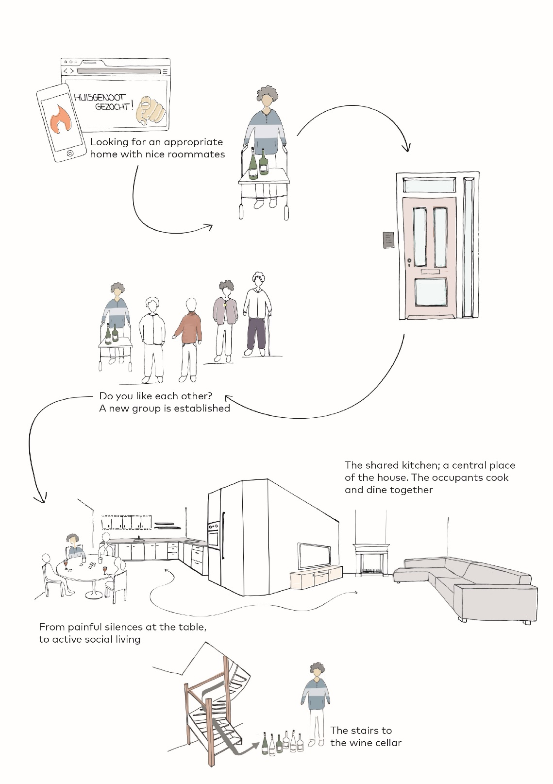
Figure 2. Social and physical aspects of housing with friends

3.2. Results of the workshop
Figure 2 shows an impression of the social and physical aspects of housing with friends, which was elaborated after the workshop. The participants regarded shared living with people who are like-minded as most valuable. For them, it was important to be socially and actively involved with their roommates. Therefore, roommates selected each other to establish a group to live together. The preferred group size was between six and ten people, small enough to have lively conversations and privacy, and sufficiently large to take care of each other. Care would be organized collectively by an external healthcare organization to gain efficiency for the care professionals and caretakers.
The future elderly were willing to share their kitchen and dining room with their roommates and have a small private bedroom and bathroom. They expected to cook and eat together every day. Therefore, the kitchen has a large table for eating, formal meetings, and informal conversations. It is the centre of the house. Also, there is a special room, which can vary in function depending on the preferences of the occupants. For example, the special room is a home cinema, greenhouse, wine cellar, or playroom with a pool table. The stairs to the wine cellar on the drawing intend to emphasise that active social involvement can contribute to mental and physical health.
As participants had contradictory preferences for living in the city centre and being surrounded by gardens and animals, a concept was developed for farm-like housing on the roofs of high-rise buildings in the city centre. Figure 3 shows an impression of the social and physical aspects of the concept, which was elaborated after the workshop. The concept intends to combine the advantages of farm-like living, such as broad views, nature, and quiet places, with the advantages of living in the city, such as vibrance, public transport, and cultural facilities. Quiet places and broad views are on the flat roofs of existing office buildings in the city centre. These roofs allow for the development of new areas that are publicly accessible. Small-scale apartments for the elderly can be located under and on these roofs, surrounded by a farmyard on the roof. Specifically, the roofs of office buildings are suitable, as the dimensions are sufficiently large to accommodate these functions. The residents have private apartments, while they receive care privately or collectively from an external care organization. The residents share the farmyard. Also, the roofs are accessible for residents from the neighbourhood to relax or take care of the garden and animals. As the elderly have direct access from their apartment to the roof, they can meet other residents. This might contribute to the enriched social lives of all occupants.

4. Discussion and conclusions:
This pilot study showed that the preferences for ways of living of the future elderly can vary largely. The results of the questionnaire and follow-up workshop contributed to the elaboration of new concepts, i.e., small-scale housing with friends and farm-like housing in the city centre. The participants represented the population of an architecture company, including different genders, ages, education, and living in a village or city. A cautious interpretation of the results is needed in relation to other groups. As the number of participants was too small to compare differences in preferences related to age, education, or living area, further study is needed. Also, while this study included different education levels, the proportion of academically educated participants was high in comparison to the total population in the Netherlands. Also, due to the study design, none of the participants were unemployed or retired. However, it was relevant to perform this study with workers of an architecture company, as they are trained to imagine spatial quality.

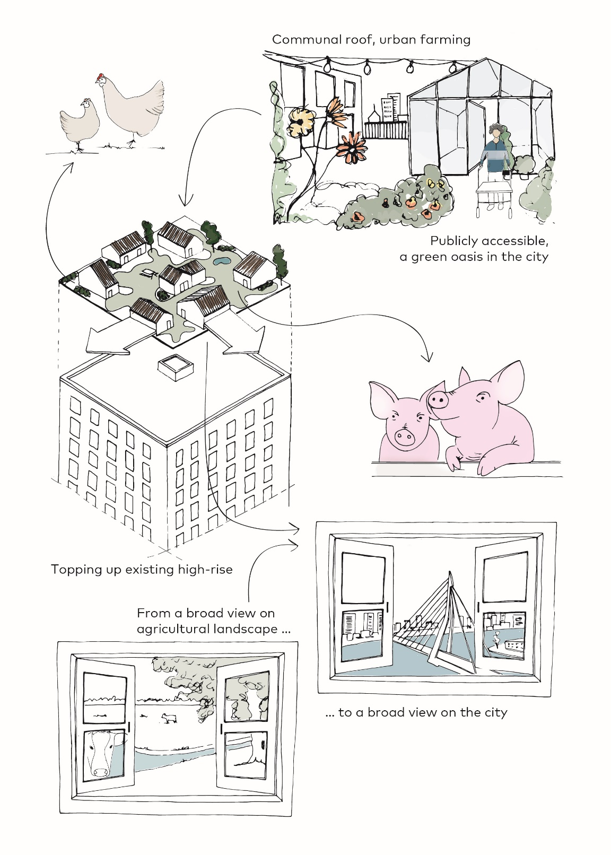
Figure 3. Social and physical aspects of farm-like housing on a roof in the city centre
The results showed that future elderly are willing to help each other with daily life, such as buying groceries, but do not want to provide physical care, such as helping another to get dressed. While the need for care from relatives increases, due to the ageing population and staff shortages, the number of relatives that take care decreases. For example, about five persons were available for informal care for one old person in 2018, and it is expected that three persons will be available for informal care in 2040 (PBL, 2019). It can be suggested that there is a gap in policy and practice, as increased informal care by relatives is part of the transformation towards integration of care and home environments.
The willingness to share places with others and to help each other contributes to the development of sustainable solutions for the integration of care and home environments. Homes with shared places respond to the needs of a large group of elderly people who do not prefer to live alone because of loneliness or feelings of unsafety (Rusinovic, van Bochove, van de Sande, 2019). Courtyard housing is a solution that is largely supported in the Netherlands (Nijkamp and Bosker, 2020). However, the findings of this study show that uniformity in housing with care does not fulfil the needs of all future elderly. The examples, which were elaborated after the workshop, pave the way for the development of a larger differentiation of care and physical concepts.
Van Hoof et al. (2021) stated that building of various forms of housing for the elderly will not necessarily convince them to move when they are not involved in the concept and design phases. As retired persons might have needs that the future elderly could not expect, it is important to include those in the development and evaluation of these concepts. The questionnaire can be used to investigate the social and physical needs and enhance the involvement of elderly in the concept and design phases.
Furthermore, the new concepts, which were elaborated on, might contribute to the development of appropriate housing on actual locations (or roofs) in urban areas. They contribute to the development of innovative design directions for integrated care and therefore might provide a useful contribution to the need for appropriate housing for the elderly and others in the Netherlands,

Data Availability Statement (if applicable)
The dataset is not publicly available, because of personal information of the participants. For information, the corresponding author can be contacted.

Contributor statement
Writing original draft AE, editing AE, WH, RA, visualization RA, data analysis RA, conceptualization WH, AE, RA, HM

References

- Doekhie, K.D.; de Veer, A.J.E.; Rademakers, J.J.D.J.M.; Schellevis, F.G.; Francke, A.L. (2014) Ouderen van de Toekomst Verschillen in de Wensen en Mogelijkheden Voor Wonen, Welzijn en Zorg: Overzichtstudies; Nivel: Utrecht, The Netherlands
- EGM architects. (2021). Hoe woont mijn 85-jarige ik? Retrieved from EGM architecten | Hoe woont mijn 85-jarige ik?
- Ministerie van Volksgezondheid, Welzijn en Sport (E.I. Schippers en M. van Rijn) (2013): Brief aan de Voorzitter van de Tweede Kamer der Staten-Generaal. Gezamenlijke agenda VWS ‘Van systemen naar mensen’. Den Haag: Ministerie van VWS.
- Nijkamp, J.E., Bosker, A.H. (2020) Enabling older people to live independently: a shared responsibility of citizens and municipality, In the Companion proceedings of the European Facility Management International Conference 2020, EFMIC 2020, 1 October 2020, online conference
- Planbureau voor de Leefomgeving (2019) Toekomstverkenning mantelzorg aan ouderen in 2040 Retrieved from Toekomstverkenning mantelzorg aan ouderen in 2040 | PBL Planbureau voor de Leefomgeving
- Rijnaard MD, van Hoof J, Janssen BM, Verbeek H, Pocornie W, Eijkelenboom A, Beerens HC, Molony SL, Wouters EJ. (2016) The Factors Influencing the Sense of Home in Nursing Homes: A Systematic Review from the Perspective of Residents. J Aging Res.
- Rusinovic, K., van Bochove, M., van de Sande, J. (2019) Senior Co-Housing in the Netherlands: Benefits and Drawbacks for Its Residents. Int. J. Environ. Res. Public Health. 16 pp.3776.
- Van Hoof, J., Rusinovic, K. M., Tavy, Zsuzsu. K. C. T., van den Hoven, R. F. M., Dikken, J., van der Pas, S., Kruize, H., de Bruin, S. R., & van Bochove, M. E. (2021). The Participation of Older People in the Concept and Design Phases of Housing in The Netherlands: A Theoretical Overview. Healthcare, 9(3), pp. 301

