Type of the Paper: Peer-reviewed Conference Paper / Full Paper
Track title: healthcare design and change – future-proofed, resilient, and crisis-adapted (pre-, post- and now) design

Pandemic resilience in Dutch hospitals: flexibility that counts in a crisis
Liesbeth van Heel ^{1,}*, Manuela Pretelt ² , Milee Herweijer ³ and Clarine van Oel ⁴
¹ Department of Public Health & Program Integrated Buildings, Erasmus University Medical Center, the Netherlands; m.vanheel@erasmusmc.nl ; ORCID 0000-0003-4799-3057
² Royal HaskoningDHV;
³ Wiegerinck;
4 Department of Architecture and the Built Environment, Delft University of Technology; ORCID 0000-0002-4959-2938

Names of the Topic editors:
Clarine van Oel
Names of the reviewers:
Andrea Brambilla
Ann Symons
Journal: The Evolving Scholar
DOI: https://doi.org/10.24404/6238f4adf3549a45fc15c732

Submitted: 24 July 2022
Accepted: 22 August 2022
Published: 31 July 2023
Citation: van Heel, L., Pretelt, M., Herweijer, M. & van Oel, C. (2022). Pandemic resilience in Dutch hospitals: flexibility that counts in a crisis [preprint]. The Evolving Scholar | ARCH22. https://doi.org/10.24404/6238f4adf3549a45fc15c732

This work is licensed under a Creative Commons Attribution BY license (CC BY).

© 2022 [Name of the authors] published by TU Delft OPEN on behalf of the authors.

Abstract: The COVID-19 pandemic placed healthcare design at the heart of the crisis. Hospitals faced challenges such as increasing their ICU capacity and enabling physical-distancing measures to prevent infectious spread. They also needed to co-house suspected COVID patients and non-COVID patients with different requirements and enforce separate entrances and routes to keep staff and patients safe. It is suspected that even in a fully vaccinated world, other pandemics are waiting in the wings. In a design brief, flexibility is typically mentioned as an important target, and single occupancy inpatient accommodations may be considered as a way to enhance flexibility. To gain insight into and inform future hospital design, this study evaluated what operational coping strategies and design solutions were considered important enablers to increase ICU capacity and support different patient flows, and what design solutions enabled physical distancing. We have collected data from 30 Dutch hospital organizations, including some recently opened hospitals, with 100% single occupancy inpatient accommodation. Using a practice-based approach, in-depth interviewing was combined with document and multimedia analyses to analyze and compare successful operational strategies and design elements that helped provide the flexibility needed in this recent crisis. As we looked at existing facilities and alterations made to allow hospitals to operate in ‘crisis mode’ during the COVID-19 pandemic, we presented emerging design considerations for future healthcare facilities that, preferably, can also be implemented in renovations or refurbishments. We add the perspective of staff as a limiting factor in a hospital’s pandemic preparedness.
Keywords: pandemic resilience, flexibility, robustness, adaptability, hospital design

1. Introduction
In early 2020, the COVID-19 pandemic overwhelmed the world. It turned out to be a multi-layered crisis, hitting health systems in subsequent waves before reaching an endemic stage as we speak. With large parts of the population in the Western world vaccinated or with a better defense against severe illness after a prior infection, societies are opening up again. It is time to share findings from the first stages of the crisis and reflect on whether preparedness for future pandemics has reached the right level.

Healthcare and healthcare buildings played an important role in facing the many challenges the COVID-19 pandemic brought to society. A sudden surge in ICU-capacity was required during the first wave and required immediate facility changes (Stichler, 2021). The need to co-house suspected COVID patients and non-COVID patients with different requirements enforced separate entrances and routes to keep staff and patients safe. In these first few weeks, Infection Prevention and Control (IPC) experts and estate and facility managers were forced to implement temporary or more permanent measures primarily based on their own expertise or guidance from national and international knowledge bodies. Since then, all over the world, practitioners and scientists have collaborated to share insights and best practices on coping with the pandemic (Dietz et al., 2020; Ramboll, 2021). Although health systems around the world adopted different coping strategies, overall, the Dutch situation compares with other European countries (Braithwaite, 2020). In their report “Dancing with the virus”, Dutch researchers identified five issues with the COVID pandemic that needed to be balanced by governing bodies at the national, regional, and institutional level: (1) scarcity of ICU capacity and Personal Protective Equipment (PPE); (2) delayed care alongside coordinating and balancing COVID and non-COVID care; (3) the acute care chain (developing scenarios for a ‘code black’); (4) client representation (highlighting existing bottlenecks); and (5) burden on nurses (de Graaff et al., 2022). Meanwhile, a European collective of architects, consultants, and knowledge partners brought together case studies on pandemic resilience. Their “Relocate, Repurpose, Reorganize” project investigated how countries and healthcare organizations coped, focusing on four aspects: (1) supply, (2) space, (3) staff, and (4) systems (Ramboll, 2021). A case study of the Netherlands in general and Erasmus MC in particular is part of this material (Van Heel, 2020). These insights show that enhancing preparedness for future pandemics requires focusing on a combination of elements. This study, however, focuses primarily on the built environment and the requirements to successfully operate hospitals in a crisis.

Thus, looking back to look forward, what measures need to be incorporated in newly designed or renovated facilities? And will that do the trick for further pandemic preparedness? As before, healthcare design will evolve over time based on the evidence established on which design concepts work best for specific patient populations, support care providers and increase safety (Stichler, 2021). Foremost, this pandemic showed the need for rapid facility changes. In a design brief, flexibility is typically mentioned as an important capacity for change. But what does it consist of? For architects, it refers to Open Building concepts or Future-proofing in healthcare building design (Capolongo et al., 2016; Karlsson et al., 2019). Carthey et al. (2011) stated that reasons for hospitals’ need for change are often given, but how well they do in practice is less well analyzed. In this sense, the recent COVID-19 crisis offered the opportunity for such an analysis. Yet again, which changes should be considered in allowing flexibility? For hospital organizations it could have to do with optimizing the operational use of existing healthcare facilities. These latter would argue that single-occupancy inpatient accommodation enhances flexibility in assigning rooms to infected or non-infected patients, keeping isolation measures in place only as long as necessary, without transferring a patient to another room when virus shedding has stopped (Kampen, 2021). Others favor cohorted wards for isolation of COVID-19 patients, even when single patient room accommodation is available, or state more research on the subject is needed (Bardwell, 2022). New hospital design models were developed to create a pandemic setting with an ‘emergency hospital’ within the hospital. This requires a modular design, with architectural and installation-technical design allowing for ‘crisis care’ alongside ‘regular care’. Smart building technology helps separate flows, while e-health solutions and hybrid working models for staff showed they could be implemented virtually overnight (Herweijer & Boonstra, 2020).

The current study targets the physical and technical interventions taken by Dutch hospitals during the first and second waves of the pandemic, as well as additional services for staff. To evaluate these interventions, the perspectives of ‘resilience’, ‘flexibility’ and ‘robustness’ in hospital design and operations were chosen using in-depth interviews with four estates and facility managers. Therefore, the aim of the present study is to gain insight into the kinds of interventions in Dutch hospital estates that can inform future facility design. In doing so, this study was particularly directed at emerging design considerations for future healthcare facilities that can also be implemented in renovations or refurbishments.

2. Theories and Methods

2.1 Resilience: flexibility, robustness, and adaptability

Developments in biomedical science and technology have changed care delivery rapidly over time. Consequently, hospitals' architectural design needs to respond to the requirements of this technological development. This means that the design needs to account for the development of new medical departments and accommodate newly commissioned medical equipment. Thus, flexibility has become an additional requirement in hospital design to comply with the evolution of medical knowledge and allow for a resilient response. The first wave of the pandemic underlined the importance of having a more flexible and versatile infrastructure to enable healthcare professionals to react and adapt quickly to coming events while still providing all the services required in a hospital (Murphy, 2020).

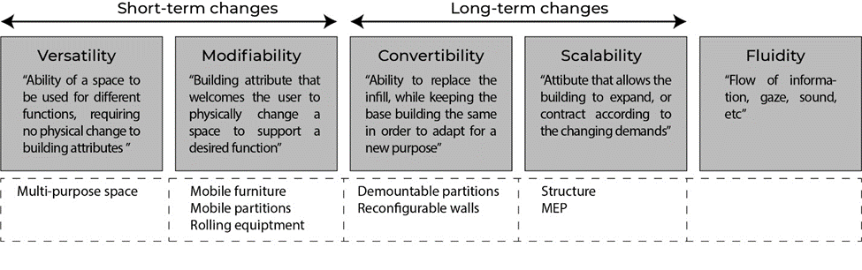
Flexibility in hospital design is a broad concept, and consequently, multiple perspectives are used by designers and practitioners in the field, as explained above, referring to work done by Capolongo and Karlsson (2016, 2019). This study follows Monahan (2002) in differentiating flexibility into five spatial dimensions, as shown in figure 1: versatility, modifiability, convertibility, scalability, and fluidity. Versatility and modifiability relate to operational changes that can occur on a short-term basis, daily or weekly, and don’t require structural changes. In contrast, convertibility and scalability involve a more long-term perspective, and are the elements one would be interested in with expansion or reconfiguration in mind (Monahan, 2002). Robustness can be defined as the ability to withstand or overcome adverse conditions. This term is more associated with continuity and the prevention of errors in hospitals’ technical infrastructure, and IT systems, and operations (Tucker & Spear, 2006). Adaptability is primarily used to indicate the psychological and organizational resilience of staff (Pati et al., 2008).

Figure 1 The five spatial dimensions of flexibility (after Monahan, 2002)

2.2 Methods

Population

Based on this framework, an online survey for real estate and facility managers in Dutch hospitals was developed. To maximize the response rate, great effort was made to involve all relevant departments from all Dutch hospitals as included in the database of the RIVM (National Institute for Public Health and the Environment), with 68 health organizations identifying 117 hospitals in 2019. In addition, as not all email addresses could be identified, the survey was advertised for two weeks on the website of ‘FMT Gezondheidszorg’, a trade magazine for the target population, to increase the rate of response. In addition, the survey was distributed using the professional LinkedIn accounts of the authors.

Survey

The questionnaire was developed on Qualtrics software; it was approximately 10 minutes long and focused on hospital working practices (operations management) and building adaptations during the COVID-19 pandemic. The survey focused on how well prepared hospitals felt they were for a pandemic and what measures were taken in the various months after the start of the pandemic. While developing our questionnaire, and with the pandemic moving from the first wave into the second wave, the survey also asked whether COVID and essential non-COVID care were competing for resources. The online survey was distributed in March 2021. Figure 2 summarizes how the concepts of flexibility and adaptability were operationalized into questions in the survey.

In total, there were 38 responses, reflecting a net response rate of 56%. Among the respondents were six academic hospitals and 24 general hospitals. There were eight respondents who filled out the questionnaire alongside a colleague from the same hospital organization. For building and technical interventions, a distinction was made between data from hospitals coming into use after 2010 (n = 6) and before 2010 (n = 24). In 2008, Dutch regulations on hospital capital investments changed, which might have led to different design priorities. The threshold was set at 2010 because it was argued that the consequences of this change in regulations would only be effective as of 2010.

In-depth interviewing

At the end of the survey, respondents were asked to reflect on what design changes they would recommend if they were to renew the current hospital or advise on a newly designed hospital. In addition, they were asked whether they would like to participate in an in-depth follow-up interview in May 2021. Due to COVID-related circumstances these in-depth follow up interviews with real estate and facility managers of four different hospitals were conducted online. Interviews were made by LvH and CvO if the interviewee preferred Dutch; otherwise, the interviews were made by LvH and MP in English with the possibility to translate between English and Dutch. Three interviewees worked at academic hospitals; one worked at a smaller general hospital. The interviews were transcribed and analyzed using ATLAS.ti, using the code categorization and relations as summarized in Figure 3. Flexibility and robustness of building and technical interventions and adaptability in staff-focused interventions were used as deductive codes; the remaining were inductive codes. Citations as used were translated from Dutch.

Analyses

The outcomes of the survey and the follow-up interviews were analyzed in a qualitative way.

3. Findings

3.1 Flexibility measures directed at the building

The most enforced building intervention measure after the introduction of hand alcohol at hospital entrances was the segmentation of wards. The option to isolate infected patients within the building is essential to managing an infectious disease. Thus, dividing the building in “red” and “green” zones should be considered in future developments: “You have to be able to separate some part of your building for infected patients. Some part without too much traffic around: an isolated part of the hospital.”

As a major lesson from previous pandemics it can be assumed that a future pandemic will also involve pulmonary infections with resulting respiratory problems. This assumption of the continued risk of infectious diseases was acknowledged by all interviewees. Hence, to be more prepared for lung-related demands, future hospital designs should plan for surge capacity, not only in terms of ICUs but also in the nursing wards. The latter became particularly clear during the second and third pandemic waves, when the bottleneck was no longer the number of ICUs. Instead, the nursing wards, where many patients were treated with oxygen, became the focal point of concern. Future hospital design should consider the number of “ventilation beds” available with artificial respiration mechanisms like Opti-flow ventilation. Medium care wards could in this way help contain a possible future surge in demand like that which occurred in the COVID-19 pandemic crisis. Thus, hospitals are evaluating strategies to increase capacity through versatile and scalable spaces, like planning larger single-patient rooms that can accommodate two patients when necessary. As one of the interviewees mentioned: “In the wards, we have now double patient rooms and single-patient rooms, and the idea is that in the future we will use single rooms for one patient, and when we have a crisis, we could accommodate another person within that same room”.

Since academic hospitals are more specialized, they need to keep spare capacity given their function as a last resort. Therefore, general hospitals played a larger role in redistributing the overflow of COVID-19 patients in the Netherlands. Especially during the first wave, regular care was scaled down and staff and spaces were repurposed to accommodate COVID-care. As, given their features to ventilate and monitor patients at ICU-level, Recovery rooms and even Operating theatres came into use as surge ICUs, elective surgical programs were halted. Medical students and other health care workers (HCW) were engaged to help out. This required the adaptability of staff, especially ICU nurses, and during later waves, this became an increasing burden. Meanwhile, hospitals with older buildings mentioned fewer issues with repurposing spaces into ICU capacity, separation of entrances, and segregation of flows. Older buildings were not affected by the 2008 policy, in which the functional floor space of facilities was limited and more compact hospitals were designed. Buildings built before 2010 had more space to accommodate the surging demand. “We had the luck that we have two big ICU units, and because of understaffing, one unit is almost always empty but could be reopened very quickly”.

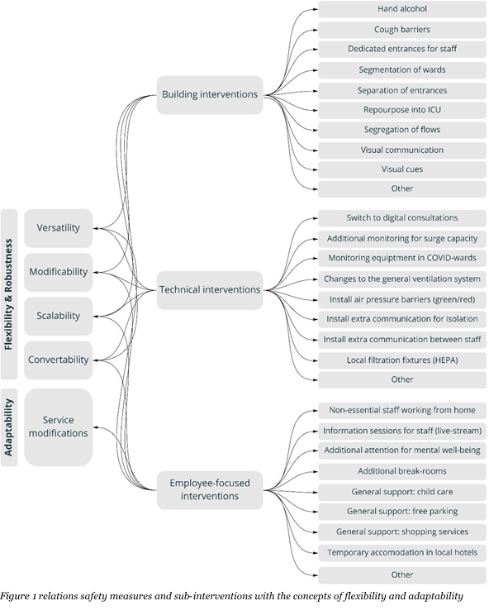
Figure 2 relations safety measures and sub-interventions with the concepts of flexibility and adaptability

Additionally, it was mentioned that multipurpose spaces are helpful in times of crisis. Hospitals found spaces like parking lots and other outdoor areas very convenient to install pop-up services or temporary structures directly connected to the building. Furthermore, inside the hospital, interviewees mentioned the need to store or install additional equipment if necessary. “There was a lot of equipment installed during the crisis, so they cleared out offices and filled them with the equipment. Another thing is: around our hospital we have space, mostly gardens and parking lots, and we claimed them when we had to put up tents.”

3.2 Flexibility measures involving technical interventions

From the survey, it became clear that a transfer to digital consultations was the most frequently used technical intervention. From the interviews, it became apparent that this change is expected to become permanent and might even increase, as mentioned by one of the interviewees. “The video consultations have increased ten times after the crisis, and are probably something that continues to be there after COVID-19”. Digital consultations have become a trend, and future hospital design needs to consider the impact of telehealth on the requirements that virtual sessions impose on the need for space and robustness of infrastructure. As mentioned by one of the interviewees, “We think about making a small space, that is only used for digital communication”, and “The goal for the outpatient

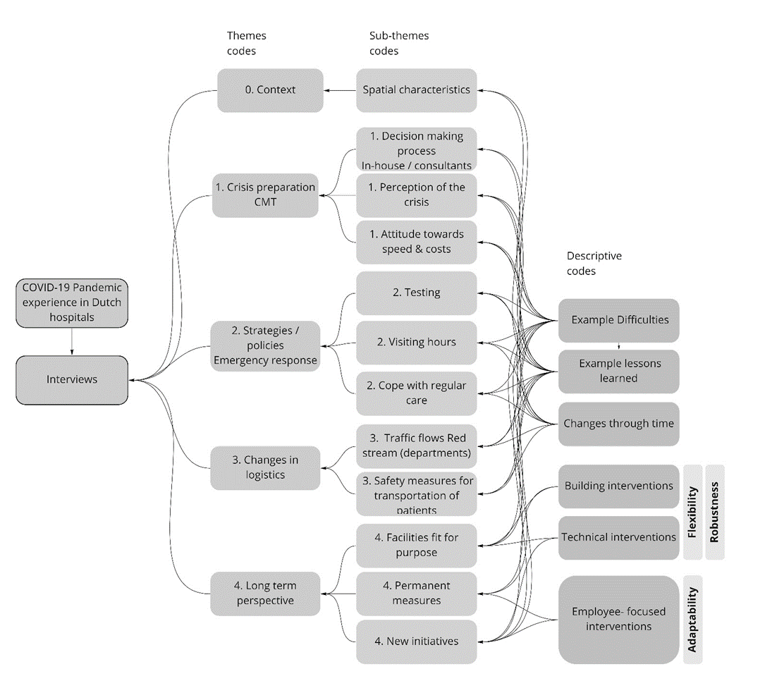

Figure 3 Codes as identified through inductive and deductive coding and associated relations

department is to reduce 50% of the physical visits to the hospital and replace them with video consulting”. During the interviews, it was discussed whether a reduction of 50% of in-person visits would be possible to achieve. Before the pandemic, reimbursement for digital consultations was a barrier to implementing telehealth. This has now been rectified and contributes to a more sustainable implementation of e-health solutions. However, given the fact that not all Dutch inhabitants have access to the necessary technological tools, and their digital and health literacy may vary, virtual talks could still prove to be too difficult for some patients.

The finding from the survey that general hospitals had to make more frequent and intrusive changes to technical installations compared to academic hospitals was also elaborated on during the interviews. Technical installations might be more advanced in academic hospitals, or it could have to do with the design practices at the time of their construction. Some hospitals mentioned difficulties during the pandemic response while providing oxygen in the regular nursing wards because the building had insufficient overall capacity to sufficiently increase the number of ventilated beds. Here the concept of the robustness of the technical infrastructure becomes apparent.

Another major issue concerns the ventilation system. Air pressure barriers have been created since the beginning of the pandemic, and this was an adaptation mentioned by multiple hospitals. Sometimes, the ventilation system is integrated into the whole building, and then it is not easy to tune the airflow hierarchy within or between departments or wards. “In the future, what is essential is to create an isolation ward inside the ICU department, instead of only creating isolation rooms”. From the interviews, it became clear that accommodation strategies should be convertible in terms of infrastructure and installations: “Ventilation adjustments can be made more permanently, so we don't have to improvise things”.

3.3 Infrastructural and operational robustness
The robustness of the technical infrastructure was already mentioned. In the interviews it was mentioned that the existing IT infrastructure was able to support working from home and video consultations within days. The infrastructure had already been there, ready for the expected switch to more telehealth, but there had not been an incentive to use it before. Likewise, one academic hospital could use the robustness of the patient monitoring infrastructure to upgrade the use of the single rooms from medium care to surge ICU. The interlude between the first and second waves was used to give some technical provisions a more permanent status. In these changes, nursing work processes, for example, their wish to have an overview of patients, were found to be leading. The robustness of these processes was challenged during the first wave when medical students and other HCW were seconded to the ICUs to help out. Despite everyone’s willingness to collaborate, crossing traditional professional borders when hospitals came into ‘crisis mode’, it quickly became clear this could not be a structural situation. Short training courses can help prepare other HCW to assist with dedicated tasks and relieve workload, but they need to be supervised by regularly trained all round ICU-nurses, adding to their burden of work. As one of the interviewees put it, “The largest problem is not the hospital real estate, but staff is the problem. So it's not possible to increase hospital capacity by 50% and operate it with the same amount of staff. It is simply not possible.”

3.4 Adaptability measures targeting staff
Consistent with the national guidelines, in the survey of employee-focused interventions, non-essential staff working from home was found to be the most implemented measure. All hospitals set up communication lines to inform staff working on site and working from home about actual developments. As far as adaptations in staff services were concerned, academic hospitals seemed to offer more free parking services (in collaboration with municipalities and in contrast to standard practice discouraging staff from coming by car to inner city locations) and additional childcare services for healthcare workers compared to general hospitals.

With future facility design in mind, the size and technical infrastructure of break and meeting rooms need to be considered when facilitating staff. This would be to accommodate social distancing and hybrid team meetings.

4. Discussion and conclusion

This study showed that, in general, the Dutch hospital buildings were able to accommodate the first waves of the pandemic and the surge in patients. This is in line with findings in other countries (Ramboll, 2021). Although two large, standalone emergency facilities were planned and were operational within weeks, non-availability of staff meant they never came into use. This echoes the findings in the UK with regard to the Nightingale Hospitals (Oliver, 2021). It underpins what was mentioned in all interviews: that availability of staff was the biggest bottleneck to relocating and repurposing spaces and dedicating resources to COVID-care. Some hospitals had fully equipped ICU wards standing idle that could be quickly repurposed or recommissioned. Other hospitals had recently moved and could reopen an abandoned ward. The use of not yet opened or existing Operating Rooms as a surge ICU was reported from Sweden and the US, amongst other countries (Ramboll, 2021; Mittel et al., 2021). All these repurposing measures required, however, a vast reduction in ‘non-COVID-care’ as it became known during the first wave. During the second wave, the shortage of staff aggravated as hospitals found physical space for additional ‘ventilated’ beds on the wards. Besides, the pressure to continue providing essential and urgent non-COVID care was much higher (de Graaff et al., 2022). Patients needing more invasive therapies, such as Optiflow ventilation, also require additional monitoring by staff, whereas these kinds of systems are usually not available outside the ICUs.

The preference of hospitals to concentrate COVID-care in so-called cohorted wards (the whole ward is seen as contagious, with personal protection equipment (PPE) worn by staff at all times) is remarkable, as single patient rooms offer the option to don and dof PPE on a ‘need to protect’-basis. They also make it possible to alter the ‘isolation regime’ without moving the patient to another room. Indeed, several Dutch hospitals built after 2010 have opted for 100% single-occupancy accommodation. One possible explanation for the emerging preference for short-term, spatial flexibility measures such as the cohorted ward might be that nursing staff might feel more in control as they have more overview and can check on their patients without losing time by putting on PPE (van Dijk et al., 2022). Indeed, it may suggest that spatial flexibility may interfere with the adaptive flexibility of staff. This requires further research, especially as hospitals now have to care for patients carrying the COVID-19 virus, but admitted for different procedures.

From the measures taken, such as setting up triage areas, introducing ‘green’ and ‘red’ zones and routes, social distancing, switching to digital consultations, and remote working, this study shows hospitals preferred to use flexibility measures that implicated the design of the building over technical interventions. All measures taken were instigated by the hospital’s own professionals, such as clinical, IPC and real estate staff. There was simply no time to consult architects or engineering consultants. This suggests that in planning and designing future facilities for pandemic resilience, engagement of the hospital’s own stakeholders, like IPC experts, is essential (van Heel & van Oel, 2022).

The current study targets the physical and technical interventions taken by Dutch hospitals during the first and second waves of the pandemic, as well as additional services for staff, as a means to gain insight into the kind of interventions taken in Dutch hospitals that can inform future facility design. In doing so, this study used Monahan’s (2002) distinction between flexibility measures that can be implemented without structural changes and therefore can be more rapidly deployed and measures requiring a long-term perspective, such as in the case of hospital expansion or renovation. Robustness adds the perspective of operational continuity under stress (Tucker, 2006). Adaptability indicated the resilience of staff (Pati et al., 2008). Although contextual factors influenced choices made, findings from this study show that flexibility and robustness in facility design and hospital operations are limited by the availability and adaptability of staff when hospitals are challenged to operate in ‘crisis mode’. Indeed, a combination of perspectives needs to be considered in enhancing pandemic resilience.

Data Availability Statement
MP’s masterthesis can be found on the TU Delft repository (https://repository.tudelft.nl/islandora/object/uuid%3A22b88828-2851-49e2-8b44-74b598522e08 ).
Contributor statement
All authors contributed significantly to the conception of this paper. MP, LvH and CvO conceptualized and conducted most of the study, which MH also supervised.

References
- Bardwell, P. L. (2022). Research Needed on Single-Bed Versus Multi-Bed Inpatient Rooms in Response to COVID-19. HERD: Health Environments Research & Design Journal, 19375867221075487. doi:10.1177/19375867221075487
- Braithwaite, J., Tran, Y., Ellis, L. A. & Westbrook, J. (2021). "The 40 health systems, COVID-19 (40HS, C-19) study." International Journal for Quality in Health Care 33(1): mzaa113.
- Capolongo, S., Buffoli, M., Nachier, D., Tognolo, C., Zanchi, E. & Gola, M. (2016). "Open building and flexibility in healthcare: strategies for shaping spaces for social aspects." Annali dell' Istituto Superiore di Sanità 52(1): 63-69.
- Carthey, J., Chow, V., Jung, Y-M. & Mills, S. (2011). "Flexibility: Beyond the Buzzword—Practical findings from a systematic literature beview." HERD: Health Environments Research & Design Journal 4(4): 89-108.
- de Graaff, B, Rahmawan-Huizenga, S., Bal, J., Kuijper, S., Felder,M., Zwart, L., Kalthoff, K., van den Bovenkamp, H., Wallenburg, I. & Bal, R. (2022) Leren dansen met een virus: Sturen van een meervoudige crisis in de zorg. Retrieved from: 2022-02-de-graaff-et-al-2022-leren-dansen-met-een-virus-eshpm-eur
- Dietz, L., Horve, P. F., Coil, D. A., Fretz, M., Eisen, J. A., & Van Den Wymelenberg, K. (2020). 2019 Novel Coronavirus (COVID-19) Pandemic: Built Environment Considerations To Reduce Transmission. Msystems, 5(2).
- van Kampen, J. J. A., et al. (2021). "Duration and key determinants of infectious virus shedding in hospitalized patients with coronavirus disease-2019 (COVID-19)." Nature communications 12(1): 1-6.
- Karlsson, S., Lindahl, G. & Strid, M. (2021). Future-proofing in healthcare building design. ARCH19 June 12–13, 2019–Trondheim, Norway. Proceedings from the 4th Conference on Architecture Research Care & Health, SINTEF Academic Press.
- Herweijer, M., Boonstra, E. (2020) Now is the time for the adaptive hospital. Retrieved from: https://wiegerinck.nl/en/research/now-is-the-time-for-the-adaptive-hospital/
- Mittel, A. M., et al. (2021). "Logistical considerations and clinical outcomes associated with converting operating rooms into an intensive care unit during the coronavirus disease 2019 pandemic in a New York City Hospital." Anesthesia & Analgesia 132(5): 1182-1190.
- Monahan, T. (2002). Flexible space & built pedagogy: Emerging IT embodiments. In: Inventio.
- Murphy, M. (2020). The role of architecture in fighting the pandemic. Retrieved from https://www.bostonglobe.com/2020/04/06/opinion/role-architecture-fighting-pandemic/
- Oliver, D. (2021). "David Oliver: Were Nightingale units and fever hospitals ever workable responses to covid-19?" bmj 374.
- Pati, D., Harvey, T., Cason, C., (2008). Inpatient Unit Flexibility – design characteristics of a successful flexibile unit. In: Environment and Behavior, 40(2), 205-232.
- Ramboll (2021) Pandemic Resilience Website. Retrieved from: https://c.ramboll.com/pandemic-resilience
- Stichler, J. F. (2021). How the Coronavirus Pandemic Has Changed Healthcare Design. HERD: Health Environments Research & Design Journal, 15(1), 12-21. doi:10.1177/19375867211060822
- Tucker, A. L. and S. J. Spear (2006). "Operational failures and interruptions in hospital nursing." Health services research 41(3p1): 643-662.
- van Dijk, M. D., van Netten, D., Severin, J. A., van Beeck, E. F., & Vos, M. C. (2021). Isolation of coronavirus disease 2019 (COVID-19) patients in cohorted wards or single-patient rooms? Advantages and disadvantages. Infection Control & Hospital Epidemiology, 42(11), 1392-1394
- Van Heel, L (2020), The case of Erasmus MC within the Dutch health system during the COVID-19 pandemic. Retrieved from: https://f.hubspotusercontent00.net/hubfs/7520151/Pandemic%20Resilience/COVID-19%20response%20the%20Dutch%20case%20of%20Erasmus%20MC_final_030321.pdf
20. van Heel, L. & van Oel, C. (2022). Balancing bricks, bytes and behavior: lessons learned from inpatient wards with 100% single occupancy rooms. ARCH22 conference paper, TU Delft OPEN, submitted

