Type of the Paper: Peer-reviewed Full Paper
Track title: Topic 3 Eengagement – co-creation, co-design, design and stakeholder management processes

Rethinking Day Surgery Model of Care and Built Environment: A Design Dialogue Study
Johanna Eriksson ^{1,}*, **, Hina Lad ^{2,3}** and Göran Lindahl ¹

1. Centre for Healthcare Architecture, Department of Architecture and Civil Engineering, Chalmers University of Technology, Göteborg, Sweden; johanna.eriksson@chalmers.se; ORCID 0000-0003-4545-4914
2. The Bartlett School of Sustainable Construction, University College London, UK;
3. Imperial College Healthcare NHS Trust, UK;
Names of the Topic editors:
Clarine van Oel

Journal: The Evolving Scholar
DOI:10.24404/623afbb69bc8a11624b8e7f6

Submitted: 23 Mar 2022
Revised: 17 May 2022
Accepted: 27 May 2022
Citation: Eriksson, J. & Lad, H. (2022). Rethinking Day Surgery Model of Care and Built Environment: A Design Dialogue Study. The Evolving Scholar | ARCH22.

This work is licensed under a Creative Commons Attribution BY license (CC BY).

© 2022 Eriksson, J. & Lad, H. published by TU Delft OPEN on behalf of the authors.

* Indicate the corresponding author.
** Indicate main authorship and contribution

Abstract:
Day surgery is an expanding service, yet in many cases the current built environment is based on the general surgical department, with access to day bed wards and has changed very little since 1950s in the UK. In Dec 2019 a one-day workshop was organised to investigate the future concept for day surgery services and to explore the spatial provisions. The event consisted of a range of stakeholders from government, practice and academia involved in healthcare environments. A design dialogue methodology was implemented, exploring the ‘ideal model of care’ through a series of activities using word, image and free association from user experiences. A design game, using tangible materials, let the participants develop and build visual proposals of new surgical environments. The workshop outcome was further processed through identification, sorting and coding of key themes for improvement, such as; user experience, logistics, adaptable design, after-care and recovery. By defining high and low parameters of patient experiences, a number of topics were discussed, including social community systems, information awareness, safety and wellbeing, continuity of patient pathways as well as efficiency and effectiveness of staff. The final design game combined the themes and topics and further deepened the insights.
The use of a variety of design dialogue methods combined perspectives and knowledge and the workshop clearly identified the value and impact of interdisciplinary collaboration to deliberate and explore ideas for future healthcare facilities.

Keywords: Day surgery; co-design; design dialogue; health care design;

1. Introduction
The basic spatial layout of the surgical department has changed very little since the 1950s in the UK, the setup of an operating suite remains the same with only variations in room sizes. In the 21st Century the advances in medical technology and the range of service available for routine procedures progressed at a rapid pace. Day surgery is now a common and expanding service, providing efficiencies in patient, staff and service outcomes. The layout and concept behind the day surgery facilties remains unchallenged and embodied in the historical design of the general surgical department.
This study looks at how the spatial perspective could be used to connect organisations, healthcare services and physical environments. Studies show that complex design challenges need to be addressed in an iterative collaborative manner, and it is in the exchange between different perspectives and knowledge fields, new and innovative ideas emerge/solutions are explored.

In December 2019 a one-day workshop was organised at UCL, to rethink the concept for day surgery, using an innovative method. The event was a part of a series of design-driven workshops in Sweden, Germany, UK and Netherlands, as part of the BauHow5 Alliance involving knowledge triangle stakeholders, sharing and co-creating knowledge about health and healthcare facilities in real-world, locally situated problems. The overall project also set out to support public administration in implementing academic knowledge and create new business possibilities for architects and designers (Eriksson et al, 2020).
Design dialogues is described as ”a method developed and used in workplace development in Sweden. The model brings the knowledge from different actors and disciplines into a process of producing joint knowledge concerning a current issue in the built environment.” (Eriksson et al, 2020). The model is artefact-driven which involves the creation of visual concepts carrying jointly constructed understanding.
The model was here implemented in a new context, as an explorative tool for stakeholders not usually meeting and discussing the topic of day surgery, together. The model was used to see if things usually not discussed would emerge. Design dialogues is here both a method for developing new knowledge and the object of study for this paper.
Based on the approach of collective sharing of knowledge and experience a group of professionals from different backgrounds linked to healthcare facilities, came together to question the current UK environment for day surgery and to create a future model of care, which could reflect current user needs.
The subject and the method of investigation was key to this study. This paper aims to present how this approach could be applied in a different context, they type of knowledge this would generate and the key factors which affected the outcomes. Further discussions and refinement on the method of design dialogue and its application to healthcare environmental design is considered.

2. Theories and Methods
With its base in 70’s and 80’s collaborative workplace design (Adler, Granat and Lindahl, 1995), the design dialogue was developed and implemented both in research and practice in relation to the healthcare building design in Sweden (Fröst, 2004, Eriksson, 2013). The experiences of the method were further elaborated (Fröst et al, 2017) and forms the base for the method implemented in this study. Design dialogues are describeds as workshops where participants iteratively explore possibilities and ideas, designing a series of prototypes using drawings, words and a selection of tangible materials including different shaped and coloured cardboard forms and sheets of paper. These prototypes became design artefacts working as carriers of collective discussion, investigations and creative insights. The model uses design as a tool for people that are designers and non-designers to describe and develop ideas collaboratively.

2.1 The Workshop
Being part of a series of workshops developed by the BauHow5 Alliance team and used in other countries, a tried and tested model and procedure was applied. The researchers and authors of this paper planned, facilitated, and participated in the workshop making it an action-based study. The study included the setup of a co-design workshop where observations, videos and photographic documentation was complemented with a questionnaire - focused on the data collection methods. The recorded material, results and outcomes were sorted and reflected upon in the process of writing an initial summary report and then this paper.

Table 1: Workshop Structure, tools and outcomes.

Workshop Structure | Tools | Outcomes
Introduction  overview | Power point presentation to participants. | Basic understanding of design methodology and aims of workshop.
Session 1, Brainstorm  Q: What are your main concerns about current UK facilities for day surgery, with reference to activity space and service delivery? | Participants individually wrote key words on different coloured post-it notes. | Individuals selected two key words to presented to the whole group for discussion.  Warm up exercise to encourage people to voice opinions and overcome shyness.
Inspirational input  Short lecture on the design history of day surgical spaces by host. | Power point presentation and short video of user experience. | Provoke further thoughts and conversation.
Session 2, Patient experience  Q: What is the experience or impression with which the patient should leave the day surgery facility with? What is the ideal?  Present three most important concepts. | Participants split into small groups of 5-6 people. Given coloured paper, pens and assorted images stamps. | Each group synthesized the information onto three cards each with a single sentence and image to describe experience/ impression to be conveyed and presented to the whole group.  A series of themes and concepts began to emerge.
Lunch | Lunch provided in workshop room. | Generated further conversation in smaller groups.
Session 3, Design Game  Q: By rethinking the surgical space for day surgery, what would the ideal ‘model of care?  Build a concept design. | Participants allocated into small groups of 5-6 people by host and given an A1 white board, a selection of shapes, colours, adhesive and images. | Each group developed a concept design and presented to the whole group, followed by Q&A session.

The basic principles of the workshop were to start with individual reflections and move onto group working and collective processing. This would enable participants to air their personal concerns and then form joint concepts through collective learning. Smaller groups presenting to the whole group would initiate an upscaling of knowledge sharing and understanding. Participants changed groups from one session to another, to avoid personal or hierarchical “locking”, and enhance spreading of different perspectives. The use of the same visual tools, and tangible materials enable a variety of expressive illustrations of ideas and concepts. (Fröst et al, 2017).

2.2 Participants
Participants were invited by the hosts, to represent a range of stakeholders involved in the planning and designing healthcare environments. These included healthcare professionals, clinicians, architects, designers, contractors, artist and researchers in healthcare services. Participants were mainly from UK, others included researchers from the Netherlands and Sweden.

3. Results and Summary of Workshop Outcomes

The study revealed two sets of distinct outcomes. The first set related to the topic of rethinking day surgery and the second to the process and method by which the study was conducted. This section presents a summary of the workshop outcomes, key themes discussed related to day surgery facility design, and the analysis from the questions posed on a methodology questionnaire. The interpretation and significance of these outcomes are explored in the discussion.
3.1 Participants
The total number of attendees was n=24, this included the organisers which participated in the days event. When categorised into different professions, several of them held dual or triple roles which provided a spectrum of different viewpoints. All had been patients (n=24).

Table 2: Participants

Profession/ Background | Number related to roles | Dual/ triple roles
Clinical Professionals | 3 | No
Architects | 13 | Yes
Healthcare Planners | 10 | Yes
Design Managers | 1 | No
Academic Professors | 3 | Yes
Senior Lectures | 3 | Yes
PhD Researchers | 4 | Yes
Commercial Artist | 1 | No

3.2 Session 1: Brainstorm outcomes, main concerns
The task produced a list of key words which described participants concern with current day care service. The key words are here summarized into common themes, which were:
- Lack of communication
- Need of better organisation and efficiency
- Importance of user experience, both staff and patients
- Need for empathetic design
- Ability to adapt and flex spaces
- Overcoming inefficiencies in space, environment, services and workforce.
Image 1: Workshop, brainstorm material

3.3 Session 2: Patient experience outcomes
In small working groups of 5-6 participants, conversations centered on the ideal experience and impressions day surgery could provide. Through discussion and deductive reasoning each group selected only three most important concepts using a phrase and an image for each concept.

Table 3: These themes emerged from debate and agreement as part of the larger group discussion.
Theme | Description
- Social systems | - A wider collaborative network in community and home for prevention, information and follow-on care.  - Systems to support all clinical and non-clinical workers, patient care-giver, families and the patient.
- Experience of service and environment | - Provide a positive experience which ensures the best treatment empathy and individual needs.  - A personalized tailored approach.  - Clean, hygienic and safe environment.  - A place which eases emotions of anxiety and stress.  - A safe place to return to.  - A place where staff enjoyed working.
- Communication | - Patient being informed of their full procedural pathway and aftercare.  - Understanding the risk and success of procedures.  - Informed staff, teamwork and well-maintained patient records system.
- Efficiency | - Reducing waiting times and cancellations.  - embracing day procures without compromising care.  - Achieving a balance between efficiency, experience and through-put.

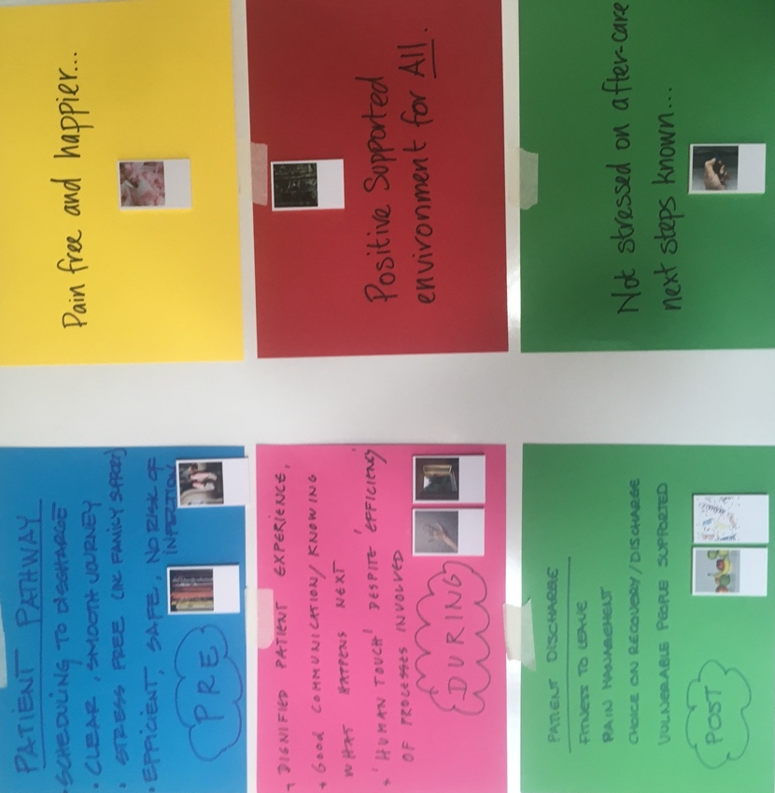
Image 2: Workshop material, patient experience

3.4 Session 3: Design game outcomes
In different small groups of 5-6 participants instigated by the host, each team discussed, designed and presented a concept of the ideal day surgery environment as follows:
Table 4: Concept Designs
Group 1  Key themes:  - Technology  - Awareness  - Zoning  - Appearance | - Facility consists of: 1) light and flexible reception, staff, patient recovery spaces. 2) changing and operating suite spaces and 3) back-stage space for surgical props/equipment creating a clean and clutter free operating space.  - Combined digital check-in services with traditional reception. = resulting in a circular reception with surrounding cubicles/nooks for patients to be seen by doctors at different time slots.  - Key drivers;flexibility and efficient use of clinician’s time
Group 2  Key themes:  - Technology  - Adaptable  - Homecare  - Staff Flexibility | - Embrace a fully integrated technological day surgery experience by creating a series on nodes.  - Concept based on a plug and play approach with variance of complexity based on need.  - A fleet of autonomous vehicles with clinical services transported to people’s homes. Making ancillary spaces for day surgery obsolete.  - This increase in flexibility required a huge number of mobile staff.  - Patient access to information during all process stages.
Group 3  Key themes:  - Service change  - Pathways  - Efficiency  - Technology | - Service change to a 24/7 day surgery service facility.  - Patient pathway included a specialist at each stage.  - In identifying the complex- convoluted process of surgery suggested efficiency by reducing the number of specialists/staff seen per patient.  - Embraced technology to create a one-stop-shop approach to reduce backlogs
Group 4  Key themes:  - Service change  - Hotel  - Flexibility  - Efficient use | - Past and future compared to implement ideas  - New concept operating theatre suite and a hotel-centric approach for before and after care.  - Surgery would take place in a mobile self-contained industrial unit for ease of upgrade and transport.  - Step-up and step-down facilities suggested.

Between groups similar themes emerged for the built environment design; technology, adaptability, flexibility, change of service pathways and efficiency.
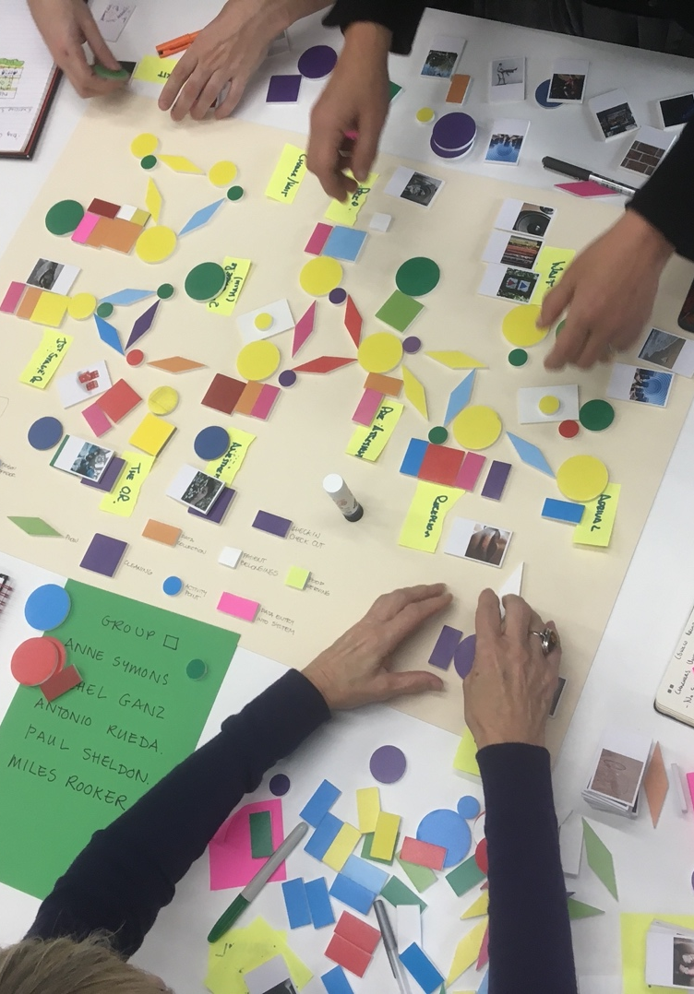

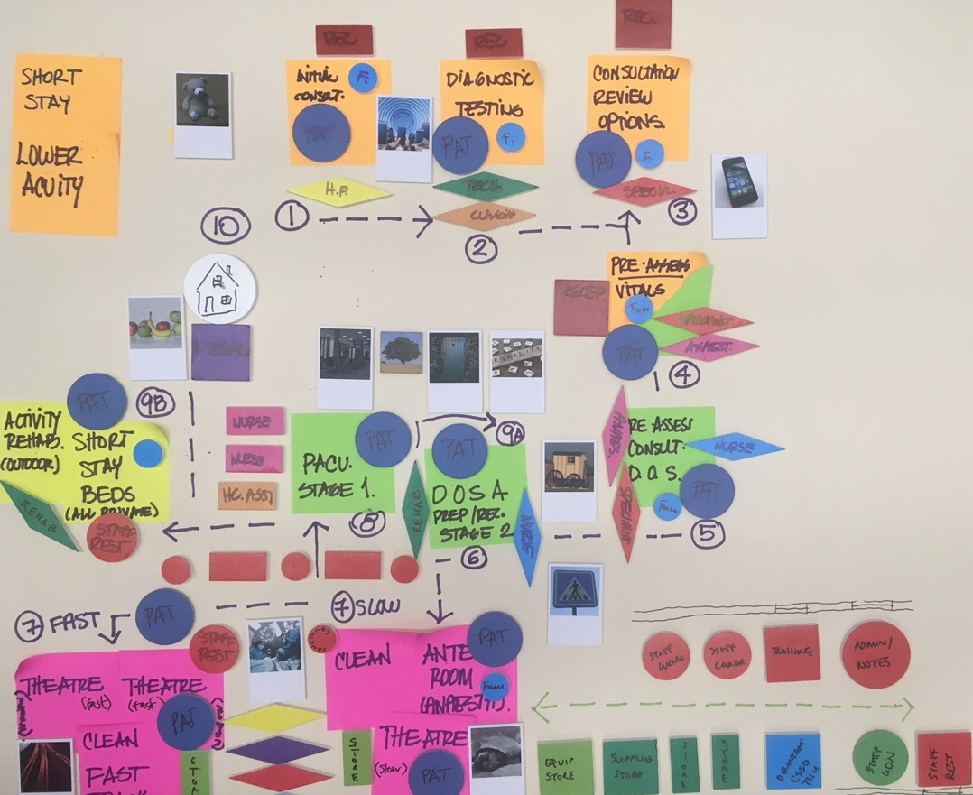
Image 3 and 4, Design game illustration

3.5 Ending discussion
In the closing remark one of the important points made, was the relative slowness of the building profession when compared to the medical and technological world in adapting to change. It was noted that healthcare buildings became obsolete just as they were built, due to the rapid changes in equipment and medical technologies compared to the time taken to construct and occupy a new facility. Also, that there is a lack of current, continuously development of design guidance to support the changing nature of healthcare facility design.

3.6 Results on methodology questionnaire
Total 16 of 20 participants responded, hosts excluded. The questionnaire included questions about:
- How the method was perceived, what went well and what could be improved
- How collaboration worked
- Workshop output
- The potential of using this collaborative method again

A general response was positive and that the events were fun and enjoyable. Other views mentioned were:
- Very interesting conversation
- Wonderful spread of disciplines represented.
- Good engagement, thought provoking discussion

13 (out of 16) respondents answered agreement or strong agreement regarding if the workshop fostered interdisciplinary collaboration.

In relation to what could be improved, there was a general conclusion that the method met expectations and worked well. Some aspects regarding improvement were mentioned included:
- Some notes on the room being too small and noises from the outside disturbing
- Considerations on how this can be developed in relation to Project Delivery Models – when UK clients methodology make it difficult to use this approach directly
- More of a focus on needs rather than activity management
- More detailed analysis for how day surgery designs/flows/operations are done elsewhere, and lessons learned
- More of possible futures of surgical spaces
- More in connection to cost/lifetime analysis method
- Workshop time management, which could be improved

A suggestion of another workshop format, for example a 2-day workshop would enable a better way of managing time, getting in-depth insights in each other’s way of thinking and a better setting for covering more aspects.
12 repsontents were in agreement with “I learned something new”. In response to the statement “The process should be used more often” 13 out of 16 answered that they were in agreement or strong agreement and 14 answered agreement or strong agreement regarding if they would use some of the applied methods in their studies or work.

4. Discussion
The research generated two sets of distinct results. The first providing a series of design options with key areas for consideration and discussion in rethinking the design and delivery of a particular healthcare service. The second a critical review of the method by which the subject was investigated. This discussion focuses on the engagement technique of co-design.

Based on the methodology questionnaire, three key topics emerged for evaluation and discussion:
- Subject and participants
- Choices and consequences of using co-design methodology
- The type and character of outcomes

4.1 Subject and Participants
The selection of the workshop subject coincided with current UK government reviews of; day surgery services, the request for improvement on activity turnaround, reduction of patient waiting lists and the need to improve staff satisfaction.

The selection of participants was driven by the responses to take part in the activity and the organizer’s network of contacts. The network consisted of university educators-researchers and professional industries including NHS Trust, construction, architecture and/or design practices. This in itself, defined the field of knowledge exchange. Patient insights was also limited, to duels roles of participants, since most had the experience of being a day surgery patient, however the subjective opinions as a patient appeared to be clouded by their profession interest. To encourage diverse opinions the smaller workshop groups consisted of different professional, yet this was limited by the initial selection.

The conversation and discussions were mostly directed at spatial design due to the high number of built environment related participants and the framing of the exercises. In hindsight a balance number of clinical practitioners, patient groups and healthcare staff could have provided a broader knowledge and experience base. To encourage diversity of discussion the structure of the workshops and questions remained open for interpretation and could have been relevant to a range of participants.

4.2 Choices and consequences of using co-design methodology
The project Bauhow 5 expresses that “this method allows an unfolding of a ‘wicked’ problem in a locally situated practice adding knowledge to all participants in the process of codesigning possible answers or solutions to the problem” (Eriksson et al, 2020).
With this in mind, the workshop was organized to frame the subject with its relation to physical space, using visual tools, such as images and coloured shapes to visualize discussions and ideas. The purpose of the workshop and its tools was to facilitate new ways of thinking, cross fertilisation of ideas and to bridge the possible knowledge asymmetry between people. The initial exercise focused on existing challenges to provoke debate. However, the main group session centered around identifying the future and ideal needs of a particular environment and service model through co-designing one or more shared answers or solutions.
Almost all participants considered that this was a methodology worth exploring more. This could be interpreted as appreciation of the setup, but also that there was more to investigate than this day could encompass.
Although being a well-studied methodology in other contexts, and hence using established methods to facilitate shared understanding, interdisciplinary learning and collaboration, co-design was a fairly new methodology for all participants.
The initial getting to know each other and preliminary discussion on the topic of interest was short and could have benefited from lengthier sessions. However, the constraints of a one-day workshop enforce short discussion and quick decision making. The setup with most of the time spend on group work and presentation was intentional, with the focus on exchange between participants and not from input outside of the group, with the effect that some missed the learning from examples and common ground.

One of the critical factors was the allowance of time for each session and for the whole workshop. A two-day workshop was considered, yet this placed a strain on individuals due to their professional commitments. A series of workshops would allow time for reflection and development of ideas that may have generate more in depth thinking and all participants, not just the vocal ones would have had a chance to voice their opinions and thoughts.
4.3 The type and character of outcomes
The questionnaire revealed that most people left the workshop on a positive note, feeling that they did contribute to the discussion, learned something new and had an interest in working with the method again. Still, there was some issues that had been unsatisfactory. Time management was one such issue.
How well did the studied methodology work for generating new ideas? The outcome indicated that no new ideas or innovation emerged, but the ordering and organisation of thoughts was improved, and clear concise themes were identified. The awareness factor improved, and the activities was clarifying the issues of “what is usually said”. A vast majority opted in the questionnaire that they learned something new during the event, although it was not mentioned in relation to what.
The issue of time vs change of building use was raised in the ending discussion, pointing out how buildings are planned to house an organisation for many years, but the organisation being in constant change affected how the discussion about needs today and in the future, is handled. Aspects of this was also mentioned in several discussion on flexibility, adaptability and service change.

5. Conclusions
This paper set out to present how the method of design dialogue could be applied in a different context, the type of knowledge this would generate and the key topics; subject, participants, choices and consequences of using co-design methodology which affected the outcomes.
The use of design dialogue as a method of letting a group of stakeholders of day surgery meet and pinpoint challenges with current facilities as well as developing solutions enabled the participants to step out of their everyday projects and look at their situation with new perspectives. Due to the method being new to most of the participants and offering a collaborative design approach, different to what they may have been used to, it made people interested, together with an engaging and current topic.
The workshop setup and tools offered, supported the sharing of perspective, knowledge and ideas, within the small group as well as to the larger group in what could be described as cross-disciplinary learning. The visual tools enabled a joint discussion, that could be shared with the whole group.
Being somewhat of a pilot project, there are off course refinements to be made in case this method is proposed in relation to an ongoing project. One aspect that needs to be studied further is what adjustments need to be made, in relation to the UK project design phases and stakeholders, as pointed out in the questionnaire. Further aspects are to look into the duration of the event, the topics presented, and consideration of representativity. Who attends the workshop plays a significant role in what perspectives get included in the discussion. Even if there was only one or a few representatives from clinical professions or artists, they still got to impact the discussion.
Although this workshop took place before COVID-19, day surgery has proven to be a vital service for many patients during the last two years. It has provided an efficient and safe care pathway by reducing length of stay in hospital environments, providing a directional flow of patient through-put and in keeping routine operations to a minimum during a time of a pandemic. Despite these worldly events, the outcome of the workshop is still relevant.

Acknowledgments
Partly funded by BauHow5 Alliance funded by Erasmus and programme of the European Union

References

Adler, N., Granath, J. Å., Lindahl, G. A., (1995). Organizational Learning Supported by Collective Design of Production Systems and Products. Papers from the 2nd International Conference of The European Operations Management Association, 1995. Twente, Netherlands
Elf, M., Frost, P., Lindahl, G., & Wijk, H. (2015). Shared decision making in designing new healthcare environments-time to begin improving quality. BMC Health Serv Res, 15, 114. doi:10.1186/s12913-0150782-7
Eriksson, J., (2014) Architects and users in collaborative design, Göteborg, Licentiate thesis, Chamers.

Eriksson J., Strid, M., van Oel, C., Lad, H., (2020) Making the knowledge triangle work in the disciplines of architecture and the built environment, Intellectual Output 3, Retrieved from http://www.bauhow5.eu/output-3/

Fröst, P., (2004). Design Dialogues in Early Phases of Building project. Göteborg, Doctoral dissertation, Chalmers.
Fröst, P., Gustafsson, A., Eriksson, J., & Lindahl, G. (2017). Designdrivna dialoger för arkitektur och samhällsbyggnad. Centrum för vårdens arkitektur, Arkitektur och samhällsbyggnadsteknik, Chalmers; Sweco.
Henderson K, (1999). On Line and On Paper. Visual Representations, Visual Culture, and Computer Graphics in Design Engineering 1999. The MIT Press, Cambridge, USA
Star, L. S., (1989). The Structure of Ill-Structured Solutions: Heterogeneous Problem-solving, Boundary Objects and Distributed Artificial Intelligence. In the Distributed Artificial Intelligence, Vol. 2 1989. Edited by Kuhns and Gasser, pp. 37-54, San Mateo, USA, Morgan Kaufman.

