Type of the Paper: Peer-reviewed Conference Paper / Full Paper

Track title: Engagement – co-creation, co-design, design and stakeholder management processes

Balancing bricks, bytes and behavior: lessons learned from inpatient wards with 100% single occupancy rooms

Liesbeth van heel 1,* and Clarine van Oel 2

1 Department of Public Health & Program Integrated Buildings, Erasmus University Medical Center, the Netherlands; [m.vanheel@erasmusmc.nl](mailto:m.vanheel@erasmusmc.nl) ; ORCID 0000-0003-4799-3057

2 Department of Architecture and the Built Environment, Delft University of Technology; ORCID 0000-0002-4959-2938

|  |
| --- |
| **Names of the Topic editors:**  Clarine van Oel  **Names of the reviewers:**  Ro Spankie  Nicoletta Setola  **Journal:** The Evolving Scholar  **DOI:**  https://doi.org/10.24404/624b228bfc807e2f62eb1e04  **Submitted:** 20 August 2022  **Accepted:** 22 August 2022  **Published:** 31 July 2023  **Citation:** van Heel, L. & Van Oel, C. (2022). Balancing bricks, bytes and behavior: lessons learned from inpatient wards with 100% single occupancy rooms. The Evolving Scholar | ARCH22. https://doi.org/10.24404/624b228bfc807e2f62eb1e04  This work is licensed under a Creative Commons Attribution BY license (CC BY).  © 2022 [Name of the authors] published by TU Delft OPEN on behalf of the authors. |

**Abstract:** The design of a new hospital is typically used as a catalyst for change, redesign, and the implementation of new work processes to improve health services. Perceived outcomes after relocation may be linked to the success of co-design and stakeholder engagement processes. Especially in striking the right balance between the building (bricks), processes and supporting IT (bytes), and work processes (behavior). Even when stakeholders are engaged in the design, that does not guarantee that their needs will be safeguarded during trade-offs in various phases of decision-making. Furthermore, the time window between engagement and project delivery may contribute to a mismatch in perceived outcomes after relocation. This study aims to gain insight into the possible causes of the perceived mismatches as expressed by ward managers some 12 months after relocation. This was some six years after the design of the facility was completed. It will increase our understanding of the complexity of design, construction, and transition processes that have to deal with a gap in time between design and use. We adopt an interpretive case study approach in which in-depth interviewing is combined with an extensive analysis of documents collected over time. We found transformative change requiring an integrative approach to the Bricks and Bytes throughout the whole process of designing, constructing and taking them into use, with stakeholder engagement as a key element. Additionally, we found that health care worker behavior was not considered sufficiently in a predominantly rational design and implementation process focusing on patient- centeredness.

**Keywords:** post occupancy evaluation, stakeholder engagement, transformation, hospital design

1. Introduction

The planning and design of a new hospital are typically used as catalysts for change, redesign, and implementation of work processes to improve health services and outcomes (Tucker, Hendy, & Barlow, 2014). These projects often include the ambition of incorporating more patient-centeredness into their care delivery. This comes with the need to encompass a cultural shift in the project and not just relying on an improved care environment (Fix et al., 2018). Adding this ambition to change organizational culture through facility and service redesign ideally requires joint optimization of continuously coordinated change, affecting both the social and technical aspects of an organization (Hamilton, Orr, & Raboin, 2008). Ideas about new innovative care models related to the organization’s strategic plan and expressed from end-user perspectives must thus already be part of the planning and design process (Elf, Fröst, Lindahl, & Wijk, 2015). The organization’s project goal is transformed from a construction project into a successful transition towards a new, smart hospital environment. Launching ideas to engage in a hospital construction project is thus to be considered a transformative change project, as was the case in a large tertiary hospital in the Netherlands. At the start of this process, in which the first author was involved from the start onward, the transformative character of the anticipated project was echoed through the ambitions that were first set out. Erasmus University Medical Center (Erasmus MC) wanted to create an innovative care environment to cater for its tertiary care patients, often requiring multidisciplinary care, that would combine ‘high tech’ with ‘high touch’. It had to support care professionals not just in patient care but also in education and research. And it had to have the ability to utilize its capacities as efficiently and effectively as possible, e.g., resulting in 100 % single-room accommodation, as evidence was already suggesting this would be the optimal environment to support patients and their families, reduce stress, prevent errors and infections, etcetera, during a hospital admission. Efficient hospital management would be supported by integrated planning and redesign of work processes to support patient pathways and process-supporting IT.

Given the dominant discourse already at the start of the project about an evidence-based approach and having a transformative project goal, project success must be measured beyond the factors of time, budget, and quality. These factors are most often used in assessing project success in the construction industry. Because transformative change is only to be evaluated after the hospital has been put into use, such an evaluation is challenging. Moreover, the quality and thus the added value of a healthcare building’s design to its end-users can only be truly assessed and appreciated after the facility is finished and taken into use. And this is seldom done, due to the difficulty of distinguishing between all the variables that change with a hospital relocation, thus changing the context of such an evaluation (Barlow et al., 2016). Exploring causality is made even more complex as this is the moment where the built environment (the bricks) has become ‘smart’ with its IT and supporting services (the bytes) in facilitating the end-user in using it in the new ways intended (the behavior). To date, only a few have included the use of ICT and supportive services in their evaluation of hospital environments (Hamilton, 2008; Elf et al., 2015).

The concept of Bricks, Bytes, and Behavior originates from introducing New Ways of Working (NWW) in an office environment, where the use of ICT (bytes) is seen as an important enabler for a more flexible use of the work environment (bricks), also leading to new relationships between employees and management (behavior) (De Kok, 2016). And indeed, during the recent COVID-19 pandemic, this IT-enabled flexibility has helped many Health Care Workers (HCW) continue their work at home or make a switch to video consultations, finally making ‘digital first’ a common practice (Voss, 2022). Ideally, all three elements (bricks, bytes and behavior) are balanced and continually optimized throughout all project phases. Making a shift to 100% single-room accommodation can be seen as an illustration of this transformative change in bricks, bytes, and behavior. It is known that single occupancy rooms (bricks) present a number of challenges to HCW, such as different relationships with co-workers and patients (behavior), changed perceptions of patient visibility, increased by-the-bed patient care interactions, altered resource allocation, and the need for different communication techniques (bytes) (Barlow, Hendy, & Tucker, 2016). However, a long lasting process with multiple stakeholders with their own needs and constraints, negotiations, and final decision-making can result in mismatches. Such mismatches are expected to become clear once the hospital has been put into use and daily practices develop.

In the current study, we aim to investigate what mismatches ward managers perceive some 12 months after relocation, and to evaluate to what extent these mismatches can be understood as reflecting conflicting processes originating from the domains of construction (Bricks), smart ICT technology (Bytes), or working practices (Behavior). In a long-lasting process with multiple stakeholders with their own needs and constraints, negotiations, and final decision-making, these mismatches are bound to occur and may hamper transformative change. In doing so, we focus on the inpatient wards. This study is part of an overarching study to learn lessons from the twenty years design and construction process of a large tertiary hospital in the Netherlands, in which trans- formative change through stakeholder engagement has been mentioned as a major positive factor in successful project delivery (AT Osborne, 2018).

2. Theories and Methods

A practicebased, interpretive case-study approach is adopted to deepen understanding of the balance between bricks, bytes, and behavior. This case study is compelling for in-depth analysis given its use of temporary organizations, its governance within complex project or program organizations, and its stakeholder and end-user engagement in extended design and transformation projects. It concerns a ‘brown field’ redevelopment on an inner city campus, encountering governmental regulation at several levels and stages, while in size, longevity, cost, and phased construction qualifying as a mega-project (Flyvbjerg, 2017).

Fundamental to the approach taken at the project’s start is that the organization’s Executive Board aimed for innovation and transformative change. To this end, three main principles were phrased and made central to the further debates. The first principle was phrased as ‘Thinking differently’ and targeted healthcare delivery in 15 years. The second principle focused on simultaneously developing work process redesign and was referred to as ‘Working differently’. Then the last principle concerned a new approach to the planning and design of the physical environment (‘Building differently’).

The work process redesign project, starting in 2001 and following an independent course, focused on patient pathways as a way to improve quality of care and patient experience, with the aim of implementing improvements straight away. Due to site constraints and the longevity of the construction process in this case study, for the new hospital wards, the redesign input at the time was limited to developing generic principles as a means to inform the design process. Table 1 summarizes, for each of the main principles, the characteristics of the ward environment that resulted from the negotiation process with project stakeholders. This negotiation process occurred at different times due to the very nature of the design and construction process of the new hospital.

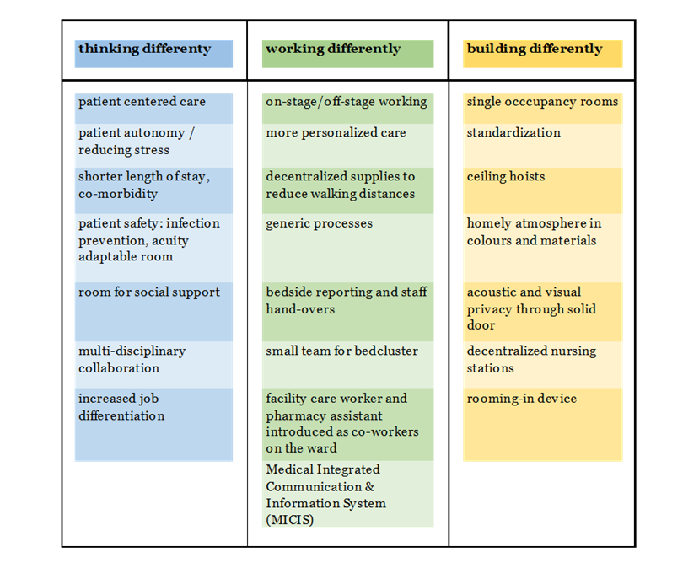

Table 1: ward characteristics: outcomes of stakeholder negotiations

The ‘Thinking differently’ user needs originate from 15-20 years prior to relocation to the new facility. The built environment was co-designed some six years before relocation. Finally, the process targeting the elaboration and implementation of the new, generic work processes started only four years before relocation. The latter process had to incorporate the introduction of a new Electronic Patient Record (EPR) and Hospital Information System (HIS) one year before the relocation, with a second release upon relocation. This ERP/HIS was considered a necessary step to enhance quality of care and business processes, but also to support new ways of working in the new hospital environment.

Evaluation interviews with ward managers were conducted 9-18 months after relocation. A semi-structured interview protocol was followed and addressed topics such as first experiences (good or bad) from managers and their nurses, patient experiences, issues with facilities on the ward and in patient rooms, communication devices and teamwork, and the new roles on the ward of facility care worker and pharmacy assistant. Interviews were transcribed and analyzed using ATLAS.ti. From the nine interviews, issues were identified where ‘work practice as imagined’ turned out to differ from ‘work practice as done’ (Pomare, Churruca, Long, Ellis, & Braithwaite, 2021). These issues were analyzed as examples of an apparent mismatch or imbalance between bricks, bytes, and behavior. In this, the time factor of design-related decision making and change management approaches were also considered. Some issues could be investigated further using the extensive project archive at the disposal of the researchers, going back to the development of the projects’ strategic ambitions. Citations as used have been translated from Dutch.

3. Findings

Stakeholders

Table 2 offers an overview of the issues that were mentioned most often during the evaluation interviews. They start with imbalances originating from concepts introduced as part of the service and process redesign. Each issue is related to choices in the built environment, such as standardization and ward size, depending on its position within the shape of the building. Some of the ward managers interviewed played a role in co- designing the new inpatient wards. So they were long-term internal stakeholders. All ward managers were involved in the NWW program. This program designed, again together with stakeholders, the generic work processes, conducted fit-gap analysis with existing ward practices, and prepared teams for working in the new environment with the new supporting IT systems and services. The late introduction of the new EPR/HIS introduced a lot of uncertainty about the process supporting IT end-users could expect at relocation. In addition, different aspects contributing to an overall functioning ward environment at relocation were commissioned from different temporary project teams, with the inherent risk of ownership issues arising between co-producing partners.

Other stakeholders involved, however, are the Infection Protection and Control team (IPC-team), whose requirements were formulated as part of the briefing process and were subsequently incorporated in the design. The Bytes are represented by the initial limitations of the EPR (implemented 11 months prior to the move with a new release on relocation) and, for instance, the smart room display (patient name and barcode, directly linked to the EPR). Besides, the Medical Integrated Communication and Information System (MICIS) project developed the IT support for the new work processes, such as brokering different alarms to the HCW’s mobile device. Building on the patient centeredness ambition, this project also developed a mobile patient alarm. In the column Behavior, we note where HCW and visitors reported difficulties in their (work) practice, as brought forward by the ward managers interviewed.

The new wards

Figure 1 offers an overview of the ward layout in our case-study. A floor has between 109 and 120 single patient rooms; the floor is divided into five units of 12-32 beds, with two units sharing off-stage office and service areas. As summarized in Table 2 the main findings were issues to do with the standardization of ward design and processes and a lack of fit between building design, equipment, and intended and actual use. Table 2 also shows that most issues can be related to a combination of bricks, bytes, and behavior. In the remainder, some findings are elaborated on given their relation to bricks, bytes, and behavior according to the perceptions of the interviewed ward managers.

Bricks

The principle of working differently was meant to overcome territory claims from different departments and ensure generic processes related to the patient’s journey were facilitated in a standardized way when encountering different specialties during following the following care episodes within the same hospital. It was also meant to ensure future flexibility if changes in caseload between specialties occurred, so beds could be redistributed. As a result, the standardized ward design, with units ranging from 12 to 32 rooms (and beds), does not always fit the allocation of rooms on one floor over different specialties. One unit of 32 beds, for instance, can be shared between two different ‘themes’ or clusters of medical departments. Eight beds in this 32-bed unit are used by a different specialty, but are dislocated from the 16 other beds in this specialty. As a consequence, this nursing team works on two sides of a service area. When staff shortages force them to close beds, these eight beds are the first to be abandoned, as they are inefficient to staff, especially at night.

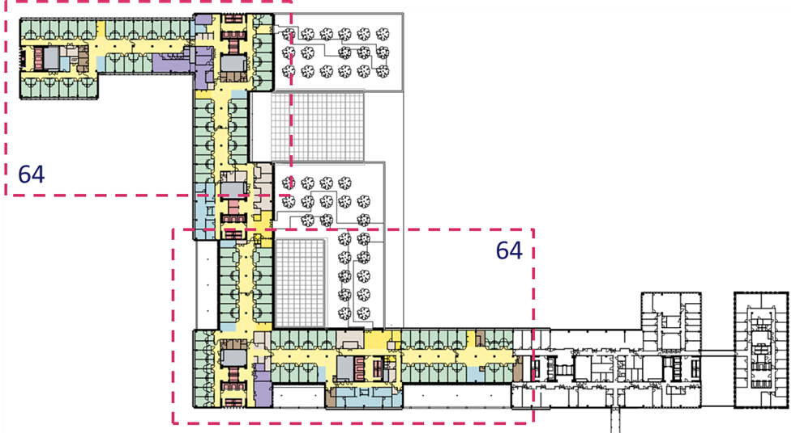

*Figure 1: schematic ward lay-out (used with permission of Erasmus MC and EGM architects)*

**

*Figure 2: part lay-out with off-stage office and service/facilities areas (used with permission of Erasmus MC and EGM architects)*

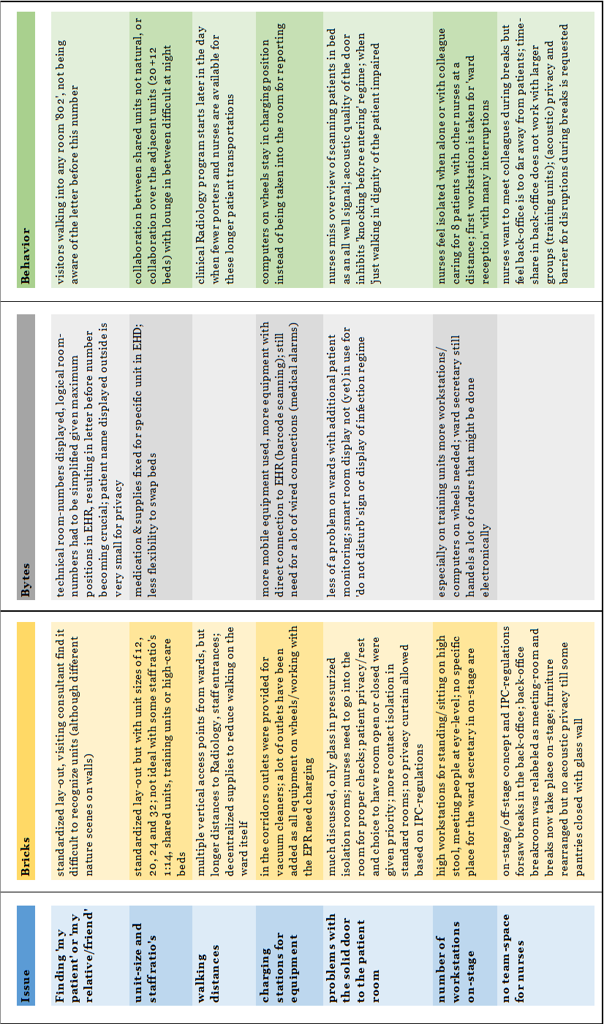

Table 2 issues and their relation to bricks, bytes, and behavior

So the intended flexibility and collaboration in the physical units do not take place in practice. Organizational or cultural barriers seem to be higher than physical ones, as a ward manager explains: “*They call it ‘the island’. … At night, they are pretty lonely, sitting with two nurses on high seats. We invited them to join us, write their reports, etcetera. … Recently, at times, nurses have indeed come to sit with my team, but to be honest, these are always the same few nurses that do. … They feel uncomfortable joining my team, so they would rather share their mobile device with us so they can join their own team further away*.”

Limited flexibility in the use of spaces was found. Where standardization of the wards has provided a ‘lounge’ area for patients and families to sit, a little away from the ward, practice shows that their use is limited due to a lack of mobility in certain patient groups. However, wards do not feel comfortable or have not thought about giving it another use, such as a break area for nurses, as we picked up in the interviews, as these were seen as being designated areas for patients and their visitors.

**Bytes**

Working differently was envisioned as largely dependent on high levels of flexibility. This flexibility was thought to be higher in the new hospital because all patient rooms were standardized as single patient bedrooms, allowing for flexible, shared use by multiple teams. The EPR/HIS was expected to support this shared use, as a room is a ‘production location’ in a ‘one patient, one file’ system. Here, not the building but the IT facilities –thus the Bytes – lack flexibility. As a ward manager explains, *“We cannot use a bed from another specialty. In the EPR/HIS, they are fixed, and we cannot change this, not for alarms being routed or for medication that can be ordered. You would expect this to be more flexible.”* This shows that IT services are poorly tailored to the needs of stakeholders.

To some extent, this may have to do with the poor integration of stakeholder needs into IT processes during the design of the hospital. This is evidenced by a stakeholder’s remark considering the use of a ‘do not disturb’ notice on the smart room-display. The smart-room display was introduced to establish a real-time link between the EPR and the location of the patient, with the intention of adding services to enhance patient control. In order to prevent HCW, or family and friends, from walking in when a patient’s privacy and dignity might be implicated due to care or a private conversation, and with patients’ rights in mind, the patient was intended to be able to use the smart-room display for putting up a ‘do not disturb’ notice and control it from the bedside using a tablet. The patient can already use this tablet to choose between several meals, to control the television, indoor climate and housekeeping requests. However, in practice, this does not work as a ward manager explained: *“It is now considered to use the interactive room displays to indicate a do not disturb warning, but we would have to operate the patient’s tablet to change this. These are, to be honest, solutions that are not going to work”.*

The example with the EPR/HIS shows that transformative change may not only need the involvement of stakeholders but also specialist knowledge on IT at the intersection of Bricks and Bytes. The example with the smart room displays highlights the importance of involving stakeholders in designing the implementation of IT into the care processes in order to realize transformative change within the Bytes domain. However, there is also evidence of interrelationships between Bytes and Behavior. Trust in technological solutions differs between wards and seems to be related to their prior experience. On a Cardiology ward, where patients are constantly monitored with telemetry equipment that generates alarms at the various decentralized nursing stations and the nurses’ mobile devices, the manager reports that the solid and closed door poses no problems[1]. Elsewhere, nurses would rather rely on a ward secretary to manage transportation orders by telephone, bringing or collecting patients from surgery, than trust an alarm generated in the EPR. These administrative tasks still require a very on-stage workplace for the ward secretary, while a more back-office environment had been envisioned for this role. So, differences in maturity in HCW in using intentionally generic support systems are encountered.

Behavior

Although all nursing teams were presented with the same ‘Working differently’ training programs, differences were found in how well prepared teams were. One manager had started to train her team, originating from two different sites, four years prior to relocation. Two managers had to deal with the extra burden of a reorganization at the relocation, bringing together nurses with a focus on surgical cases with those with a prior focus on internal medicine. A central message in this Working differently training program was that “The relocation will be like starting a new job in another hospital, but with the benefit of your colleagues all joining you”. However, this central message did not take into account differences between teams, particularly when a new team resulted from a merger of two previously independent locations or in the case of a team that went through a reorganization shortly before the relocation. The need for peer consultation was higher in these teams, but this was obstructed by the new ward design that introduced decentralized nursing stations.

HCW were supposed to have their breaks in the off-stage break area. Given the open ward structure, the ‘Thinking differently’ message had been the distinction between HCW being ‘on-stage’, visible and accessible in the rooms, corridor, and at the decentralized nursing stations, with ‘off-stage’ break facilities available in the back-office area, adjacent to the ward. These break facilities would allow for formal and informal ‘huddles’, for gossiping, celebrations, and debriefings away from the prying eyes of patients and visitors. In a later phase, ‘Working differently’ labeled these break areas as multi-purpose rooms, and as part of the office environment. This, for instance, restricted the size of the bin provided in the room, which posed problems after break times. While HCW’s need for team ‘huddles’ was high, not only the distance to the back-office, with a keycard controlled door in between, was felt to be a barrier, but also the new label as part of the office environment. “*Early on, we had lunch breaks here (the ward manager indicated a multi-purpose room in the back-office), but it was not tolerated by someone monitoring the use of these rooms [reflecting the design principles that were agreed upon], so now we go downstairs or stay on the ward (on-stage). … During the evening, we use the decentralized stations or the pantry [area of mixed use with a coffee machine in the on-stage area]. But then it is awkward if a patient comes in to get a coffee, or if a patient is sitting there and three nurses and three juniors come in with their lunchboxes; so the use of the pantry is not clearly defined.”* This example clearly shows that transformative change needs to acknowledge the needs of all major stakeholders.

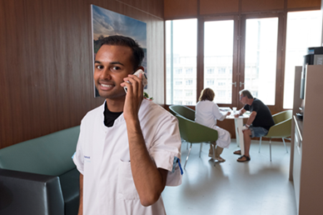 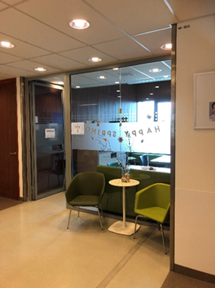

Photo 1 and 2: pantry for mixed use and converted to on-stage break-area

(photo 1: Erasmus MC, photo 2: Van Heel, used with permission of Erasmus MC)

In designing the new hospital, there was a strong focus on patient-centeredness, and here the needs of the HCW were not recognized to the same extent. This reflects the dominant discourse at the time when the hospital design principles were decided upon. These design principles are at odds with the HCW’s needs to deal with their own privacy and their mental workload, as there was no close-by place for them to have informal encounters with colleagues. They were even using the staircases next to the wards for this purpose. Indeed, as mentioned before, this need was not recognized and accommodated for, therefore impeding transformative change given the IPC-team’s directive that nurses were not to eat ‘on-stage’, with the exception of meals during evening or night shifts. On the one hand, this example shows the interrelatedness of the Bricks and Behavior domains to realize transformative change. However, it also shows that transformative change requires the organization to adapt its behavior once the Bricks have been constrained.

**4. Discussion and conclusion**

A guiding design principle in the development of a new tertiary Dutch hospital is the ambition that, in designing the new hospital, the work processes were also redesigned, as expressed in the phrase of “Working differently”. To ensure transformative change, an extensive process of stakeholder engagement was developed and sustained. In a long lasting process with multiple stakeholders with their own needs and constraints, negotiations, and final decision-making can result in mismatches and may therefore hamper transformative change. Such mismatches are expected to become clear once the hospital has been put into use and daily practices develop. The current study focuses on mismatches, but by and large, the project has been externally evaluated as successful project, and stakeholder engagement has been highlighted as one of its success factors. However, by investigating what mismatches ward managers perceive some 12 months after relocation and evaluating to what extent these mismatches can be understood as reflecting conflicting processes in the domain of construction (Bricks), information/smart technology (to which we refer as Bytes), or working practices (Behavior), this study explored the felt gap between ‘work practice as imagined’ and ‘work practice as done’ (Pomare, 2021). These practices typically reflect decisions originating from a negotiation or trade-off between user needs, as expressed in the different design phases.

The main findings of the current study are twofold. First, transformative change requires an integrative approach to the Bricks and Bytes throughout the whole process of designing, constructing, and putting them into use, with stakeholder engagement as a key element. An important asset of the whole process is that the implementation of Working differently started on time. The EPR/HIS can be considered the backbone of the Working differently approach as it allows HCWs to exchange information independently of their physical location. This is important as one of the drivers for providing 100% single room accommodation is that it allows for a break from traditional ways of working, with all specialties having their own territory with assigned wards supported by central nursing stations. Transformative change was supported by already integrating new elements of the future working process at the wards. This was done at an early stage, allowing for a revision of the EPR/HIS. The current findings suggest that a further revision of the EPR/HIS is important to realize the intended transformative change. Currently, the inability of the EPR/HIS to fully support Working differently, and to allow for a true flexible and shared use of the patient rooms can be a major reason for a rather traditional organization of specialties demarcating their own territories. In the presence of specialist territories, it is unlikely for HCW to cross borders, as all groups maintain their own culture. The report of the ward manager shows that HCW behaviors strengthen the distinct territories. One might argue that the late detailing of the Working differently principle, i.e., only four years before relocation, is key because stakeholder engagement in how to redesign these work processes is then delayed as well. Stakeholder engagement had a strong focus on the Bricks given the emphasis in Table 2 on patient-centeredness in conceptualizing Thinking differently. Both the EPR/HIS and the example of the smart-room display may suggest in hindsight that IT was targeted as the innovative solution to the problems that had to be addressed, at the expense of using stakeholder engagement in the further detailing of what Working differently using IT could be like. An alternative explanation could be that in designing the generic ward, the assumptions that were made about the technological specifications were not closely monitored and addressed in the preparation and implementation phase. An example of the latter would be the expectation that all nurses were to be equipped with a device that could be directly connected to the patient’s device, so that HCW could take over the control of the smart room display if a patient was not capable of doing so himself. Indeed, in a recent scoping review on patients’ and nurses’ experiences in all single occupancy inpatient rooms, IT or communication systems are not at all mentioned (Søndergaard, Beedholm, Kolbæk, & Frederiksen, 2021). One could therefore argue that there is an unmet and urgent need to balance Bricks and Bytes to encourage intended behaviors.

The second major finding is that in designing the new hospital, HCW behavior was not well addressed. As suggested before, to some extent, this might be so because the dominant discourse emphasized the importance of a healing environment and highlighted patient-centeredness as a common ground in hospital design (Bromley, 2012; Fix et al., 2018). Alternatively, it may also reflect that many professional stakeholders have a background in technology and engineering, and were trained to consider behavior as the result of a rational process that can be shaped by Bricks and Bytes. However, trans- formative change does not qualify as a rational process. Especially in healthcare the complexity and related uncertainty for individual actors in transformative change comes with ‘messiness’ and room must be allowed for adaptive actions alongside intentional approaches (Khan et al, 2018). To reach a state of ‘mental ownership’ of the new ward environment HCW will want to adapt their work environment to better suit their needs. From the interviews it became clear that HCW were dissatisfied with the lack of (on-stage) space to withdraw within the ward. Meanwhile, the nearby designated areas for patients and relatives are not used to their full potential. Since the organization enforced a guarded policy on HCW not to use these designated patient areas, these areas that could be used to support HCW in their work by offering spaces for informal communications and respite, are now hardly used at all. However, over time, HCW started to claim these spaces while acknowledging the discomfort of the mixed usage of the pantry: “*But then it is awkward if a patient comes in to get a coffee, or a patient is sitting there and three nurses and three juniors come in with their lunchboxes”.* Some wards still allow this mixed usage, with the awkwardness attached, while in other wards the pantry has been repurposed as a formal break area for HCW, and a glass partition has been installed to provide some acoustic privacy.

To achieve transformative change, it is important to strike a balance between the needs of patients and HCW. This evaluation might provide leads to reassign the use of parts of the building. In a related study regarding the flexibility of hospitals during the pandemic, we found that the adaptability of HCW might be a major factor determining whether designed-in flexibility can be used to its full potential (Van Heel, Pretelt, Herweijer & Van Oel, 2022). However, the pandemic also learned that the adaptability of HCW requires organizations to better cater to their HCW needs. This evaluation adds in that it shows that the designed-in flexibility can also be used to refrain from placing too much emphasis on patient needs at the expense of HCW’s wellbeing.

**Data Availability Statement**

Not applicable.

**Contributor statement**

Both authors contributed to the conceptualization of this paper. The study was developed by LvH and CvO, and supervised by CvO. LvH did the data collection, validation and analysis and wrote the original draft. CvO critically reviewed and edited the paper.

References

1. Barlow, J., Hendy, J., & Tucker, D. A. (2016). Managing major health service and infrastructure transitions: A comparative study of UK, US and Canadian hospitals. World Health Design, 9(1), 8-22.
2. Bromley, E. (2012). "Building patient-centeredness: Hospital design as an interpretive act." Social Science & Medicine 75(6): 1057-1066.
3. De Kok, A. (2016). The new way of working: Bricks, bytes, and behavior. In The impact of ICT on work (pp. 9-40): Springer.
4. Elf, M., Fröst, P., Lindahl, G., & Wijk, H. (2015). Shared decision making in designing new healthcare environments—time to begin improving quality. BMC health services research, 15(1), 114.
5. Fay, L., Carll-White, A., Schadler, A., Isaacs, K. B., & Real, K. (2017). Shifting Landscapes: The Impact of Centralized and Decentralized Nursing Station Models on the Efficiency of Care. HERD: Health Environments Research & Design Journal, 10(5), 80-94. doi:10.1177/1937586717698812
6. Fix, G. M., VanDeusen Lukas, C., Bolton, R. E., Hill, J. N., Mueller, N., LaVela, S. L., & Bokhour, B. G. (2018). Patient‐centred care is a way of doing things: How healthcare employees conceptualize patient‐centred care. Health Expectations, 21(1), 300-307.
7. Flyvbjerg, B. (2017). "Introduction: The iron law of megaproject management." Bent Flyvbjerg: 1-18.
8. Khan, S., Vandermorris, A., Shepherd, J. et al. Embracing uncertainty, managing complexity: applying complexity thinking principles to transformation efforts in healthcare systems. BMC Health Serv Res 18, 192 (2018). https://doi.org/10.1186/s12913-018-2994-0
9. Hamilton, D. K., Orr, R. D., & Raboin, W. E. (2008). Organizational transformation: A model for joint optimization of culture change and evidence-based design. HERD: Health Environments Research & Design Journal, 1(3), 40-60.
10. Pomare, C., Churruca, K., Long, J. C., Ellis, L. A., & Braithwaite, J. (2021). Work-as-Imagined Versus Work-as-Done: The Disconnect Between Policy Expectations and Staff Experiences in Hospital Redevelopment. In Managing Healthcare Organisations in Challenging Policy Contexts (pp. 133-149): Springer.
11. Søndergaard, S. F., Beedholm, K., Kolbæk, R., & Frederiksen, K. (2021). Patients’ and Nurses’ Experiences of All Single-Room Hospital Accommodation: A Scoping Review. HERD: Health Environments Research & Design Journal, 19375867211047548.
12. Tucker, D. A., Hendy, J., & Barlow, J. (2014). When infrastructure transition and work practice redesign collide. Journal of Organizational Change Management, 27(6), 955-972.
13. Voss, A. (2022). BSAC Vanguard Series: The future of infection prevention and control: how COVID is already transforming our approach to antimicrobial resistance. Journal of Antimicrobial Chemotherapy, 77(3), 545-546.
14. Van Heel, L, Pretelt, M., Herweijer, M. & Van Oel, C.J. (2022). Pandemic resilience in Dutch hospitals: flexibility that counts in a crisis. ARCH22 Conference paper, TU Delft OPEN (preprint).
15. Zborowsky, T., & Hellmich, L. B. (2011). Impact of Place on People and Process: The Integration of Research on the Built Environment in the Planning and Design of Critical Care Areas. Critical Care Nursing Quarterly, 34(4), 268-281. doi:10.1097/CNQ.0b013e31822c3831

1. An in-depth study of stakeholder trade-offs encountered around a single design element, the door to the patient room, generating issues with privacy and visibility within this case-study, is to follow.