Type of the Paper: Peer-reviewed Conference Paper / Full Paper

Adapting the ICU Model to Deliver Flexible, Innovative and Personalised Care in a Post-Pandemic Society
Emma Smyth¹,
¹ HDS Architects Ltd; emma.smyth@hdsholdings.com;

(to be completed by the editors)

Names of the Topic editors:

Names of the reviewers:

Journal: The Evolving Scholar
DOI:

Submitted: 01 January 2021
Accepted:
Published:
Citation:

This work is licensed under a Creative Commons Attribution BY license (CC BY).

© 2022 [Name of the authors] published by TU Delft OPEN on behalf of the authors.

Abstract: At the height of the Covid-19 pandemic, healthcare Trusts were stretched to capacity, utilising existing Intensive Care Units (ICU) and general wards to treat severely ill patients in respiratory distress. Current design guidance and healthcare infrastructure has had to accommodate these new needs, with little flexibility within the current system to cope. The pandemic has raised three issues; why are ICU facilities inflexible, a major problem pre- pandemic but compounded by the last 18 months? How can medical advancements still be achieved while addressing the backlog of patient referrals and outpatient procedures? Finally, how fit-for-purpose is our current design guidance legislation? Concentrating on the ICU model, we will question how flexible it can be to meet future patient requirements, including personalised medicine, while maintaining effective isolation within intensive care. Current ICU designs will be evaluated, and hypothetical clinical models for care will be developed for testing and investigation. These are later analysed for suitability, effectiveness and versatility, at clinical and patient level. All findings will inform recommendations for changes to design guidance. We will examine what can be achieved while working outside the constraints of the current clinical model and design guidance. With flexibility at its core, can the current ICU clinical design be updated to allow for the needs of current and future requirements?
Keywords: design guidance; architecture; Intensive care;

1. Introduction
Within healthcare design circles, it is acknowledged that the current NHS estate stock, a high proportion of which was constructed in the 1960-1990s, no longer aligns with current treatment methods and pathways. Some believe that adequate funding is at the core of this, with a mostly reactive approach to building and refurbishment projects and maintenance elsewhere. Writing for the Guardian, Sonia Sodha notes that “painting the health service as inefficient ignores a decade of chronic underfunding” (Sodha, 2021). She goes on to discuss the reasons for why improving the NHS is an uphill struggle; including how the UK spends less per person than comparable countries, how we have fewer doctors and nurses than the OECD average, and that the UK generally has poorer health outcomes on cancer survival and infant mortality. Underfunding, the pattern since 2010, has exacerbated the problem, but it is compounded by out-of-date legislative documentation which is still used to inform the building of new facilitates.
For this paper, we wish to concentrate on the designs for Intensive Care. In 2019/20, the UK had 141,000 overnight general and acute beds, including ICU, with an occupancy of 90.2% (which increased to 95% in winter) (Ewbank, Thompson, McKenna, Anandaciva, & Ward, 2021). This was a reduction of 53% from 299,400 in 1987/88. Many reasons exist to explain this fall; changes in mental health policies, older adult care and greater use of outpatient facilities to name a few. Funding and operational changes aside, design efficiency would allow the available budgets to be most useful and represent improved value for money in that investment. At the core of healthcare design is the statutory guidance notes, in which there are currently no provisions for design flexibility or the future proofing of facilities.

1.1 Current Analysis of the HBNs and HTMs
HTMs (Health Technical Memorandums) and HBNs (Health Building Notes) are recognised as essential sources of vital information, which describe to architects and the design teams what to include within the design, construct or refurbish all types of medical facilities. These guidance collections are taken as a handbook and provide essential technical detail to ensure safe and efficient environments for patients and staff alike.
Firstly, it is worth differentiating between the types of beds available within existing hospitals, and the level of care each patient needs:

Level of Care | Definition | Bed type | Optimum size per bed | Statutory Guidance reference
Level 0 | Normal ward care | Adult Inpatient | 3.6 x 3.7m = 13.3m² | HBN 04-01: Adult In-Patient Facilities
Level 1 – critical care | - Step down from level 2,  - those at risk of their condition deteriorating | Adult Inpatient | 3.6 x 3.7m = 13.3m² | HBN 04-01: Adult In-Patient Facilities
Level 2 – critical care | - Step down from level 3  - requiring more detailed observation  - post-operative  - support for a single failing organ system | High Dependency Care (HDU) | 3.6 x 3.7m = 13.3m² | HBN 04-01: Adult In-Patient Facilities
Level 3 | - advanced respiratory support  - support for more than one organ or system failing  - complex medical cases | Intensive Care (ICU) or  Critical Care (CCU) | 4.8 x 5.2m = 25.6m² | HBN 04-02: Critical Care Units
Other | - Single rooms with ensuite facilities  - specifically excludes isolation wards for cohorting groups of infectious patients and critical care areas. | Adult Inpatient | 3.6 x 3.7m = 13.3m², with the lobby access as optional. | HBN 04-01: Supplement 1: Isolation Facilities for Infectious Patients within Acute Settings.  Refers to HBN 04-01 for room sizes.

Table 1: Comparative Bed Accommodation (Source: compiled from The Kings Fund Critical Care Services report, HBN 04-01, HBN 04-01: supp 1, and HBN 04-02)
It is a common opinion within healthcare design circles that the HBNs and HTMs are outdated, or at best represent a ‘lowest standard to meet’ rather than pushing for design excellence. Some have been reissued in the last few years, though HBN 04-02: Critical Care Units was published in March 2013 and remains unedited. Where notes have been updated, details such as the finishes for a room (smooth, impervious, unjointed etc) have been omitted, which begins to degrade their value as a go-to source of information. The opinion of clinical teams is often that the HBNs don’t consider day to day use of facilities and as a result will change them to suit their own needs for a project to represent how they want their unit to run. The effect is that the current notes appear incomplete, lacking in detail, and lacking in real life experience.
Architects for Health conducted a Round Table survey in 2017, gathering opinions on the relevance of the guidance notes and with a view to reach an industry-wide consensus on a way forward. Many interesting views were expressed, together with a unanimous agreement that continuation of the Guidance Notes is vital. This ensures our future design teams are supplied with the information and advice needed to facilitate well-designed and efficient centres of healthcare into the future – but only so long as they remained relevant to modern and future practice (Architects for Health, 2017).
Updates to the remaining documents, including HBN 04-02, are urgently needed to prevent the notes from becoming further outdated. It is also apparent that when they are reviewed, input should be sought from clinicians, experts, designers, consultants, and policy makers, both from the UK and abroad. Above all, the strategic management of guidance must be impartial and authoritative, whether it is undertaken by a government body a private organisation. It was noted that an official body would bolster international and domestic credibility of the guidance.
Taking the focus back to Intensive Care, the research undertaken as part of this paper seeks to address three main issues: why are ICU facilities inflexible, a major problem pre-pandemic but compounded by the last 24 months? How can medical advancements still be achieved while addressing the backlog of patient referrals and outpatient procedures? Finally, how fit-for-purpose is our current design guidance legislation?
Concentrating on the ICU model and therefore only a selection of the current guidance notes, we will question how flexible it can be to meet future patient requirements, including changing clinical practice and a move towards personalised medicine, while maintaining effective care and/or isolation within ICU.

2.0 Designing to Add Flexibility to Hospital Ward Design
In 2020, the Kings Fund published a report titled Critical Care Services in the English NHS. This showed that there were 156,494 flexible level-2 and level-3 ICU beds available across the UK. It was also found that HDU beds and ICU beds were used interchangeably, though HBN 04-01: Adult Inpatient Facilities, and HBN 04-02: Critical Care Units list these beds having minimum floor areas of 13.3m² and 25.3m² respectively. This does present the question of how ‘flexibility’ is currently defined; as a design intent or in the idea of ‘making do’?
Generally, hospital beds are not made to be used interchangeably, as they are designed to a specific size and with the correct number of power outlets for a particular patient group. Met with increasing bed occupancy in the UK and supply not keeping up with demand, space is also at a premium. As the above illustrations show, a six-bed General Adult In-Patient bed bay is almost half the size of a 4-bed ICU bay, though the general bay requires sanitary facilities whereas the ICU does not. For flexible use, the following criteria must be followed:

- The width of the ICU bay be expanded to comfortably accommodate
two 6-bed bays positioned side-by-side
- Ensuites added for the use of the 6-Bed bays (though evidence suggests
that they will also be used by ICU patients.
- Sufficient electrical provision for additional circuitry, with the
flexibility to commission or decommission it as required. This could be
overcome by using retractable ceiling pendants to power the central
beds, with a demountable partition.

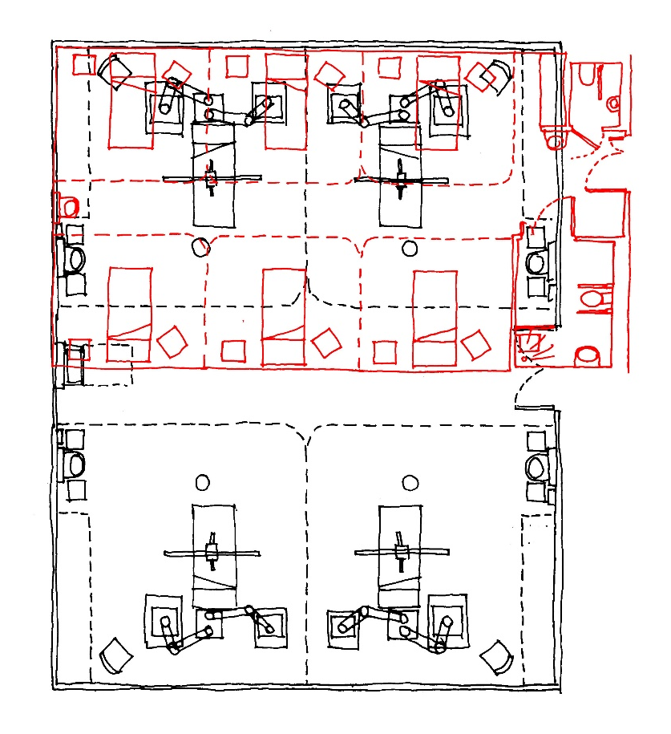
Figure 1: ICU (black) and Adult In-Patient (red) bed bays, overlaid

However, when the same exercise is applied to single side rooms, two General Adult beds will fit into a single ICU side room. As with the higher occupancy bays, the single ICU room would require an ensuite (currently outside the HBN 04-02 brief), and the electrical services for both bed configurations planned and installed in advance. In current times there is a conscious to move towards single bedded care (Wilson, 2017), so if this were encouraged for ICU, it could alleviate non-ICU and non-covid care at other times of the year, such as for winter pressures.

2.1 Designing for future pandemic preparedness and resilience
At the start of the SARS-CoV-2 (Covid-19) pandemic, the NHS and other international healthcare services quickly noted the importance of bolstering existing intensive care facilities to cater for an influx of patients needing critical respiratory care:
“A significant proportion of hospitalised patients with Covid-19 require help with breathing, including mechanical ventilation… The need to avoid critical care units being overwhelmed as Covid-19 cases rise has been cited as a key factor in significant policy decisions, including regional and national ‘lockdowns’.” (The Kings Fund, 2020)
In addition to this, the Centre for Global Development (in association with Metabiota) estimates that the annual probability of a pandemic on the scale of COVID-19 in any given year to be between 2.5-3.3%, which means a 47-57% chance of another global pandemic as deadly as [SARS CoV-2] in the next 25 years (Smitham & Glassman, 2021). The data also shows that the geographical distribution of spillover events, where a virus moves from one species to another, (predominantly occurs within Asia and Saharan/Central Africa (Oppenheim & Stephenson, 2021).
This illustrates how investment into preparedness and resilience is needed within lower-income countries as a first line of defence (against spill-over event pandemics in particular), which will in turn protect the rest of the world. Knowledge learnt in dealing with previous epidemics, such as Mers in 2012, Ebola in 2014 and Zika in 2015, can also be passed to other countries, creating a worldwide preparedness database. Architects for Health stated in their 2017 report, Health Estates and Facilities Guidance Round Table Discussion: Final Report, that official design guidance should be informed by worldwide practice, and that the resultant new guidance should be made freely available worldwide (Architects for Health, 2017). To summarise, the existing issues need to be solved before they are tested again, and with some urgency to preserve momentum.
In response to the Ebola outbreak, and the Zika Virus epidemic, in 2016 NHS England released supplement 1 for HBN 04-01, titled Isolation Facilities for Infectious Patients within Acute Settings. However, this document specifically excludes using the guidance within it for isolation wards or for critical care patients and so only applies to those within levels 0, 1 and 2 (refer to Table 1).
In May 2020, the British Medical Journal published a report How to Rapidly Design and Operationalise PPE Donning and Doffing Areas for a COVID-19 Care Facility. This was the first instance of specific PPE donning and doffing areas being set (Wundavalli, Singh, Singh, & Satpathy, 2021), despite it already being in practice within hospitals across the globe in response to country-specific practices or previous outbreaks of disease. The design and location of these rooms are still not contained within any officially published design guidance note published by the UK Department for Health.

2.3 The Evolution of Care Within ICU
It is anticipated that the ICUs of the future will contain a larger percentage of hospital beds. This is due to a shift in the location of treatment for less seriously ill patients, either to home or other community environments (Zimmerman, 2019) and changing patterns in treatment. In the immediate term, the capacity of ICU will be adapting to an increased demand for services as people live longer and with multi morbidities, coupled with the economic pressures of keeping up with expected levels of efficiency and new innovations. “The future ICU will see changes in form, function, staff and patients”, remarks Zimmerman.
Longer term, technologies that aid in faster treatment, early diagnosis, and in some cases, prevention, should decrease the number of ICU admissions. Consequently, the type of patient needing ICU care will have more complex problems and be harder to treat, which will in turn shift the focus of critical care. If staffing levels are also not addressed, we may also see the role of a patient’s family becoming more involved in their care.
“Precision medicine for patient care is the goal of the future ICU—tailoring therapy for conditions based on individual characteristics, risk profile or genetic markers” (Zimmerman, 2019) - a sentiment echoed by Smyth in her paper Pharmacogenetics and Architecture (Smyth E. , 2018). Design guidance and clinical protocols will both require the ability to adapt to defined patient groups.

2.3.1 Designing for the Future: Family care within ICU
The typical aim of ICU is to protect a patient from infections and stress, to enable them to recover. Restricting visiting hours also protects staff access to patients, allowing them to undertake their role and care on an hour-by-hour basis. Patient-and Family-Centred Care (PFCC) models try to address the balance between infection, stress and attention. The AMA Journal of Ethics describes how PFCC models shifts the emphasis of care from a clinician-led system to a joint effort between clinicians and patients’ relatives.
Pikka Lam and Marcia Beaulieu note in their study Experiences of Families in the Neurological ICU: A ‘Beside Phenomenon’ that an ICU that invites family presence and participation fulfils many important social, emotional, and informational needs, both for the patient and their relatives (Lam & Beaulieu, 2004). Anxiety is reduced for the family and stress hormones are reduced for the patient (Cox, 2022). Likewise, when patients are unable to speak for themselves, family members often represent a key decision maker, being familiar with the cultural and religious beliefs of the patient, which can greatly influence clinical outcomes (AACN, 2016). Ongoing communication of important information, such as medical histories and changes in patients’ conditions, can play a key role in safe and effective care delivery (Hua, Becker, Wurmser, Bliss-Holtz, & Hedges, 2012).
However, the adoption of a PFCC must also be met with caution. The presence of families within ICU can present problems for staff, who must suddenly navigate increased scrutiny, inevitable questions, and a complex array of interpersonal, social and cultural hurdles while at the bedside (AACN, 2016). There is an increased risk of stress within nursing teams as they grapple with the increased responsibility, and cases in the USA where particular patients (such as those with complex neurological or coronary needs) needing additional safeguarding, despite families acting in what they believe to be best intentions (Rippin, Zimring, Samuels, & Denham, 2015).
Clinicians appear to be divided on the suitability of Patient-and Family-Centred Care models, with some staff preferring them and others actively disliking them. The decisions made by staff are routinely questioned, occasionally resulting in stories within the media on families taking their loved ones elsewhere for a more preferential (and often experimental or not approved within the UK) treatment plan.
The design of the ICU ward can also restrict the implementation of PFCC models, mostly due to available space. A standard ICU side room is 25.6m², which is appropriately sized for the monitoring and treatment equipment needed for the patient. Additional space for the use of families is often not available, or comes at the cost of a unit having less patient beds available in order to create space for families. Clinical teams will find their privacy interrupted, and their work could be disrupted more frequently when making notes, even when their attention isn’t on the direct family member. The AMA Journal concludes that “switching from a clinician-centred model to a PFCC model requires organizations and clinicians to trade the benefits of one model for the benefits of the other.” (Rippin MS, 2016).
Primarily, staffing levels at some Trusts are forcing the subject of implementing a Patient-and Family-Centred Care model as a temporary answer to alleviate pressures. However, the shortage of space within the current ICU footprint is not considered (in many places, even staff have insufficient space for changing and breaks), and the department ‘makes do’ with the situation they have.
The example schedule of accommodation contained within HBN 04-02: Critical Care Units itemises four single side rooms, which are 26m² each, and no ensuite facilities. There is one Assisted Shower room (at 8m²) for the ward, and one wheelchair Accessible WC for the use of visitors. US parents cite spatial limitations and a lack of facilities as the reason they visit their children in hospital less (JBI Library, n.d), so it seems straightforward to add an additional floor area to some (rather than all) of the individual side rooms, together with an ensuite. If two of the four rooms were enhanced in this way, it would not only accommodate Patient-and Family-Centred Care, but also the requirements of personalised medicine discussed previously.

2.3.2 Designing for the Future: Personalised Medicine
Personalised medicine is widely considered to be the next disruptive technology within healthcare and will see a shift from a traditional trial-and-error (albeit informed by extensive experience) with genetically influenced treatment paths (Smyth E. , 2018).
In December 2018, the NHS completed the 100,000 Genomes Project, the first of it’s kind in the world. The aim of the project was to better understand how genes play a role in the treatment of many diseases, including rare diseases. The NHS wishes to deliver the four Ps:
- Prediction and Prevention of disease
- More Precise diagnoses
- Personalised and targeted interventions
- A more Participatory role for patients (NHS, no date)

Types of personalised or precision medicine include:
- Pharmacogenetics: using genetic markers to predict the metabolic rate of a patient, and therefore the efficacy of a particular drug It will improve drug safety, tailor treatments to meet the needs of patients’ genetic disposition, improve proof of principle for efficacy trials, and improve drug discovery.
- Chimeric Antigen Receptor (CAR) T-Cell Therapy, a treatment for blood cancers which uses the patient’s own white cells as a vehicle for modified T-cells, tailored to the particular cancer type. Successes have been seen in almost all patients, and with between 30-40% of patients entering lasting remission, with no additional treatment within the following three-year period (Bishop, 2019).
- Use of artificial intelligence and machine learning. This has two strands:
- Working beyond traditional symptom-based
diagnoses by looking for genetic markers
- Utilising image processing to improve the
accuracy and speed of a diagnosis (Ahmed, 2020). There are some fields where this is highly beneficial, such as radiology, but others with less success.

Currently, most available personalised medicine options are targeted at oncology but there are ongoing studies into cardiovascular, mental health, cystic fibrosis and familial disorders and diseases which will prove fruitful in the future.
Many, if not all the procedural personalised medicine treatment methods require the use of isolation facilities due to immunosuppression, and the use of intensive care in case of an adverse reaction. Taking CAR T-Cell therapy as an example, the risk of an adverse reaction is low as the reinfused blood and engineered white blood cells originate from the patient, but in some US-based cases patients have developed cytokine release syndrome. Serious side effects of this release can include very high fevers and dangerously low blood pressure in the days after treatment is given (Kochenderfer & Brudno, 2016). Other serious side effects have included neurotoxicity, or changes in the brain that causes severe headaches, swelling, confusion or seizures. The result is that during the final stages of treatment, the patient must be admitted as an inpatient and carefully monitored, preferably within intensive care.
The idea of designing ICU to be capable of procedures informed by personalised medicine should be one that gains traction when the current design guidance is reviewed. Its importance is already apparent, and as a future proofing exercise it should be a consideration within the design of all new healthcare spaces, including but not limited to intensive care units.

3.0 Research Results: How does this Translate into Legislative Change?
We have discussed the requirements of designing flexibly, for future emergency preparedness, and for changing methods of ICU care. On future projects, we will begin to look at how this translates into changes in design guidance.
Firstly, current UK design guidance for ICU facilities does not assume a patient is ambulatory so this creates an ideal initial update. Staying with the CAR T-Cell therapy as an example of personalised medicine occurring within an IUC setting, this already represents a deviation from our current standards for clinical design. The patient may need intensive care if adverse side effects occur, but in the meantime, they require stimulation, sanitary facilities, and access to supporting patient spaces that a traditional ICU patient would not ordinarily use (Smyth E. K., 2020). Units where Patient-and Family-Centred Care (PFCC) models is encouraged also need additional space and sanitary facilities.
Below is an example of a refurbishment project from a UK hospital Trust; two of the four side rooms are larger than the guidance stipulates, and one has an ensuite. This represents options for the use of these rooms, facilitating moves towards personalised medicine and PFCC in the future.
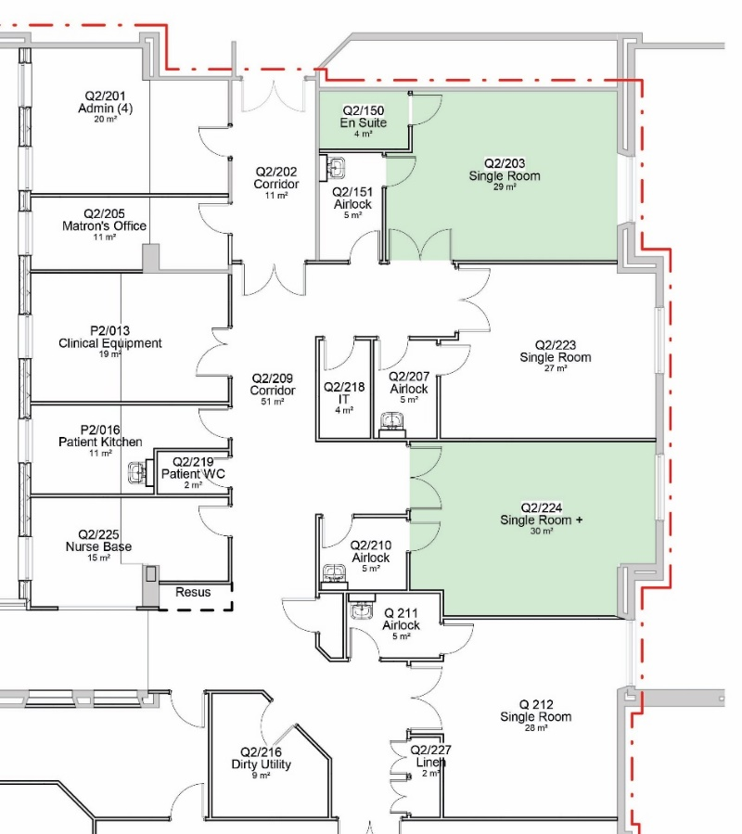

Figure 2: Additional Facilities within Single Side Rooms to allow for PFCC. Note the inclusion of an Ensuite to one room and oversizing the footprint of others. (Source: HDS Architects)

We have also sought to adjust the footprint of new wards in order to allow for future conversion, as discussed in section 2.0, however this is more easily achieved within new build schemes. We are looking to include larger single side rooms, sized and serviced for an ICU patient initially, with the future option of expanding this for two general adult inpatients, and supplying an ensuite. This actually satisfies both the changing ICU care models angle, and design flexibility; an ensuite to an ICU side room which can be converted into general beds to increase bed numbers during times of pressure.
If the design guidance notes were to include illustrated examples of flexible design, it would be more readily adopted into new projects. The notes could also be updated to reflect additional space allowances, and to permit a mirroring of bed-head services within the ‘expanded’ scenario if that method were adopted (unless alternative power provisions were installed to ensure bedhead services remained identical). Designing additional accommodation or at a slightly different size would be project dependant, but with evidence-based design guidance, these changes are easier to implement.

4.0 Designing for the Future: Covid-19 and Other Infectious Diseases
How can infectious patients be treated within ICU, while taking all necessary steps to ensure that infection is controlled, and risks of contamination are minimised? Following discissions with a lotal NHS Trust, we were appointed to answer this with a ward refurbishment scheme.
Initially, we began with a plan we were familiar with; the standard 4-Bed ICU bed bay (as defined within HBN 04-02: Intensive Care Units). Airflow requirements were added on a room-by-room basis, which was then interpreted into positive and negative pressure differentials between areas with the aim of purging or protecting certain spaces, and in certain directions. Alongside, we applied the notes within supplement 1, which added the two lobbies, and personal experience led us to also add a store and an airlock (likening the multibed bay to the single side room within HBN 04-01).
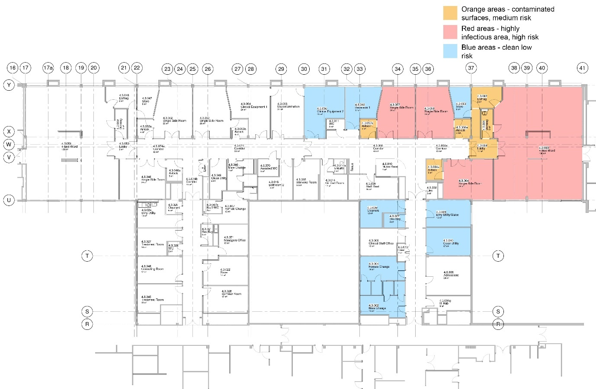
The area contained within the four-bed ward is now defined as a ‘red’ area, with the donning and doffing lobbies as ‘orange’; in these spaces, PPE is applied or removed, taking a person from ‘green to red’, or ‘red to green’.
Figure 3: Half Department Isolation, up to 7no. Isolation beds with separate Utilities, Staff Change, Clinical Stores and Assisted Bathroom within the red area, leaving the rest of the department as non-isolation. (Source: HDS Architects)
On presenting the scheme to the clinical team, they requested a Dirty Utility, Disposal Hold and Cleaner’s Store within the ‘red’ area. This upgraded what was originally a multi-bed bay with designated entrances into a specific area contained within a ‘red’ zone. The theory behind this was that waste from a red patient, be it dressings, other disposables, or bed linen, is also infectious, and for staff to effectively undertake their roles it was necessary to access other ancillary rooms without the need to don and doff PPE repeatedly.
The disadvantage here is that this layout assumes that there is a maximum of four infectious patients at one time, and that they also all have the same infection. We expanded the scheme further to allow any combination of one, two or three single side rooms (also isolation rooms with airlock entries) to be used, either alongside or instead of the multi-bed bay. The result was that the ward could accommodate any number between one and seven ‘red’ patients, at which point half of the ward would be ‘red’ rather than green’, while the remaining half remained ‘green’.
Mechanically, the strategy relies on airtightness being achieved between all individual red, yellow and adjacent rooms to preserve pressure differentials and ensure air movement in the correct directions. The airlock into the multi-bed bay needs 60 air changes per hour and a 60 second time delay between each door opening. Operationally, porters would deliver a bedded patient to the airlock and retreat, then donned staff would collect them once the minute had passed. This was so that the air within the lobby would be entirely refreshed between exit or entrance, whereby preventing the spread of contaminated air in each direction. The same was not applied to the Donning and Doffing lobbies as it was deemed the activities in these rooms would take longer than the required air change time (Lenoir, 2021).
To date, no guidance exists on the airflow requirements for donning and doffing lobbies, nor for infectious patient wards. Therefore, the mechanical engineer implemented the requirements for operating theatres, as stipulated within HTM 03-01: Specialised Ventilation for Healthcare Buildings, as is requires more air changes in pursuance of infection control.
It is also worth noting that there is a duty of care to all patients in both directions; not only must the infectious contents of the multi-bed bay be kept within that area, protecting patients in other areas from infection, but also in preventing another illness (such as norovirus) from infecting patients already confined to the infectious patients’ ward.
To summarise; here we have designed an infectious patients ward for up to four patients, complete with donning, doffing, storage and an entry lobby. This ward keeps the patients within it isolated from the rest of the hospital, preventing the spread of infection, but also isolated away from other infections that may be circulating within the main ward, such as norovirus. In addition, we have also designed the ward to accommodate additional isolated patients within singe side rooms, so that up to half of the whole ward can be designated ‘red’ while the other half remains ‘green’.

5.0 Conclusion
This paper seeks to examine how the future of Intensive Care is evolving with time, and how the statutory design guidance should change. We asked what can be achieved while working outside the constraints of the current clinical model and design guidance.
We have discussed the needs of designing for infectious patients following the effects of the SARS CoV-2 (Covid-19) pandemic, and where the HBNs and HTMs need to provide clarity on the design of these spaces so that new and refurbished ICU wards are prepared for the future. While Covid-19 is still a major part of day-to-day life, this appears to be one of the most important updates that can be made, but careful detail is needed to ensure that the resultant facilities perform as expected. The ventilation strategy in particular is important, and staff will require sufficient training on why it is designed in this way to understand how it supports them.
The ICU of the future will continue to facilitate the high quality and specialised care of patients, but the configuration of the facility will change to support future technological and operational changes. The simple additions of an ensuite and greater floor area to some rooms will make personalised and family centred care more practical, and is very easy to achieve.
The physical ICU environment of the future must promote a healing environment for patients, families, visitors and ICU staff (Zimmerman, 2019), and must be a flexible environment with built-in adaptability for technological advances. Recent changes made to the HBNs that omitted material considerations should be reversed, as these environmental and building fabric items can inform and confirm multiple uses for one room. The correct material selection for rooms will reduce noise and environmental stresses, minimise the potential for error in care, decrease infection risk and can provide subconscious comfort for families and visitors. Cohorting critically ill patients with the same infectious disease in a defined, carefully designed ICU area will be combined with using these spaces as a standard ICU, ensuring that no bed is left unused but insuring against the risk of future pandemics.
Non-ICU staff and the families of patients will be progressively involved in patient care, and it would be wise to consider the design requirements of this now. “Patient-centred care will continue to drive operational change in the future” (Zimmerman, 2019)
Technology will be the most constantly changing variable in future ICUs that will affect the environment, patients, and staff (Thompson DR, 2012). Including factors for enabling this, especially where the basic requirement is to add more space and an ensuite to a single side room, is straightforward. The guidance notes should contain the option for its inclusion to ensure facilities are ready for technologically advanced methods of care before they occur.
To conclude, the guidance notes form a vital tool in the design of healthcare premises around the world. They should be informed by worldwide practice and be available for anyone to use and include clear and precise information. There should be no place for ambiguity within the design notes, and so interpretations should be clear with any consequential risks identified and mitigated. An effective collection of design guidance notes for healthcare premises will ensure that standards are not only met, but they are maintained, exceeded, and prioritised within future projects.

References
- AACN. (2016). Family Presence During Resuscitation and Invasive Procedures. American Association of Critical Care Nurses.
- Ahmed, Z. (2020). The Future of Precision Medicine. Rutgers / The State University of New Jersey.
- Architects for Health. (2017). Health Estates and Facilities Guidance Round Table Discussion: Final Report. London.
- Bishop, M. (2019, October 17). UChicago Medicine. Retrieved from Three years after CAR T-cell therapy for lymphoma, patient still cancer-free: https://bit.ly/39a502e
- Cox, J. (2022). unpublished.
- Department of Health. (2021). Health Building Note 04-01: supplement 1. Retrieved from NHS England.
- Department of Health. (2021). Health Technical Memorandum 04-01: Adult In-Patient Facilities. Retrieved from NHS England.
- Department of Health. (2021). Specialised Ventilation for Healthcare Buildings. Retrieved from NHS England.
- Department of Health,. (2021). Health Technical Memorandum 04-02: Critical Care. Retrieved from NHS England.
- Ewbank, L., Thompson, J., McKenna, H., Anandaciva, S., & Ward, D. (2021). NHS hospital bed numbers: past, present, future. London: The King's Fund.
- Hua, Y., Becker, F., Wurmser, T., Bliss-Holtz, J., & Hedges, C. (2012). Effects of Nursing Unit Spatial Layout on Nursing Team Communication Patterns, Quality of Care, and Patient Safety. SAGE Journals.
- JBI Library. (n.d). Family-centred care for hospitalised children aged 0-12 Years: A systematic review of quasi-experimental studies. JBI Library of Systematic Reviews, Volume 9 - Issue 16 - p 1-18.
- Kochenderfer, J., & Brudno, J. (2016). Toxicities of chimeric antigen receptor T cells: recognition and management. Retrieved from ASH Publications: https://bit.ly/3Lu81bT
- Lam, P., & Beaulieu, M. (2004). Experiences of Families in the Neurological ICU: A ‘Beside Phenomenon’. ProQuest.
- Lenoir, T. (2021, Oct). Proposed Mechanical Design. Mechanical Design Strategy. Eastbourne: Avinny Consulting Engineers.
- Metabiota. (2021). Human Epidemic Database.
- NHS. (no date). Personalised Medicine. Retrieved from NHS England: https://www.england.nhs.uk/healthcare-science/personalisedmedicine/
- Oppenheim, B., & Stephenson, N. (2021). A Global Deal for our Pandemic Age: Report of the G20 High Level Independent Panel on Financing the Global Commons for Pandemic Preparedness and Response.
- Rippin MS, A. (2016). Evidence-Based Design: Structuring Patient- and Family-Centered ICU Care. AMA Journal of Ethics.
- Rippin, A., Zimring, C., Samuels, O., & Denham, M. (2015). Finding a middle ground: exploring the impact of patient- and family-centred design on nurse-family interactions in the neuro ICU. SAGE Journals.
- Smitham, E., & Glassman, A. (2021, August 21). The Next Pandemic Could Come Soon and Be Deadlier. Retrieved from Centre for Global Development: https://bit.ly/3LsyvLa
- Smyth, E. (2018). Pharmacogenetics and Architecture. European Healthcare Design Congress. London: SALUS Global.
- Smyth, E. K. (2020). Advancing Technology vs. Architectural and Environmental Design. European Healthcare Design Congress. London: SALUS Global.
- Sodha, S. (2021, Dec). A Dangerous Lie is Stalking the NHS; That it is no longer fit for Purpose. Retrieved from The Guardian: https://bit.ly/3MURzCb
- The Kings Fund. (2020). Critical care services in the English NHS. London.
- Thompson DR, H. D. (2012). Guidelines for intensive care unit design. Society of Critical Care Medicine.
- Wilson, R. (2017, 05 02). How hospital design is being shaped by the trend for single-person rooms. Retrieved from Architects Journal: https://www.architectsjournal.co.uk/buildings/how-hospital-design-is-being-shaped-by-the-trend-for-single-person-rooms
- Wundavalli, L., Singh, S., Singh, A. R., & Satpathy, S. (2021). How to rapidly design and Operationalise PPE Donning and Doffin Areas for a Covid-19 Care Facility. BMJ.
- Zimmerman, J. (2019, November). What is the future of ICUs? Retrieved from National Library of Medicine: https://bit.ly/3vTrNXM

A UK-based organisation of health designers and professionals
This could be as straightforward as over-specifying the ICU pendants to power each bed and positioning them appropriately. However, this also presents a derogation from the standard, as the HBN stipulates for beds to be handed identically, whereas in this scenario they would be mirrored.
whose primary aim is to predict pandemics, build resilience and protect global health
such as the current coronavirus, SARS-CoV-2, which **+transmitted from bats to humans)
A project to sequence 1000,000 genomes from 85,000 patients who are affected by rare diseases or cancer. 18.5% of the data have so far been turned into actionable findings.
A sensible precaution still used while the techniques are still being explored and developed
As cells multiply, massive amounts of cytokines are released into the blood, which can be toxic
A covid-driven interpretation of the document NHS Improvement: Rapid Improvement Guide to Red and Green Bed Days, first published 2016. Both red and green patients are receiving hospital-based care, but a red patient is not progressing towards discharge, and a green patient is.

