Type of the Paper: Peer-reviewed Conference Paper / Full Paper
Track title: Inclusive Design / Health Promotion

UrbanCare Sahlgrenska, a hospital landscape co-creation case to integrate sustainable development goals Alvaro Valera Sosa ^{1,2}* and Göran Lindahl ³
¹ Division of Design & Building Science; Technische Universität Berlin, Germany
² Research & Technical Development; BHL Building Health Lab, Germany; a.valera.sosa@buildinghealth.eu; https://orcid.org/0000-0001-7662-4459
³ Division Building Design, Architecture and Civil Engineering; Chalmers University of Technology, Sweden
https://orcid.org/0000-0003-0007-7270
Names of the Topic editors:
Clarine van Oel
Names of the reviewers:
Clarine van Oel
Journal: The Evolving Scholar
DOI:10.24404/62c4ac18e37b1e1aef408269

Submitted: 1 August 2022
Accepted: 22 August 2022
Published: 9 January 2024
Citation: Valera Sosa, A. & Lindahl, G. (2022). UrbanCare Sahlgrenska, a hospital landscape co-creation case to integrate sustainable development goals [preprint]. The Evolving Scholar | ARCH22.

This work is licensed under a Creative Commons Attribution BY-ND license (CC BY-ND).

© 2022 [Valera Sosa, A. & Lindahl, G.] published by TU Delft OPEN on behalf of the authors.

Abstract:
In planning an urban hospital, the complex priority-setting of goals often neglects how landscape designs impact ecosystem quality and threaten public health. As a result, the difficulty of counteracting the urban heat island effects and reaching sustainable development goals on time exponentially increases. In this context, a research workshop conducted with facility managers, planners, designers, and various groups of hospital users helped to analyze and propose actions to solve climate and health environmental issues for the future redevelopment of the Sahlgrenska University Hospital campus. The groups participated in community-led research and applied landscape planning tools to visualize and problem-solve climate, energy, and urban environmental health issues that affect outdoor campus users and pedestrians. This research is an illustrative case study that depicts the methods employed in the four-session research workshop and the development of its results on (i) visualizing the street environment and spatial inequities in urban scenes, (ii) reviewing heat, runoff, and biotope data at the pedestrian level, (iii) applying prioritized planning at critical urban scenes, and (iv) proposing spatial design solutions centered on vulnerable hospital outdoor users. The results are descriptions of the group dynamics and their outputs on how public transportation stops, street crossings, free-seating areas, and spaces at building entrances affect the local urban ecosystem, the energy balance of buildings, and the mobility of vulnerable pedestrians, including outdoor workers.
Keywords: urban health; capacity building; research workshops; integrated urban planning; green hospitals

1. Introduction
As cities around the globe grow, congestion and environmental degradation also increase. Sealed pavements taking over green soils result in rainwater runoff and hazardous urban heat spots that impact soil, water, and air quality. Among these, streets have historically formed impervious layers, disrupting hydrological cycles and requiring expensive stormwater infrastructure to manage stormwater runoff and protect ground and surface water quality (National Association of City Transportation Officials, 2021). The consequence is environmental degradation capable of destroying local ecosystems, habitats, wildlife, and our health (WHO, 2015).
Hospitals add to this urban health problem as a significant contributor to environmental degradation. In perspective, the entire health sector is above emissions compared to the air traffic and shipping sectors, with a production of 4.4% of global greenhouse gases such as CO₂ (HCWH, 2021). Within the sector, hospitals are the main contributor to the high economic impacts and economic costs to society (Keller et al., 2021). It becomes a priority for hospital planners and developers to act on reducing greenhouse gas emissions by also reducing factors contributing to urban heat islands (Chen & You, 2019) and their effects on people.

The Sahlgrenska University Hospital campus in Gothenburg has an urban proposal for 2023 that will connect the University Hospital campus through buildings and footbridges with the University of Gothenburg. The aim is to offer a more social and safer environment to the community (Sahlgrenska, 2021). At this site in the summer of 2021, a field survey using UrbanCare assessment tools collected data on heat spots, surface runoff, and biotope loss; three environmental degradation processes that decrease water, soil, and air quality (Building Health Lab, 2021a). Its online visualization tool made the data available for urban development stakeholders to assess possible impacts on the local climate, the energy balance of buildings, and the health of vulnerable hospital outdoor users such as children, the elderly, patients and their caregivers (Building Health Lab, 2021b).
The field survey includes the hospital’s recently renewed plaza, the Blä sträket (Blue Line). It shows a pedestrian space with hard surfaces that increase rainwater runoff, decrease biotope levels, and generate a persistent heat spot where the most visited buildings and seating areas are. Altogether, the urban scene indicates a poor ecosystem service to the community that might also reduce the users’ quality experience. However, this is inconclusive without spatial assessments from the hospital’s outdoor users, who need to be informed about environmental stressors and their impacts on climate and health.
Capacity building in urban research for hospital development needs to be built out for all types of stakeholders to jointly battle urban degradation processes and integrate sustainable development goals into plans. Informed decision-making can accelerate by enhancing problem-solving skills and applying integrated planning to co-create climate change adaptation and mitigation strategies through community-led research and innovation (International Accountability Project, 2018; Milojević, 2018).

A research workshop realized at Chalmers University in early 2022 used UrbanCare methods and tools to investigate urban climate, energy, and health issues and propose spatial solutions at the pedestrian level. Facility managers, planners, designers, and various groups of hospital users were among the 43 workshop participants that applied community-led research and urban integrated planning strategies.
This case study aims to describe how the participants grasp and apply novel urban planning tools for sustainable development and public health and to what extent the outputs integrate sustainable development goals related to climate, energy, and health.

2. Theories and Methods
The purpose of structuring this case study is to give insight on how to tap into local knowledge for developing co-creation approaches (Tan et al., 2019) with systems thinking. It aims to strengthen transdisciplinary techniques and skills to collaboratively work on problems societies face (Grohs et al., 2018), such as the current climate and health twin crises.
With an illustrative case study approach, this section explains (i) the research workshop conceptual framework, (ii) its structure and tools, (iii) the process with problem-solving tasks delivered to participants, and (iv) the knowledge check on the participant outputs. Steps, previous research, and resources required for preparing the workshop are not part of the aim and are, therefore, excluded from this study.

(i) Workshop conceptual framework
The UrbanCare methodology used in the workshop is primarily for capacity building at higher education institutes. It employs a mixed methods design to gather and use urban ecosystem data at the street level to develop evidence-based spatial actions that improve climate and energy outcomes while building pedestrian health (Valera Sosa, 2021). The methodology stems from a conceptual framework of four pillars: (i) walkability, (ii) urban climate, (iii) energy balance, and (iv) public health that improves urban health (Urban Health, 2021).
(i) Walkability measurements are based on density maps of specific urban functions and networks of walkways using open-source data. Density values interpolate point data (priority destinations) and polygons (pedestrian infrastructure) using Line Density tools in GIS (Telega et al., 2021). (ii) Urban climate focuses on the relation of landscapes with microclimates (Gkatsopoulus, 2017) and its mitigation properties on environmental stressors. (iii) Energy balance is about urban planning and regenerative landscape design (Everard, 2021) for this study to improve the energy balance of hospital buildings (Shen et al., 2019), specifically non-operational energy consumption (Teke, 2015). (iv) The public health aspect centers on ecosystem degradation mechanisms and their relation to human health. Specifically, the rise in cities of allergies, heat strokes, inflammatory diseases, auto-immune diseases (Flies et al., 2019), cardiovascular diseases, kidney failure, respiratory problems, metabolic disorders, and other health conditions affecting the elderly, children, socially isolated groups or individuals, and outdoor workers (Paravantis et al., 2017).
The workshop design makes the conceptual framework practical with Pedestrian Loops. Using Google Maps, the study site is defined with priority destinations identified and mapped (points) within a 1 km radius. Walkways and sidewalks (lines) connecting the priority destinations render GIS units called “Pedestrian Loops”, or theoretical continuous walkways within neighborhoods, within reach for people to do daily errands and other activities safely from street threats.
The loops are composed of streetscape sections or urban scenes that are used as templates to fill in the data from the field surveys (Figure 1).

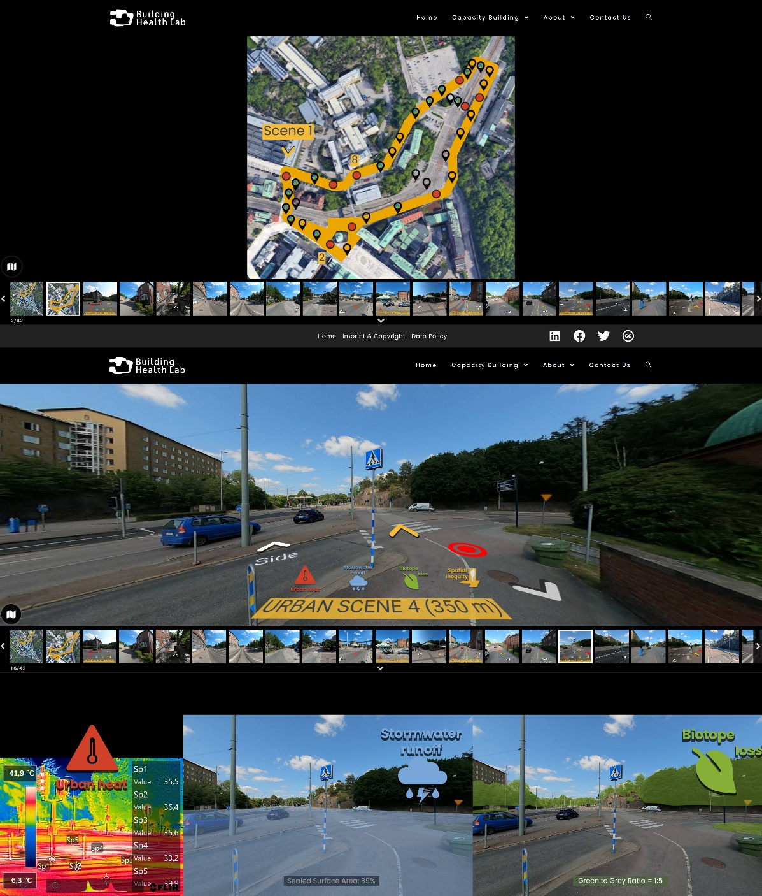
Figure 1. The Data Viewer for individual navigation of the Pedestrian Loops. Row 1: Satellite View of Pedestrian Loop 1 with clickable pins to its urban scenes; Row 2: Pedestrian View of an urban scene with clickable icons to environmental data; Row 3: environmental data of the urban scene.
(ii) Workshop structure and tools
The workshop structure has three main parts. First, an online input lecture introduces the pedestrian health concept and describes its risk factors from spatial inequities in streetscapes and urban ecosystem degeneration mechanisms. Second, a guided walk is offered at the site to visit short segments of the pedestrian loops and some of its four walkway connectors: spaces close to building entrances, seating areas, street crossings, and public transportation stops. The third is executing the workshop's four sessions (Table 1).
Table 1. UrbanCare Workshop session objectives and deliverables
Sessions | Objectives | Deliverables
S1: Gap Finder | Identify urban scenes that hinder active travel. | Hand-written and online survey replies.
S2: Diagnostics | Describe for the scenes selected the urban ecosystem degeneration mechanisms present and how they affect human health. | Selection of the most critical urban scene in each pedestrian loop.
S3: Planning | Gather information on Policies, Technical Resources, and Economic resources available for climate and health spatial projects. | Written comments on each domain.
S4: Design | Communicate visually the urban issues found and possible solutions addressing vulnerable hospital outdoor users. | Conceptual sketches and drawings.  Presentation of the sketches including session 3 comments.

Analog and digital tools are available for the workshop participants to help produce the deliverables. The designs of both sets offer infographics with the data gathered in the field surveys.
The analog interface includes four card sets (Figure 2), surveys, and other didactic materials arranged over a pedestrian loop board (Figure 3). Persona cards express the gait conditions and mobility needs of vulnerable outdoor users. Pedestrian challenge cards instruct the participant on where to locate pathway street connectors and rate their level of convenience, safety, comfort, and attractiveness (Speck, 2018). Eco killer cards provide definitions and terminology used in both versions of the Data Viewer. The pedestrian disease cards offer short descriptions of urban-associated diseases.
The digital interface is UrbanCare Data Viewer, a web-based immersive journey for citizens and other stakeholders to navigate urban scenes, such as Google Streets, but from a pedestrian perspective instead of a vehicle perspective. It shows 360° urban scene images with clickable icons for urban heat, surface runoff, and biotope loss that display climate-related infographics to help participants understand the possible environmental impacts on pedestrians (Figure 1). A fourth clickable opens an online survey for participants to rate the environmental conditions of walkway connectors in pedestrian loops.

(iii) Workshop process
A principal investigator and two assistants conducted the research workshop.
First, the principal investigator gave the 43 participants of the workshop an online input lecture to introduce the concept of pedestrian health and describe its risk factors from spatial inequities in streetscapes and urban ecosystem degeneration mechanisms.
Secondly, workshop participants had a guided walk on the site to visit short segments of the three pedestrian loops and some of its four walkway connectors: spaces close to building entrances, seating areas, street crossings, and public transportation stops.

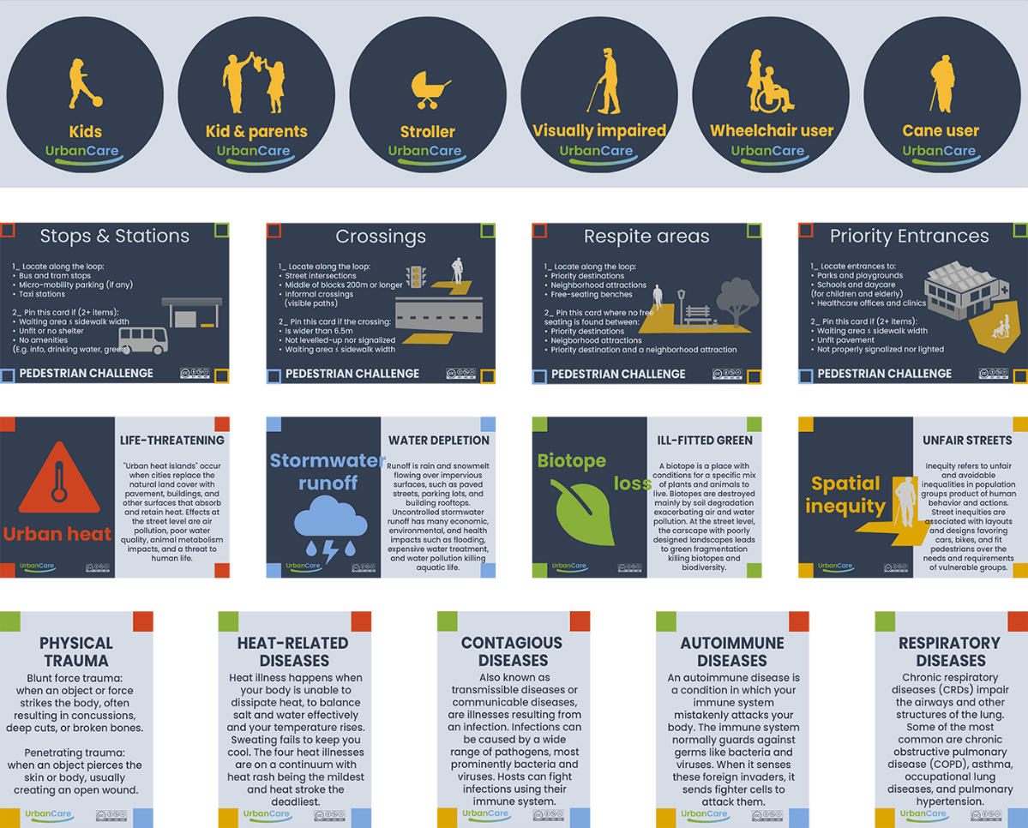
Figure 2. UrbanCare Cards for group tasks at the Working Table. Row 1: Persona cards; Row 2: Pedestrian challenge cards; Row 3: Eco-killer cards; Row 4: Pedestrian disease cards. Each pedestrian loop board has a satellite image of the loop to be analyzed and space to place the cards and other workshop materials.
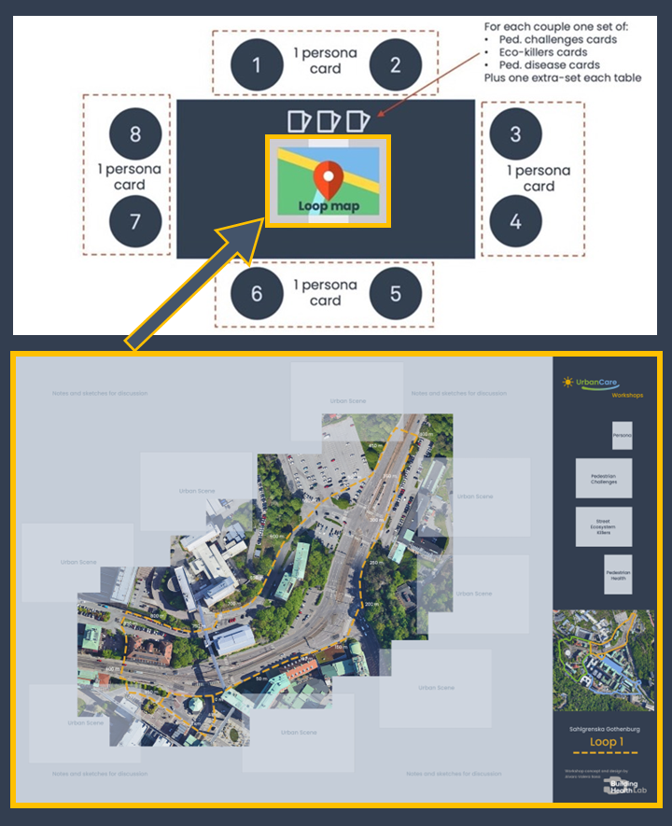
Figure 2. Working Table layout to place the loop map (row 2) and UrbanCare cards.
Thirdly, the main investigator introduced the workshop sessions, their objectives, and deliverables (Table 1) and offered an overview of the materials placed on the working tables (Figure 3). The participants were grouped into six teams. Each team joined a Working Table identified with a letter, from A to F. Tables A and B worked on Loop 1, tables C and D on Loop 2, and teams E and F on Loop 3. In the execution of the workshop’s four sessions, both assistants mentored the working tables to help the participants follow instructions and ensure timekeeping. The main investigator responded to questions and doubts from the mentors and participants. The first two sessions revisited inputs from the lecture and the guided walk using the analog and digital materials. Workshop sessions 3 and 4 gathered participant outputs for a knowledge check.

Session 1: Gap Finder. This session had two parts. In part 1, the participants opened a QR code to access the UrbanCare Data Viewer. In 25 minutes, they individually visited the pedestrian loops with their laptops or phones, visualized urban scenes, and clicked on urban heat, surface runoff, biotope loss, and spatial inequity icons. The latter opened an online multiple-choice survey to fill out and rate the environmental conditions of walkway connectors within the urban scenes of the pedestrian loop assigned to their working table. In part two, the participants had 15 minutes to team up, select one user persona chip per working table, and make a second tour of the loops. This time, the persona chip moved along the loop board. The pedestrian challenge and pedestrian health cards enriched the group discussions on the urban scenes and encouraged participants to fill out a written survey (Tables 2, 3 in Results Session 1).

Session 2: Diagnostics. In 45 minutes, each working table had to discuss the findings from session 1 to select the most challenging urban scene for vulnerable users with a focus on the persona (Table 4 in Results Session 2). The viewer was also available to enhance the discussion with infographic data.

(iv) Workshop knowledge check
In sessions 3 and 4, the main investigator had the opportunity to determine if the participants understood and applied the content from previous inputs and again rehearsed it in sessions 1 and 2.

Session 3: Planning. In this session, participants had 25 minutes to develop a planning strategy following three steps. 1. Prioritize climate, energy, and health goals for the urban scene selected. 2. Create a team to align goals and develop actions. And 3. Create a time plan (Table 5 in Results Session 3).

Session 4: Design. In 45 minutes, the participants were instructed to sketch on A4 sheets the various pedestrian and environmental issues found in the urban scene previously selected and their possible solutions. The data viewer was used to revisit urban scenes while sketching the before and after scenarios. At the end of the session, each working table team had 10 minutes to present their findings from session 3 and show the sketches (Figures 4 to 6 in Results Session 4).

3. Results
This section describes participant outputs in all four workshop sessions.

3.1 Session 1
Table 2 shows the aggregated results attained with the individual online survey and notes taken by the mentors from the group handout surveys.
Table 2. Online survey aggregated results.
Walkway connectors | Question | Aggregated results by loops  (based on a Likert scale response survey)  Strongly agree | Agree | Neutral | Disagree | Strongly disagree
 |  | Loop 1 | Loop 2 | Loop 3
Public Transportation Stops & stations | Convenience | Disagreed | N.A. | Neutral
 | Safeness | Disagreed | N.A. | Agreed
 | Comfort | Disagreed | N.A. | Disagreed
 | Attractiveness | Disagreed | N.A. | Neutral
Priority Entrances to open spaces and buildings | Convenience | Strongy disagreed | Disagreed | Disagreed
 | Safeness | Disagreed | Neutral | Neutral
 | Comfort | Disagreed | Neutral | Neutral
 | Attractiveness | Disagreed | Disagreed | Neutral
Public free seating | Convenience | Strongy disagreed | Neutral | Disagreed
 | Safeness | Disagreed | Disagreed | Neutral
 | Comfort | Disagreed | Disagreed | Neutral
 | Attractiveness | Strongly disagreed | Disagreed | Disagreed
Street crossings | Convenience | Neutral | Strongly disagreed | Disagreed
 | Safeness | Neutral | Strongly disagreed | Neutral
 | Comfort | Neutral | Neutral | Agreed
 | Attractiveness | Neutral | Neutral | Neutral

Table 3. Handwritten survey results.
 | Loop 1
Walkway connectors | Persona selected | Main environmental barriers  to your persona?
Public Transportation Stops & stations | Cane User | Different levels create obstacles in the journey.
 | Kids & Parents | Lacking landmarks and pathway finding
Priority Entrances to  open spaces and buildings | Cane User | Difficult to find and locate priority entrances
 | Kids & Parents | Difficult to find
Public free seating | Cane User | Very few seating spaces. Eg. Only one bench at the parking spot
 | Kids & Parents | Very few and oddly placed
Street crossings | Cane User | Long crossings with no markings
 | Kids & Parents | Long and vague crossings, no safety from traffic
 | Loop 2
Walkway connectors | Persona selected | Main environmental barriers to your persona?
Public Transportation Stops & stations | Kids & Parents | None Nearby
 | Wheelchair user | Difficult to find. No signages. Unsafe
Priority Entrances to  open spaces and buildings | Kids & Parents | Green areas are relaxing but difficult to find. Priority entrances are difficult to find.
 | Wheelchair user | Difficult to find entrances to different types of healthcare clinics. No orientation.
Public free seating | Kids & Parents | None Nearby
 | Wheelchair user | No pause spaces found.
Street crossings | Kids & Parents | Unsafe and informal crossings
 | Wheelchair user | No markings for crossings, risky to get through traffic. Only stairs, no ramps, or elevators.
 | Loop 3
Walkway connectors | Persona selected | Main environmental barriers to your persona?
Public Transportation Stops & stations | All personas | Very hot to wait at the stops. No shade. Poor accessibility due to heavy traffic
 | Kid | Heavy traffic flow, sharp curved roads.
Priority Entrances to  open spaces and buildings | All personas | Difficult to find entrances. Blocked by cars.
 | Kid | Not obvious that it is an entrance. No orientation. Scary impression and dead spaces.
Public free seating | All personas | Few free seatings are available but not shaded
 | Kid | No spaces to play. Few unshaded seatings.
Street crossings | All personas | No proper markings for crossings, pedestrian safety at risk.
 | Kid | Long crossings. No signages

3.2 Session 2
The diagnostics session results are a selection of urban scenes with the highest levels of urban heat, surface runoff, and biotope loss at the pedestrian level. Teams A to D selected four urban scenes, two for loop 1 and two for loop 2. Teams E and F selected the same scene for loop 3 (Table 4).
Table 4. Urban Scenes selected by each Working Table
Loop No. | # Urban Scenes | Working tables  (teams) | Urban Scenes selected
1 | 9 | A, B | Working Table A, Loop 1, Urban Scene 6 | Bus stop  Working Table B, Loop 1, Urban scene 2 | Priority entrance
2 | 8 | C, D | Working Table C, Loop 2, Urban Scene 1 | Priority entrance  Working Table D, Loop 2, Urban Scene 2 | Tram stop
3 | 8 | E, F | Working Table E and F, Loop 3, Urban Scene 8 | Free seating

3.3 Session 3
The planning session results summarize the planning strategies for critical urban scenes in the loops discussed by the participants and noted by the two workshop mentors. The notes reflect the consensus on the environmental issues from the urban scenes selected in session 2.
For each urban scene selected, it highlights (i) climate, energy, and health problems; (ii) the configuration of the technical team that aligns climate, energy, and health goals and develops actions; and (iii) the ideal timeframe to execute the project (Table 5).
Table 5. Planning strategies for each urban scene selected.
Loop No. | Urban Scenes selected | Climate, Energy, and Health problems | Who develops the plan?  Technical team required | Ideal timeline  (years)
1 | Working Table A, Loop 1, Urban Scene 6 | A. Large paved asphalt surfaces and low green | A. Landscape designers and architects | A. 3 to 5
 | Working Table B, Loop 1, Urban scene 2 | B. Lack of safety from vehicles. | B. urban planner, traffic authorities, landscape designer, climate specialist | B. 3 to 5
2 | Working Table C, Loop 2, Urban Scene 1 | C. No orientation and landmarks to identify entrance. No seating leading to fatigue. | C. Architect, climate designer | C. 1 to 2
 | Working Table D, Loop 2, Urban Scene 2 | D. Unsafe from vehicles. Low biotope and high runoff. | D. Biodiversity planner, botanist, landscape designer | D. 3 to 5
3 | Working Table E and F, Loop 3, Urban Scene 8  Safeness | E. Poor biotope and high runoff. | E. Urban planner, landscape designer | E. 2 to 3
 |  | F. Unshaded seating spaces. | F. Landscape designer, architect | F. 1 to 2

3.4 Session 4
Results from the design session include concept notes and sketches of the selected urban scenes that should improve pedestrian health and outdoor areas at buildings to optimize their energy balance. Both groups made sketches per loop, expressing the before and after scenarios shown at the end of the session through an oral presentation.

In Loop 1, Working Table A presented problem-solving sketches for Urban Scene 6. The Before scenario showed high surface runoff, no biotope, and unsafe and inaccessible spaces. The after scenario recreated a start-up village with shaded cafeterias and green spaces. Working Table B presented problem-solving sketches for Urban Scene 2. The Before scenario highlighted a lack of orientation and landmarks, no resting and social spaces, and cars priority. The after scenario presented a connecting water stream and a fountain and proposed retrofitting the entrance at the plaza (Figure 4).

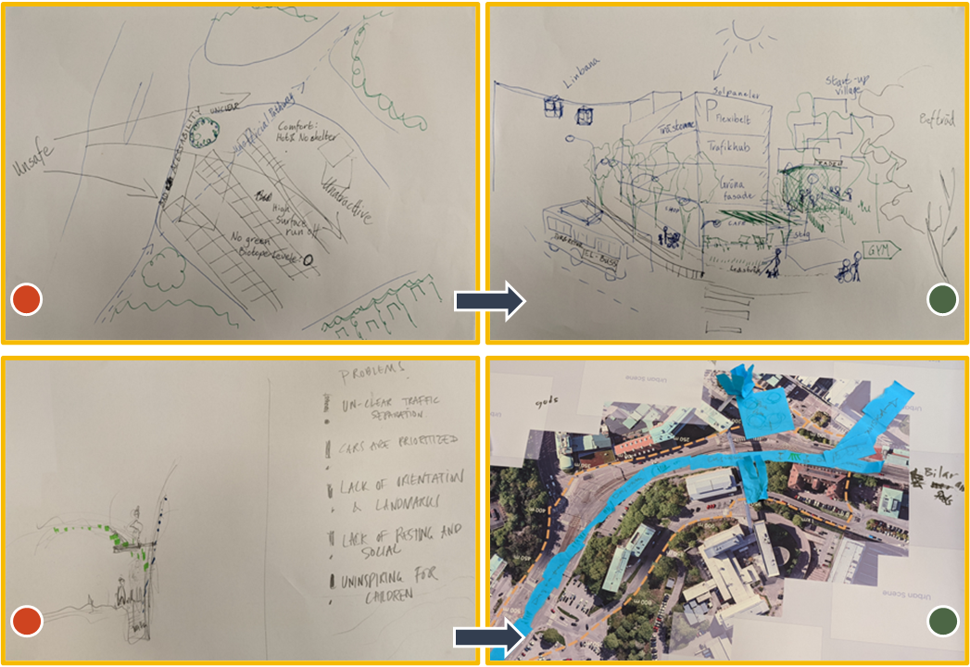
Figure 4. Loop 1 results from Working Tables A and B.
In Loop 2, Working Table C presented problem-solving sketches for Urban Scene 1. The Before scenario showed high surface runoff and urban heat, a lack of safety from vehicles, and buildings exposed to heat spots. The after scenario drew shaded spaces with green space, green facades for nearby buildings, and a tree avenue. Working Table D presented problem-solving sketches for Urban Scene 2. The Before scenario accused a lack of social spaces, a low biotope, and high urban heat levels. The After scenario incorporated the neighboring botanical garden to protect pedestrians, aiming to improve social cohesion with nearby communities (Figure 5).

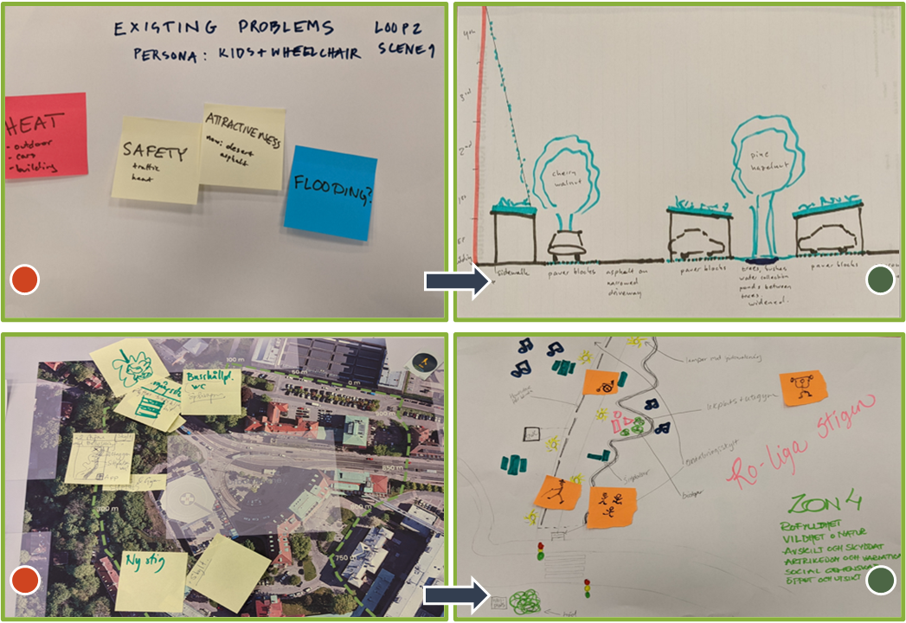
Figure 5. Loop 2 results from Working Tables C and D.
In Loop 3, Working Table E presented problem-solving sketches for Urban Scene 8. The Before scenario showed high surface runoff and low biotope levels. The After scenario suggested creating more green spaces and a water stream along the plaza to cool the environment. Working Table F presented problem-solving sketches also for Urban Scene 8. The Before scenario pointed out poor pedestrian navigation and a lack of social spaces. The After scenario proposed retrofits with permeable surfaces, shared open spaces, and adding shading greenery to the plaza (Figure 6).

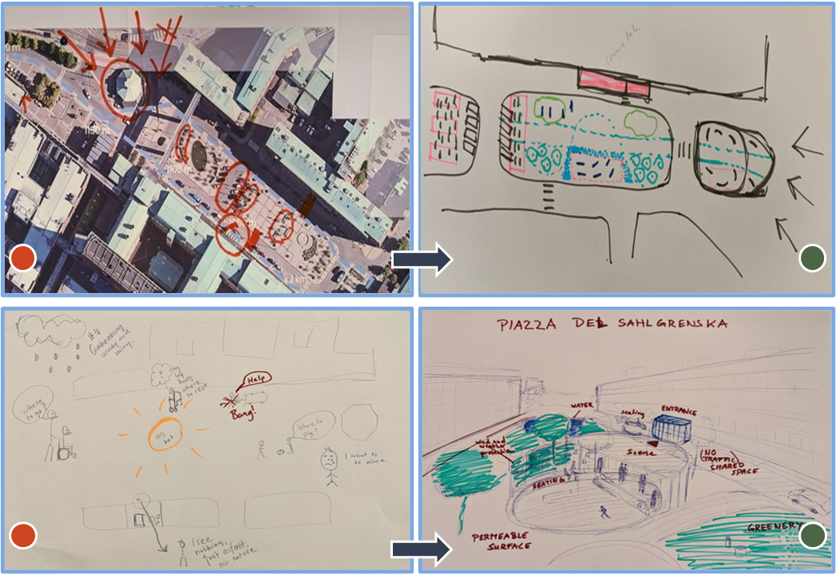
Figure 6. Loop 3 results from Working Tables E and F.

4. Discussion
95% of the workshop participants attended the online input lecture, which may explain why there was no need for clarification of concepts or terminology in the four main research topic areas: urban heat, surface runoff, biotope loss, and spatial inequity.
In sessions 1 and 2, the teams had a learning curve with the Data Viewer but did engage in community-led research while investigating through the table boards. The surveys, sketches, and notes at all Working Tables reflected climate, energy, and health issues.
The knowledge check on participant outputs in sessions 3 and 4 were positive. In session 3, the proposals for building technical teams to problem-solve the selected urban scenes were diverse and adjusted to the climate and energy needs. It offered valuable hints on developing tasks to understand and apply transdisciplinary approaches. The execution times proposed were discussed and agreed upon by consensus. It indicates that despite the groups being diverse in technical backgrounds and levels, decision-making in urban development processes can be significantly improved when informed.
The final presentation of sketches per working table referred to the concepts and included terminology discussed in the input lecture and the cards. However, the prioritization of problems only highlighted climate and energy aspects and did not list impacts on any subgroup of the vulnerable pedestrians depicted in the persona chips. Emphasizing the assessment and development of concept designs for vulnerable hospital outdoor users must be reinforced in the input lecture and during the workshop.

5. Conclusions
This illustrative case study systematically described how a research workshop assisted a group of participants in grasping and applying novel urban planning concepts and tools for sustainable development and public health. It gave insight into implementing community-led research in a short time to co-create local spatial actions that integrate sustainable development goals related to climate, energy, and health.
The recording of steps and tasks showed that the research workshop conceptual framework was well communicated. The workshop structure was effective in attaining the expected outputs from participants. The digital interface may need a tutorial and software improvements, while the analog tools did not raise questions. The four sessions were structured to achieve the expected outputs and outcomes within the programmed time. The knowledge check was possible with the format of the deliverables, which allowed review after the workshop was finished.
For the research workshop participants, it is straightforward to understand the climate and energy aspects of urban health. Reinforcing the public health aspect of urban health is needed. Also, it is necessary to carefully study the economic and technical burden of preparing the research workshop to evaluate its cost-efficiency and determine if it is feasible to replicate and upscale at the city and regional levels.

Data Availability Statement
The UrbanCare methodology description is available at: https://buildinghealth.eu/urbancare-methodology-and-tools/
Links to the Data Viewer for Sahlgrenska are: https://buildinghealth.eu/sahlgrenska-university-hospital-pedestrian-loops/
Contributor statement
Author 1: Conceptualization, Methodology, Software, Formal Analysis, Investigation. Author 2: Validation.
Acknowledgments
This research was supported by BHL Building Health Lab, and partly supported by the Humboldt Foundation, the Erasmus Programme, and the Centre for Healthcare Architecture of Chalmers University of Technology.
We thank Netra Naik, MSc Environmental Planning, Humboldt Foundation research fellow, for assistance in preparing infographics for thermal and surface data that greatly contributed in the preparation phase of the workshop, and Gregorio Pezzoli, geographic information system analyst, University of Bergamo for assisting in the preparation of the digital maps and interfaces, and Clarine van Oel from Delft University for comments that greatly improved the manuscript.

References

- Building Health Lab. (2021a, September). UrbanCare methodology. https://buildinghealth.eu/urbancare-methodology-and-tools/
- Building Health Lab. (2021b, October). Sahlgrenska Pedestrian Loops. https://buildinghealth.eu/sahlgrenska-university-hospital-pedestrian-loops/
- Chen, R., & You, X. Y. (2019). Reduction of urban heat island and associated greenhouse gas emissions. Mitigation and Adaptation Strategies for Global Change, 25(4), 689–711. https://doi.org/10.1007/s11027-019-09886-1
- Everard, M., Kass, G., Longhurst, J., Zu Ermgassen, S., Girardet, H., Stewart-Evans, J., Wentworth, J., Austin, K., Dwyer, C., Fish, R., Johnston, P., Mantle, G., Staddon, C., Tickner, D., Spode, S., Vale, J., Jarvis, R., Digby, M., Wren, G., . . . Craig, A. (2021). Reconnecting society with its ecological roots. Environmental Science & Policy, 116, 8–19. https://doi.org/10.1016/j.envsci.2020.11.002
- Flies, E. J., Mavoa, S., Zosky, G. R., Mantzioris, E., Williams, C., Eri, R., Brook, B. W., & Buettel, J. C. (2019). Urban-associated diseases: Candidate diseases, environmental risk factors, and a path forward. Environment International, 133, 105187. https://doi.org/10.1016/j.envint.2019.105187
- Gkatsopoulos, P. (2017). A Methodology for Calculating Cooling from Vegetation Evapotranspiration for Use in Urban Space Microclimate Simulations. Procedia Environmental Sciences, 38, 477–484. https://doi.org/10.1016/j.proenv.2017.03.139
- Grohs, J. R., Kirk, G. R., Soledad, M. M., & Knight, D. B. (2018). Assessing systems thinking: A tool to measure complex reasoning through ill-structured problems. Thinking Skills and Creativity, 28, 110–130. https://doi.org/10.1016/j.tsc.2018.03.003
- HCWH. (2021, June 16). Health care climate footprint report. Health Care Without Harm. https://noharm-europe.org/content/global/health-care-climate-footprint-report
- International accountability project. (2018). Community action guide on community-led research. https://accountabilityproject.org/wp-content/uploads/2018/11/IAP-Comm-Act-Guide-web.pdf
- Keller, R. L., Muir, K., Roth, F., Jattke, M., & Stucki, M. (2021). From bandages to buildings: Identifying the environmental hotspots of hospitals. Journal of Cleaner Production, 319, 128479. https://doi.org/10.1016/j.jclepro.2021.128479
- Milojević, B. (2018). INTEGRATED URBAN PLANNING IN THEORY AND PRACTICE. САВРЕМЕНА ТЕОРИЈА И ПРАКСА У ГРАДИТЕЉСТВУ, 13(1). https://doi.org/10.7251/stp1813323m
- NACTO. (2017, June 29). Streets are Ecosystems. National Association of City Transportation Officials. https://nacto.org/publication/urban-street-stormwater-guide/streets-are-ecosystems/
- Paravantis, J., Santamouris, M., Cartalis, C., Efthymiou, C., & Kontoulis, N. (2017). Mortality Associated with High Ambient Temperatures, Heatwaves, and the Urban Heat Island in Athens, Greece. Sustainability, 9(4), 606. https://doi.org/10.3390/su9040606Sahlgrenska. (2021). Sahlgrenska Life – an investment for future research and care. Sahlgrenska Universitetssjukhuset. https://www.sahlgrenska.se/om-sjukhuset/sjukhuset-vaxer/sahlgrenskalife/
- Shen, C., Zhao, K., Ge, J., & Zhou, Q. (2019). Analysis of Building Energy Consumption in a Hospital in the Hot Summer and Cold Winter Area. Energy Procedia, 158, 3735–3740. https://doi.org/10.1016/j.egypro.2019.01.883
- Speck, J. (2018). Walkable City Rules: 101 Steps to Making Better Places (3rd ed.). Island Press.
- Tan, D. T., Siri, J. G., Gong, Y., Ong, B., Lim, S. C., MacGillivray, B. H., & Marsden, T. (2019). Systems approaches for localising the SDGs: co-production of place-based case studies. Globalization and Health, 15(1). https://doi.org/10.1186/s12992-019-0527-1
- Teke, A., & Timur, O. (2014). Assessing the energy efficiency improvement potentials of HVAC systems considering economic and environmental aspects at the hospitals. Renewable and Sustainable Energy Reviews, 33, 224–235. https://doi.org/10.1016/j.rser.2014.02.002
- Telega, A., Telega, I., & Bieda, A. (2021). Measuring Walkability with GIS—Methods Overview and New Approach Proposal. Sustainability, 13(4), 1883. https://doi.org/10.3390/su13041883
- Valera Sosa, A. (2021). UrbanCare Capacity Building – Building Health Lab. Building Health. https://buildinghealth.eu/climate-change-and-urban-health-capacity-building/
- WHO. (2015). CLIMATE AND HEALTH COUNTRY PROFILE – 2015 Germany. https://apps.who.int/iris/rest/bitstreams/1031213/retrieve

