Type of the Paper: Peer-reviewed Conference Paper / Full Paper
Track title: Inclusive Design & Health Promotion: communal design

The role of the built environment in experiences of hospice care: Considerations for hospice design
Koen Coomans ^{1,2,*}, Margo Annemans ³ and Ann Heylighen ⁴
¹ KU Leuven, Department of Architecture, Research[x]Design, Leuven, Belgium;
koen.coomans@kuleuven.be; ORCID ID 0000-0003-4894-1582
² D E Architecten, Tervuren, Belgium; koc@dearchitecten.be
³ KU Leuven, Department of Architecture, Research[x]Design, Leuven, Belgium;
margo.annemans@kuleuven.be; ORCID ID 0000-0001-6541-4069
⁴ KU Leuven, Department of Architecture, Research[x]Design, Leuven, Belgium;
ann.heylighen@kuleuven.be; ORCID ID 0000-0001-6811-3464
* the corresponding author.

Names of the Topic editors:
Clarine van Oel

Journal: The Evolving Scholar
DOI:10.24404/62d015598df837aee90961e0

Submitted: 14 Jul 2022
Accepted: 14 Jul 2022
Citation: Coomans, K., Annemans, M. & Heylighen, A. (2022). The role of the built environment in experiences of hospice care: challenges for hospice design. The Evolving Scholar | ARCH22.

This work is licensed under a Creative Commons Attribution BY license (CC BY).

© 2022 Coomans, K., Annemans, M. & Heylighen, A. published by TU Delft OPEN on behalf of the authors.

Abstract: The term ‘hospice’ refers to both a philosophy of end-of-life care and a building type, dedicated to offering this care. Hospice care strives to offer dignity, personal choice, peace, calm, and freedom from pain. Hospice care is anchored in space and spatial practices; however this relation is understudied. It is a rather new building type, for which architects have few historical references, post-occupancy evaluations, or direct experiences available. The prospect of replacing a Belgian hospice offered an opportunity for a case study. We aim to understand how the built environment of a hospice affects experiences of care, and discuss design considerations derived from that.
Our qualitative research approach was based on principles of Grounded Theory and combined observations with semi-structured interviews with six staff members, six volunteers, three relatives and eight patients. Our analysis shows that the built environment contributes to hospice care by the balance it affords between privacy and social interaction, by the discrete ways in which it affords offering high-level care, and by its human scale and relation to the natural environment. Insights gained challenge hospice designers to consider how meaningful encounters are often spontaneously triggered by daily activities; guests’ lifeworld changes in size; a delicate balance is required between proximity and seclusion; the built environment can support the ethos of staff and volunteers; aspects of environmental support (e.g. accessibility) are intertwined with aspects of emotional comfort (e.g. hominess); high-level care can be offered in discrete ways.
Keywords: built environment; case study; environmental design; hospice; palliative care

1. Introduction
The term ‘hospice’ refers primarily to a philosophy of end-of-life care (Milicevic 2002, McGann 2011). Just like dame Sicely Saunders’ concept of ‘total pain’ (Thoresen, 2003) includes physical symptoms, mental distress, social and emotional problems (Clark 1999), person-centered hospice care puts the satisfaction of physical needs on the same level as spiritual, existential, social and psychological needs (Bökberg et al. 2019). Hospice care is about offering personal choice and striving to guarantee dignity, peace and calm, and freedom from pain (Radbruch & Payne 2010).
Today, the term ‘hospice care’ is sometimes used interchangeably with ‘palliative care’ (Clark and Seymour 1999 in Thoresen, Wyller, Heggen 2011, Radbruch & Payne 2010). When they are not used interchangeably, these terms can indicate a difference in building type (e.g. a hospice as free-standing versus a palliative care unit (PCU) in a hospital), or a difference in criteria for admission (e.g. limited life-expectancy in hospice care versus not life-threatening in the short term for palliative care). However, the underlying philosophy of both hospice and palliative care overlaps considerably (Radbruch & Payne 2010). Actually, such care can take place at home, in a free-standing hospice, or in a PCU.
Many people dying in institutions have unmet needs concerning communication with physicians, emotional support, and respectful treatment (Teno et al., 2004)—psychosocial aspects of care in which hospices are known to excel (Bainbridge et al., 2018). Although home is considered the preferred place to die (Gomes et al. 2013, Keirse et al. 2009), this shifts to the hospice for people who have already stayed in a hospice before (Arnold et al. 2013; Gerrard et al., 2011). Caregivers rated the hospice environment highest in a comparative study (above home care, hospitals, and cancer settings) for relief of physical pain and other symptoms, and for spiritual and emotional support (Bainbridge & Seow, 2018). These studies indicate that free-standing hospices offer an added value on the care continuum, between home and hospital. Therefore this environment is the focus of our study.
The hospice as a building type is considered rather new, with few historical references and post-occupancy evaluations available, let alone relevant experiences of architects (Worpole 2009). There are some design guidelines for hospices (Zadeh et al., 2018; Verderber, 2014; Moorhouse, 2006; The Irish Hospice Foundation, 2008; Realdania Fund, 2006), and literature highlights the role of nature, the domestic, home-like, or human scale aspect, and the duality between privacy and social interaction (Verderber and Refuerzo 2006, Rasmussen and Edvardsson 2007, Worpole 2009, McGann 2011, Verderber 2014, Zadeh et al. 2018). However, the role of the built environment in experiences of hospice care is still stated to be understudied (Rasmussen and Edvardsson 2007, Adams 2016, Bellamy et al. 2020). Contributing to understanding this role is the aim of our case study in a Belgian hospice.

2. Methods
In 2019 Belgium counted 197 palliative care services, including 51 PCU’s, and two hospices, of which one is free-standing (Arias-Casais et al. 2019). The prospect of replacing this (for Belgium) unique hospice, created an opportunity for our case study.
The old hospice is based in a former farm, surrounded by greenery (Fig. 1 and 2). Patients are addressed as ‘guests’, a term that fits the ethos of the hospice team and will be used throughout this paper. The residential care part (RC) can accommodate eight guests overnight. The day-care part (DC) welcomes five or six guests per day. These parts are spread over two buildings, positioned a few meters apart (Fig. 2). The inner side of the U-shaped building complex has large windows on all sides. Care is offered by staff and volunteers.
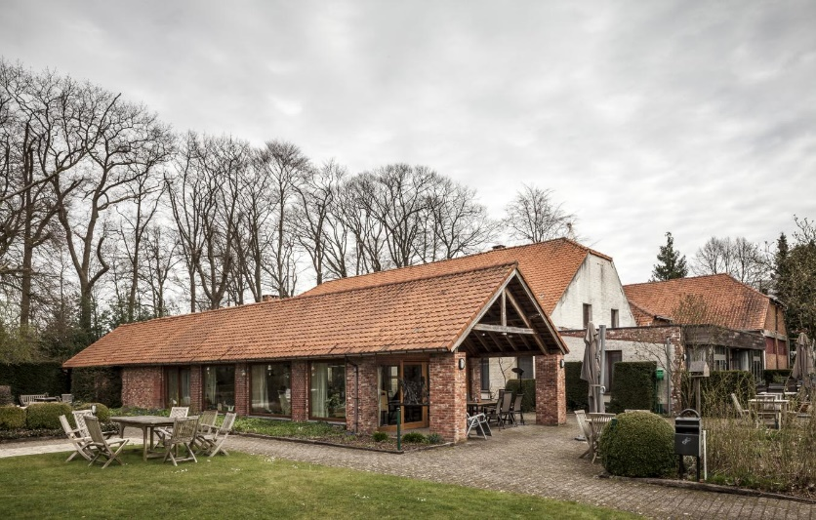
Figure 1. Photo of current hospice; day-care (front) and residential (back) parts.
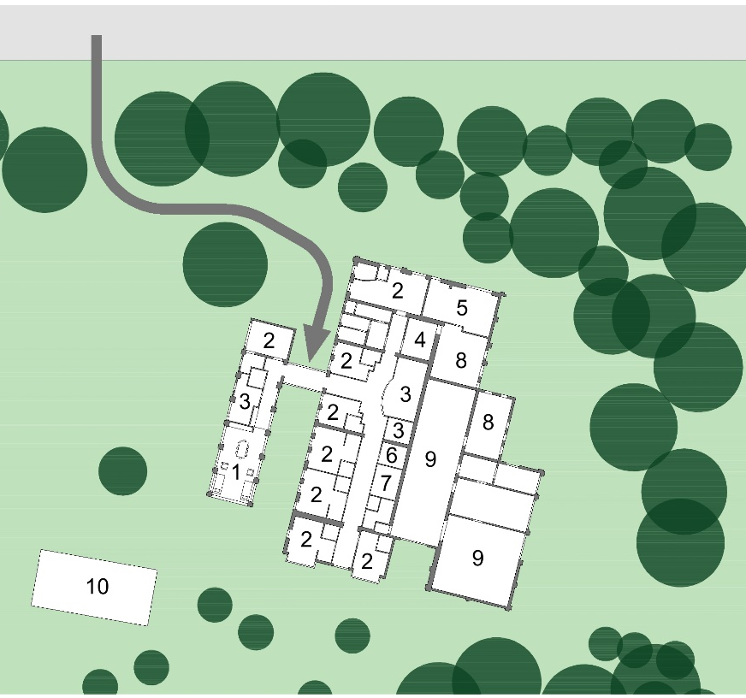
Figure 2. Situation plan of the hospice site. Key: 1 Living space DC, 2 Private rooms RC, 3 Office, 4 Kitchen RC, 5 Living room RC, 6 Seating corner RC, 7 Bathroom RC, 8 Utility, 9 Unused barn, 10 “Orangery” (garden shed used for small gatherings); arrow indicates entrance from main road.
As our study aims to uncover possible associations between phenomena from an insider’s perspective, a qualitative research approach based on the principles of Grounded Theory was considered most appropriate (Lim et al. 2017, Glaser 2006). Rather than starting from preconceived ideas and an explicit hypothesis, we aimed to evolve towards new insights through data analysis.
Data collection combined observations, in-depth interviews with guests, and focus-group interviews with staff, volunteers, and relatives (see Table 1). Observations were done first and they were performed only in the DC (two days). They allowed the researchers to observe how the building was used and to experience the atmosphere first hand. We consider them mainly as background information for the interviews.
Interviewees were selected by staff, contacted in advance by a contact person in the hospice, and explained the details of the research. All interviews (see Table 1) were semi-structured, with an interview guide based on our previous experience (with qualitative research about the built environment in other care contexts), insights from observations, discussion with staff about data collection, and relevant literature. The guide covered three parts: one about expectations and first impressions, one about more specific spatial and social aspects, and one overarching concluding part. In the focus-group interviews, all participants were asked first to write down what hospice care means for them, and next to discuss this.
Observations were documented with field-notes, all interviews were audio-recorded and transcribed verbatim. Transcripts were analysed in line with the Qualitative Analysis Guide of Leuven (Dierckx de Casterlé et al. 2012), following an iterative process of coding, memo-writing and developing concepts and categories. No coding software was used. Relevant themes were identified in the data individually, and compared and combined later to mitigate possible biases.
Rooted in a reaction against the institutionalization of death, the philosophy of hospice care is exactly about not following principles and guidelines (Ahuja, 2018). Therefore, we do not conclude with additional guidelines, or a bulleted list of design implications, intended to “save the reader a trip” to this hospice (Dourish, 2006, pp. 549). Instead, we conclude with design considerations that connect the different themes and that suggest “models of thinking” or “ways of approaching” when designing a hospice (Dourish, 2006, pp. 548 & 549), where possible accompanied with concrete examples for inspiration. The translation from themes into design considerations results from a collective and creative process by the research team, which combines insights from literature and the case study, but also from prior experience in studying and designing the built environment in care contexts.
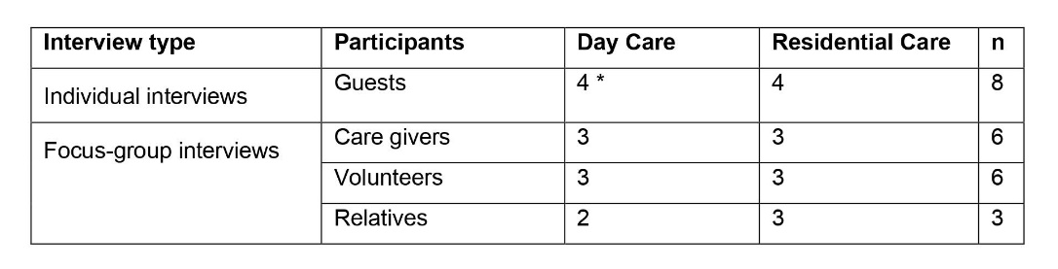
Table 1: overview of the interviews; * = two guests were accompanied by a family member; n = total number of unique participants (some relatives had experience with DC and RC); Date: January – May 2017; Length: from 30 minutes up to 2 hours.
Ethical approval was obtained from the KU Leuven Social and Societal Ethics Committee. Since all authors have a background in architecture and experience in qualitative research in care settings, but not in the context of hospice care, we discussed the methods with staff to adapt them to the sensitive context. For instance, staff advised against observing in the RC. An information sheet explaining the study was distributed in advance in the hospice, and staff always orally introduced the researchers to the participants. The researchers gave more explanation about the research and obtained written informed consent.
Since staff selected a limited number of participants, complete data saturation could not be guaranteed. The quality of the analysis was nevertheless improved by gathering rich data in a semi-structured way and triangulating these (Fusch & Ness, 2015). The perspective of guests from both RC and DC was triangulated with that of staff, volunteers, and relatives and with observations. The interview guides allowed considering experiences at the hospice from multiple angles and getting a sense of the relative importance of different spatial aspects.

3. Results
The analysis made clear that the care ethos in the hospice creates an important background for how care is experienced there. Therefore, we first present how this ethos was described. With this context in mind, next we present and combine the main themes that resulted from our analysis: privacy & social interaction, discrete high-level care and nature and human scale.

3.1. Ethos of Hospice care
Several participants agreed that the hospice ethos is well captured by a quote brought by a relative: “and there was a place where I found room for me, for everything that I am more than my disease”.
Staff, volunteers, and family members described the hospice’s philosophy of care as striving to offer personal choice and guarantee dignity, peace and calm, and freedom from pain. High-level medical care, as offered in hospitals, was considered as self-evident. The focus was more on mental, social, and emotional aspects.
Dignity was most clearly translated into the intention to make patients feel ‘human’ again: they are addressed as ‘guests’, there are no uniforms, and humor should be possible. Personal choice was considered crucial and mentioned mostly in relation to meals, but also to care and activities.
Guests mentioned they fear medical (e.g., a painful death) and social (e.g., dying alone) issues. Because of the focus on the dying person, caregivers could risk overlooking relatives’ well-being. For both guests and relatives, knowing that care (medical, but also psychosocial) is always nearby helps to find peace and calm. The care team ensures that there is always someone who has time to sit down and talk or listen, and coffee is always offered as an implicit invitation for conversation.

3.2. Built environment and hospice care

3.2.1. Privacy & social interaction
The relation between privacy and social interaction is delicate and balance is continuously sought for. In the RC, caregivers focus on facilitating, intensifying and sometimes mediating interaction between guests and relatives. Staff and volunteers direct people to other places when they notice that guest or relative needs a moment alone. This interaction mainly occurs in the private room.
The other available spaces are perceived ill-suited for meeting. The seating area along the corridor is small and unattractive, and therefore seldom used. Although relatives often prefer to stay close to the guest, the living room is positioned rather far away and only accessible through the kitchen. This results in a lack of good meeting spaces. For example, a mourning family had to share the living room with a group of volunteers arranging flowers. The volunteers felt uncomfortable, while the family members had difficulty being so far away from the deceased.
When feeling better, RC guests sometimes long for social contact with peers. Out of privacy concern, guests seldom visit each other’s room. Yet the small seating area is considered unpleasant (see above) and the living room too remote, offering RC guests few places to meet each other.
RC guest ‘[we meet eachother] where we’re all allowed to smoke [laughs] that’s in fact the only social contact that remains, because yes, you have to go outside with a cigarette’
In the DC, the interaction with peers is essential and occurs mainly at the central table, but a relax chair and bed are nearby.
Volunteer DC: ‘we have [a guest] who finds it a bit too busy at the table, and then he stays in the sofa, and others want to take a bit more distance, and they stay in the bed […] the degree of social contact one wants, is adjusted within this small distance’
Caregivers believe that guests would benefit from more secluded spaces, for resting or to separate guests with different interests. However, the interviewed guests seem to consider supplementary spaces mainly as needed by others, while they themselves prefer staying close to the group.
Volunteer DC: ‘I think [the guests would] even postpone resting if it had to be in a separated space. Because then they also miss something, (…) after lunch they usually go resting, but they’re still there, often they do fall asleep but, it gives a kind of (…) again, peace of mind mainly.’
Spatially, the RC and DC are very close and have windows watching each other. Curtains guarantee privacy in the RC rooms. In both RC and DC caregivers lack a space to retreat to for privacy or to share difficult experiences.

3.2.2. High-level care in discrete ways
Medical care - The same high-level medical care as in hospitals is offered, but in a less clinical and more human or homelike atmosphere. An example is the bathroom door (Fig. 3): while the sliding mechanism optimizes accessibility, the materials might be found also in a house.
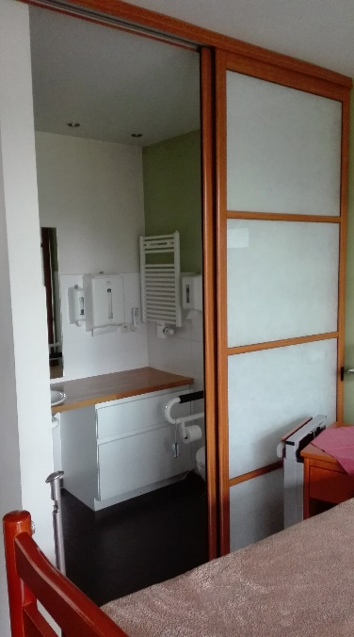
Figure 3. Sliding bathroom door.
In an ideal building, caregivers wish for a small space connected to each private room, to have medical materials right at hand but out of sight. To lift people from their bed or toilet, they prefer using an extra pair of hands rather than mechanical lifting aids. However, the dimensions of the bedrooms or bathrooms sometimes do not allow organizing this smoothly.
Staff RC: ‘it’s important that it’s not only basic care, but that we can cover it up […] constantly consider whether you’re not working too clinically’
Other aspects of care - Also aspects related to mental, social and emotional care are inspired by a homelike atmosphere and supported by spatial cues. At the entrance of the building, like at home, there is no reception desk. Instead, caregivers leave the office or kitchen and greet visitors face to face, often guiding them personally to their destination.
Relatives are invited to pick up coffee in the kitchen, as an implicit invite to come in and talk. It is a very small space and volunteers comment that the unpractical layout makes people feel as if they are standing in the way. At the same time, it is exactly this small scale that offers intimacy.
Volunteer RC1: ‘the kitchen is an amazing place […] we should keep that, a place people spontaneously come to, and where there’s always someone present’
Volunteer RC3: ‘they almost crawl into the pots and pans, and then the whole story comes out, because if you make it too big, where also others can sit, I don’t think they’ll tell their story’
Caregivers notice relatives seeking for ways to ask (often intimate and private) questions out of the guest’s hearing range, but still within close distance.
Staff RC: ‘[Relatives] want to grasp you, and ask how it’s going, and what we think, that kind of stuff. So they don’t want to lose sight of us. They really won’t go make themselves comfortable in the living room.’

3.2.3. Nature & human scale
The building’s small scale results in short distances between spaces, within a space and between inside and outside. As mentioned, in the DC, table, relax-chairs, and bed are close to each other. In the RC, the small size of the kitchen stimulates intimate conversations. The RC living room was used often when it was close to the private rooms, but noticeably less since it was moved behind the kitchen.
In guests’ appreciation for the hospice environment views outside, light, and nature are important. Short distances and accessible routes allow guests to easily go outside: walking by themselves, pushed in a wheelchair, driven around in a golf cart, or wheeled outside in their bed.
Caregiver: ‘In a hospital you don’t roll a bed outside you know, in snow and wind and rain, while here you can, I mean, we can do that, we don’t have a lot of limits.’
When going outside is not feasible, nature and daylight can be enjoyed through the window. Guests take pleasure in distraction offered by playing squirrels, tranquility offered by greenery, and warmth of sunlight. Interviewees indicate that nature contributes to finding peace of mind, and how it is therefore an essential part of the hospice environment. The small scale affords this relation with nature throughout the building.
Caregiver RC: ‘Everything is on the same level, and that way you immediately have that nature, everywhere you are, because if we had an extra storey with some rooms, that would already be totally different.’

4. Discussion
The care ethos experienced in this hospice corresponds to what literature considers a person-centered approach (Bökberg et al. 2019) and hospice care: offering personal choice and guaranteeing dignity, peace and calm, and freedom from pain (Radbruch et al. 2010). This case is unique in its country, but the ethos aligns with what is internationally considered to be a hospice.
The results provide insight into the role of the built environment in experiences of care in this hospice. Below we discuss design considerations, connecting the different themes, that suggest new ways of approaching hospice design.
Existing design guidelines include dedicated places for social encounters, such as living rooms or lounge areas (Zadeh et al., 2018; Verderber, 2014). In the case studied, these are hardly used when too small, unpleasant or difficult to reach. The most meaningful social interaction occurs when people pick up coffee or food in the kitchen or go for a smoke on the terrace. A first consideration is therefore to design spaces for daily activities such that spontaneous and meaningful interactions are stimulated. For example, a counter with stools in the kitchen could invite to enter without hampering the volunteers at work.
When guests’ medical condition allows, interaction with peers and direct contact with nature are important. When their condition worsens, priorities shift to privacy, contact with relatives, and enjoying nature from inside. In the last moments, these priorities narrow to the closest relatives and comfort care. These results confirm what is found in literature: experiences along this spectrum are important (Zadeh et al., 2018; Verderber, 2014). Designers are challenged to consider that needs change over time. For example sliding doors or curtains make spaces adaptable.
The small scale of the built environment in the case studied creates a high level of proximity, although the balance with seclusion is delicate. Even when away from the guest, RC relatives prefer to stay close. Therefor they lack an adjacent space close to the private room, but secluded from the open space of the corridor. Examples from literature include private areas and nooks for relatives outside but nearby patient rooms (Zadeh et al., 2018; Verderber, 2014). In the DC proximity and seclusion are realized within one small space. Rasmussen & Edvardsson (2007) describe the choice between proximity and seclusion as part of ‘creating an atmosphere of safety’. Our study shows how this safety can be created by spaces that offer the choice to retreat while still staying nearby (Annemans et al. 2020).
Research confirms the importance of ethos in the overall hospice experience (Bainbridge et al., 2018), our case study demonstrates how the built environment can support this ethos. Like in other care contexts (Annemans et al. 2012), the absence of a reception desk contributes to a more human approach. Offering attractive and nearby meeting spaces in the RC could support caregivers to bring freedom of choice into practice. Although such spaces are mentioned in literature and guidelines (Zadeh et al., 2018; Verderber, 2014; Moorhouse, 2006; The Irish Hospice Foundation, 2008; Realdania Fund, 2006), little attention goes to how this affects (often implicitly) staff’s attitude. The hospice studied is small-scale, situated in an old farm, and runs into practical limitations and deficiencies. These features contrast with hospitals, and result in proximity and a so-called ‘homelike mess’, allowing to find peace and calm.
Both literature and our results show how in hospice care, the built environment can offer physical and emotional support: the former by being barrier-free and ergonomic; the latter by being homelike, being surrounded by nature, and keeping medical equipment out of sight (Zadeh et al., 2018; Verderber, 2014). Our findings stress how they are often intertwined in design decisions. For example, small-scaleness reduces distances and makes spaces easier to reach, while benefiting proximity of care (givers) and social support. A private terrace contributes to guests’ emotional comfort, if it is truly accessible.
Our results show how guests tend to abandon their ideal of ‘dying at home’ in favour of the hospice, because they fear lacking the medical equipment and care required to avoid pain and discomfort. Offering high-level care is needed to live up to this wish. Combining this with a homelike ambience requires constant attention from caregivers and needs to be reflected in the material environment. ‘Hiding medical equipment’ is also mentioned by Zadeh et al. (2018), our findings underline that this should not impact the quality of care. For example, bathrooms should be ergonomic and allow assisting guests with multiple caregivers at once, but consciously chosen materials can avoid a clinical atmosphere. For designers the challenge is to balance atmosphere and high-level care within each design decision.

Study limitations & strengths
Our results are based on a single case study, therefore they cannot be generalized. Since we had little control over who participated, and the number of interviews is limited, we could not guarantee complete data saturation. Yet, we did include several techniques to improve the quality of the analysis (see Methods). By combining the perspectives of multiple stakeholders, including guests themselves, the results provide a nuanced understanding of how hospice care is experienced in this specific hospice.

5. Conclusions
We analyzed the role of built environment in how care at a Belgian hospice is experienced by staff, volunteers, relatives, and guests. From the insights gained, literature and prior experience we derived design considerations that could provide new ways of approaching hospice design. These insights into experiences and considerations can contribute to the redesign of the facility at stake, the further development of hospices in Belgium and, in general, the design of palliative care settings of different types and in different regions. In future research we plan to focus on the new built facility, and compare the experiences before and after.

Contributor statement
Author 1 and 2 performed the literature study, fieldwork and transcriptions, under supervision of author 3. The analysis of the data and the process to derive design considerations was a collective work of all authors. All authors contributed to the final manuscript.
Acknowledgments
The authors want to thank the participants and organization of the hospice for their time and efforts for collaboration. We also want to thank Kom op tegen Kanker and FWO for their financial support.

References
- Adams, A. (2016). Home and/or hospital. Change Over Time, 6(2), 248-263.
- Ahuja, N. (2018). End stages. Places , May 2018. Accessed 09 Jan 2020. doi:10.22269/180515
- Annemans, A., Van Audenhove, Ch., Vermolen, H., Heylighen, A. (2012). What makes an environment healing? Users and designer about the Maggie’s cancer caring centre London. Proceedings of the 8th International Design and Emotion Conference, 1-8.
- Annemans, M., Coomans, K., Heylighen, A. with Annemans, M. (corresp. author) (2020). Building scale and well-being in a hospice: a qualitative exploration. Bmj Supportive & Palliative Care. doi: 10.1136/bmjspcare-2019-002151
- Arias-Casais, N., Garralda, E., Rhee, J.Y., Lima, L. de, Pons, J.J., Clark, D., Hasselaar, J., Ling, J., Mosoiu, D. & Centeno, C. (2019). EAPC Atlas of Palliative Care in Europe 2019. Vilvoorde, Belgium: EAPC Press.
- Arnold, E., Finucane, A. M., Oxenham, D. (2015). Preferred place of death for patients referred to a specialist palliative care service. BMJ Support Palliat Care, 5(3), 294-296.
- Bainbridge, D., Giruparajah, M., Zou, H., & Seow, H. (2018). The care experiences of patients who die in residential hospice. Palliative and Supportive Care, 16(4), 421-431.
- Bainbridge, D., Seow, H. (2018). Palliative care experiences in the last 3 months of life. Am J Hosp Palliat Care, 35(3), 456-463.
- Bellamy, A., Clark, S., & Anstey, S. (2020). The dying patient: taboo, controversy and missing terms of reference for designers-an architectural perspective. Med Humanit, Epub ahead of print: 3.03.2021.
- Bökberg, C., Behm, L., Wallerstedt, B., & Ahlström, G. (2019). Evaluation of person-centeredness in nursing homes after a palliative care intervention: pre- and post-test experimental design. BMC Palliative Care, 18:44.
- Clark, D. (1999). ‘Total pain’, disciplinary power and the body in the work of Cicely Saunders, 1958-1967. Social Science & Medicine, 49(6), 727-736.
- Clark, D., & J. Seymour. 1999. Reflections on palliative care. Buckingham: Phil., Open University Press.
- Dierckx de Casterlé, B., Gastmans, C., Bryon, E., Denier, Y. (2012). QUAGOL. International journal of nursing studies 49(3), 360-371.
- Dourish, P. (2006). Implications for design. Proceedings of the SIGCHI conference on Human Factors in computing systems, Canada (pp. 541-550).
- Fusch, P.I., Ness, L.R. (2015). Are we there yet? Qual. Rep. 20(9), 1408-1416.
- Gerrard, R., Campbell, J., Minton, O., Moback, B., Skinner, C., McGowan, C., Stone, P. C. (2011). Achieving the preferred place of care for hospitalized patients at the end of life. Palliat Med, 25(4), 333-336.
- Glaser, B. (2006). The discovery of grounded theory: Strategies for qualitative research. New Brunswick: Aldine Transaction.
- Gomes, B., Calanzani, N., Gysels, M., Hall, S., & Higginson, I. J. (2013). Heterogeneity and changes in preferences for dying at home. BMC Palliative Care, 12(7).
- Keirse, E., Beguin, C., Desmedt, M., Deveugele, M., Menten, J., Simoens, S., ... Paulus, D. (2009). Organisation of palliative care in Belgium – Supplement. Health Services Research. Brussels: Belgian Health Care Knowledge Centre. Report 115C (D/2009/10.273/42).
- Lim, C. T., Tadmor, A., Fujisawa, D., MacDonald, J. J., Gallagher, E. R., Eusebio, J., … Park, E. R. (2017). Qualitative research in palliative care. JPM, 20(8), 857-861.
- McGann, S. (2013). The production of hospice space. Conceptualising the space of caring and dying. Farnham, England: Ashgate Publishing
- Milicevic, N. (2002). The hospice movement: History and current worldwide situation. Archive of Oncology, 10(1), 29-32.
- Moorhouse, T. (2006). Hospice Design Manual: For In-patient Facilities. Maine, Hosp. Ed. Inst.
- Radbruch, L., & Payne, S.A. (2010). White paper on standards and norms for hospice and palliative care in Europe: Part 1. Eorpean Journal of Palliative Care, 17(1), 22-33.
- Rasmussen, B. H., & Edvardsson, D. (2007). The influence of environment in palliative care. Contemp Nurse, 27(1), 119-131.
- Realdania Fund (2006). Programme for the good hospice in Denmark. Copenhagen, Denmark: Author.
- Thoresen, L. (2003). A reflection on Cicely Saunders’ views on a good death through the philosophy of Charles Taylor. International Journal of Palliative Nursing, 9(1), 19-23.
- Teno, J. M., Clarridge, B. R., Casey, V., Welch, L. C., Wetle, T., Shield, R., & Mor, V. (2004). Family perspectives on end-of-life care at the last place of care. JAMA, 291(1), 88-93.
- The Irish Hospice Foundation (2008). Design & dignity guidelines for physical environments of hospitals supporting end-of-life care. Dublin, Ireland: Author.
- Thoresen, L., Wyller, T., & Heggen, K. (2011). The significance of lifeworld and the case of hospice. Med Health Care and Philos, 14, 257-263.
- Verderber, S., & Refuerzo, B. J. (2006). Innovations in hospice architecture. London, England: Taylor & Francis.
- Verderber, S. (2014). Residential hospice environments. Journal of Palliative Care, 30(2), 69-82.
- Worpole, K. (2009). Modern hospice design. London, England: Routledge.
- Zadeh, R. S., Eshelman, P., Setla, J., Kennedy, L., Hon, E., & Basara, A. (2018). Environmental design for end-of-life care. Journal of Pain and Symptom Management, 55(3), 1018-1034.

