Type of the Paper: Peer-reviewed Conference Paper / Full Paper

Architects’ perspective on the implementation of natural blue elements (sky and water) in CT scan environments
Fatemeh Amirbeiki Tafti ^{1,}*, Gesine Marquardt ²
¹ TU Dresden; fatemeh.amirbeiki_tafti@tu-dresden.de;
Names of the Topic editors:
Clarine van Oel
Names of the reviewers:
Madeleine Liljegren
Elke Miedema
Journal: The Evolving Scholar
DOI:10.24404/62309f56625209e3a42b1803
Submitted: 2 June 2022
Accepted: 22 August 2022
Published: 12 January 2024
Citation: Amirbeiki Tafti, F. & Marquardt, G. (2022). Architects’ perspective on the implementation of natural blue elements (sky and water) in CT scan environments. The Evolving Scholar | ARCH22.

This work is licensed under a Creative Commons Attribution CC BY license (CC BY).

© 2022 Amirbeiki Tafti, F. & Marquardt, G. published by TU Delft OPEN on behalf of the authors.
² TU Dresden; gesine.marquardt@tu-dresden.de;

Abstract: (1)Objectives: This paper explores architects’ opinions on the implementation of natural blue elements (sky and water) in windowless areas of healthcare facilities, specifically computerized tomography (CT) scan environments (2)Background: Compared to green elements, there is little evidence about the beneficial aspects of exposure to blue elements in healthcare facilities. (3)Methods: Participants were architects involved in designing healthcare settings, and an online photo questionnaire was distributed among them; 25 responses were analyzed. It was followed by six semi-structured interviews. All participants evaluated the restorative qualities of 1) Sky panel on the ceiling of the CT room; 2) Water pool adjacent to the wall between the CT and the control room; 3) Sky panel on the wall in front of the door to the CT room; 4) Water pool behind the glass wall in CT room; 5) Sky panel on the ceiling of the changing room; 6) Sky panel on the wall of the changing room. (4)Results: According to the architects’ opinion, exposure to the sky panel on the ceiling of the CT room and exposure to the water pool behind the glass wall in the CT room might create a more restorative environment. Furthermore, architects believed that implementing interventions such as adding movement to the content of blue elements, considering specific architectural layouts, considering specific sizes of sky panels and adding water walls can increase the positive influences of blue elements on reducing patients’ stress. (5)Conclusions: The findings aim to increase awareness regarding the role of blue elements, specifically water, among architects as a group who design environments that cater to patients’ needs.

Keywords: Blue elements, Sky, Water, Restorative influences, CT scan environments.

1. Introduction
Healthcare facilities are generally characterized by fear, anxiety, stress, and uncertainty for patients (Ulrich, 2001), and psychological health, as an important aspect of human health (WHO, 1946), is negatively affected when people encounter healthcare situations (Huisman, Morales, van Hoof, & Kort, 2012). However, with the development of evidence-based design, it has been repeatedly demonstrated that applying some specific design strategies in the built environment of healthcare facilities can bring about significant health benefits for various groups of patients (Marquardt, Bueter, & Motzek, 2014; Ulrich et al., 2008). Nature exposure, especially through plants and green areas, is known as one of these effective design strategies that can produce many psychological health benefits. Indeed, it has been indicated that providing nature exposure in various forms, such as views of green spaces through the windows (Ulrich, 1984), having indoor plants in different areas of healthcare settings (Beukeboom, Langeveld, & Tanja-Dijkstra, 2012), installing posters of natural environments on the walls (Beukeboom et al., 2012), and using motion nature in the CT scan environments (Zijlstra, Hagedoorn, Krijnen, van der Schans, & Mobach, 2017) has been able to bring about positive influences on patients.
The research today, however, has tended to focus on green elements rather than blue elements. Even though sky and water are substantial parts of what humans perceive as “nature” and both have considerable value in terms of restorative effects in various environments (Amirbeiki & Khaki Ghasr, 2020; Ottosson & Grahn, 2008; Tafti, Rezaeian, & Razavi, 2018; White, Elliott, Gascon, Roberts, & Fleming, 2020), research on their role in healthcare facilities has been restricted to limited numbers. Yet despite the scarce evidence about their role, they have been applied in such environments.

Already in the nineteenth century, by using large windows and skylights, exposure to nature, especially the sky was provided in hospitals. In order to use the maximum amount of sunlight, large windows facing south were designed (Sternberg, 2010) which consequently led to the sky exposure. In addition to sky exposure through windows, which might occur unintentionally, sky panels located on the ceiling, sky projection on the ceiling and walls (Zijlstra et al., 2017), and skylight implementation are among other design strategies that have brought the sky into healthcare settings in recent times (Pati, Freier, O’Boyle, Amor, & Valipoor, 2016; Pati et al., 2014).
Water has also been used in healthcare settings in various forms and its implementation is not limited only to outdoor environments. There have been several forms of exposure to water in indoor healthcare settings as well. Indirect exposure such as window views of water in various parts, water projection, water paintings on walls, grounds, and even ceilings, and aquariums are the existing design strategies (Annerstedt et al., 2013; Barker, Rasmussen, & Best, 2003; Edwards & Beck, 2002).
Noticing the aforementioned studies and applications, however, there exists a main gap in this research area. Not only has research on blue elements been mostly restricted to a limited number but they have also been scarcely merged within the indoor environment as an architectural form.
The mentioned gap becomes more evident when considering windowless or minimally windowed spaces in healthcare facilities such as the radiology department. With emerging advanced equipment in some departments, new hospitals have been mainly designed to accommodate these expensive medical instruments rather than considering patients’ health. Radiology departments containing delicate instruments such as CT devices have been affected by this notion in which there is still special attention paid to the care of CT devices. Further, due to radiation protection, several limitations of the application of windows in these areas have been materialized. Therefore, such departments have remained mostly windowless and lack exposure to nature (Verderber, 2010). All these aspects trigger the stress level, fear, and unpleasant feeling of patients in CT scan environments who are simultaneously negatively affected by their diseases. Therefore, providing a better experience for patients supported by the design of the environment shows the necessity of considering CT scan environments as a case study.
Considering the gap, this study is therefore aimed at clarifying architects’ perspectives on the implementation of natural blue elements in CT scan environments. It intends to answer these questions:
- How to bring blue elements into the CT scan environments?
- Which interventions associated with blue elements have higher potential to decrease patients' stress and make more restorative CT scan environments?
It is necessary here to clarify that although patients’ role as one of the main user groups is important for designing healthcare facilities, their perspectives are not investigated in this paper. Since architects operate as advocates for patients’ needs, this study investigates particularly their perceptions on how to design the CT scan environments associated with blue elements. However, further research will aim at bringing both architects’ and patients’ perspectives together.

2. Theories and Methods

2.1. Theories
This study relies on three core theories. “Ulrich’s Psycho-evolutionary theory” (Ulrich et al., 1991) as pioneering research showed that preferences and positive psychophysiological responses are associated with natural elements since cognitive capabilities evolved in natural environments. Further, Ulrich developed the theory of “supportive design” (Ulrich, 1997) which focusses on healthcare facilities and promoting patients’ well-being. Ulrich argues that the physical environments of healthcare facilities should support patients in coping with stress and having natural elements can play a major role in this regard. The third theory pointing to the restorative effects of nature has been proposed by Kaplan (Kaplan, 1995) which is widely cited in research and, similar to the psycho-evolutionary theory, shows people have restorative experiences in natural environments.
These three theories contribute to much and still growing research that emphasizes that compared to the built elements, exposure to the natural elements can bring about greater positive influences on human beings (Tzoulas et al., 2007; Ulrich et al., 2008).

2.2. Method

The research design for this study included two phases, both evaluating architects' preferences for the same photo set. In the first phase, a photo questionnaire was distributed as an online survey. It was followed by semi-structured interviews in order to get more in-depth knowledge and to have further detailed discussions regarding the participants’ points of view.

2.2.1. Participants

The participants were mainly architects in practice and the majority of them were recruited from the organization “AKG-Architekten für Krankenhausbau und Gesundheitswesen”, who are German architects specializing in healthcare design. The photo questionnaire was sent using the Lime survey to the email addresses of 101 members of AKG. They were asked to answer the questionnaire themselves and/or distribute the survey among their colleagues who are involved in the design of CT scan environments. 25 participants responded, and eight of them gave further comments with more detailed information regarding their responses. The semi-structured interviews were carried out over Zoom with an additional six architects who were not involved in the online survey.

2.2.2. Developing the photo questionnaire

Based on typical room layouts found in CT Scan environments in German hospitals, a set of visual assessments, including design strategies associated with blue elements, and interventions altering the perception of design strategies, was developed. The designs were presented as a photo questionnaire, including thirteen questions (in English) and an open-comment section.

The first item investigates architects' preferences regarding the fundamentals of spatial organization, regardless of any specific design feature associated with blue elements. Hence, it presents four common layouts of CT scan environments in which the designs vary with regard to the location of the CT room, control room, and changing room. The architects were asked to select one layout and give the reason for their preference (see Figure 1).

The next six items each consist of two parts (See Table 1). The first one introduces one of the design strategies, represented graphically by a perspective and the floor plan of a specific CT scan room, including: 1) A sky panel on the ceiling of the CT room; 2) A Water pool adjacent to the wall between the CT and control room; 3) A sky panel on the wall in front of the door to the CT room; 4) A water pool behind the glass wall in the CT room; 5) A sky panel on the ceiling of the changing room; and 6) A sky panel on the wall of the changing room.
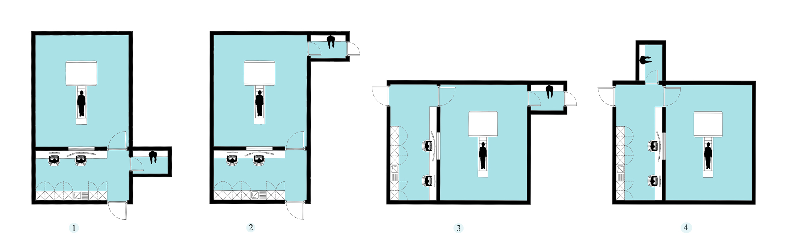
Figure 1. First item of the photo questionnaire

Table 1. Design strategies and interventions of the photo questionnaire
Design strategies | Interventions
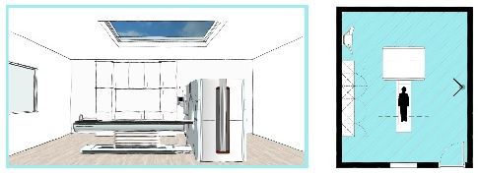  1. Exposure to the sky panel located on the ceiling of the CT room | 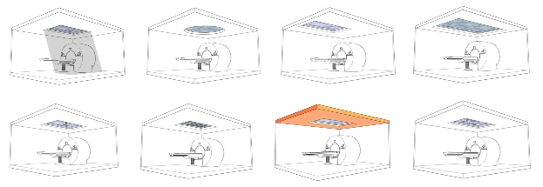
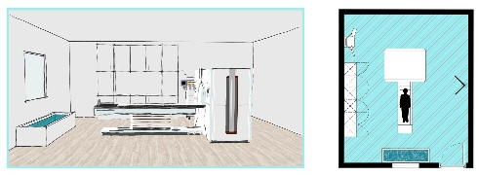2. Exposure to the water pool located adjacent to the wall between CT and the control room | 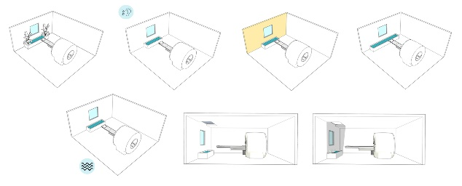
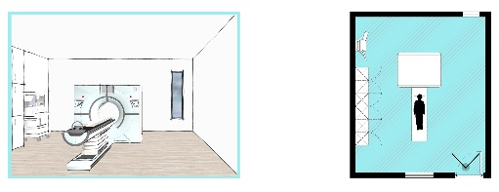  3. Exposure to the sky panel located on the wall in front of the door to the CT room | 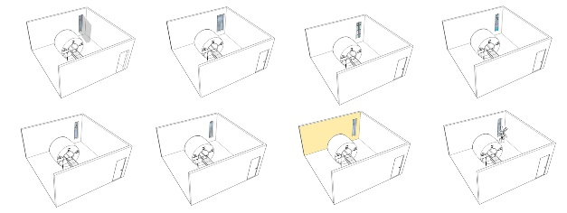
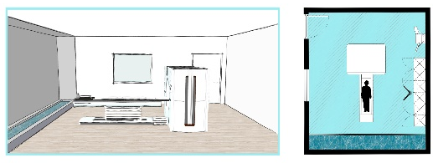  4. Exposure to the water pool located behind the glass wall in the CT room | 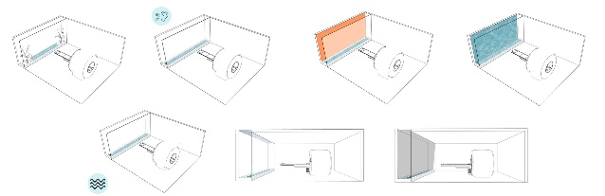
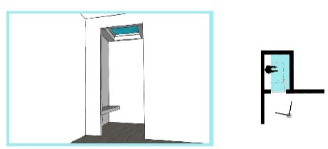  5. Exposure to the sky panel located on the ceiling of changing room | 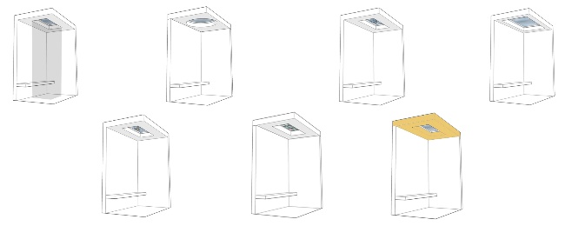
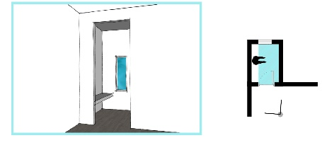  6. Exposure to the sky panel located on the wall of changing room | 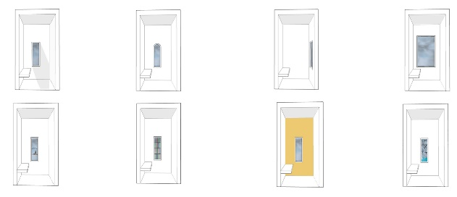

The second part offers several interventions to the original design strategy, such as changing the location of blue elements, adding movement to the content of blue elements, adding a water wall, adding green elements, adding a skylight, and changing the color of the wall containing the design strategy. Each item included the same questions for assessment. For the design strategy introduced in the first part, it was asked: “Please evaluate this environment on a scale of 1-5 (1-low, 5-high) in terms of its restorativeness and how effectively it can help to decrease patients' stress?”. For the interventions in the second part, the question was: “Considering your rating to the previous question, please write down the number of top three interventions that can enhance the influence of design strategy on reducing patients' stress.” As the last item, an open-comment section for suggestions and concerns was presented.

2.2.3. Online survey

The starting page of the online survey not only included an explanation of the project but also outlined how the blue elements are presented in feasible forms for healthcare settings (such as panels and projections).

2.2.4. Semi-structured interviews

The interviewer (FA) showed the photo questionnaire, while instead of the starting page, an explanation about the whole project was given and four existing implementations of blue elements that are applicable in healthcare settings were presented. Furthermore, interviewees were requested to explain their answers and they were allowed to change their responses during the interviews. Contrary to the online survey, for questions related to the interventions, they could select as many interventions as they intended.

2.2.5. Data analysis
For both phases, the frequency of responses was considered for the analysis since the sample groups were small.

3. Results

3.1. Results of the online survey
The preference of the participants for the 4 alternatives (see figure 1) was primarily for floor plans 1 and 2 (n=8), then plan 4 (n=5) and plan 3 (n=4).
The mean scores for questions related to the design strategies revealed architects’ estimations of the design strategies’ capability to provide a restorative and stress-reducing environment. Table 2 shows the mean differences between each pair of items (from the highest mean score to the lowest one), as well as the top three selected interventions. The highest rating, with a mean score of 4,20 on a scale of 1 (worst) to 5 (best), was received by design strategy number 1, featuring patients’ exposure to a sky panel located on the ceiling of the CT room. It was followed by design strategy number 5 (mean score of 3.72), including exposure to the sky panel located on the ceiling of the changing room. Design strategies number 3 (a sky panel on the wall in front of the door to the CT room) and number 6 (a sky panel on the wall of the changing room) were selected as the next effective strategies and got mean scores of 3.00 and 2.72 respectively. Both design strategies providing exposure to water were given the lowest ratings (2.20 for the water pool behind the glass wall and 1.96 for the water pool adjacent to the wall between the CT and control room). Therefore, the analysis shows that only two design strategies (the sky panel on the ceiling of the CT room (#1) and exposure to the sky panel on the ceiling of the changing room (#5)) associated with sky exposure got higher mean scores than 3 as the neutral point. Accordingly, architects did not agree with the restorativeness of any design strategy associated with water exposure (the water pool behind the glass wall (#2) and the water pool adjacent to the wall between the CT and control room (#4)). These results indicate that the participants rated water as less helpful in creating a restorative environment and decreasing patients' stress.
In the open-comment section of the survey, six architects stated that, due to technical and hygienic reasons, water cannot be applied to CT scan environments.
For design strategy number 1, the top three selected interventions were: adding artificial skylight (n= 16), changing the size of the sky panel (n=15), and adding motion to the content of the sky panel (n=15). For design strategy number 5, the top three interventions were: adding artificial skylight (n=20), changing the size of the sky panel (n=16), and changing the color of the ceiling (n=12). The last three preferred design strategies and the related top three interventions are shown in Table 2.
Table 2. Summary of online survey on preferred design strategies associated with blue elements in CT scan environments
Design strategies | Top three interventions
Strategy 1: Exposure to the sky panel located on the ceiling of the CT room (mean score: 4.2) | -Adding artificial skylight: 16 participants  -Changing the size of the sky panel: 15 participants  -Adding motion to the content of the sky panel: 15 participants
Strategy 5: Exposure to the sky panel located on the ceiling of the changing room  (mean score: 3.72) | -Adding artificial skylight: 20 participants  -Changing the size of the sky panel: 16 participants  -Changing the color of the ceiling: 12 participants
Strategy 3: Exposure to the sky panel on the wall in front of the door to the CT room  (mean score: 3.00) | -Adding green elements adjacent to the sky panel: 19 participants  -Adding artificial skylight: 14 participants  -Changing the size of the sky panel: 11 participants
Strategy 6: Exposure to the sky panel located on the wall of the changing room  (mean score: 2.72) | -Changing the size of the sky panel: 13 participants  -Adding artificial skylight: 12 participants  -Changing the color of the wall in the background: 12 participants
Strategy 4: Exposure to the water pool behind the glass wall  (mean score: 2.20) | -Adding a water wall: 17 participants  -Adding a source of light and creating water reflection on the ceiling and the wall: 16 participants  -Adding the sound of flowing water to the environment: 10 participants
Strategy 2: Exposure to the water pool located adjacent to the wall between the CT and control room  (mean score: 1.96) | - Adding a source of light and creating water reflection on the ceiling and the wall:19 participants  -Adding green elements adjacent to the water pool: 14 participants  -Adding the sound of flowing water to the environment: 11 participants

  - Results of semi-structured interviews
In the interviews on the preference for the CT scan room layout, four of the interviewees preferred floor plan 2. One of the interviewees emphasized that for the stress relief of patients, the environment should support a good connection with medical staff and floor plan number 2 is the most supportive one in this regard. Furthermore, while plan number 1 provides the possibility of patients passing through the control room, plan number 2 limits patients’ access only to the CT room. Two participants selected plan 3 as it provides better control over patients for medical staff, and consequently, it would be reassuring for patients to go through the CT procedure. Additionally, two interviewees pointed out that the better integration of floor plan number 3 with blue elements leads to a more restorative CT scan environment.
Results of the semi-structured interviews (see Table 3) showed that, contrary to the outcomes of the online survey, five participants regarded a water pool behind a glass wall (#5) as having the highest potential to create a restorative environment. It should be noted that two participants from the beginning selected the highest rating for this design strategy, while the other three initially selected a low rating for it and changed their opinions to a higher rating after observing the water wall as the intervention. Also, one interviewee, who personally was not interested in water and initially disagreed with having any forms of water in the CT scan environment, stated that the water wall is a piece of art, can create multisensory experiences (visual and auditory) for patients, and can lead to a better restorative CT scan environment.

The sky panel on the ceiling of CT room (#1) was selected as the second design strategy by four interviewees to bring about restorative influences on patients. For interventions related to the water pool behind the glass wall, experts declared that adding a water wall (n=6), adding a water sound (n=3), adding a sky panel on top of the water pool (n=3), and creating a reflection on the ceiling and the walls (n=2) can enhance the positive influences on patients. For exposure to the sky panel located on the ceiling, experts stated that adding motion to the content of the sky panel, including clouds movement and birds’ flight (n=4), adding an artificial skylight (n=3), changing the size of the panel (n=3), and changing the location of the panel (n=3), are able of bringing about a decrease in a patients’ stress.

Table 3. Summary of semi-structured interviews on preferred design strategies associated with blue elements in CT scan environments
Design strategies | Top three interventions
Strategy 4: Exposure to the water pool behind the glass wall  (mean score: 4.60) | - Adding a water wall: 6 interviewees  - Adding water sound: 3 interviewees  - Adding a sky panel on top of the water pool: 3 interviewees
Strategy 1: Exposure to the sky panel located on the ceiling of the CT room (mean score: 4.00) | -Adding motion to the content of the sky panel including clouds movement and birds’ flight: 4 interviewees  - Adding an artificial skylight: 3 interviewees  - Changing the size of the panel: 3 interviewees  - Changing the location of the panel: 3 interviewees
Strategy 6: Exposure to the sky panel located on the wall of the changing room (mean score: 3.00) | -Changing the size of the sky panel: 4 interviewees  -Adding green elements: 3 interviewees  -Adding motion to the content of the sky panel: 3 interviewees
Strategy 3: Exposure to the sky panel on the wall in front of the door of the CT room (mean score: 2.60) | -Adding green elements adjacent to the sky panel: 4 interviewees  -Adding artificial skylight: 2 interviewees  -Changing the size of the sky panel: 2 interviewees
Strategy 5: Exposure to the sky panel located on the ceiling of the changing room (mean score: 2.60) | -Changing the size of the sky panel: 3 interviewees  -Adding artificial skylight: 2 interviewees  -Adding green elements to the content of the sky panel: 2 interviewees
Strategy 2: Exposure to the water pool located adjacent to the wall between the CT and control room (mean score: 2.00) | -Adding a source of light and creating water reflection on the ceiling and the wall: 3 interviewees  -Adding the sound of flowing water to the environment: 3 interviewees  -Adding green elements adjacent to the water pool: 2 interviewees

4. Discussion

This paper aimed to clarify architects’ perspectives on the implementation of natural blue elements in CT scan environments. The results showed that, according to the architects’ opinion, exposure to the sky panel on the ceiling of the CT room and exposure to the water pool behind the glass wall in the CT room might create a more restorative environment for patients.

Generally, architects indicated the role of medical staff for the preferred layout. Considering the overlaps between the results of the online survey and semi-structured interviews, they both selected floor plan number 2 (see Fig.1), where the window of the control room is in front of the CT device, and subsequently, it provides a better view through the gantry during the CT process. They mentioned that it may better support patients’ contact with medical staff and the human contact can provide a more restorative journey for the patients. This remark revealed that specific architectural layouts are capable of increasing the positive influences of blue elements on patients in such environments, and layout should thus be taken into consideration for better implementation of blue elements.
This study showed that architects may not yet consider water as part of the blue elements, nor the restorative influence of it in CT rooms. Actually, the responses of architects to the survey (the online survey and its open-comment section) highlighted the impracticability of water in CT scan environments and that they have not considered the water as having high potential in making restorative healthcare spaces. On contrary, they argued that, due to hygienic reasons, it is not possible to have it in CT scan environments. These remarks suggest that there is the possibility that some of the participants skipped the starting page and lacked experience with feasible forms of implementing water in the healthcare setting. Consequently, water exposure is not considered as a strategy for restorative healthcare environments by architects and it has not found its place among them.

However, during the semi-structured interviews, interviewees stated that the design strategy associated with water is the most effective one to be implemented in a CT scan environment. They argued that, with the glass wall, water is well integrated into the environment and comes into stronger contact with the environment. Furthermore, the role of the water wall, which is the only intervention selected by all six interviewees, was highlighted since they declared that, as it is within the view of patients, their attention is drawn to it more notably. For exposure to the sky panel on the ceiling of the CT scan room, both groups of participants agreed that it might be an effective design strategy for making the CT scan environment more restorative. Interestingly, about the interventions that can alter positively the perceptions of design strategies, both groups agreed that adding natural light, adding motion to the content of the sky, and changing the size of the panel are helpful. During the semi-structured interviews, interviewees revealed more details about their selection. Regarding the size of the sky panel, two of them stated that, on the one hand, being too big might create the feeling of getting lost in the sky. On the other hand, when it is too small, it cannot attract the attention of patients during the short-term stressful CT scan procedure. One of the interviewees also pointed out that changing the location of the sky panel and placing it in a better view direction for the patients can improve the better relationship between the sky and the environment.

5. Conclusions
This study showed that architects consider the implementation of blue elements in the healthcare environment to be restorative for patients. Even though the majority of architects are aware of sky potential, water has not found its place in debates on healthcare facilities, especially in windowless areas such as CT scan environments. However, after an explanation of ways to implement water inside health care settings, architects seem very interested in pursuing water exposure and interventions that alter perceptions towards it.
The findings intend to increase awareness regarding blue elements’ role, specifically water, among architects as a group who act on the patients’ behalf and design environments that cater more efficiently to the patients’ needs.
Further research is needed to elucidate the perspective of patients in order to inform architects and, therefore, to have more holistic designs of healthcare environments associated with blue elements.

Contributor statement

The authors confirm their contribution to the paper as follows: study conception and design: Both authors; data collection: First author; analysis and interpretation of results: Both authors; draft manuscript preparation: First author. All authors reviewed the results and approved the final version of the manuscript.

Acknowledgments

The authors disclosed receipt of the following financial support for the research, authorship, and/or publication of this article: Scholarship Program for the Promotion of Early-Career Female Scientists of TUD.

We would like to thank all the architects of the organization “AKG-Architekten für Krankenhausbau und Gesundheitswesen” who distributed the online survey among their members.

Special thanks are extended to the six architects who contributed to further elucidate the topic during the interviews.

References
- Amirbeiki, F., & Khaki Ghasr, A. (2020). Investigating the Effects of Exposure to Natural Blue Elements on the Psychological Restoration of University Students. Iran University of Science & Technology, 30(1), 1-10.
2. Annerstedt, M., Jönsson, P., Wallergård, M., Johansson, G., Karlson, B., Grahn, P., . . . Währborg, P. (2013). Inducing physiological stress recovery with sounds of nature in a virtual reality forest—Results from a pilot study. Physiology & behavior, 118, 240-250.
3. Barker, S. B., Rasmussen, K. G., & Best, A. M. (2003). Effect of aquariums on electroconvulsive therapy patients. Anthrozoös, 16(3), 229-240.
4. Beukeboom, C. J., Langeveld, D., & Tanja-Dijkstra, K. (2012). Stress-reducing effects of real and artificial nature in a hospital waiting room. The Journal of Alternative and Complementary Medicine, 18(4), 329-333.
5. Edwards, N. E., & Beck, A. M. (2002). Animal-assisted therapy and nutrition in Alzheimer’s disease. Western journal of nursing research, 24(6), 697-712.
6. Huisman, E. R., Morales, E., van Hoof, J., & Kort, H. S. (2012). Healing environment: A review of the impact of physical environmental factors on users. Building and environment, 58, 70-80.
7. Kaplan, S. (1995). The restorative benefits of nature: Toward an integrative framework. Journal of environmental psychology, 15(3), 169-182.
8. Marquardt, G., Bueter, K., & Motzek, T. (2014). Impact of the design of the built environment on people with dementia: an evidence-based review. HERD: Health Environments Research & Design Journal, 8(1), 127-157.
9. Ottosson, J., & Grahn, P. (2008). The role of natural settings in crisis rehabilitation: how does the level of crisis influence the response to experiences of nature with regard to measures of rehabilitation? Landscape research, 33(1), 51-70.
10. Pati, D., Freier, P., O’Boyle, M., Amor, C., & Valipoor, S. (2016). The impact of simulated nature on patient outcomes: A study of photographic sky compositions. HERD: Health Environments Research & Design Journal, 9(2), 36-51.
11. Pati, D., O'Boyle, M., Amor, C., Hou, J., Valipoor, S., & Fang, D. (2014). Neural correlates of nature stimuli: an FMRI study. HERD: Health Environments Research & Design Journal, 7(2), 9-28.
12. Sternberg, E. M. (2010). Healing spaces: The science of place and well-being: Harvard University Press.
13. Tafti, F. A., Rezaeian, M., & Razavi, S. E. (2018). Sunken courtyards as educational environments: Occupant's perception and environmental satisfaction. Tunnelling and Underground Space Technology, 78, 124-134.
14. Tzoulas, K., Korpela, K., Venn, S., Yli-Pelkonen, V., Kaźmierczak, A., Niemela, J., & James, P. (2007). Promoting ecosystem and human health in urban areas using Green Infrastructure: A literature review. Landscape and urban planning, 81(3), 167-178.
15. Ulrich, R. S. (1984). View through a window may influence recovery from surgery. Science, 224(4647), 420-421.
16. Ulrich, R. S. (1997). A theory of supportive design for healthcare facilities. Paper presented at the Journal of healthcare design: proceedings from the... Symposium on Healthcare Design. Symposium on Healthcare Design.
17. Ulrich, R. S. (2001). Effects of healthcare environmental design on medical outcomes. Paper presented at the Design and Health: Proceedings of the Second International Conference on Health and Design. Stockholm, Sweden: Svensk Byggtjanst.
18. Ulrich, R. S., Simons, R. F., Losito, B. D., Fiorito, E., Miles, M. A., & Zelson, M. (1991). Stress recovery during exposure to natural and urban environments. Journal of environmental psychology, 11(3), 201-230.
19. Ulrich, R. S., Zimring, C., Zhu, X., DuBose, J., Seo, H.-B., Choi, Y.-S., . . . Joseph, A. (2008). A review of the research literature on evidence-based healthcare design. HERD: Health Environments Research & Design Journal, 1(3), 61-125.
20. Verderber, S. (2010). Innovations in hospital architecture: Routledge.
21. White, M. P., Elliott, L. R., Gascon, M., Roberts, B., & Fleming, L. E. (2020). Blue space, health and well-being: A narrative overview and synthesis of potential benefits. Environmental research, 191, 110169.
22. WHO, I. (1946). Preamble to the constitution of th World Health Organization as adopted by the International Health Conference. New York, 19-22.
23. Zijlstra, E., Hagedoorn, M., Krijnen, W. P., van der Schans, C. P., & Mobach, M. P. (2017). Motion nature projection reduces patient's psycho-physiological anxiety during CT imaging. Journal of Environmental Psychology, 53, 168-176.

