American Journal of Engineering and Applied Sciences
Review

Bio-Inspired Materials: Exhibited Characteristics and Integration Degree in Bio-Printing Operations
Antreas Kantaros

Department of Industrial Design and Production Engineering, University of West Attica, Greece

Article history  Received: 25-10-2022  Revised: 16-11-2022  Accepted: 21-11-2022 Email: akantaros@uniwa.gr | Abstract: In the last decade, additive manufacturing techniques, commonly known under the term "3d printing" have seen constantly increasing use in various scientific fields. The nature of these fabrication techniques that operate under a layer-by-layer material deposition principle features several de facto advantages, compared to traditional manufacturing techniques. These advantages range from the precise attribution of pre-designed complex shapes to the use of a variety of materials as raw materials in the process. However, its major strong point is the ability to fabricate custom shapes with interconnected lattices, and porous interiors that traditional manufacturing techniques cannot properly attribute. This potential is being largely exploited in the biomedical field in sectors like bio-printing, where such structures are being used for direct implantation into the human body. To meet the strict requirements that such procedures dictate, the fabricated items need to be made out of biomaterials exhibiting properties like biocompatibility, bioresorbability, biodegradability, and appropriate mechanical properties. This review aims not only to list the most important biomaterials used in these techniques but also to bring up their pros and cons in meeting the aforementioned characteristics that are vital in their use.  Keywords: 3D Printing, Βio-Printing, Biomaterials, Fused Deposition Modeling (FDM), Stereolithography (SLA) Direct Ink Writing (DIW) Laser- Guided Direct Writing (LGDW)

Introduction
Additive manufacturing, most commonly referred to as "3D printing", can be described as the additive process where a three-dimensional object is fabricated by laying successive material layers at controlled speed and layer thickness. These materials can be biomaterials, metals, ceramics, plastics, resins, concrete, or other materials. Even though printing time, processing speed and printing resolution have been constantly improving over recent years, still, the lack of variety in 3D printable materials persists. Emerging fields like 3D printing of biomaterials, 3D printing of tissues, and high viability cell printing are highly dependent upon printing ink's compatibility and flowability with the current printing techniques available. This study reports the advances in 3D printing materials for emerging biomedical fields and their compatibility with currently available printing techniques.
Bio-printing is the additive process of creating cell patterns by successively depositing cells along with biomaterials that form a substrate thereby fabricating living human constructs with similar biological, chemical and mechanical properties for proper recuperation of tissues, scaffolds and organs. Materials used in this process are known as biomaterials and should exhibit biocompatibility, i.e., being compatible with the human body, bioresorbability, i.e., being able to be naturally absorbed by the human body, biodegradability i.e., the capacity for biological degradation and appropriate mechanical properties dependent on the implantation spot (Bielenstein et al., 2022; Kowalewicz et al., 2021; Guo et al., 2022; Kantaros et al., 2016).
In this context, the field where the aforementioned bio- printing technique is growingly being adopted is tissue engineering. Tissue engineering is an innovative, multidisciplinary field that incorporates the fundamental principles of engineering and biology to invent structures with elevated biological functions. Regarding clinical

© 2022 Antreas Kantaros. This open-access article is distributed under a Creative Commons Attribution (CC-BY) 4.0
license.

applications, one of the most decisive targets of tissue engineering is to surpass the numerous barriers imposed by current treatments that are currently based mainly on organ transplants and biomaterial use for implantation (Guillotin and Guillemot, 2011). Organ and tissue malfunctions are a major problem regarding human health and well-being. Especially in cases where the human body fails to self-heal using its mechanisms, targeted medical intervention is crucial.
Even though tissue engineering may be newly introduced, the initial concept of tissue substitution was first expressed in the 16th century. Gasparo Tagliacozzi (1546-1599), Professor of Surgery and Anatomy at the University of Bologna, can be considered as the initial/first documented relevant case when he managed to construct a nose replacement by a forearm flap in “De Custorum Chirurigia per Insitionem” announced in 1597 (O'brien, 2011). The primal clinical application of human cells in this field involved skin tissue development by utilizing fibroblasts, keratinocytes, or a scaffold (that would act as a tissue substrate). In another published work, the regeneration procedure of rabbit articular surfaces by utilizing allograft chondrocytes along with collagen gel is also reported (Wakitani et al., 2002). A published literature work by Langer and Vacanti (1993) named "Tissue Engineering" is considered a great contribution towards advancing tissue engineering research on a worldwide scale (Ikada, 2006).
The first decade of the current century is linked with the first successful cases of developing the first solely lab- grown organs by utilizing 3D bioprinters. The contribution of Anthony Atala is considered fundamental in this field, where cell therapies, tissue engineering constructs, and organs for many diverse areas of the body have been developed (Anthony, 2022). In addition, he is attributed with the development of 3D bioprinters (Murphy and Atala, 2014) and, in 2006, he and his team developed the first lab-fabricated organ (a human bladder) for implantation to humans (Atala et al., 2006). Dr. Paolo de Coppi’s work is also fundamental in this sector, where a tissue-engineered tracheal replacement for a child being developed by him and his team was reported (Elliott et al., 2012).
Lattice tissue engineering structures fabricated by bio- printers and compatible biomaterials must exhibit a variety of desired characteristics in the sense of providing a proper substrate for 3D tissue development as the final target. More commonly referred to as "scaffolds", they act as bioresorbable constructs in the spot of the defect with the role of cell-encapsulated tissue constructs containing cells/hydrogels (Dong et al., 2017; Nicodemus and Bryant, 2008). They can be categorized as "acellular scaffolds" (scaffolds with no cells, like hip and knee implants, etc.) or "cellular scaffolds" (scaffolds with cells, like skin constructs). Bio-printed scaffolds should exhibit
the desired mechanical behavior in terms of providing mechanical integrity in the healing and degradation periods. Controlled porosity is also desired, where an interconnected pore network is considered crucial for blood and nutrient flow. The aforementioned dictates the ability for scaffold fabrication in well-defined geometrical shapes (Kantaros and Piromalis, 2021). Bio-printing techniques exhibit high potential in this field, by being able to provide dimensional stability, reproducibility, and the fabrication of pre-designed interconnected porosity networks at distinct sizes (Moroni et al., 2006; Amirkhani et al., 2012). Several published works describe cases of bio-printed scaffold structures (Moroni et al., 2006; Leong et al., 2003; Gauvin et al., 2012; Kantaros, 2022). Stages of the bio- printing process are depicted in Fig. 1.

3D Bioprinting Techniques

Stereolithography (SLA)
SLA printing is a 3D printing technique that uses a laser or a DLP projector to cure photopolymer resin layer-by-layer. SLA 3D printers use a UV laser or a DLP projector to cure a specific layer of photosensitive resin in a tank. The light source cures or hardens the resin, forming a very thin sliced solid layer. This slice bonds to the previously formed layer or the build plate. The build plate then moves away from a value that equals the pre- determined layer thickness. This is how the process of object formation is repeated until the complete object is created.
SLA printing produces higher resolution than FDM printing because it uses a light source to solidify the material, resulting in small-sized prints. The horizontal resolution of an SLA scanner depends on the size of the light source spot and can range from 30 to 140 microns. The vertical resolution (or Z-direction resolution) varies from 25 to 200 microns (Jo and Song, 2021). To create a good print, you need to set the layer height and the support placement correctly. Figure 2 depicts an SLA 3D Printer apparatus schematic.
Ink materials compatible with the SLA process should
exhibit properties like biocompatibility, stability under exposure to UV light, low viscosity, and optical transparency (Rasheed et al., 2021).
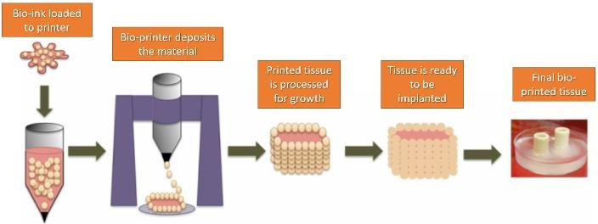

Fig. 1: Distinct stages of the bio-printing process

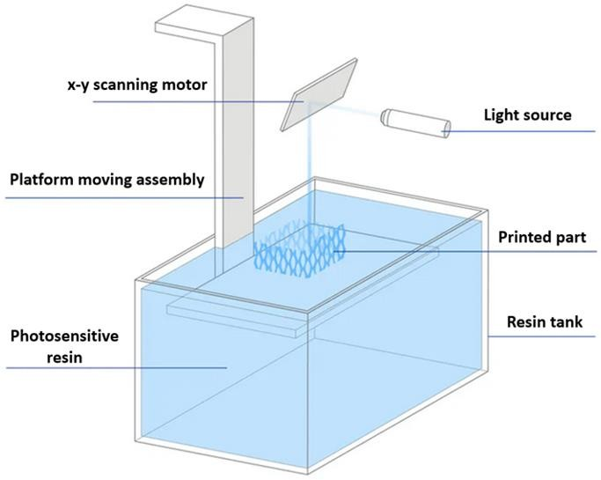

Fig. 2: Stereolithography 3D Printing schematic

Bio-Inks Compatible with SLA Process

Poly (D, L-Lactide) (PDLLA)
PDLLA is a versatile polymer with many applications in the medical field, including as a scaffold material for tissue engineering, as a controlled delivery system for drugs, and as synthetic nerve conduits made out of PDLLA, β-TCP, and collagen for regeneration of peripheral nerves (Hofmann et al., 2012; Lin et al., 2006; Lin et al., 2017).
Literature works describe the fabrication of composite scaffolds from HA biocement embedded in PDLLA oligomers using SLA 3D printing technology using ethyl 2,4,6-trimethylbenzoylphenylphosphinate as a photoinitiator and N-Methyl-2-Pyrrolidone (NMP) as a diluent. With increasing percentages of ceramic in the resin, the viscosity of the resin increases and so a non- reactive diluent, such as NMP, is necessary to help maintain the desired viscosity for SLA. It has been found that as the concentration of HA powders increases, the elasticity of the material increases. (Cai et al., 2019).

Poly (Propylene Fumarate) (PPF)
PPF is used in SLA due to exhibiting pho-to-cross- linkability. It is also biodegradable and possesses elevated mechanical properties. In the majority of cases, it is being used in SLA by creating a solution consisting of PPF as the base polymer and Diethyl Fumarate (DEF) as a solvent. The solvents were used in an attempt to avoid premature crosslinking of the polymer. Along with the above-mentioned solution, a photoinitiator is required in SLA. In this case, bisacryl phosphrine oxide is used. A proper balance between PPF and DEF is essential. It has been observed that with a ratio higher than 0.5 of PPF to DEF mechanical strength decreases significantly. On the other hand, adding DEF decreases the viscosity of the solution and hence improves printability. The recent
introduction of a ring-opening polymerization method allows the precise determination of PPF molecular mass, viscosity, and molecular mass distribution. Decreased molecular mass distribution assists in the time-certain resorption of the fabricated structures. Newly introduced post-polymerization and post-processing functionalization methods have increased the number of biomedical applications that use PPF material.
Recently, literature works suggest that the influence of PPF molecular mass in scaffolds fabricated via the SLA technique proved critical regarding the degradation rate and bone regeneration in vivo. PPF with lower mass exhibited finer behavior in healing rates while no inflammation and host cell acceptability were reported (Kondiah et al., 2020; Mamaghani et al., 2018).

PEGDA and GelMA Inks
Literature works report the use of SLA-based 3D bio- printing for a novel cell-laden cartilage tissue construction. The resin used was comprised of 10% Gelatin Methacrylate (GelMA) as base material, various percentages of Polyethene Glycol Diacrylate (PEGDA), biocompatible photo-initiator and trans-forming growth Factor-Beta 1 (TGF-β1) embedded nanospheres fabricated via a core-shell electrospraying technique. It was found that adding PEGDA to GelMA hydrogel greatly improved printability while compressive modulus also elevated proportionally with PEGDA whilst the swelling ratio decreased. Cells grown on 5/10% (PEGDA/GelMA) hydrogel present the highest cell viability and proliferation rate. The TGF-β1 embedded in nano- spheres can keep a sustained release for up to 21 days and improve the chondrogenic differentiation of encapsulated MSCs. Therefore, such materials feature high potential in cartilage regeneration processes (Martinez-Garcia et al., 2022; Jiang et al., 2022).

Fused Deposition Modeling (FDM)
In this technique, the material is led to the extrusion nozzle as a liquid of predefined viscosity or it is melted by the heated nozzle to form a layer on the build platform. The required ink is fabricated in the form of a solid filament which is then heated to a semi-molten state in the stage of extrusion. A temperature-controlled nozzle then oozes out the filament material. The forced-out extruded material is deposited onto a platform in a layer-by-layer deposition principle. After completing one layer, the platform gets lowered further and then the next layer gets deposited. The main parameters decisively contributing to the final properties of the material are layer thickness or height, printing speed, infill percentage, nozzle temperature, retraction, shell thickness, and support potential presence (Kantaros and Karalekas, 2013; Antreas and Piromalis, 2021; Kantaros et al., 2022; Kantaros and Karalekas 2013; Tsaramirsis et al., 2022; Kantaros et al., 2013).

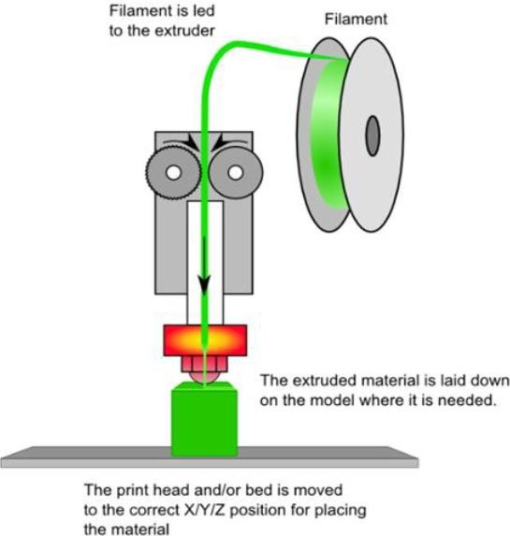

Fig. 3: Fused Deposition Modeling (FDM) schematic

Figure 3 depicts a Fused Deposition Modeling (FDM) 3D Printer apparatus schematic.
The majority of FDM printers are compatible with a wide range of inks. However, the viscosity should be greater than 6 × 10⁷ MPa/s, they should be molten at temperatures between 200 and 250℃ and a fast rate of solidification is needed to melt them. In addition, the ratio of elastic modulus to melt viscosity should be less than 5 × 10⁵ s⁻¹.

Bio-Inks Compatible with FDM Process

Poly (Caprolactone)
PCL has properties that make it well-suited for melt-based extrusion processes. The low acquisition cost and shear-thinning properties of this material make it well-suited for use in medical devices and its thermal stability makes it a desirable choice for medical applications. Published literature works suggest that PCL can be used to fabricate a tissue-engineered scaffold to be used as a restoration substrate of breast tissue after a partial mastectomy operation (Jwa et al., 2022). Other reported literature cases indicate the use of PCL material combined with sodium Mesoglycan (MSG) which exhibited high rates in targeted wound healing (Liparoti et al., 2022) and the design and bio- printing of a novel wound-dressing material by incorporating Juglone (5-hydroxy-1,4- naphthoquinone) to a 25% Polycaprolactone (PCL) scaffold (Ayran et al., 2022).

Poly (Lactic Acid)
Polylactic Acid (PLA) is one of the most commonly used polymers for FDM due to advantages such as biocompatibility, biodegradability, and low cost. The melting point temperature of this material makes it suitable for forming filaments and it can be extruded at a temperature of 180-250℃ (Kantaros et al., 2021). One of the challenges with PLA is the release of acidic by- products when it degrades. There was a significant decrease in the physiological acidity level due to the release of lactic acid. To reduce the likelihood of acidic release, PLA and ceramics are combined to create a composite material. The composite material also tends to increase the strength of compressive forces, making it a good candidate for tissue engineering processes.

Polyether Ether Ketone (PEEK)
Peek is a semi-crystalline thermoplastic polymer that has a melting temperature between 330-340℃ and a service temperature of 260℃ (Ikada, 2006). Due to its high melting point, it was initially excluded from its use in FDM processes. Recent advances in FDM printer technology have allowed the use of PEEK in FDM printers. Published literature suggests that the main factors affecting the 3D printing of PEEK in FDM processes are the melting point temperature, the extrusion speed, and the extrusion force. (Dorovskikh et al., 2022).

Poly-Vinyl Alcohol (PVA)
Poly-Vinyl Alcohol (PVA) is a synthetic polymer created by vinyl alcohol and acetate monomers. The presence of the latter provides biocompatibility, biodegradability, and bio- inertia. PVA is soluble in lukewarm water and can be used in FDM techniques in filament form. The tensile properties of this material are highly comparable to those of human articular cartilage, thus, providing a suitable substrate for bone cell ingrowth (Chua et al., 2004). Its hydrophilicity and chemical stability allow extreme pH and temperature exposure and its semi-crystalline form ensure proper oxygen and nutrients flow to the cell. PVA is extensively used in various load-bearing implant cases like cranio-facial defects and bone tissue regeneration treatments (Oka et al., 2000).

Direct Ink Writing (DIW)
DIW is an extrusion-based 3D printing exhibiting similarities with the FDM method that uses a nozzle to extrude materials onto a build platform in a layer-by-layer manner. By utilizing this technique, controlled deposition of raw materials in a highly viscous liquid state is achievable which allows them to retain their shape upon the deposition stage. DIW can be considered more versatile than FDM as it can use a large variety of materials ranging from ceramics, hydrogels, plastic, food, and even living cells. The prime parameters which decide the final properties of the product are nozzle size,

viscosity and density of the material, printing speed, and thickness kept between the layers. In DIW, similarly to FDM, the use of support structures is vital in cases of complex geometrical shapes featuring overhangs and steep deposition angles. However, the use of dissolvable materials as supports helps towards overcoming this issue due to their ability to be easily removed upon the completion of the printing procedure. The post- fabrication processing stages also assist in the elevation of the printed item’s mechanical properties (such as elastic modulus) by using UV-curing apparatus (Shuai et al., 2013a-b). Figure 4 depicts a Direct ink writing schematic
Ink materials using the DIW method should exhibit a fast rate of gelation and maintain proper structural integrity upon the completion of the printing process.

Laser-Guided Direct Writing (LGDW)
LGDW is a laser-assisted direct writing technique that is capable of depositing cells with micrometer accuracy. The technique of cell deposition using a weakly focused laser beam can be used on a variety of surfaces and matrices. Laser-guided bio-printing is a process in which a laser beam is used to direct cells onto a receiving substrate (Bunea et al., 2021).

Bio-Inks Suitable for DIW and LGDW

Hydrogel Inks
Hydrogels are complex three-dimensional networks of hydrophilic polymers that can absorb a large amount of water. The key advantage of those materials is their high biocompatibility and biodegradability rates because of their ability to supply the proper conditions that favor the encapsulation of viable cells further protecting the cells without hindering cell-cell interaction. Hydrogel inks should be able to flow fluently under working pressure conditions by exhibiting controlled viscosity. Also, they ought to provide sufficient structural integrity upon the completion of the printing, furthermore as a fast rate of gelation which will be controlled by exploiting shear thinning (Tamo et al., 2022). The literature desired approach to design a hydrogel ink is to fabricate a polymer solution that forms a network upon the completion of the printing process. The network thus formed could be physically or chemically crossed-linked using external stimuli like temperature, light, or ion concentration (Rioux et al., 2022). The majority of natural polymers such as gelatin, cellulose, collagen, fibrinogen, alginate, and agar and synthetic polymers such as polyacrylamide, polyurethane, Polyethene Glycol (PEG) are being utilized in hydrogel fabrication in 3D bio-printing (Ramezani et al., 2022; Teixeira et al., 2022).
The rate of proliferation towards the targeted tissue decreases as the polymer concentration and cross-linking
density increase. However, due to their increased viscosity, higher polymer concentrations are ideal for extrusion-based DIW. Mechanical properties increase as polymer concentration increases. Shear stress rises with viscous inks, high pressure, and small diameter nozzles and can cause cell death during extrusion. Shear stresses greater than 60 MPa have been found to cause 35% or more cell death (Duan, 2017). Thus, when using the DIW technique, shear stress is the most important parameter influencing resolution in hydrogel bioprinting.

Gelatin-Methacryloyl (GelMA)
GelMA is a semi-synthetic hydrogel consisting of gelatin derivatized with methacrylamide and methacrylate groups. Sauty et al. (2022). experimented that GelMA hydrogels can be synthesized with a specific Degree of Functionalization (DoF) and adjusted to the intended application as a three- Dimensional (3D) cell culture platform and GelMa was also shown to support cartilage tissue formation using chondrocytes and MSCs (Sauty et al., 2022). Piao et al. (2021) found out that while dispensing cell-laden GelMa from a glass capillary significantly higher pressure was required; however, cell vitality and proliferation weren't significantly affected.
Bio-printing neural tissues via DIW dictate some specific ink material requirements. More specifically, the elastic modulus (i.e., stiffness of the matrix of composite ink used) affects neural cell growth, vitality, and cell signaling. It has been found that brain tissues are compatible with a stiffness of 0.5 MPa approximately which is much less as compared to bone or cartilage tissues. Therefore, soft hydrogels need to exhibit low interfacial tension which allows cells to move across the tissue implant line. This can be achieved by a combination of two or more printing inks where one will possess the required biological property and the other with the task to regulate stiffness percentage (Mohd et al., 2022).
Recent research suggests several approaches to combining nucleic acid delivery and bio-printing. One of them is developing gene-activated bioink. In this case, the nucleic acid of interest and its delivery mechanism could be incorporated in a single step by encapsulating it in a bio-printable material, resulting in a gene-activated bio-ink (Wu et al., 2019).

Inkjet Bioprinting
Inkjet printing is a non-contact, controlled 3D printing process that allows for the dispersion of droplets with volumes ranging from 1-100 picoliters that include cell viability. Droplets are extruded from a nozzle in one of two ways: Drop by Drop (DOD) or Continuous Inkjet (CI) (CIJ). DOD is the more suited of the two for tissue engineering. Furthermore, DOD can be classified into three types according to the depositing techniques.

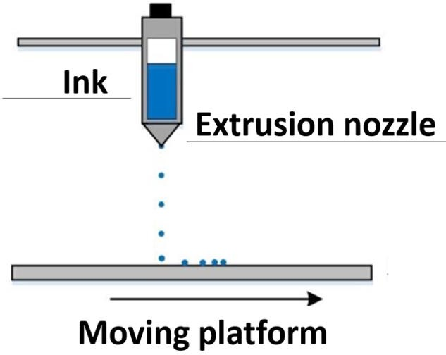

Fig. 4: Direct ink writing schematic
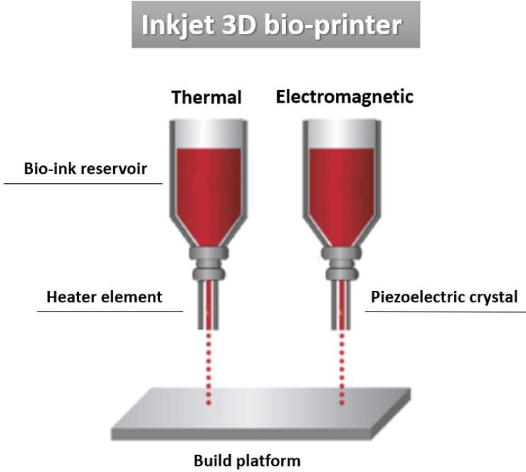
Fig. 5: Different Inkjet 3D bio-printer schematic Thermal (using heat to expand and deposit the material
before the nozzle), electromagnetic and mechanical are considered some examples. Individual drops with diameters ranging from 25 to 50 μm are generated according to predetermined requirements in DOD inkjet 3D bio-printing. In CIJ 3D bio-printing continuous streams of individual droplets possessing a volume of 100 µm in diameter are ejected. It is found that as far as tissue engineering is concerned, electromagnetic and thermal inkjet printing has not been broadly adopted since these processes tend to affect the cell wall and its vitality after sonication at 15-25 Hz. That is the reason why thermal inkjet is more widely used for better cell vitality (Xiao et al., 2022; Yang et al., 2022; Aversa et al., 2021a-b; Aversa et al., 2022; Yang et al., 2022). Multiple inkjets print heads consisting of
several individual nozzles are being utilized to fasten the process. In the case of Thermal Inkjet Printing, ink is super- heated and bubbles are created which expand further until the ink is released through the nozzle. The heating temperature can reach up to 300˚C for a few microseconds, thus, not affecting the viability of biologically printed DNA, cells, tissues, and other organs. Cell viability, in this case, has been found out approximately 85% (Tofan et al., 2022). Figure 5 depicts different inkjet3D bio-printer schematics.
In this technique, ink requirements dictate properties like desired viscosity and surface tension as viscosity affects clogging, and surface tension has an immense contribution to the shape of the drop not only after emerging from the nozzle but also on the substrate. The viscosity of the ink should be below 10 centipoises while surface tension should ideally range between 28-350 mn m⁻¹ (Yang et al., 2022).

Conclusion
3D Printing technology has greatly evolved in the past decade, with several different techniques being introduced in various fields and sectors. Available equipment now features reduced fabrication times as well as newly introduced materials, exhibiting a variety of properties. The introduction of 3D bio-printers utilizing bio-materials compatible with the human body offers an unprecedented ability to fabricate highly controlled porous interconnected structures that act as biological substrates for human cells to proliferate and lead to grown tissues. These structures must exhibit a variety of properties such as biocompatibility, bioresorbability as well as appropriate mechanical behavior. In this context, advanced biomaterials, like bio-inks acting as raw materials for 3D bio-printers, now offer the ability to produce high viability cell, tissue, and even direct DNA fabrication. The careful tuning of process parameters in the 3D bio-printer settings as well as the continuous introduction of new biomaterials possesses an unrivaled way to realize the full potential of this technology.

Funding Information
The authors have not received any financial support or funding to report.

Ethics
This article is original and contains unpublished material. The corresponding author confirms that all of the other authors have read and approved the manuscript and no ethical issues involved.

References
Amirkhani, S., Bagheri, R., & Yazdi, A. Z. (2012). Effect of pore geometry and loading direction on deformation mechanism of rapid prototyped scaffolds. Acta materialia, 60(6-7), 2778-2789. https://doi.org/10.1016/j.actamat.2012.01.044

Anthony, A. (2022) Wake Forest Innovations. https://www.wakeforestinnovations.com/experts/ant hony-atala-md/
Atala, A., Bauer, S. B., Soker, S., Yoo, J. J., & Retik, A.
B. (2006). Tissue-engineered autologous bladders for patients needing cystoplasty. The lancet, 367(9518), 1241-1246.
https://doi.org/10.1016/S0140-6736(06)68438-9 Antreas, K., & Piromalis, D. (2021). Employing a low-
cost desktop 3D printer: Challenges and how to overcome them by tuning key process parameters. Int. J. Mech. Appl, 10, 11-19. https://doi.org/10.5923/j.mechanics.20211001.02
Aversa, R., Petrescu, R. V., Perrotta, V., Ungureanu, L. M., Apicella, A., & Petrescu, F. I. T. (2022). Somethings About Biological Prostheses. Independent Journal of Management & Production, 13(2), 507-547. https://doi.org/10.14807/ijmp.v13i2.1585
Aversa, R., Petrescu, R. V. V., Apicella, A., & Petrescu, F. I. T. (2021a). About biological hip joint prostheses and the biomechanical behavior of implanted femur. Independent Journal of Management & Production, 12(8), 2017-2044. https://doi.org/10.14807/ijmp.v12i8.958
Aversa, R., Petrescu, R. V., Petrescu, F. I. T., Perrotta, V., Apicella, D., & Apicella, A. (2021b). Biomechanically Tunable Nano-Silica/P-HEMA Structural Hydrogels for Bone Scaffolding. Bioengineering, 8(4), 45. https://doi.org/10.3390/bioengineering8040045
Ayran, M., Dirican, A. Y., Saatcioglu, E., Ulag, S., Sahin, A., Aksu, B., ... & Ficai, A. (2022). 3D-Printed PCL Scaffolds Combined with Juglone for Skin Tissue Engineering. Bioengineering, 9(9), 427.427. https://doi.org/10.3390/bioengineering9090427
Bielenstein, J., Radenković, M., Najman, S., Liu, L., Ren, Y., Cai, B., ... & Barbeck, M. (2022). In Vivo Analysis of the Regeneration Capacity and Immune Response to Xenogeneic and Synthetic Bone Substitute Materials. International Journal of Molecular Sciences, 23(18), 10636. https://doi.org/10.3390/ijms231810636
Bunea, A. I., del Castillo Iniesta, N., Droumpali, A., Wetzel, A. E., Engay, E., & Taboryski, R. (2021, September). Micro 3D printing by two-photon polymerization: Configurations and parameters for the nanoscribe system. In Micro (Vol. 1, No. 2, pp. 164-180). MDPI.
https://doi.org/10.3390/micro1020013
Cai, Z., Wan, Y., Becker, M. L., Long, Y. Z., & Dean,
D. (2019). Poly (propylene fumarate)-based materials: Synthesis, functionalization, properties, device fabrication and biomedical applications. Biomaterials, 208, 45-71. https://doi.org/10.1016/j.biomaterials.2019.03.038
Chua, C. K., Leong, K. F., Tan, K. H., Wiria, F. E., & Cheah,
C. M. (2004). Development of tissue scaffolds using selective laser sintering of polyvinyl alcohol/hydroxyapatite biocomposite for craniofacial and joint defects. Journal of Materials Science: Materials in Medicine, 15(10), 1113-1121. https://doi.org/10.1023/B:JMSM.0000046393.814 49.a5
Dorovskikh, S. I., Vikulova, E. S., Sergeevichev, D. S., Guselnikova, T. Y., Zheravin, A. A., Nasimov, D. A.,
... & Morozova, N. B. (2022). Biological Studies of New Implant Materials Based on Carbon and Polymer Carriers with Film Heterostructures Containing Noble Metals. Biomedicines, 10(9), 2230. https://doi.org/10.3390/biomedicines10092230
Dong, L., Wang, S. J., Zhao, X. R., Zhu, Y. F., & Yu, J. K.
(2017). 3D-printed poly (ε-caprolactone) scaffold integrated with cell-laden chitosan hydrogels for bone tissue engineering. Scientific reports, 7(1), 1-9. https://doi.org/10.1038/s41598-017-13838-7
Duan, B. (2017). State-of-the-art review of 3D bioprinting for cardiovascular tissue engineering. Annals of biomedical engineering, 45(1), 195-209. https://doi.org/10.1007/s10439-016-1607-5
Elliott, M. J., De Coppi, P., Speggiorin, S., Roebuck, D., Butler, C. R., Samuel, E., ... & Birchall, M. A. (2012). Stem-cell-based, tissue engineered tracheal replacement in a child: A 2-year follow-up study. The Lancet, 380(9846), 994-1000.
https://doi.org/10.1016/S0140-6736(12)60737-5 Gauvin, R., Chen, Y. C., Lee, J. W., Soman, P.,
Zorlutuna, P., Nichol, J. W., ... & Khademhosseini,
- (2012). Microfabrication of complex porous tissue engineering scaffolds using 3D projection stereolithography. Biomaterials, 33(15), 3824-3834. https://doi.org/10.1016/j.biomaterials.2012.01.048
Guillotin, B., & Guillemot, F. (2011). Cell patterning technologies for organotypic tissue fabrication. Trends in biotechnology, 29(4), 183-190. https://doi.org/10.1016/j.tibtech.2010.12.008
Guo, C., Qi, J., Liu, J., Wang, H., Liu, Y., Feng, Y., & Xu, G. (2022). The Ability of Biodegradable Thermosensitive Hydrogel Composite Calcium- Silicon-Based Bioactive Bone Cement in Promoting Osteogenesis and Repairing Rabbit Distal Femoral Defects. Polymers, 14(18), 3852. https://doi.org/10.3390/polym14183852
Hofmann, M. C., Whited, B. M., Mitchell, J., Vogt, W. C., Criswell, T. L., Rylander, C. G., ... & Xu, Y. (2012). Scanning-fiber-based imaging method for tissue engineering. Journal of Biomedical Optics, 17(6), 066010.
https://doi.org/10.1117%2F1.JBO.17.6.066010 Ikada, Y. (2006). Challenges in tissue engineering.
Journal of the Royal Society Interface, 3(10), 589- 601. https://doi.org/10.1098/rsif.2006.0124

Jo, B. W., & Song, C. S. (2021). Thermoplastics and photopolymer desktop 3D printing system selection criteria based on technical specifications and performances for instructional applications. Technologies, 9(4), 91. https://doi.org/10.3390/technologies9040091
Jiang, F., Zhou, M., & Drummer, D. (2022). Effects of Fumed Silica on Thixotropic Behavior and Processing Window by UV-Assisted Direct Ink Writing. Polymers, 14(15), 3107. https://doi.org/10.3390/polym14153107
Jwa, S. J., Won, J. M., Kim, D. H., Kim, K. B., Lee, J.
- , Heo, M., ... & Baek, W. Y. (2022). Breast Tissue Restoration after the Partial Mastectomy Using Polycaprolactone Scaffold. Polymers, 14(18), 3817.
https://doi.org/10.3390/polym14183817
Kantaros, A. (2022). 3D Printing in Regenerative Medicine: Technologies and Resources Utilized. International Journal of Molecular Sciences. 2022; 23(23), 14621.
https://doi.org/10.3390/ijms232314621
Kantaros, A., & Karalekas, D. (2013). Fiber Bragg grating based investigation of residual strains in ABS parts fabricated by fused deposition modeling process. Materials & Design, 50, 44-50. https://doi.org/10.1016/j.matdes.2013.02.067
Kantaros, A., Diegel, O., Piromalis, D., Tsaramirsis, G., Khadidos, A. O., Khadidos, A. O., ... & Jan, S. (2022). 3D printing: Making an innovative technology widely accessible through makerspaces and outsourced services. Materials Today: Proceedings, 49, 2712-2723. https://doi.org/10.1016/j.matpr.2021.09.074
Kowalewicz, K., Vorndran, E., Feichtner, F., Waselau, A. C., Brueckner, M., & Meyer-Lindenberg, A. (2021). In-vivo degradation behavior and osseointegration of 3D powder-printed calcium magnesium phosphate cement scaffolds. Materials, 14(4), 946. https://doi.org/10.3390/ma14040946
Kantaros, A., & Piromalis, D. (2021). Fabricating lattice structures via 3D printing: The case of porous bio- engineered scaffolds. Applied Mechanics, 2(2), 289-
302. https://doi.org/10.3390/applmech2020018 Kantaros, A., Chatzidai, N., & Karalekas, D. (2016). 3D
printing-assisted design of scaffold structures. The International Journal of Advanced Manufacturing Technology, 82(1), 559-571. https://doi.org/10.1007/s00170-015-7386-6
Kantaros, A., Laskaris, N., Piromalis, D., & Ganetsos, T. (2021). Manufacturing zero-waste COVID-19 personal protection equipment: A case study of utilizing 3D printing while employing waste material recycling. Circular Economy and Sustainability, 1(3), 851-869. https://doi.org/10.1007/s43615-021-00047-8
Kantaros, A., Giannatsis, J., & Karalekas, D. (2013, October). A novel strategy for the incorporation of optical sensors in Fused Deposition Modeling parts. In Proc. Int. Conf. Adv. Manuf. Eng. Technol., Stockolm, Sweden (pp. 163-170). https://www.researchgate.net/publication/269631461_ A_novel_strategy_for_the_incorporation_of_optical_s ensors_in_FDM_parts
Kondiah, P. J., Kondiah, P. P., Choonara, Y. E., Marimuthu, T., & Pillay, V. (2020). A 3D bioprinted pseudo-bone drug delivery scaffold for bone tissue engineering. Pharmaceutics, 12(2), 166. https://doi.org/10.3390/pharmaceutics12020166
Leong, K. F., Cheah, C. M., & Chua, C. K. (2003). Solid freeform fabrication of three-dimensional scaffolds for engineering replacement tissues and organs. Biomaterials, 24(13), 2363-2378.
https://doi.org/10.1016/S0142-9612 (03)00030-9 Liparoti, S., Mottola, S., Viscusi, G., Belvedere, R., Petrella,
A., Gorrasi, G., ... & De Marco, I. (2022). Production of Mesoglycan/PCL Based Composites through Supercritical Impregnation. Molecules, 27(18), 5800. https://doi.org/10.3390/molecules27185800
Lin, Y. M., Boccaccini, A. R., Polak, J. M., Bishop, A. E., & Maquet, V. (2006). Biocompatibility of poly-DL- lactic acid (PDLLA) for lung tissue engineering. Journal of Biomaterials Applications, 21(2), 109-118. https://doi.org/10.1177/0885328206057952
Langer, R., & Vacanti, J. P. (1993). Tissue engineering.
Science, 260(5110), 920-926.
https://doi.org/10.1126/science.8493529
Lin, F., Wang, X., Wang, Y., Yang, Y., & Li, Y. (2017).
Preparation and biocompatibility of electrospinning PDLLA/β-TCP/collagen for peripheral nerve regeneration. RSC advances, 7(66), 41593-41602. https://doi.org/10.1039/C7RA05966C
Mamaghani, K. R., Naghib, S. M., Zahedi, A., Rahmanian, M., & Mozafari, M. (2018). GelMa/PEGDA containing graphene oxide as an IPN hydrogel with superior mechanical performance. Materials Today: Proceedings, 5(7), 15790-15799. https://doi.org/10.1016/j.matpr.2018.04.193
Martinez-Garcia, F. D., van Dongen, J. A., Burgess, J. K., & Harmsen, M. C. (2022). Matrix Metalloproteases from Adipose Tissue-Derived Stromal Cells Are Spatiotemporally Regulated by Hydrogel Mechanics in a 3D Microenvironment. Bioengineering, 9(8),
340. https://doi.org/10.3390/bioengineering9080340 Moroni, L., De Wijn, J. R., & Van Blitterswijk, C. A. (2006). 3D fiber-deposited scaffolds for tissue engineering: influence of pores geometry and architecture on dynamic mechanical properties.
Biomaterials, 27(7), 974-985. https://doi.org/10.1016/j.biomaterials.2005.07.023

Mack, B. C., Wright, K. W., & Davis, M. E. (2009). A biodegradable filament for controlled drug delivery. Journal of Controlled Release, 139(3), 205-211. https://doi.org/10.1016/j.jconrel.2009.06.020
Mohd, N., Razali, M., Ghazali, M. J., & Abu Kasim, N.
H. (2022). Current Advances of Three- Dimensional Bioprinting Application in Dentistry: A Scoping Review. Materials, 15(18), 6398. https://doi.org/10.3390/ma15186398
Murphy, S. V., & Atala, A. (2014). 3D bioprinting of tissues and organs. Nature Biotechnology, 32(8), 773-785. https://doi.org/10.1038/nbt.2958
Nicodemus, G. D., & Bryant, S. J. (2008). Cell encapsulation in biodegradable hydrogels for tissue engineering applications. Tissue Engineering Part B: Reviews, 14(2), 149-165.
https://doi.org/10.1089/ten.teb.2007.0332
O'brien, F. J. (2011). Biomaterials & scaffolds for tissue engineering. Materials Today, 14(3), 88-95. https://doi.org/10.1016/S1369-7021(11)70058-X
Oka, M., Ushio, K., Kumar, P., Ikeuchi, K., Hyon, S.
H., Nakamura, T., & Fujita, H. (2000). Development of artificial articular cartilage. Proceedings of the Institution of Mechanical Engineers, Part H: Journal of Engineering in Medicine, 214(1), 59-68. https://doi.org/10.1243/0954411001535246
Piao, Y., You, H., Xu, T., Bei, H. P., Piwko, I. Z.,
Kwan, Y. Y., & Zhao, X. (2021). Biomedical applications of gelatin methacryloyl hydrogels. Engineered Regeneration, 2, 47-56. https://doi.org/10.1016/j.engreg.2021.03.002
Rasheed, S., Lughmani, W. A., Obeidi, M. A., Brabazon, D., & Ahad, I. U. (2021). Additive Manufacturing of Bone Scaffolds Using PolyJet and Stereolithography Techniques. Applied Sciences, 11(16), 7336. https://doi.org/10.3390/app11167336
Rioux, Y., Fradette, J., Maciel, Y., Bégin-Drolet, A., & Ruel, J. (2022). Biofabrication of Sodium Alginate Hydrogel Scaffolds for Heart Valve Tissue Engineering. International Journal of Molecular Sciences, 23(15), 8567. https://doi.org/10.3390/ijms23158567
Ramezani, H., Mohammad Mirjamali, S., & He, Y. (2022). Simulations of Extrusion 3D Printing of Chitosan Hydrogels. Applied Sciences, 12(15), 7530. https://doi.org/10.3390/app12157530
Shuai, C., Mao, Z., Lu, H., Nie, Y., Hu, H., & Peng, S. (2013b). Fabrication of porous polyvinyl alcohol scaffold for bone tissue engineering via selective laser sintering. Biofabrication, 5(1), 015014. https://doi.org/10.1088/1758-5082/5/1/015014
Shuai, C., Mao, Z., Lu, H., Nie, Y., Hu, H., & Peng, S. (2013a). Fabrication of porous polyvinyl alcohol scaffold for bone tissue engineering via selective laser sintering. Biofabrication, 5(1), 015014. https://doi.org/10.1088/1758-5082/5/1/015014
Sauty, B., Santesarti, G., Fleischhammer, T., Lindner, P., Lavrentieva, A., Pepelanova, I., & Marino, M. (2022). Enabling Technologies for Obtaining Desired Stiffness Gradients in GelMA Hydrogels Constructs. Macromolecular Chemistry and Physics, 223(2), 2100326.
https://doi.org/10.1002/macp.202100326
Tsaramirsis, G., Kantaros, A., Al-Darraji, I., Piromalis, D., Apostolopoulos, C., Pavlopoulou, A., ... & Khan,
F. Q. (2022). A modern approach towards an industry
4.0 model: From driving technologies to management. Journal of Sensors, 2022. https://doi.org/10.1155/2022/5023011
Tamo, A. K., Tran, T. A., Doench, I., Jahangir, S., Lall,
A., David, L., ... & Osorio-Madrazo, A. (2022). 3D Printing of Cellulase-Laden Cellulose Nanofiber/Chitosan Hydrogel Composites: Towards Tissue Engineering Functional Biomaterials with Enzyme-Mediated Biodegradation. Materials, 15(17), 6039. https://doi.org/10.3390/ma15176039
Tofan, T., Borodinas, S., Kačianauskas, R., & Jasevičius,
R. (2022). Modeling 3D Droplet Movement Using a Drop-on-Demand Inkjet Printhead Model. Processes, 10(8), 1467. https://doi.org/10.3390/pr10081467
Teixeira, M. C., Lameirinhas, N. S., Carvalho, J. P., Valente, B. F., Luís, J., Pires, L., ... & Freire, C. S. (2022). Alginate-Lysozyme Nanofibers Hydrogels with Improved Rheological Behavior, Printability and Biological Properties for 3D Bioprinting Applications. Nanomaterials, 12(13), 2190. https://doi.org/10.3390/nano12132190
Wu, Y., Heikal, L., Ferns, G., Ghezzi, P., Nokhodchi, A., & Maniruzzaman, M. (2019). 3D bioprinting of novel biocompatible scaffolds for endothelial cell repair. Polymers, 11(12), 1924. https://doi.org/10.3390/polym11121924
Wakitani, S., Imoto, K., Yamamoto, T., Saito, M., Murata, N., & Yoneda, M. (2002). Human autologous culture expanded bone marrow mesenchymal cell transplantation for repair of cartilage defects in osteoarthritic knees. Osteoarthritis and Cartilage, 10(3), 199-206. https://doi.org/10.1053/joca.2001.0504
Xiao, X., Li, G., Liu, T., & Gu, M. (2022).
Experimental Study of the Jetting Behavior of High-Viscosity Nanosilver Inks in Inkjet-Based 3D Printing. Nanomaterials, 12(17), 3076. https://doi.org/10.3390/nano12173076
Yang, J., Petrescu, F. I. T., Li, Y., Song, D., & Shi, G. (2022). A Novel Bio-Inspired Ag/3D-TiO2/Si SERS Substrate with Ordered Moth-like Structure. Nanomaterials, 12(18), 3127. https://doi.org/10.3390/nano12183127

