American Journal of Engineering and Applied Sciences
Review

Setting up a Digital Twin Assisted Greenhouse Architecture
¹Antreas Kantaros and ²Dimitrios Piromalis

1Department of Industrial Design and Production Engineering, University of West Attica, Greece
2Department of Electrical and Electronics Engineering, University of West Attica, Greece

Article history  Received: 25-10-2022  Revised: 11-11-2022  Accepted: 11-11-2022  Corresponding Author: Antreas Kantaros Department of Industrial Design and Production Engineering, University of West Attica, Greece  Email: akantaros@uniwa.gr | Abstract: The present article contains a study about utilizing the Digital Twins concept in the field of contemporary agricultural production. Through this study, an exemplary architecture has been developed regarding the conversion of a conventional greenhouse to a digital greenhouse. A digital greenhouse modus operandi features a great number of advantages compared with the traditional workflow in a conventional greenhouse. The purpose of the work is to propose tools for assisting the possible reduction of the consumption of the used resources for the crops. This requires the application of automation of tools for cultivation such as Controlled Environment Agriculture (CEA). The article shows that the Digital Twins concept can immensely contribute towards controlling the agricultural environment and at the same time improve performance and quality while reducing the consumption of resources for a variety of crops. The proposed workflow starts by identifying the parameters that need to be taken into account and finally proposes several cyber and physical tools for setting up a Digital Twin for the case of a greenhouse. The objective of this study was the development of a DT architecture that would be able to optimize productivity in the context of CEA applications.  Keywords: Digital Twin, Cyber-Physical Systems, Simulation, Smart Agriculture, Greenhouse, 4th Industrial Revolution

Introduction
Currently, there is a need to increase productivity and reduce the resources being consumed. According to the data and statistics, it is estimated that by 2050 the world population will reach over 9.6 billion people. Today the population is estimated at 7.9 billion according to the UN's average estimate. Agricultural production must increase food production compared to today to ensure the nutrition demands of this population are met. However, there are many obstacles to this effort. Thus, arises the need for applying new, state-of-the-art innovative technologies in agricultural production systems. In this context, Digital Twin (DT) technology comes to the forefront. DTs in agriculture can offer productivity optimization by balancing production and resource consumption by using their prediction/forecasting ability. This will be achieved through the construction of a Digital Twin architecture for Controlled Environment Agriculture (CEA) which will optimize the following crucial elements depicted in Fig. 1.
According to Asseng and Cowan calculations (Asseng et al., 2020; Cowan et al., 2022), the wheat harvest using CEA is about 700±40 and 1940±230
tons/hectare/year whereas it was only 3.2 tons/hectare/year with traditional open field harvest. In addition, according to Nicole's finding (Nicole et al., 2016), lettuce quality is improved by growing it in plant factories, and the improvement is observed both in the color and nutritive value offered when consumed.
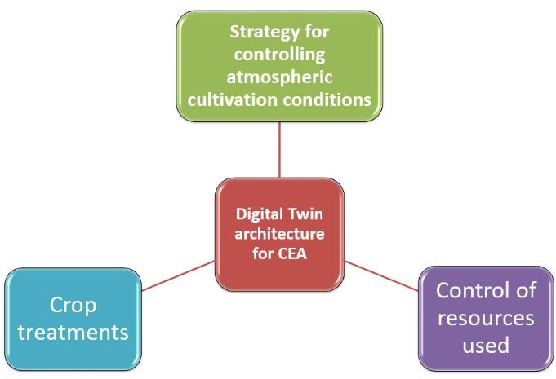

Fig. 1: Digital Twin architecture for Controlled Environment Agriculture (CEA)

© 2022 Antreas Kantaros and Dimitrios Piromalis. This open-access article is distributed under a Creative Commons
Attribution (CC-BY) 4.0 license.

However, the aforementioned optimization procedure has certain drawbacks. As the applied automation percentage increases, energy consumption increases as well, elevating operating costs. Graamans et al. (2018), found that by comparing the production of 1 kg of lettuce in a greenhouse or plant, 70, 111, 182, and 211 kWh are required in greenhouses and 247 kWh in plants in the Netherlands, while in the United Arab Emirates and Swe-den energy consumption is twice as high as in the Netherlands (in terms of building total energy). These data came from the study of
2 greenhouses in Sweden, one with additional artificial lighting and the other without. Based on the above data, it is obvious that the production benefits come into conflict with the energy consumption that creates a need for optimized choices in applying CEA systems. This is where Digital Twin technology can offer a potential solution. According to Kritzinger et al. (2018); Negri et al. (2017), DT "utilizes sensible data, mathematical models and real-time data processing to predict and optimize physical asset behavior in each phase of the life cycle, in real-time."

Digital Twins
Digital twins are virtual representations of real-time data on an object or system using simulations, engineer learning, and logical reasoning to aid in decision-making (Piromalis and Kantaros, 2022; Kantaros et al., 2021; Tsaramirsis et al., 2022; Singh et al., 2021). The operation of the Digital Twin is achieved through the precise representation of a physical object through the designed virtual model. The physical twin, for example, will contain some media (e.g., sensors) for data collection. Then the data are transferred to a corresponding processing system to be applied to the digital twin. This is used for the subsequent data in processing so that it is possible to study problems and performance issues to improve the physical object or system. Mainly the data are collected to re-apply the corresponding actions to be done on the original physical object. The application of Digital Twins in production enables the user to decrease the downtime of the equipment and at the same time increase productivity (Tao et al., 2019; Parrott and Warshaw, 2017; Erol et al., 2020; Barricelli et al., 2019; Liu et al., 2021; He and Bai, 2021).
At the highest level, a digital twin is an architectural
compilation powered by a combination of cutting-edge technologies such as IoT (Internet of Things), Cloud Computing, Edge Computing, Fog Computing, Artificial Intelligence, Robotics, Machine Learning, and Big Data Analytics. A Digital Twin is designed by collecting data and creating computational models for testing. This may include an interface between the digital model and a real physical
Table 1: Greenhouse Digital Twins applications/systems Greenhouse digital twins’ applications/systems
object for sending and receiving real-time feedback and data. By combining all the necessary digital technologies in a coherent platform, a virtual representation of agricultural production will be created consisting of natural elements, processes, systems, resources, etc., (Lu et al., 2020; Grieves, 2016; Batty, 2018; Markets and Markets, 2020; Tao et al., 2019).

Simulation Applications for Agriculture
In agricultural production, the fundamental resources that determine crop production are water, nitrogen, energy, and crop disease-tackling measures. In addition, data such as weather, soil characteristics, field hydrology, crop characteristics, sowing, and other factors should also be taken into account. For the compilation of a Digital Twin in agriculture and specifically for a greenhouse, simulation applications are needed for the digital display of the greenhouse. Simulation applications use tailored models for better management of specific physical object parameters to make the best possible production decisions.
In this context, applications from the literature were sought that will offer improvement in the way crops are managed and in monitoring the condition of crops, and for the reduction of crop treatments. A crucial factor that concerns all growers is the consumption of resources. The consumption of resources used for plant production is high water consumption, heating, and ventilation. The goal of growers is to reduce this consumption as much as possible.
Table 1 depicts some suggested applications/systems for the Digital Twin Greenhouse that can help manage energy, water, and crop health.

Energy Plus
Energy Plus is a simulation application for engineers, architects, and researchers designed to model energy i.e., energy such as heating, cooling, ventilation, lighting, and power receivers during loading, and also model the use of water. Energy Plus applies detailed building physics to the transfer of air, moisture, and heat, including radiation transfer and heat (convection and conduction) transfer separately to support the modeling of radiation systems and the calculation of thermal comfort measurements. It calculates light, shading, and visual comfort measurements. Flexible configuration is supported at the level of HVAC system components, installation cooling, and heating as well as including a large set of HVAC component models and installations. It simulates hourly time steps to quickly manipulate system dynamics and control strategies and has a programmed external interface for modeling control sequences and interfacing with other analyzes (Energy Plus, 2022).

Energy Plus | TRNSYS | DSSAT (decision support system for agrotechnology transfer) | CropX
 | Climate Field View | APSIM CropSyst

TRNSYS
TRNSYS offers a flexible graphical-based software environment, used to simulate the behavior of transient systems. It offers, like other similar systems, evaluation of the efficiency of thermal and electrical systems, but also can be used for modeling other dynamic systems, such as the flow circulation or biological processes. TRNSYS consists of two parts. The first is a Camera (called a kernel) that reads and processes the input file, repeatedly solves the system, determines convergence, and plots the system variables. The kernel also provides utilities that (among other things) determine the thermophysical properties, invert arrays, perform linear regressions and interrupt external data files. The second part of TRNSYS is an extensive data library, which models the performance of one part of the system. The application library offers approximately 150 models ranging from pumps to multi-zone buildings, wind turbines to electrolytes, weather data processors to economical routines, and basic HVAC equipment to emerging cutting-edge technologies (TRNSYS, 2022).

DSSAT (Decision Support System for Agrotechnology Transfer)
The Rural Technology Transfer Decision Support System (DSSAT) is an application that offers crop simulation models and tools for their more efficient use. The tools offer database management for soil, weather, crop management, experimental data, utilities, and application programs. Application models simulate growth and yield as a function of soil-plant-atmosphere dynamics. Includes farm management and accuracy, regional assessments of the impact of climate variability and climate change, genetic modeling and reproduction selection, water use, greenhouse gas emissions, and long-term viability through soil organic carbon and nitrogen balances. Crop models require daily weather data, soil surface, and profile information, and detailed crop management as data. At the end of each day, the water, nitrogen, phosphorus, and carbon balances of the plants and the soil are updated, as well as the stage of germination and reproductive development of the crop. For applications, DSSAT combines crop, soil, and weather databases with crop models and implementation programs to simulate multiannual results of crop management strategies (DSSAT, 2022).

CropX
CropX application is a system that offers automation and crop management with advanced analysis technologies for agriculture. The system offers management of irrigation, and fertilization with accurate forecasts, offering the best possible result. It processes data from the soil for an even better picture of the crop and the atmosphere that surrounds the crop. Thus, the system will be able to adapt the strategies of optimal cultivation. It then offers an adapted variable rate
irrigation system based on changing soil and weather conditions. It constantly adapts the specific needs of the crop to its development stage (CropX, 2022).

Climate Field View
The Climate Field View application helps in making decisions from crop data to maximize the yield of each cultivated acre. The system collects, stores, and visualizes critical data. In this way, it will be possible to monitor and measure the decisions made regarding the cultivation to improve the yield and maximize the profit (Climate Field View, 2022).

APSIM
The Agricultural Production Systems Simulator (APSIM) is internationally recognized as an extremely advanced platform for modeling and simulation of systems containing a platform that enables the simulation of systems with a variety of plant, animal, soil, climate, and management interactions. APSIM is constantly evolving, with new features being added to APSIM Next Generation. Its development and maintenance are based on strict standards of software science and engineering (APSIM, 2022).

CropSyst
CropSyst is a multi-year multi-crop crop simulation model developed by a team at the Department of Biological Systems Engineering at Washington State University. The model is used to study the impact of pruning system management on productivity (Stöckle et al., 2003).

Digital Twin Architecture Design and Compilation for a Greenhouse
Digital Twin's architecture development work to optimize productivity is conducted through the development of a controlled greenhouse environment. A greenhouse is an enclosed space, covered with a permeable (transparent or opaque) material, which allows sunlight to enter to heat the greenhouse during the day. In general, a greenhouse is necessary for the modification of climatic conditions internally in contrast to the external environment, to plant plants, and production of plant products regardless of the external climatic conditions. In case of an unwanted temperature rise, ventilation is necessary, while for cold nights or days, a heating system is necessary to maintain the desired temperature for plant growth (Howard et al., 2021; Verdouw et al., 2021; Pylianidis et al., 2021; Tekinerdogan and Verdouw, 2020; Monteiro et al., 2018; Howard et al., 2020a; Mukhtar et al., 2022; Borowski, 2021; Howard et al., 2020b; Yang et al., 2022). The necessary prerequisites for the creation of a greenhouse are depicted in Fig. 2.
The additional equipment required consists of the automation infrastructure elements of the greenhouse which

include systems of heating, ventilation, humidity, automatic control of the climatic conditions, and irrigation.

Construction of DT
For the proper compilation of the architecture for creating a greenhouse DT, the following elements depicted in Fig. 3 must be included.
In this context, Chaux's methodology based on virtual simulation technology is used for indicative development of the DT greenhouse architecture (Chaux et al., 2021; Traoré, 2021). It proposes a strategy to modernize production with DT systems including the following elements depicted in Table 2. According to Chaux’s methodology, ’The data necessary for the optimization must be available in the cloud and the user must download them in his/her local device. The optimization occurs in the local device and the optimal crop treatment and climate control strategy are communicated to the controller for its implementation through a gateway (Chaux et al., 2021).

Framework.
This stage includes the design of subsequent stages in which the developing architecture will operate with specific functions' definitions. This categorization includes the following parts with corresponding functions, i.e.:

- Greenhouse

A natural element that needs the help of DT to optimize production and where after the training the selected strategies will be verified.

- Controller

It is a set of measuring instrument layers, actuators, sensors, monitors, and controllers for the greenhouse. Which are important for the collection of data to be used in DT. Then the controller exchanges data with the network portal to make the corresponding appropriate decisions for the crop.

- Portal

It is the software that will be used for the connection between different network environments, i.e., at work, it is the connection between the physical and digital components. Its function is to transfer data to storage for later use.

- Storage

The data used by the simulation (current and historical) requires space to be stored as well as for decisions made. So that the data can be processed at any
time and there is a record of successful decisions to be used in the physical element. It is a very important part of DT tests.

- Intelligence Layer

The Intelligence Layer organizes and provides smart services. It is the main element used to direct the service. It is responsible for the evaluation and then the selection of the best strategy.

- Digital Twin (1)

One of the recommended or equivalent simulation applications to control power consumption resources.

- Digital Twin (2)

One of the recommended or equivalent simulation apps for controlling atmospheric conditions and selecting case-specific treatments.
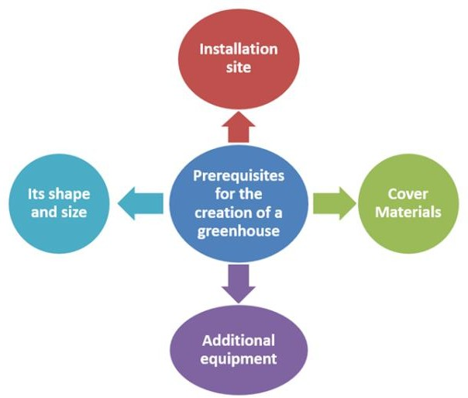

Fig. 2: Necessary prerequisites for the creation of a greenhouse
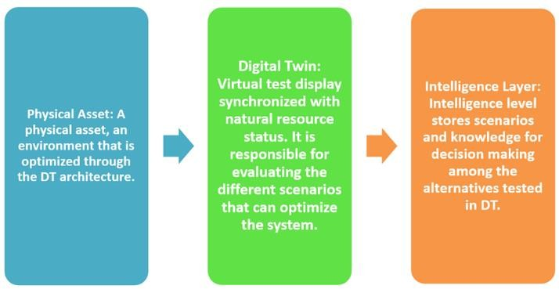

Fig. 3: Elements comprising the architecture set-up of a Digital Twin for a greenhouse

Table 2: Development stages of a DT greenhouse architecture

Physical-Cyber
Framework: Technologies: Digital Twin: Intelligence Layer: Interface: Implementation:

It is the framework on The point where The Use of selected This part is the Here is the part of Upon completing all the which the entire DT the non-structural simulation level of intelligence the interaction and stages, the elaboration the architecture will be elements of the to develop and whose main function data transmission and application of the based. An initial framework- planned use of software and to compare the physical architecture is applied, theoretical multilevel are implemented, models to optimize applied strategies and digital element, which is applied to the structure with functions applying the technologies to the physical and choose the it as also a responsible physical element for
the mode of necessary for operation element best one. It interacts for determining the verification Operation of the of the DT and the way with the applied way of interaction
designed DT in which they will interact technologies of the system

Technologies

- Greenhouse

For the collection of data from the physical element, sensors are needed to receive inside and outside temperature, humidity, and automatic mechanisms that based on the desired temperature and humidity will self-excite (regulate).

- Controller

The Arduino Uno Microcontroller can be used as a controller.

- Portal

The portal is used for communication between the controller and storage. Communication can be either wireless or serial.

- Storage

Storage of all data requires cloud storage which can host the data for example a database. i.e., the MySQL Database, specifically the phpMyAdmin.

- Intelligence Layer

An operating system to store, and connect with information such as data and financial aspects `to achieve communication between the level of intelligence and the DT.

- Digital Twin (1)

One of the recommended or equivalent simulation applications to control power consumption resources.

- Digital Twin (2)

One of the recommended or equivalent simulation apps for controlling atmospheric conditions and selecting case-specific treatments.

Intelligence Layer
The control and automation of agricultural production and in particular of a green-house consisting of distinct workflows. By properly defining the workflow sequence, the categorization of actions and their position in the value chain from farm to consumer can be achieved, which will be the optimization of productivity.

Workflow Optimization
- Climate conditions data flow: At the intelligence level, all data comes from the database, i.e., database cloud, which must be sent for processing to be used to create improvement strategies, as follows:
  - Data on the atmospheric conditions of the Climate inside the greenhouse which are temperature, relative humidity, solar gain/loss, and outdoor air speed
  - Data on the atmospheric conditions of the Climate outside the greenhouse which are temperature and relative humidity
  - All data on the previous cultivation conditions (atmospheric conditions and treatments)
- Climate conditions: The level of intelligence through the evaluation of the sent data and predicted data transfers to the software
- Data therapy cultivation data: The level of intelligence receives the predicted energy consumption data and atmospheric data to produce appropriate suitable conditions for the necessary application of therapies
- Crop treatments: Where the level of intelligence through the evaluation of the sent data and predicted data transfers them to the software for the selection of appropriate treatments
- Completion of the data flow: After all possible cultivation conditions have been obtained and tested, the best cultivation conditions are selected and applied with as little resource consumption as possible. It is the final stage where the final optimization is achieved
Figure 4 depicts a flowchart of the aforementioned steps regarding workflow optimization.

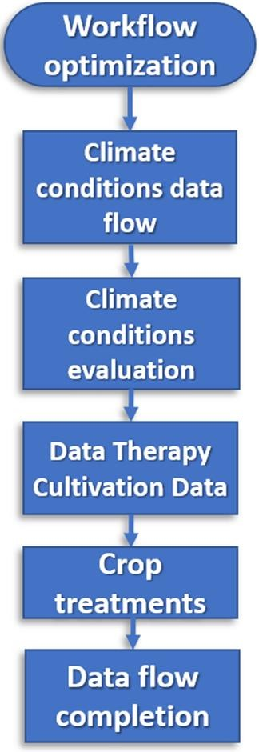

Fig. 4: Workflow optimization sequence

Physical-Cyber Interface
The interaction of the cyber-physical and physical system is an intelligent system, is a computer system through which the mechanism developed by computer- based algorithms is applied. Physical data is collected and computer components are integrated to operate a process safely and efficiently. CPS grasps the majority of beneficial elements that the Internet of Things (IoT) can offer, in its basic architecture. Thus, CPS can achieve a high combination and coordination between physical and computational components.
After defining the workflow, its operation consists of the following:

- The controller-level data received is transmitted through the network gateway continuously to the storage level
- In case of success of the strategic optimization, the corresponding data is sent to the local device, i.e., to the controller, so that the stream of optimization tasks can be applied at the level of intelligence

Implementation
In this stage, all the aforementioned steps are implemented, including the actual coding compilation and its application i.e., in the Arduino microcontroller and a platform such as Node-RED (Node-RED, 2022). Node-RED is a programming tool for combining hardware devices, APIs (Application Programming Interface), and online services for such purposes. In this context, it provides a browser- based editor that enables the simultaneous wiring of program flows using a wide range of nodes in the offered palette that can be deployed in a single click.

Conclusion
Agricultural production systems should innovate towards increasing production while utilizing fewer resources to assure food security. Digital twins and controlled environment agriculture may prove to be essential mechanisms for maximizing output and ensuring the world's food security.
The present work presents a step-by-step approach to the development of architecture regarding a Digital Twin- assisted controlled greenhouse. The goal was achieved by creating an architecture that makes use of simulation software (such as DTs) and allows for the optimization of climate control techniques connected to crop microclimate control. The proposed tools and actions show that it is possible to implement such a practice in an already existing greenhouse. Achieving a controlled environment in agriculture with the help of Digital Twins can be considered an essential tool to achieve productivity optimization to reduce the consumption of resources as well as to immensely contribute towards the seamless food supply of the planet (Symeonaki et al., 2021a; 2021b; 2019a,b; Aversa et al., 2016a,b; Petrescu and Petrescu, 2019; Petrescu et al., 2017). Such practices propose a new innovative approach for vertical integration and optimization of greenhouse processes to achieve elevated energy efficiency and production outputs without compromising the quality of the offered products or sustainability. In this context, the developed Digital Twins will be able to forecast how the physical twin will perform under constantly changing
operational conditions.
Future work can be identified as the proposed architecture's constant evolution due to the introduction of new software and hardware tools that will allow swifter development and integration of such practices. In this context, to confirm the capacity of the suggested DT architecture to maximize productivity, a case study must be implemented to validate the productivity increase.

Funding Information
This study did not receive any funding.

Author’s Contributions
Antreas Kantaros: Writing, edited.
Dimitrios Piromalis: Conceptualization, edited.

Ethics
There is no ethical concern, to the knowledge of the authors, that arises from the present work.

References
APSIM. (2022). https://www.apsim.info/
Asseng, S., Guarin, J. R., Raman, M., Monje, O., Kiss, G.,
Despommier, D. D., ... & Gauthier, P. P. (2020). Wheat yield potential in controlled-environment vertical farms. Proceedings of the National Academy of Sciences, 117(32), 19131-19135.
https://doi.org/10.1073/pnas.2002655117
Aversa, R., Petrescu, R. V., Petrescu, F. I., & Apicella, A. (2016a). Smart-factory: Optimization and process control of composite centrifuged pipes. American Journal of Applied Sciences, 13(11), 1330-1341. https://papers.ssrn.com/sol3/papers.cfm?abstract_id
=3075399
Aversa, R., Petrescu, R. V., Petrescu, F. I., & Apicella, A. (2016b). Biomimetic and evolutionary design-driven innovation in sustainable products development. American Journal of Engineering and Applied Sciences, 9(4). https://papers.ssrn.com/sol3/papers.cfm?abstract_id
=3074457
Barricelli, B. R., Casiraghi, E., & Fogli, D. (2019). A survey on digital twin: Definitions, characteristics, applications, and design implications. IEEE Access, 7, 167653-167671.
https://doi.org/10.1109/ACCESS.2019.2953499 Batty, M. (2018). Digital twins. Environment and Planning
B: Urban Analytics and City Science, 45(5), 817-820. https://doi.org/10.1177/2399808318796416
Borowski, P. F. (2021). Digitization, digital twins, blockchain, and industry 4.0 as elements of management process in enterprises in the energy sector. Energies, 14(7), 1885. https://doi.org/10.3390/en14071885
Chaux, J. D., Sanchez-Londono, D., & Barbieri, G. (2021). A digital twin architecture to optimize productivity within controlled environment agriculture. Applied Sciences, 11(19), 8875. https://doi.org/10.3390/app11198875
Climate Field View. (2022). https://climate.com/
Cowan, N., Ferrier, L., Spears, B., Drewer, J., Reay, D., & Skiba, U. (2022). CEA systems: The means to achieve future food security and environmental sustainability? Frontiers in Sustainable Food Systems, 6, 891256. https://doi.org/10.3389/fsufs.2022.891256
CropX. (2022). https://cropx.com/
DSSAT. (2022) https://dssat.net/
Energy Plus. (2022). https://energyplus.net/
Erol, T., Mendi, A. F., & Doğan, D. (2020, October). Digital transformation revolution with digital twin technology. In 2020 4th international symposium on multidisciplinary studies and innovative technologies (ISMSIT) (pp. 1-7). IEEE.
https://ieeexplore.ieee.org/abstract/document/9254288 Graamans, L., Baeza, E., Van Den Dobbelsteen, A.,
Tsafaras, I., & Stanghellini, C. (2018). Plant factories versus greenhouses: Comparison of resource use efficiency. Agricultural Systems, 160, 31-43. https://doi.org/10.1016/j.agsy.2017.11.003
Grieves, M. (2016). Origins of the Digital Twin Concept. 2016. https://www.researchgate.net/publication/30750972 7_Origins_of_the_Digital_Twin_Concept
He, B., & Bai, K. J. (2021). Digital twin-based sustainable intelligent manufacturing: A review. Advances in Manufacturing, 9(1), 1-21. https://doi.org/10.1007/s40436-020-00302-5
Howard, D. A., Ma, Z., & Jørgensen, B. N. (2020a, June). Digital Twin Framework for Energy Efficient Greenhouse Industry 4.0. In International Symposium on Ambient Intelligence (pp. 293-297). Springer, Cham. https://doi.org/10.1007/978-3-030- 58356-9_34
Howard, D. A., Ma, Z., Aaslyng, J. M., & Jørgensen, B.
N. (2020b, October). Data architecture for digital twin of commercial greenhouse production. In 2020 RIVF International Conference on Computing and Communication Technologies (RIVF) (pp. 1-7). IEEE. https://doi.org/10.1109/RIVF48685.2020.9140726
Howard, D. A., Ma, Z., Veje, C., Clausen, A., Aaslyng, J. M., & Jørgensen, B. N. (2021). Greenhouse industry 4.0–digital twin technology for commercial greenhouses. Energy Informatics, 4(2), 1-13. https://doi.org/10.1186/s42162-021-00161-9
Kantaros, A., Piromalis, D., Tsaramirsis, G., Papageorgas, P., & Tamimi, H. (2021). 3D printing and implementation of digital twins: Current trends and limitations. Applied System Innovation, 5(1), 7. https://doi.org/10.3390/asi5010007
Kritzinger, W., Karner, M., Traar, G., Henjes, J., & Sihn,
W. (2018). Digital Twin in manufacturing: A categorical literature review and classification. IFAC-PapersOnLine, 51(11), 1016-1022. https://doi.org/10.1016/j.ifacol.2018.08.474

Liu, M., Fang, S., Dong, H., & Xu, C. (2021). Review of digital twin about concepts, technologies, and industrial applications. Journal of Manufacturing Systems, 58, 346-361. https://doi.org/10.1016/j.jmsy.2020.06.017
Lu, Y., Liu, C., Kevin, I., Wang, K., Huang, H., & Xu, X. (2020). Digital Twin-driven smart manufacturing: Connotation, reference model, applications and research issues. Robotics and Computer-Integrated Manufacturing, 61, 101837. https://doi.org/10.1016/j.rcim.2019.101837
Markets & Markets. (2020). Digital Twin Market by Technology, Type (Product, Process, and System), Application (Predictive Maintenance and Others), Industry (Aerospace & Defense, Automotive & Transportation, Healthcare, and others), and Geography—Global Forecast to 2026; Markets and Markets: Pune, India, 2020; p. 177.
Monteiro, J., Barata, J., Veloso, M., Veloso, L., & Nunes,
J. (2018, September). Towards sustainable digital twins for vertical farming. In 2018 Thirteenth International Conference on Digital Information Management (ICDIM) (pp. 234-239). IEEE. https://doi.org/10.1109/ICDIM.2018.8847169
Mukhtar, H., Wunderlich, R. F., & Lin, Y. P. (2022). Digital Twins of the Soil Microbiome for Climate Mitigation. Environments, 9(3), 34. https://doi.org/10.3390/environments9030034
Negri, E., Fumagalli, L., & Macchi, M. (2017). A review of the roles of the digital twin in CPS-based production systems. Procedia Manufacturing, 11, 939-948. https://doi.org/10.1016/j.promfg.2017.07.198
Nicole, C. C. S., Charalambous, F., Martinakos, S., Van De Voort, S., Li, Z., Verhoog, M., & Krijn, M. (2016, May). Lettuce growth and quality optimization in a plant factory. In VIII International Symposium on Light in Horticulture 1134 (pp. 231-238). https://doi.org/10.17660/ActaHortic.2016.1134.31
Node-RED. (2022). https://nodered.org/
Parrott, A., & Warshaw, L. (2017). Industry 4.0 and the digital twin. Deloitte Insights.
Petrescu, N., & Petrescu, F. I. (2019). Energy Sources Today. Energy Research Journal. https://papers.ssrn.com/sol3/papers.cfm?abstract_id
=3460767
Petrescu, R. V., Aversa, R., & Florian, I. (2017). Permanent green energy production ttp://www.altenergymag.com/article/2017/04/perma nent-green-energy-production/25973
Piromalis, D., & Kantaros, A. (2022). Digital Twins in the Automotive Industry: The Road toward Physical- Digital Convergence. Applied System Innovation, 5(4), 65. https://doi.org/10.3390/asi5040065
Pylianidis, C., Osinga, S., & Athanasiadis, I. N. (2021). Introducing digital twins to agriculture. Computers and Electronics in Agriculture, 184, 105942. https://doi.org/10.1016/j.compag.2020.105942
Singh, M., Fuenmayor, E., Hinchy, E. P., Qiao, Y., Murray, N., & Devine, D. (2021). Digital twin: Origin to future. Applied System Innovation, 4(2), 36. https://doi.org/10.3390/asi4020036
Stöckle, C. O., Donatelli, M., & Nelson, R. (2003). CropSyst, a cropping systems simulation model European J. https://doi.org/10.1016/S1161-0301(02)00109-0
Symeonaki, E. G., Arvanitis, K. G., & Piromalis, D. D. (2019a). Current trends and challenges in the deployment of IoT technologies for climate-smart facility agriculture. International Journal of Sustainable Agricultural Management and Informatics, 5(2-3), 181-200. https://doi.org/10.1504/IJSAMI.2019.101673
Symeonaki, E., Arvanitis, K. G., Loukatos, D., & Piromalis, D. (2021a). Enabling IoT wireless technologies in sustainable livestock farming toward agriculture 4.0. In IoT-based Intelligent Modelling for Environmental and Ecological Engineering (pp. 213-232). Springer, Cham. https://doi.org/10.1007/978-3-030-71172-6_9
Symeonaki, E., Arvanitis, K., Papageorgas, P., & Piromalis, D. (2021b). AI-Based Chatbot System Integration to a Social Media Platform for Controlling IoT Devices in Smart Agriculture Facilities. In Information and Communication Technologies for Agriculture—Theme IV: Actions (pp. 193-209). Springer, Cham. https://doi.org/10.1007/978-3-030-84156-0_10
Symeonaki, E., Arvanitis, K., Piromalis, D., & Papoutsidakis, M. (2019b, September). Conversational User Interface Integration in Controlling IoT Devices Applied to Smart Agriculture: Analysis of a Chatbot System Design. In Proceedings of SAI Intelligent Systems Conference (pp. 1071-1088). Springer, Cham. https://doi.org/10.1007/978-3-030-29516-5_80
Tao, F., Zhang, M., & Nee, A. Y. C. (2019). Digital twin- driven smart manufacturing. Academic Press.
Tekinerdogan, B., & Verdouw, C. (2020). Systems architecture design pattern catalog for developing digital twins. Sensors, 20(18), 5103. https://doi.org/10.3390/s20185103
Traoré, M. K. (2021). Unifying Digital Twin framework: Simulation-based proof-of-concept. IFAC-Papers Online, 54(1), 886-893.
https://doi.org/10.1016/j.ifacol.2021.08.105 TRNSYS. (2022). https://www.trnsys.com/

Tsaramirsis, G., Kantaros, A., Al-Darraji, I., Piromalis, D., Apostolopoulos, C., Pavlopoulou, A., ... & Khan,
F. Q. (2022). A modern approach towards an industry
4.0 model: From driving technologies to management. Journal of Sensors, 2022. https://doi.org/10.1155/2022/5023011
Verdouw, C., Tekinerdogan, B., Beulens, A., & Wolfert,
S. (2021). Digital twins in smart farming. Agricultural Systems, 189, 103046. https://doi.org/10.1016/j.agsy.2020.103046
Yang, B., Lv, Z., & Wang, F. (2022). Digital Twins for Intelligent Green Buildings. Buildings, 12(6), 856. https://doi.org/10.3390/buildings12060856

