Type of the Paper: Peer-reviewed Conference Paper / Full Paper
Track title: User-needs - stroke & dementia

A day in stroke rehabilitation: Exploring different inpatient
experiences
Maja Kevdzija ^{1,2}
¹ Technische Universität Dresden, Faculty of Architecture, Chair of Social and Health Care Buildings and Design; ORCID: 0000-0003-2120-2026
² TU Wien, Faculty of Architecture and Planning, Institute of Architecture and Design;
maja.kevdzija@tuwien.ac.at*

Names of the Topic editors:
Clarine van Oel
Names of the reviewers:
Birgit Jürgenhake
Ann Petermans
Journal: The Evolving Scholar
DOI:10.24404/6230f24578c03045d3f728c8

Submitted: 15 Mar 2022
Accepted: 22 August 2022
Published: 3 May 2023
Citation: Kevdzija, M. (2022). A day in stroke rehabilitation: Exploring different inpatient experiences [preprint]. The Evolving Scholar | ARCH22.

This work is licensed under a Creative Commons Attribution CC BY license (CC BY).

© 2022 [Kevdzija, M.] published by TU Delft OPEN on behalf of the authors.

Abstract: This research aims to provide insight into the various ways stroke patients use and interact with the built environment during their inpatient stay in rehabilitation centres. Rehabilitation centres are multi-story buildings where stroke patients live for weeks or months to receive intensive, individualised therapies. Regardless of their impairments and abilities, patients are commonly accommodated in similar ward types with shared therapy rooms. They are generally inactive during rehabilitation, and the built environment's impact on patient experience and recovery is still unclear. Five stroke patients (LOS on the observation day ranging from 7 to 128 days) were shadowed for one whole day, each in a different centre. They were all wheelchair users in the same rehabilitation phase. Patients' movements in the centres, their comments, the spaces they visited, and the challenges they encountered were recorded. A patient survey accompanied the shadowing. Physical barriers experienced by patients, level of dependency on staff, reliance on different built environment elements (e.g., handrails) for mobility support, and patients' spatial preferences differed greatly. Their use of free time during the day and the amount of socialisation with others also differed. While some patients may greatly benefit from a supportive and barrier-free environment, others may find that a more challenging environment with training opportunities contributes better to their recovery. These differences in patients' behaviours and experiences may help inform the design of rehabilitation environments.
Keywords: stroke patients; rehabilitation centres; patient shadowing; built environment; rehabilitation day

1. Introduction
A stroke is a sudden event that can completely change how people experience and interact with the built environment. The post-stroke impairments experienced after a stroke are numerous and complex. In addition to hemiparesis (one-sided weakness) or hemiplegia (one-sided paralysis), stroke patients can have different cognitive deficits, encompassing memory, orientation, language, and attention (Tatemichi et al., 1994), speech difficulties (Flowers et al., 2016), and visual impairments (Rowe et al., 2009). Additionally, stroke patients frequently experience spatial awareness and navigation difficulties, reducing their wayfinding ability (Claessen, 2017). This can impact their independence (Desrosiers et al., 2002) and quality of life (De Wit et al., 2017). Older stroke patients are also less likely to recover and regain independence after a stroke (Knoflach et al., 2012; Kugler et al., 2003), most likely due to the added age-related impairments and comorbidities typical for older age (Ween et al., 1996). As a result, post-stroke rehabilitation is critical for restoring lost capabilities, increasing independence in everyday activities, and returning home.
Rehabilitation centres are multi-story buildings where stroke patients stay as inpatients for multiple weeks or months to receive intensive, individualised therapies after their hospital stay. Regardless of their impairments and abilities, patients are commonly accommodated in the same ward types with shared therapy rooms and communal areas. Time use studies in various types of rehabilitation environments, from hospital wards to rehabilitation centres, found that patients are very inactive and that only a small proportion of time is spent in therapy (Anåker et al., 2018; Åstrand et al., 2016; Blennerhassett et al., 2018; Chen et al., 2020; de Wit et al., 2005; West & Bernhardt, 2012). Furthermore, stroke patients are highly bored during inpatient rehabilitation (Kenah, 2022) and wish for more recreational and social activities (Luker et al., 2015).
Recent studies increasingly recognise that the built environment could play a role in the patients' experiences and activities during rehabilitation (Anåker et al., 2019; Nordin et al., 2021; Kevdzija & Marquardt, 2021). While some studies investigate the effect of the enriched environment on patients' activity levels (Janssen et al., 2014, 2021; Rosbergen et al., 2017), others focus on various aspects of the built environment (Anåker et al., 2018; Kevdzija & Marquardt 2021, 2022; Lipson-Smith et al., 2019, 2020). Still, the built environment's impact on patients' well-being, activity levels, and the recovery process is not entirely understood, as the field of research focusing on stroke rehabilitation environments is in its early stages (Lipson-Smith et al., 2021).

2. Theories and Methods
Even though the number of qualitative research studies exploring older people's experiences of healthcare environments is increasing, there is still a lack of observational studies (van der Meide et al., 2015). Furthermore, observational research involving stroke patients mainly focuses on quantitative aspects such as time use and activity levels using behavioural mapping (Blennerhassett, 2018). This focus on quantitative data might not provide a complete picture of patients' behaviours and experiences during rehabilitation. At the same time, the prevalent qualitative approach of using interviews to explore patients' experiences relies on their recollections of events (Booth & Booth, 1996) and might exclude participants who are unable to communicate or are not capable of adequately describing their experiences (Kirkevold & Bergland, 2007).
As stroke patients often experience cognitive speech impairments, and since the study was limited by a language barrier between the researcher and the patients, the shadowing method (Quinlan, 2008) was selected to explore patients' daily interactions with the built environment. When available, patients' comments were recorded as textual notes. To supplement the shadowing findings, a survey asking patients about their favourite spaces in the centre and the barriers they experienced in the built environment was used to give them more flexibility and opportunities to express themselves. This survey consisted of open-ended and multiple-choice questions (with an open-ended "other" option), allowing patients to freely express their thoughts and experiences. The extended amount of time spent shadowing a person allowed for focusing on the often overlooked aspects of everyday activities (Meunier & Vasquez, 2008). The researcher's feelings and thoughts prompted by what was observed frequently lead to valuable insights; however, they do not imply the researcher's complete immersion in the shadowee's experiences (van der Meide, 2013).
Even though shadowing in architectural research is commonly used with an objectivist approach to record behaviour in the form of counts of occurrences of behaviours against predetermined categories (McDonald, 2005), this study used an exploratory research approach (Kevdzija, 2022). The results presented in this paper are part of larger research where more than 70 stroke patients were shadowed. One researcher shadowed each patient for one whole day (12 consecutive hours). The researcher adopted an open attitude and made an effort to write down as much as possible of what was happening (van der Meide et al., 2013), using the building's floor plans and the previously prepared time log sheets without predetermined behaviour categories. Patients' movements in the centres, their comments, the spaces they visited, and their interactions with the built environment were recorded in the form of paths drawn on the floor plans, sketches, and textual notes.
Shadowing started around the patient's breakfast and continued until after their dinner (after 12 hours had passed). Unless explicitly invited by the patient, the researcher did not shadow patients inside their rooms or therapy rooms to protect their privacy. This research was approved by the Ethical Committee of TU Dresden, and all participants consented to the study.

3. Results
The five patient cases presented in this paper were selected because they represented distinctive interactions with the built environment. Each patient was recovering at a different rehabilitation centre. Their length of stay on the shadowing day ranged from 7 to 128 days, and they were all wheelchair users in the same rehabilitation phase. Each patient's day is presented in the form of a time-use sunburst diagram (Figure 1) and a short story highlighting the main observed events and activities and patients' perspectives (shared verbally or in their survey responses). Some of the patients could not verbally communicate with the researcher; this is why their direct verbal quotations and quotations from the survey are presented in the same way in the results section. The names used in this paper were chosen by the author to preserve patients' privacy.

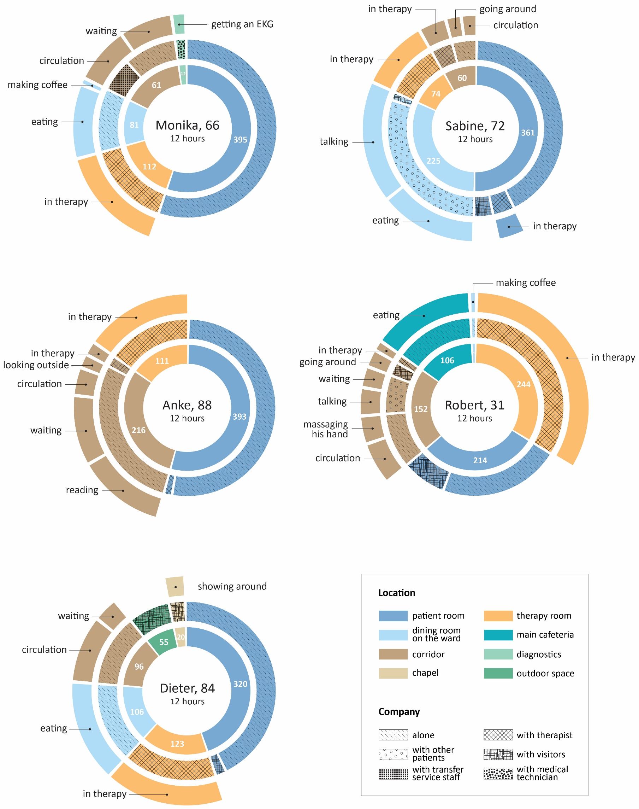
Figure 1. Patients' observed activities and locations during 12 consecutive hours of shadowing. The first circle (starting from inside) shows time spent per location in minutes; the second circle shows patients' company; and the third circle shows their activities.

3.1. Monika (age: 66)
She arrived at the rehabilitation centre seven days ago. As for most people, her stroke was a sudden and devastating event, especially because she saw herself as still young and relatively fit and healthy. The patient described her experience with a stroke.
She was a single woman living alone in an apartment. She fell asleep on the couch in front of the TV one night. She awoke in the middle of the night and tried to stand up, but she lost her balance and fell to the floor. Something was wrong, so she went to look for her phone; it was in the kitchen. Her muscles on one side were weak. It took her a long time to drag herself across the kitchen floor and call for help. Fortunately, she recovered enough in the hospital to be transferred to a rehabilitation facility. She was grateful for the opportunity. (Field notes)
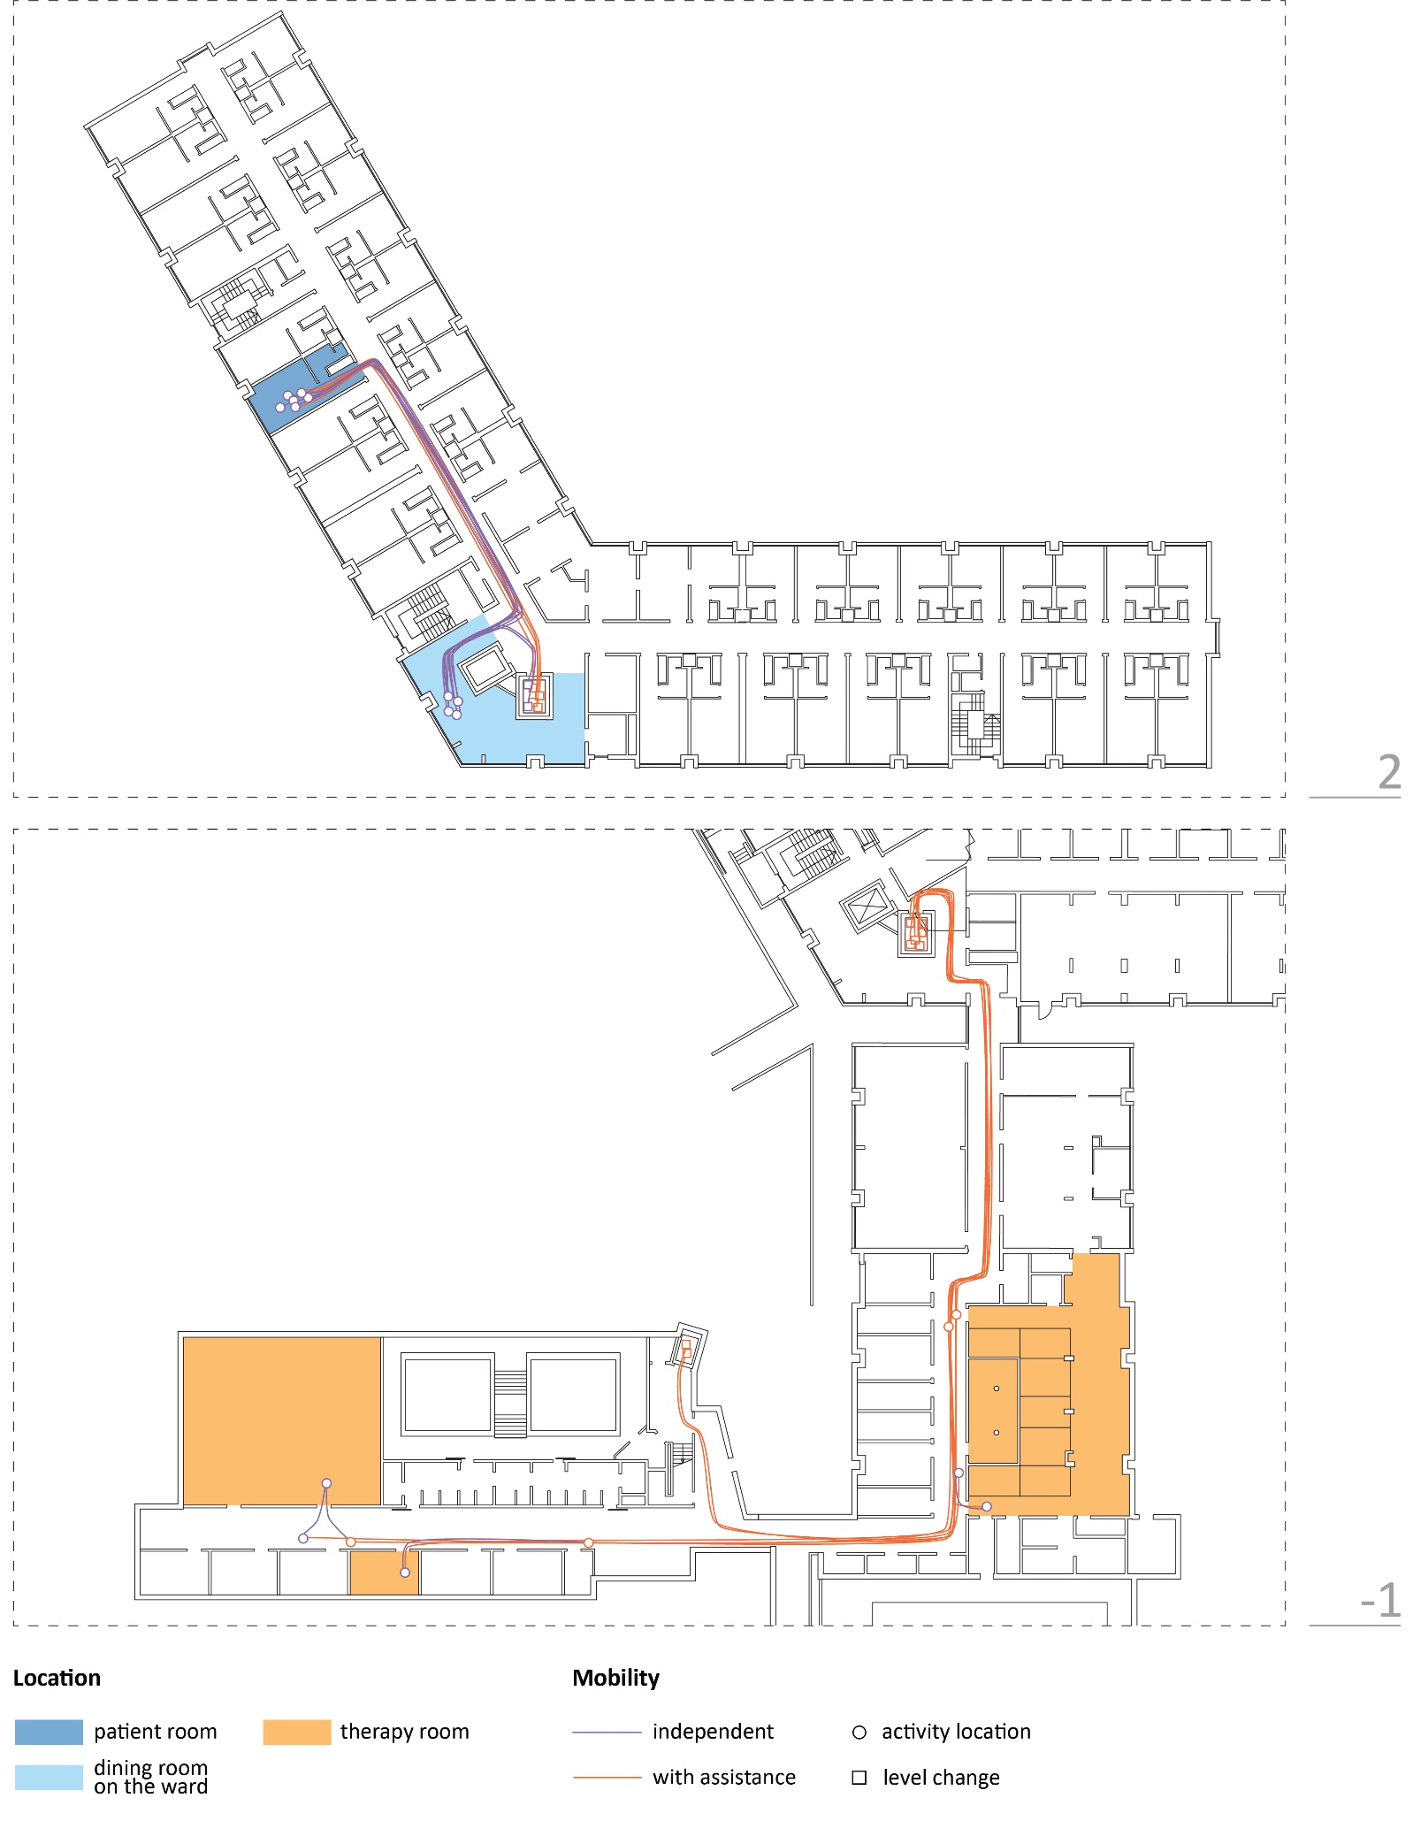
Figure 2. Floor plans showing Monika's movements during 12 observation hours
Monika needed a wheelchair for mobility and could not cover long distances because of her one-sided muscle weakness (hemiparesis). Because the rehabilitation centre had a "hotel-like" configuration with patient rooms on the upper floors and therapy rooms spread on the basement level, therapy rooms were too far away for her to reach independently. On the shadowing day, she was transported to all therapies by a centre's transfer service staff member (Figure 2). She acknowledged that distance was a challenge for her: "You have to travel long distances between therapies." One corridor on the basement level was especially challenging because it connected the neurological and orthopaedic rehabilitation centres. "There is a connecting corridor that is a slope. This can't be handled alone using a wheelchair." Monika also found the centre difficult for wayfinding; "it all seems a bit chaotic to me."
Around 3 p.m., Monika went to the small living/dining room shared by two wards on her floor to make coffee and take it to her room. This space was close to her room, and she could visit it independently (Figure 2). This was also the space where she had all her meals during the day. She shared that she visited the main cafeteria on the ground floor with her visitors several times per week. "It is the only room in the centre where you can sit reasonably comfortably." She complained that this cafeteria closed too early: "Opening hours are far too short! It should be open until at least 9 p.m."

3.2. Anke (age: 88)
Before the scheduled shadowing day, Anke had been in the rehabilitation centre for 24 days. She was experiencing right-sided hemiparesis and had to rely on a wheelchair to move around the centre. Her patient room was on the same floor as the main therapy corridor. She was required to reach therapies independently, but her meals were delivered to her room. Even though the corridor with all the therapy rooms she had to visit was only 26 m away from her room, with the farthest therapy room being 73 m away, she had a lot of difficulty going to therapy on her own. She shared that the main barrier she experienced in the built environment was "long corridors; I am still weak and slow at using the wheelchair independently." Each trip to the therapy room and back was challenging for Anke (Figure 3).
She is going to therapy. She stops to rest in the corridor. She cannot pass through the corridor and has to wait because another patient in a wheelchair is in front. After the patient moves, she continues and arrives in the therapy room. She is too early and has to wait in front of the therapy room. There is not enough space to park her wheelchair in front of the therapy room, and she is blocking the door. (Field notes)
She is going back to her room after therapy. Stops to rest. She continues moving, using the handrail on the wall to pull herself. She stops to rest again. She continues, using the handrail to pull herself, stops to rest, and then uses the handrail again. (Field notes)
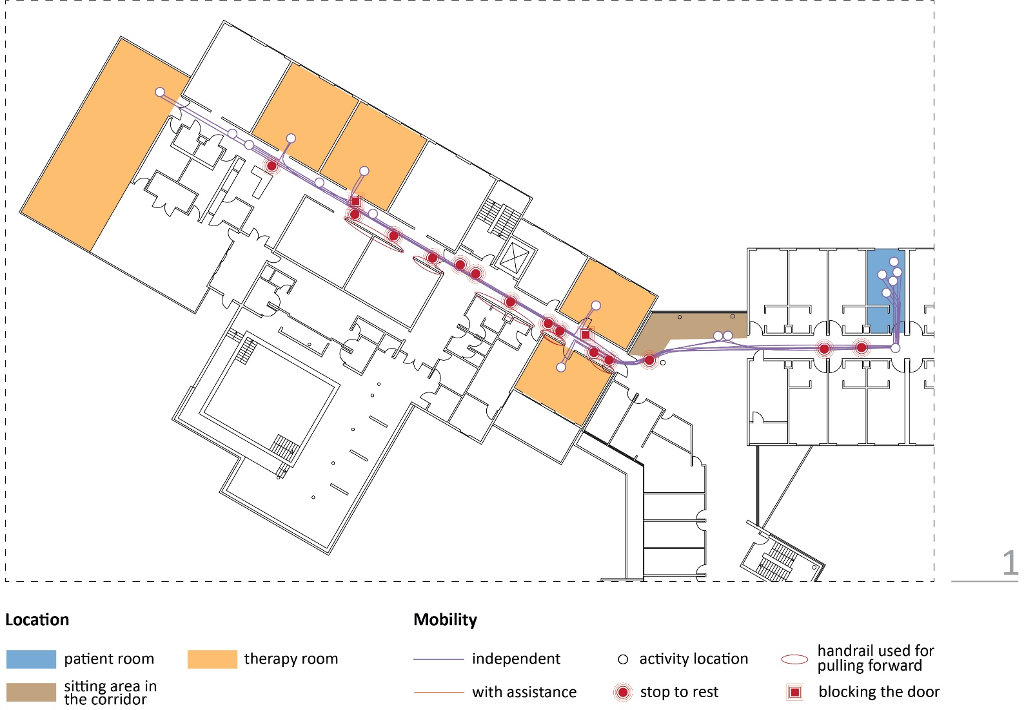
Figure 3. Floor plan showing Anke's movements during 12 observation hours

While resting in this corridor, Anke blocked all other patients' passage due to the corridor's insufficient width. This was problematic because this was the main centre's therapy corridor, where around 200 patients received therapies at similar times.
Anke also shared a room with another patient. She did not want to be in her room "because the other patient is there and is making weird noises." She stated that she did not have any favourite spaces to visit during her free time outside of her room. She would like "a common space on my ward to sit and read." Since there were no suitable spaces near her room, Anke often spent time reading in the open sitting area in the main corridor on her floor, close to her room (Figure 3).

3.3. Dieter (age: 84)
Dieter had already been in the rehabilitation centre for 35 days before the shadowing day. At the beginning of rehabilitation, he had a score of 0 (zero) on the mobility section of the Barthel Index scale (Mahoney & Barthel, 1965), which means "immobile." On the observation day, he had already reached a score of 5 (wheelchair-independent, including corners). He was required to independently go to various therapy rooms scattered throughout different building areas and floors. Dieter invited me to join him in the therapy room while he received occupational therapy. The therapist agreed with my joining, as only hand exercises would be done with the patient and I would not interfere with the treatment.
While performing a hand exercise guided by the therapist, he shares that his hobby is playing the piano. He cannot play anymore since he had a stroke because of left-sided muscle weakness (hemiparesis). He is upset about it and wishes he could play again because he enjoys it so much. While speaking, he is picking up a small wooden cube from the table with his weakened hand. He drops it several times, getting frustrated, but finally succeeds in lifting it and holding it in the air for a few moments. (Field notes)
His meals were served in the ward's small dining/living room, close to his room. Dieter did not have any issues visiting this room, but he did encounter various problems while going to therapy on the shadowing day. On the day of the observation, Dieter covered 1355,83 m of distance in the centre. He would often get tired from driving the wheelchair and stop to rest or ask me to push it. Once, while returning from the therapy room to his room, he experienced difficulties in the corridor, could not control his wheelchair, and hit chairs on the left side of the corridor. Dieter encountered wayfinding challenges four times during the day, such as choosing the wrong turn in the corridor or not knowing which elevator to take (Figure 4). He would try to find the right way on his own or ask me for directions. He shared that he got lost in the centre multiple times while finding therapy rooms, because "room numbers are misleading, too little signage." Dieter also shared his thoughts about the centre's building: "One can see that the clinic was expanded in phases - no underlying concept can be recognised."
Additionally, he shared that he liked to go outside to the park to "be undisturbed" and get "good air" in his free time. On the shadowing day, his family members visited him in the afternoon after therapies; he showed them the chapel in the centre, and then they went together to the park.
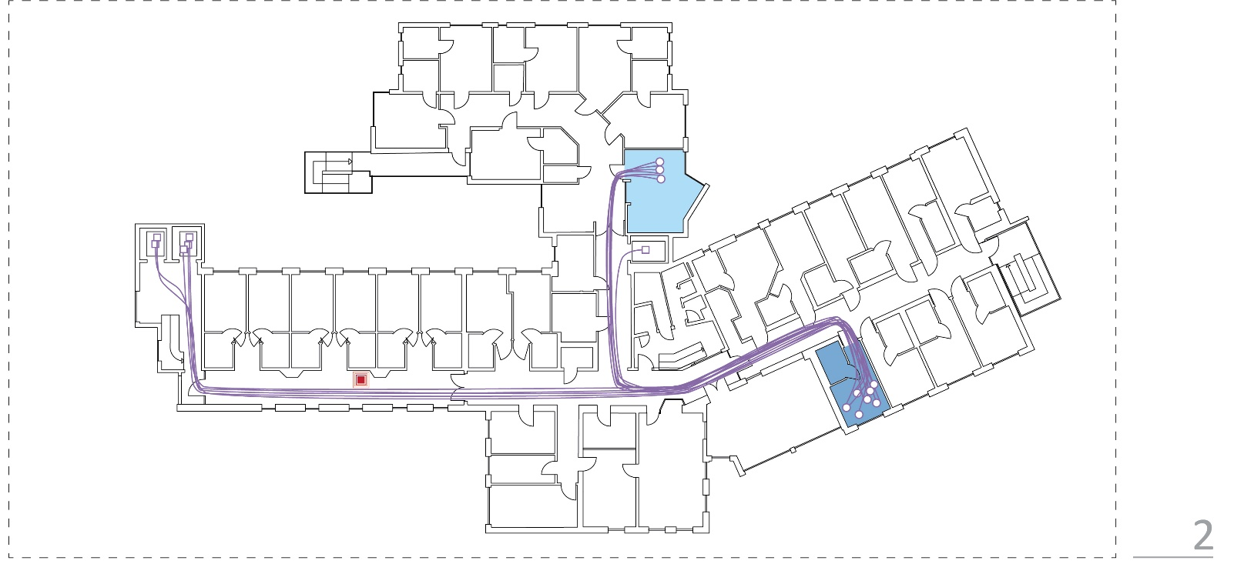
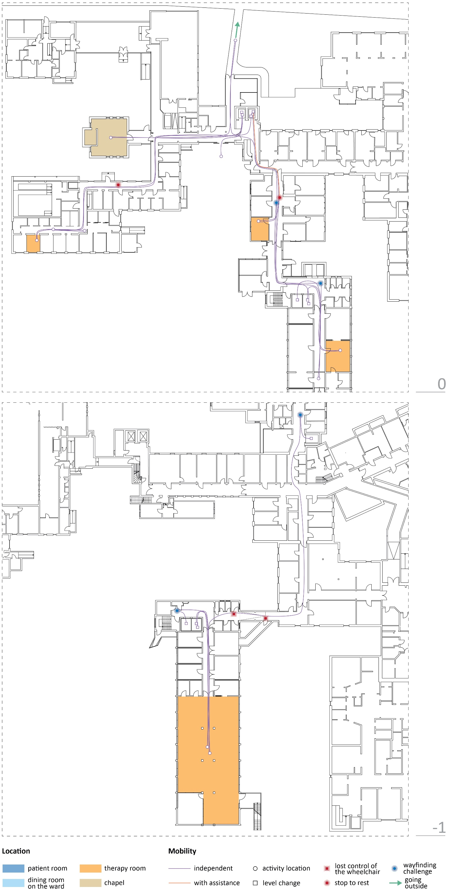Figure 4. Floor plans showing Dieter's movements during 12 observation hours

3.4. Sabine (age: 72)
This patient arrived at the rehabilitation centre 13 days before the shadowing day. She relied on the use of a wheelchair, sometimes with help from staff members. She often experienced wayfinding challenges in the centre. "Corridors, they are all the same. I often do not know in which corridor I am. The visitors also get lost." Sabine was also observed entering another patient's room.
The patient entered another patient's room by mistake. The other patient was not inside. The nurses on the ward did not notice this, and I was not entirely sure, so I went there to check. She was in the wrong room but did not realise it. She was resting at the small table next to the window. I notified the nurses, and one of them took the patient to her room. She seemed confused. (Field notes)
Sabine could reach the therapy rooms on the same floor as her ward mostly without assistance (Figure 5). For therapy in the building's basement, a member of the staff would always pick her up and bring her there. She liked to visit the ward's small dining/living room to talk to other patients in her free time during the day, as it was otherwise "boring". She was very social and spent most of her free time with other patients or visitors (Figure 1). She also came here with her visitors. On the observation day, she stayed in this room after dinner to talk to other patients for more than an hour before withdrawing to her room. Sabine liked the centre's design, describing it as "very good, modern" and adding that "maybe more colour would be better."
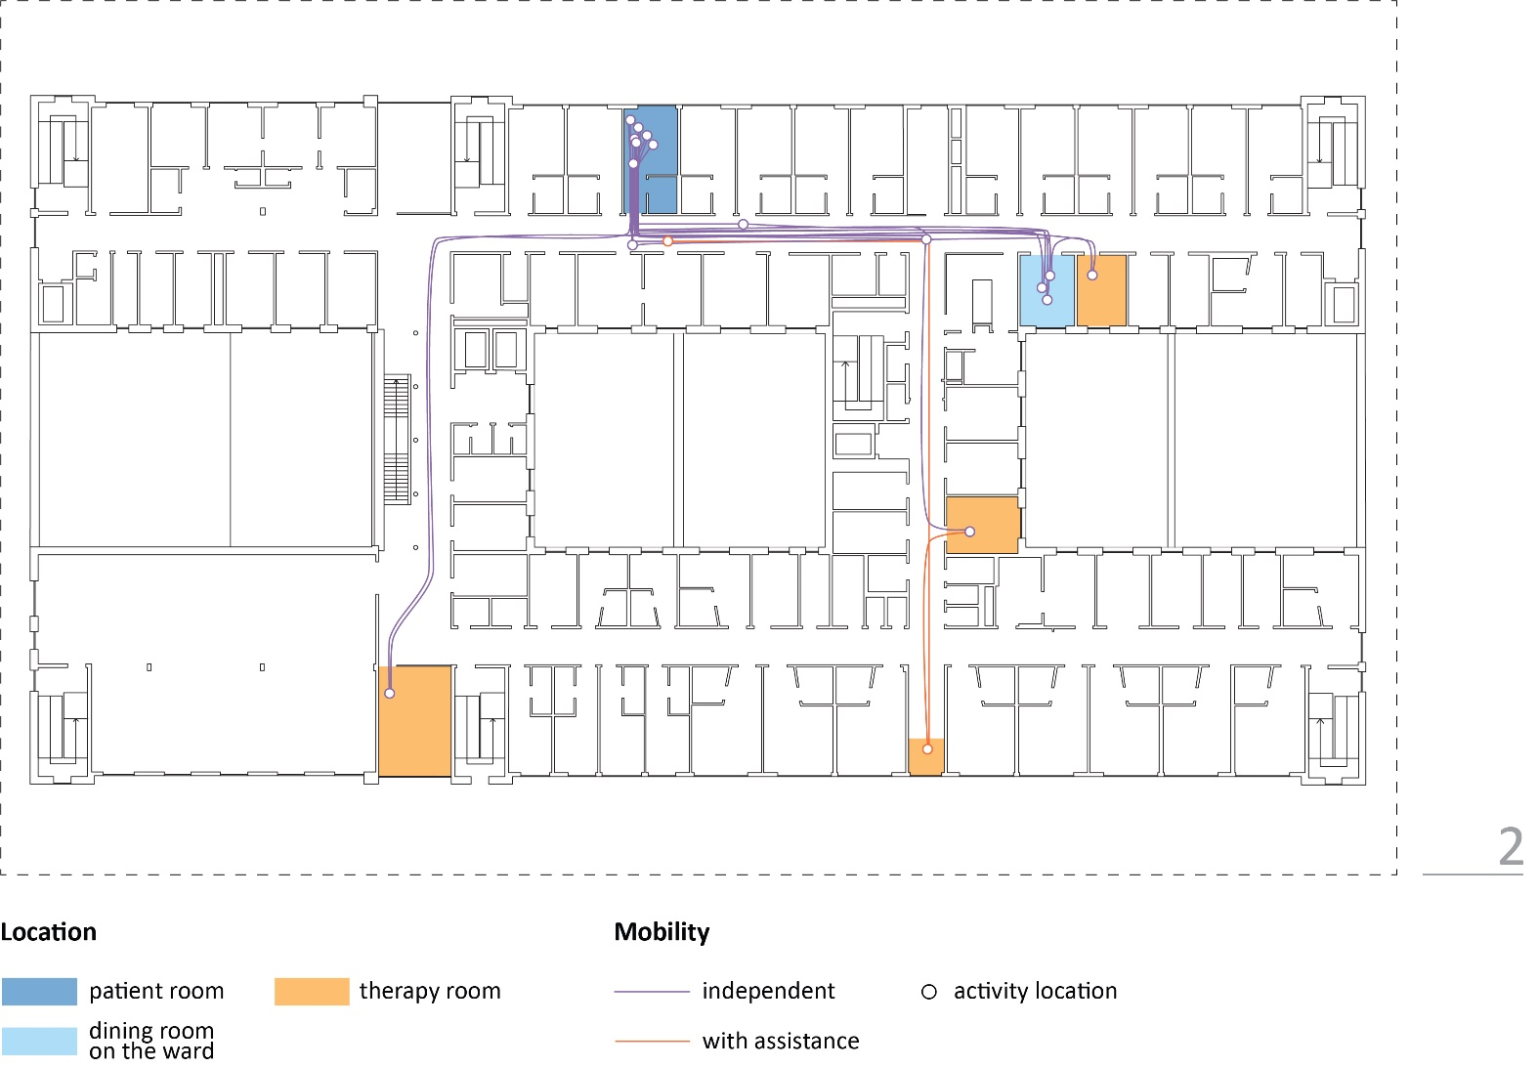
Figure 5. Floor plan showing Sabine's movements during 12 observation hours

3.5. Robert (age: 31)
He was a young patient who had a serious motorcycle accident and suffered a stroke while lying in the hospital. He had already been in the rehabilitation centre for 128 days before the shadowing day. Robert was experiencing left hemiparesis and left neglect (lack of awareness of that side of the body) and needed a wheelchair for mobility. At the beginning of his rehabilitation, he was completely immobile and became independent in using a wheelchair during his inpatient stay. He visited all the therapies in the building on his own. He was doing everything he could to help him recover faster.
While waiting for therapy in the corridor in front of the therapy room, he uses an electric toothbrush to massage his left hand. He comments that the therapist recommended doing this to improve blood circulation in the weakened hand and help improve sensation. (Field notes)
Robert shared that he got lost once in the centre. "The elevator stopped on the wrong floor. I ended up on the second floor. It was not that bad." He also told about when he could not pass with his wheelchair through a heavy door, "which was half closed." Other than that, despite his hemiparesis, Robert was not observed to experience any other barriers in the built environment. He was very active and could find his way easily while going to therapy. He had a tight schedule and spent little time in the room (Figure 1).
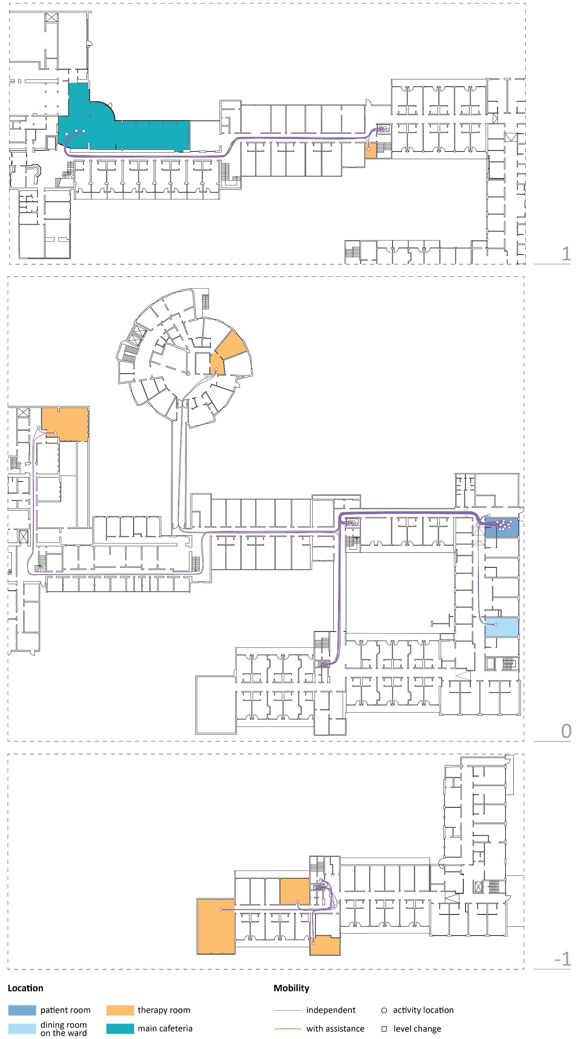
Figure 6. Floor plans showing Robert's movements during 12 observation hours
Robert was also one of the very few young patients and felt he did not have suitable company for socialising in the centre. He could choose between having meals in the ward's dining room with other patients from his ward or in the main centre's cafeteria on a different building level (Figure 6), and he picked the latter.
He says that he doesn't like to eat in the dining room at the ward because it is like a cave and "people are strange." (Field notes)
This centre was built into a hill, and the dining room only had small and very high windows that did not let in a lot of light. Robert did not like that and did not like spending time in this space. He shared that he would like a relaxation room to exist in the centre.

3.6. Common themes
The participating patients had different interactions with the built environment. Patients' mobility limitations were very diverse, even though they were all in the same rehabilitation phase and used a wheelchair. They ranged from Robert, who could cover all distances independently and without issues, to Anke (independent but experiencing many difficulties when travelling to therapies) and Monika (dependent on staff members to bring her to therapies). Some struggled with long distances between spaces and wayfinding, becoming dependent on staff members or encountering barriers, while others were more active and independent. Wayfinding was observed or described as a challenge by all patients except Anke.
The length of time patients spent in therapy varied greatly, with Robert spending far more time in therapy than others. (Figure 1). Therapies took place in various locations, including designated therapy rooms, corridors, and the patient's room. Some patients were observed arriving too early for therapies and spending a great amount of time waiting in the corridors (Figure 1).
Socialising with others, especially with other patients, was important to Sabine. Others spent most of their day alone, with occasional visits from family and friends (Figure 1). Boredom was common for these patients. They found no attractive spaces in the centre outside of their room, and if they existed, they closed too early (Monika and the cafeteria comment). Patients (except Robert) also spent a large proportion of their day in their rooms (Figure 1). It is unclear whether they engaged in physical or cognitive activities while in their rooms because they would close their doors for privacy.

4. Discussion
This paper presents a typical day in the rehabilitation of five patients. Most research on healthcare environments for stroke patients focuses on quantitative approaches, such as time use (Åstrand et al., 2016; Blennerhassett et al., 2018; de Wit et al., 2005; West & Bernhardt, 2012) and the effect of the enriched environment on patient activity (Rosbergen et al., 2017; Janssen et al., 2014, 2021). This study used an exploratory research method to shed light on considerable disparities in how stroke patients spend their days and interact with the built environment during rehabilitation. These differences have several implications for the design of healthcare environments.
Patients in this study had varying levels of mobility and independence in the centres. The built environment was often hindering simply by spaces being too far away and out of reach; patients had to rely on staff members to get around. This might limit patients from exercising and reaching independence, which is seen as one of the main signs of rehabilitation progress (Luker et al., 2015). The locations of communal areas and their distance from patient rooms are critical in the rehabilitation centre layout so that patients can get to them independently (Kevdzija & Marquardt, 2022). By restricting access to communal spaces, rehabilitation environments may also add to boredom (Kenah, 2018). Furthermore, as shown in this research, more availability and diversity in communal spaces are needed. Some patients prefer socialising with other patients and visitors, while others prefer solitude. Recreation in free time is critical in both scenarios since it relieves boredom and contributes to stroke recovery (Luker et al., 2015); the built environment should create diverse recreation opportunities.
If environments are designed for severely impaired patients, fairly mobile patients may not have adequate opportunities to be active and exercise. Certain physical barriers could be used as exercise aids to assist patients in transitioning from life in a rehabilitation centre to life at home by challenging them while recovering. They may also encourage patients to be physically active outside of therapy sessions. As seen in the case of the youngest patient in this research (Robert, 31), his activity level and wish to exercise his hand during his free time were completely different compared to older patients who spent much time inside their rooms. Because of this, physical barriers are not necessarily a negative aspect of the built environment if they are purposely designed for training and exercise rather than resulting from poor planning. However, even without the built-environment barriers, patients using a wheelchair who are still adjusting to their impairments and making progress towards independence might already encounter many difficulties. One of the main issues in the healthcare environment is wayfinding; getting lost might be dangerous for patients with serious cognitive, visual, and physical impairments (Rabadi et al., 2008). Therapy schedules and staffing might also be disrupted if patients are late for therapy because they get lost (Cooper, 2010). Therefore, one of the main challenges in designing rehabilitation environments could be navigating between providing opportunities for patients to exercise their independence and creating barriers and, in some cases, even danger.
Even though the built environment plays an important role in patients' activities and experiences, organisational culture may also have a major impact. Therefore, patients' independence and activities should not be encouraged only by the built environment but also by the cultural environment of the rehabilitation facility (Janssen et al., 2021).
This research has several limitations that need to be mentioned. One limitation is that the researcher's presence may have influenced the behaviours of the patients on the shadowing day. This paper only includes five cases and their experiences; thus, the results should not be overly generalised. In addition, this study captures only one day of the patients' transition towards recovery. Their behaviours might differ on other rehabilitation days, and their needs might also change during recovery.

5. Conclusions
Stroke patients in rehabilitation spend their days and interact with the built environment very differently, depending on post-stroke impairments, age, and personal preferences. Their spatial needs should be explored further to adequately inform the design of rehabilitation spaces.

Acknowledgements
This research study was supported by the European Social Fund (ESF) and the Sächsische Aufbaubank (RL ESF Hochschule und Forschung 2014 bis 2020, scholarship agreement no. 100235479) and the Graduate Academy at the Technische Universität Dresden.

References
- Anåker, A., von Koch, L., Heylighen, A., & Elf, M. (2019). "It's Lonely": Patients' Experiences of the Physical Environment at a Newly Built Stroke Unit. Health Environments Research and Design Journal, 12(3), 141–152.
- Anåker, A., Von Koch, L., Sjöstrand, C., Heylighen, A., & Elf, M. (2018). The physical environment and patients' activities and care. A comparative case study at three newly built stroke units. Journal of Advanced Nursing, 1–33.
- Åstrand, A., Saxin, C., Sjöholm, A., Skarin, M., Linden, T., Stoker, A., Roshandel, S., Dedering, Å., Halvorsen, M., Bernhardt, J., & Cumming, T. (2016). Poststroke Physical Activity Levels No Higher in Rehabilitation than in the Acute Hospital. Journal of Stroke and Cerebrovascular Diseases, 25(4), 938–945.
- Blennerhassett, J. M., Borschmann, K. N., Lipson-Smith, R. A., & Bernhardt, J. (2018). Behavioral Mapping of Patient Activity to Explore the Built Environment During Rehabilitation. Health Environments Research & Design Journal, 11(3), 109–123.
- Booth, T. & Booth, W. (1996) Sounds of silence: narrative research with inarticulate subjects. Disability and Society 11(1), 55–69.
- Chen, E., Viktorisson, A., Danielsson, A., Palstam, A., & Sunnerhagen, K. S. (2020). Levels of physical activity in acute stroke patients treated at a stroke unit: A prospective, observational study. Journal of Rehabilitation Medicine, 52(4).
- Claessen, M. H. G., Visser-Meily, J. M. A., Meilinger, T., Postma, A., de Rooij, N. K., & van der Ham, I. J. M. (2017). A systematic investigation of navigation impairment in chronic stroke patients: Evidence for three distinct types. Neuropsychologia, 103, 154–161.
- Cooper, R. (2010). Wayfinding for health care: Best practices for today's facilities. Chicago, IL: AHA Press/Health Forum.
- De Wit, L., Putman, K., Dejaeger, E., Baert, I., Berman, P., Bogaerts, K., Brinkmann, N., Connell, L., Feys, H., Jenni, W., Kaske, C., Lesaffre, E., Leys, M., Lincoln, N., Louckx, F., Schuback, B., Schupp, W., Smith, B., & De Weerdt, W. (2005). Use of time by stroke patients: A comparison of four European rehabilitation centers. Stroke, 36(9), 1977–1983.
- De Wit, L., Theuns, P., Dejaeger, E., Devos, S., Gantenbein, A. R., Kerckhofs, E., Schuback, B., Schupp, W., & Putman, K. (2017). Long-term impact of stroke on patients' health-related quality of life. Disability and Rehabilitation, 39(14), 1435–1440.
- Desrosiers, J., Noreau, L., Rochette, A., Bravo, G., & Boutin, C. (2002). Predictors of handicap situations following post-stroke rehabilitation. Disability and Rehabilitation, 24(15), 774–785.
- Flowers, H. L., Skoretz, S. A., Silver, F. L., Rochon, E., Fang, J., Flamand-Roze, C., & Martino, R. (2016). Poststroke Aphasia Frequency, Recovery, and Outcomes: A Systematic Review and Meta-Analysis. Archives of Physical Medicine and Rehabilitation, 97(12), 2188-2201.e8.
- Janssen, H., Ada, L., Bernhardt, J., McElduff, P., Pollack, M., Nilsson, M., & Spratt, N. J. (2014). An enriched environment increases activity in stroke patients undergoing rehabilitation in a mixed rehabilitation unit: A pilot non-randomised controlled trial. Disability and Rehabilitation, 36(3), 255–262.
- Janssen, H., Ada, L., Middleton, S., Pollack, M., Nilsson, M., Churilov, L., Blennerhassett, J., Faux, S., New, P., McCluskey, A., Spratt, N. J., Bernhardt, J., & AREISSA Trial group (2022). Altering the rehabilitation environment to improve stroke survivor activity: A Phase II trial. International journal of stroke, 17(3), 299–307.
- Kenah, K., Bernhardt, J., Cumming, T., Spratt, N., Luker, J., & Janssen, H. (2018). Boredom in patients with acquired brain injuries during inpatient rehabilitation: a scoping review. Disability and Rehabilitation, 40(22), 2713–2722.
- Kenah, K., Bernhardt, J., Spratt, N. J., Oldmeadow, C., & Janssen, H. (2022). Depression and a lack of socialisation are associated with high levels of boredom during stroke rehabilitation: An exploratory study using a new conceptual framework. Neuropsychological rehabilitation, 1–31. Advance online publication.
- Kevdzija, M. (2022). Using shadowing for architectural research in healthcare environments: Opportunities and Challenges [preprint]. The Evolving Scholar | ARCH22.
- Kevdzija, M., & Marquardt, G. (2021). Impact of distance on stroke inpatients' mobility in rehabilitation clinics: A shadowing study. Building Research & Information, 50(1-2), 74–88.
- Kevdzija, M., & Marquardt, G. (2022). Stroke patients' nonscheduled activity during inpatient rehabilitation and its relationship with the architectural layout: A multicenter shadowing study. Topics in stroke rehabilitation, 29(1), 9–15.
- Kirkevold, M., & Bergland, Å. (2007). The quality of qualitative data: Issues to consider when interviewing participants who have difficulties providing detailed accounts of their experiences. International Journal of Qualitative Studies on Health and Well-Being, 2(2), 68–75.
- Knoflach, M., Matosevic, B., Rücker, M., Furtner, M., Mair, A., Wille, G., Zangerle, A., Werner, P., Ferrari, J., Schmidauer, C., Seyfang, L., Kiechl, S., & Willeit, J. (2012). Functional recovery after ischemic stroke - A matter of age: Data from the Austrian Stroke Unit Registry. Neurology, 78(4), 279–285.
- Kugler, C., Altenhöner, T., Lochner, P., & Ferbert, A. (2003). Does age influence early recovery from ischemic stroke? A study from the Hessian Stroke Data Bank. Journal of Neurology, 250(6), 676–681.
- Lipson-Smith, R., Churilov, L., Newton, C., Zeeman, H., & Bernhardt, J. (2019). A Framework for Designing Inpatient Stroke Rehabilitation Facilities: A New Approach Using Interdisciplinary Value-Focused Thinking. Health Environments Research & Design Journal, 12(4), 142–158.
- Lipson-Smith, R., Pflaumer, L., Elf, M., Blaschke, S.-M., Davis, A., White, M., Zeeman, H., & Bernhardt, J. (2021). Built environments for inpatient stroke rehabilitation services and care : a systematic literature review. BMJ Open, 1–11.
- Lipson-Smith, R., Zeeman, H., & Bernhardt, J. (2020). What's in a Building? A Descriptive Survey of Adult Inpatient Rehabilitation Facility Buildings in Victoria, Australia. Archives of Rehabilitation Research and Clinical Translation, 2(1), 100040.
- Luker, J., Lynch, E., Bernhardsson, S., Bennett, L., & Bernhardt, J. (2015). Stroke Survivors' Experiences of Physical Rehabilitation: A Systematic Review of Qualitative Studies. Archives of Physical Medicine and Rehabilitation, 96(9), 1698-1708e10.
- Mahoney, F. I., & Barthel, D. W. (1965). Functional evaluation: The Barthel Index: A simple index of independence useful in scoring improvement in the rehabilitation of the chronically ill. Maryland State Medical Journal, 14, 61-65.
- McDonald, S., & Simpson, B. (2014). Shadowing research in organisations: the methodological debates. Qualitative Research in Organisations and Management: An International Journal, 9(1), 3–20.
- Meunier, D., & Vasquez, C. (2008). On shadowing the hybrid character of actions: A communicational approach. Communication Methods and Measures, 2(3), 167–192.
- Nordin, S., Swall, A., Anåker, A., Koch, L. Von, Elf, M., Nordin, S., Swall, A., Anåker, A., Koch, L. Von, Elf, M., Nordin, S., Swall, A., & Anåker, A. (2021). Does the physical environment matter ? - A qualitative study of healthcare professionals' experiences of newly built stroke units professionals' experiences of newly built stroke units. International Journal of Qualitative Studies on Health and Well-Being, 16(1).
- Quinlan, E. (2008). Conspicuous Invisibility: Shadowing as a Data Collection Strategy. Qualitative Inquiry, 14(8), 1480–1499.
- Rabadi, M. H., Rabadi, F. M., & Peterson, M. (2008). An analysis of falls occurring in patients with stroke on an acute rehabilitation unit. Revista Espanola de Cirugia Ortopedica y Traumatologia, 52(3), 104–109.
- Rosbergen, I. C., Grimley, R. S., Hayward, K. S., Walker, K. C., Rowley, D., Campbell, A. M., McGufficke, S., Robertson, S. T., Trinder, J., Janssen, H., & Brauer, S. G. (2017). Embedding an enriched environment in an acute stroke unit increases activity in people with stroke: a controlled before–after pilot study. Clinical Rehabilitation, 31(11), 1516–1528.
- Rowe, F., Brand, D., Jackson, C. A., Price, A., Walker, L., Harrison, S., Eccleston, C., Scott, C., Akerman, N., Dodridge, C., Howard, C., Shipman, T., Sperring, U., Macdiarmid, S., & Freeman, C. (2009). Visual impairment following stroke: Do stroke patients require vision assessment? Age and Ageing, 38(2), 188–193.
- Tatemichi, T. K., Desmond, D. W., Stern, Y., Paik, M., Sano, M., & Bagiella, E. (1994). Cognitive impairment after stroke: frequency, patterns, and relationship to functional abilities. Journal of Neurology, Neurosurgery & Psychiatry, 57(2), 202–207.
- van der Meide, H., Leget, C., & Olthuis, G. (2013). Giving voice to vulnerable people: The value of shadowing for phenomenological healthcare research. Medicine, Health Care and Philosophy, 16(4), 731–737.
- van der Meide, H., Olthuis, G., & Leget, C. (2015). Participating in a world that is out of tune: shadowing an older hospital patient. Medicine, Health Care and Philosophy, 18(4), 577–585.
- Ween, J. E., Alexander, M. P., D’Esposito, M., & Roberts, M. (1996). Factors predictive of stroke outcome in a rehabilitation setting. Neurology, 47(May 1994), 388–392.
- West, T., & Bernhardt, J. (2012). Physical activity in hospitalised stroke patients. Stroke research and treatment, 2012, 813765.

