Type of the Paper: short Paper
Track title: staff perspective, stream 1 (future proofing)

A new approach to the living environment of people with intellectual disabilities and severe behavioural problems in long-term care
Andrea Möhn ^{1,}*, Jacqueline Roos ² and Annelies Mulder ³

Names of the Topic editors:
Clarine van Oel
Names of the reviewers:
H. Schouten
Laura Airpiainen

Journal: The Evolving Scholar
DOI: 10.24404/621cb161a03fefa3b272b9cc

Submitted: 31 May 2022
Accepted: 22 August 2022
Published: 1 May 2023
Citation: Möhn, A., Roos, J. & Mulder, A. (2022). A new approach to the living environment of people with intellectual disabilities and severe behavioural problems in long-term care [preprint]. The Evolving Scholar | ARCH22. https://doi.org/10.24404/621cb161a03fefa3b272b9cc
This work is licensed under a Creative Commons Attribution BY license (CC BY).

© 2022 Möhn, A., Roos, J. & Mulder, A published by TU Delft OPEN on behalf of the authors

¹ Andrea Möhn Architects; mohn@am-a.eu; https://orcid.org/0000-0002-3724-4231
² Ipse de Bruggen; Jacqueline.Roos@ipsedebruggen.nl; https://orcid.org/0000-0002-3478-7900
³ Ipse de Bruggen; Annelies.Mulder@ipsedebruggen.nl

* Use * to indicate the corresponding author.

Research highlights
1) Transforming the rooms of people with intellectual disabilities can have remarkable results.
2) The combination of the caregiver's knowledge and the architect's fresh eyes can lead to new solutions.

Keywords: intellectual disability; behavioural problems; long-term care; living environment

1. Introduction
Little research is available on the impact of the physical environment on the health, behaviour, and quality of life of people with intellectual disabilities and severe behavioural problems in long-term care facilities (Casson et al., 2021; Roos et al., 2022). This is in contrast to the knowledge that exists about, for example, people in hospitals or dementia patients (e.g., Joseph, A., et al., 2016, Marquardt et al., 2014; Ulrich, 2008; Woodbridge et al., 2018). Because of their specific vulnerabilities and needs, it cannot be automatically assumed that research on other groups would also apply to people with intellectual disabilities, and therefore more research on this particular group is needed (Casson et al., 2021; Roos et al., 2022).
By intellectual disabilities we mean that there are limitations in both intellectual and adaptive functioning in the conceptual, social, and practical domains, beginning during the developmental period (APA, 2013). We speak of long-term care when individuals, due to an illness or impairment, have a continued need for permanent supervision or 24-hour care in the vicinity (Centrum Indicatiestelling Zorg, 2019), and live in a residential setting. Some of these patients exhibit high-risk problem behaviours, including aggressive and destructive behaviour. In order to protect them from themselves, the design of living spaces sometimes emphasises the provision of control and safety. This usually means an environment with few stimuli and molest-resistant materials, which sometimes results in an atmosphere-less private room. This is in contrast to the healing environment that is intended to be offered, a place where the interaction between the person and the physical environment has a positive effect on someone's healing process or well-being (Huisman et al., 2012).
Eight years ago, the transformation of ‘D’s room’ changed the life of D, a person with severe intellectual disabilities and behavioural problems (Leuenberger & Möhn, 2022; Möhn, 2021). His aggressive and destructive behaviour has been reduced, and he lives in less isolation. Following this experience, the care facility (Ipse de Bruggen) decided to initiate a project to transform the physical environment of twelve of its most vulnerable patients and to study the impact of these transformations on patients and staff. We present the project, the transformation process, and part one of the study, a file analysis of the first four transformations.

2. Theories and Methods

2.1. Project
In 2020, we started a project called ‘physical environment’. Our goal is to get a clear picture of what an intervention in the physical environment can contribute to the quality of life of vulnerable patients with intellectual disabilities and intensive care needs, creating a new perspective, and the impact on staff. Within the project, twelve rooms for patients living in the Dutch care facility will be transformed within a four-year period. In addition, the project aims to open up a knowledge platform and network in the care sector for people with intellectual disabilities. This platform will contain knowledge and evidence-based practises about the physical environment for healthcare providers, patients, and their families.

2.2. Process
To streamline and replicate the processes, the transformations are carried out on the basis of a step-by-step plan. This roadmap meticulously describes the steps in the process, the roles and responsibilities of all those involved, and the outcomes of each step in the process. The process is divided into ten steps (Table 1).

Table 1 Ten steps of the Transformation Process
Step | Subject | Description
1 | Analysis of eligible patients | Screening for which patient the transformation could make a valuable contribution to the quality of his life. The patient is admitted if there appears to be no other treatment prospect and the room has deteriorated severely over the years. Data collected: patient's diagnosis, behaviour, and condition of the room.
2 | Allocate resources | Verification of preconditions of all funds, allocation of funds by the decision-making board.
3 | Transformation coach | Introducing the transformation coach, who will guide all stakeholders in a case through the process.
4 | Informed consent | Obtaining consent for the use of personal data. Data collected: written consent from a legal representative.
5 | Workshops and description of patient’s behaviour and needs | Workshops with all parties to arrive at a common description of patient-specific behaviour and needs. Data collected: e.g., history, diagnosis (classifications, developmental level, problems), daily functioning, treatment, use of psycho-tropic medication, and restrictions.
6 | Selection architect/designer | The stakeholders choose a suitable architect or designer based on the previous steps.
7 | Design process | Design process of the architect or designer.
8 | Design proposal | Presentation of the design proposal by the architect/designer to the stakeholders for mutual agreement.
9 | Realisation | Transformation of the room.
10 | Evaluation | Evaluation of the project and its impact on patients and staff. Data collected: statements on the process and the perceived impact on patients and staff.

2.3 Research
The study of room transformations is conducted through the multiple N=1 research method, also called ‘case study’ (Yin, 2014). The aim is to establish hypotheses about what effects on the patient can plausibly be traced back to the intervention. Case studies are an important source for evidence-based practices and are especially appropriate in new topic areas (Eisenhardt, 1989; Schalock et al., 2011). The subjects of the study are the patients participating in the project. Part one of the multiple case study consists of a narrative description of the four completed room transformations, based on retrospective analysis of patient and project files regarding the perceived impact on patients (changes in behaviour and well-being) and staff (working environment) according to staff.

3. Intervention

3.1. Observation and biographical work
When designing the physical environment, certain key aspects proved to be extremely valuable in finding a solution, or rather a theme, for the redesign of the space (Figure 1). First, the careful observation of the original spatial situation and the patient's behaviour in the space. Second, listening and exchanging with staff about psychological aspects of the patient. Third, an open approach to observing the patient’s behaviour without immediately drawing conclusions leads to interesting findings. In D's case, the architect’s perception when observing him was that he played the role of a farmer, which became the guiding aspect for the renovation of his physical environment. It turned out that he had grown up in a typical Dutch landscape. This inspired the architect, as a fourth aspect, to focus more on exploring the biography of a patient with staff and family members. It is about finding the moment in the biography when, in the patient's perception, his or her life was in order. To this moment, they may long to return. Patient R was a big fan of the Dutch royal family, and everything related to this fascinated him. As a young boy, he accompanied his mother when the Dutch Queen passed by in the golden carriage on her way to the opening of the Parliament. The architect designed a royal bed and throne for him, as well as a golden toilet in his bathroom.

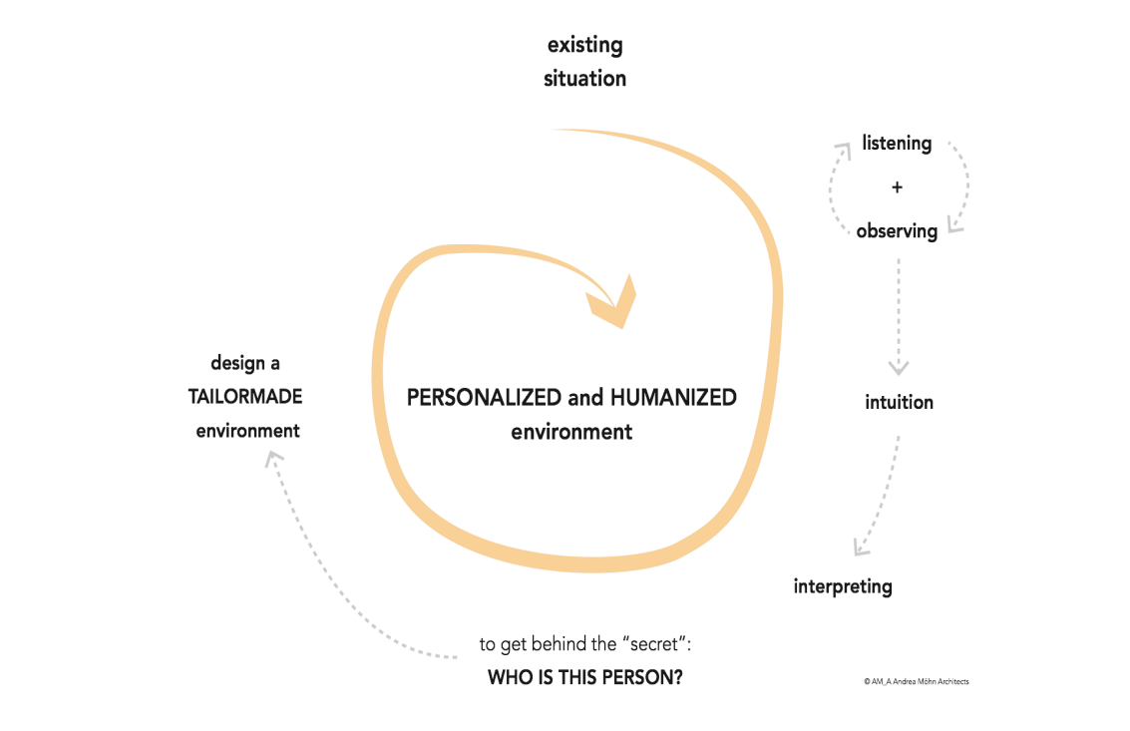
Figure 1 Design process and approach. Source: Andrea Möhn Architects

3.2. Privacy and self-determination
Female patient S loved pink, soft fabrics, and glitter. At the same time, she needed protection, as she preferred not to wear any clothes at all. As part of the intervention, the architect designed a massive cherrywood cocoon for her to hide in, as well as a willow fence up to the tip of her nose so that she could look around but not be seen from the outside (Figure 2). Regarding the layout of the physical environment, it is important that the patient has a natural overview and the possibility to leave his or her room. A passage to the garden was created, as well as a direct open exit to the group, so that she could decide for herself where to stay.

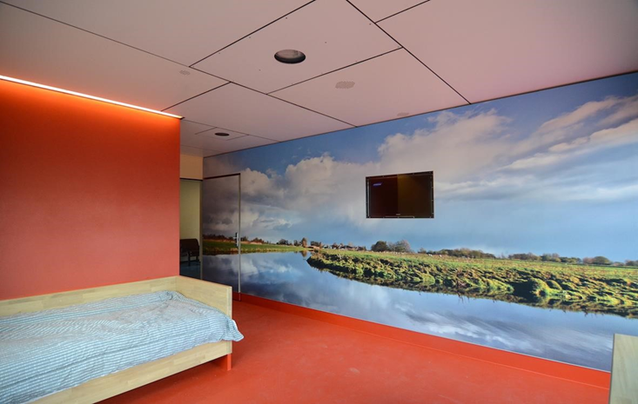
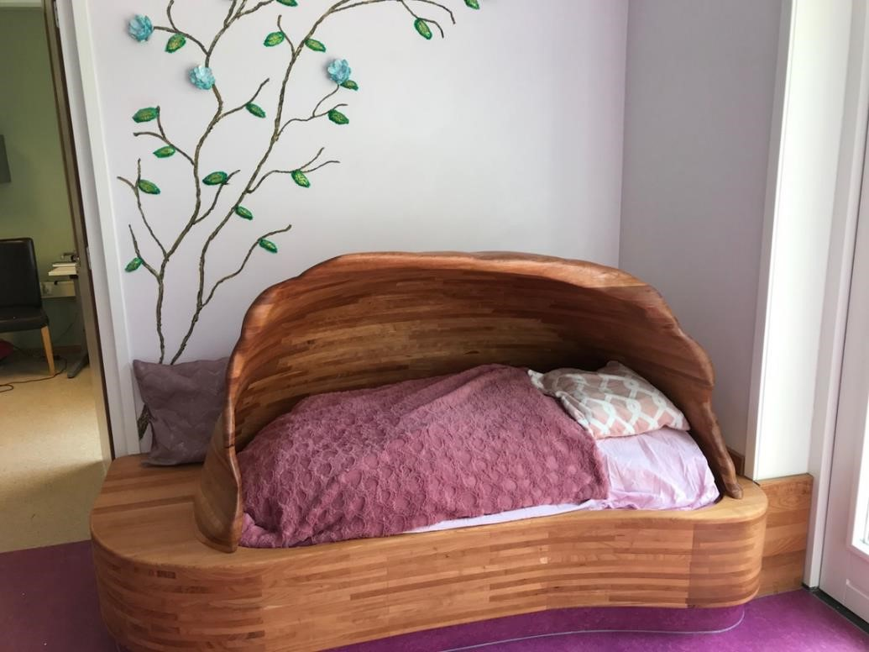
Figure 2 Cocoon of massive cherrywood and pink colours. Source: Andrea Möhn Architects
Figure 3 D’s Room with image of Dutch Landscape and bed of massive oak. Source: Möhn + Bouman Architects

3.3. Smart solutions, natural materials, and the importance of dignity
It is particularly important to create a humane and dignified environment and at the same time to find smart solutions for a violence-resistant facility. For example, not sleeping in a steel bed like D used to do, but in a bed of massive oak ‘like normal people’, gives them a feeling of dignity (Figure 3). Patient B bit the corners of his walls out of frustration. Since he loved nature, the architect used this as a leitmotif and had him choose his favourite motif of a forest for a large wallpaper in his room to calm him down. The ruined corners of the walls were covered with solid ash wood, a type of wood used for the toys of small children who still put everything in their mouths, which can be easily repaired.

4. Results

4.1. Process
Firstly, open collaboration between different disciplines, patient, family, and architect proved to be of great importance. A multidisciplinary collaboration enables a broad view of the problem. Parties involved may include, for example, supervisors, carers, psychologists, therapists, and professionals from the real estate department who work closely with the architects. The key seems to lie in the combination of the approaches and perspectives of both carers and architect. The carer's attention is focused on the mental and physical health of the patient, and that of the architect on the effect of the physical environment on the user. The combination and integration of both aspects and approaches lead to the emergence of new solutions. Collaboration with and input from the patient himself and his family is also of great importance, so that the patient's wishes can be truly customised. Involvement also seems to give the patient a sense of self-worth. The family can provide valuable information about the patient and his background. The involvement of an architect or designer is of great value. As an outsider, he looks at the situation from a different angle, which leads to new perspectives and insights.
Secondly, the process requires staff members to be open to reconsidering old beliefs and letting go of control. Because it is unclear in advance how things will turn out, a certain risk is taken. This requires courage and support from the management. Thirdly, experience shows that the whole process often takes a long time, usually about one and a half years. Although the working methods (including workshops with all parties) are considered of great value, they take up a lot of time, as do other issues in the process such as finances and temporary relocation. Perseverance and a tenacious central director are seen as valuable in this regard.

4.2. Research
The data show that the room transformations lead to positive changes in all four patients, for example, with regard to destructive behaviour and mood, and more possibilities for self-determination. It is notable that S has stopped self-mutilating and that B no longer bites the walls. Staff experienced a more pleasant, safer, and functional working environment. It is remarkable that there is much less fear among the staff of R.

5. Discussion and conclusions
The first four room transformations within the project have been completed, as has part one of our study, in which we examined them through retrospective file analysis. In doing so, we have seen that the room transformations can have remarkable results for patients with intellectual disabilities and chronic severe conditions, as well as for their staff. In these cases, it seemed particularly important to look at the patient and his biography, where the combination of the carer's knowledge and the architect's fresh eyes led to new solutions. Based on the twelve rooms, we hope, by looking for results that occur repeatedly, to be able to formulate hypotheses about the impact of the physical environment on people with intellectual disabilities. In the meantime, we will continue to enrich the knowledge platform with various experiences, practical applications, and useful tips. It is the wish of all those involved to raise public awareness of the importance of a suitable living environment as an integral part of disability care.

Contributor statement
Author 1: Conceptualization, Methodology, Visualisation, Writing, Original Draft
Author 2: Conceptualization, Investigation, Methodology, Data Curation, Formal Analysis, Writing, Review & Editing
Author 3: Conceptualization, Project Administration, Resources

References

- American Psychiatric Association (2013). Diagnostic and statistical manual of mental disorders (5th ed.). American Psychiatric Publishing.
- Casson, J., Hamdani, Y., Dobranowski, K., Lake, J., McMorris, C., Gonzales, A., Lunsky, Y. and Balogh, R. (2021), Housing Design and Modifications for Individuals With Intellectual and Developmental Disabilities and Complex Behavioral Needs: Scoping Review. Journal of Policy and Practice in Intellectual Disabilities, 18: 217-228. https://doi.org/10.1111/jppi.12377
- Centrum Indicatiestelling Zorg (2019, December 3). Beleidsregels indicatiestelling Wlz 2020 [Policy Rules for referrals Wlz 2020]. https://www.ciz.nl/images/pdf/beleidsregels/Beleidsregels_indicatiestelling_Wlz_2020.pdf
- Eisenhardt, K. M. (1989). Building Theories from Case Study Research. The Academy of Management Review, 14(4), 532–550. https://doi.org/10.2307/258557
- Huisman, E. R. C. M., Morales, E., van Hoof, J., & Kort, H. S. M. (2012). Healing environment: A review of the impact of physical environmental factors on users. Building and Environment, 58. https://doi.org/10.1016/j.buildenv.2012.06.016
- Joseph, A., Choi, Y. S., & Quan, X. B. (2016). Impact of the Physical Environment of Residential Health, Care, and Support Facilities (RHCSF) on Staff and Residents: A Systematic Review of the Literature. Environment and Behavior, 48(10), 12031241.
- Leuenberger, T., & Möhn, A. (2022). Ein Zimmer zum Wohnen- Eine architektursoziologische Perspektive auf die Gestaltung von Lebensräumen in der Psychiatrie. In L. Hofrichter, M. Könne, & A. Kuckert-Wöstheinrich, Soul in Space Psychiatrie trifft Architektur. Medizinisch Wissenschaftliche Verlagsgesellschaft.
- Marquardt, G., Bueter, K., & Motzek, T. (2014). Impact of the design of the built environment on people with dementia: an evidence-based review. Herd, 8(1), 127-157.
- Möhn, A. (2021). Best Practice: a personalized and humanized environment. In C. Günther, & B. Klein (Eds.), Connected Living: international and interdisciplinary conference (pp. 117-125). Frankfurt university of Applied Sciences. https://doi.org/10.48718/98d5-zp59
- Roos, J., Koppen, G., Vollmer, T. C., Van Schijndel-Speet, M., & Dijkxhoorn, Y. (2022). Unlimited Surrounding: A Scoping Review on the Impact of the Built Environment on Health, Behavior, and Quality of Life of Individuals With Intellectual Disabilities in Long-Term Care. HERD. https://doi.org/10.1177/19375867221085040
- Schalock, R., Verdugo, M.A., & Gomez, L.E. (2011). Evidence-based practices in the field of intellectual and developmental disabilities: An international consensus approach. Evaluation and Program Planning, 34, 273-282
- Ulrich, R., Zimring, C., Zhu, X., DuBose, J., Seo, H.-B., Choi, Y.-S., Quan, X., & Joseph, A. (2008). A Review of the Research Literature on Evidence-Based Healthcare Design. HERD, 1(3), 61–125. https://doi.org/10.1177/193758670800100306
- Woodbridge, R., Sullivan, M. P., Harding, E., Crutch, S., Gilhooly, K. J., Gilhooly, M. L. M., McIntyre, A. Wilson, L. (2018). Use of the physical environment to support everyday activities for people with dementia: A systematic review. Dementia-International Journal of Social Research and Practice, 17(5), 533-572.
- Yin, R. (2014). Case Study Research Design and Methods (5th ed). Sage.

