Type of the Paper: Peer-reviewed Conference Paper / Full Paper
Track title: Stream user needs

Wayfinding in a hospital environment: proposing a methodology to positively impact the well-being of patients, visitors, and staff

Ann Petermans ^{1*}, & Luciana Mattiello ²
¹ Faculty of Architecture and Arts, Hasselt University, Belgium; ann.petermans@uhasselt.be; ORCID 0000- 0001-7023-4628
² /STUDIOMDA wayfinding design, Belgium; luciana@studiomda.be
* Corresponding author

Names of the Topic editors: Clarine van Oel

Names of the reviewers:
Maja Kevdzija

Journal: The Evolving Scholar
DOI: 10.24404/622fa20a06178a1cb8717a6b

Submitted: 15-07-2022
Accepted: 22-08-2022
Published:
Citation: PETERMANS, A. & Mattiello, L. (2022). Wayfinding in a hospital environment: proposing a methodology to positively impact the well-being of patients, visitors, and staff [preprint]. The Evolving Scholar | ARCH22. https://doi.org/10.24404/622fa20a06178a1cb8717a6b
This work is licensed under a Creative Commons Attribution BY license (CC BY).
© 2022 Ann Petermans, & Luciana Mattiello published by TU Delft OPEN on behalf of the authors.

Abstract: When in a hospital environment, whether for medical consultation, visiting a loved one, or even starting a new job, many people might experience stress and frustration. Those negative feelings and emotions impact well-being and are not necessarily or solely the consequence of the reason people go to the hospital. The experience of people needing help finding their way through the hospital campus or buildings instigates those feelings. Although many healthcare environments and hospitals often invest a lot of money and effort to implement a proper signage system, as it represents one of the critical aspects of their "identity", many challenges remain.
A good wayfinding strategy is fundamental to all users involved in the daily functioning of a healthcare environment, as it can dramatically impact their well-being. In this paper, we highlight the importance of wayfinding as a crucial element for a comfortable hospital atmosphere and, consequently, a positive experience for the public. We illustrate our point of view by discussing the applied methodology to gain insight into the wayfinding system of a Belgian hospital to nurture the design process of developing a new wayfinding strategy for this client.
We highlight different perspectives considering the understanding of various user groups and their difficulties and challenges encountered when trying to find their way in hospitals: the public, the architecture, the local culture, complex buildings and sites, the stress and vulnerability of the people, routes, and many other aspects. Together, these insights shaped the strategy and design of an effective wayfinding system for the concerned healthcare facility.
Keywords: wayfinding design; healthcare design; well-being; positive experiences; hospital signage

1. Introduction
  - Importance of a user-centred focus when designing wayfinding in hospitals
Upon entering a hospital, users expect to be able to find their way intuitively. Wayfinding is a tool to assist them in such a way that they can recognise where they are, where to go, and how to get there. In his seminal work "The Image of the city", Kevin Lynch wrote about the anxiety and fear people can suffer when they cannot find their way (1960, p. 4):

To become completely lost is perhaps a rather rare experience for most people in the modern city. We are supported by the presence of others and by special wayfinding devices: maps, street numbers, route signs, bus placards. But let the mishap of disorientation once occur, and the sense of anxiety and even terror that accompanies it reveals to us how closely it is linked to our sense of balance and well-being. The very word "lost" in our language means much more than simple geographical uncertainty; it carries overtones of utter disaster.
Proper wayfinding design is crucial in this respect, as a good-quality wayfinding system can enable users to move around independently, safely, and intuitively, so they have positive experiences.
Hospitals have only recently recognised the importance of servicescape elements as factors that can impact users' satisfaction (Suess & Mody, 2018; Vigolo et al., 2020). In her seminal paper, Bitner (1992) indicated that “a complex mix of environmental features constitutes the servicescape and influences internal responses and behaviours. Specifically, the dimensions of the physical surroundings include all the objective physical factors the firm can control to enhance (or constrain) employee and customer actions” (p. 65).
To date, many studies have investigated the effect of isolated servicescape elements (i.e., by focusing on one particular variable of the servicescape) on customer satisfaction and behaviour in numerous settings, but few studies have focused on the role of signage and wayfinding on satisfaction with the concerned servicescape in general, and hospitals in particular (Hamed et al., 2019; Vigolo et al., 2020).
In 2018, Suess & Mody demonstrated that four servicescape elements (i.e., the atmospherics of the healthcare environment, staff's service delivery, the environment's design, and wayfinding) significantly impacted patients' overall satisfaction with the healthcare experience. Also, patients' satisfaction predicted their loyalty intentions and willingness to pay for healthcare services. Such insights can be highly relevant for healthcare management in an increasingly competitive market where the experience of stakeholders is a crucial consideration for management. However, in Belgian hospital contexts, many challenges still stand in this respect, both from a hospital managerial point of view and a research point of view. The approach we describe in this paper is an example of an explorative attempt to address this concern.
1.2. Importance of engaging multiple stakeholders' points of view
The reflection on the spatial aspects of the places that offer 'care' and 'experience' to people and where a dialogue between a 'space' and a 'user' is automatically created brings up the need to involve various stakeholders in a research process. In the context of this paper, we can relate to patients' experiences with wayfinding in a hospital but also the insights of healthcare providers, hospital managers, and visitors, among others. The needs and expectations of the diversified players involved in experiencing navigation in hospitals can align with each other, but they can also generate specific dilemmas or conflicts. It can happen, for example, that certain decisions made with the best intentions during the design phase of a new hospital wayfinding system have an impact on the well-being experienced by particular users after the project's conclusion. A simple example makes this clear: the use of coloured sticker lines on the floors throughout various hospital buildings, for example, can seem like an optimal solution to users who are familiar with the concerned spaces and routes, but due to the architectural reality of various hospitals (e.g., with many buildings interlinked with each other, a set of connected buildings built in different stages, with many corridors, corners, and staircases), many users might lose track on their way to a particular destination.
From the point of view of the 'objective well-being' a user might encounter, specific design interventions may thus be entirely justified. However, people who circulate through the environment in question may have a completely different experience concerning their 'subjective well-being' (Petermans & Cain, 2020).
Such considerations impact the research methodologies used to gather insights into these matters. Understanding the wayfinding experiences resulting from these methodological approaches can nurture the wayfinding design process . In the next section, we discuss the methodology applied to gain insight into the wayfinding system of a Belgian hospital to nurture the design process of developing a new wayfinding strategy for this particular client.

2. Theories and Methods
By collecting insights from various users involved in the daily 'functioning' and 'living' or 'staying' in a hospital setting, we aim to draw a consistent understanding that can ultimately inspire designers and other actors involved in wayfinding projects' development. In what follows, we explain different steps we took in the design process to gain insights into different users' perspectives regarding wayfinding.
2.1 A first site visit
The aim is to experience the hospital from the perspective of someone who has never visited the space. That person can be a patient, a visitor, a student looking for their internship department, or any other professional. The wayfinding system in a specific hospital can thus be tracked and experienced from a so-called 'neutral' perspective. During the site visits, notes and pictures of the environment are collected. After that survey, the report documents the site tour.
2.2 Thematically focused site visits
These site visits aim to experience the hospital through a specific lens. Considering that the typological focus of the research project refers to a hospital, it is valuable to set up site visits focusing on accessibility and inclusive design. Hospitals need to accommodate and welcome diverse users with individual needs and wishes. We can think of older people, people with visual impairments (colour weakness) or maybe people in wheelchairs, parents who come by for a doctor's visit with a child in a baby stroller, and people with impairments, among others. During thematically focused site visits, researchers experience the site from the users' point of view, putting themselves in their shoes. A researcher can bring a wheelchair and experience the site as such. Another researcher brings a baby stroller and tries to find their way. Someone else can wear customised glasses, which help to simulate particular visual impairments. Moreover, experiencing the hospital as such via these users' (simulated) viewpoints, can teach researchers a lot regarding experiences and wayfinding in a hospital.
2.3 Survey with hospital staff
A survey is prepared to interview hospital staff (among others) (i) in which department they worked, (ii) how their experiences with that specific hospital's wayfinding design went during the first weeks they started working there, (iii) their thoughts about the current wayfinding system, (iv) their perceptions about the clarity of the current wayfinding system to outsiders, (v) their perceptions about the sign system leading to the main exit, (vi) their experiences regarding how often they needed to guide visitors or patients to find their way in the hospital, (vii) their thoughts on the possibilities of improvement of the current wayfinding system, considering understanding and trust from the public who will interact with it.

3. Vision and strategy development

3.1 Vision

Wayfinding design demands collaboration and multidisciplinary thinking. Via the gathered data, we learned to better understand the social, cultural, and psychological influences that affect how various users think, feel, and behave within the concerned hospital setting. Regarding vision, the best solutions, in our view, result from a careful process of searching for a balance of functionality, problem-solving, and strategy while creating experiences that connect spaces with a diverse audience on an emotional level.

3.2 Strategy

When developing the new wayfinding strategy and design for this setting, it was clear from the start that it needed to cover the complete journey from the public space outside the hospital campus to the destination inside the buildings and back again.

The strategy is the overall method we developed after analysing the data collected and discussed earlier in this paper. The physical signage system, when implemented, was envisioned to be the exact application of that method.

Regarding challenges, it was first decided that the new wayfinding system needed to make circulation in the building highly intuitive. As soon as people would enter the building, they were envisioned to be immediately in touch with and guided by a consistent system they could unknowingly trust and follow. Secondly, the strategic approach envisioned aimed to reduce frustration, stress, and the unpleasant sensation of being lost in the hospital. Thirdly, the strategy planned for the hospital aimed to bring efficient solutions to currently reported issues, such as:

- there is no rule for the use of language, pictograms, colours, or arrows;
- absence of a consistent system, easy-to-replace information, or maintain;
- there is no hierarchy among different zones according to importance or magnificence;
- the way back to the exit is not signed;
- there are too many signs without a strategy behind the layers of different systems;
- people need help finding their way from the entrance and parking floors to the main reception;
- the various zones and blocks have limits that need to be better defined.

Regarding opportunities, we created differentiation in approach for the different zones of the building, thus going further than just functionality while keeping the various groups of visitors and users comfortable and autonomous so they could circulate the spaces through:
- analysing the existing codification system and appropriating a new visual identity to present a more connected and accessible communication language to its audience
- Making the environment readable to be more accessible to all audiences;
- offering safe guidance to users and presenting the possibilities of individual routes, fostering their independence while circulating;
- using 'progressive disclosure' to make information easy to understand, parse, and subsequently act on. This implies giving information to people where they can read it, understand it, and act upon it. At each decision point, it was thus necessary to determine who is using the related wayfinding information, what can be (or should be) reached from that point, and whether that information is needed.

Overall, engaging people in this way allows them to make choices and contributes to building a meaningful relationship between the organisation and its users.

From our vision and strategy, we distilled concrete objectives for the new wayfinding in this hospital:

- Elaborate on a new wayfinding system for exterior and interior areas of the hospital and its connections to the other buildings on the same campus, the car park, and emergency, organising circulation and making them a place that is welcoming, respectful, organised, and sober.

- Create wayfinding signage standards and methodology, applying those standards while creating a custom design for the entire hospital.

Those objectives considered many essential and diverse factors and input to reach a good solution as a system: improving legibility, accessibility, and universality; studying decision points; respecting architecture; and considering common sense and expertise.

We elaborated a wayfinding system that relied on essential features, such as:
- sharp contrast;
- coherence of terms and pictograms;
- controlled hierarchy in textual information;
- introduction of a consistent and friendly pictogram system;
- improvement of directories with maps;
- systematisation of coding;
- system components acting at strategic points.

3.3 Installing a prototype with a wayfinding system on a heavily used corridor
We presented the new wayfinding system design to the hospital’s Direction board. Next, the design company developed a unique concept of square-shaped, suspended signs, bringing the possibility of having eight panels to organise information in four directions. A prototype allowed the team to verify and approve the solution on-site (see Figures 1-2-3).

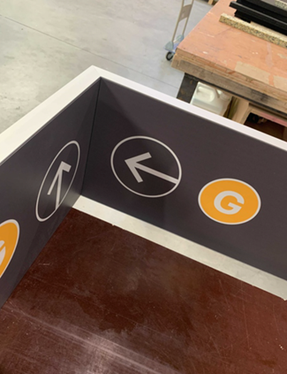
Figure 1. Prototype, inside view upon finalisation in the production site
Source: /STUDIOMDA

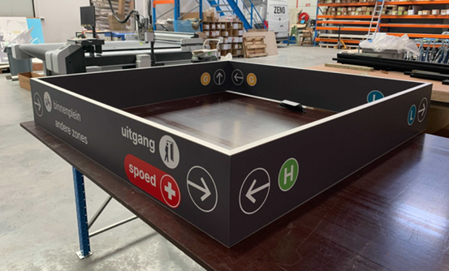
Figure 2. Prototype, outside view upon finalisation in the production site
Source: /STUDIOMDA

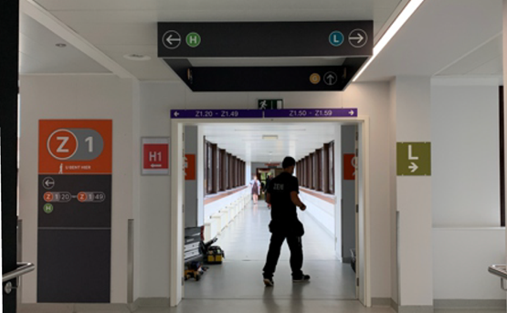
Figure 3. Prototype installed in situ
Source: /STUDIOMDA

A prototype was thus produced and hung in a principal intersection in the main central corridor of the hospital. That way, it was possible to check the effectiveness of its concept and graphic resolution.

4. Results and discussion
The descriptive data collected during the research phase helped the design team understand how people behaved, how they moved about, and where the problems regarding wayfinding were more evident on campus. The insights helped us learn more about the existing system and the logic of the structure of the facilities. The team also gathered information concerning the various stakeholders' issues concerning accessibility, comprehension of the built environment that multiple actors have, and, not less importantly, the personality and principles of the hospital. It is evident that these also have an essential role in the new wayfinding design.
In the end, the collected insights nurtured the design process of the new wayfinding system. Indeed, after the research phase, the design team learned more about the four key topics related to developing a new wayfinding system for the concerned hospital.
First, regarding the technique of Progressive Disclosure (Society for Experiential Graphic Design, 2014), the performed research helped to check how to deliver information throughout the hospital, only when and where needed. Applying a step-by-step strategic approach can provide people with information in digestible pieces at the correct times. A few clear and well-placed signs will be more effective than a multiplicity of them. In that way, wayfinding establishes a sense of legibility and order, making the system intuitive and trustworthy.
Second, the research insights helped check for the best visibility in each space to ensure that the wayfinding information would be easy to find on every key spot of the circulation for diverse users. For example, we studied the use of colours to encourage future choices in the design process with regard to a proposed new colour palette for the system. The proposal for a new standard needed to be aesthetically pleasing but also readable and understandable for users with visual weaknesses. Figures 4 and 5 show the proposed colour palette at the end of the design process:
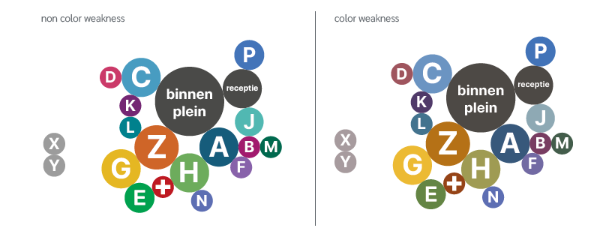
Figure 4-5. Colour palette with vision perception for people with no colour weakness at the left and for people with colour weakness at the right
Third, the data facilitated understanding the location of various route decision points. In that way, during the design process of the new wayfinding system, through the planned strategy, we could ensure and facilitate the search for destinations and ensure that the navigation throughout the various routes in the hospital would be straightforward, spontaneous, and reliable.
Fourth, the research insights helped to define paths throughout the hospital, which nurtured the design process by assisting the design team in deciding how and where clear ways could lead users. Also, where and how paths could be given in a sequenced way.
The concrete wayfinding design strategy that came out of this research will be able to translate different needs and complexities into a system that will focus on being trusted by all people, as a tool for an independent and self-confident journey from one point to the other. This way, the collected research insights contributed to a concrete design intervention in practice. As such, the research adds to the body of theory on wayfinding design in healthcare facilities by demonstrating how research in situ can nurture actual design practice.

5. Conclusions
Considering that 'well-being' has been one of the UN Sustainable Development Goals for some years and is gaining increasing resonance in a lot of countries' policies, economies and societies, it seems an opportunity to state that the well-being of future and current users of spaces should preferably receive as much attention as other issues have received over the years.

Specifically for hospitals, where wayfinding is crucial for a comfortable atmosphere, investing in design for an innovative, friendly, clear, and flexible wayfinding system is fundamental. Integrating various stakeholders' perceptions of wayfinding has brought much input to the design team that works on the strategy and design of an effective wayfinding system for a healthcare facility.

Looking at training programs in design, we are ready to educate spatial designers and train professionals who can make a difference in the spatial practice of healthcare environmental design, so they can be better trained and informed on such matters.

Contributor statement
Ann Petermans is the leading researcher on this project. Together with /STUDIOMDA, she presented the project to students, whom she helped to guide throughout the research process. She analyzed the data of the study, evaluated the students, and wrote the paper.
Luciana Mattiello is the creative director and founder of /STUDIOMDA, a Belgian-Brazilian studio specialising in strategies for wayfinding design. Together with her team, she contributed to the research process the students went through and assisted in writing this paper. For this paper, she facilitated collaboration with the design team working on this project and the collaborating students.

Acknowledgments
We would like to thank all students who participated in the research phases, the team of /StudioMDA and the hospital involved with whom we collaborated for this project.

References
Bitner, M.J. (1992). Servicescapes: the impact of physical surroundings on customers and employees. Journal of Marketing, 56, 57-71.

Hamed, S., El-Bassiouny, N. & Ternès, A. (2019). Hospital servicescape design for inpatient wellbeing. Services Marketing Quarterly, 40(1), 1-32.

Lynch, K. (1960). The image of the city. Cambridge, Massachusetts: Harvard University Press.

Petermans, A. & Cain, R. (2020). Design for Wellbeing: an applied approach. London: Routledge.

Society for Experiential Graphic Design (2014). Wayfinding is where place meets information design. Available at https://segd.org/wayfinding-where-place-meets-information-design, Accessed on March 13, 2022.

Suess, C. & Mody, M. (2018). The influence of hospitable design and service on patient responses. The Service Industries Journal, 28(1-2), 127-147.

Vigolo, V., Bonfanti, A., Sallaku, R. & Douglas, J. (2020). The effect of signage and emotions on satisfaction with the servicescape: an empirical investigation in a healthcare service setting. Psychology & Marketing, 37, 408-417.

