Type of the Paper: Peer-reviewed Conference Paper / Short Paper
Track title: Topic 3: engagement – co-creation, co-design, design and stakeholder management processes

Conducting user research for development of gait assessment interface for incomplete spinal cord injury through user-centered design approach
Rebekah Kempske ¹, Karin Postma^{2,3}, Daniel Lemus Perez³, Rutger Osterthun^{2,3}, and Herwin Horemans ^{2,3}*
¹ Faculty of Industrial Design Engineering, Delft University of Technology, Delft
² Rijndam Rehabilitation Center, Rotterdam, The Netherlands
³ Dept. Rehabilitation Medicine, Erasmus MC University Medical Center Rotterdam, Rotterdam, The Netherlands
* Corresponding author: Herwin Horemans (h.l.d.horemans@erasmusmc.nl)

Research highlights
1) Used user-centered design to develop a user interface to assess the gait of patients with incomplete spinal cord injury
2) Conducted user research through incorporating interactive activity boards into focus groups
Keywords: user-centered design; spinal cord injury; user interface design; gait analysis; rehabilitation
Names of the Topic editors:
Clarine van Oel
Names of the reviewers:
Iris Beuls
Göran Lindahl
Journal: The Evolving Scholar
DOI:10.24404/622f989a3b8923372335f04a

Submitted: 31 Jul 2022
Accepted: 22 August 2022
Published: 28 July 2023
Citation: Kempske, R., Postma, K., Lemus Perez, D., Osterthun, R., & Herwin, H. (2023). Conducting user research for development of gait assessment interface for incomplete spinal cord injury through user-centred design approach. The Evolving Scholar | ARCH22. https://doi.org/10.24404/622f989a3b8923372335f04a

This work is licensed under a Creative Commons Attribution CCBY license (CC BY).

© 2022 Kempske, R., Postma, K., Lemus Perez, D., Osterthun, R., & Herwin, H. Published by TU Delft OPEN on behalf of the authors.

Abstract

For most patients with an incomplete spinal cord injury, gait rehabilitation plays a key role in functional recovery. A study was initiated to develop a user-friendly gait assessment interface that allows physicians and physiotherapists to objectively assess the gait characteristics of patients with incomplete spinal cord injury. The paper focuses on the first stage of the design process, user research, and how user-centered design was used to identify users’ needs and expectations, and the context wherein the gait assessment interface would be used. This was done through conducting focus group sessions with professional users (physicians and physiotherapists) and using interactive activity boards to obtain answers and facilitate discussion. The information obtained, as well as user-centered design practices, will be used throughout the further development of the gait assessment interface.

1. Introduction

1.1. Background
Injury to the spinal cord results in loss or impairment of motor and/or sensory function in the lower half of the body (paraplegia) or below the neck (tetraplegia). Within paraplegia and tetraplegia, a spinal cord injury (SCI) is classified as neurologically complete or incomplete, in which the severity of the SCI largely determines functional capacity. The majority of people with preserved sensory and/or motor function in the lowest sacral segment (incomplete SCI) regain full or partial walking function (Kirshblum et al. 2011). For incomplete SCI patients, a part of their rehabilitation is improving their mobility skills through gait training. Physicians and physiotherapists use observational gait analysis and, if available, laboratory gait analysis to assess a patient's gait to evaluate progress, select interventions, and guide the therapy program (Post et al., 2017).
However, these methods have drawbacks. Observational gait analysis lacks sufficient interrater reliability, due to its subjective nature (Ong et al., 2008). Laboratory gait analysis is time-consuming, has to be performed by specialised personnel, and due to the nature of testing in a lab environment, may not be representative of the patient’s everyday walking pattern (Baker, 2006). Therefore, we initiated a study to develop a user-friendly gait assessment interface based on data from inertial measurement units (IMUs) that allows physicians and physiotherapists to objectively assess the gait characteristics of patients with incomplete SCI outside the lab – improving the patient’s overall quality of care. An example of a potentially appropriate IMUs system is that of Xsens (Xsens MTw Awinda IMUs combined with MVN Analyse software in a lower body with sternum setup; Xsens Technologies B.V., Enschede, The Netherlands) ("MTw Awinda" 2021).

1.2. Aim of Study

The design process undergone to develop the gait assessment interface was adapted from the Double Diamond Model (Melles et al., 2021) and consisted of four stages (Figure 1): (1) user research to identify physicians and physiotherapists' needs, expectations, and the context wherein the system will be used (Discover Phase); (2) analysing and interpreting user research results to collect insights and define the design vision (Define Phase); (3) conceptualisation and assessment of initial concepts for the layout of the gait assessment interface and visualisation of the gait parameters (Develop and Deliver Phases); and (4) developing and evaluating the final design and prototype of the interface (Develop and Deliver Phases).

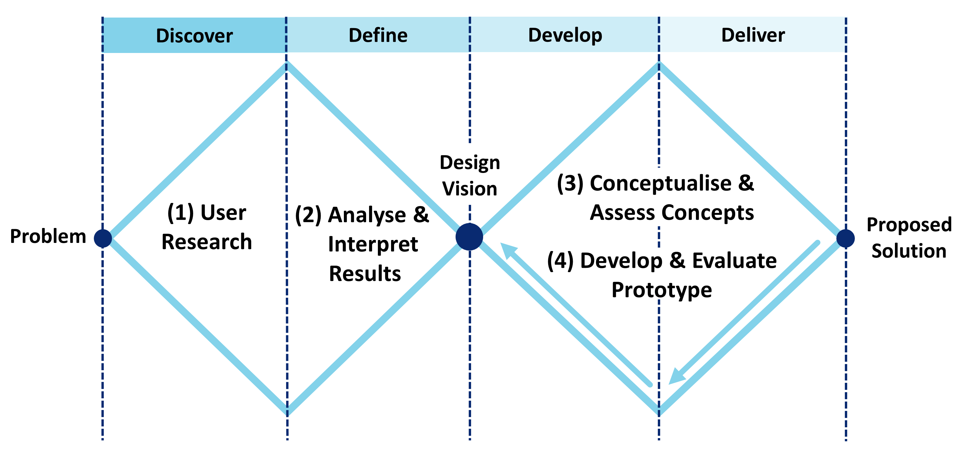
Figure 1: The user-centered design process used to develop the IMU-based gait assessment interface consisted of four stages: (1) User Research (Develop); (2) Analyse and Interpret Results (Define); (3) Conceptualise and Assess (Develop and Deliver); and (4) Develop and Evaluate Prototype (Develop and Deliver). This paper will focus on stage one, User Research.

This paper is methodological and will focus on stage one of the design process, user research, and how user-centered design was used to identify the users' needs.

2. Theories and Methods
User-centered design was utilised in every stage of the design process to better understand and assess user needs and adapt the design to meet these needs. For this project, the users were rehabilitation physicians and physiotherapists who treat patients with neurological disorders, including incomplete SCI. Through involving users throughout the entire design process, this approach allowed for a more usable and accessible product to be designed (Melles et al., 2021).
Before designing the user interface, it was important to identify users’ needs, expectations, and the context wherein the gait assessment interface would be used. To do so, user research was conducted to examine what features and gait analysis parameters physicians and physiotherapists would like to present in the user interface, and how these parameters should be visualised. This was done by conducting focus groups.
Physiotherapists and physicians who work for Rijndam Rehabilitation and treat patients with neurological disorders, including incomplete SCI, were recruited to participate in the focus groups. Most participants had limited to intermediate experience with interpreting laboratory gait analysis reports. Therefore, a focus group format was selected, rather than a questionnaire, to avoid confusion regarding terminology surrounding gait analysis parameters and to allow for discussion between participants.
The focus groups ranged in size to fit participants’ schedules, with a maximum of six participants in a session. The focus groups were conducted in person and over video teleconferencing over the course of two weeks, with each lasting one hour. Six physicians and twelve physiotherapists participated in the focus groups.
At the beginning of each session, a short presentation was given to explain the project’s purpose and how the session would be conducted. The presentation also briefly explained what IMUs are and how they would be used in the operation of the user interface.
The participants then completed a series of interactive activities on a digital board through the platform Miro (Figure 2) (“Miro,” 2022). Each participant was assigned their own board and could access it via a link sent by the principal designer. The board was broken down into three sections: (1) Selecting gait analysis parameters; (2) Selecting how the parameters should be visualised; and (3) Additional features wanted to be included in the user interface. Each activity was first explained, and then after the participants completed it, there was a discussion on why the participants formed those answers.
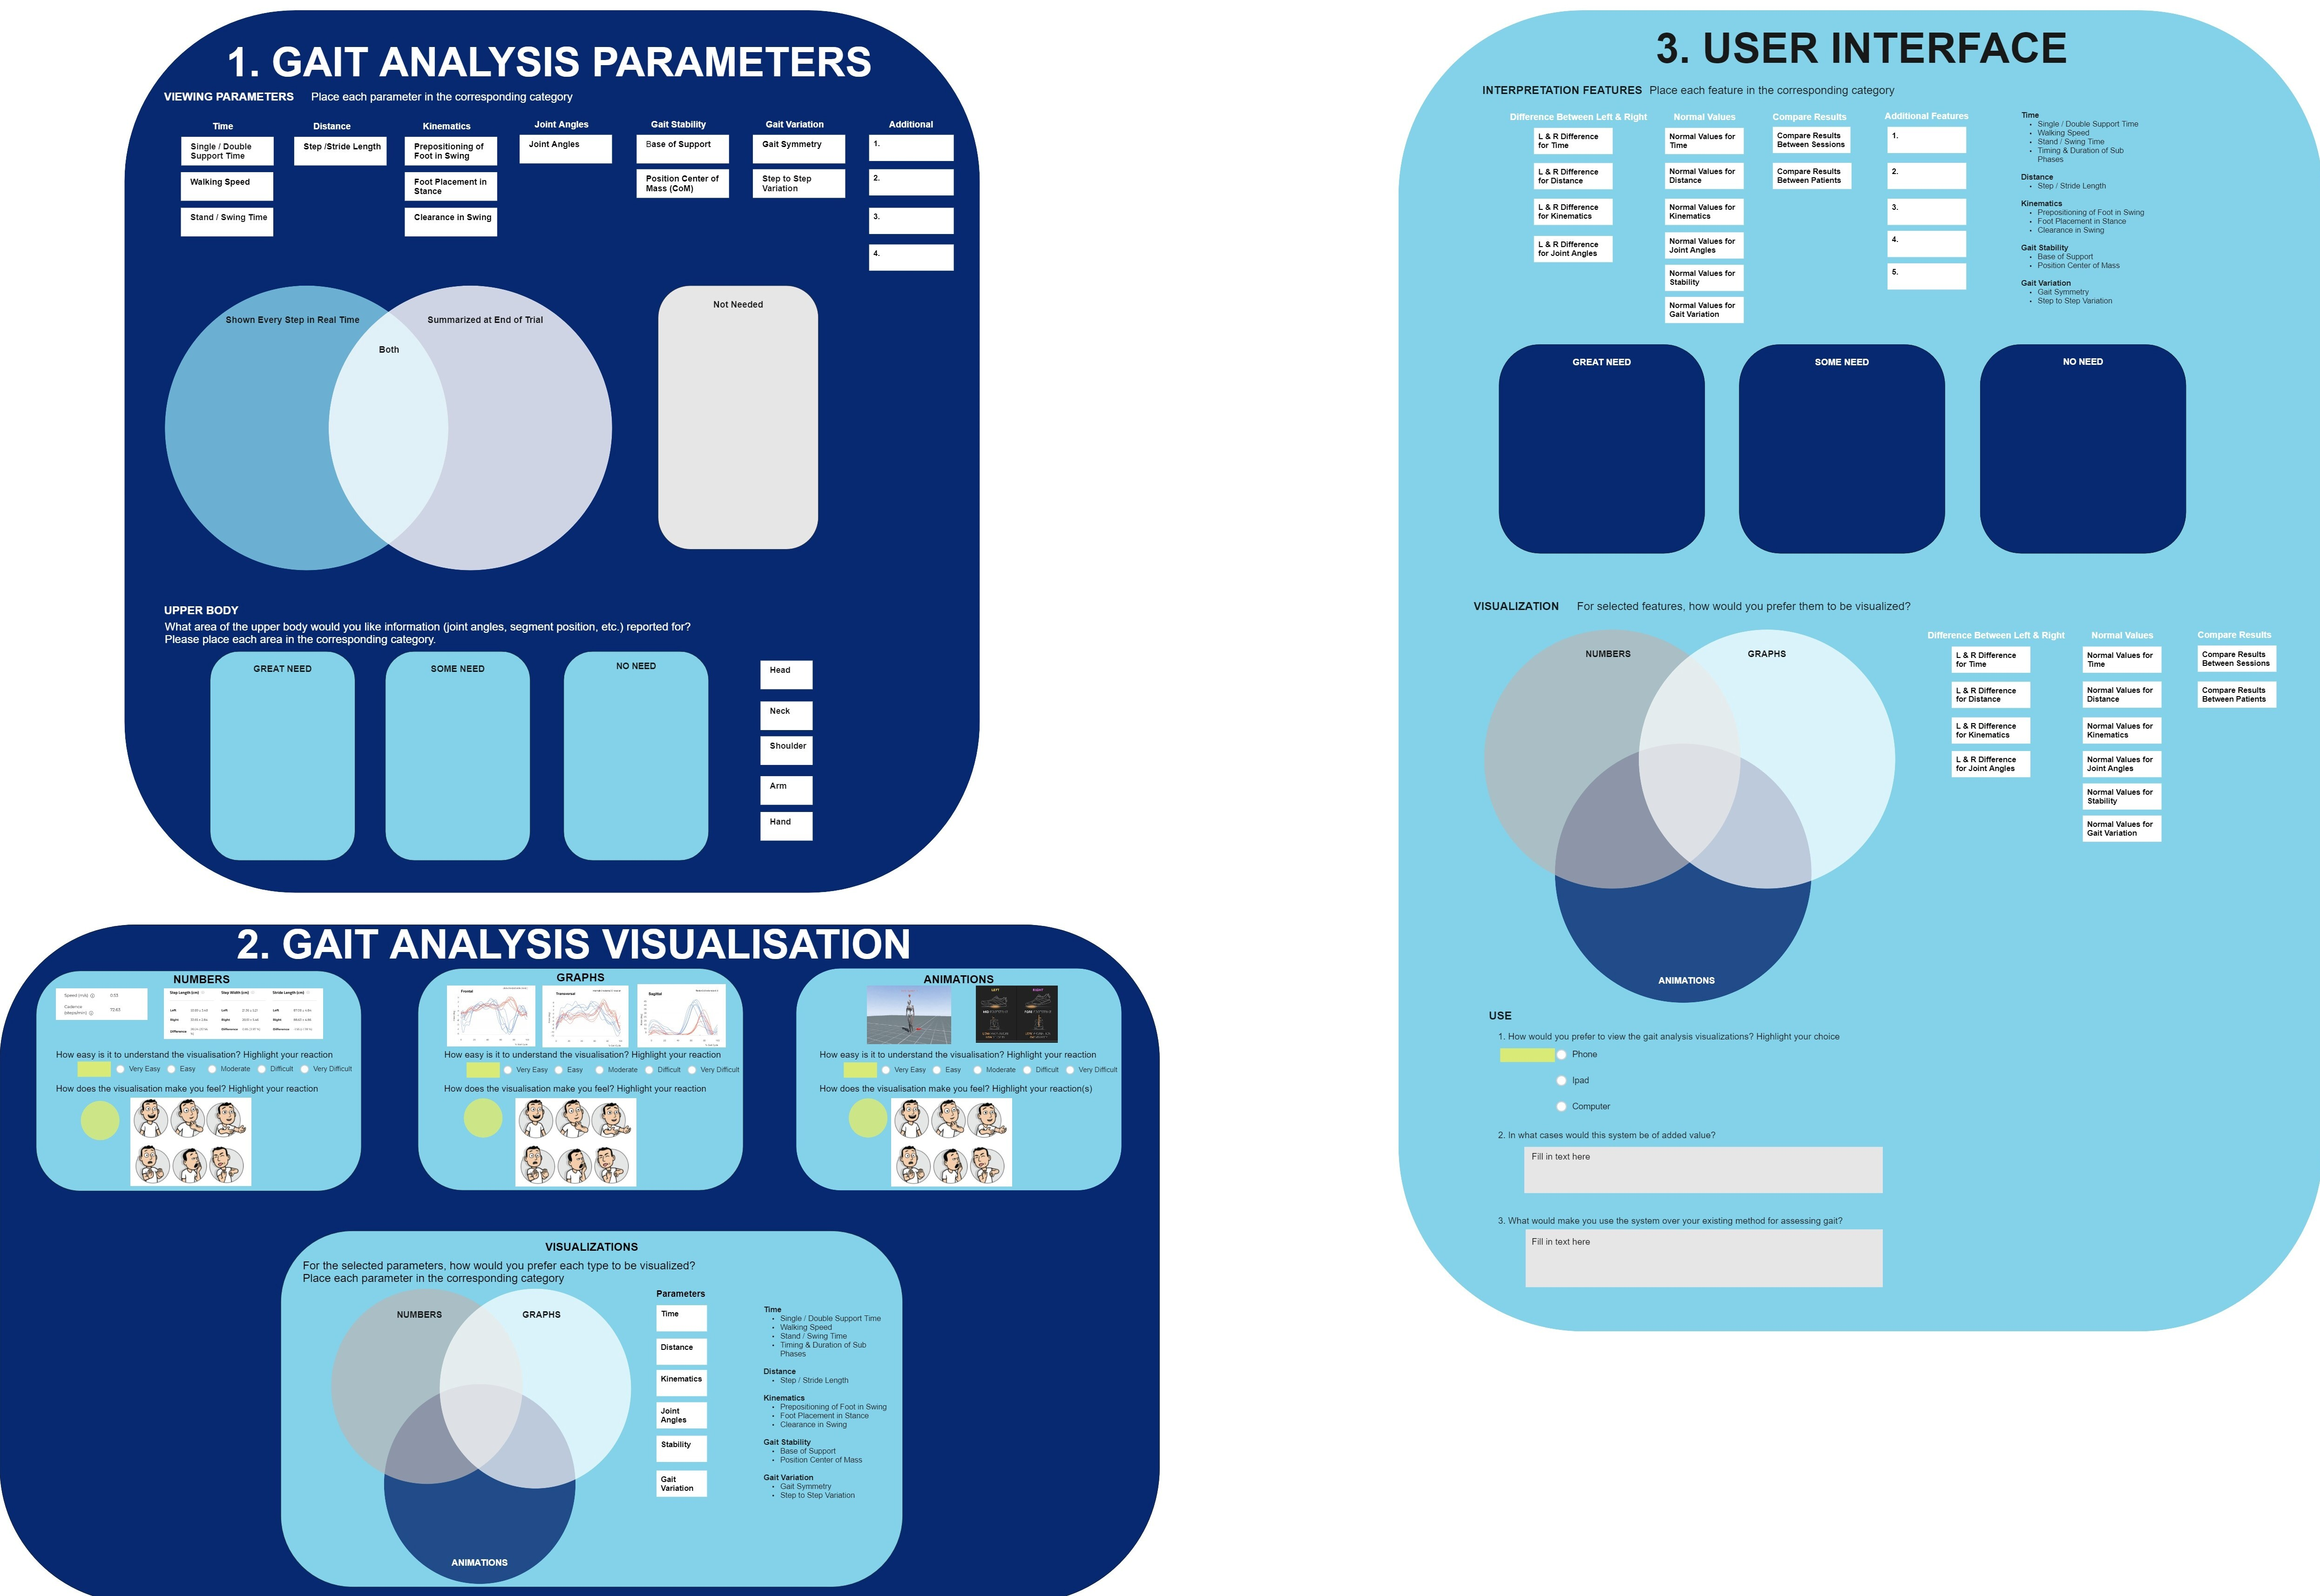
Figure 2: Participants each had their own Miro activity board during the focus group sessions. The activity board consisted of interactive questions that were divided into three sections: (1) Gait Analysis Parameters, (2) Gait Analysis Visualisations, and (3) User Interface Features.
Questions asked in the interactive activities on the board included:
- Place each gait analysis parameter in the corresponding category: Great Need, Some Need, or No Need.
- For the selected gait analysis parameters, how would you prefer each type to be visualised? Place each parameter in the corresponding category: Numbers, Graphs, or Animations.
- What would make you use the system over your existing method for assessing gait?
The activity board format was selected as it facilitated group discussion but still allowed for answers to be collected from every participant. Interactive elements were incorporated into the activity board, such as participants’ moving blocks into boxes and Venn diagrams based on preferences and highlighting their answers. Miro was chosen rather than the alternative of a paper activity, as the sessions were conducted over video teleconferencing and in person.
During each focus group session, notes were taken by the principal designer. The audio of each session was recorded and later transcribed. Answers to the quantitative questions were analysed using Excel. Responses to the qualitative questions were collected and categorised using the Affinity Diagram method. In this method, ideas are clustered into similar groups and themes. These groups are then broken down into smaller groups to evaluate the relationship between the ideas (Beyer and Holtzblatt, 2016).

3. Results
At the beginning of each session, it took the designer about five to ten minutes to ensure that all participants were on their respective activity boards and to explain how to operate them. Once the participants understood the basic workings of the board, only minor technical assistance was needed throughout the remainder of the session.
The participants found that using the interactive activity boards was a more enjoyable experience than in a previous survey when they answered questions regarding gait assessment through an online questionnaire. Participants appreciated being able to discuss their answers with each other if they were confused about how the question related to the context of their work. It also allowed for discussion to be facilitated about why participants chose their answers.
By having the participants fill out the boards during the session, the designer could immediately answer any questions regarding the content on the boards and help with technical issues. If the designer was confused about any participant’s answers, they could ask the participants to clarify their answers.

4. Discussion

4.1. Focus Group Results
In a previous survey related to this project, there was confusion about how some of the questions were worded and the terminology used, inherent to the differences in background and level of experience of the participants. To avoid this confusion, a focus group format was selected. Focus groups allowed the designer to answer any of the participant’s questions and provide answers in real-time, while also letting participants discuss the questions with each other. Through discussion and asking follow-up questions, the designer also understood the participants’ answers more thoroughly and comprehended the why behind their answers. This also saved the designer and participants a lot of time, as follow-up meetings were not needed to ask any additional or clarifying questions.
The interactive components of the Miro activity board allowed the designer to keep the participants’ attention and interest throughout the hour-long session. Each participant having their own board permitted made it possible for individual answers to be collected while still having a group discussion and to obtain detailed explanations from every participant in a short amount of time. This would not have been possible if only questions were asked in a group discussion format.

4.2. Future Recommendations
Since the sessions were only one hour each, the designer needing five to ten minutes to set up and explain how to use the interactive activity board took away valuable time. This led to some participants rushing to answer the final questions. In turn, the quality of these answers was lower than the questions asked at the beginning of the session and only allowed for limited discussion of these final questions.
If this study were conducted again, it would be recommended to send a tutorial or short video to the participants beforehand demonstrating how to access and operate the activity board. This would allow the participants to start answering the questions on the activity board at the very beginning of the session.
Also, there was only one designer present per session. In doing so, there was a limitation in that the designer could not take extensive notes during the session and had less time to listen to discussions and interact with the participants. In the future, having an additional designer present at each session would be recommended. The additional designer can take more extensive notes and solve any technical difficulties participants may have.

4.3. Implementation of User-Centered Design in Project
User-centered design was continued throughout the remainder of the project. From the results and insights from the focus groups, a design vision was formed, followed by the development of concepts for the gait assessment interface. These concepts were evaluated with the users through user test sessions. The concepts were assessed in terms of usability, functionality, and level of understanding. From the feedback in these sessions, a final design and interactive prototype of the user interface were created. Users tested the interface prototype to evaluate and obtain feedback on usability, aesthetics, intuitiveness of use, and functionalities of the developed design.

5. Conclusions
In developing the gait assessment interface, user-centered design was utilised in the user research stage to identify the users' needs and expectations, and the context wherein the interface would be used. This was done through conducting focus group sessions with physicians and physiotherapists and using interactive activity boards to obtain answers and facilitate discussion. This information, as well as user-centered design practises, will be used throughout the further development of the gait assessment interface.

Contributor statement
Rebekah Kempske was the principal designer who developed and led all user tests in this project. She also developed the final design of the gait assessment interface and was the primary author of the article.
Karin Postma contributed to the conception of the work, organizing the group sessions, interpretation of data, and drafting and revising the manuscript.
Daniel Lemus Perez contributed to the conception of the work, interpretation of data, and drafting and revising the manuscript.
Rutger Osterthun advised on the methodological aspects of the project and reviewed and co-edited the manuscript.
Herwin Horemans contributed to the conception of the work, the acquisition of data, the interpretation of data, and drafting and revising the manuscript.

Acknowledgments
The authors would like to thank all of the physicians and physiotherapists who participated in this project and aided in its development.

References
Baker, R. (2006). Gait Analysis Methods in Rehabilitation. Journal of Neuroengineering and Rehabilitation, 3, 1-10.
Beyer, H., Holtzblatt, K. (2016). Contextual Design: Design for Life. Netherlands: Elsevier Science.
Kirshblum, Steven C., Stephen P. Burns, Fin Biering-Sorensen, William Donovan, Daniel E. Graves, Amitabh Jha, Mark Johansen, Linda Jones, Andrei Krassiokov, M.J. Mulcahey, Mary Schmidt-Read, and William Waring. (2011). International standards for neurological classification of spinal cord injury (revised 2011). The journal of spinal cord medicine, 34(6), 535-546.
Melles, M., Albayrak, A., & Goossens, R. (2021). Innovating health care: key characteristics of human-centered design. International Journal for Quality in Health Care, 33(Supplement_1), 37-44.
“Miro.” (2022). Miro. Retrieved 2 January 2022, from https://miro.com/.
"MTw Awinda." 2021. Xsens. Retrieved 5 October 2021, from https://www.xsens.com/products/mtw-awinda.
Ong, A. M. L., Hillman, S. J., & Robb, J. E. (2008). Reliability and validity of the Edinburgh Visual Gait Score for cerebral palsy when used by inexperienced observers. Gait & Posture, 28(2), 323-326.
Post, M. W., Nooijen, C. F., Postma, K., Dekkers, J., Penninx, F., van den Berg-Emons, R. J., & Stam, H. J. (2017). People with spinal cord injury in the Netherlands. American Journal of Physical Medicine & Rehabilitation, 96(2), S93-S95.

