Type of the Paper: Peer-reviewed Conference Paper / Full Paper
Track title: Stream inclusive design/health promotion – inclusive communal living

Home and Healthcare. The prospect of home adaptation through a computational design decision-support system
Federica Romagnoli ¹, Pirouz Nourian ², Tiziana Ferrante ³, and Teresa Villani ⁴
¹ Department of Civil, Constructional and Environmental Engineering, Sapienza University of Rome, Italy ; federica.romagnoli@uniroma1.it; 0000-0001-5520-3356
² Department of Architectural Engineering & Technology, Faculty of Architecture and the Built Environment, TU Delft; p.nourian@tudelft.nl; 0000-0002-3817-7931
³ Department of Planning, Design, and Technology of Architecture, Sapienza University of Rome, Italy; tiziana.ferrante@uniroma1.it; 0000-0002-0625-4453
⁴ Department of Planning, Design, and Technology of Architecture, Sapienza University of Rome, Italy; teresa.villani@uniroma1.it; 0000-0003-3665-1609

Names of the Topic editors:
Clarine van Oel
Names of the reviewers:
Birgit Jürgenhake
Journal: The Evolving Scholar
DOI:10.24404/6230c7305e57b895ac66bc74

Submitted: 21 March 2022
Accepted: 22 August 2022
Published: 11 April 2023
Citation: Romagnoli, F., Nourian, P., Ferrante, T. & Villani, T. (2023). Home and Healthcare. The prospect of home adaptation through a computational design decision-support system The Evolving Scholar | ARCH22. https://doi.org/10.24404/6230c7305e57b895ac66bc74
This work is licensed under a Creative Commons Attribution CC BY-ND license (CC BY-ND ).

© 2022 Romagnoli, F., Nourian, P., Ferrante, T. & Villani, T. published by TU Delft OPEN on behalf of the authors.

Abstract: This paper presents ongoing research to define the framework of a computational design approach based on the ideas of spatial analysis and spatial synthesis to implement multi-criteria evaluations and provide evidence of the performance of the design alternatives in the specific case of home adaptation for healthcare at home. The European health systems place among their priority objectives the strengthening of the provision of healthcare at home to guarantee the well-being of elderly people and to limit, at the same time, the unnecessary use of resources. Therefore, existing homes must provide adequate safety, comfort, and accessibility features to ensure a high quality of life for the care receivers and facilitate the carer' tasks. To address the complexity of the requirements to be met, we propose a spatial decision support system (SDSS) to implement multi-criteria assessments to ergonomic design problems at a spatial scale of apartment homes. The system is intended to streamline and assist designers and homeowners in planning interventions for home adaptations for healthcare. Such design problems can be formulated as decision problems with costs and benefits modelled within the constraints of validity and quality criteria. Concerning the specific field of study, the system evaluates the degree of compliance with the accessibility and visibility quality criteria of each design alternative. The reiteration of the evaluation mechanism allows for the classification and supports the selection of satisfactory technical solutions identified with an informed and well-balanced trade-off between the relevant quality criteria.
Keywords: healthcare at home; home adaptation; human-centred design; evidence-based design; multi-criteria decision-making.

1. Introduction
This paper describes the intermediate results of an ongoing research that intends to contribute to the strategies for the adaptation of the built environment in response to the new health needs of the elderly population (according to the 11th Sustainable Development Goal SDG11 of the UN 2030 Agenda for Sustainable Development and aligned with the United Nations Decade of Healthy Ageing 2021-2030). Observing the demographic trends expected for the next few decades, in 2050 the percentage of people over 65 will reach 24.4% of the European population (Eurostat, 2020). This will also lead to an increase in the demand for long-term care for the treatment of chronic diseases, which mainly affect the older population. Since, as we age, we are generally witnessing a reduction in autonomy and mobility, there are many European health systems that, according to the 18th Pillar of the European Pillars of Social Rights, promote the strengthening of home care services within the territorial care network (European Union, 2017). This is encouraging, in many countries, as is the development of new housing models for assisted living and, at the same time, the implementation of adaptation strategies to make existing homes more accessible, safe, and suitable for the ageing in place of inhabitants, to save resources and land consumption. The introduction of nursing activities (personal care, medication, etc.), rehabilitation, and assistance in daily life tasks (toileting, dressing, feeding, etc.) requires the home environment to meet several requirements through an adequate configuration and physical characterization of the architectural components (Ferrante & Cellucci, 2021).
Changing a home so that care can be given at home means taking into account many technical, economic, psychological, etc. factors at the same time, which can make it hard to find a single solution. Because of this multi-dimensional complexity (Azadi & Nourian, 2021), it is important to use tools and methods to do multi-criteria assessments from the beginning of the design process to help make technical decisions that meet the needs of all users.
The generative formulation of the project can be thought of as a series of discrete decisions that can be supported and informed by evaluation procedures that use simulations and computer analyses. Starting from the definition of a BIM model of a house, it is possible to associate a home renovation plan with a layout problem where the goal is to find the configuration (in terms of spaces, objects, and architectural elements) that meets several predetermined quality criteria. As shown in Figure 1, the BIM model of a domestic space contains a set of both geometric and informational data related to the characteristics of individual objects and their belonging to an architectural element or space (e.g., a door belonging to a wall, or an object belonging to a room).
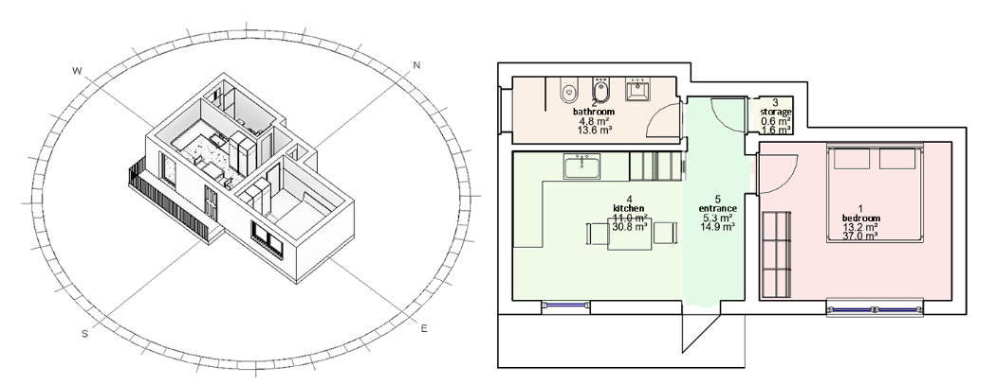
Figure 1. Scheme of the spatial BIM model.
In line with what has been said, the goal of the research is to define a spatial decision support system (SDSS) that can analyse the ergonomic properties at a spatial scale of a given configuration of spaces and objects represented by a BIM model that has all the relevant data. In the following sessions, we describe the definition of several analyses to establish a multicriteria evaluation mechanism to support selecting technical intervention choices in the specific field of housing adaptation for home care.

2. Theories and Methods
As a preliminary step, following a human-centred design approach, we have identified and categorised into a set of requirements that the domestic space must guarantee to be supportive and therapeutic for the care receiver and facilitate the carers' tasks. This phase has been conducted through direct observation, semi-structured interviews with carers, and a study of literature sources such as Wright et al. (2017) and Piatkowski et al. (2019). To reduce the field of investigation, we considered the case of high-intensity home care for totally dependent people. Although the extreme variability of specific cases (due to each individual's particular functional and pathological state) makes it impossible (and not so valuable) to establish the prioritised spatial requirements for all exhaustively, some recurring aspects can be observed. In particular, some layout features such as the proximity of the assisted room to a toilet or storage area of medicines are valid for most cases. In addition, some features of the physical accessibility of the spaces are necessary to allow the performance of all the activities of care and assisted walking within the living space. Finally, some visibility features are also fundamental, such as the daylight availability that helps the correct alternation of sleeping and waking cycles, and visual access to preferential views that psychologically support the care receiver to bear the symptoms (Ulrich, 1984).
In our approach, the selected requirements are the quality standards that the home adaptation project needs to meet. As shown in Table 1, they were divided into three macro-categories: layout proximity (closeness of spaces), accessibility, and visibility criteria.
Table 1. Summary of quality criteria
 | Quality criteria
Layout (closeness) | Criteria 1.a: The storage area for equipment and medicines must be close to the care-receiver’s bedroom.
 | Criteria 1.b: The care-receiver’s bedroom must be close to a toilet.
Accessibility | Criteria 2.a: The width of passages should never be less than 80 cm, or 120 cm in the case of assisted walking.
 | Criteria 2.b: There must be a free space with a diameter of 150 cm in the care-receiver’s bedroom and bathroom.
 | Criteria 2.c: It must be possible to approach the care-receiver's bed on three sides, ensuring a 120-cm -wide band on at least one long side.
Visibility | Criteria 3.a: A daylight factor greater than 3% (or at least 2%) must be guaranteed in the care-receiver's bedroom.
 | Criteria 3.b: The care-receiver must be able to see out the window from the bed.

Then, the key features of an ideal SDSS for our purpose have been defined as follows:
1) The tool has to verify the response of a given spatial configuration model to the set of quality criteria. Therefore, each criterion needs to be formally defined as an aggregation of the results of a spatial analysis. To this end, a series of spatial quality functions need to be defined to measure the degree of satisfaction of the requirement set.
2) The way the evaluation is done has to take into account the logistical and functional limitations of existing housing that affect how easy the different intervention options are to use. Since the subject of the study concerns the adaptation of existing dwellings, these factors involve some characteristics that must remain unchanged (i.e., the perimeter of the floor plan, the windows' location, the main entrance location, the drains' location, etc.) and others that, although modifiable, represent a burden for the owners (i.e., wall rebuilding, floor renovation, etc.).
3) The tool must be easy for designers to use so that the decision-making process is open to everyone and can be changed to fit the needs of each user. Therefore, the evaluation mechanism should be transparent, and flexible in defining different priorities for each quality criterion (which can be established on a case-by-case basis), and allow real-time interaction with the design team.
According to these required features, we explored some computer-aided tools applicable in the residential environment by studying recent systematic reviews such as (Nisztuk & Myszkowski, 2018; Zhang et al., 2019). This phase led to the identification of previous approaches based mainly on two research areas that have deepened the potential of computational design to solve "spatial allocation problems" experienced in video games and applicable to housing architectural design. The first area concerns "architectural floorplan optimization" (Merrell et al., 2010; Veloso et al., 2018; Keshavarzi et al., 2021), while the second relates to "automated furniture arrangement" (Merrell et al., 2011; Yeh et al., 2012; Yu et al., 2011; Kán & Kaufmann, 2017).
Many of the observed techniques adopt the approach proposed by Merrell et al. (2011), in which ergonomic and functional requirements derived from design guidelines are modelled in terms of a cost function that defines a ‘score’ associated with a space and furniture configuration. Each term of the function is multiplied by a factor that defines its priority concerning the whole set of considered criteria. However, existing tools are aimed primarily at designing new buildings within a predefined perimeter with known context conditions (Sönmez, 2018). To date, according to the authors' knowledge, none of the available tools can support the decision-making process in the case of the renovation of existing housing to maximise accessibility and visual comfort features. This specific field of study presents particular complexities, due not to the size in terms of the extent of the intervention to be carried out, but to the heterogeneity of the ergonomic, functional, and technical requirements to meet and the specificity of the contextual constraints (structural, plant, economic, etc.) to comply (National Research Council, 2011), together with the subjective preferences of users for the customization of their living space.
Therefore, a literature search has been undertaken, focusing on specific computer-aided methods based on the three main categories of defined quality criteria. The goal was to identify the most appropriate techniques for modelling the quality criteria functions and allowing an objective measurement of the performance provided by a given spatial configuration. The following subsections report on the identified methods and techniques, particularly those considered most promising for future implementation.

2.1 Layout (closeness) criteria
Criteria 1.a: The storage area for equipment and medicines must be close to the care-receiver’s bedroom.
Criteria 1.b: The care-receiver’s bedroom must be close to a toilet.

The shortest path problem between two points on a grid made by floorplan discretization has to do with both of these criteria. For our proposal, the most promising methods seem to be the Dijkstra algorithm and its extension, the A*Algorithm, which have been used in many previous applications (Goldstein et al., 2020; Goel et al., 2017) and whose popularity has been largely documented (Abd Algfoor et al., 2015; Madkour et al., 2017; Kumawat et al., 2021). As shown in Figure 2, the system overlays the spaces with a regular grid. Then, the shortest paths between the relevant points are calculated in terms of the minimum number of touched nodes on the network formed by the grid cells.
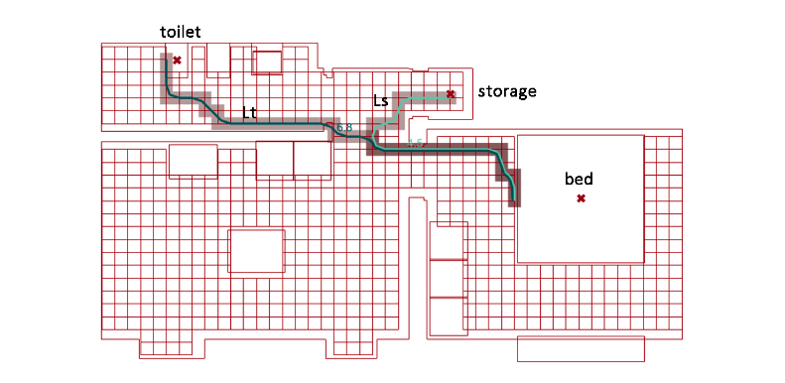
Figure 2 : An example of how the shortest paths between important points on a grid are calculated.

2.2 Accessibility Criteria
Criteria 2.a: The width of passages should never be less than 80 cm, or 120 cm in the case of assisted walking.

Except as described for criteria 1.a and 1.b, the paths taken in the domestic space during the care activities are too vague to establish the points of departure and arrival for all the care activities. Moreover, the distance between the objects is not sufficient to describe the actual reachability for those who, for example, use a wheelchair. For these reasons, we preferred to evaluate other aspects relating to the accessibility characteristics of the spaces, such as the maximum walkable surface within the spaces most involved in the care activities.
Referring to studies proposed in the simulation of the flow of people along navigation paths, (van Toll et al., 2018; Ghosh et al., 2020; Naderpour et al., 2019), we chose to model free space with skeletonization techniques that capture the topological skeleton of a bounded space through the medial axis transformation technique (Lee, 1982). All the feasible navigation paths are identified by searching for the topological skeleton (or medial axis) of the mesh formed by the inner perimeter of the housing, from which obstacles (such as walls or furniture) are subtracted. Since the topological skeleton is the locus of the centres of the circles inscribed within a given polygon, it is possible to select only the circles with a diameter greater than 80 cm (or 120 cm) to calculate the walkable surface as the union of the regions formed by all the selected circles. (see Figure 3 – part a).

Criteria 2.b: Presence in the bedroom and in the bathroom of a free area with a diameter of 150 cm.

For this criterion, two identical procedures are performed (one in the bedroom and one in the toilet), in which, within the free surfaces, the circle of maximum inscribable diameter is identified and its area is calculated (see Figure 2 - part b).

Criteria 2.c: Possibility to approach on three sides of the bed, ensuring a 120-cm-wide band on at least one long side.

In this case, a quality parameter is given by the free area near the bed, defined by the 120 cm offset of the ground projection of the bed, minus the projection of the obstacles on the ground, as shown in Figure 3 (c).

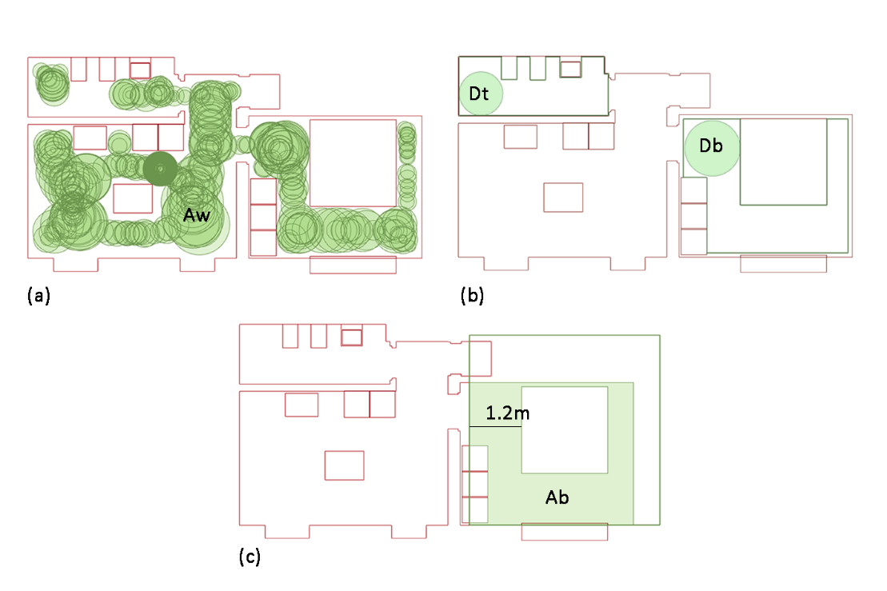
Figure 3. (a): Calculation of the area formed by the union of the circles with a diameter greater than 80 cm inscribed within the portion of the surface free from obstacles. (b): Calculation of the maximum inscribed circle within the portion of the surface of the bedroom free from obstacles. (c): Calculation of the area resulting from the difference between the surface around the bed (within a perimeter of 120cm offset from it), minus the area on the ground of the obstacles.

2.3 Visibility Criteria

Criteria 3.a: Ensure a daylight factor greater than 3% (or at least 2%) within the care receiver's room.

The percentage of daylight factor is calculated by adding to the model’s input data the geographical location of the project, the height of the patient's bedroom, the position, the size of the openings, the type of glass, and the chromatic characteristics of the internal cladding surfaces. In this case, the calculation was done through Ladybug (Sadeghipour Roudsari & Pak, 2013), an open-source tool available and usable through the visual programming language (VPL) Grasshopper (Figure 4 -part b).

Criteria 3.b: Guarantee the possibility for the care receiver to view out of the window from the bed.

To measure the performance against this requirement, we referenced an analysis of the isovists property, defined as the area (or volume) of space visible from a given point in space (Benedikt, 1979). These represent a measurement of a spatial quality also taken from the Space Syntax methodology (Hillier & Hanson, 1984) for the objective measure of the visibility among each observation point. According to this methodology, several studies have proposed tools for configurational analyses (including the Isovists analysis) implemented within VLP applications for BIM environments. In this case, the parameter that describes the response to the quality criterion is the angle of the horizontal view that encloses the visual rays that intersect the window. A more sophisticated analysis could be implemented through better structured open-source tools to verify compliance with daylight availability requirements and "view out" quality, such as the one proposed by Brembilla et al. (2021).

Figure 4.(a): 2D Isovists analysis; (b) daylight factor calculation.

2.4 Minimum Intervention Criteria
In the previous sessions, some possible ways to define the quality criteria functions to assign a score to a given spatial configuration have been identified. Based on the analysis results, the design team could think of "n" different configurations to improve the score. . However, in the case of home modifications, the decision-making process could be heavily influenced by the cost and impact of the transformations on the building components required to achieve the desired configuration. For this reason, the tool should be able to compare the alternative configurations with respect to a starting one (assumed to be the existing state of the housing) and penalise the design alternatives that involve the greatest intervention burden. Therefore, we consider building transformations a fourth quality criteria category that design alternatives should meet.

Criteria 4.1 Minimising demolition
Criteria 4.2 Minimising new construction
Criteria 4.3 Minimising the refurbishment of flooring
Criteria 4.4 Minimising the distance of bathroom fixtures from pre-existing drains
For that purpose, the system could calculate the demolished and new wall volumes and the area of new paving needed, as well as the Euclidean distance between the old and new position of the bathroom fixtures.

3. Results
Based on the described methods and techniques tested in other fields of application, the flowchart for the framework of a new spatial decision support system (SDSS) specific to implementing multi-criteria assessments of the different design alternatives in the case of domestic adaptation for home care is illustrated in Figure 5. The system is designed to measure the correspondence of a housing spatial model to a set of predefined quality criteria that refer to requirements of proximity between specific spaces, accessibility, and visibility. Each criterion is represented by a success indicator, which gives an objective measurement of the model’s performance, as summarised in Table 2. The weighted sum of the success indicators defines a function that establishes a score associated with a specific configuration of spaces, objects, and architectural components.

The system workflow includes the following steps:
- Input and weight acquisition:
The designer defines the BIM model of the housing to analyse. This model shall contain the inputs necessary for the system to process the automated analyses. By assigning a variable multiplier factor, the designer can decide the "weight" of the different criteria regarding the entire set.

- First assessment and starting score:
Based on the inputs and weights entered, the system calculates the scoring function and shows the overall and partial results for each criterion. The results of each measurement are normalised to a range from 0 to 1 based on their performance. The score for a certain arrangement of space will be determined by the weighted sum of the results of the functions.
- Implementation of n design alternatives:
The design alternatives are manually implemented by the designer.
- Evaluation and classification of n design alternatives:
All alternative configurations are compared with the starting one (assumed to be an existing state). The system re-evaluates the scoring function. This time, the system also evaluates the fourth category of minimum intervention criteria.

The reiteration of the evaluation mechanism gives a dynamic response to changes in the assumed configuration and makes it easier to group different design options.

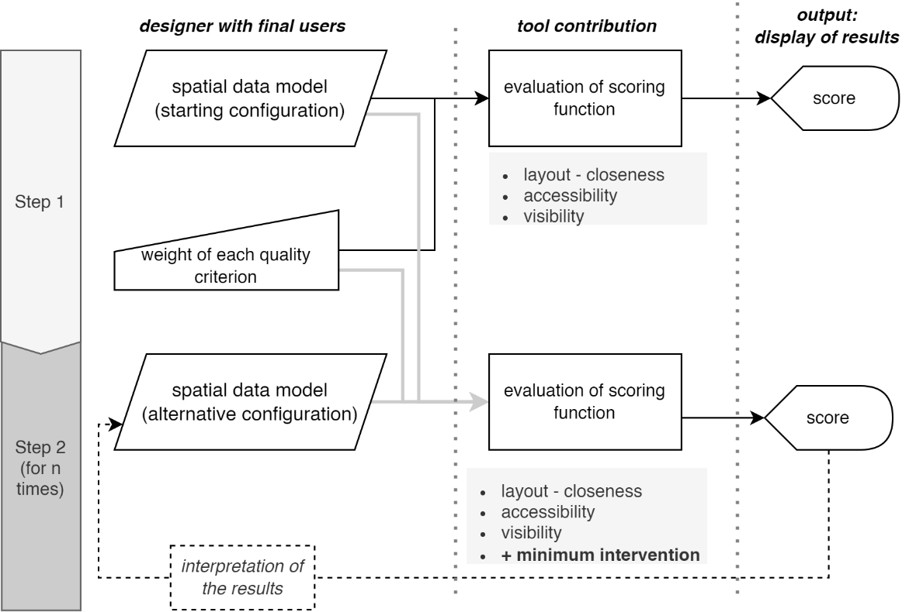
Figure 5: Workflow of the proposed SSDS for home modification designs.

4. Discussion
The goal of the proposed framework is to give designers a new SSDS to help with the home adaptation project for healthcare at home. It is meant to be compatible with the most commonly used software for architectural design and able to base the decision-making process on clear performance specifications to increase the effectiveness and quality of interventions. Moreover, it attempts to offer a possible solution to bridge a gap in the available CAD and BIM tools by assessing the building transformations impact (by modelling them as penalties in the scoring function).
To make human-computer interaction work as well as possible, we choose a mechanism that can give real-time feedback on how well the design choices made by the designer work. This quick response based on objective spatial analysis of a spatial model makes the workflow more interactive and participatory, and supports selecting satisfactory technical solutions identified by an informed and balanced compromise between the relevant quality criteria. The open structure of the evaluation mechanism allows for flexible and customizable use according to the specifics of individual cases. Furthermore, its transparency makes it easier to control expected performance.
One of the limitations identified is that, to date, we have been able to consider only a minimum number of requirements that do not constitute a faithful representation of the characteristics that the home must possess in order to be suitable for home healthcare. At present, the framework does not consider the characteristics of the technical elements (i.e., finishing materials, shading devices, the ’performances of the windows, etc.). However, since they are not neutral qualitative factors, the subsequent developments will concern their modelling by converting the expected performance into scores added to the criteria already defined for the scoring function. This aims to increase the accuracy of the analyses and, consequently, the evaluations carried out by the design team.
Some potential of our approach is that although it is proposed for a specific design sector, the SDSS could be applied in similar contexts: renovations or new buildings for assisted living, or other contexts in which it is necessary to maximise the project’s compliance with ergonomic requirements in an inclusive and for all way (Villani, 2013). Finally, the objective measurement of the adaptability of pre-existing housing could orient the real estate market by increasing the resources allocated to adapt the housing stock from an age-friendly and care-friendly perspective.
Table 2. Summary of quality criteria and success indicators.
 | Quality criteria | Success indicators
Layout (closeness) | Criteria 1.a: The storage area for equipment and medicines must be close to the care-receiver’s bedroom. | Length of the shortest path between the bed and the storage area (Ls).
 | Criteria 1.b: The care-receiver’s bedroom must be close to a toilet. | Length of the shortest path between bed and toilet (Lt).
Accessibility | Criteria 2.a: The width of passages should never be less than 80 cm, or 120 cm in the case of assisted walking. | Walkable floor area (Aw).
 | Criteria 2.b: There must be a free space with a diameter of 150 cm in the care-receiver’s bedroom and bathroom. | Area of an inscribed disc with a diameter greater than 150cm within the free area of the room. (Db; Dt)
 | Criteria 2.c: It must be possible to approach the care-receiver's bed on three sides, ensuring a 120-cm-wide band on at least one long side. | Free area around the bed (Ab).
Visibility | Criteria 3.a: A daylight factor greater than 3% (or at least 2%) must be guaranteed in the care-receiver's bedroom. | Percentage of daylight factor (df).
 | Criteria 3.b: The care-receiver must be able to see out the window from the bed. | Angle of the horizontal view that intersects the window (θ).
Minimum  Intervention | Criteria 4.1 Minimising demolition | Volume of demolished partitions (Vd).
 | Criteria 4.2 Minimising new construction | Volume of newly built partitions (Vn).
 | Criteria 4.3 Minimising the refurbishment of flooring | Area of new flooring (An).
 | Criteria 4.4 Minimising the distance of bathroom fixtures from pre-existing drains | The Euclidean distance between the old and the new bathroom fixture locations (Nt).

5. Conclusions
Because of changes in society and the population, more people will want to make their homes more accessible, safe, and comfortable so they can get care at home. This design area will have a big effect on the construction industry, and its complexity will require a more open and inclusive way of making decisions. Even though there are a lot of tools in the literature that are based on computerised design approaches and use multi-criteria evaluation techniques, there is still no one that can help choose the right technical choices for adapting housing for older people. To fill this gap, the paper shows the structure of a spatial decision support system (SDSS) that uses multi-criteria analysis to help with decision-making and project design in the field of home modifications for healthcare at home. The tool is based on modelling quality criteria in computable functions that define a scoring function that measures the project’s compliance with the desired quality objectives, considering the impact of the necessary transformations. The ultimate goal is to improve the quality of home adaptation interventions by structuring a repeatable and flexible process, supporting technical choices, and allowing stakeholders to make informed and evidence-based decisions. Together with the actual implementation of the framework outlined, the limitations highlighted in the discussion section will be the starting point for pursuing the next research trajectory.

Contributor statement
Writing-Original draft: Federica Romagnoli
Writing – Review & Editing: Pirouz Nourian, Tiziana Ferrante, Teresa Villani

References
- Abd Algfoor, Z., Sunar, M. S., & Kolivand, H. (2015). A Comprehensive Study on Pathfinding Techniques for Robotics and Video Games. International Journal of Computer Games Technology, 2015, 1–11.
- Azadi, S., & Nourian, P. (2021). A modular generative design framework for mass-customization and optimization in architectural design. 39th eCAADe Conference 2021, Towards a new, configurable architecture, Novi Sad, Serbia
- Benedikt, M. L. (1979). To take hold of space: Isovists and Isovist fields. Environment and Planning B: Planning and Design, 6(1), 47–65.
- Brembilla, E., Azadi, S., & Nourian, P. (2021). A Computational Approach for Checking Compliance with European View and Sunlight Exposure Criteria. ArXiv:2109.11037.
- European Union. (2017). European pillar of social rights.
- Eurostat. (2020). Ageing Europe: Looking at the lives of older people in the EU : 2020 edition. Publications Office.
- Ferrante, T., & Cellucci, C. (2021). Impact of Aging: The New Frontier of Healthcare at Home. Advances in Human Factors and Ergonomics in Healthcare and Medical Devices, 263, 485–492.
- Ghosh, M., Thomas, S., & Amato, N. M. (2020). Fast Collision Detection for Motion Planning Using Shape Primitive Skeletons. In M. Morales, L. Tapia, G. Sánchez-Ante, & S. Hutchinson (Eds.), Algorithmic Foundations of Robotics XIII (Vol. 14, pp. 36–51). Springer International Publishing.
- Goel, S. K., Ansari, M. S., & Kuwalekar, T. (2017). Using A* algorithm to find shortest path in Indoor positioning system. 04(06), 3.
- Goldstein, R., Breslav, S., Walmsley, K., & Khan, A. (2020). SpaceAnalysis: A Tool for Pathfinding, Visibility, and Acoustics Analyses in Generative Design Workflows. 8.
- Hillier, B., & Hanson, J. (1984). The Social Logic of Space. Cambridge University Press.
- Kán, P., & Kaufmann, H. (2017). Automated interior design using a genetic algorithm. Proceedings of the 23rd ACM Symposium on Virtual Reality Software and Technology, 1–10.
- Keshavarzi, M., Parikh, A., Zhai, X., Mao, M., Caldas, L., & Yang, A. Y. (2021). SceneGen: Generative Contextual Scene Augmentation using Scene Graph Priors. 0(0), 20.
- Kumawat, S., Dudeja, C., & Kumar, P. (2021). An Extensive Review of Shortest Path Problem Solving Algorithms. 2021 5th International Conference on Intelligent Computing and Control Systems (ICICCS), 176–184.
- Lee, D. T. (1982). Medial Axis Transfrmation of a Planar Shape. Medial Axis Transfrmation of a Planar Shape, 4, 363–369.
- Madkour, A., Aref, W. G., Rehman, F. U., Rahman, M. A., & Basalamah, S. (2017). A Survey of Shortest-Path Algorithms. ArXiv:1705.02044.
- Merrell, P., Schkufza, E., & Koltun, V. (2010). Computer-generated residential building layouts. ACM SIGGRAPH Asia 2010 Papers on - SIGGRAPH ASIA ’10, 1.
- Merrell, P., Schkufza, E., Li, Z., Agrawala, M., & Koltun, V. (2011). Interactive furniture layout using interior design guidelines. ACM SIGGRAPH 2011 Papers on - SIGGRAPH ’11, 1.
- Naderpour, A., Johnson, B., & Anderson, A. (n.d.). A2B: A Toolkit for Computing Circulation Metrics in Buildings. 2576–2583.
- National Research Council. (2011). Health Care Comes Home: The Human Factors (p. 13149). National Academies Press.
- Nisztuk, M., & Myszkowski, P. B. (2018). Usability of contemporary tools for the computational design of architectural objects: Review, features evaluation and reflection. International Journal of Architectural Computing, 16(1), 58–84.
- Piatkowski, M., Abushousheh, A., & Taylor, E. (2019). Healthcare at Home: A white paper supporting the Center for Health Design Interactive Diagrams. The Center for Health Design.
- Sadeghipour Roudsari, M., & Pak, M. (2013). Ladybug: A Parametric Environmental Plugin for Grasshopper to Help Designers Create an Environmentally-Conscious Design.” Proceedings of the 13th International conference of Building Performance Simulation Association. Chambery, France, Aug 25-28 2013.
- Sönmez, N. O. (2018). A review of the use of examples for automating architectural design tasks. Computer-Aided Design, 96, 13–30.
- Ulrich, R. S. (1984). View Through a Window May Influence Recovery from Surgery. Science, 224(4647), 420–421.
- van Toll, W., Iv, A. F. C., Kreveld, M. J. V., & Geraerts, R. (2018). The Medial Axis of a Multi-Layered Environment and Its Application as a Navigation Mesh. ACM Transactions on Spatial Algorithms and Systems, 4(1), 1–34.
- Veloso, P., Celani, G., & Scheeren, R. (2018). From the generation of layouts to the production of construction documents: An application in the customization of apartment plans. Automation in Construction, 96, 224–235.
- Villani, T. (2013). Design for All. In Lezioni di Design (pp. 232–241). Design Press.
- Wright, C. J., Zeeman, H., & Whitty, J. A. (2017). Design principles in housing for people with complex physical and cognitive disability: Towards an integrated framework for practice. Journal of Housing and the Built Environment, 32(2), 339–360.
- Yeh, Y.-T., Yang, L., Watson, M., Goodman, N. D., & Hanrahan, P. (2012). Synthesizing open worlds with constraints using locally annealed reversible jump MCMC. ACM Transactions on Graphics, 31(4), 1–11.
- Yu, L.-F., Yeung, S.-K., Tang, C.-K., Terzopoulos, D., Chan, T. F., & Osher, S. (2011). Make it Home: Automatic Optimization of Furniture Arrangement. 11.
- Zhang, S.-H., Zhang, S.-K., Liang, Y., & Hall, P. (2019). A Survey of 3D Indoor Scene Synthesis. Journal of Computer Science and Technology, 34(3), 594–608.

