Type of the Paper: Extended Abstract

Adapting a variable stability mechanism for a tilting tricycle from the delta to the tadpole wheel configuration
Andrew Dressel¹*, Jason Moore²
¹TU Delft; AndrewDressel@hotmail.com, ORCID 0000-0003-0322-9815
²TU Delft; J.K.Moore@tudelft.nl, ORCID 0000-0002-8698-6143
*corresponding author.

Name of Editor: Christoph Schmidt
Submitted: 01/03/2023
Accepted: 20/03/2023
Published: 26/04/2023
Citation: Dressel, A. & Moore, J. (2023). Adapting a variable stability mechanism for a tilting tricycle from the delta to the tadpole wheel configuration. The Evolving Scholar - BMD 2023, 5th Edition.
This work is licensed under a Creative Commons Attribution License (CC-BY).

Abstract:
We previously presented a narrow-track tilting tricycle with a variable stability mechanism integrated between the swing arms that support a pair of rear wheels, in the so-called “delta” configuration. We now examine adopting that variable stability mechanism to work on a tricycle with a parallelogram linkage between a pair of front wheels, in the so-called “tadpole” configuration.
It was fairly straightforward to allow for varying the stability by splitting the parallelogram into two independent halves, each comprising two A-arms and a kingpin, and then controlling the motion of the two halves with a bell crank and two tie rods, just as we did with the swing arms of the previous vehicle.
We have also separated the two tasks of positioning the tie rod ends on the bell crank and enforcing symmetry of the tie rods. The former does not require much force and can be easily implemented with the same cables the rider uses to control the mechanism, but the latter does require large forces and is better implemented with a local linkage.
Implementing a decent Ackermann steering geometry, allowing for both large tilt and steer angles, and decoupling tilting from steering, however, proved to be quite a challenge, at least while we attempted to implement it with bar linkages. Fortunately, we discovered a 2006 paper by Prof Drstvenšek et al. describing a Bowden cable and cam system that looked promising.
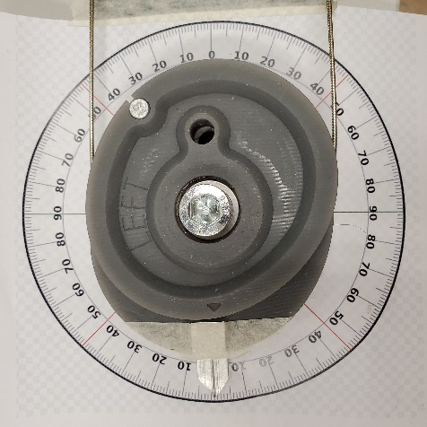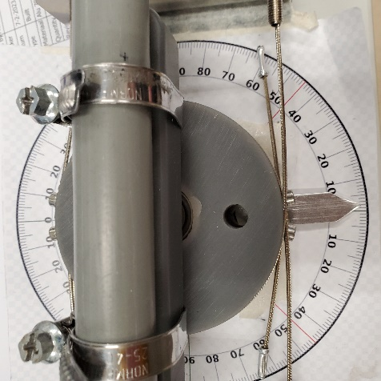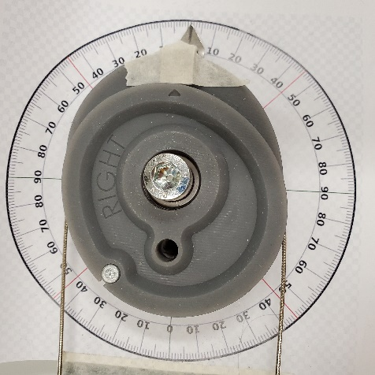
Figure 1. Images of the cable and cam steering system proof-of-concept prototype.
The system performed well in numerical simulations, but we were concerned that drag in the Bowden cables would interfere with the natural self-stability we hoped the vehicle would demonstrate. Thankfully, evaluations of several commercially available steer-by-cable cargo bikes and a couple of our own proof-of-concept prototypes proved that very low friction was possible.
Finally, we are building a working prototype of the complete vehicle and will evaluate its handling in a separate submission.
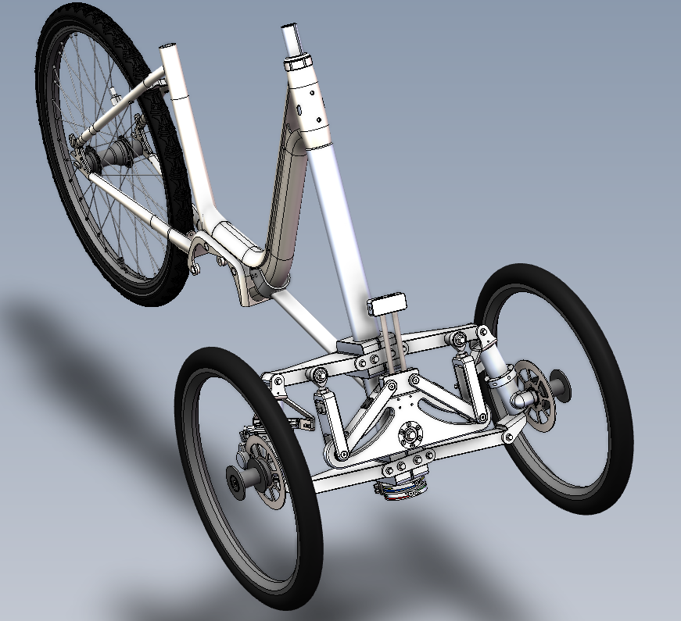
Figure 2. Final design solid model.
This project was financed and supported by the TKI/ClickNL 'De Fiets van de Toekomst' grant and Royal Dutch Gazelle.

References
Drstvenšek, I., Drstvenšek, S., Valentan, B., Baliĉ, J. (2006, April 20-22), Mathematical Background of Development of Steering Mechanism for Human Powered Vehicle, 5th International DAAAM Baltic Conference "Industrial Engineering - Adding Innovation Capacity of Labour Force and Entrepreneurs", Tallinn, Estonia
Pierson, A. M., Shortreed, A. K., Van Asten, P. D., Dressel, A. E. (2020, August 17–19), A Narrow-Track Tilting Tricycle With Variable Stability That the Rider Can Control Manually, Proceedings of the ASME 2020 International Design Engineering Technical Conferences and Computers and Information in Engineering Conference. Volume 4: 22nd International Conference on Advanced Vehicle Technologies, Virtual, Online

